University of Melbourne Logo****

Shared decision support in general practice: An antimicrobial stewardship strategy to promote appropriate use of antibiotics in primary care

8 October 2021

Table of Contents

Research team 5

Acknowledgements 6

1. Executive summary 8

2. Background 11

3. Aim 12

4. Literature Review 13

4.1 Aim 13

4.2 Summary of key information 13

4.3 Shared decision making and patient decision information tools – current evidence 14

4.4 Current patient decision aids/information leaflets 15

4.5 Conclusion 16

5. Phase 1 – Development of Decision Support Tools 17

5.1 Aim 17

5.2 Methodology 17

5.3 Results 18

6. Phase 2 – Piloting Decision Support Tools 25

6.1 Aim 25

6.2 Methodology 25

6.3 Results 26

6.4 Final information sheets for publication 35

7. Summary of key findings 42

7.1 Literature Review 42

7.2 Phase 1 – Development of Decision Support Tools 42

7.3 Phase 2 – Piloting Decision Support Tools 42

8. Conclusion 43

Appendices 45

Appendix A. 45

Appendix B. 50

Appendix C. 51

Appendix D. 56

Appendix E. 67

References 71

Tables and Figures

Figure 1. Co-design session 1 with participants and facilitators 18

Figure 2. Ranking of topics on information sheets by healthcare providers and consumers 19

Figure 3. First prototype of the bronchitis patient information sheet 19

Figure 4. Co-design session 2 20

Figure 5. Information resources for before, during and after consultation 20

Figure 6. Themes from the co-design sessions and patient interviews 21

Table 1. Characteristics of healthcare providers 26

Table 2. Characteristics of patients 27

Figure 7.Themes from the healthcare providers and patient interviews in the pilot phase 27

Table 3. Participants’ preference of delivery of patient information sheets 31

Table 4. Participants’ preference of access to patient information sheets 32

# Research team

Dr Ruby Biezen

Research Fellow

Department of General Practice, The University of Melbourne

A/Prof Jo-Anne Manski-Nankervis

Academic GP

Department of General Practice, The University of Melbourne

Dr Stephen Ciavarella

Student Researcher

Department of General Practice, The University of Melbourne

Dr Tim Monaghan

GP Researcher

Department of General Practice, The University of Melbourne

Ms Kaleswari Somasundaram

Research Assistant

Department of General Practice, The University of Melbourne

Ms Robyn Ingram

National Antimicrobial Prescribing Survey Program Manager

National Centre for Antimicrobial Stewardship, Doherty Institute for Infection and Immunity

Prof Kirsty Buising

Project Lead

National Centre for Antimicrobial Stewardship, Department of Infectious Diseases, The University of Melbourne

# Acknowledgements

This project was funded by the Australian Government Department of Health. The General Practitioner Antimicrobial Stewardship Expert Group (GP AMS Expert Group), a subgroup of the Australian Strategic and Technical Advisory Group on Antimicrobial Resistance was consulted throughout the project.

The research team would like to acknowledge and thank all participants in this study. We would like to especially thank the GP AMS Expert Group and the Content Expert Group for their input into the study. We would also like to express our thanks to Ms Sri Elkins for the graphic design and Dr Barbara Hunter for assisting with student supervision.

**Abbreviations**

AMS Antimicrobial Stewardship

CALD Culturally and Linguistically Diverse

ESBL Extended Spectrum Beta-lactamase

GP General Practitioner

GP NAPS General Practice National Antimicrobial Prescribing Survey

NCAS National Centre for Antimicrobial Stewardship

NPS National Antimicrobial Prescribing Survey

PN Practice Nurse

LRTIs Lower Respiratory Tract Infections

RTIs Respiratory Tract Infections

SSTIs Skin and Soft Tissue Infections

TG Therapeutic Guidelines

URTIs Upper Respiratory Tract Infections

UTIs Urinary Tract Infections

VicREN Victorian primary care practice-based Research and Education Network

# Executive summary

The National Centre for Antimicrobial Stewardship (NCAS), in collaboration with the Department of General Practice, The University of Melbourne, was commissioned by the Australian Government Department of Health, to develop and pilot a suite of tools to provide information, support clinical discussion and decision making for patients with common infections in primary care. Currently there are very few of these resources in Australia, especially those that have been developed in consultation with both healthcare providers and consumers using a documented, transparent process. None have formally assessed the acceptability of these resources in the clinical setting. This project addressed the need to develop and evaluate robust decision support tools in the form of patient information sheets to assist both healthcare providers and patients to guide antibiotic use in primary care.

## Approach

The study comprised of three components: A literature review to assess current decision support tools for antibiotic prescribing for respiratory tract infections (RTIs), skin and soft tissue infections (SSTIs) and urinary tract infections (UTIs); co-design with key stakeholders/end-users to develop patient information tools; and piloting of these tools in metropolitan and regional general practices in Victoria to assess user acceptance.

## Findings

### Literature review

The literature review demonstrated that there is limited evidence on the development and effectiveness of patient information tools in primary care.  While there were resources available in the form of patient decision aids/information leaflets for common infections such as RTIs, SSTIs and UTIs, most of them lacked clear evidence of key stakeholder and end-user involvement in their development. Furthermore, only one assessed usability in a pilot study before implementation, and none have objectively assessed impact on antibiotic prescribing and use.

### Phase 1: Co-design sessions

The co-design sessions provided opportunities for healthcare providers and consumers to discuss the strengths and limitations of existing patient information resources. Together they advised on the attributes of patient information sheets that would address their information needs. Content, presentation and mode of delivery were examined. Both healthcare providers and consumers emphasised the importance of communication features such as using simple, concise and inclusive language, and design elements, like layout and formatting to engage users and improve usability. Information needed to be unambiguous. Complex diagrams and numbers were not favoured as they were confusing to some. In addition, participants provided insights into suitable delivery modes and access points for these information sheets to enable use. They felt that the information sheets should be able to be utilised before, during and after general practice consultations. The result of the co-design sessions was a robust product in the form of seven patient information sheets on common infections (acute bronchitis, middle ear infection, nose & sinus infection, sore throat, urinary tract infection, cellulitis and leg ulcers). The information sheets summarised signs and symptoms, management and treatment options including appropriate use of antibiotics, prevention and when to see a doctor. The information sheets were consulted with the GP AMS Expert Group prior to piloting.

### Phase 2: Piloting the patient information sheets

The seven patient information sheets were piloted across eight general practices in metropolitan and regional Victoria between August and November 2020. Post implementation evaluation with 15 healthcare providers and 13 patient interviews were conducted, with participants reporting that the patient information sheets were simple, clear and easy to use. In terms of drivers for using patient information sheets, general practitioners (GPs) expressed that they mainly used patient information sheets to reinforce their decision making in the consultation discussion, as an alternative to providing an antibiotic script and to provide a written summary of management recommendations for patients. For patients, the information sheets provided education around their diagnosis and how to self-manage their conditions. While the reasons behind using these information sheets were different for participants, they agreed that the contents were relevant, and increased patient knowledge of disease conditions, treatment and management options, including when to see a doctor. The use of the patient information sheets was lower than anticipated due to the impact of the COVID-19 pandemic on reduced presentation for infections and increased telephone telehealth consultations. Nevertheless, GPs used the information sheets when possible during the intervention period and both healthcare providers and patients thought they were acceptable and easy to use. In addition, participants thought it was important for these information sheets to be available in pharmacies, general practice waiting rooms and accessible via the internet. Translation into other languages would facilitate use with patients from culturally and linguistically diverse (CALD) backgrounds.

## Conclusions

The study demonstrated high usability and acceptance of the seven patient information sheets for common infections. They were developed using a transparent co-design process with healthcare providers and consumers, and were evaluated by piloting these tools in eight metropolitan and regional general practices across Victoria between August and November 2020. The co-design approach with healthcare providers and consumers was used to ensure that the patient information sheets met the needs of both groups. Thus, the piloting phase showed that GPs used the patient information sheets as an alternative to prescribe antibiotics, reinforced their treatment and management options, and patients expressed that the information sheets increased their knowledge in terms of understanding their disease conditions and treatment and management options. The patient information sheets also encouraged conversations between healthcare providers and patients during consultations.

The co-design and piloting process used in this study can be applied to suit a range of other diseases, and for other clinical settings such as the hospital setting or residential aged care. It is important these information sheets are regularly updated to remain consistent with guidelines.

## Possible next steps

1. Promote the patient information sheets across the Australian community; options might include (with appropriate consultation) the Australian Government Department of Health websites, and the Australian Government One Health AMR website, and organisations including the Royal Australian College of General Practitioners, the Australian Commission on Safety and Quality in Health Care, Australian Primary Health Networks, the Australian College of Rural and Remote Medicine;
2. Increase awareness of these resources through the community via advertisement in practice waiting rooms, and posters in pharmacies and practice waiting rooms;
3. Optimise the tools to facilitate access for both healthcare providers and patients. This may include integration with existing guidelines, such as Therapeutic Guidelines and HealthPathways, electronic medical record systems and pharmacy systems. The tools will be made available online through the National Centre for Antimicrobial Stewardship;
4. Devise mechanisms and support to ensure that tools are updated to make sure they remain consistent with guidelines as required, and to sustain long term use of these tools;
5. Continue to assess the impact on outcomes such as consumer knowledge and attitudes and prescriber behaviors to reduce inappropriate prescribing and use of antibiotics;
6. Increase the number of conditions for which information sheets are available e.g. boils, pneumonia, pyelonephritis, conjunctivitis;
7. Translate patient information sheets into different languages to facilitate use in culturally and linguistically diverse patients.

## Future directions:

* Patient information sheets can be adapted for use in developing countries in the Asia Pacific region;
* Provide similar processes that could be used to develop information sheets for other cohorts such as patients and carers in residential aged care, and discharged hospital patients to inform them of their conditions, signs and symptoms to look out for, and when to see a GP to avoid hospital re-admission;
* Explore how to incorporate information sheets in education (e.g. schools) to improve awareness of self-management strategies for illness.

# Background

Antibiotic resistance is a threat to global health. Inappropriate antibiotic use is associated with promotion of antimicrobial resistance amongst bacterial pathogens, as well as significant adverse drug effects for individuals, posing both immediate and long-term threats to human health.(1, 2) Australia is one of the highest prescribing countries in antibiotic use per capita, at double the rate of the lowest prescribers such as Sweden and The Netherlands.(3) The vast majority of antibiotic prescribing in Australia happens in primary care, thus it is imperative that stewardship strategies are identified for that context.

A recent pilot study, the General Practice National Antimicrobial Prescribing Survey (GP NAPS) conducted in 2017-2018 across eleven general practices explored the appropriateness of antimicrobial prescribing. It found that the most frequent indications for antibiotic use (from 572 consecutive antibiotic prescriptions) were respiratory tract infections (26.7%), ear, nose and throat infections (18.7%), skin and soft tissue infections (17.5%) and acute cystitis (10.7%). Many of these infections (such as acute pharyngitis, otitis media, rhinosinusitis, acute bronchitis) do not usually warrant antibiotic use. Similarly, a report from the NPS MedicineWise MedicineInsight program in 2014 estimated more than 50% of patients presenting with upper respiratory tract infections (URTIs) were prescribed an antibiotic when this would not usually be indicated. This included patients with acute pharyngitis/tonsillitis, acute sinusitis, acute otitis media and acute bronchitis.(3)

Studies have suggested inappropriate prescribing of antibiotics may be due to factors such as diagnostic uncertainty,(4, 5) physicians’ perceptions that patients would be more satisfied with the visit if antibiotics were prescribed,(6, 7) physicians’ perceptions that patients expect them to prescribe antibiotics during the visit,(8-10) and patients’ demand for antibiotics.(11) Recommendations from these studies included: 1) encourage better communication between patients and healthcare providers such as GPs, practice nurses, pharmacists in appropriate antibiotic use; 2) provide decision aids to patients to assist with the shared-decision making between the patient and the healthcare provider; and 3) deliver patient education on infectious diseases such as respiratory tract infections (RTIs), skin and soft tissue infections (SSTIs) and urinary tract infections (UTIs), and appropriate antibiotic usage to reduce expectation and inappropriate use of antibiotics.

The Clinical Care Standards in antimicrobial stewardship launched by the Australian Commission for Safety and Quality (12) in healthcare, specify that patients should expect to receive information about their clinical condition, its natural history and the treatment options available to them in a form that they can understand. In Australia, such information has not been readily available to GPs and patients for use at the point of care. Information authored for international audiences has been extremely popular. For example, the TARGET toolkit for antibiotic use has been the most downloaded resource from the Royal College of General Practitioners website in the United Kingdom.(13) These resources contain recommendations that do not align with Australian prescribing guidelines, and so local resources are required.

Patients need to be empowered in self-management of self-limiting conditions and guided in navigating over the counter therapies which may or may not be supported by evidence. Providing patients with alternatives to antibiotics can assist in the conversation between patients and GPs.

Shared decision making, where the benefits and risks of treatment options are discussed between healthcare providers and patients, can be used to guide health care decisions to help ensure management meets the patient’s expectations for health outcomes. Tools such as patient information sheets and decision aids that contain relevant information to assist patients in that decision process can facilitate shared decision making.(14) Patient decision aids have been developed for use in the areas of mental health, screening choices and treatment options, and antibiotic use.(15-20) They have been shown to be effective in reducing decisional conflicts,(15) supporting patients with complicated treatment options,(17) and encouraging shared decision making.(18) However, many patient decision aids are not based on current evidence, or not updated.(21) In addition, many are in clinical use despite limited studies to explore their effectiveness.(22)Clearly not all resources and tools will have the same impact. A clear process is needed to ensure that new tools and resources are developed with appropriate interpretation of evidence, and adequate stakeholder review. Ideally both medical and consumer stakeholders should be involved in a transparent evidence-based process. They also need a clear evaluation plan and a commitment to maintenance.

Currently there are very few patient decision aids for antibiotic use, targeting patients available in Australia.(23) Importantly, none have been developed in consultation with both healthcare providers and consumers using a documented, transparent process. In addition, none have formally assessed the acceptability in the clinical setting.

# Aim

The overall aim of this project is to develop and pilot a suite of tools to provide information and support clinical discussion and decision making for patients with common infections in primary care. This information will help to empower consumers to better understand their illness and facilitate self-management for conditions that often drive antibiotic overuse.

To achieve the overall aim, we conducted:

1. Literature review: Assess existing decision support tools available in Australia and overseas, relating to antibiotic use for respiratory tract infections, skin and soft tissue infections and urinary tract infections;
2. Phase 1 study: Develop tools using co-design methodology with healthcare providers and consumers;
3. Phase 2 study: Pilot the tools in eight general practices across Victoria to assess user acceptance and workflow through healthcare provider and patient interviews.

# 4.Literature Review

## 4.1 Aim

The aim of this literature review is to assess existing decision support tools, available in Australia and overseas, relating to antibiotic use for respiratory tract infections (RTIs), skin and soft tissue infections (SSTIs) and urinary tract infections (UTIs). This review is divided into three parts:

1. Summary of the key information available in current evidence-based guidelines that might inform the content of decision aids/patient information for RTIs (to include acute bronchitis, otitis media, acute sinusitis and tonsillitis), SSTIs (including cellulitis and ulcers), and UTIs (including acute cystitis and urinary tract infections in aged care). This includes common symptoms, causes, natural history, treatment and management options, and antibiotics if advised;
2. Review current literature on evidence of impact of shared decision making and patient decision tools (including patient information sheets) for antibiotic prescribing in primary care; and
3. Summary of currently available patient decision aids and information leaflets for these conditions available for primary care patients.

## 4.2 Summary of key information (cause, symptoms, natural history and antibiotic use) for respiratory tract infections, urinary tract infections, and skin and soft tissue infections

### 4.2.1 Respiratory tract infections

RTIs can be classified into upper respiratory tract infections (URTIs) e.g., the common cold, rhinosinusitis, pharyngitis, tonsillitis, laryngitis, and otitis media; and lower respiratory tract infections (LRTIs) affecting the bronchi and lungs e.g., bronchitis, bronchiolitis, and pneumonia.(24) Many RTIs are caused by viruses and these infections occur when viruses are deposited onto the mucous membranes of the upper respiratory tract through inhalation of airborne droplets from sneezing and coughing and/or through touching infected mucous on contaminated surfaces or hands. Antibiotics are not indicated for the majority of these infections.

Signs, symptoms and natural history of RTIs, treatment and management advice are summarized in Appendix A

### 4.2.2 Skin and soft tissue infections

SSTIs are usually caused by bacteria such as *Staphylococcus aureus*, *Streptococcus pyogenes*, and beta-haemolytic streptococcus.(25) While optimal treatment for boils and carbuncles is incision and drainage, and antibiotic therapy may not be needed, other SSTIs, such as cellulitis, usually require antibiotic therapy.

For cellulitis besides antibiotic treatment, management advice may include pain relief, rest, and elevating the infected limb (Appendix A).(25, 26)

Ulcers, in particular venous ulcers, can become infected, but more often become colonised by opportunistic bacteria.(27) Treatment may include wound cleansing, wound dressing and debridement. Antibiotics are not recommended unless there is clinical evidence of an active infection (Appendix A).(28, 29)

### 4.2.3 Urinary tract infections

UTIs are common, especially in women and older people. They can drive high volumes of antibiotic use. Over-diagnosis and possible overuse of long term preventative antibiotic treatments have been raised as concerns for patients residing in aged care facilities. Increasing antibiotic resistance amongst pathogens has influenced recommendations for empiric therapy. Non-antibiotic strategies to manage infections have been promoted recently (Appendix A).(29)

## 4.3 Shared decision making and patient decision information tools – current evidence

### 4.3.1 Aim

The aim of this review is to assess currently available shared decision making tools and patient decision information aids to assist patients in the decision making regarding antibiotic use for RTIs, SSTIs, and/or UTIs, focussing on the strategies used in their development and the outcome of the studies done to assess their impact.

### 4.3.2 Search methods

Two databases, MEDLINE (1946 to 11 September 2019) and Web of Science (1900 to 11 September 2019) were used using search terms and search strategies below:

**Combinations of terms used in searches:**

1. Common cold OR sinusitis OR pharyngitis OR laryngitis OR sore throat OR tonsillitis OR otitis media OR bronchitis OR respiratory infection(s) OR respiratory tract infection(s)
2. Cellulitis OR ulcer(s) OR folliculitis OR pseudofolliculitis OR pitted keratolysis OR erythrasma OR boil(s) OR carbuncle OR erysipelas OR impetigo OR staphylococcal scalded skin syndrome OR recurrent staphylococcal skin infection
3. UTI OR urinary tract infection(s) OR cystitis OR acute cystitis OR bladder infection(s) OR prophylaxis
4. Shared decision OR patient decision aid(s) OR patient decision tool(s) OR patient information aid(s) OR patient information tool(s)
5. General practice OR primary care OR primary health care
6. Aged care
7. Antibiotic(s) OR antimicrobial(s)

**Combination searches (to include all interchangeable terms from above):**

**For respiratory tract infections:**

[Terms from 1] AND [Terms from 4] AND [Terms from 5] AND [Terms from 7]

**For skin and soft tissue infections:**

[Terms from 2] AND [Terms from 4] AND [Terms from 5] AND [Terms from 7]

**For urinary tract infections**:

[Terms from 3] AND [Terms from 4] AND [(Terms from 5) OR (Terms from 6)] AND [Terms from 7]

### 4.3.3 Selection criteria

We included studies that used patient information tools or leaflets to assess antibiotic prescribing and/or use, as primary or secondary outcomes. Studies were excluded if they were:

1. Not in English;
2. Not conducted in general practice;
3. Protocol papers;
4. Assessing outcomes not related to information aids to reduce antibiotic prescribing/use;
5. Assessing outcomes on decisional conflict rather than shared decision making;
6. Assessing diseases other than RTIs, UTIs, SSTIs; and
7. Assessing delayed prescribing not involving shared decision tools.

We did not include any systematic reviews or other review papers, as the relevant papers from these reviews were included in the additional records identified if not already included in the initial search. Please refer to Appendix B, Prisma flowchart for search and inclusion strategies.

### 4.3.4 Main findings

We identified six published papers that fit the selection criteria. Of these studies, two were clustered randomised controlled trials,(30, 31) one parallel group randomised controlled trial,(19) one nested randomised controlled trial,(32) one before and after study,(33) and one perspective observational study.(34) All studies except for one investigated the impact of decision support on antibiotic use for RTIs, while the other study investigated the use of a tool kit for UTI caused by bacteria with extended spectrum beta-lactamases (ESBL).(34) Three studies were from the UK,(30-32) one each from Europe,(34) United States of America (USA)(33) and Australia.(19) Summary of the studies are displayed in Appendix C.

Some of the findings highlighted:

* Clinical decision support tools in the form of patient information leaflets or booklets were developed in consultation with expert groups and key stakeholders in three studies.(19, 30, 31) However, it was not clear whether these tools were developed in a co-design environment at the start of development process, or whether the consultation with expert groups and key stakeholders came after the tool design. The other three studies did not mention the tool development process.(32-34)
* The impact on antibiotic prescribing and use were assessed directly in four of the six studies.(30-32, 34) Of the four studies, only one showed a significant reduction in antibiotic prescribing after uptake of the patient information tool.(30)
* The other two studies assessed parental knowledge(19) and guideline compliance.(33) In both of these studies the patient decision aids increased parental knowledge and influenced their intention to use antibiotics for a future RTI.(19) Interventions such as clinician education and posters targeting patients in the waiting room significantly improved provider compliance with antibiotic prescribing guidelines.(33)
* Of the six studies, only one used patient information tools in the form of shared decision making during consultations between patients and healthcare providers.(30) Antibiotic prescribing was significantly reduced in the intervention group compared to the control group.

### 4.3.5 Discussion

Currently, there are limited studies on shared decision support tools in the form of patient decision information tools/aids that aim to reduce antibiotic prescribing and use, and even less on assessing their effectiveness in a clinical setting in primary care. It was difficult to evaluate the effectiveness of these tools as most were not used within a patient consultation, and none of the studies assessed the frequency of tool use either during consultations or outside of the consultation. In addition, none of the studies developed decision support tools using a co-design methodology and did not assess the sustainability of these tools long term.

## 4.4 Current patient decision aids/information leaflets

### 4.4.1 Aim

This section is to review some of the current patient decision aids/information leaflets available to assist patients with the decision-making process of using antibiotics for RTIs (bronchitis, otitis media, sinusitis, tonsillitis), SSTIs (cellulitis and ulcers), and UTIs (including cystitis) in primary care.

### 4.4.2 Methods

We searched Australian government websites such as the Australian Commission on Safety and Quality in Health Care,(36) Better Health Channel,(28) NPS MedicineWise,(26) Safer Care Victoria,(37) and the Victorian Department of Health and Human Services,(38) as well as international sites including US Centers for Disease Control and Prevention,(39) Choosing Wisely,(40, 41) UK National Health Service,(42) National Institute for Health and Care Excellence,(43) Public Health England(44)and Self Care forum(45) on patient information tools for RTIs, SSTIs and UTIs. Where appropriate, information leaflets were also included from studies found in the literature search. Patient decision aids/information leaflets were included if they were used in primary care, while decision aids used solely in the hospital setting were excluded.

The following categories were assessed (Appendix D):

* Where and when it was published, and updated where mentioned;
* The type of illness (indication);
* Whether the tool development involved key stakeholders;
* Whether the tool was piloted before implementation;
* Main target audience; and
* Whether the information tool discussed the cause, symptoms, and natural history of the illness; treatment and management options; benefit and harm; and whether an antibiotic was mentioned.

### 4.4.3 Main findings and discussion

In this study, we included patient decision aids/patient information leaflets from five Australian websites and nine overseas websites from the US, UK and Europe. Most of the information provided in the decision aids/information leaflets included cause, symptoms, natural illness duration, treatment and management options, and antibiotics advised. Some included other information such as prevention, antibiotic benefit and harm, and dangerous signs to look out for (see Appendix D). While illustrations in some of these tools may be appealing to the audience, the majority of the patient decision aids/information leaflets included a large amount of text. This may be difficult for patients to understand, especially if the information is not discussed during consultations with healthcare providers.

Of the 49 decision aids/information leaflets included in this study, less than half (43%, n=21) were stated to have been developed in consultation with expert groups; others did not mention how these tools were developed. In addition, many were not piloted or trialled before implementation, therefore acceptability and usability of these decision aids/information leaflets were not known. Furthermore, around 25% (n=12) of these decision aids/information leaflets were more than 5 years old, and have not been recently updated or reviewed.

It is important that tools are developed in consultation with key stakeholders, including content experts, healthcare providers and patients, in order to create evidence-based patient decision support tools that are robust, easy to understand, visually appealing, acceptable, and feasible. This can be facilitated by involving key stakeholders in the design and development of tools. Support should be provided to healthcare providers to encourage communication and shared decision making with patients during consultations. Finally, there needs to be a maintenance process to ensure information is relevant and up to date, easy to access and to provide on-going support and feedback to healthcare providers and patients for long term sustainability.

## 4.5 Conclusion

This review has demonstrated that there is a limited amount of literature to support the tools that are currently available for use in primary care.  While there are resources available in the form of patient decision aids/information leaflets for common infections such as RTIs, SSTIs, and UTIs, most of them lacked clear evidence of key stakeholder and consumer involvement in their development. Furthermore, only one assessed usability in a pilot study before implementation, and none have objectively assessed impact on prescribing.

Many shared decision making tools referencing prescribing guidelines, have information targeted for healthcare providers; this means they are not necessarily appropriate for patient use. The tools do not consistently include specific information to address common issues such as prevention, warning signs and complications, and when to re-consult.

In order to develop and implement successful decision support tools there is a need for a clear, transparent and evidence-based process for design and evaluation involving healthcare providers and patients in primary care. Specifically, there is a need to consider:

1) The use of a co-design methodology to develop decision support tools with key stakeholders (GPs, practice nurses, pharmacists, consumers) involved from the outset to increase acceptability and usability of these tools;

2) Independent consumer and GP assessment to ensure they meet expectations and requirements;

3) Strategies to make the tools easy to access in the clinical context and an assessment of uptake in a real world setting;

4) An assessment of impact on outcomes such as consumer knowledge and attitudes and prescriber behaviors; and

5) Provision of ongoing support to ensure there are regular updates to sustain long term use of these tools.

Tools to guide shared decision making between healthcare providers and patients may help to optimise antibiotic prescribing, but more work is needed to ensure that they are well designed to meet specific needs.

# 5.Phase 1 – Development of Decision Support Tools

## 5.1 Aim

The aim of the phase 1 study was to co-design shared decision support tools to promote antimicrobial stewardship in primary care with healthcare providers including GPs, practice nurses, pharmacists and consumers.

## 5.2 Methodology

### 5.2.1 Study design

Co-design study consisting of three sessions to develop shared decision support tools.

### 5.2.2 Participant recruitment

Participants consisted of GPs, a practice nurse, a pharmacist, and patients/consumers that attend general practice for the majority of their medical care. They were recruited via the research team’s professional network such as NCAS and Victorian primary care practice-based Research and Education Network (VicREN). An advertisement of the project, a plain language statement and a consent form were sent to potential participants via email. Interested participants contacted the research team, who explained the project in detail and answered any questions. All participants signed their consent forms before commencement of the project and participated in all the three of the sessions.

### 5.2.3 Co-design sessions data collection and analysis

The first co-design session focussed on what information participants considered as important to include in patient decision aids/information sheets and by what mode(s) this information should be delivered. Using bronchitis as an example, participants were asked to rank eleven categories of information (e.g. cause, symptoms, natural illness, when to see a GP, prevention, risk of antibiotics) from most important to least important. Participants were then asked to critique five current patient information sheets, discuss what they liked and disliked about these information sheets, and once again asked to rank the eleven categories of information. Following this, participants were to provide feedback on how to optimise the information and delivery of the information in those materials. The session was video and audio recorded. Category rankings were analysed descriptively in Excel. Audio recording was transcribed verbatim, with any identifying information removed, and common themes were identified using thematic analysis.

Following data analysis of the first co-design meeting, the research team composed draft content which aligned with the Therapeutic Guidelines and was reviewed by a Content Expert Group consisting of two GPs, one pharmacist, one infectious diseases physician, one aged care nurse and two microbiologists. Information for bronchitis was provided to a graphic designer to develop the prototype information sheet.

The second-co-design session focused on the content, format, and layout of the prototype bronchitis information sheet. The content was also discussed for the other six conditions (tonsillitis, otitis media, rhinosinusitis, urinary tract infection, leg ulcers and cellulitis). The session was video and audio recorded. Audio recording was transcribed verbatim. Identifying information was removed after which a thematic analysis was conducted.

Feedback from the second co-design session was reviewed by the research team. The graphic designer refined the bronchitis information sheet based on the feedback received and applied the resulting formatting to information sheets for the other six conditions (tonsillitis, otitis media, rhinosinusitis, urinary tract infection, leg ulcers and cellulitis). These conditions were selected as they were the most common conditions seen in general practice.

The third co-design meeting was scheduled for March 2020, however, due to COVID-19 restrictions enforced in Melbourne it was replaced with individual semi-structured interviews that were conducted by Zoom online platform or via telephone. In these interviews, participants were asked to provide feedback on the information sheets and how these tools could be delivered and used. These interviews were subsequently transcribed and analysed thematically. Drafts of the seven patient information sheets were also mailed to all participants with a request to comment on layout and content. These were returned to the researcher via reply paid Express Post. Marked up information sheets were summarised, and changes provided to the graphic designer for refinement.

Qualitative data were analysed using a deductive thematic analysis approach using NVivo 12 (QSR International). The coding scheme was developed by grouping recurrent ideas during data analysis, and then refined under themes and subthemes. Data were coded independently by two researchers with differences in perspective negotiated with a third researcher until consensus was reached. The thematic coding scheme adopted by the coders was described under six headings: content, communication of content, design, delivery and access, usability, and engagement.

### 5.2.5 Ethics

Ethics approval was obtained from The University of Melbourne General Practice Human Ethics Advisory Group (Ethics ID: 1954925.1).

## 5.3 Results

Data from the two co-design sessions and the participant interviews were collected between October 2019 to April 2020. Participants included five healthcare providers (three GPs, one pharmacist, one practice nurse), and six consumers (one older male (>70 years of age), one older female (>70 years of age), one 39yo mother of a young child, one 49yo father of a teenager, one 50yo single male, and one 19yo male) (see Figure 1).



Figure 1. Co-design session 1 with participants and facilitators

In the first exercise participants were asked to rank the 11 categories of information in order of importance before and after critiquing five commonly used patient information sheets. There were significant differences between healthcare providers and consumers. For healthcare providers, ‘when to see a GP’ was the most important information needed to be on patient information sheets. This view did not change after critiquing other patient information sheets. They rated ‘the risks and benefits of antibiotics’ as least important (see Figure 2).

In contrast, consumers initially stated that they prioritised the definition and management options for their condition. After critiquing the commonly used patient information sheets, they reported that the most common symptoms and the natural history of the disease were more important. Prevention was considered the least important by consumers.

Figure 2. Ranking of topics on information sheets by healthcare providers and consumers (co-design session 1)

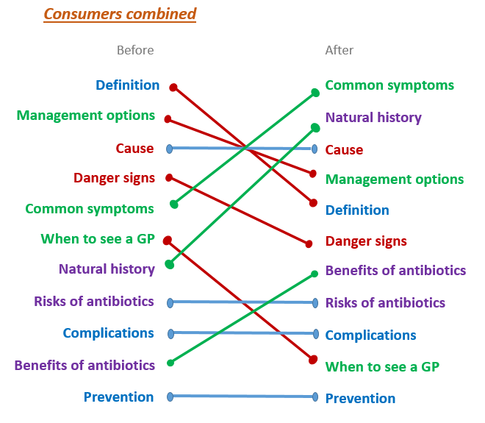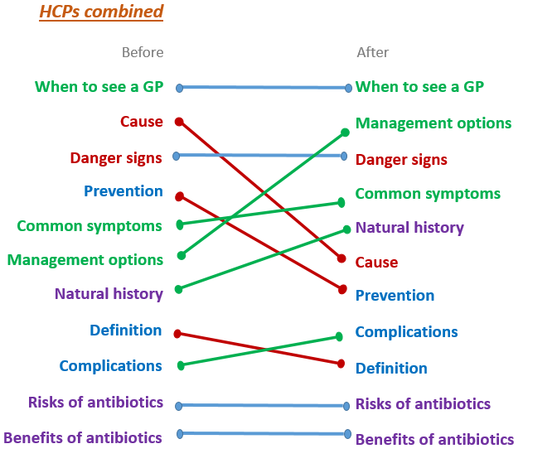

After co-design session 1 data analysis and review by the Content Expert Group, the first prototype was then developed (see Figure 3).

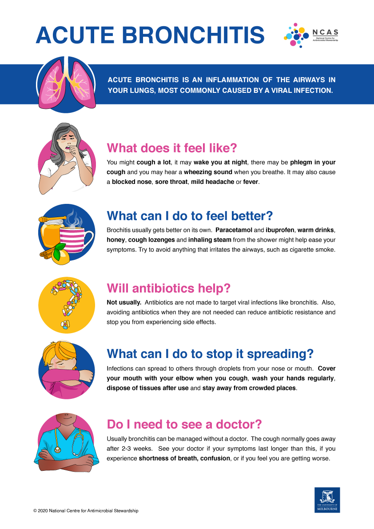

Figure 3. First prototype of the bronchitis patient information sheet

During the second co-design sessions, participants commented on the design, layout and format of the bronchitis patient information sheet (detailed in Section 5.3.4), what they liked and disliked about the information sheet (see Figure 4). In addition, participants thought including a ‘disclaimer’ at the bottom of the patient information was seen as important, to reiterate that the purpose of these information sheets was a guide and not as a replacement to seek a healthcare professional for advice.

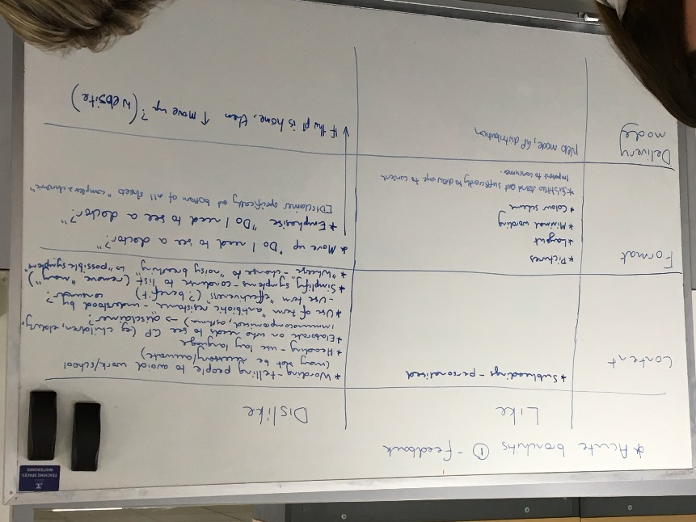

Figure 4. Co-design session 2

Results from both co-design sessions and participant interviews indicated that healthcare providers and consumers would find that information sheets would be useful before, during and after a GP consultation to support patients in their knowledge of common infections and when deciding to see their GP (Figure 5). They commented that these information sheets should be available within the community, including pharmacies, aged care facilities and schools to promote antimicrobial stewardship.

**Before consultation**

**During consultation**

**Games**

**Check list**

**Websites with information**

**Posters**

**Pamphlets**

**Shared decision aids**

**Websites with information**

**Pamphlets**

**After consultation**

Figure 5. Information resources for before, during and after consultation

### 5.3.4 Qualitative data from co-design sessions and participant interviews

Seven shared decision support tools, in the form of patient information sheets, were developed: acute bronchitis, middle ear infection, nose & sinus infection, sore throat, urinary tract infection, cellulitis and leg ulcers.

Qualitative data from the co-design sessions and interviews have been grouped under six major themes: content, communication of content, design, delivery and access, usability, and engagement (Figure 6).

The results from the co-design sessions showed that healthcare providers and consumers prioritised information differently. In addition, it was interesting to note even though current literature suggests that risks and benefits were important to include in patient information sheets, they were considered as least important by healthcare providers and not as important for consumers. This exercise demonstrated the importance of a co-design process in any tool development and to involve end-users, such as healthcare providers and patients/consumers, in the development process.

Figure 6. Themes from the co-design sessions and patient interviews

#### 5.3.4.1 Content

Participants commented that information sheets should show relevant content, and display in a format that is engaging for both healthcare providers and patients.

*“We want the important stuff on the first page and I think this stuff on the first page that’s irrelevant and meaningless should be on the back page and vice versa.”* Participant 11, consumer, co-design session 1

*“…the message it’s trying to convey, it’s a very simplified version of them writing it out and having lots of words and stats and things like that, so they’ve done it in a good way, but I think it is just too much, and if it is going to be a two-pager you’re not going to get them to turn over to read the second page…*” Participant 5, pharmacist, co-design session 1

“…Just a little bit too much reading.” Participant 8, consumer, co-design session 1

“…and you don’t need the words super pubic pain … you just need to say if you’ve got blood in your urine or feel the need to pass urgently. I don’t think you need actual medical terms… *Obviously you need to adapt it for general practice… Make sure the information is relevant not only for target audience, also the setting…”* Participant 2, GP, co-design session 1

*“…it’s easy to read and it draws your attention to it with the pictures on the side, the decorations on the side, and it’s got the headings in bold, and short description. I think this is good for the public consumers, I think they would read this.”* Participant 8, consumer, co-design session 1

Healthcare providers often favoured information covering ‘danger signs’, and ‘when to seek healthcare advice’, to manage medico-legal risk and to ensure patients were not unduly dissuaded from seeking medical review.

*“If your symptoms aren’t improving, if you’re not getting better, and I think that’s why I personally prioritised that higher, because, that’s… if people aren’t getting better, not improving, to come back and see me.”* Participant 1, GP, co-design session 2

This was considered especially true for certain at-risk groups, such as those with chronic medical conditions. It was agreed that having a generic warning was important to ensure that patients seek the professional advice of healthcare providers if they are not sure about whether they need antibiotics.

Many healthcare providers felt that including information on bacterial versus viral pathogenesis of infections was too complex. Similarly, they reported that there was little point exploring the risks and benefits of antibiotics if antibiotics were not appropriate to the management of the patient before them.

#### 5.3.4.2 Communication of Content

Participants indicated that the use of simple, concise language was essential for communicating the necessary information. Avoiding complex medical terminology was seen as particularly desirable.

*“With the benefits and risks, I just think it is a bit too complex to be on the person’s level of health literacy.”* Participant 5, pharmacist, co-design session 1

It was considered important to use generic language where possible, however it was acknowledged that confusion could arise because of the different brand names of medications patients may be familiar with.

*“I’ve had a patient who took their two Panadol, and they had their Panamax, and they had their paracetamol.”* Participant 4, practice nurse, co-design session 2

#### 5.3.4.3 Design

Participants suggested important design elements, such as bold text headings, and balancing words with pictures. Some features became especially apparent when participants were asked to critique existing resources, suggesting that important healthcare messages could otherwise be lost.

*“There’s nothing highlighted, there’s nothing to stand out, it’s all put with the same importance as everything else so – there’s no highlight of the fact when to see a doctor, it’s exactly the same text as symptoms.”* Participant 10, consumer, co-design session 1 (reviewing existing patient information sheets)

The information sheets needed to be engaging and able to highlight important content to make it easy for the patients so they did not have to search for relevant information.

*“I love the way you've bolded some of the things, because I always either highlight or underline, I'm like, "These are the reasons I want you to come see me.". So the fact that that's already done would be good. I wouldn't have to go searching for my highlighter...”* Participant 1, GP, co-design session 2 (reviewing Shared Decision Support Patient Information sheet Bronchitis prototype)

It was considered crucial that all the information be kept to a single-sided A4-sized page.

*“If it is going to be a two-pager you’re not going to get them to turn over to read the second page.”* Participant 5, pharmacist, co-design session 1

Use of colour was also an important consideration, though healthcare providers often indicated that they may only be able to print the resource in black-and-white. Pictures related to the adjacent subheadings were regarded as useful in increasing readability.

#### 5.3.4.4 Delivery and access

Participants were encouraged to consider the delivery mode for the information sheets. Participants primarily focussed on delivery modes and access points appropriate for use prior to visiting a healthcare provider. They suggested different modalities would be required to sufficiently target diverse groups within the community and increase their knowledge of management of common infections, including appropriate use of antibiotics.

Before the consultation, having the tools visible in the community, including pharmacies, aged care facilities, and schools, was seen as an effective means of promoting the antimicrobial stewardship (AMS) message, as were posters and slides on the waiting room television. The handouts themselves, websites and online booking platforms were also raised by many participants as a convenient mode of access both before and after consultations that would assist in the promotion of AMS.

*“I was thinking - this is before they see the doctor. This might be at the chemists, or it could be online or in a child care centre or a school, or I don’t know, whatever - a community thing where people see information.”* Participant 2, GP participant interview

*“We could put it on the practice website, you know, in our resources section” Participant 1, GP, participant interview*

During the consultation, many participants agreed the handout itself was the most appropriate form to promote AMS. Some participants suggested the handout could be integrated into the practice management software, or transferred to patients electronically.

*“I think this is really good… when I go and see him (GP) and quite often… he pulls up an information sheet and he clicks print. Then he prints it and hands it to me as here's some more information. So it would be nice if he has this in a file and can just hand it to me. Because when he actually hands it to me, hands me this information, I actually read it.”* Participant 9, consumer, co-design session 2

Some hesitancy was expressed that electronic delivery modes or access points would be a barrier to promoting AMS in older patients.

*“I also think quite a few, especially elderly patients, don’t use computers and emails. So I think for them you need to have a written handout that their doctor gives them.”* Participant 8, consumer, co-design session *1*

#### 5.3.4.5 Usability

Usability features were discussed at length during participant interviews. A key principle that emerged was that the tools needed to be readily accessible to facilitate use.

*“I use the three-click rule when we talk about all this co-design stuff. If they're too far away, the GPs won't use it.”* Participant 3, GP, participant interview

The size of the tool in terms of being on a A4, single-sided sheet, was seen as important in improving adherence to AMS amongst participants.

*“If you're going to get someone to do something, it needs to be really short.”* Participant 1, GP, participant interview

Several healthcare providers mentioned shared decision support tools may help them save time during consultations for common infections, and assist them in shortening the duration of future consultations with patients.

*“Half the time - normally, I can make up my mind pretty quickly about what needs to happen… The hard part then is the… communication. It's educating. If I've got a tool or resource, which is easily accessible - I know where it is, it sits on my screen, I can print it off, it saves me so much time.”* Participant 1, GP, participant interview

*“… I see so many people… who come in with symptoms suggestive of a viral sinusitis, and often want to have that discussion about getting antibiotics. I think that the way the … tool is written and formatted would make it really… user-friendly and great to have it in a consult*...” Participant 1, GP, participant interview

Along with these suggestions, some participants raised concerns that certain components of the shared decision support tools could inhibit their use. For example, some participants were concerned that the language in the legal disclaimer may encourage readers to seek additional medical review. Similarly, some participants suggested there may be a conflict of interest that may prevent some pharmacists from wanting to use the tools in their community pharmacy as the information sheets stated there was insufficient evidence for use of some over-the-counter products. It was also suggested that pharmacists may be concerned about indemnity as a result of providing these information sheets.

*“I think pharmacists might want something to cover them too, because then if they go ‘oh well the pharmacist gave me this and says that I didn’t have to go (to see the GP) or they didn’t tell me to go’ like I think that might be a bit of a trap as well.”* Participant 5, pharmacist, participant interview

#### 5.3.4.6 Engagement

During the first co-design meeting, participants often suggested the shared decision support tools can make consumers aware of other effective management options. Furthermore, the tools may have the potential to provide them with a reference for later, which may be used to educate others about AMS.

*“[The tools] takes it away from the doctor and says, ‘What brings you here today?’, ‘That cough’s back again, I need the antibiotics.’ ‘Okay, let’s talk about that. There’s this new tool that I have….’”* Participant 3, GP, co-design session 1.

*“It’s another resource, then they’re going to walk away with…. a piece of paper that says I’m not taking antibiotics but I’m going to have some rest, sleep, drink more fluids”* Participant 5, pharmacist, co-design session 1

Broader exploration of user engagement was achieved during participant interviews. Participants said they were able to recognise non-antimicrobial management strategies for common infections as a result of engaging with the shared decision support tools.

*“I think if I could give them this sheet with that and say, ‘Look, this is what the advice is saying. You don't need antibiotics, you need to go home and take some Panadol and rest….”* Participant 1, GP, participant interview

Many participants reported the tools contained sufficient information to allow consumers to make decisions about whether or not they needed to see a healthcare provider for a discussion about antibiotic use for their illness.

*“I think if I have an ailment of some sort and I want to quickly decide before I contact a doctor what the best initial course of action is, I think these would be quite useful.”* Participant 10, consumer, participant interview

In general, patient information sheets should be kept simple and relevant, communicated in plain, concise and logical manner, using inclusive and simple language, and agreed that they should be developed to a grade 5 reading level.

At the end of the third co-design phase, participants thought the information sheets they helped to co-design were concise, easy to understand and relevant. In addition, participants commented that the information was consistent, and they liked the disclaimer at the bottom of the information sheets. Minor changes were suggested to wording such as replacing ‘complex medical conditions’ to ‘other medical conditions’.

Seven patient information sheets were hence developed. The resultant information sheets were sent to the GP AMS Expert Group (consisting of representatives from the Australian College of Rural and Remote Medicine, North Western Melbourne Primary Health Network, the Australian Government Department of Health, and a Royal Australian College of General Practitioners representative) for their feedback. The research team reviewed all comments and addressed them accordingly to include in the final version (including COVID-19 information) for piloting.

# 6.Phase 2 – Piloting Decision Support Tools

## 6.1 Aim

The aim of the phase 2 study was to pilot the seven patient information sheets into eight general practices across Victoria to assess its usability and acceptability of these tools.

## 6.2 Methodology

### 6.2.1 Study design

The pilot study consisted of an intervention where participating practices were provided with access to the seven patient information sheets (via printed copies, files saved locally on the GPs’ general practice computers, and via online access through NCAS’s website) to be used during the intervention period (3 August – 30 November 2020). Participating GPs and practices nurses were asked to utilise these patient information sheets with patients presenting with a respiratory tract infection (acute bronchitis, tonsillitis, otitis media, rhinosinusitis), skin and soft tissue infections (cellulitis and leg ulcers), or urinary tract infections (cystitis) where appropriate.

### 6.2.2 Recruitment

An email was sent to 120 VicREN practices to advertise the project. Phone calls were made to 10 practices who expressed an interest in the research project. Of those, eight Victorian practices (four metropolitan and four regional practices) consented to participate in the study. Zoom conference calls and phone calls were made to participating practices to discuss the study in detail and to answer any questions the practice participants might have.

Two healthcare providers from each of the eight participating practices were invited to participate in an interview during the intervention period to discuss acceptability and usability of the shared decision support tools. In addition, it was planned that up to four patients from each practice who have attended the practice with symptoms of respiratory tract infection, skin and soft tissue infection, or urinary tract infections were to be approached to be invited to participate in an interview in the practice waiting room. However, this was not possible during the pandemic, especially when most face to face consultations were replaced by telehealth consultations. We had to rely on the GPs who used the tool with their patients to assist with patient interview recruitment. After the lockdown period ended at the end of October 2020, we were then able to go into participating practice’s waiting rooms to recruit patients. Healthcare providers were provided with a $100 Coles e-gift card for the one hour interview, and patients were provided with a $50 Coles e-gift care for a 30minute interview.

We had intended to recruit 10 practices for the pilot study. However, after approaching other practices, it was clear that practices in general were finding it difficult to cope with existing workload due to the COVID-19 pandemic and hence not willing to be involved in further research. After discussions with the research team and the Australian Government Department of Health, it was decided to pilot the seven information sheets at the eight participating practices without further delaying the intervention period

### 6.2.3 Data collection and analysis

Interviews up to an hour duration were conducted with participating GPs, practice nurses and up to 30minutes with patients via phone or Zoom videoconference as per participants’ preference between October 2020 to March 2021. All interviews were digitally recorded and transcribed verbatim.

Qualitative data were analysed under a deductive thematic analysis approach using NVivo 12 (QSR International). The coding scheme was developed by grouping recurrent ideas during data analysis, and then refined under themes and subthemes. Data were coded independently by two researchers with differences in perspective negotiated with a third researcher until consensus was reached. The thematic coding scheme adopted by the coders is then compared to the co-design coding structure. The thematic coding scheme is described under nine headings: drivers for use of information sheets, content, communication of content, design, delivery and access, usability, engagement, different language, and barriers to using information sheets (Figure 7).

The number of page views of the patient information sheets stored on the NCAS website was recorded.

### 6.2.4 Ethics

Ethics approval was obtained from The University of Melbourne General Practice Human Ethics Advisory Group (Ethics ID: 1954925.2).

## 6.3 Results

A total of 14 GPs, one practice nurse and 13 patients participated in the interviews between October 2020 to March 2021. Participant characteristics are presented in Tables 1 and 2. This participate sample size was sufficient to reach data saturation. During the COVID-19 lockdown and restrictions period in Victoria (July 2020 to October 2020), five patients were recruited through participating GPs at their practices. After the restrictions were eased in late 2020, eight patients were recruited from practice waiting rooms. However, these patients did not use the patient information sheets during GP consultations, but were provided with copies of the patient information sheets via email, and subsequently asked to reflect on these information sheets during the interviews.

During the intervention period (3 August to 30 November 2020), 494 NCAS community information sheets page views and 407 unique page views (individual patient information sheets) were recorded.

Table 1. Characteristics of healthcare providers (GP8 did not participate in the interview)

| Healthcare provider ID | Gender | Age range | Location of practice | Work fraction | Years of experience in general practice |
| --- | --- | --- | --- | --- | --- |
| GP1 | Male | 41-50 | Regional | Full-time | 10 |
| GP2 | Male | 31-40 | Regional | Full-time | 6 |
| GP3 | Male | 61-70 | Metropolitan | Full-time | 38 |
| GP4 | Female | 51-60 | Metropolitan | Part-time | 31 |
| GP5 | Male | 41-50 | Regional | Full-time | 12 |
| GP6 | Male | 31-40 | Regional | Full-time | 4.5 |
| GP7 | Male | 41-50 | Metropolitan | Full-time | 20 |
| GP9 | Female | 41-50 | Metropolitan | Full-time | 4 |
| GP10 | Female | 61-70 | Metropolitan | Part-time | 40 |
| GP11 | Female | 41-50 | Regional | Part-time | 21 |
| GP12 | Female | 31-40 | Regional | Full-time | 1 |
| GP13 | Female | 51-60 | Metropolitan | Part-time | 30 |
| GP14 | Male | 31-40 | Regional | Part-time | 1 |
| GP15 | Female | 31-40 | Regional | Part-time | 2 |
| PN1 | Female | 25-30 | Metropolitan | Part-time | 6 |

Table 2. Characteristics of patients

|  |  |  |  |  |
| --- | --- | --- | --- | --- |
| Patient ID | Gender | Age range | Residential location | Highest qualification |
| Patient 1 | Female | 46-55 | Regional | University degree |
| Patient 2 | Female | 36-45 | Regional | Year 12 |
| Patient 3 | Male | 18-25 | Regional | Trade Certificate |
| Patient 4 | Female | 46-55 | Regional | Trade certificate |
| Patient 5 | Male | 36-45 | Metropolitan | University degree |
| Patient 6 | Male | 65+ | Metropolitan | Trade certificate |
| Patient 7 | Female | 65+ | Metropolitan | Post graduate degree |
| Patient 8 | Female | 65+ | Metropolitan | Year 9 |
| Patient 9 | Female | 56-65 | Metropolitan | Year 10 |
| Patient 10 | Male | 56-65 | Metropolitan | Trade certificate |
| Patient 11 | Female | 46-55 | Metropolitan | Post graduate degree |
| Patient 12 | Male | 65+ | Metropolitan | Post graduate degree |
| Patient 13 | Female | 26-35 | Metropolitan | Post graduate degree |

Figure 7. Themes from the healthcare providers and patient interviews in the pilot phase

### 6.3.1 Drivers for use of patient information sheets

Participants stated various reasons for using patient information sheets. GPs expressed that they mainly used patient information sheets to reinforce their decision making in the consultation discussion, as an alternative to providing an antibiotic prescription and to provide a written summary of management recommendations for patients. For those patients who used the information sheets during the consultation with their GPs, they reported that the information sheets improved their treatment and management knowledge regarding their condition.

GPs identified that some patients have difficulty remembering information discussed during their consultation. The information sheets were useful as a written advice or summary of discussion which helped patients in terms of self-management for their condition.

*“I believe, as far as I’ve understood from patients during the years that I’ve practiced, most of the time they cannot remember the whole information that has been given to them, so having something written always helps.”* GP9

*“… because if they’re feeling sick, they don’t remember what you tell them either. So if you give them that information handout, they go “oh that’s right, I’m getting sicker. She did tell me that!...””* GP11

In addition, GPs reported that the information sheets helped to reinforce their advice on appropriate use of antibiotics, particularly when antibiotics were not necessary.

*“It was nice I think, because a lot of the things that I say anyways was just reiterated by them [patient information sheet], and so if they read it again to say, “Oh yeah, this is what my GP said.” Anyways, it just helps reinforce the point that we’re trying to make….and then the sheet is mainly there for reinforcement.”* GP14

*“This is again that reinforcement about why… maybe there’s a bit of a bias in me, because I am interested in antibiotic stewardship. Yeah, maybe reinforces that practice, and gives me the ability to feel like, yeah, I’m backed up here as well. I think what would help a lot of GPs, who maybe do hand out lots of antibiotics, is something that says, so they can provide to a patient, to show why they might not need**antibiotics.”* GP9

GPs expressed the importance of providing patient information sheets as useful and evidence-based information to educate patients about appropriate antibiotic use. A couple of GPs have previously developed their own patient information sheets in order to address this gap.

*“… I think that what’s good about it is that it does point to what she can do to feel better. So, it’s not giving them nothing. It’s not a cold shoulder… this is how you get better from a sore throat. Rather than just get out of my room, you don’t need it [antibiotic prescription].”* GP15

*“So, when people are really trying to get a script for it, saying the typical things, they say, ‘I know my body, I know I need them,’ and the other ones are about parents who are really worried about their children getting worse. So, safety netting for those people can be a way to help that, and potentially providing them with these sheets could help as part of that process, so giving them different avenues to look at what they’ve done.”* GP1

*“Well, I guess one of the reasons I’m interested in it is that I have made little information sheets like this myself, to use with patients already. They don’t look anywhere near as nice as this. But the stuff around sore throats, I have my own handout that I made to provide to people, utilising evidence from CDC and eTG, to explain that they’re mostly viral and you don’t need antibiotics. That was partly to give people something, so they don’t feel so disappointed they don’t get their antibiotics when they go away…. compared to my one, I was like, “This is great!””* GP 1

Almost all patients commented that the information sheets were important to provide education around their diagnosis and how to self-manage their conditions.

*“Yes, it was very helpful and helped me understand it a bit more as I had no clue what tonsillitis does to you or that it was that easy to spread as well. It was very helpful.”* Patient 3

*“Well, it would help me to understand my symptoms and what to do, how to care for myself, and what to expect. Because I suffer with a bit of anxiety, and I would need as much information about my diagnosis. It’s very important, yes.”* Patient 9

### 6.3.2 Content

Participants commented that the patient information sheets were well designed, informative, visually appealing, and easy to understand. Information was conveyed in a way that was brief but sufficient for patients to assess their current condition and decide whether they need to see their doctor.

*“Well, I find it very easy. I like the colours, I think colour is important in capturing peoples’ attention and I like the design and I like that it’s sort of, kind of cute with little cartoons and I think I’m a very visual person, so visually it appeals to me. Sometimes some content is presented in such a way that the paragraphs are too big, there’s too much and you just stop reading because it’s not - it’s not presented in a more palatable way but I really quite like the layout of this. It’s good.“* Patient 1

*“Yeah, the content’s easy to understand, especially for a plumber like myself… not good with words but it was very easy to understand and just breaks down what I need to know about it…”* Patient 3

*“Well, it would because it gives you – it tells you what is actually happening in your body. A lot of people get frightened if they start coughing up mucus or stuff like that. So that does help, but I mean I can look at this and say, “well okay I’ve got this, this, this and that’s happening”. So yeah, I can look at the ‘what can I do to feel better’, I don’t have to go to the doctor straight away, I can do this, this, this, that helps me through... All the basic information is there…”* Patient 8

Suggestions were provided for optimisation of the content. These were primarily around education regarding natural course of disease, that antibiotics were not necessarily required with a perforated tympanic membrane in the context of otitis media and that the presence of fever did not necessarily indicate that antibiotics were required.

### 6.3.3 Communication

Participants expressed that the patient information sheets were written at the appropriate level, and helped with their understanding of the condition.

*“I think it’s written in plain English, which is good. What does it feel like? …painful burning or a stinging sensation when urinating, and the need to urinate more often. Yeah, I think short sentences [are good]…”* Patient 13

*“So last week a patient with cellulitis, and they were saying, “Well, how can I get it? How can it actually be?” So it just helps to be able to give them a picture type of thing with that. Yeah. That was a person who has good English but has a non-English-speaking background...”* GP7

The information sheets were a helpful communication aid to assist in ‘convincing’ patients that antibiotics were not necessary for their indication.

*“It’s primarily been most useful for tonsillitis I would say – which is the area where people are most expecting antibiotics…”* GP15

*“Yeah. Well, for tonsillitis a few patients that have come to me in the past and had antibiotics, you know, but the guidelines haven’t really recommended antibiotics for it, and I sort of just used it as a bit of a template to run through. And it’s pretty good. You’ve just got the section, will antibiotics help and sort of just more through that...”* GP6

### 6.3.4 Design

Important design elements such as bold text headings, and balancing words with pictures were considered as important during the co-design phase. Similarly, participants from the pilot phase also commented on having bold text headings, straight forward question and answer format, simple sentence structure, eye catching illustrations, and meaningful pictures as important elements when delivering essential messaging to the public.

*“Absolutely. Just because they would be super basic questions. What does it feel like? Feel, look, help, prevent, when should I see a doctor? It is five really easy questions, and the information is super simple. There are no overly complicated sentence structures. The key points of medications and symptoms are bolded. From a graphical representation point of view, I think they are about as simple as you could get without taking away from the main message. I think they are really well designed.”* Patient 5

*“They’re very colourful, they’re very nice. The little animated little pictures in there were very helpful. I had a read through all of them, I printed out all the cases that you had for it and I stuck it on my monitor so it would remind me of when to give it out. Yeah. In general, I thought the information sheets were really well written; plain language, very good…Well, look, they’re beautiful. Have that on record, they’re beautiful pictures.”* GP14

*“…well, it was easy to find what I needed, what could help me and how to stop spreading it as the title was big and bold. For an example, what can I do to stop the spreading, you can just find that easy.”* Patient 3

Comparable to the co-design results, participants in the pilot phase also considered that colour and graphic representation were important.

*“Yeah, I do because it’s got bright colours and the headings attract you to – to me it attracts me because I would say if you just had the girl there with nothing like what’s it feel like… what does that say? What’s that telling you?... So you explain each little picture, you put the ‘what does it feel like’… you’ve explained what that picture says, you explain ‘what does it feel like’ and it explains ‘what can I do’, you put the picture there with tea and the honey and the lemon and your antibiotics and the little child or person coughing into their arm and the doctor there. So to me it’s the perfect little sheet.”* Patient 8

*“I think the illustrations are kind of - it’s very eye-catching, it’s very clear. I quite like the question/answer kind of format. Yeah, it’s just got that simplicity about it, it’s not overwhelming to a patient to have that...”* GP13

*“There wasn’t much of it that I didn't like. I thought they were very eye-catching, I thought they were simple format, easy to read and I did show a few different people… not just nurses or doctors, but different professions here. They all said the same thing, aesthetically it was very good and the information they thought it was yeah, very easy to follow, quick and easy to read and we gave them information that they wanted. And I said about the pharmacy thinking it was great. They said “Oh can we put these up?” I said “Oh you don't have to, don't feel like you have to”… “No, we really like them”, so that was good.”* Practice nurse 1

### 6.3.5 Delivery and access

In terms of delivery mode, participants were divided as to whether the patient information sheets should be online for patients to access, or as printouts during consultation with their GPs (Table 3). Having easy online access and not able to have printouts due to telehealth consultations were reasons for having online access. At a period when people are sensitive about touching/handling things due to the potential spread of COVID-19, this may have contributed to some participants’ preference for ‘paperless’ access. However, for older patients with no online access, patients preferring hard copies rather than searching online, and the ability to have a copy in hand were reasons for having printouts of the information sheets. In general, having the ability to access these information sheets online, as well as printed copies available would be the best possible means of delivery, moving forward.

*“I would have probably preferred that it had been emailed to me…Because I’ve got email on every device I have ever owned and lying in bed at night with my phone, I could have a quick read. So, it’s quite accessible that way...”*  Patient 1

*“I think the main thing is going to be with telehealth going forward is how can we integrate this make it a little bit more user-friendly to the GP to be able to give out electronically.”* GP2

*“I will appreciate if he gave me a print out, because I’ve got it in front of me rather than go looking for it and get lost and on Google or whatever it is.... If he gives it to me well, I’ve got it. Yeah, I’m quite happy.”* Patient 12

*“For me, I just ask the patient what they want, and they usually will tell me. My default is the paper based one, because when you give them something physical it’s a little bit more…present in their mind, rather than nebulous email type thing. Sometimes I’ll do both, so I’ll give them it, and then I’ll say, ‘I’ll email you as well just so you have a copy, because it’s pretty useful.’ … I think moving forward I probably want to do both.”* GP14

*“Middle ear infections, oh my gosh that’s GP all over, and give that to our parents is just amazing. I’d really like to have a pad of those to give out. And your bronchitis, because they’re more your – that elderly ones as well. And sometimes your younger, chesty, yeah kind of ones….The tonsillitis, the middle ear and the bronchitis are probably the ones that I would use, because they’re probably the ones that, by the time when I am seeing them, it’s usually earlier in the stage of their infections, and most of them would very much benefit from a handout like that…”* GP11

Table 3. Participants’ preference of delivery of patient information sheets

| Delivery mode | Healthcare providers (n=15) | Patients (n=13) |
| --- | --- | --- |
| Printout | 4 (27%) | 4 (31%) |
| Online | 2 (13%) | 4 (31%) |
| Printout and online | 8 (53%) | 5 (38%) |
| No preference | 1 (7%) |  |

Most participants suggested pharmacies and waiting rooms as prospective delivery places or access to the information sheets (Table 4).

*“… and they (patient information sheets) might be really handy going to chemists, those ones. That’s where I can see the UTI ones being with the pharmacists giving them out… because that’s often where they do go there first up.”* GP1

*“Yeah, because I know past, not recently, but in the past, some of the pharmacies that I've gone to they would have like a stand, like a bookshelf. It holds fliers in it and you'd have all the different illnesses or sicknesses like asthma, sore back or whatever. Maybe something like that in a pharmacy, yeah.”* Patient 10

*“Probably the waiting room would be the best, and then, I guess, they could put it on their website or a link through to this – is it NCAS or something…”* Patient 13

Table 4. Participants’ preference of access to patient information sheets

| Access | Healthcare providers (n=15) | Patients (n=13) |
| --- | --- | --- |
| Waiting rooms | 11 (73%) | 3 (23%) |
| Pharmacies | 3 (20%) | 8 (62%) |
| Websites/ online platform | 7 (47%) | 2 (15%) |
| Other suggestions | TV in general practice waiting room  Child health books | Community centres and youth centres  Libraries  Church  Pathology  Dentist  Supermarkets |

Some participants suggested the information sheets in the form of posters could be displayed in waiting rooms.

*“If I didn’t come in for it I, probably, wouldn’t have gone and picked it out and looked at it, but if it was on the wall, like a poster type thing, I would probably look at it and read it because there’s not much to do in the waiting room.”* Patient 13

*“But I like that it’s - if you blew it up a bit bigger you could then just have it as a poster around the waiting room, which is also good. So, in terms of the size and that kind of thing, that’s what I would do.”* Practice Nurse 1

One patient suggested information sheets could be compiled into a booklet.

*“Do you know what I really think, if and I mean I know it probably would be costly, but if you could print up something like that in maybe a booklet or something with all of these little cases if you have on this whole thing then perhaps even think about sending it out to households.”* Patient 8

### 6.3.6 Usability

Patients expressed that the information sheets provided useful information about infectious diseases, management and treatment options without complicated medical terms.

*“I think it’s good because it doesn’t have a huge amount of writing, so it’s just brief and to the point, because if it’s too detailed you don’t read it. The pictures are helpful, and the fact that certain words are bold, I think, is good because then it draws your attention to the important information. And not, necessarily, in my case because I can understand this, but I think the fact that it’s written quite simply, and not using big medical words, is good for the average person to understand.”* Patient 13

It was thought that the patient information sheets could be used before, during, and after a GP consultation. Patient interviews reiterated the importance of using these information sheets before seeing the GP to assess when they should see a GP, during the consultation to discuss with their GPs the treatment and management options, and after the consultation to have something to take home to read.

*“To make it probably it would be good to get it before – I know it’s good that obviously the doctor gives it to you but to have it out there so that you – it might be – so it’s a reference before as okay this is what I need. Because it does say at the end “do I need to see a doctor”*. Patient 2

*“I think it would be more helpful for the doctor to provide rather than prior, because otherwise you are just trying to identify things of; what does it feel like? I have got this, I have got that, and then it might not be that at all. It could be something completely different.”* Patient 5

“*You store them at home in a pile, or what do you to them? You recommend when, say, my daughter’s got bronchitis, I ring up and say, “Look at this sheet.”…* *You tell them about it, and they look it up and get it.” Patient 6*

However, some GPs thought the information sheets would be best to use during the consultation, to reinforce their message around antibiotic use and educate patients around disease management.

*“Yes, you tell them while discussing the why you probably don’t need antibiotics and when you would - while I’m talking about that I pull it up… Remembering that they’re there…”* GP15

*“I would see it, I can guess that at the end of the consult, really as a kind of supporting piece of information. So, I hope that I would have covered that in the consultation but, you know, for instance I might forget to say what can you do to stop it spreading. That might be forgotten in the consultation so that might be a useful adjunct to people, to have something written down. It also gives you that tick of closure, so right, we’ve talked about that, hopefully we’ve covered the points from here just to reiterate the points in an info sheet.”* GP13

### 6.3.7 Engagement

While the patient information sheets were not used as intended during the pilot phase due to the pandemic, patients who were interviewed thought the patient information sheets would educate patients around disease management and treatment options, as well as prevention and antibiotic use. They also thought it would encouraged patients to see their GPs if the symptoms have not improved or have worsened.

*“No, I’d say that – for me personally it’s good to have… information… I’d say for me, stressing the doctor’s role and encourage people to go and see a doctor…”* Patient 12

*“… and the bit down here is very good about ‘what you can and can’t do’ like covering your mouth, washing your hands, getting rid of the tissues and all that sort of stuff. It’s a really good information thing. And the fact that you don’t really – well you might not usually need to see your doctor but if it gets any worse yes, definitely go and see him. I think that that’s a really good helpful hint.”* Patient 8

### 6.3.8 Cultural diversity

Both health professionals and patients suggested that the information sheets would be useful for patients from different cultural backgrounds where English may not be their first language. Translating these resources would be important for GPs to be able to share them with cultural and linguistic diversity (CALD) patients.

*“Yeah, absolutely, having printed in different languages is always really, really helpful…* *I mean Anglesea’s overwhelmingly Caucasian and English-speaking, but I think it is important, depending on different areas, I mean look, I’ve got Thai patients and Vietnamese patients. If you did have those resources, it’s really beneficial.”* GP2

*“I think you’d need to have the common languages that are spoken in Victoria, if this is just for Victoria. And then, maybe, regional – you know, in some areas, for example, North Richmond you’ve got a lot of Vietnamese people, or the Greek people in Carlton, so you’d have the pamphlets available for areas where more common languages are spoken.”* Patient 13

### 6.3.9 Barriers to using patient information sheets

One of the barriers encountered during the intervention period was the pandemic. Many face-to-face general practice consultations became telehealth consultations, and the majority of patients with respiratory tract infection symptoms were referred to respiratory clinics rather than being seen in general practice. This resulted in the patient information sheets not being used as frequently as they might have been.

*“So pretty limited in COVID context probably, yeah. A lot of the information sheets are infective conditions and unfortunately with our health practice set up a lot of people that had any infective symptoms including fever were seen in the carpark where we were consulting with full PPE and you were going out to the carpark... trying to minimise you coming back and forth and just taking what you need there. So, unless for whatever reason there was a suggestion of what the patient was coming with you weren’t taking these information sheets out to the carpark.”* GP12

GPs also recognised that some patients were not technology savvy and therefore it was difficult to deliver the information sheets via email or to direct patients online to access the information.

“*Now, we found it difficult… because we’ve got a very elderly population who aren’t particularly Internet-savvy, we haven’t been able to use some of the telehealth, video-type consultations. Internet has been a bit of a barrier as well with certain people, so we’ve tended to use telephone over the video because of that. And so, in saying that, it’s been hard to use those sorts of leaflets in that area.”* GP5

Some GPs expressed that having to remember to handout the information sheets as a barrier given their busy routine in general practice.

*“I have indeed had some patients but unfortunately I wasn’t in my sort of immediate thought process…”* GP12

*“Q: So, were there any barriers in using these information sheets that you can think of?*

*A: Yes. Remembering that they’re there.”* GP15

*“So I’m thinking from the GP point of view, it’s kind of like oh no, not another thing I have to remember. I’d love it if I was to type in the word bronchitis there was a pop up, something which it would then - it would just say ‘print this off for the patient’, or something. Or keep it away from the GP, instead of having to interrupt my train of thought during that consultation.”* GP10

Most GPs preferred the information sheets in colour but were limited to black and white printing at their clinical settings. They thought that printing in black and white was not as attractive for patients. Furthermore, some practices were moving away from paper usage.

*“I actually liked the colour ones better. So, the hard copies were actually able to come in colour, and that was heaps better, because they just look nicer…So, I ran out of a number of them quicker. There were a few conditions that you see more frequently, so having that as a handout was so great. And then you print it black and white, it just didn’t look as pretty, like colour.”* GP11

*“But these, kind of are a bit - it takes me back so I’m trying to go away from paper. The fact this that these are colourful, I don’t have a colour printer so they’re going to come out black and white, they’re not going to look nearly as attractive, et cetera. And I’m trying to move away from bits of paper.”* GP13

At the end of the pilot study and participant interviews, all participant issues/comments regarding possible changes to the information sheets were collated and reviewed by the research team (please see Appendix E for summary). Where appropriate, the patient information sheets were further optimised. The finalised information sheets are available in section 6.4.

## 6.4 Final information sheets for publication

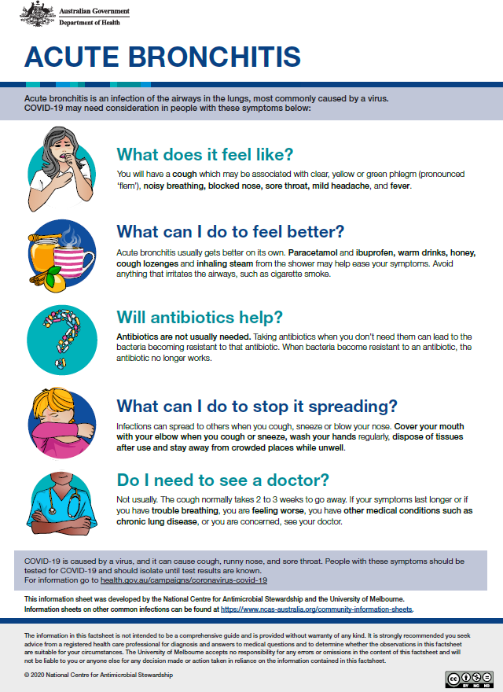

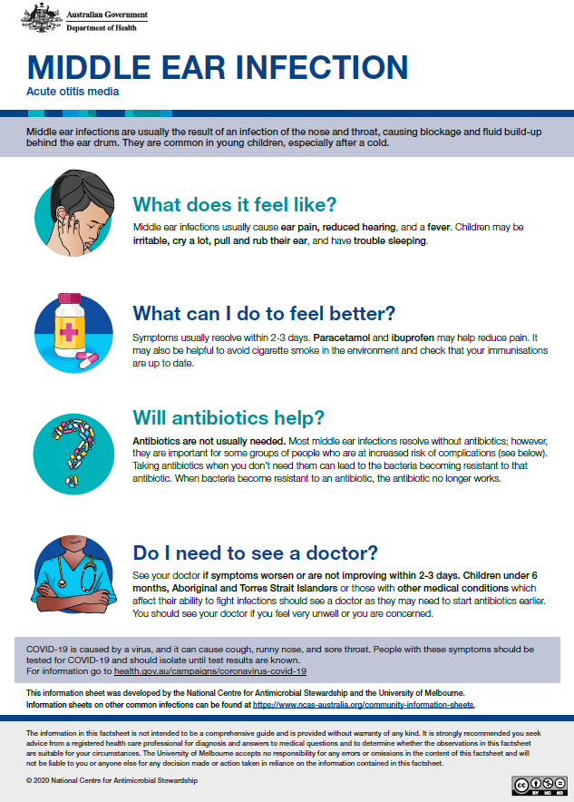

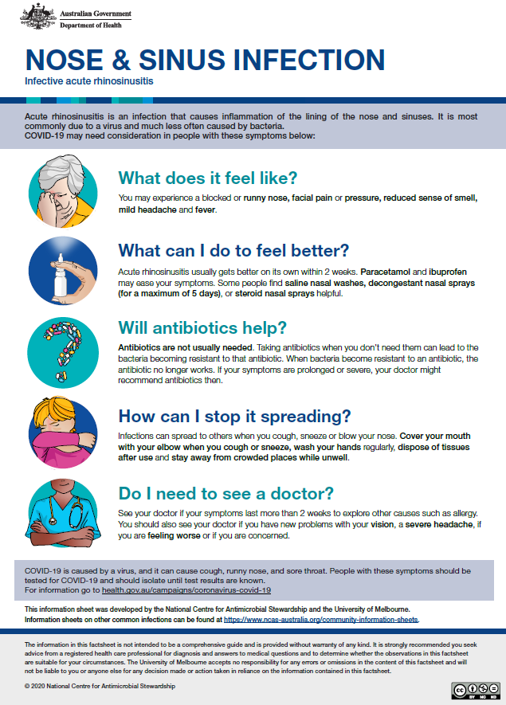

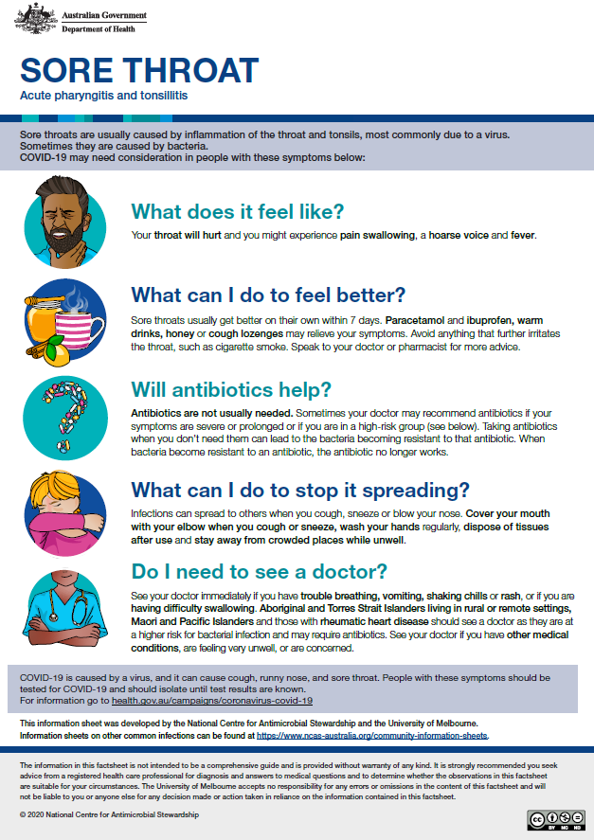

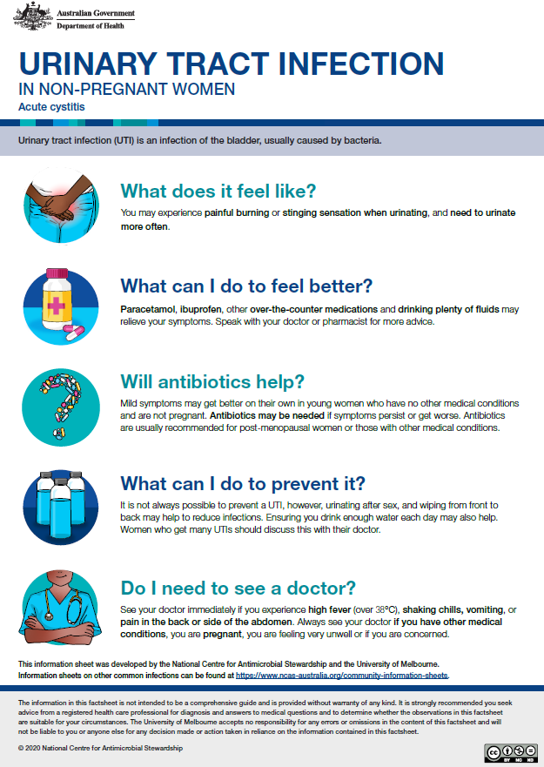

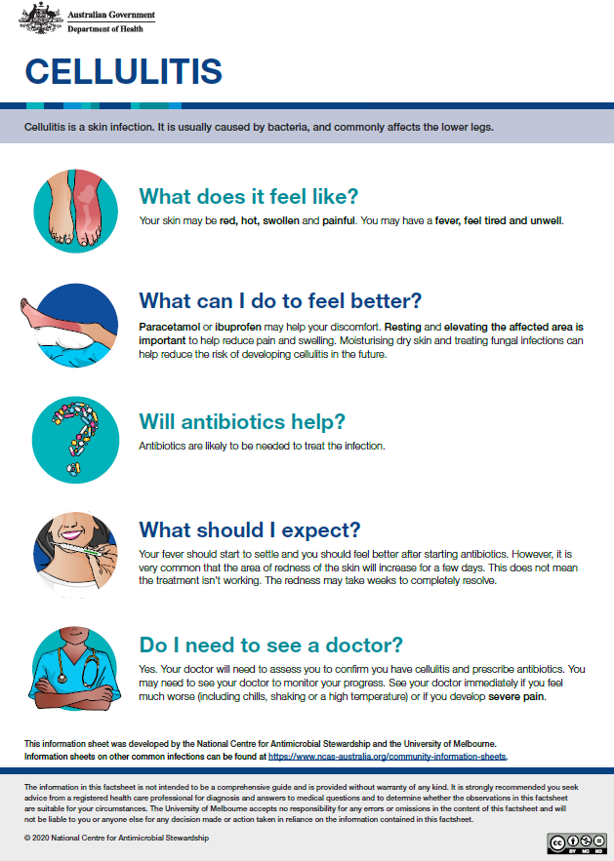

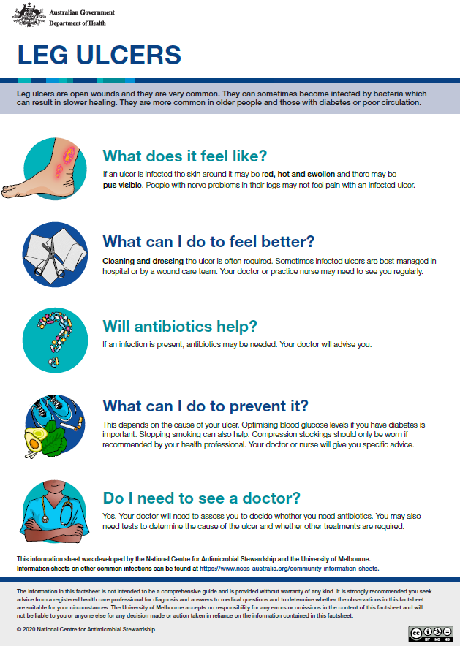

# 7. Summary of key findings

## 7.1 Literature Review

* The literature review has demonstrated that there is limited evidence that current resources available such as patient decision aids/patient information leaflets reduce inappropriate antibiotic use in primary care;
* Where resources are available, they lacked clear evidence of key stakeholder and consumer involvement in their development;
* No studies have objectively assessed impact on antibiotic prescribing;
* It is therefore important that tools are developed in consultation with key stakeholders, including content experts, healthcare providers and patients, in order to create evidence-based patient decision support tools that are robust, easy to understand, visually appealing, acceptable, and feasible.

## 7.2 Phase 1 – Development of Decision Support Tools

* Healthcare providers and consumers have different priorities when it comes to what is important for them, demonstrating the importance of a co-design process in any tool development to involve end-users, such as healthcare providers and patients/consumers, in the development process;
* Information provided should be clear, simple with concise language (pitched to a grade 5-6 literacy level) without medical jargon, and relevant to the patient setting were deemed important in terms of content communication of the information sheets;
* Design elements should include bold text headings, balancing words with pictures, and aesthetically pleasing to the audience;
* It is important for the information sheets to be suitable and available for before, during and after GP consultations. Delivery modalities differ depending on place of use such as general practice, pharmacies, and schools, to increase awareness of appropriate antibiotic use.

## 7.3 Phase 2 – Piloting Decision Support Tools

* The reasons behind using patient information sheets were different for GPs and patients; while GPs provided these resources to patients to reinforce their clinical decisions, as a written advice or summary of discussion, and as an alternative to an antibiotic script, patients found the information sheets were acceptable and useful as they would increase their knowledge and understanding of their condition;
* For patients who did not received the information sheets during a consultation, they commented the information sheets would be helpful during their GP consultations;
* The ability to have online and hard copy access to the patient information sheets were important to both healthcare providers and patients. Online access would suit patients who prefer not to have printouts and can access electronically, as opposed to older patients with limited or no online access, would prefer a printed copy of the patient information sheets;
* Similar to the co-design phase, participants wanted the information sheets to be available for before, during and after GP consultations, with delivery mode suitable depending on place of use, such as general practice waiting room, pharmacies, and online Government websites;
* Both healthcare providers and patients suggest translating these information sheets into multiple languages to accommodate patients in different cultural background;
* The patient formation sheets were acceptable to both healthcare providers and patients in metropolitan and regional settings in Victoria;
* The pandemic was a significant barrier to the use of the patient information sheets during the intervention period as GPs did not see patients with respiratory tract infections and many consultations were restricted to telehealth consultations.

# 8.Conclusion

The focus of this study was to develop robust decision support tools, in the form of patient information sheets, to assist both healthcare providers and patients to reduce inappropriate antibiotic use in primary care. This was achieved using co-design with GPs, a practice nurse, a pharmacist and consumers, resulting in the development of seven information sheets. The subsequent piloting of these tools in eight metropolitan and regional general practices in Victoria confirmed the acceptability and usability of these tools.

The study confirmed the importance of using a co-design methodology to include end-users’ voices in the development of these information sheets. In addition, through the participant interviews via the pilot phase, the patient information sheets were found to be acceptable to both healthcare providers and patients, have the potential to increase patients’ knowledge of disease and conditions, treatment and management options including appropriate antibiotic use, and supported their clinical decision that could lead to better patient outcome in primary care.

We used a co-design methodology to develop these information sheets, from the evaluation of what participants thought was important to include in a patient information sheet, to developing the patient information sheets. The co-design process allowed participants from different backgrounds and professions to come together to understand key priorities and needs and to work together to develop a product that met the needs of both health professionals and patients. The group was able to come to mutual agreement on the content, format and layout, delivery mode and access of these patient information sheets resulting in an end-product that was simple, clear, and attractive to both healthcare providers and patients to use. Each information sheet summarised disease symptoms and signs, prevention, management and treatment strategies, and when to see a GP.

Over the piloting period, the patient information sheets were used with patients coming in for these common infections during GP consultations. The COVID-19 pandemic restricted the use of these information sheets throughout the piloting period, however, healthcare provider and patient interviews revealed that the information sheets were acceptable (in both metropolitan and regional settings in Victoria) and participants were happy to use them and would continue to use them where appropriate.

Participants overwhelmingly wanted information sheets that were informative, with information that has disease symptoms, signs to look out for, prevention, management and treatment strategies, and when to see a GP. They also needed to be simple, clear, with balance between words and pictures, and relevant to patients’ conditions. Options of access and delivery of these information sheets, and translating to different languages were important considerations when disseminating these tools into primary care.

This project has demonstrated that there is a place for patient information sheets to assist patients to understand their health needs, in terms of recognising symptoms of disease, identifying treatment and management options, and understanding possible prevention and transmission of diseases. By understanding the symptoms, treatment and management options of these common infections (acute bronchitis, middle ear infection, nose & sinus infection, sore throat, urinary tract infection, cellulitis and leg ulcers), patients were educated on the appropriate use of antibiotics, on understanding disease symptoms and management, encourage the conversation between patient and GPs, and to support clinical discussion and decision support for patients with common infections in primary care.

## 8.1 Possible next steps

1. Promote the patient information sheets across the Australian community; options might include (with appropriate consultation) the Australian Government Department of Health websites, and the Australian Government One Health AMR website, and organisations including the Royal Australian College of General Practitioners, the Australian Commission on Safety and Quality in Health Care, Australian Primary Health Networks, the Australian College of Rural and Remote Medicine;
2. Increase awareness of these resources through the community via advertisement in practice waiting rooms, and posters in pharmacies and practice waiting rooms;
3. Optimise the tools to facilitate access for both healthcare providers and patients. This may include integration with existing guidelines, such as Therapeutic Guidelines and HealthPathways, electronic medical record systems and pharmacy systems. The tools will be made available online through the National Centre for Antimicrobial Stewardship;
4. Devise mechanisms and support to ensure that tools are updated to make sure they remain consistent with guidelines as required, and to sustain long term use of these tools;
5. Continue to assess the impact on outcomes such as consumer knowledge and attitudes and prescriber behaviors to reduce inappropriate prescribing and use of antibiotics;
6. Increase the number of conditions for which information sheets are available e.g. boils, pneumonia, pyelonephritis, conjunctivitis;
7. Translate patient information sheets into different languages to facilitate use in culturally and linguistically diverse patients.

**Future directions:**

* Patient information sheets can be adapted for use in developing countries in the Asia Pacific region;
* Provide similar processes that could be used to develop information sheets for other cohorts such as patients and carers in residential aged care, and discharged hospital patients to inform them of their conditions, signs and symptoms to look out for, and when to see a GP to avoid hospital re-admission;
* Explore how to incorporate information sheets in education (e.g. schools) to improve awareness of self-management strategies for illness.

# Appendices

## Appendix A. Summary of information provided in commonly used evidence based guidelines for respiratory tract infections, urinary tract infections, and skin and soft tissue infections that could be used to inform patient information (reproduced from the Therapeutic Guidelines (TG)(29) and the National Institute for Health and Care Excellence (NICE) Guidelines(36))

### Respiratory Tract Infections

|  |  |  |  |  |  |
| --- | --- | --- | --- | --- | --- |
| Indication | Possible symptoms | Cause | Illness duration | Non-antibiotic treatment and management | Antibiotic mentioned |
| Acute bronchitis | Cough, purulent or coloured sputum, dyspnoea, wheeze, chest discomfort or pain, nasal congestion, headache, fever. | Commonly caused by viral infections in upper respiratory tract such as the common cold or flu. Can also be caused by bacterial infections, but this is rare. | Cough may last on average 2-3 weeks, and resolves by 4 weeks in 90% of patients. The cough may persist for up to 8 weeks in 10% of patients. | Management includes rest, increase fluid intake and over-the-counter medications. For pain or fever, paracetamol and nonsteroidal anti-inflammatory drugs (NSAIDs) is advised. Drug and non-drug interventions to reduce further irritations to the larynx can be considered for cough. | As acute bronchitis is caused by viruses, over 90% of cases are self-limiting, antibiotics are of no benefit and are associated with harm. |
| Otitis media in children | Crying, irritability, sleeplessness, pulling on the ears, ear pain, fluid drainage from the ear, fever. | Acute otitis media is commonly a viral infection; however, can be caused by a bacterial infection. It is usually self-limiting. | Resolution without medication occurs in 80% of children within 2-3 days; symptoms may persist in some children for up to 8 days. | Most otitis media can be initially treated with analgesia alone. For children, less than 2 years of age, initial antibiotic therapy may be reasonable depending on the clinical context and likelihood of follow-up, clinical judgement is required. | Antibiotic therapy can be safely withheld for most children with acute otitis media, however, antibiotic therapy is required for the following: infants younger than 6 months, children younger than 2 years with bilateral infection; children who are systemically unwell (e.g., lethargic, pale, very irritable); children with otorrhoea; Aboriginal and Torres Strait Islander children; and children at high risk of complications (e.g., Immunocompromised children). |
| Indication | **Possible symptoms** | **Cause** | **Illness duration** | **Non-antibiotic treatment and management** | **Antibiotic mentioned** |
| Acute sinusitis (rhino-sinusitis) | Nasal blockage (congestion or obstruction), nasal discharge (anterior or posterior nasal drip); facial pain or pressure; reduction or loss of sense of smell. | Often called the common cold, it is usually a self-limiting viral infection. Less than 2% of patients develop a secondary bacterial infection. | Illness duration should last less than 4 weeks. For patients with symptoms lasting 4 to 12 weeks, assessment and management same as patient with an acute presentation; however, a bacterial cause may be more likely than a viral cause. If symptoms persist for longer than 12 weeks, the condition is termed chronic rhinosinusitis. | Often self-limiting, management includes rest, and for viral acute sinusitis, regular oral analgesia, saline nasal preparations, intranasal corticosteroids, intranasal and systemic decongestants may be used. | Antibiotic therapy is commonly inappropriately prescribed for acute rhinosinusitis and should only be considered if bacterial infection is likely, although it is usually a self-limiting condition. If antibiotics are prescribed, the rate of symptom improvement is increased at days 3 and 7, but at day 10, there is no difference in improvement between patients treated with or without antibiotics and the use of antibiotics does not prevent the occurrence of rare complications. |
| Tonsillitis (sore throat/ pharyngitis) | Viral tonsillitis: cough, hoarse voice, conjunctivitis, nasal congestion, diarrhoea, absence of fever.  Bacterial tonsillitis: fever (38oC), tender cervical lymph-adenopathy, tonsillar exudate, and absence of cough, rhinorrhoea or nasal congestion. | Viral infections are self-limiting; however, bacterial tonsillitis is commonly caused by *Strep. pyogenes* (Group A streptococcus). There are other causes of sore throat, consider differential diagnosis. | Symptoms usually resolve within 7 days and antibiotic therapy is of no benefit. If symptoms worsen or persist (particularly fever) within a reasonable timeframe (e.g., 3-7 days), or if new symptoms develop (e.g., vomiting, dehydration, rigors), re-consultation is recommended. | For viral pharyngitis or tonsillitis, symptomatic therapy such as paracetamol or NSAIDs to relieve pain and fever, medicated lozenges containing an antiseptic, anti-inflammatory or anaesthetic drug to relieve throat pain are recommended for adults and adolescents. | Empirical antibiotic therapy should only be considered if streptococcal pharyngitis and tonsillitis are the likely cause of sore throat. Streptococcal pharyngitis and tonsillitis are usually self-limiting. Antibiotic therapy can be considered for patients with confirmed *Strep.* *pyogenes* on throat swab culture. |

### Skin and soft tissue infections

|  |  |  |  |  |  |
| --- | --- | --- | --- | --- | --- |
| Indication | Possible symptoms | Cause | Illness duration | Non-antibiotic treatment and management | Antibiotic mentioned |
| Cellulitis | Cellulitis and erysipelas present as diffuse, spreading areas of skin erythema. While cellulitis often develops in one leg, redness and swelling in both legs may suggest other possible conditions. Lymphangitis, lymphadenopathy, fever or other systemic features may be present. | *Strep. pyogenes*, or other Streptococcus spp. (e.g. Group B, C or G), are the most common cause of non-purulent, recurrent cellulitis. Purulent cellulitis is typically caused by *Staph. aureus*. | N/A | Assess patients with cellulitis associated with systemic features for necrotizing fasciitis or myonecrosis. Evaluate patients with drainable sources of infection (i.e., Abscess). Rest and elevation of the affected area improves clinical response. | Oral therapy is adequate for cellulitis and erysipelas not associated with systemic features of infection, and is usually suitable for patients with a single systemic feature of infection. Phenoxymethylpencillin can be provided for patients with persistent risk factors for recurrent cellulitis. Alternatively, for patients with frequent recurrences, prophylaxis can be considered and reviewed regularly. |
| Ulcers (venous) | Patients with a venous leg ulcer may have edema or pain that is worse at the end of the day, and may have skin changes such as haemosiderin staining, or lipodermatoscelerosis. Infection may be suspected if there is redness, heat, pain, swelling, purulent discharge of fever. | Venous ulcers can develop after a minor injury if there is venous valve incompetence, venous obstruction and calf muscle pump insufficiency, resulting in venous stasis and venous hypertension. | N/A | Standard ulcer care includes wound cleansing and debridement, diagnosing and minimising oedema, optimising wound moisture balance (wound dressing). | Ulcers are always colonised with bacteria and antibiotics do not improve healing unless there is active infection, characterised by purulent exudate/odour, increased pain, cellulitis and/or pyrexia. |

### Urinary tract infections

|  |  |  |  |  |  |
| --- | --- | --- | --- | --- | --- |
| Indication | Possible symptoms | Cause | Illness duration | Non-antibiotic treatment and management | Antibiotic mentioned |
| Acute cystitis | Acute dysuria, frequency, urgency and, occasionally, suprapubic tenderness. Consider acute pyelonephritis in patients with flank pain, vomiting, fever (38°C or higher) or costovertebral tenderness. | Bacteria such as *E. coli* | Most women under the age of 65 who are treated symptomatically (without antibiotic therapy) for acute uncomplicated cystitis become symptom free within 1 week. | Nonantibiotic therapy such as oral fluids and analgesia including paracetamol and NSAIDs regimens might be reasonable for selected low risk adults. Other treatments, including urinary alkalinising agents, might help symptoms but the efficacy of these medications have not been established. Cranberry products, ascorbic acid and methenamine hippurate are not effective for the treatment of acute UTI. | Non-pregnant women under age 65  After discussion of risks and benefits, some women may choose to treat UTI symptomatically (without antibiotic therapy), while others may choose the antibiotic treatment option.  Consistent with TG, nonpregnant women with a first episode of acute uncomplicated cystitis, urine culture and susceptibility testing may not be necessary; empirical therapy can be started based on symptoms alone. A urine sample for culture and susceptibility should be obtained for those who do not respond to empirical antibiotic therapy.  If antibiotic therapy is not given, the risk of acute pyelonephritis or sepsis following uncomplicated cystitis is low; a delayed script for antibiotics might be considered for use if symptoms worsen.  **Other groups**  Cystitis in men is uncommon and evidence to guide antibiotic recommendation is lacking. Antibiotic recommendations for men with acute cystitis are extrapolated from the recommendations for nonpregnant women.  For aged-care facility residents, please see next section “Urinary tract infections in aged care”. |
| Urinary tract infections in aged care | The diagnosis of symptomatic UTI in aged-care facility residents can be difficult. Acute dysuria is the most specific genitourinary symptom of symptomatic UTI. | Bacteria such as *E. coli,* Klebsiella spp. are the most common cause of UTIs in this group. | N/A | Before starting antibiotic therapy, correct dehydration. A urine sample is recommended to try to verify the diagnosis. Delaying antibiotic therapy to assess for symptomatic UTI does not generally lead to adverse outcomes in aged-care facility residents. Modify therapy based on the results of culture and susceptibility testing. | Overtreatment with antibiotics is common in aged-care facility residents and contributes to antimicrobial resistance. Mental status change is often inappropriately used to start antibiotics in elderly patients. The justification for, and risk/benefit of preventative antibiotics for recurrent UTI should be reviewed regularly.  Asymptomatic bacteriuria is common in aged-care facility residents; do not screen for or treat asymptomatic bacteriuria. |

## Appendix B. Prisma flowchart – Review on shared decision making tools and information aids to assist patients in the decision making of antibiotic use for respiratory tract infections, skin and soft tissue infections and urinary tract infections in primary care

**Screening**

**Included**

**Eligibility**

**Identification**

Records identified through

database searching

(n = 115)

Additional records identified through

other sources, such as reference lists of retrieved articles

(n = 9)

Records after duplicates removed

(n =94)

Records screened

(Title and abstract)

(n = 94)

Records excluded

(n = 52)

Full-text articles assessed

for eligibility

(n = 42)

Full-text articles excluded, with reasons

(n = 36)

**Reason 1**: Not assessing decision support tools (n = 10)

**Reason 2:** Not assessing information aids (n = 12)

**Reason 3:** No relevant outcome – reducing antibiotic prescribing/use (n = 3)

**Reason 4:** Review/commentary (n = 11)

Articles included in the

rapid review

(n = 6)

## Appendix C. Summary of relevant studies on shared decision making tools and information aids to assist patients in the decision making of antibiotic use for respiratory tract infections, skin and soft tissue infections and urinary tract infections in primary care

| Study | Year | Country | Indication | Intervention | Control | Design/Study type | N | Data collection | Outcomes | Effect | Statistically significant effect  (yes/no) |
| --- | --- | --- | --- | --- | --- | --- | --- | --- | --- | --- | --- |
| Coxeter et al (19) | 2017 | Australia | Acute respiratory tract infections | Decision aid  (n = 60) | Fact sheet (n = 60) | Two-arm, parallel group, randomised trial -  Computer-generated randomisation sequence | Adult parents of children aged 1–16 years (n = 120) | Questionnaire to assess knowledge, attitudes and intentions | The primary outcome was informed choice (conceptual and numerical knowledge; attitudes towards, and intention to use, antibiotics for a future ARI (acute respiratory infection). Secondary outcomes were decisional conﬂict, decisional self-efﬁcacy, and material acceptability | Intervention group participants significantly made informed choice (57%) compared with control group (29%) (95% conﬁdence interval (CI) 11–45%, p<0.01), and had higher total knowledge (95% CI 2.2–3.5, p<0.01), conceptual knowledge (95% CI 0.4–1.1, p<0.01) and numerical knowledge (95% CI 1.6–2.5, p<0.01) | Yes |
| Francis et al (30) | 2009 | United Kingdom | Respiratory tract infections | Clinicians trained in the use of an interactive booklet on respiratory tract infections (n=30 practices) | Usual care  (n=31 practices) | Clustered randomised controlled trial | Intervention group n=256, Control group n=272 | Based line data collected at consultation, follow up phone call 2 weeks after consultation | The proportion of children who attended a face-to-face consultation about the same illness during the two-week follow-up period. Secondary outcomes included antibiotic prescribing, antibiotic consumption, future consulting intentions, and parental satisfaction, reassurance, and enablement | Re-consultation occurred in 12.9% of children in the intervention group and 16.2% in the control group (absolute risk reduction 3.3%, 95% CI 2.7% to 9.3%, p=0.29).  Antibiotics were prescribed to 19.5% of children in the intervention group and 40.8% of children in the control group (absolute risk reduction 21.3%, 95% CI 13.7 to 28.9, p<0.001). | Not for re-consultation but significant for antibiotic prescribed |
| Gulliford et al (31) | 2019 | United Kingdom | Respiratory tract infections | Education webinar, audit and feedback,  decision support tools including patient information sheets and advice on the indications for antibiotic prescription | Usual care | A parallel-group, cluster randomised controlled study | All registered patients were included.  Intervention arm n=41 practices (323,155 patient-years) control arm n=38 practices (259,520 patient-years) | 12-month period | The primary outcome was the rate of antibiotic prescriptions for self-limiting RTIs over the 12-month intervention period. Secondary outcomes included rates of RTI consultations, proportion of RTI consultations with antibiotics prescribed and the incidence of 11 different safety outcomes. | The antibiotic-prescribing rate was about 12% lower in the intervention trial arm than in the control arm.  Although there was no evidence of effect in children aged < 15 years (risk ratio (RR) 0.96, 95% CI 0.82 to 1.12) or adults aged ≥ 85 years (RR 0.97, 95% CI 0.79 to 1.18), antibiotic prescribing was reduced in adults aged 15–84 years (RR 0.84, 95% CI 0.75 to 0.95). | N/A |
| Hingorani et al (33) | 2015 | United States of America | Acute upper respiratory infections | Education for providers, posters in waiting room, clinical decision support tool integrated into the electronic medical record, audit and feedback | None | Before and after study with interventions introduced at different time points | 240 consultations | Data were pooled by year, individual diagnosis (upper respiratory infections, sinusitis, pharyngitis), aggregate diagnosis ARI, and rate of guideline adherence | Compliance with antibiotic prescribing guidelines. | Improvement in compliance with treatment guidelines for sinusitis (90.90% vs. 57.58%, p<0.001), pharyngitis (64.28% vs. 25.00%, p=0.003), URIs (96.18% vs. 73.68%, p=0.008), and the aggregated measure of ARI (91.25% vs. 78.6%, p<0.001). | Yes |
| Macfarlane et al (32) | 2002 | United Kingdom | Acute bronchitis | Given an information leaflet  (n=106) | Not given an information leaflet (n=106) | Nested, single blind, randomised controlled trial. | 212 participants | Patients were contacted by telephone at around one week and two weeks after the consultation by research assistants blinded to the grouping of the patients. | Antibiotic use in the next two weeks. Re-consultation for the same symptoms in the next month | Fewer patients who received the information leaflet took antibiotics compared with those who did not receive the leaflet (49 v 63, RR 0.76, 95% CI 0.59 to 0.97, p=0.04). | No |
| Zucconi et al (34) | 2018 | France | ESBL-producing Enterobacteriaceae-related urinary tract  infection | Tool kit includes treatment protocols, GP and patient information leaflets, a list of infection control measures, and contact details of infectious diseases physicians for specialized advice.  (n=39) | GPs who didn’t use the tool kit  (n=20) | Perspective observational study | Not specified | ESBL-producing Enterobacteriaceae related UTI identified, GPs contacted by the microbiology laboratory to assess use of kit and appropriateness of antibiotic prescription | Extent the ESBL tool kit is conveyed to GPs and its related procedures duly followed to correlate with appropriate antibiotic prescription | Significantly correlated with appropriate antibiotic prescription, which concerned 36/39 tool kit users versus 13/20 non-users (p=0.0125). | Yes |

## Appendix D. Current patient decision aids and information leaflets available on antibiotics for respiratory tract infections, skin and soft tissue infections and urinary tract infections in primary care

| Title | Place and Year published | Country | Indication(s) | Key-stakeholder involvement (who) | Piloted | Target audience | Cause | Symptoms | Natural history | Treatment and management options | Benefit and harm | Antibiotic mentioned | Other |
| --- | --- | --- | --- | --- | --- | --- | --- | --- | --- | --- | --- | --- | --- |
| Acute bronchitis: should I take antibiotics? (46) | Australian Commission on Safety and Quality in Health Care  2016 (update due Nov 2018)**[1]** | Australia | Acute bronchitis | Clinicians and researchers | Yes | Patients | Yes | Yes | Yes | Yes | Yes | Yes | * Antibiotic resistance * When to see a GP * Questions to consider when talking with GP |
| Middle ear infection: should my child take antibiotics?(47) | Australian Commission on Safety and Quality in Health Care  2016 (update due Nov 2018)[2] | Australia | Middle ear infection in children | Clinicians and researchers | Yes | Parents | Yes | Yes | Yes | Yes | Yes | Yes | * Antibiotic resistance * When to see a GP * Questions to consider when talking with GP |
| Sore throat: should I take antibiotics?(48) | Australian Commission on Safety and Quality in Health Care  2016 (update due Nov 2018)[3] | Australia | Sore throat | Clinicians and researchers | Yes | Patients | Yes | Yes | Yes | Yes | Yes | Yes | * Antibiotic resistance * When to see a GP * Questions to consider when talking with GP |
| Chest infections(49) | Better Health Channel 2012 | Australia | Chest infections (includes Bronchitis) | None stated | Unknown | Patients | Yes | Yes | No | Yes | No | Yes | * Diagnosis and vaccines |
| Cellulitis(27) | Better Health Channel 2018 | Australia | Cellulitis | Developed in consultation with Sinclair Dermatology | Unknown | Patients | Yes | Yes | Yes | Yes | Yes | Yes | * Reduce risk of transmission and where to get help |
| Cold(50) | Better Health Channel 2011 | Australia | Colds | Developed in consultation with Royal Children’s Hospital | Unknown | Patients | Yes | Yes | Yes | Yes | Yes | Yes | * Prevention |
| Cystitis(51) | Better Health Channel 2018 | Australia | Cystitis | Developed in consultation with Kidney Health Australia | Unknown | Patients | Yes | Yes | No | Yes | No | Yes | * Prevention |
| Ear infections(52) | Better Health Channel 2019 | Australia | Ear infections | Developed in consultation with Royal Victorian Eye and Ear Hospital | Unknown | Patients | Yes | Yes | No | Yes | No | Yes | * Information on types of ear infections |
| Leg ulcers(28) | Better Health Channel 2014 | Australia | Leg ulcers | None stated | Unknown | Patients | Yes | Yes | No | Yes | No | Yes | * Risk factors |
| Sinusitis(53) | Better Health Channel 2011 | Australia | Sinusitis | None stated | Unknown | Patients | Yes | Yes | No | Yes | No | Yes | * Risk factors |
| Tonsillitis(54) | Better Health Channel 2013 | Australia | Tonsillitis | None stated | Unknown | Patients | Yes | Yes | No | Yes | No | Yes | * Complications |
| Urinary tract infections (UTIs)(55) | Better Health Channel 2018 | Australia | Urinary tract infections | Developed in consultation with Kidney Health Australia | Unknown | Patients | Yes | Yes | No | Yes | No | Yes | * Risk factors and prevention |
| Cellulitis and erysipelas(56) | British Association of Dermatologists 2012  (last update 2018) | United Kingdom | Cellulitis and Erysipelas | Assessed for readability by BAD’s Patient Information Lay Review Panel | Unknown | Patients | Yes | Yes | No | Yes | No | Yes |  |
| When should I worry? Your guide to coughs, colds earache & sore throats(57) | Cardiff University 2006  (reviewed 2010) | United Kingdom | Cough, colds, earache and sore throats | Clinicians, GPs, parents | Yes | Parents | Yes | Yes | Yes | Yes | Yes | Yes | * Warning signs, useful ED contacts - this leaflet is from ED |
| Chest cold (acute bronchitis)(58) | Centers for Disease Control and Prevention Reviewed 2019 | USA | Bronchitis | Unknown | Unknown | Patients | Yes | Yes | Yes | Yes | Yes | Yes | * Prevention, and when to seek medical care |
| Common cold(59) | Centers for Disease Control and Prevention Reviewed 2019 | USA | Common cold | Unknown | Unknown | Patients | Yes | Yes | Yes | Yes | Yes | Yes | * Website only, no printable format. Prevention, risk factors, when to seek medical care and over the counter medicine for children |
| Ear infections(60) | Centers for Disease Control and Prevention Reviewed 2019 | USA | Ear infections | Unknown | Unknown | Parents | Yes | Yes | No | Yes | No | Yes | * Prevention, when to seek medical care and over the counter medicine for children |
| Sinus infection (Sinusitis)(61) | Centers for Disease Control and Prevention Reviewed 2019 | USA | Sinusitis | Unknown | Unknown | Patients | Yes | Yes | Yes | Yes | Yes | Yes | * Website only, no printable format. Prevention, risk factors, when to seek medical care and over the counter medicine for children |
| Sore throat(62) | Centers for Disease Control and Prevention Reviewed 2019 | USA | Sore throat | Unknown | Unknown | Patients | Yes | Yes | No | Yes | Yes | Yes | * Website only, no printable format. Prevention, risk factors, when to seek medical care and over the counter medicine for children |
| Urinary tract infection(63) | Centers for Disease Control and Prevention Reviewed 2019 | USA | Urinary tract infection | Unknown | Unknown | Patients | No | Yes | No | Yes | Yes | Yes | * Website only, no printable format. Prevention, risk factors, when to seek medical care and over the counter medicine for children |
| Antibiotics for ear infections in children – when you need them – and when you don’t(64) | Choosing Wisely  2017 | USA | Ear Infections in children | American Board of Internal Medicine Foundation and American Academy of Family Physicians | Unknown | Parents | Yes | No | No | Yes | Yes | Yes | * Leaflet on when you need antibiotics and when you don’t |
| Antibiotics for urinary tract infections in older people – when you need them – and when you don’t(65) | Choosing Wisely  2017 | USA | Urinary tract infections in older people | American Board of Internal Medicine Foundation and Geriatrics  Healthcare Professionals | Unknown | Patients | No | Yes | No | Yes | Yes | Yes | * Leaflet on when you need antibiotics and when you don’t |
| Antibiotics for your skin – when you need them – and when you don’t(66) | Choosing Wisely  2016 | USA | Skin infections | American Board of Internal Medicine Foundation and American Academy of Dermatology | Unknown | Patients | Yes | Yes | No | Yes | Yes | Yes | * Leaflet on when you need antibiotics and when you don’t |
| Colds flu and other respiratory illnesses in adults – when you need antibiotics – and when you don’t(67) | Choosing Wisely  2016 | USA | Colds flu and other respiratory illnesses in adults | American Board of Internal Medicine Foundation and Infectious Diseases Society of America | Unknown | Patients | Yes | Yes | Yes | Yes | Yes | Yes | * Leaflet on when you need antibiotics and when you don’t |
| Treating sinus problems – don’t rush into antibiotics(68) | Choosing Wisely  2016 | USA | Sinusitis | American Board of Internal Medicine Foundation and American Academy of Family Physicians | Unknown | Patients | Yes | Yes | No | Yes | Yes | Yes | * Leaflet on when you need antibiotics and when you don’t |
| Colds, flu, and other respiratory illnesses: don’t rush into antibiotics(69) | Choosing Wisely Canada  2014 | Canada | Colds, Flu and other respiratory illnesses | Unknown | Unknown | Patients | Yes | No | No | Yes | Yes | Yes | * Warning signs, when you might need antibiotics |
| Antibiotics for urinary tract infections in older people: when you need them – and when you don’t(70) | Choosing Wisely Canada  2014 | Canada | Urinary tract infections in older people | Unknown | Unknown | Patients | Yes | Yes | No | Yes | Yes | Yes |  |
| Treating sinus infections: don’t rush into antibiotics(71) | Choosing Wisely Canada  2016 | Canada | Sinusitis | Developed in cooperation with American Academy of Allergy, Asthma & Immunology | Unknown | Patients | Yes | Yes | No | Yes | Yes | Yes |  |
| Cellulitis – information for patients, relatives and carers(72) | National Health Service  Imperial College Healthcare 2017  (review due 2020) | United Kingdom | Cellulitis | Unknown | Unknown | Patients, carers | Yes | Yes | No | Yes | No | Yes | * Warning signs, useful Emergency Department (ED) contacts - this leaflet is from ED |
| Cellulitis(73) | National Health Service  University Hospital Southampton 2019  (review due 2022) | United Kingdom | Cellulitis | Unknown | Unknown | Patients | Yes | Yes | No | Yes | No | Yes | * Risk factors and prevention |
| Cellulitis – patient information leaflet(74) | National Health Service  City Hospitals Sunderland 2006  (last review 2012) | United Kingdom | Cellulitis | Unknown | Unknown | Patients | Yes | Yes | No | Yes | No | Yes | * Risk factors |
| Cellulitis – patient information leaflet(75) | National Health Service  Tameside and Glossop Integrated Care 2010  (last review 2018) | United Kingdom | Cellulitis | Unknown | Unknown | Patients | Yes | Yes | No | Yes | No | Yes | * Risk factors and complications |
| Cystitis: taking an antibiotic(76) | National Institute for Health and Care Excellence 2018  (last updated 2018) | United Kingdom | Cystitis | Unknown | Unknown | Women who are not pregnant | Yes | No | No | Yes | Yes | Yes | * It is specific for cystitis in women and taking antibiotics. Limited information on antibiotic resistance |
| Respiratory tract infections – Manage your symptoms(77) | NPS MedicineWise 2016 | Australia | Respiratory tract infections | Unknown | Unknown | Patients | Yes | No | Yes | Yes | No | Yes | * This is an action plan for patients regarding RTIs. Patients can then discuss with their doctor for concerns |
| What every parent should know – about colds, coughs, earaches and sore throats(78) | NPS MedicineWise 2017 | Australia | Colds, coughs, earaches and sore throats | Unknown | Unknown | Parents | Yes | Yes | Yes | Yes | No | Yes | * Fact sheet for parents regarding their children’s RTIs. Very detailed |
| Treating your infection – respiratory tract infection (RTI) (79) | Public Health England  2018  (review due 2020) | United Kingdom | Respiratory tract infection | Professional medical bodies | Unknown | Patients | N/A | N/A | Yes | Yes | No | Yes | * Part of the TARGET tool kit – management guide |
| Urinary tract infection (UTI) information leaflet(80) | Public Health England 2018 | United Kingdom | Urinary tract infection | Professional medical bodies | Unknown | Women | Yes | Yes | Yes | Yes | Yes | Yes | * Part of the TARGET tool kit. Includes prevention, antibiotic resistance and warning signs |
| Chest infections(81) | Safer Care Victoria  2019 | Australia | Chest infections | Developed in consultation with Consumers Health Forum of Australia | Unknown | Patients | Yes | Yes | No | Yes | No | Yes | * Prevention and where and when to seek help |
| Cellulitis(82) | Safer Care Victoria  2019 | Australia | Cellulitis | Developed in consultation with Consumers Health Forum of Australia | Unknown | Patients | Yes | Yes | No | Yes | No | Yes | * Prevention and where and when to seek help |
| Colds and flu(83) | Safer Care Victoria  2019 | Australia | Colds and flu | Developed in consultation with Consumers Health Forum of Australia | Unknown | Patients | Yes | Yes | Yes | Yes | No | Yes | * Prevention and where and when to seek help |
| Fever in children(84) | Self Care Forum  2014 | United Kingdom | Fever (in children) | Unknown | Unknown | Parents | Yes | Yes | N/A | Yes | No | N/A | * Fact sheet regarding fever in children, not about antibiotics |
| The common cold (adults)(85) | Self Care Forum  2013 | United Kingdom | Common cold (in adults) | Unknown | Unknown | Patients | Yes | Yes | Yes | Yes | Yes | Yes | * Fact sheet regarding common colds in adults. Very brief section on antibiotics including side effects |
| Middle ear infection (acute otitis media)(86) | Self Care Forum  2013 | United Kingdom | Middle ear infection | Unknown | Unknown | Parents | Yes | Yes | Yes | Yes | Yes | Yes | * Fact sheet regarding acute otitis media in children |
| Sore throat(87) | Self Care Forum  2013 | United Kingdom | Sore throat | Unknown | Unknown | Patients | Yes | Yes | Yes | Yes | No | Yes | * Fact sheet regarding sore throat |
| Cough in adults(88) | Self Care Forum  2013 | United Kingdom | Cough  (in adults) | Unknown | Unknown | Patients | Yes | N/A | Yes | Yes | No | Yes | * Fact sheet regarding cough in adults |
| Acute sinusitis (adults)(89) | Self Care Forum  2013 | United Kingdom | Sinusitis  (in adults) | Unknown | Unknown | Patients | Yes | Yes | Yes | Yes | No | Yes | * Fact sheet regarding acute sinusitis |
| Urine symptoms in men(90) | Self Care Forum  2014 | United Kingdom | Urine symptoms  (in men) | Unknown | Unknown | Patients | Yes | Yes | Yes | Yes | No | No | * Fact sheet regarding urine symptoms in men |
| Caring for children with coughs(91) | University of Bristol  2016 | United Kingdom | Cough  (in children) | Unknown | Unknown | Parents | No | Yes | Yes | Yes | No | No | * Section on when to see a GP |
| Cellulitis(92) | Victoria State Government Department of Health  2010 | Australia | Cellulitis | Unknown | Unknown | Patients in ED | Yes | Yes | No | Yes | No | Yes | * Prevention and when to seek health |

## Appendix E. Issues/comments raised by participants from pilot phase interviews, and suggested fix

| Issues/Comments | Frequency | Suggested fix | Comments | Fix? |
| --- | --- | --- | --- | --- |
| Disclaimer as a ‘space hogger’, no one will read it  However, understand it is a legal requirement | GP1 | Reduce words/size | Legal requirement, cannot really change | No |
| To include referencing (TG) to legitimize content | GP1 | Include referencing, i.e. All information cross-referenced with TG | Possible, but room on page? | No |
| Room to write other instructions, comments for patients | GP2, GP7, GP12 | Include a blank box on page for GPs/patients, i.e. Specific instructions from GP, GP recommendations, doctor’s advice | ? room on page | No |
| Blue banner up on top hard to read | GP3 | Take away blue banner, leave text in black |  | No |
| “Does antibiotics help” – illustration with question mark – GP has issues saying that is not the right illustration for this, as antibiotics should relate to bacteria and virus, not about treatment itself | GP3 |  | I don’t agree, as the question mark is consistent across all infections and it is about whether you need to treat with antibiotics or not | No |
| “Do I need to see a doctor” – the flow is not right as they are already seeing a doctor | GP3, GP9, GP13, Patient 11 | To include/replace with ‘Do I need to see a GP again’ | We have been careful phrasing this, and discussed these information sheets can be used before, during and after consultation, and not just for while they are actually seeing the GP. After explaining this to some GPs, they thought it then made sense | No |
| Language may not be suitable – phlegm, ‘may be associated with’, ‘dispose of tissues’, ‘elevating the affected area’, ‘abdomen’ | Patient 7, Patient 11, Patient 13 | Patient 11 said can use app that hovers over the word and provides explanation or translate to another language (like e-reader) | Great idea, but it might be expensive to link into an app – something to think about | No |
| Too wordy? | Patient 13 | Use dot form | We decided not to, as this will take up more space | No |
| Consistent language i.e. Acute bronchitis throughout | Patient 7 |  | Change | Yes |
| Severity of illustration (cellulitis) – patient might look at this and say ‘mine doesn’t look as bad’, then might not go see GP | GP3, Patient 8 | Need to highlight this is not a comprehensive guide | Perhaps disclaimer on this is too small or not clear enough? | No |
| Illustrations are not consistent, i.e. Have people in various stage of distress, and only cellulitis and leg ulcer showing actual disease | GP3 | Consistent illustrations | I think this is a bit nit picking, and illustrations really is a representation as to the condition. Perhaps not necessary to change as no other participants have made the same comment – they all loved the illustrations | No |
| Include potential harm of antibiotics | GP6, GP12 | Include section on what it could mean when antibiotics no longer works in future, resistant bug and no antibiotics etc.  Gut bacteria | GP understood that there is a limitation on space as it needs to be kept to a one pager | No |
| Include what to expect without antibiotics | GP6 | Include if you don’t have antibiotics, this is the likely scenario | This and the one above is about risks and benefits of antibiotics – they both ranked really low on co-design participants list | No |
| ‘When bacteria become resistant to an antibiotic, the antibiotic no longer works’ may not be necessary | Patient 7 | Take this last sentence out | Maybe include the points above, but I think this is fine as is | No |
| Otitis media to include information around fever as patients are concerned with fever in child | GP9 | Provide more information on fever, what to expect, how long to wait for regarding taking antibiotics for ear pain etc. | Check re. Panadol to help with fever rather than just pain – check with paediatrician (ear and throat?) | Checked, paediatrician considered fine as is |
| Otitis media to include advice on being up to date with immunisation for child, avoiding smoking in the environment | GP9 | Provide information on keeping child immunisation up to date | Under ‘Do I need to see a doctor’, change to ‘you can keep up to date with immunisation and avoid smoking in the environment…’  Minimise exposure to cigarette smoke if possible (what can I do to feel better)  Do I need to see a doctor?  It may also be helpful to check that your immunisations are up to date. | Yes |
| Perforation of the ear and discharge not mentioned in Otitis media information sheet | GP11 |  | Checked RCH guidelines, not necessary? | No |
| Worried about patients with bronchiectasis with a cold that need antibiotics | GP4 | Disclaimer on chronic lung issues | Have included this in the ‘do I need to see a doctor’ section | No |
| Ural not mentioned in UTI information sheet | GP11 | To include as this is the more common advice doctor gives patient | We have discussed this in co-design, as this is not a recommendation in TG and Ural is a brand name, so left it out | No |
| Leg ulcer information sheet doesn’t tell you what leg ulcer is | GP7 |  | Changed to ‘Leg ulcers are open wounds, they are very common and sometimes can be infected’ | Yes |
| “some people have problems with the nerves in their legs, which can mean that the infected ulcer may not cause any pain’, it just seems quite long. | GP7 | Replace with ‘people with problems with nerves in their legs often don’t feel pain with an infected ulcer’ | Changed to ‘People with nerve problems in their legs may not feel pain with an infected ulcer’ | Yes |
| GP decision-making - use a flowchart | GP15 | Decision-making matrix, such as a decision tree | Flowchart for GP/patient, and checklist for patients? | No |
| COVID should be upfront | GP5 | COVID box needs to be higher up or changed | I think GP was thinking out loud rather than a real issue | No |
| Have an information sheet for COVID-19 | PN1, Patient 1 | Create a COVID-19 information sheet | I think they are plenty of those around from Government websites, however, it would be good to create one for a complete set | No |
| Should have emergency numbers, or contact numbers on government websites if they don’t have access to open link | Patient 8, Patient 9, Patient 10 | Include contact numbers | Include emergency numbers, contact numbers for Government website, ? nurse-on-call  Have links to NCAS, Government website and perhaps TG (but they are not free to public) | No |

# References

1. World Bank. Drug-Resistant Infections: A threat to our economic future (Discussion Draft). Washington, DC: World Bank. License: Creative Commons Attribution CC by 3.0 IGO; 2016.

2. The Review on Antimicrobial Resistance. Tackling drug-resistant infections globally: Final report and recommendations. HM Government and Wellcome Trust 2016.

3. Australian Commission on Safety and Quality in Health Care. AURA 2019: Third Australian report on antimicrobial use and resistance in human health Sydney: Australian Commission on Safety and Quality in Health Care; 2019 [cited 2021 25 March] Available from: <https://www.safetyandquality.gov.au/sites/default/files/2019-06/AURA-2019-Report.pdf>.

4. Moro ML, Marchi M, Gagliotti C, Mario SD, Resi D, Group PBaAPR. Why do paediatricians prescribe antibiotics? Results of an Italian regional project. BMC Pediatrics. 2009;9:69.

5. Whaley LE, Businger AC, Dempsey Pp, Linder JA. Visit coplexity, diagnostic uncertainty, and antibiotic prescribing for acute cough in primary care: a retrospective study. BMC Family Practice. 2013;14:120.

6. Stearns CR, Gonzales R, Camargo JCA, Maselli J, Metlay JP. Antibiotic Prescriptions Are Associated with Increased Patient Satisfaction With Emergency Department Visits for Acute Respiratory Tract Infections. Academic Emergency Medicine. 2009;16(10):934-41.

7. Ashworth M, White P, Jongsma H, Schofield P, Armstrong D. Antibiotic prescribing and patient satisfaction in primary care in England: cross-sectional analysis of national patient survey data and prescribing data. British Journal of General Practice. 2016;66(642):e40-e6.

8. Biezen R, Brijnath B, Grando D, Mazza D. Management of respiratory tract infections in young children—A qualitative study of primary care providers’ perspectives. npj Primary Care Respiratory Medicine. 2017;27(1):15.

9. Dempsey PP, Businger AC, Whaley LE, Gagne JJ, Linder JA. Primary care clinicians’ perceptions about antibiotic prescribing for acute bronchitis: a qualitative study. BMC Family Practice. 2014;15:194.

10. Ong S, Nakase J, Moran GJ, Karras DJ, Kuehnert MJ, Talan DA. Antibiotic use for emergency department patients with upper respiratory infections: prescribing practices, patient expections, and patient satisfaction. Ann Emerg Med. 2007;50:213-20.

11. Bagger K, Nielsen ABS, Siersma V, Bjerrum L. Inappropriate antibiotic prescribing and demand for antibiotics in patients with upper respiratory tract infections is hardly different in female versus male patients as seen in primary care. European Journal of General Practice. 2015;21(2):118-23.

12. Australian Commission on Safety and Quality in Health Care. Antimicrobial Stewardship Clinical Care Standard. Australian Commission on Safety and Quality in Health Care, 2019 [cited 2019 28 August]. Available from: <https://www.safetyandquality.gov.au/our-work/clinical-care-standards/antimicrobial-stewardship-clinical-care-standard>.

13. Royal College of General Practitioners. TARGET Antibiotics Toolkit. Royal College of General Practitioners, 2019 [cited 2019 15 September]. Available from: <https://www.rcgp.org.uk/clinical-and-research/resources/toolkits/amr/target-antibiotics-toolkit.aspx>16. Bae J-M. Shared decision making: relevant concepts and facilitating strategies. Epidemiology and health. 2017;39:e2017048-e.

14. Bae J-M. Shared decision making: relevant concepts and facilitating strategies. Epidemiology and health. 2017;39:e2017048-e.

15. Simmons MB, Elmes A, McKenzie JE, Trevena L, Hetrick SE. Right choice, right time: Evaluation of an online decision aid for youth depression. Health Expectations. 2017;20(4):714-23.

16. Stacey D, Légaré F, Lewis KB. Patient decision aids to engage adults in treatment or screening decisions. JAMA. 2017;318(7):657-8.

17. Hawley ST, Newman L, Griggs JJ, Kosir MA, SJ K. Evaluating a Decision Aid for Improving Decision Making in Patients with Early-stage Breast Cancer. The Patient. 2016;9(2):161-9.

18. Lee YK, Lee PY, Ng CJ, Teo CH, Abu Bakar AI, Abdullah KL, et al. Usability and utility evaluation of the web-based “Should I Start Insulin?” patient decision aid for patients with type 2 diabetes among older people. Informatics for Health and Social Care. 2018;43(1):73-83.

19. Coxeter PD, Del Mar CB, Hoffmann TC. Preparing Parents to Make An Informed Choice About Antibiotic Use for Common Acute Respiratory Infections in Children: A Randomised Trial of Brief Decision Aids in a Hypothetical Scenario. The Patient. 2017;10(4):463-74.

20. Avent ML, Hansen MP, Gilks C, Del Mar C, Halton K, Sidjabat H, et al. General Practitioner Antimicrobial Stewardship Programme Study (GAPS): protocol for a cluster randomised controlled trial. BMC Family Practice. 2016;17(1):48.

21. Montori VM, LeBlanc A, Buchholz A, Stilwell DL, Tsapas A. Basing information on comprehensive, critically appraised, and up-to-date syntheses of the scientific evidence: a quality dimension of the International Patient Decision Aid Standards. BMC medical informatics and decision making. 2013;13 Suppl 2(Suppl 2):S5-S.

22. Hargraves I, Montori VM. Decision aids, empowerment, and shared decision making. BMJ : British Medical Journal. 2014;349:g5811.

23. Australian Commission on Safety and Quality in Health Care. Patient Decision Aids 2019 [Available from: https://www.safetyandquality.gov.au/our-work/shared-decision-making/patient-decision-aids/.

24. National Prescribing Service - MedicineWise. Respiratory tract infections (RTIs) - nose, throat and lungs 2018 [Available from: https://www.nps.org.au/medical-info/consumer-info/respiratory-tract-infections-rtis-nose-throat-and-lungs.

25. Therapeutic Guidelines Limited. Therapeutic Guidelines West Melbourne, Victoria 3003, Australia2018 [Available from: https://www.tg.org.au/.

26. NPS Medicine Wise. NPS Medicine Wise 2013 [Available from: http://www.nps.org.au/.

27. Better Health Channel. Cellulitis Australia: State Goverment of Victoria; 2018 [cited 2019 28 August]. Available from: https://www.betterhealth.vic.gov.au/health/ConditionsAndTreatments/cellulitis.

28. Better Health Channel. Leg ulcers Australia: State Government of Victoria; 2014 [cited 2019 23 August]. Available from: https://www.betterhealth.vic.gov.au/health/ConditionsAndTreatments/leg-ulcers.

29. Better Health Channel. Better Health Channel Australia: State Government of Victoria; 2019 [cited 2019 23 September]. Available from: https://www.betterhealth.vic.gov.au/.

30. Francis NA, Butler CC, Hood K, Simpson S, Wood F, Nuttall J. Effect of using an interactive booklet about childhood respiratory tract infections in primary care consultations on reconsulting and antibiotic prescribing: a cluster randomised controlled trial. BMJ (Clinical research ed). 2009;339.

31. Gulliford MC, Juszczyk D, Prevost AT, Soames J, McDermott L, Sultana K, et al. Electronically delivered interventions to reduce antibiotic prescribing for respiratory infections in primary care: cluster RCT using electronic health records and cohort study. Health technology assessment. 2019;23:11.

32. Macfarlane J, van Weel C, Holmes W, Gard P, Thornhill D, Macfarlane R, et al. Reducing antibiotic use for acute bronchitis in primary care: blinded, randomised controlled trial of patient information leaflet. BMJ (Clinical research ed). 2002;324(7329):91-4.

33. Hingorani R, Mahmood M, Alweis R. Improving antibiotic adherence in treatment of acute upper respiratory infections: a quality improvement process. Journal of Community Hospital Internal Medicine Perspectives. 2015(0):1.

34. Zucconi A, Courjon J, Maruéjouls C, Saintpère F, Degand N, Pandiani L, et al. Managing ESBL-producing Enterobacteriaceae-related urinary tract infection in primary care: a tool kit for general practitioners. European Journal Of Clinical Microbiology & Infectious Diseases: Official Publication Of The European Society Of Clinical Microbiology. 2018;37(5):983-6.

35. Australian Commission on Safety and Quality in Health Care. Australian Commission on Safety and Quality in Health Care Australia: Australian Commission on Safety and Quality in Health Care; 2019 [cited 2019 23 September]. Available from: https://www.safetyandquality.gov.au/.

36. National Institute for Health and Care Excellence. NICE guidance United Kingdom2019 [cited 2019 28 August]. Available from: https://www.nice.org.uk/guidance.

37. Safer Care Victoria. Safer Care Victoria Australia: State Government of Victoria; 2019 [cited 2019 23 September]. Available from: https://www.bettersafercare.vic.gov.au/.

38. Department of Health and Human Services. Aspiring for all Victorians to be healthy, safe and able to lead a life they value Australia: State Government of Victoria; 2019 [cited 2019 23 September]. Available from: https://www.dhhs.vic.gov.au/.

39. Centers for Disease Control and Prevention. Centers for Disease Control and Prevention USA: U.S. Department of Health & Human Services; 2019 [cited 2019 23 September]. Available from: cdc.gov.

40. Choosing Wisely. Choosing Wisely - Promoting conversation between patients and clinicians US: ABIM Foundation; 2019 [cited 2019 23 September]. Available from: http://www.choosingwisely.org/.

41. Choosing Wisely Canada. Choosing Wisely Canada Canada: Choosing Wisely Canada; 2019 [cited 2019 23 September]. Available from: https://choosingwiselycanada.org/.

42. NHS. NHS sites UK: NHS; 2019 [cited 2019 23 September]. Available from: https://www.nhs.uk/nhs-sites/.

43. National Institute for Health and Care Excellence. Improving health and social care through evidence-based guidance UK: National Institute for Health and Care Excellence; 2019 [cited 2019 23 September]. Available from: https://www.nice.org.uk.

44. Public Health England. Public Health England UK: Public Health England; 2019 [cited 2019 23 September ]. Available from: https://www.gov.uk/government/organisations/public-health-england.

45. Self Care Forum. Self Care Forum UK: Self Care Forum; 2019 [cited 2019 23 September]. Available from: http://www.selfcareforum.org/.

46. Australian Commission on Safety and Quality in Health Care. Acute bronchitis: should I take antibiotics?2016 [cited 2019 27 August]. Available from: https://www.safetyandquality.gov.au/sites/default/files/migrated/Patient-Decision-Aid-Acute-bronchitis-Nov-2016.pdf.

47. Australian Commission on Safety and Quality in Health Care. Middle ear infection: should my child take antibiotics?2016 [cited 2019 28 August]. Available from: https://www.safetyandquality.gov.au/sites/default/files/migrated/Patient-Decision-Aid-Middle-Ear-Infection-Nov-2016.pdf.

48. Australian Commission on Safety and Quality in Health Care. Sore throat: should I take antibiotics?2016 [cited 2019 28 August]. Available from: https://www.safetyandquality.gov.au/sites/default/files/migrated/Patient-Decision-Aid-Sore-Throat-Nov-2016.pdf.

49. Better Health Channel. Chest infections Australia: State Government of Victoria 2012 [cited 2019 27 August]. Available from: https://www.betterhealth.vic.gov.au/health/ConditionsAndTreatments/chest-infections.

50. Better Health Channel. Colds Australia: State Government of Victoria; 2011 [cited 2019 25 August]. Available from: https://www.betterhealth.vic.gov.au/health/ConditionsAndTreatments/colds.

51. Better Health Channel. Cystitis Australia: State Government of Victoria; 2018 [cited 2019 25 August]. Available from: https://www.betterhealth.vic.gov.au/health/ConditionsAndTreatments/cystitis.

52. Better Health Channel. Ear infections Australia: State Government of Victoria; 2019 [cited 2019 27 August]. Available from: https://www.betterhealth.vic.gov.au/health/ConditionsAndTreatments/ear-infections.

53. Better Health Channel. Sinusitis Australia: State Goverment of Victoria; 2011 [cited 2019 16 August]. Available from: https://www.betterhealth.vic.gov.au/health/ConditionsAndTreatments/sinusitis.

54. Better Health Channel. Tonisillits Australia: State Government of Victoria; 2013 [cited 2019 26 August]. Available from: https://www.betterhealth.vic.gov.au/health/ConditionsAndTreatments/tonsillitis.

55. Better Health Channel. Urinary tract infections (UTI) Australia: State Govenment of Victoria; 2018 [cited 2019 27 August]. Available from: https://www.betterhealth.vic.gov.au/health/ConditionsAndTreatments/urinary-tract-infections-uti.

56. British Association of Dermatologists. Patient Information Leaflets (PILs) UK: British Association of Dermatologists; 2018 [cited 2019 27 August]. Available from: http://www.bad.org.uk/for-the-public/patient-information-leaflets.

57. Cardiff University. When Should I Worry? Your guide to coughs, colds, earache and sore throats UK: Cardiff Univeristy; 2010 [cited 2019 25 August]. Available from: http://www.whenshouldiworry.com/resources/When%20should%20I%20worry-Booklet_Scotland.pdf.

58. Centers for Disease Control and Prevention. Chest Cold (Acute Bronchitis) US: U.S. Department of Health & Human Services; 2019 [cited 2019 21 August]. Available from: https://www.cdc.gov/antibiotic-use/community/for-patients/common-illnesses/bronchitis.html.

59. Centers for Disease Control and Prevention. Common Cold US: U.S. Department of Health & Human Services; 2019 [cited 2019 21 August]. Available from: https://www.cdc.gov/antibiotic-use/community/for-patients/common-illnesses/colds.html.

60. Centers for Disease Control and Prevention. Ear Infection US: U.S. Department of Health & Human Services; 2019 [cited 2019 21 August]. Available from: https://www.cdc.gov/antibiotic-use/community/for-patients/common-illnesses/ear-infection.html.

61. Centers for Disease Control and Prevention. Sinus Infection (Sinusitis) US: U.S. Department of Health & Human Services; 2019 [cited 2019 21 August]. Available from: https://www.cdc.gov/antibiotic-use/community/for-patients/common-illnesses/sinus-infection.html.

62. Centers for Disease Control and Prevention. Sore Throat US: U.S. Department of Health & Human Services; 2019 [cited 2019 21 August]. Available from: https://www.cdc.gov/antibiotic-use/community/for-patients/common-illnesses/sore-throat.html.

63. Centers for Disease Control and Prevention. Urinary Tract Infections US: U.S. Department of Health & Human Services; 2019 [cited 2019 21 August]. Available from: https://www.cdc.gov/antibiotic-use/community/for-patients/common-illnesses/uti.html.

65. Choosing Wisely. Antibiotics for Ear Infections in Children US: ABIM Foundation; 2017 [cited 2019 27 August]. Available from: http://www.choosingwisely.org/patient-resources/antibiotics-for-ear-infections-in-children/.

65. Choosing Wisely. Antibiotics for Urinary Tract Infections in Older People US: ABIM Foundation; 2017 [cited 2019 21 August]. Available from: http://www.choosingwisely.org/patient-resources/antibiotics-for-urinary-tract-infections-in-older-people/.

66. Choosing Wisely. Antibiotics For Your Skin US: ABIM Foundation; 2016 [cited 2019 21 August]. Available from: http://www.choosingwisely.org/patient-resources/antibiotics-for-your-skin/.

67. Choosing Wisely. Colds, Flu, and Other Respiratory Illnesses in Adults US: ABIM Foundation; 2016 [cited 2019 22 August]. Available from: http://www.choosingwisely.org/patient-resources/colds-flu-and-other-respiratory-illnesses-in-adults/.

68. Choosing Wisely. Treating Sinusitis US: ABIM Foundation; 2016 [cited 2019 21 August]. Available from: http://www.choosingwisely.org/patient-resources/treating-sinusitis-aafp/.

69. Choosing Wisely Canada. Colds, Flu and Other Respiratory Illnesses Canada: Choosing Wisely Canada; 2014 [cited 2019 22 August]. Available from: https://choosingwiselycanada.org/colds-flu-respiratory-illnesses-dont-rush-antibiotics/.

70. Choosing Wisely Canada. Antibiotics for Urinary Tract Infections in Older People US: Choosing Wisely Canada; 2014 [cited 2019 22 August]. Available from: https://choosingwiselycanada.org/antibiotics-urinary-tract-infections/.

71. Choosing Wisely Canada. Treating Sinus Infections US: Choosing Wisely Canada; 2016 [cited 2019 22 August]. Available from: https://choosingwiselycanada.org/treating-sinusitis/.

72. NHS Imperial College Healthcare. Cellulitis UK: Imperial College Healthcare NHS Trust; 2017 [cited 2019 23 August]. Available from: https://www.imperial.nhs.uk/patients-and-visitors/patient-information.

73. NHS University Hospital Southhampton. Cellulitis UK: NHS University Hospital Southhampton; 2019 [cited 2019 22 August]. Available from: https://www.uhs.nhs.uk/Media/Controlleddocuments/Patientinformation/Generalmedicine/Cellulitis-patientinformation.pdf.

74. NHS City Hospitals Sunderland. Cellulitis UK: NHS City Hospitals Sunderland; 2012 [cited 2019 23 August]. Available from: https://www.rcem.ac.uk/docs/Local%20Guidelines_DischargeAdvice/12c.%20Cellulitis%20-%20discharge%20advice%20(Sunderland%20Royal%20Hospital,%20June%202012).pdf.

75. NHS Tameside and Glossop Integrated Care. Cellulitis UK: NHS Tameside and Glossop Integrated Care; 2006 [updated 2012; cited 2019 23 August]. Available from: https://www.tamesidehospital.nhs.uk/documents/CellulitisLeaflet.pdf.

76. National Institute for Health and Care Excellence. Decision aids - Cystitis UK: National Institute for Health and Care Excellence; 2018 [cited 2019 23 August]. Available from: https://www.nice.org.uk/guidance.

77. NPS MedicineWise. Respiratory Tract Infections Australia: NPS MedicineWise; 2016 [cited 2019 23 August]. Available from: https://www.nps.org.au/assets/fc2723c4a3fcdec8-31e4936adc6c-NPS-MedicineWise-RTI-Action-Plan-1.pdf.

78. NPS MedicineWise. What every parent should know about coughs, colds, earaches and sore throats Australia: NPS MedicineWise; 2017 [cited 2019 23 August]. Available from: https://www.nps.org.au/consumers/what-every-parent-should-know-about-coughs-colds-earaches-and-sore-throats.

79. Public Health England. Treating your infection – Respiratory tract infection (RTI) UK: UK Government; 2018 [cited 2019 23 August]. Available from: <https://www.prescqipp.info/media/3163/treating-your-infection-rti.pdf>

80. Public Health England. Urinary tract infection (UTI) information leaflet UK: UK Government; 2018 [cited 2019 23 August]. Available from: http://www.target-webinars.com/wp-content/uploads/2016/08/UTI-Leaflet-V16.pdf.

81. Safer Care Victoria. Chest infections Australia: State Government of Victoria; 2019 [cited 2019 23 August]. Available from: https://www.bettersafercare.vic.gov.au/resources/tools/chest-infections.

82. Safer Care Victoria. Cellulitis Australia: State Government of Victoria; 2019 [cited 2019 23 August]. Available from: https://www.bettersafercare.vic.gov.au/resources/tools/cellulitis.

83. Safer Care Victoria. Colds and flu Australia: State Government of Victoria; 2019 [cited 2019 23 August]. Available from: https://www.bettersafercare.vic.gov.au/search?search=colds+and+flu.

84. Self Care Forum. Fevder in Children UK: Self Care Forum; 2014 [cited 2019 24 August]. Available from: http://www.selfcareforum.org/wp-content/uploads/2013/12/4-Fever-in-Children.pdf.

85. Self Care Forum. The common cold (adults) UK: Self Care Forum; 2013 [cited 2019 23 August]. Available from: http://www.selfcareforum.org/wp-content/uploads/2013/03/20131030-SCF-Fact-Sheet-No-12-Common-Cold-v1-final.pdf.

86. Self Care Forum. Middle ear infection (acute otitis media) UK: Self Caer Forum; 2013 [cited 2019 23 August]. Available from: http://www.selfcareforum.org/wp-content/uploads/2013/03/20131030-SCF-Fact-Sheet-No-11-Otitis-Media-v1-final.pdf.

87. Self Care Forum. Sore Throat UK: Self Care Forum; 2013 [cited 2019 23 August]. Available from: http://dev.selfcareforum.org/wp-content/uploads/2013/03/190227-SCF-Fact-Sheet-No-10-Sore-Throat-v102.pdf.

88. Self Care Forum. Cough in Adults UK: Self Care Forum; 2013 [cited 2019 23 August]. Available from: http://dev.selfcareforum.org/wp-content/uploads/2013/03/190405-SCF-Fact-Sheet-No-7-Cough-in-Adults-v102_final_NICE.pdf.

89. Self Care Forum. Acute sinusitis (adults) UK: Self Care Forum; 2013 [cited 2019 23 August]. Available from: http://www.selfcareforum.org/wp-content/uploads/2013/03/20131030-SCF-Fact-Sheet-No-13-Sinusitis-v1-final.pdf.

90. Self Care Forum. Urine symptoms in men UK: Self Care forum; 2014 [cited 2019 23 August]. Available from: http://dev.selfcareforum.org/wp-content/uploads/2013/03/190227-SCF-Fact-Sheet-No-14-LUTS-in-Men-v102.pdf.

91. University of Bristol. Caring for children with coughs UK: University of Bristol; 2016 [cited 2019 23 August]. Available from: https://www.bristol.ac.uk/media-library/sites/primaryhealthcare/documents/target/caring-for-children-with-cough-A4-leaflet.pdf.

92. Victorian State Government Department of Health. Cellulitis Australia Victoria: Victorian State Government Department of Health; 2010 [cited 2019 23 August]. Available from: https://www2.health.vic.gov.au/~/media/Health/Files/Collections/Factsheets/E/ED%20factsheets/edfact_cellulitis-pdf.

University of Melbourne Logo

1. This leaflet has since been updated. Please see [Acute bronchitis: should I take antibiotics? | Australian Commission on Safety and Quality in Health Care](https://www.safetyandquality.gov.au/publications-and-resources/resource-library/acute-bronchitis-should-i-take-antibiotics)
2. This leaflet has since been updated. Please see [Middle ear infection: should my child take antibiotics? | Australian Commission on Safety and Quality in Health Care](https://www.safetyandquality.gov.au/publications-and-resources/resource-library/middle-ear-infection-should-my-child-take-antibiotics)
3. This leaflet has since been updated. Please see [Sore throat: should I take antibiotics? | Australian Commission on Safety and Quality in Health Care](https://www.safetyandquality.gov.au/publications-and-resources/resource-library/sore-throat-should-i-take-antibiotics)