**Antimicrobial prescribing   
in Australian residential aged care facilities**



**2020**

Results of the 2020 Aged Care National Antimicrobial Prescribing Survey



Published by the Australian Government Department of Health and Aged Care For issues regarding the content of the report:

Email: [support@naps.org.au](mailto:support@naps.org.au)

Website: <https://www.naps.org.au/>

ISBN: 978-1-76007-351-0

© Australian Government Department of Health and Aged Care

All material and work produced by the Department of Health and Aged Care is protected by copyright. The Department reserves the right to set out the terms and conditions for the use of such material.

Enquiries about the licence and any use of this publication are welcome and can be sent to [AMR@health.gov.au](mailto:AMR@health.gov.au)

**Preferred citation**

Royal Melbourne Hospital and the National Centre for Antimicrobial Stewardship. Antimicrobial prescribing practice in Australian residential aged care facilities. Results of the 2020 Aged Care National Antimicrobial Prescribing Survey Canberra: Department of Health and Aged Care; 2023.

**Disclaimer**

This document is not intended to provide guidance on particular healthcare choices. You should contact your healthcare provider for advice on particular healthcare choices.

This document includes the views or recommendations of its authors and third parties. Royal Mebourne Hospital, the National Centre for Antimicrobial Stewardship and the Department of Health and Aged Care do not accept any legal liability for any injury, loss or damage incurred by the use of, or reliance on, this document.

Table of contents

Summary 4

Key findings of the 2020 Aged Care NAPS 5

Implications for clinical practice 5

1. Introduction 6

About the Aged Care NAPS 6

Australian aged care services 6

1. Methodology 7
   1. Time frame 7
   2. Recruitment 7
   3. Survey method 7
   4. Data collection forms 8
   5. Electronic Aged Care NAPS 9
   6. Data definitions and data analysis 9
   7. Support 9
   8. Considerations for data interpretation 10
2. Key Results 11
   1. Participation 11
   2. Prevalence of infections and antimicrobial use 12
   3. Suspected infections on the survey day 14
   4. Antimicrobial use 15
   5. Adverse events 15
   6. Duration 15
   7. Most commonly prescribed antimicrobials 15
   8. Quality indicators 17
   9. Common indications for prescribing antimicrobials 19
   10. Most commonly prescribed antimicrobials for common indications 21
3. Discussion 22

Appendix 1: Facility form 24

Appendix 2: Antimicrobial and infection form 26

Appendix 3: Additional data on infections and antimicrobials 28

Appendix 4: Abbreviations 35

References 36

# Summary

All Australian aged care homes and multipurpose services (aged care facilities) are encouraged each year to complete the Aged Care National Antimicrobial Prescribing Survey (Aged Care NAPS). This standardised surveillance tool can be used to monitor the prevalence of infections and antimicrobial use, provide feedback to key clinicians and administrators, and measure the effectiveness of infection prevention and control (IPC) and antimicrobial stewardship (AMS) programs. It is an important safety and quality initiative, as there is longstanding evidence of residents colonised or infected by multidrug- resistant organisms and inappropriate antimicrobial use.

This report primarily presents analyses of resident infection and antimicrobial use data reported by Australian aged care facilities that contributed to the 2020 Aged Care NAPS. All states/territories, remoteness classifications (major cities, regional and remote) and provider groups (private, not for profit and public) are represented. Comparisons are made against aged care facilities that participated in the 2017 (n=277), 2018 (n=402) and 2019 (n=641) Aged Care NAPS. Early Aged Care NAPS data (2015 and 2016) is not included.

The 2020 Aged Care NAPS identified issues in relation to infections and antimicrobial use that were similar to those identified in previous annual surveys, including:

* high numbers of suspected skin and soft tissue, urinary tract and respiratory tract infections
* high prevalence of residents prescribed at least one antimicrobial; this includes those residing in facilities that have consistently participated in the Aged Care NAPS
* prolonged duration of antimicrobial prescriptions
* extensive prescribing of topical antimicrobials, especially clotrimazole
* frequent prescribing of pro re nata (PRN; as required) antimicrobials
* continuous prophylactic antimicrobial therapy, especially for urinary tract infections
* incomplete documentation of indication and review and stop dates.

## Key findings of the 2020 Aged Care NAPS

Important findings in 2020 included the following:

* On the survey day, 2.9% of residents had signs and/or symptoms of a suspected infection and 11.9% were prescribed antimicrobials. While the prevalence of residents with signs and/or symptoms of a suspected infection has remained stable compared with previous years, the prevalence of residents prescribed antimicrobials continues to increase.
* The most commonly reported suspected infections on the survey day were skin or soft tissue (44.1%), urinary tract (29.8%) and respiratory tract (11.2%).
* The majority (76.0%) of prescribed antimicrobials were for therapeutic (as opposed to prophylactic) indications.
* The most common clinical (therapeutic or prophylactic) indications for antimicrobial prescriptions were unspecified skin, soft tissue or mucosal conditions (21.7%), cystitis (17.6%) and tinea (8.0%). The most common prophylactic indications were cystitis (26.0%), unspecified skin, soft tissue or mucosal conditions (13.0%) and unspecified urinary tract conditions (6.3%).
* Clotrimazole (23.9%), cefalexin (20.4%) and chloramphenicol (6.3%) were the most commonly prescribed antimicrobials.
* Many antimicrobials (43.8%) were prescribed for topical administration.
* Almost one-third (32.3%) of antimicrobials still prescribed on the survey day were for PRN administration; the majority (90.4%) of these were for topical antimicrobials, most commonly clotrimazole (61.5%).
* Of antimicrobials still prescribed on the survey day, 39.2% (n=2,499) were commenced more than 6 months prior.
* Documentation of the indication for prescribing an antimicrobial increased to 76.7% compared with 73.1% in 2019. Documentation of antimicrobial review or stop dates, however, decreased to 46.2%, compared with 54.4% in 2019.

## Implications for clinical practice

The seriousness and consistency of the identified issues reinforce the need for aged care facilities to develop and implement effective IPC and AMS programs that will lead to improvement in resident safety. There are nationally accepted guidelines that facilities should reference and use, such as the Australian Guidelines for the Prevention and Control of Infection in Health Care,1 Therapeutic Guidelines: Antibiotic2 and AMS Clinical Care Standard.3 The Australian Commission on Safety and Quality in Health Care has published strategies that specifically support IPC and AMS in general practice and in community and residential aged care. As of early 2021, all facilities must have employed one or more trained IPC Leads; it is expected these IPC Leads will play a pivotal role in supporting their facility’s IPC and AMS programs. Alongside on-site and visiting staff, residents and their carers should be actively engaged too.

# Introduction

This report presents analyses of data collected for the 2020 Aged Care National Antimicrobial Prescribing Survey (Aged Care NAPS) and includes comparisons with 2017, 2018 and 2019 Aged Care NAPS data.

## About the Aged Care NAPS

The Aged Care NAPS is a standardised surveillance tool that all Australian aged care homes and multipurpose services (aged care facilities) can use to monitor the prevalence of infections and antimicrobial use, provide feedback to key clinicians and administrators, and measure the effectiveness of infection prevention and control (IPC) and antimicrobial stewardship (AMS) programs.4,5 The survey, first piloted in 2015,6 was modelled on the European Centre for Disease Prevention and Control Healthcare-Associated Infections in Long-Term Care Facilities (HALT) study.7 The Aged Care NAPS has subsequently been conducted annually.8-11

Coordination of the Aged Care NAPS is overseen by the National Centre for Antimicrobial Stewardship (NCAS), Guidance Group and the Victorian Healthcare Associated Infection Surveillance System (VICNISS) Coordinating Centre. In 2020, funding was provided by the Australian Commission on Safety and Quality in Health Care (ACSQHC) and the Australian Government Department of Health. Aged Care NAPS data are provided to the Antimicrobial Use and Resistance in Australia (AURA) Surveillance System - a comprehensive and coordinated national surveillance of antimicrobial use and antimicrobial resistance.

## Australian aged care services

In Australia, aged care services are primarily provided through Commonwealth Home Support, Home Care Packages and permanent or respite residential care in aged care facilities. There are also 5 flexible service options that provide home support and/or residential care, including multipurpose services.

Multipurpose services, located in all states, the Northern Territory and the External Territories (Norfolk Island), provide integrated health and aged care services for small regional and remote communities where a standalone hospital or aged care home would not be viable.12

At 30 June 2020, 845 approved providers operated 2,722 aged care homes. Across 2019–20, there were 217,145 operational places, with an occupancy rate of 88%. This does not include flexible aged care places. Most homes were located in New South Wales (32.4%), Victoria (28.1%) and Queensland (17.4%), and almost two-thirds (62%) were located in metropolitan areas. Not-for-profit (religious, charitable and community), private and government organisations operated 57%, 34% and 9% of the homes respectively. Additionally, multipurpose services (n=179) provided 3,668 operational places.12

IPC and AMS in aged care facilities is supported by the Aged Care Quality Standards. Standard 3(3)(g) specifically aims to minimise infection-related risks by implementing standard transmission-based precautions and practices to promote appropriate antimicrobial use. Standard 8(3)(e) notes that where clinical care is provided a clinical governance framework must include AMS. Clinical governance is the set of relationships and responsibilities between the facility’s governing body, clinicians, residents and others, and the systems in place that aim to deliver safe, quality clinical care and continuously improve services.13

# Methodology

## Time frame

The official data collection and submission period for the 2020 Aged Care NAPS was 1 June to 31 December 2020.

## Recruitment

All Australian aged care facilities are eligible to participate in the Aged Care NAPS. Since 2017, participation by Victorian state government aged care facilities has been mandatory as part of the VICNISS Infection Control Indicator Program. The remainder of participants contribute on a voluntary basis. In 2020, participation was promoted mostly prior to the commencement date via email to potential participants listed on NCAS and VICNISS contact databases.

The survey can be completed by senior nurses, infection control professionals and/or pharmacists. Ideally, surveyors should have at least 2 years of clinical experience and collaborate with other staff as deemed appropriate.

## Survey method

On any day during the 2020 time frame, participating facilities could choose one of 2 survey methods to collect data (see boxes below). Method 2 was recommended for smaller facilities that wished to expand their sample size to better assess their performance. Facilities could participate more than once.

Method 1: A single-day point prevalence survey

On the survey day, all residents are screened to determine if they:

* have an antimicrobial prescription noted on their medication chart
* have signs and symptoms of a suspected infection.

Method 2: A single-day point prevalence survey plus an additional one-month retrospective survey

On the survey day, all residents are screened to determine if they:

* have an antimicrobial prescription noted on their medication chart
* have signs and symptoms of a suspected infection.

In addition, all residents present on the survey day are screened to determine if they had an antimicrobial prescription noted on their medication chart on any day during the previous month that was ceased prior to the survey day.

## Data collection forms

### Facility form

Each participating facility completed the ‘Facility form’ (Appendix 1). Resident-level data fields included listing the number of residents present on the survey day. All residents who were present on the survey day were eligible for inclusion. To simplify data collection, the number of residents transferred to hospital with suspected or confirmed infection was no longer reported. The time frame for the number of residents admitted to hospital was changed from ‘previous 30 days’ to ‘previous seven days’.

### Antimicrobial and infection form

The ‘Antimicrobial and infection form’ (Appendix 2) was completed for residents who:

* + - * were prescribed an antimicrobial on the survey day (Methods 1 and 2) and within the previous month (Method 2 only)
      * had at least one sign and/or symptom of a suspected infection present on the survey day (Methods 1 and 2).

Demographic data included date of birth, gender, if the resident had been admitted to the facility within the last 48 hours and if the resident had been admitted to hospital within the previous 7 days (previously 30 days).

Data collected about adverse reactions to antimicrobials for those residents prescribed an antimicrobial were classified as nil known, not documented or yes. If yes, the adverse reaction for each causative antimicrobial (one or more) was classified as allergic (anaphylaxis/angioedema, rash/urticarial and other), side effect (e.g. nausea, vomiting, diarrhoea) or unknown.

Data were collected about key prescribing elements including the choice of antimicrobial agent, dose, route of administration, frequency, start date, and documentation of a review or stop date. If the prescription was for PRN administration, also reported was if the antimicrobial had been administered on the survey day or in the 6 days prior. Antimicrobial prescriptions included all antibacterial, antiviral, antifungal and anti-parasitic agents in all formulations. Methenamine hippurate (also known as hexamine hippurate), an antibacterial antiseptic, was included due to its common use for urinary tract infection prophylaxis.14

The indication and body system for the prescription were reported according to a standardised list. If an indication was not included on the list, the surveyor was required to report ‘Other’ and the body system – for example, ‘Other: urinary tract’. For 2020, the skin, soft tissue and mucosal body system list now included impetigo and cutaneous candidiasis (thrush).

If the antimicrobial start date was known and the therapy had commenced less than 6 months before the survey day, data were collected about what microbiology specimens had been taken. For 2020, the time frame (on the antimicrobial start date or in the 6 days prior) was extended to include 3 days after the antimicrobial start date. Previous surveyors had fed back that microbiology specimens were frequently taken during this time. Data about culture and sensitivity results as detailed in finalised microbiology reports (not always accessible at the aged care facilities) were no longer required.

A list was provided for recording signs and/or symptoms of infections documented on the survey day and if present in the 2 days prior. The list was divided into 6 body systems: urinary tract, respiratory tract, skin or soft tissue, oral, eye, and other. A list was also provided of constitutional criteria, or signs and symptoms common to many different infection types; these included fever, change in mental status from baseline, acute functional decline in activities of daily living, and results of full blood examination. The methodology for collection of infection data included reviewing medical histories, staff handover notes, incident reports, wound-care folders, and verbal information provided by a senior clinician.

## Electronic Aged Care NAPS

On the survey day, hard-copy data collection forms were completed by the surveyors and then used to assist with electronic data entry. Registered surveyors could access the e-versions via the NAPS web portal.

Once the data were entered, a 2-page dashboard report could be generated and downloaded immediately via the NAPS web portal. These reports enabled participating facilities to compare their performance against their last year and national aggregate data. Key results were presented in simple table or graph format. Surveyors were encouraged to forward the reports to those who are able to influence resident care, including administrators and clinicians such as general practitioners, pharmacists and nurses.

## Data definitions and data analysis

Data quality processes for the Aged Care NAPS dataset included identification and, if necessary and possible, follow-up consultation with the surveyors to correct missing, miscoded and out-of-range errors. Duplicate and non-finalised resident records were excluded; surveys that included only   
non-finalised resident records were omitted. For those facilities that participated more than once each year, only their last survey was included. Changes to the dataset and decisions about how to assess certain data fields were documented.

A suspected infection was defined as at least one sign or symptom of infection on the survey day and, if present, other signs and/or symptoms in the 2 days prior to the survey day. More than one suspected infection could be reported for each resident. An electronic decision algorithm was applied to each suspected infection to determine whether the McGeer et al. infection surveillance definitions were met.

These widely referenced definitions, which were specifically developed for use in long-term care facilities, were last revised in 2012 to take into account the most recent evidence and the availability of improved diagnostics for surveillance.15

The prevalence of infection was calculated as the proportion of residents present on the survey day who had signs and/or symptoms of at least one suspected infection. The prevalence of antimicrobial use was calculated as the proportion of residents present on the survey day who were prescribed at least one antimicrobial.

To analyse antimicrobial use, Method 1 and Method 2 antimicrobial data were usually combined. Antimicrobials prescribed on a known start date within 6 months and still prescribed on the survey day only were included in exact duration and date of administration estimates. This is because both the start date and survey date were required for these analyses.

## Support

Throughout the year, the NAPS coordinating team provided email and telephone assistance as required. Surveyors were encouraged to access via the Aged Care NAPS resources webpage the updated Aged Care NAPS user guide; frequently asked questions documents about registration, data collection and data submission; and the eLearning module. The eLearning module outlined how to prepare for the survey, the methodology and how to complete the data collection forms. As requested, online training sessions were delivered for different provider groups.

## Considerations for data interpretation

### Aged Care NAPS data

Data from 2017 to 2019 included in the analyses for this report differ from the data in previous reports.

This is because some data were retrospectively entered and an extensive data cleaning process was undertaken before commencing the 2020 analysis. Also, as part of merging the separate 2018 antimicrobial and infection data collection forms, from 2019 some data fields were omitted that may have been previously included and some new data fields were included.

### Sampling

For some states and territories, remoteness and provider type categories, there was a relatively small number of participating facilities. Also, multipurpose services, unlike aged care homes, provide a range of health services.

Over time, different cohorts of facilities have participated in the annual Aged Care NAPS. Each year, the number of participating facilities has increased, ‘new’ facilities have participated and some facilities that have previously participated have chosen not to participate.

### Signs and symptoms

A suspected infection was defined as at least one sign and/or symptom of infection on the survey day and, if present, other signs and/or symptoms in the 2 days prior to the survey day. In many cases, prescriptions audited were prescribed more than 3 days prior to the survey day. As signs and symptoms are likely to be most significant in the time period just prior to or on commencement of antimicrobial prescriptions, the number of suspected infections may under-represent the true number of antimicrobial prescriptions where signs and symptoms were present prior to the prescription.

### Infection surveillance definitions

Signs and symptoms of infection in older residents may be atypical, so failure to meet the McGeer et al. definitions may not fully exclude the presence of a true infection. In addition, the McGeer et al. definitions require microbiological confirmation for some infections (for example, urinary tract infections). This means that these infections will not be confirmed unless microbiological specimens are collected.

Specimens for microbiological testing are less likely to be collected in aged care facilities, compared to acute care services. The McGeer et al. definitions are generally useful to compare the proportion of defined infections between facilities over time as opposed to being used to rule in or rule out the clinical need for a prescription.

### Variation

The survey was conducted on a single day. The results may have been different on another day, depending on the season. Certain respiratory infections, for example, are usually more frequent in winter.

### Validation

The analysis relied on the validity of local assessments. There was no additional external validation undertaken.

# Key Results

Results are presented both in this section and in the tables in Appendix 3: Additional data on infections and antimicrobials.

## Participation

In 2020, 823 aged care facilities (725 aged care homes and 98 multipurpose services; 46,922 surveyed residents) collected and submitted Aged Care NAPS data at least once during the official time frame.

Thirty-eight facilities participated more than once. Since 2018, 253 facilities have participated at least once each year during the official data collection period.

Most participating facilities were located outside Victoria (n=532, 64.6%); 171 (20.8%) facilities were located in NSW. About three-quarters of participating facilities were located in either major cities (n=382, 46.4%) or regional areas (n=395, 48.0%). Nearly half (n=411, 49.9%) of the participating facilities were not-for-profit operated (Appendix 3: Table A1).

Participation within states/territories and remoteness areas varied from 7.7% (NT) to 47.5% (WA) (Figure 1 and Appendix 3: Tables A1 and A2) and from 22.4% (major cities) to 43.2% (remote) respectively (Appendix 3: Table A1).

#### Figure 1: Percentage of participating facilities within states and territories, Aged Care NAPS contributors, 2017–2020

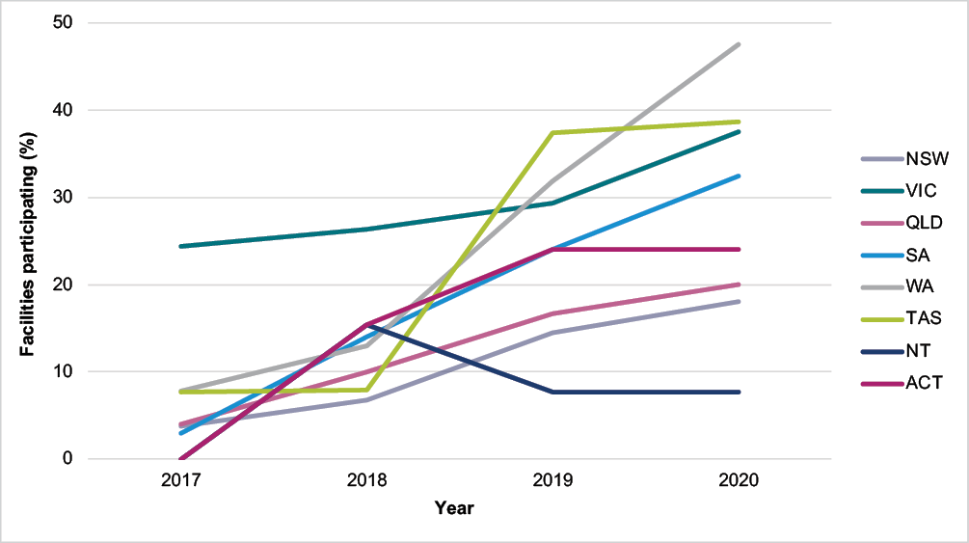

Sources: 1. Facility form and 2. Aged care service list: 30 June 2017, 2018, 2019 and 2020 Australian Institute of Health and Welfare (AIHW) GEN Aged Care Data.

Participation within each of the 3 provider groups varied between government (68.6%), not for profit (26.4%) and private (13.9%) (Figure 2 and Appendix 3: Tables A1 and A2).

#### Figure 2: Percentage of participating facilities within provider types, Aged Care NAPS contributors, 2017–2020

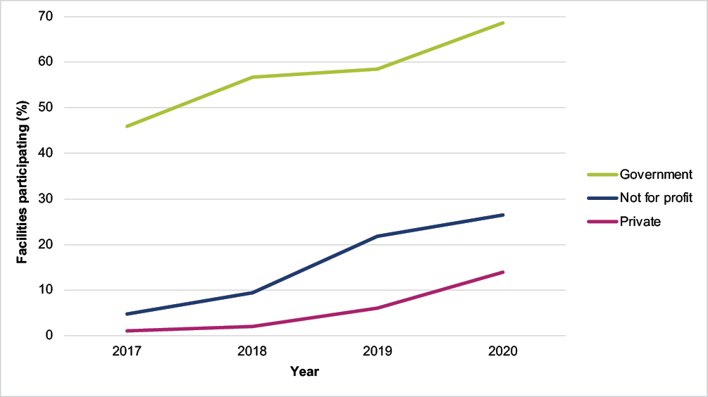

Sources: 1. Facility form and 2. Aged care service list: 30 June 2017, 2018, 2019 and 2020 Australian Institute of Health and Welfare (AIHW) GEN Aged Care Data.

## Prevalence of infections and antimicrobial use

In comparison to previous years, the prevalence of residents who had a suspected infection remained constant, whereas those prescribed at least one antimicrobial significantly increased. In 2020, the prevalence of residents who had signs and/or symptoms of at least one suspected infection on the survey day was 2.9% (n=1,361). The prevalence of residents prescribed at least one antimicrobial was 11.9% (n=5,586). If all topical antimicrobials or if all PRN orders not administered in the 7 days prior were excluded, the prevalence of residents prescribed at least one antimicrobial was 6.1% (n=2,882) and 8.5% (n=3,996) respectively (Figure 3 and Appendix 3: Table A4).

#### Figure 3: Prevalence of suspected infections and antimicrobial use, Aged Care NAPS contributors, 2017–2020

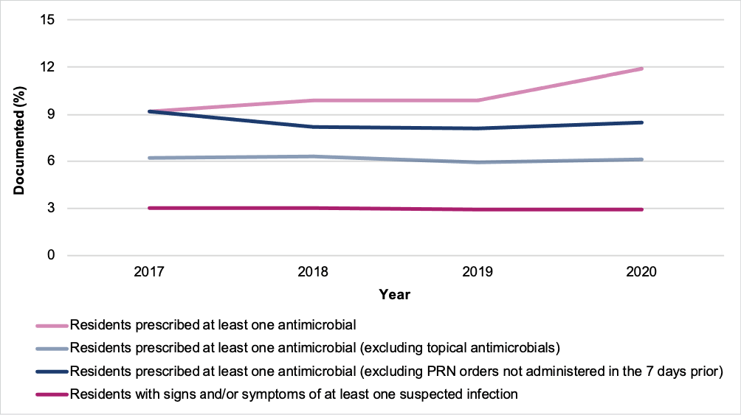

Sources: 1. Facility form and 2. Antimicrobial and infection form.

For the 253 facilities that participated annually from 2018 to 2020, there was no notable change in the prevalence of residents with signs and/or symptoms of at least one suspected infection. However, there was an increase in the prevalence of residents prescribed one or more antimicrobials   
(Figure 4 and Appendix 3: Table A5).

#### Figure 4: Prevalence of suspected infections and antimicrobial use for facilities that have participated annually, Aged Care NAPS contributors, 2018–2020

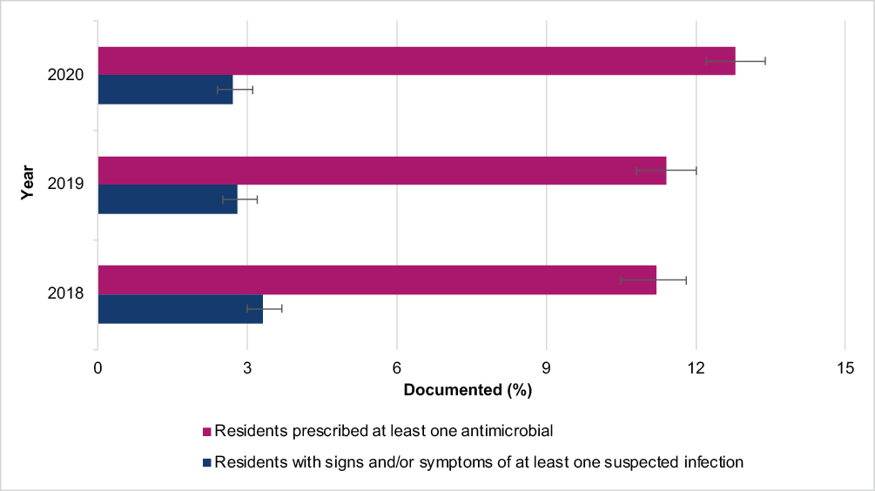

Sources: 1. Facility form and 2. Antimicrobial and infection form.

## Suspected infections on the survey day

A total of 1,361 residents were reported to have a total of 1,432 suspected infections on the survey day. Suspected skin or soft tissue (44.1%), urinary tract (29.8%) and respiratory tract (11.2%) infections were most commonly reported. About one-third (32.6%) met the McGeer et al. infection surveillance definitions (Table 1).

#### Table 1: Number and percentage of suspected infections by body system, Aged Care NAPS contributors, 2020

|  |  |  |  |
| --- | --- | --- | --- |
| **Body system** | **No. of suspected infections** | **Suspected infections that met McGeer et al. definition** | |
| **No.** | **%** |
| Skin or soft tissue | 632 | 229 | 36.2 |
| Respiratory tract | 160 | 28 | 17.5 |
| Urinary tract | 427 | 50 | 11.7 |
| Eye | 93 | 74 | 79.6 |
| Oral | 41 | 7 | 17.1 |
| Other systems | 79 | 79 | 100 |
| **Total** | **1,432** | **467** | **32.6** |

Source: Antimicrobial and infection form Section 5, Method 1 data.

## Antimicrobial use

Antimicrobial use data collected by both Method 1 and Method 2 were combined for the analyses presented in this section, unless otherwise stated. The unit of analysis is antimicrobial prescriptions.

A total of 6,418 residents were prescribed 7,581 antimicrobials, of which 6,382 were still prescribed on the survey day.

## Adverse events

A total of 1,546 residents prescribed an antimicrobial reported a history of an adverse reaction to antimicrobials. The most common antimicrobials (class) for which an adverse reaction was reported were penicillins (33.0%), trimethoprim (9.0%) and cefalexin (8.8%).

## Duration

The start date was unknown for 1.8% (n=136) of the antimicrobial prescriptions. Of antimicrobials still prescribed on the survey day, 39.2% (n=2,499) were commenced more than 6 months prior. Of antimicrobials still prescribed on the survey day that had a known start date and were prescribed less than 6 months prior to the survey day, 31.7% (n=2,025) had been commenced more than 7 days prior to the survey day.

## Most commonly prescribed antimicrobials

Most antimicrobials were prescribed for oral (n=4,164, 54.9%) or topical (n=3,323, 43.8%) administration. The majority of prescriptions were for therapeutic use (n=5,760, 76.0%); the remainder were for prophylaxis. As in previous surveys, clotrimazole (n=1,810, 23.9%) and cefalexin (n=1,546, 20.4%) were the most frequently prescribed antimicrobials (Figure 5 and Appendix 3: Table A6).

#### Figure 5: Most commonly prescribed antimicrobials, Aged Care NAPS contributors, 2017–2020

Source: Antimicrobial and infection form Section 2, Method 1 and 2 data.

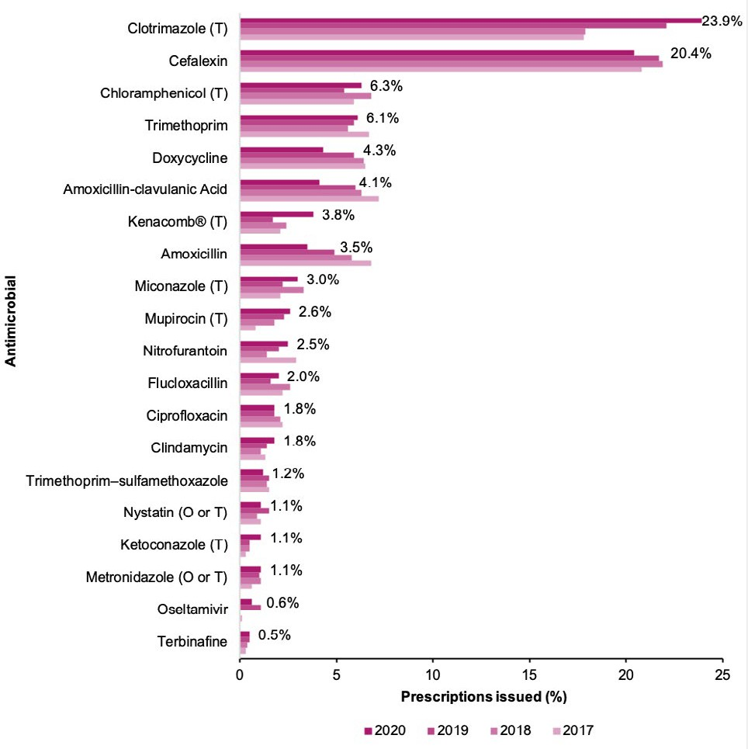

Only top 20 antimicrobials prescribed listed.

Denominator = all 8,322 antimicrobials prescribed O = oral; T = topical.

Kenacomb® contains triamcinolone, neomycin, nystatin and gramicidin.

Cefalexin (61.0%) and clotrimazole (89.4%) were most commonly prescribed for therapeutic use (Table 2).

#### Table 2: Cefalexin and clotrimazole prescriptions, therapeutic and prophylactic use, Aged Care NAPS contributors, 2020

|  |  |  |  |  |  |  |
| --- | --- | --- | --- | --- | --- | --- |
| **Antimicrobial** | **Category** | **No.** | **%** | **% of therapeutic prescriptions (n=5,760)** | **% of prophylactic prescriptions (n=1,821)** | **% of total prescriptions (n=7,581)** |
| Cefalexin  (n=1,546) | Therapeutic | 943 | 61.0 | 16.4 | – | 12.4 |
| Prophylactic | 603 | 39.0 | – | 33.1 | 8.0 |
| Clotrimazole (n=1,810) | Therapeutic | 1,618 | 89.4 | 28.1 | – | 21.3 |
| Prophylactic | 192 | 10.6 | – | 10.5 | 2.5 |

Source: Antimicrobial and infection form Section 2, Method 1 and 2 data.

About one-third (n=2,062, 32.3%) of antimicrobials still prescribed on the survey day (n=6,382) were for PRN administration; the majority of these (n=1,864, 90.4%) were topical antimicrobials, most commonly clotrimazole (n=1,268, 61.5%). Furthermore, approximately 3 in 10 (n=615, 29.8%) had been prescribed for durations of between one week and 6 months. Of those administered on the survey day or in the 6 days prior, there was an approximate 2% reduction from 2019 to 2020   
(Table 3).

#### Table 3: Antimicrobials prescribed for PRN administration, duration of prescription and administration on the survey day or in the 6 days prior, Aged Care NAPS contributors, 2019–2020

|  |  |  |  |  |  |  |
| --- | --- | --- | --- | --- | --- | --- |
| **Duration of prescription** | **2019** | | | **2020** | | |
| **Number of antimicrobials prescribed**  **for PRN administration** | **Administration on survey day or 6 days prior** | | **Number of antimicrobials prescribed**  **for PRN administration** | **Administration on survey day or 6 days prior** | |
| **No.** | **%** | **No.** | **%** |
| Less than 1 week | 25 | 10 | 40.0 | 47 | 18 | 38.3 |
| 1 week – 6 months | 338 | 37 | 10.9 | 615 | 65 | 10.6 |
| Greater than 6 months | 423 | 28 | 6.6 | 1,364 | 84 | 6.2 |
| Unknown | 37 | 5 | 13.5 | 36 | 2 | 5.6 |
| Total | 823 | 80 | 9.7 | 2,062 | 169 | 8.2 |

Source: Antimicrobial and infection form Section 2, ‘Still prescribed today’, antimicrobial prescriptions only.

## Quality indicators

In 2020 compared to 2019 (73.1%) there was an increase in the percentage of antimicrobial prescriptions (n=5,817, 76.7%) that had a documented indication for prescribing an antimicrobial. At the same time, compared to 2019 (54.4%) there was a decrease in the percentage of antimicrobial prescriptions (n=3,499, 46.2%) that had a documented review or stop date (Figure 6 and Appendix 3: Table A7).

#### Figure 6: Key quality indicators for all participating facilities, Aged Care NAPS contributors, 2017–2020

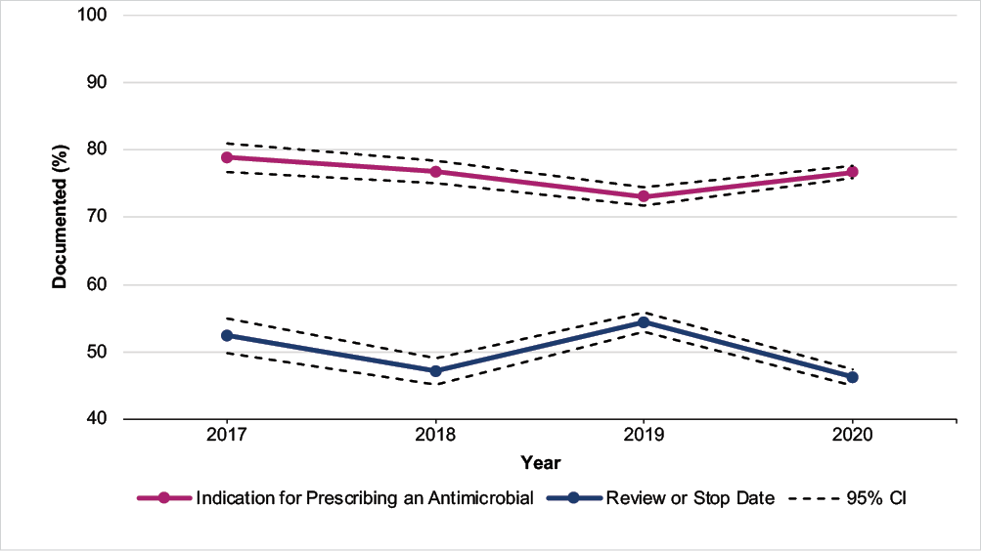

Source: Antimicrobial and infection form Section 2, Method 1 and 2 data. CI= Confidence Interval.

For the 253 facilities that participated annually from 2018 to 2020, there was an increase in the documentation of an indication for prescribing an antimicrobial (n=1,394, 79.1%) but a decrease in the recording of the review or stop date (n=723, 41.0%) (Figure 7 and Appendix 3: Table A8).

#### Figure 7: Key quality indicators for facilities that have participated annually, Aged Care NAPS contributors, 2018–2020

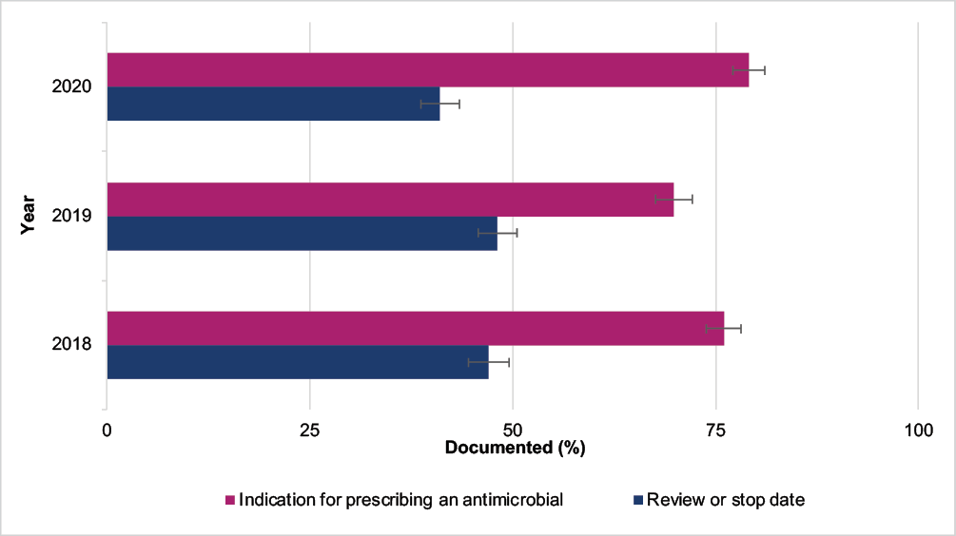

Source: Antimicrobial and infection form Section 2, Method 1 and 2 data.

## Common indications for prescribing antimicrobials

The top 5 known indications for prescribing antimicrobials were other – skin, soft tissue or mucosal; cystitis; tinea; wound infection (non-surgical); and cellulitis (Figure 8 and Appendix 3: Table A9). There were no prescriptions where the indication was reported as unknown.

#### Figure 8: Most common indications for antimicrobial prescriptions, Aged Care NAPS contributors, 2017–2020

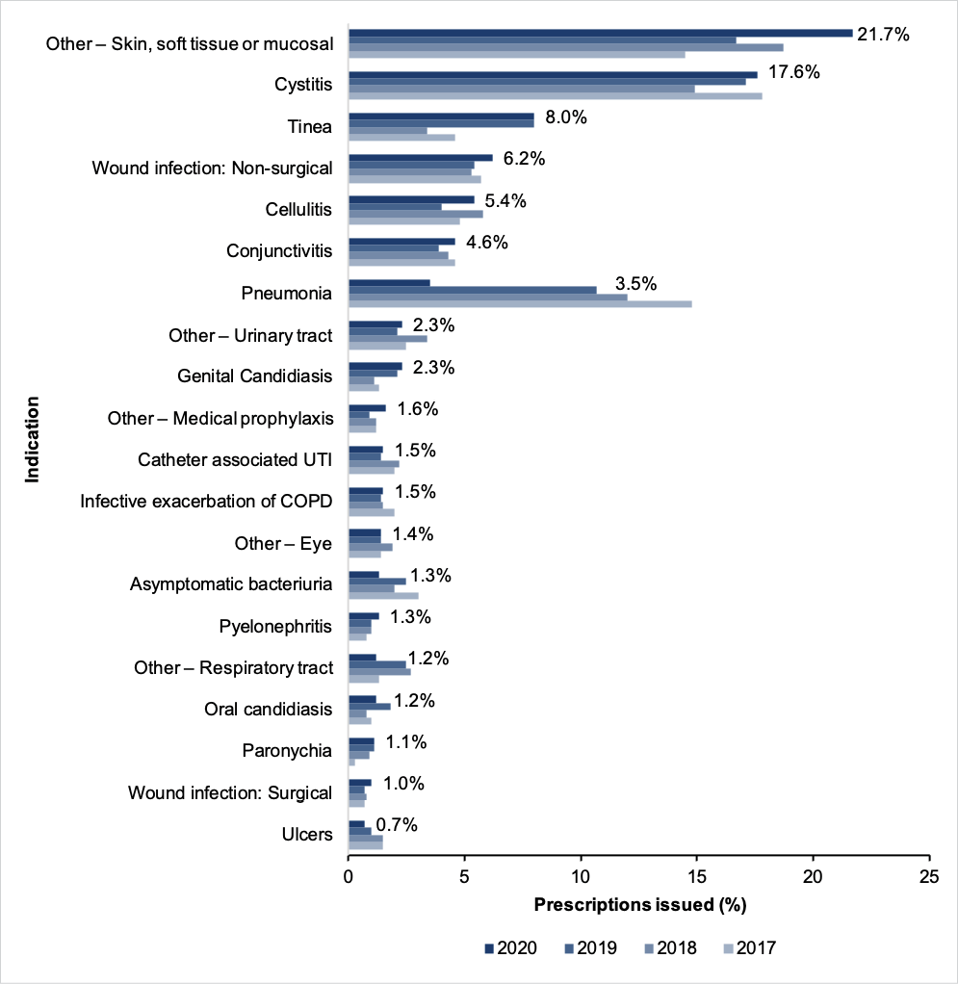

Source: Antimicrobial and infection form Section 2, Method 1 and 2 data.

Only top 20 indications for antimicrobial prescriptions listed.

Unknown indications for commencing an antimicrobial excluded.

UTI = urinary tract infection; COPD = chronic obstructive pulmonary disease.

Antimicrobials were consistently and most commonly prescribed for prophylactic indications associated with the urinary tract. In 2020, over one-third of the 1,821 prophylactic prescriptions were for cystitis (26.0%), other – urinary tract (6.3%), asymptomatic bacteriuria (3.2%) and catheter-associated urinary tract infection (2.0%) (Figure 9 and Appendix 3: Table A10).

#### Figure 9: Most common prophylactic indications for antimicrobial prescriptions, Aged Care NAPS contributors, 2017–2020

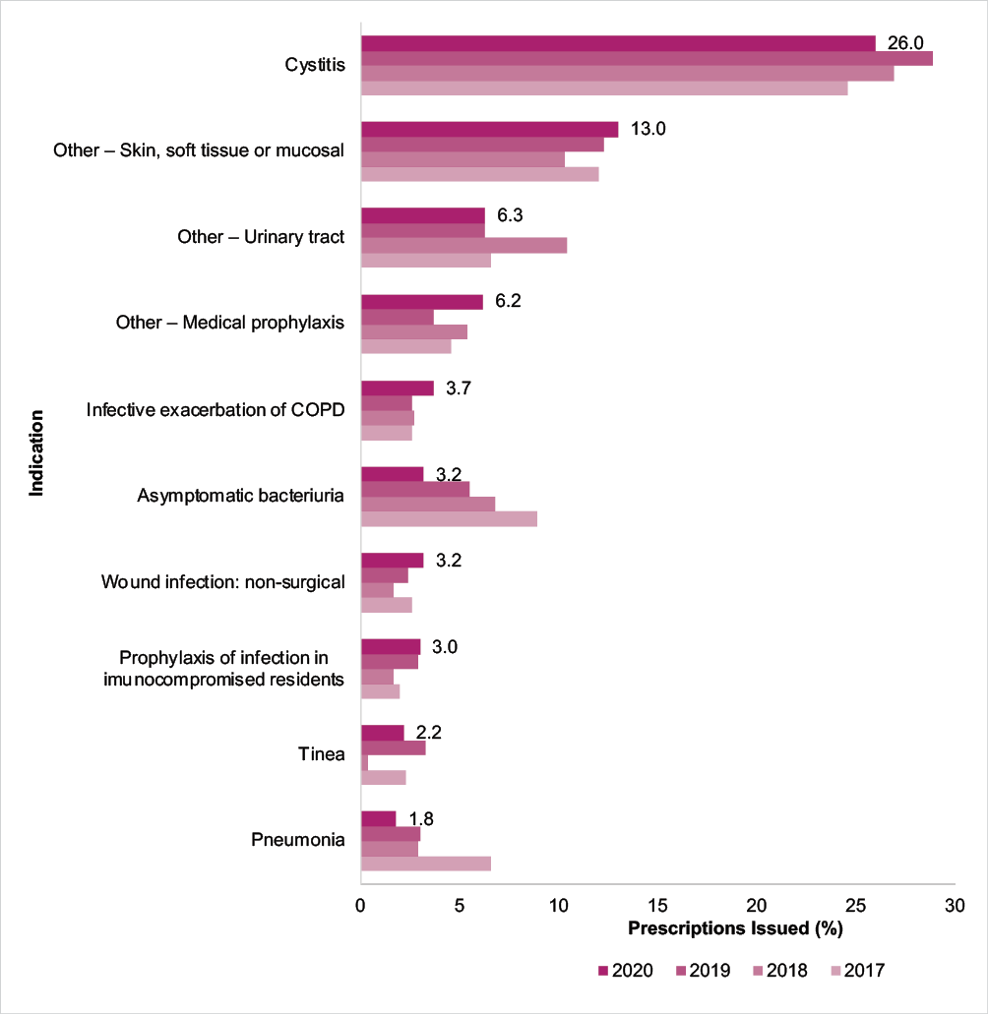

Source: Antimicrobial and infection form Section 2, Method 1 and 2 data.

Only top 10 indications for prophylactic antimicrobial prescriptions listed.

Unknown indications for commencing an antimicrobial excluded.

COPD = chronic obstructive pulmonary disease.

For cystitis, nearly two-thirds of the antimicrobials (n=1,334) were for either therapeutic (n=860, 64.5%) or prophylactic (n=474, 35.5%) indications (Figure 10 and Appendix 3: Table A11).

#### Figure 10: Comparison of therapeutic and prophylactic antimicrobial prescriptions for common indications, Aged Care NAPS contributors, 2020

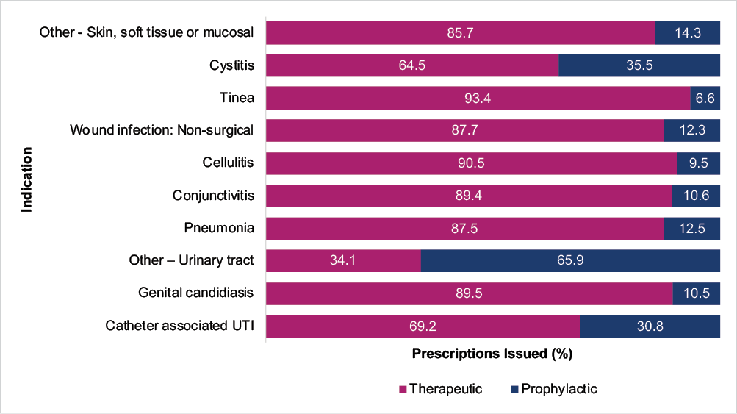

Source: Antimicrobial and infection form Section 2, Method 1 and 2 data.

Only top 10 indications for prophylactic antimicrobial prescriptions listed.

Medical prophylaxis and unknown indications for commencing an antimicrobial excluded.

UTI = urinary tract infection.

## Most commonly prescribed antimicrobials for common indications

The most commonly prescribed antimicrobials for cystitis, tinea and wound infection (non-surgical) were cefalexin (47.4%), clotrimazole (75.5%) and cefalexin (34.5%) respectively (Table 4).

#### Table 4: Commonly prescribed antimicrobials for cystitis, tinea and wound infection (non-surgical), Aged Care NAPS contributors, 2020

|  |  |  |  |  |  |  |  |  |
| --- | --- | --- | --- | --- | --- | --- | --- | --- |
| **Cystitis (n=1,334 prescriptions)** | | | **Tinea (n=603 prescriptions)** | | | **Wound infection (non-surgical) (n=470 prescriptions)** | | |
| **Antimicrobial** | **No.** | **%** | **Antimicrobial** | **No.** | **%** | **Antimicrobial** | **No.** | **%** |
| Cefalexin | 632 | 47.4 | Clotrimazole | 455 | 75.5 | Cefalexin | 162 | 34.5 |
| Trimethoprim | 353 | 26.5 | Miconazole | 79 | 13.1 | Mupirocin | 53 | 11.3 |
| Nitrofurantoin | 127 | 9.5 | Terbinafine | 22 | 3.6 | Kenacomb® | 40 | 8.5 |
| Amoxicillin–clavulanic acid | 73 | 5.5 | Ketoconazole | 19 | 3.2 | Doxycycline | 33 | 7.0 |
| Amoxicillin | 41 | 3.1 | Kenacomb® | 9 | 1.5 | Flucloxacillin | 31 | 6.6 |

Source: Antimicrobial and infection form Section 2, Method 1 and 2 data.

# Discussion

Compared to previous years, an increased number of Australian aged care facilities participated in the 2020 Aged Care NAPS; higher too was the representation of participating facilities for most states or territories and all provider groups (private, not for profit and government). This indicates more facilities valued the opportunity to participate in a national standardised survey that enabled monitoring and benchmarking of infections and antimicrobial use; it also facilitated their compliance with the Aged Care Quality Standards 3(3)(g) and 8(3)(e).13 It was helpful that the 2020 official time frame was extended from 1 June until 31 December; this allowed ample time for facilities in the midst of responding to the challenging COVID-19 pandemic to schedule their survey day. In previous years, the official 3- to 4-month time frame was over the winter months only.

The 2020 Aged Care NAPS identified issues in relation to infections and antimicrobial use that were similar to those identified in previous annual surveys, including:

**High numbers of suspected skin and soft tissue, urinary tract and respiratory tract infections**

Older people are especially vulnerable to infections and may not have typical signs and symptoms of infection.16

**High prevalence of residents prescribed at least one antimicrobial**

This includes those residing in facilities that have consistently participated in the Aged Care NAPS. Inappropriate antimicrobial use can cause harm to the individual and the community.17

**Prolonged duration of antimicrobial prescriptions**

In general, the shortest possible duration of therapy, consistent with the condition being treated and the resident’s clinical response, should be used. Prolonged duration of antimicrobial therapy is associated with an increased risk of adverse outcomes including antimicrobial resistance.2

**Extensive prescribing of topical antimicrobials, especially clotrimazole**

It is probable that many clotrimazole prescriptions are combination topical antifungal and corticosteroid preparations such as Hydrozole®. These combination products should only be used until inflammation subsides and then replaced with an antifungal alone to complete the treatment. This is to avoid complications of prolonged corticosteroid use such as thinning of the skin.

**Frequent prescribing of PRN antimicrobials**

PRN prescribing of antimicrobials is not recommended, as it encourages sporadic use which may be harmful and ineffective. Clinical review of antimicrobials, especially at the time of infection onset, may be reduced.

**Continuous prophylactic antimicrobial therapy, especially for urinary tract infections (UTIs)**

Prophylactic antimicrobial therapy for UTIs should only be (re)considered when the resident has been diagnosed with confirmed recurrent UTIs based on consistent clinical and microbiological criteria, non-antimicrobial strategies (e.g., dehydration correction) have been trialled, the benefit of the therapy outweighs any potential adverse effects or harm (e.g., candidiasis), and advanced care plans have been checked to ensure therapy is consistent with the expressed goals of the resident.

Further research is required before methenamine hippurate can be recommended to prevent chronic or recurrent UTIs. It may reduce the incidence of symptomatic UTI in women without urinary tract abnormalities; it is, however, not effective for the prevention of UTI in residents with urinary tract abnormalities.2

Patient-initiated treatment (antimicrobials taken at onset of symptoms) instead of continuous prophylactic therapy may reduce overall use.2

#### Incomplete documentation of indication and review and stop dates

Complete and accurate documentation ensures that all those involved in resident care have access to consistent and current information. When, for example, a resident is prescribed an antimicrobial, the indication, active ingredient, dose, frequency, route of administration, and intended duration or review plan should be documented in their healthcare record. Where electronic healthcare records are being used, flags and reminders in the record management system can be incorporated to support documentation in all relevant fields.3 Use of paper or electronic medication charts that are consistent with the ACSQHC’s National Residential Medication Chart is recommended.18

The seriousness and consistency of the identified issues reinforce the need for aged care facilities to develop and implement effective IPC and AMS programs that will lead to improvement in resident safety. There are nationally accepted guidelines that facilities should reference and use, such as the Australian Guidelines for the Prevention and Control of Infection,1 Therapeutic Guidelines: Antibiotic2 and AMS Clinical Care Standard.3 The ACSQHC has published strategies that specifically support IPC and AMS in general practice and in community and residential aged care.19 As of early 2021, all facilities must have employed one or more trained IPC Leads;20 it is expected these IPC Leads will play a pivotal role in supporting their facility’s IPC and AMS programs. Alongside on-site and visiting staff, residents and their carers should be actively engaged too.

# Appendix 1: Facility form

(Previously ‘Aged care home form’)

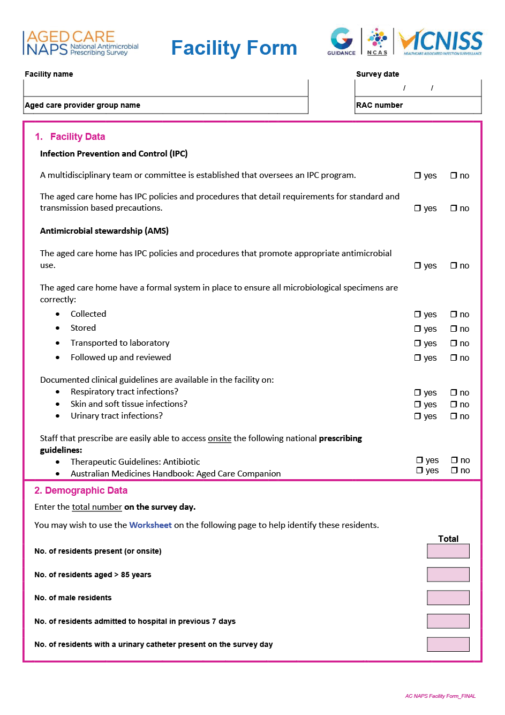

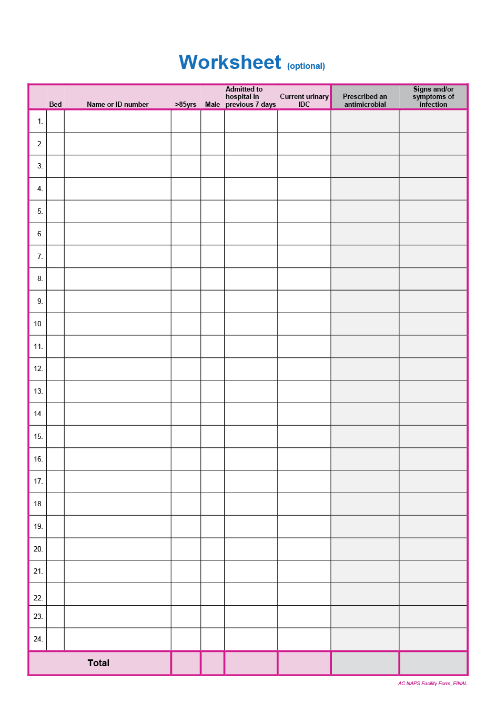

# Appendix 2: Antimicrobial and infection form

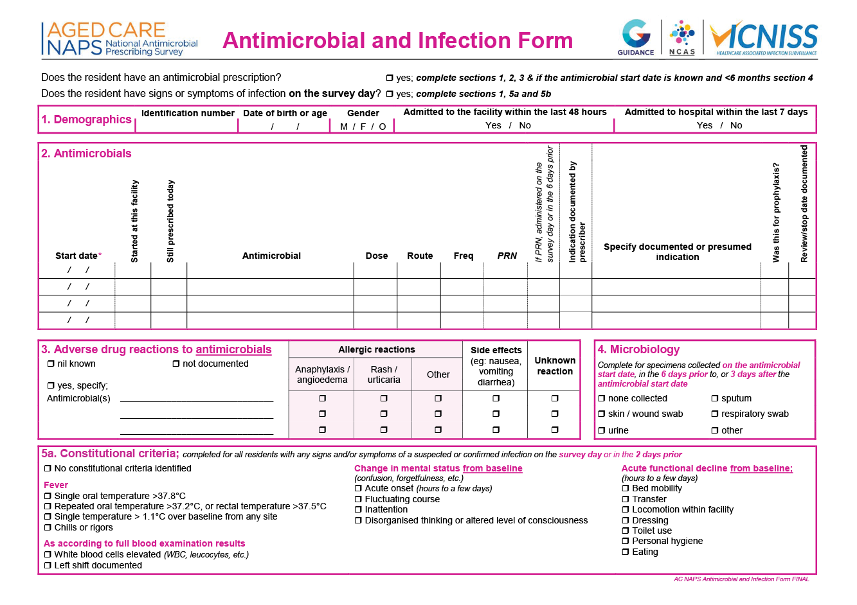

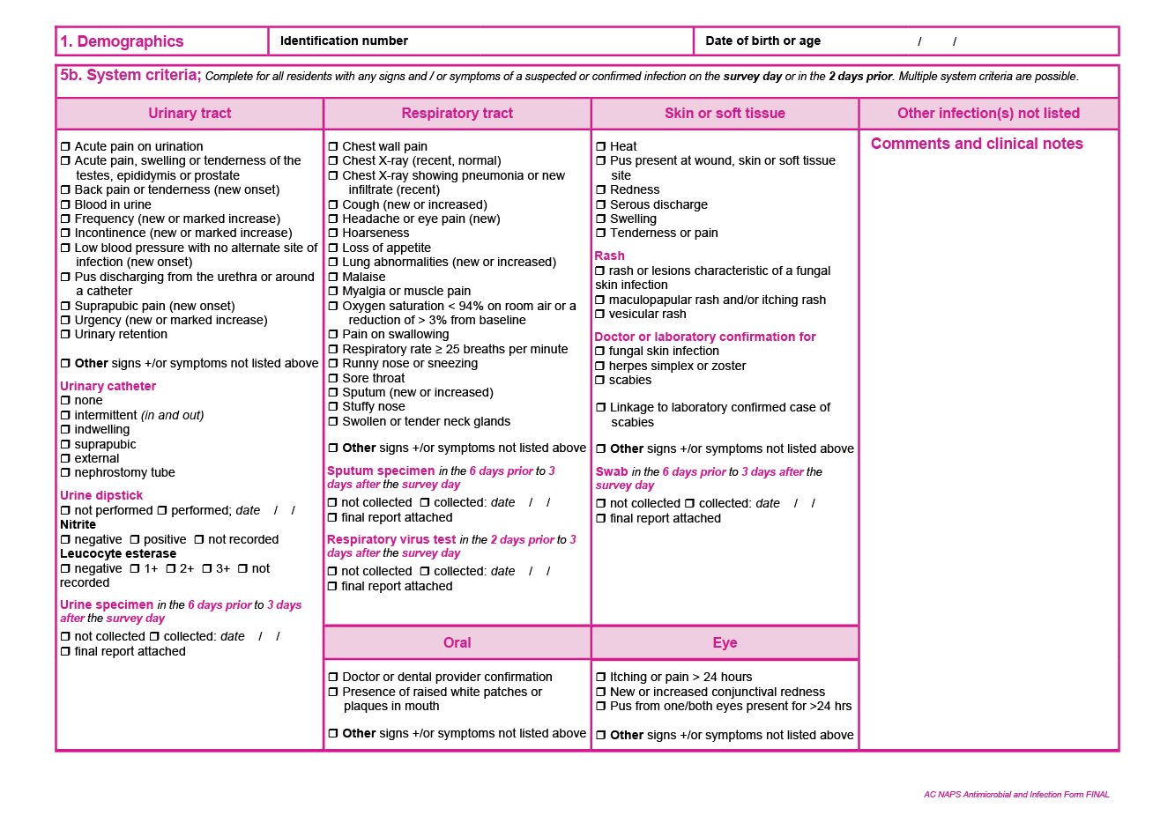

# Appendix 3: Additional data on infections and antimicrobials

#### Table A1: Participating facilities by state/territory, remoteness area classification and provider type, Aged Care NAPS contributors, 2020

|  |  |  |  |  |  |  |
| --- | --- | --- | --- | --- | --- | --- |
| **Category** | | **Residents audited** | **Participating facilities** | | **Facilities in reporting group** | **Participating facilities in  reporting group** |
| **No.** | **No.** | **%** | **No.** | **%** |
| State or territory | ACT | 641 | 6 | 0.7 | 25 | 24.0 |
| NSW | 9,194 | 171 | 20.8 | 946 | 18.1 |
| NT | 129 | 1 | 0.1 | 13 | 7.7 |
| Qld | 7,659 | 102 | 12.4 | 509 | 20.0 |
| SA | 5,254 | 88 | 10.7 | 271 | 32.5 |
| Tas | 2,130 | 29 | 3.5 | 75 | 38.7 |
| Vic | 14,163 | 291 | 35.4 | 777 | 37.5 |
| WA | 7,822 | 135 | 16.4 | 284 | 47.5 |
| Remoteness | Major cities | 28,668 | 382 | 46.4 | 1,708 | 22.4 |
| Inner regional | 12,104 | 225 | 27.3 | 676 | 33.3 |
| Outer regional | 5,553 | 170 | 20.7 | 402 | 42.3 |
| Remote | 485 | 32 | 3.9 | 74 | 43.2 |
| Very remote | 182 | 14 | 1.7 | 40 | 35.0 |
| Provider type | Not for profit | 29,308 | 411 | 49.9 | 1,556 | 26.4 |
| Private | 10,407 | 130 | 15.8 | 933 | 13.9 |
| Government | 7,277 | 282 | 34.3 | 411 | 68.6 |
| **Total** | | **46,992** | **823** | **100** | **2,900** | **28.4** |

Sources: 1. Facility form and 2. Aged care service list: 30 June 2020 AIHW GEN Aged Care Data.   
See Figures 1 and 2 for graphical presentation.

Transition care, innovative pool, national Aboriginal and Torres Strait Islander and short-term restorative care services excluded.

#### Table A2: Participating facilities by state/territory and provider type, Aged Care NAPS contributors, 2017–2019

|  |  |  |  |  |  |  |  |
| --- | --- | --- | --- | --- | --- | --- | --- |
| **Group** | | **2017** | | **2018** | | **2019** | |
| **No. of participating facilities** | **% of eligible facilities** | **No. of participating facilities** | **% of eligible facilities** | **No. of participating facilities** | **% of eligible facilities** |
| **State or territory** | ACT | 0 | 0.0 | 4 | 15.4 | 6 | 24.0 |
| NSW | 36 | 3.8 | 64 | 6.8 | 136 | 14.4 |
| NT | 0 | 0.0 | 2 | 15.4 | 1 | 7.7 |
| Qld | 19 | 4.0 | 49 | 10.0 | 84 | 16.7 |
| SA | 8 | 2.9 | 38 | 14.0 | 66 | 24.0 |
| Tas | 6 | 7.7 | 6 | 7.9 | 28 | 37.3 |
| Vic | 187 | 24.4 | 203 | 26.3 | 228 | 29.3 |
| WA | 21 | 7.7 | 36 | 12.9 | 90 | 31.8 |
| **Provider type** | Government | 193 | 46.0 | 236 | 56.7 | 242 | 58.5 |
| Not for profit | 74 | 4.8 | 147 | 9.5 | 341 | 21.8 |
| Private | 10 | 1.1 | 19 | 2.1 | 56 | 6.1 |
| **Total** | | **277** | **9.7** | **402** | **14.0** | **639** | **22.1** |

Sources: 1. Facility form and 2. Aged care service list: 30 June 2017, 2018, 2019 AIHW GEN Aged Care Data.   
See Figures 1 and 2 for graphical presentation.

Eligible facilities does not include transition care, innovative pool, national Aboriginal and Torres Strait Islander and   
short-term restorative care services.

#### Table A3: Number and characteristics of all residents on the survey day, Aged Care NAPS contributors, 2018–2020

|  |  |  |  |  |  |  |
| --- | --- | --- | --- | --- | --- | --- |
| **Measurement** | **2018** | | **2019** | | **2020** | |
| **No.** | **%** | **No.** | **%** | **No.** | **%** |
| Present on survey day | 19,571 | – | 35,297 | – | 46,992 | – |
| Aged >85 years | 11,643 | 59.5 | 20,607 | 58.4 | 27,212 | 57.9 |
| Male | 6,404 | 32.7 | 11,381 | 32.2 | 15,215 | 32.4 |
| Admitted to hospital in previous 7 days | 1 | 0.0 | 3 | 0.0 | 728 | 1.5 |
| Indwelling urinary catheter present | 734 | 3.8 | 1,271 | 3.6 | 1,668 | 3.5 |

Source: Facility form.

#### Table A4: Prevalence of suspected infections and antimicrobial use, Aged Care NAPS contributors, 2017–2020

|  |  |  |  |  |  |  |  |  |
| --- | --- | --- | --- | --- | --- | --- | --- | --- |
| **On survey day** | **2017** | | **2018** | | **2019** | | **2020** | |
| **No.** | **%** | **No.** | **%** | **No.** | **%** | **No.** | **%** |
| Residents prescribed at least one antimicrobial | 1,069 | 9.2 | 1,934 | 9.9 | 3,490 | 9.9 | 5,586 | 11.9 |
| Residents prescribed at least one antimicrobial (excluding topical antimicrobials) | 719 | 6.2 | 1,232 | 6.3 | 2,099 | 5.9 | 2,882 | 6.1 |
| Residents prescribed at least one antimicrobial (excluding PRN orders not administered in the last 7 days) | 1,069 | 9.2 | 1,610 | 8.2 | 2,850 | 8.1 | 3,996 | 8.5 |
| Residents with signs and/or symptoms of at least one suspected infection | 345 | 3.0 | 588 | 3.0 | 1,012 | 2.9 | 1,361 | 2.9 |
| Number of residents present | 11,662 | – | 19,571 | – | 35,297 | – | 46,992 | – |

Sources: 1. Facility form and 2. Antimicrobial and infection form.   
See Figure 3 for graphical presentation.

#### Table A5: Prevalence of suspected infections and antimicrobial use for facilities that have participated annually*, Aged Care NAPS contributors, 2018–2020

|  |  |  |  |  |  |  |  |  |  |
| --- | --- | --- | --- | --- | --- | --- | --- | --- | --- |
| **On survey day** | **2018** | | | **2019** | | | **2020** | | |
| **No.** | **%** | **95% CI** | **No.** | **%** | **95% CI** | **No.** | **%** | **95% CI** |
| Residents prescribed at least one antimicrobial | 1,207 | 11.2 | 10.6 – 11.8 | 1,228 | 11.4 | 10.8 – 12.0 | 1,347 | 12.8 | 12.1 – 13.4 |
| Residents with signs and/or symptoms of at least one suspected infection | 356 | 3.3 | 3.0 – 3.7 | 306 | 2.8 | 2.5 – 3.2 | 288 | 2.7 | 2.4 – 3.1 |
| Number of residents present | 10,782 | – | – | 10,787 | – | – | 10,542 | – | – |

Sources: 1. Facility form and 2. Antimicrobial and infection form.   
See Figure 4 for graphical presentation.

* 253 aged care facilities participated annually between 2018 and 2020.

#### Table A6: Most commonly prescribed antimicrobials, Aged Care NAPS contributors, 2017–2020

|  |  |  |  |  |  |  |  |  |
| --- | --- | --- | --- | --- | --- | --- | --- | --- |
| **Antimicrobial** | **2017**  **(n=1,510)** | | **2018**  **(n=2,503)** | | **2019**  **(n=4,630)** | | **2020**  **(n=7,581)** | |
| **No.** | **%** | **No.** | **%** | **No.** | **%** | **No.** | **%** |
| Clotrimazole (T) | 269 | 17.8 | 448 | 17.9 | 1,022 | 22.1 | 1,810 | 23.9 |
| Cefalexin | 314 | 20.8 | 547 | 21.9 | 1,007 | 21.7 | 1,546 | 20.4 |
| Chloramphenicol (T) | 89 | 5.9 | 169 | 6.8 | 249 | 5.4 | 481 | 6.3 |
| Trimethoprim | 101 | 6.7 | 141 | 5.6 | 271 | 5.9 | 463 | 6.1 |
| Doxycycline | 98 | 6.5 | 161 | 6.4 | 275 | 5.9 | 329 | 4.3 |
| Amoxicillin–clavulanic acid | 108 | 7.2 | 158 | 6.3 | 280 | 6.0 | 311 | 4.1 |
| Kenacomb® (T) | 32 | 2.1 | 60 | 2.4 | 77 | 1.7 | 289 | 3.8 |
| Amoxicillin | 103 | 6.8 | 145 | 5.8 | 229 | 4.9 | 268 | 3.5 |
| Miconazole (T) | 32 | 2.1 | 83 | 3.3 | 102 | 2.2 | 227 | 3.0 |
| Mupirocin (T) | 12 | 0.8 | 46 | 1.8 | 107 | 2.3 | 200 | 2.6 |
| Nitrofurantoin | 44 | 2.9 | 34 | 1.4 | 91 | 2.0 | 188 | 2.5 |
| Flucloxacillin | 33 | 2.2 | 65 | 2.6 | 76 | 1.6 | 148 | 2.0 |
| Ciprofloxacin | 33 | 2.2 | 52 | 2.1 | 85 | 1.8 | 140 | 1.8 |
| Clindamycin | 19 | 1.3 | 28 | 1.1 | 65 | 1.4 | 137 | 1.8 |
| Trimethoprim–sulfamethoxazole | 23 | 1.5 | 36 | 1.4 | 69 | 1.5 | 88 | 1.2 |
| Nystatin (O or T) | 16 | 1.1 | 23 | 0.9 | 71 | 1.5 | 87 | 1.1 |
| Ketoconazole (T) | 4 | 0.3 | 12 | 0.5 | 22 | 0.5 | 85 | 1.1 |
| Metronidazole (O or T) | 9 | 0.6 | 27 | 1.1 | 45 | 1.0 | 80 | 1.1 |
| Oseltamivir | 1 | 0.1 | 1 | 0.0 | 49 | 1.1 | 48 | 0.6 |
| Terbinafine | 4 | 0.3 | 11 | 0.4 | 22 | 0.5 | 41 | 0.5 |

Source: Antimicrobial and infection form Section, 2 Method 1 and 2 data. See Figure 5 for graphical presentation.   
Only top 20 antimicrobials prescribed listed.

O = oral; T = topical.

Kenacomb® contains triamcinolone, neomycin, nystatin and gramicidin.

#### Table A7: Key quality indicators for all participating facilities, Aged Care NAPS contributors, 2017–2020

|  |  |  |  |  |  |  |  |  |  |  |  |  |
| --- | --- | --- | --- | --- | --- | --- | --- | --- | --- | --- | --- | --- |
| **Indicator** | **2017** | | | **2018** | | | **2019** | | | **2020** | | |
| **No.** | **%** | **95% CI** | **No.** | **%** | **95% CI** | **No.** | **%** | **95% CI** | **No.** | **%** | **95% CI** |
| **Indication for prescribing an antimicrobial** | | | | | | | | | | | |  |
| Documented | 1,192 | 78.9 | 76.8 – 81.0 | 1,922 | 76.8 | 75.1 – 78.4 | 3,384 | 73.1 | 71.8 – 74.4 | 5,817 | 76.7 | 75.8 – 77.7 |
| Not documented | 318 | 21.1 | 19.0 – 23.2 | 581 | 23.2 | 21.6 – 24.9 | 1,246 | 26.9 | 25.6 – 28.2 | 1,764 | 23.3 | 22.3 – 24.2 |
| **Review or stop date** | | | | | | | | | | | |  |
| Documented | 791 | 52.4 | 49.8 – 54.9 | 1,179 | 47.1 | 45.1 – 49.1 | 2,521 | 54.4 | 53.0 – 55.9 | 3,499 | 46.2 | 45.0 – 47.3 |
| Not documented | 719 | 47.6 | 45.1 – 50.2 | 1,324 | 52.9 | 50.9 – 54.9 | 2,109 | 45.6 | 44.1 – 47.0 | 4,082 | 53.8 | 52.7 – 55.0 |
| **Total** | **1,510** | **–** | **–** | **2,503** | **–** | **–** | **4,630** | **–** | **–** | **7,581** | **–** | **–** |

Source: Antimicrobial and infection form Section 2, Method 1 and 2 data.   
See Figure 6 for graphical presentation.

#### Table A8: Key quality indicators for facilities that have participated annually, Aged Care NAPS contributors, 2018–2020

|  |  |  |  |  |  |  |  |  |  |
| --- | --- | --- | --- | --- | --- | --- | --- | --- | --- |
| **Indicator** | **2018** | | | **2019** | | | **2020** | | |
| **No.** | **%** | **95% CI** | **No.** | **%** | **95% CI** | **No.** | **%** | **95% CI** |
| **Indication for prescribing an antimicrobial** | | | | | | | | |  |
| Documented | 1,213 | 76.0 | 73.8 – 78.1 | 1,156 | 69.8 | 67.6 – 72.1 | 1,394 | 79.1 | 77.1 – 81.0 |
| Not documented | 383 | 24.0 | 21.9 – 26.2 | 499 | 30.2 | 27.9 – 32.4 | 368 | 20.9 | 19.0 – 22.9 |
| **Review or stop date** | | | | | | | | |  |
| Documented | 750 | 47.0 | 44.5 – 49.5 | 796 | 48.1 | 45.7 – 50.5 | 723 | 41.0 | 38.7 – 43.4 |
| Not documented | 846 | 53.0 | 50.5 – 55.5 | 859 | 51.9 | 49.5 – 54.3 | 1,039 | 59.0 | 56.6 – 61.3 |
| **Total** | **1,596** | **–** | **–** | **1,655** | **–** | **–** | **1,762** | **–** | **–** |

Source: Antimicrobial and infection form Section 2, Method 1 and 2 data.   
See Figure 7 for graphical presentation.

#### Table A9: Most common indications for antimicrobial prescriptions, Aged Care NAPS contributors, 2017–2020

|  |  |  |  |  |  |  |  |  |
| --- | --- | --- | --- | --- | --- | --- | --- | --- |
| **Indication** | **Antimicrobial prescriptions** | | | | | | | |
| **2017**  **(n=1,446)** | | **2018**  **(n=2,356)** | | **2019**  **(n=4,370)** | | **2020**  **(n=7,581)** | |
| **No.** | **%** | **No.** | **%** | **No.** | **%** | **No.** | **%** |
| Other – skin, soft tissue or mucosal | 209 | 14.5 | 440 | 18.7 | 731 | 16.7 | 1,648 | 21.7 |
| Cystitis | 258 | 17.8 | 352 | 14.9 | 746 | 17.1 | 1,334 | 17.6 |
| Tinea | 66 | 4.6 | 79 | 3.4 | 350 | 8.0 | 603 | 8.0 |
| Wound infection: non-surgical | 82 | 5.7 | 125 | 5.3 | 236 | 5.4 | 470 | 6.2 |
| Cellulitis | 70 | 4.8 | 137 | 5.8 | 176 | 4.0 | 410 | 5.4 |
| Conjunctivitis | 67 | 4.6 | 102 | 4.3 | 172 | 3.9 | 350 | 4.6 |
| Pneumonia | 214 | 14.8 | 282 | 12.0 | 468 | 10.7 | 264 | 3.5 |
| Other – urinary tract | 36 | 2.5 | 79 | 3.4 | 93 | 2.1 | 173 | 2.3 |
| Genital candidiasis | 19 | 1.3 | 27 | 1.1 | 90 | 2.1 | 171 | 2.3 |
| Other – medical prophylaxis | 17 | 1.2 | 29 | 1.2 | 38 | 0.9 | 123 | 1.6 |
| Catheter associated UTI | 29 | 2.0 | 53 | 2.2 | 63 | 1.4 | 117 | 1.5 |
| Infective exacerbation of COPD | 29 | 2.0 | 36 | 1.5 | 60 | 1.4 | 113 | 1.5 |
| Other – eye | 20 | 1.4 | 45 | 1.9 | 61 | 1.4 | 107 | 1.4 |
| Asymptomatic bacteriuria | 44 | 3.0 | 48 | 2.0 | 108 | 2.5 | 99 | 1.3 |
| Pyelonephritis | 11 | 0.8 | 23 | 1.0 | 43 | 1.0 | 96 | 1.3 |
| Other – respiratory tract | 19 | 1.3 | 63 | 2.7 | 108 | 2.5 | 93 | 1.2 |
| Oral candidiasis | 15 | 1.0 | 20 | 0.8 | 80 | 1.8 | 90 | 1.2 |
| Paronychia | 5 | 0.3 | 21 | 0.9 | 49 | 1.1 | 80 | 1.1 |
| Wound infection: surgical | 10 | 0.7 | 18 | 0.8 | 31 | 0.7 | 79 | 1.0 |
| Ulcers | 22 | 1.5 | 36 | 1.5 | 44 | 1.0 | 55 | 0.7 |

Source: Antimicrobial and infection form Section 2, Method 1 and 2 data.   
See Figure 8 for graphical presentation.

Only top 20 indications for antimicrobial prescriptions listed. Unknown indications for commencing an antimicrobial excluded.

UTI = urinary tract infection; COPD = chronic obstructive pulmonary disease.

#### Table A10: Most common prophylactic indications for antimicrobial prescriptions, Aged Care NAPS contributors, 2017–2020

|  |  |  |  |  |  |  |  |  |
| --- | --- | --- | --- | --- | --- | --- | --- | --- |
| **Indication** | **2017**  **(n=350)** | | **2018**  **(n=517)** | | **2019**  **(n=1,021)** | | **2020**  **(n=1,821)** | |
| **No.** | **%** | **No.** | **%** | **No.** | **%** | **No.** | **%** |
| Cystitis | 86 | 24.6 | 139 | 26.9 | 295 | 28.9 | 474 | 26.0 |
| Other – skin, soft tissue or mucosal | 42 | 12.0 | 53 | 10.3 | 126 | 12.3 | 236 | 13.0 |
| Other – urinary tract | 23 | 6.6 | 54 | 10.4 | 64 | 6.3 | 114 | 6.3 |
| Other – medical prophylaxis | 16 | 4.6 | 28 | 5.4 | 38 | 3.7 | 112 | 6.2 |
| Infective exacerbation of COPD | 9 | 2.6 | 14 | 2.7 | 27 | 2.6 | 67 | 3.7 |
| Asymptomatic bacteriuria | 31 | 8.9 | 35 | 6.8 | 56 | 5.5 | 59 | 3.2 |
| Wound infection: non-surgical | 9 | 2.6 | 9 | 1.7 | 24 | 2.4 | 58 | 3.2 |
| Prophylaxis of infection in immunocompromised residents | 7 | 2.0 | 9 | 1.7 | 30 | 2.9 | 54 | 3.0 |
| Tinea | 8 | 2.3 | 2 | 0.4 | 34 | 3.3 | 40 | 2.2 |
| Pneumonia | 23 | 6.6 | 15 | 2.9 | 31 | 3.0 | 33 | 1.8 |

Source: Antimicrobial and infection form Section 2, Method 1 and 2 data.   
See Figure 9 for graphical presentation.

Only top 10 prophylactic indications for antimicrobial prescriptions listed.   
Unknown indications for commencing an antimicrobial excluded.

COPD = chronic obstructive pulmonary disease.

#### Table A11: Comparison of therapeutic and prophylactic antimicrobial prescriptions for common indications, Aged Care NAPS contributors, 2020

|  |  |  |  |  |  |
| --- | --- | --- | --- | --- | --- |
| **Indication** | **Therapeutic** | | **Prophylactic** | | **Total** |
| **No.** | **%** | **No.** | **%** |
| Other – skin, soft tissue or mucosal | 1,412 | 85.7 | 236 | 14.3 | 1,648 |
| Cystitis | 860 | 64.5 | 474 | 35.5 | 1,334 |
| Tinea | 563 | 93.4 | 40 | 6.6 | 603 |
| Wound infection: non-surgical | 412 | 87.7 | 58 | 12.3 | 470 |
| Cellulitis | 371 | 90.5 | 39 | 9.5 | 410 |
| Conjunctivitis | 313 | 89.4 | 37 | 10.6 | 350 |
| Pneumonia | 231 | 87.5 | 33 | 12.5 | 264 |
| Other – urinary tract | 59 | 34.1 | 114 | 65.9 | 173 |
| Genital candidiasis | 153 | 89.5 | 18 | 10.5 | 171 |
| Catheter associated UTI | 81 | 69.2 | 36 | 30.8 | 117 |

Source: Antimicrobial and infection form Section 2, Method 1 and 2 data.   
See Figure 10 for graphical presentation.

Only top 10 indications for antimicrobial prescription listed.

Unknown and medical prophylaxis indications for commencing an antimicrobial excluded.

UTI = urinary tract infection.

# Appendix 4: Abbreviations

|  |  |
| --- | --- |
| **Abbreviation** | **Definition** |
| ACSQHC | Australian Commission on Safety and Quality in Health Care |
| Aged Care NAPS | Aged Care National Antimicrobial Prescribing Survey |
| AMS | Antimicrobial Stewardship |
| AURA | Antimicrobial Use and Resistance in Australia |
| IPC | Infection Prevention and Control |
| NAPS | National Antimicrobial Prescribing Survey |
| NCAS | National Centre for Antimicrobial Stewardship |
| PRN | Pro Re Nata (as required) |
| VICNISS | Victorian Healthcare Associated Infection Surveillance System |

# References

1. National Health and Medical Research Council. Australian Guidelines for the Prevention and Control of Infection in Healthcare. Canberra: NHMRC; 2019.
2. Antibiotic Expert Group. Therapeutic Guidelines: Antibiotic (version 16). Melbourne: Therapeutic Guidelines Limited; 2019.
3. Australian Commission on Safety and Quality in Health Care. Antimicrobial Stewardship Clinical Care Standard. Sydney: ACSQHC; 2020.
4. Australian Government Aged Care Quality and Safety Commission. Guidance and Resources for Providers to support the Aged Care Quality Standards. ACQSC; 2021.
5. Center for Disease Prevention and Control. The Core Elements of Antibiotic Stewardship for Nursing Homes. Atlanta; 2015.
6. National Centre for Antimicrobial Stewardship and Australian Commission on Safety and Quality in Health Care. Antimicrobial prescribing and infections in Australian residential aged care facilities: Results of the 2015 Aged Care National Antimicrobial Prescribing Survey pilot. Sydney: ACSQHC; 2016.
7. European Centre for Disease Prevention and Control. Healthcare-associated infections in long-term care facilities in Europe: The HALT project. Available from: https://ecdc.europa.eu/en/healthcare-[associated-infections-long-term-care-facilities](https://www.ecdc.europa.eu/en/healthcare-associated-infections-long-term-care-facilities). [Cited 2021 December].
8. National Centre for Antimicrobial Stewardship and Australian Commission on Safety and Quality in Health Care. Aged Care National Antimicrobial Prescribing Survey 2016. Sydney: ACSQHC; 2017
9. National Centre for Antimicrobial Stewardship and Australian Commission on Safety and Quality in Health Care. Antimicrobial prescribing and infections in Australian aged care homes: Results of the 2017 Aged Care National Antimicrobial Prescribing Survey. Sydney: ACSQHC; 2018.
10. National Centre for Antimicrobial Stewardship and Australian Commission on Safety and Quality in Health Care. Antimicrobial prescribing and infections in Australian residential aged care facilities: Results of the 2019 Aged Care National Antimicrobial Prescribing Survey Sydney ACSQHC; 2020.
11. National Centre for Antimicrobial Stewardship and Australian Commission on Safety and Quality in Health Care. Antimicrobial prescribing and infections in Australian aged care homes: Results of the 2018 Aged Care National Antimicrobial Prescribing Survey. Sydney: ACSQHC; 2019.
12. Commonwealth of Australia Department of Health. 2019–20 Report on the Operation of the Aged Care Act 1997. Canberra; 2020.
13. Australian Government Aged Care Quality and Safety Commission. Aged Care Quality Standards 2019. Available from: <https://www.agedcarequality.gov.au/providers/standards>. [Cited 2020 April].
14. Lee BS, Bhuta T, Simpson JM, Craig JC. Methenamine hippurate for preventing urinary tract infections. *Cochrane Database Syst Rev*. 2012; 10.
15. Stone ND, Ashraf MS, Calder J, Crnich CJ, Crossley K, Drinka PJ, Gould CV, Juthani-Mehta M, Lautenbach E, Loeb M, Maccannell T, Malani PN, Mody L, Mylotte JM, Nicolle LE, Roghmann MC, Schweon SJ, Simor AE, Smith PW, Stevenson KB, Bradley SF. Surveillance definitions of infections in long-term care facilities: Revisiting the McGeer criteria. *Infect Control Hosp Epidemiol*. 2012; 33(10): 965-77.
16. Juthani-Mehta M, Quagliarello VJ. Infectious diseases in the nursing home setting: challenges and opportunities for clinical investigation. *Clin Infect Dis*. 2010; 51(8): 931-6.
17. Australian Government Department Health and Department of Agriculture, Water and the Environment. Australia’s National Antimicrobial Resistance Strategy: 2020 and Beyond. Canberra; 2020.
18. Australian Commission on Safety and Quality in Health Care. National Residential Medication Chart 2014. Available from: <https://www.safetyandquality.gov.au/our-work/medication-safety/national-residential-medication-chart/>. [Cited 2018 February].
19. Australian Commission on Safety and Quality in Health Care. Antimicrobial stewardship in Australian health care. Sydney: ACSQHC; 2018.
20. Australian Government Department of Health. Infection prevention and control leads . Available from: https://[www.health.gov.au/initiatives-and-programs/infection-prevention-and-control-](https://www.health.gov.au/our-work/infection-prevention-and-control-leads#:~:text=Residential%20aged%20care%20facilities%20must,including%20COVID%2D19%20and%20influenza) leads#:~:text=Residential%20aged%20care%20facilities%20must,including%20COVID%2D19%20 and%20influenza. [Cited 2021 May].

All information in this publication is correct as at January 2023



DT0002451 April 2023

#### amr.gov.au