Antimicrobial prescribing in Australian residential aged care facilities



Results of the 2021 Aged Care National Antimicrobial Prescribing Survey

Published by the Australian Government Department of Health and Aged Care

For issues regarding the content of the report:

Email: support@naps.org.au

Website: https://www.naps.org.au/

ISBN: 978-1-74186-081-8

© Australian Government Department of Health and Aged Care

All material and work produced by the Department of Health and Aged Care is protected by copyright. The Department reserves the right to set out the terms and conditions for the use of such material.

Enquiries about the licence and any use of this publication are welcome and can be sent to AMR@health.gov.au

Preferred citation

Royal Melbourne Hospital and the National Centre for Antimicrobial Stewardship. Antimicrobial prescribing practice in Australian residential aged care facilities. Results of the 2021 Aged Care National Antimicrobial Prescribing Survey Canberra: Department of Health and Aged Care; 2023.

Disclaimer

This document is not intended to provide guidance on particular healthcare choices. You should contact your healthcare provider for advice on particular healthcare choices.

This document includes the views or recommendations of its authors and third parties. Royal Melbourne Hospital, the National Centre for Antimicrobial Stewardship and the Department of Health and Aged Care do not accept any legal liability for any injury, loss or damage incurred by the use of, or reliance on, this document.

Contents

Summary 4

Key findings of the 2021 Aged Care NAPS 4

Key concerns in 2021 (similar to previous Aged Care NAPS) included: 4

Implications for clinical practice 5

1 Introduction 6

1.1 About the Aged Care NAPS 6

1.2 Australian aged care services 6

2 Methods 7

2.1 Time frame 7

2.2 Recruitment 7

2.3 Survey method 7

2.4 Data collection forms 7

2.5 Electronic Aged Care NAPS 8

2.6 Data definitions and data analysis 9

2.7 Support 9

2.8 Considerations for data interpretation 10

3 Results 11

3.1 Participation 11

3.2 Prevalence of infections and antimicrobial use 12

3.3 Suspected infections on the survey day 14

3.4 Antimicrobial use 14

3.5 Adverse events 14

3.6 Duration 14

3.7 Most commonly prescribed antimicrobials 15

3.8 Quality indicators 16

3.9 Common indications for prescribing antimicrobials 18

3.10 Most commonly prescribed antimicrobials for common indications 22

3.11 Microbiology 22

4 Conclusion 23

Appendix 1: Facility form 24

Appendix 2: Antimicrobial and infection form 26

Appendix 3: Additional data on infections and antimicrobials 28

Appendix 4: Case study – improvement of topical antimicrobial use 38

Appendix 5: Abbreviations 40

References 41

Acknowledgements 43

# Summary

All Australian aged care homes and multipurpose services (aged care facilities) are encouraged each year to complete the Aged Care National Antimicrobial Prescribing Survey (NAPS). This standardised surveillance tool can be used to monitor the prevalence of infections and antimicrobial use, provide feedback to key clinicians and administrators, and measure the effectiveness of infection prevention and control (IPC) and antimicrobial stewardship (AMS) programs. It is an important safety and quality initiative, as there is longstanding evidence of residents colonised or infected by multidrug-resistant organisms and inappropriate antimicrobial use.

This report primarily presents analyses of resident infection and antimicrobial use data reported by 689 Australian aged care facilities that contributed to the 2021 Aged Care NAPS. All states/territories, remoteness classifications (major cities, inner and outer regional, remote and very remote) and provider groups (private, not for profit and public) are represented. Comparisons are made against aged care facilities that contributed to the 2016 (n=262), 2017 (n=271), 2018 (n=397), 2019 (n=638) and 2020 (n=825) Aged Care NAPS. Pilot Aged Care NAPS data (2015) is not included.

## Key findings of the 2021 Aged Care NAPS

Important findings in 2021 included:

* On the survey day, 3.1% of residents had signs and/or symptoms of a suspected infection and 13.7% were prescribed antimicrobials.
* The most commonly reported suspected infections on the survey day were skin or soft tissue (52.6%), urinary tract (22.1%) and respiratory tract (11.8%).
* About one-fifth (n=1,701, 22.3%) of prescriptions were for prophylactic use.
* The most common clinical (therapeutic or prophylactic) indications for antimicrobial prescriptions were unspecified skin, soft tissue or mucosal conditions (25.0%); cystitis (13.6%); and tinea (9.7%). The most common prophylactic indications were cystitis (21.3%); unspecified skin, soft tissue or mucosal conditions (16.3%); and unspecified medical prophylaxis conditions (8.8%).
* Clotrimazole (28.3%), cefalexin (18.2%) and chloramphenicol (6.2%) were the most commonly prescribed antimicrobials.
* Of antimicrobials still prescribed on the survey day, 42.1% (n=2,679) were commenced more than 6 months previously.
* Many antimicrobials (48.4%) were prescribed for topical administration.
* Just over one-third (35.1%) of antimicrobials still prescribed on the survey day were for pro re nata (PRN – as required) administration; the majority of these (92.3%) were topical antimicrobials, most commonly clotrimazole (65.2%).

## Key concerns in 2021 (similar to previous Aged Care NAPS) included:

* high numbers of suspected skin and soft tissue, urinary tract and respiratory tract infections
* high prevalence of residents prescribed at least one antimicrobial; this includes those residing in facilities that have consistently participated in the Aged Care NAPS
* prolonged duration of antimicrobial prescriptions. In general, the shortest possible duration of therapy, consistent with the condition being treated and the resident’s clinical response, should be used
* continuous prophylactic antimicrobial therapy, especially for urinary tract infections (UTIs). Prophylactic antimicrobial therapy for UTIs should only be (re)considered when the resident has been diagnosed with confirmed recurrent UTIs based on consistent clinical and microbiological criteria; non-antimicrobial strategies (e.g., dehydration correction) have been trialled; the benefit of the therapy outweighs any potential adverse effects or harm (e.g., candidiasis); and advance care plans have been checked to ensure therapy is consistent with the expressed goals of the resident. Patient-initiated treatment (antimicrobials taken at the onset of symptoms) instead of continuous prophylactic therapy may reduce overall use
* extensive prescribing of topical antimicrobials, especially clotrimazole
* frequent prescribing of PRN antimicrobials. PRN prescribing of antimicrobials is not recommended as it encourages sporadic use, which may be harmful and ineffective
* incomplete documentation of indication and review and stop dates. Complete and accurate documentation ensures that all those involved in resident care have access to consistent and current information.

## Implications for clinical practice

The seriousness and consistency of the identified issues reinforce the need for aged care facilities to develop and implement effective IPC and AMS programs that will lead to improvement in resident safety. There are nationally accepted guidelines that facilities should reference and use, such as the Australian Guidelines for the Prevention and Control of Infection,1 Therapeutic Guidelines: Antibiotic2 and AMS Clinical Care Standard.3 The Aged Care Quality and Safety Commission, and the Australian Commission on Safety and Quality in Health Care have both published strategies that specifically support IPC and AMS in aged care facilities. The National Centre for Antimicrobial Stewardship (NCAS) and the Victorian Healthcare Associated Infection Surveillance System (VICNISS) Coordinating Centre provide a range of useful educational resources accessible via their websites.

As of early 2021, all aged care facilities must have employed one or more trained IPC Leads. It is expected these IPC Leads will play a pivotal role in supporting their facility’s IPC and AMS programs. In one 70-bed aged care facility (as detailed in this report) the IPC Lead was prompted by the facility’s Aged Care NAPS report to initiate AMS strategies to investigate and improve Hydrozole® use; this included developing a toolbox to assist clinical staff with optimal skin care of susceptible residents. Following implementation of these strategies, inappropriate Hydrozole® use notably decreased.

Alongside on-site and visiting staff, residents and their carers should be actively engaged too. The possibility of direct communication via a national newsletter, for example, is to be explored. Residents have the right to influence how their care and services (IPC and AMS strategies included) are delivered.

# 1 Introduction

This report presents analyses of data collected for the 2021 Aged Care National Antimicrobial Prescribing Survey (Aged Care NAPS) and includes comparisons with previous (2016 to 2020) Aged Care NAPS data.

## 1.1 About the Aged Care NAPS

The Aged Care NAPS is a standardised surveillance tool that all Australian aged care homes and multipurpose services (aged care facilities) can use to monitor the prevalence of infections and antimicrobial use, provide feedback to key clinicians and administrators, and measure the effectiveness of infection prevention and control (IPC) and antimicrobial stewardship (AMS) programs. The survey, first piloted in 2015,4 was modelled on the European Centre for Disease Prevention and Control Healthcare-Associated Infection in Long-Term Care Facilities (HALT) study.5 The Aged Care NAPS has subsequently been conducted annually.6-9

Coordination of the Aged Care NAPS is overseen by the National Centre for Antimicrobial Stewardship (NCAS), Guidance Group and the Victorian Healthcare Associated Infection Surveillance System (VICNISS) Coordinating Centre. In 2021, funding was provided by the Australian Government Department of Health. Aged Care NAPS data are provided to the Antimicrobial Use and Resistance in Australia (AURA) Surveillance System, a comprehensive and coordinated national scheme for surveillance of antimicrobial use and antimicrobial resistance.

## 1.2 Australian aged care services

In Australia, aged care services are primarily provided through Commonwealth Home Support, home care packages and permanent or respite residential care in aged care homes. There are also 5 flexible service options that provide home support and/or residential care, including multipurpose services. Multipurpose services, located in all states, the Northern Territory and the External Territories (Norfolk Island), provide integrated health and aged care services for small regional and remote communities where a standalone hospital or aged care home would not be viable.10

At 30 June2021, 830 providers were delivering services across 2,704 aged care homes. Most were located in New South Wales (32.2%), Victoria (28.0%) and Queensland (17.6%), and almost two-thirds (63%) were located in metropolitan areas. Not-for-profit (religious, charitable and community), private and government organisations operated 57%, 34% and 7.7% of the homes respectively. Additionally, 179 multipurpose services, mostly in New South Wales (35.8%), were funded to provide care.11

The majority of people permanently living in these residential aged care homes were aged 65 and over. Sizeable proportions were born overseas, had a parent who was born overseas and/or had a preferred language other than English. Indigenous Australians represented 2.7% of people using mainstream aged care services (residential care, home care, home support, transition care), where Indigenous status was known.

IPC and AMS in aged care facilities is supported by the Aged Care Quality Standards. Standard 3(3)(g) specifically aims to minimise infection-related risks by implementing standard and transmission-based precautions and practices to promote appropriate antimicrobial use. Standard 8(3)(e) notes that where clinical care is provided a clinical governance framework must include AMS. Clinical governance is the set of relationships and responsibilities between the facility’s governing body, clinicians, residents and others, and the systems in place that aim to deliver safe, quality clinical care and continuously improve services.12

# 2 Methods

## 2.1 Time frame

The official data collection and submission period for the 2021 Aged Care NAPS was 1 June to 31 December 2021.

## 2.2 Recruitment

All Australian aged care facilities are eligible to participate in the Aged Care NAPS. Since 2017, participation by Victorian state government aged care facilities has been mandatory, as part of the VICNISS Infection Control Indicator Program. The remainder of participants contribute on a voluntary basis. In 2021, participation was promoted mostly prior to the commencement date via email to potential participants listed on NCAS and VICNISS contact databases.

The survey can be completed by senior nurses, infection control professionals and/or pharmacists. Ideally, surveyors should have at least 2 years clinical experience and collaborate with other staff as deemed appropriate.

## 2.3 Survey method

On any day between 1 June and 31 December 2021, participating facilities could choose one of 2 survey methods to collect data (see boxes below). Method 2 was recommended for smaller facilities that wished to expand their sample size to better assess their performance. Facilities could participate more than once.

**Method 1: A single-day point prevalence survey**

On the survey day, all residents are screened to determine if they:

* have an antimicrobial prescription noted on their medication chart
* have signs and symptoms of a suspected infection.

**Method 2: A single-day point prevalence survey plus an additional one-month retrospective survey**

On the survey day, all residents are screened to determine if they:

* have an antimicrobial prescription noted on their medication chart
* have signs and symptoms of a suspected infection.

In addition, all residents present on the survey day are screened to determine if they had an antimicrobial prescription noted on their medication chart on any day during the previous month that was ceased prior to the survey day.

## 2.4 Data collection forms

### Facility form

Each participating facility completed the ‘Facility form’ (Appendix 1). Resident-level data fields included listing the number of residents present on the survey day. All residents who were present on the survey day were eligible for inclusion. As for the 2020 Aged Care NAPS, to simplify data collection, the total number of residents transferred to hospital with suspected or confirmed infection was not reported, and the time frame for the reported total number of residents admitted to hospital was ‘previous seven days’; formerly the time frame was ‘previous 30 days’.

### Antimicrobial and infection form

The ‘Antimicrobial and infection form’ (Appendix 2) was completed for residents who:

* were prescribed an antimicrobial on the survey day (Methods 1 and 2), and within the previous month (Method 2 only), and/or
* had at least one sign and/or symptom of a suspected infection present on the survey day (Methods 1 and 2).

Demographic data included date of birth, gender, whether the resident had been admitted to the facility within the last 48 hours and whether the resident had been admitted to hospital within the previous 7 (formerly 30) days.

Data collected for residents prescribed an antimicrobial and their history of adverse reactions to antimicrobials were classified as ‘nil known’, ‘not documented’ or ‘yes’. If ‘yes’, the adverse reaction for each causative antimicrobial (one or more) was classified as allergic (anaphylaxis/angioedema, rash/urticarial and other), side effect (e.g., nausea, vomiting and/or diarrhoea) or unknown.

Data were collected about key prescribing elements including the choice of antimicrobial agent, dose, route of administration, frequency, start date, and documentation of a review or stop date. If the prescription was for PRN administration, also reported was whether the antimicrobial had been administered on the survey day or in the 6 days prior. Antimicrobial prescriptions included all antibacterial, antiviral, antifungal and antiparasitic agents in all formulations. Methenamine hippurate (also known as hexamine hippurate), an antibacterial antiseptic, was included due to its common use for urinary tract infection prophylaxis.13

The indication and body system for the prescription were reported according to a standardised list. If an indication was not included on the list, the surveyor was required to report ‘Other’ and the body system – for example, ‘Other – urinary tract’.

If the antimicrobial start date was known and the therapy had commenced less than 6 months before the survey day, data were collected about what microbiology specimens had been taken. As of 2020, the time frame (on the antimicrobial start date or in the 6 days prior) was extended to include 3 days after the antimicrobial start date. Data about culture and sensitivity results as detailed in finalised microbiology reports (not always accessible at the aged care facilities) were no longer required.

A list was provided for recording signs and/or symptoms of infections documented on the survey day and if present in the 2 days prior. The list was divided into 6 body systems: urinary tract, respiratory tract, skin or soft tissue, oral, eye, and other. A list was also provided of constitutional criteria, or signs and symptoms common to many different infection types; these included fever, leucocytosis, change in mental status from baseline, acute functional decline in activities of daily living, and results of full blood examination. The methodology for collection of infection data included reviewing medical histories, staff handover notes, incident reports, wound-care folders and verbal information provided by a senior clinician.

## 2.5 Electronic Aged Care NAPS

On the survey day, mostly hard-copy data collection forms were completed by the surveyors and then used to assist with electronic data entry. Registered surveyors could access the e-versions via the NAPS web portal. Surveyors were expected to check and finalise each resident data record by clicking on ‘finalise resident’. Finalisation was disallowed if the data entered were identified as incomplete. Once the data were entered, a 2-page dashboard report could be generated and downloaded immediately via the NAPS web portal. These reports enabled participating facilities to compare their performance against data from their surveys in the year prior and national aggregate data. Key results were presented in simple table or graph format. Surveyors were encouraged to forward the reports to those who are able to influence resident care, including administrators and clinicians such as general practitioners, pharmacists and nurses.

## 2.6 Data definitions and data analysis

Data quality processes for the Aged Care NAPS dataset included identification and, if necessary and possible, ‘follow-up consultation’ with the surveyors to correct missing, miscoded and out-of-range errors. Duplicate and non-finalised resident records were excluded; surveys that included only non-finalised resident records were omitted. For facilities that participated more than once each year, only their last survey was included. Changes to the dataset and decisions about how to assess certain data fields were documented.

A suspected infection was defined as at least one sign or symptom of infection on the survey day, and if present, other signs and/or symptoms in the 2 days prior to the survey day. An ‘aged care facility associated suspected infection’ was defined as an infection that had developed in a resident at least 48 hours post (re)admission. More than one suspected infection could be reported for each resident.

An electronic decision algorithm was applied to each suspected infection to determine whether the McGeer et al. infection surveillance definitions were met. These widely referenced definitions, which were specifically developed for use in long-term care facilities, were last revised in 2012 to take into account the most recent evidence and the availability of improved diagnostics for surveillance.14 The criteria that define the infections were selected to increase the likelihood that ‘true infections’ were captured.14

The prevalence of infection was calculated as the proportion of residents present on the survey day who had signs and/or symptoms of at least one suspected infection. The prevalence of antimicrobial use was calculated as the proportion of residents present on the survey day who were prescribed at least one antimicrobial.

To analyse antimicrobial use, Method 1 and Method 2 antimicrobial data were usually combined. Antimicrobials prescribed on a known start date within 6 months and still prescribed on the survey day only were included in exact duration and date of administration estimates. This is because both the start date and survey date were required for these analyses.

## 2.7 Support

Throughout the year, the NAPS coordinating team provided email and telephone assistance as required. Surveyors were encouraged to access via the Aged Care NAPS resources webpage the updated user guide; frequently asked questions documents about registration, data collection and data submission; and the eLearning module. The eLearning module outlined how to prepare for the survey, the methodology, and how to complete the data collection forms. As requested, online training sessions were delivered for different provider groups.

## 2.8 Considerations for data interpretation

**Aged Care NAPS data**

Data from 2016 to 2020 included in the analyses for this report differ from the data in previous reports. This is because some data were retrospectively entered and an extensive data cleaning process was undertaken before commencing the analysis for this report. Also, as part of merging the separate 2018 antimicrobial and infection data collection forms, from 2019 some data fields were omitted that may have been previously included and some new data fields were included.

**Sampling**

For some states and territories, remoteness categories and provider type categories, there were relatively small numbers of participating facilities. Also, multipurpose services, unlike aged care homes, provide integrated aged and acute care services to regional and remote communities that cannot separately support both services; therefore, a small number of (sub)acute care patients may have been inadvertently included for participating multipurpose services.

Over time, different cohorts of facilities have participated in the Aged Care NAPS. Each year, the number of participating facilities has mostly increased, ‘new’ facilities have participated and some facilities that have previously participated have chosen not to participate.

**Signs and symptoms**

A suspected infection was defined as at least one sign and/or symptom of infection on the survey day and, if present, other signs and/or symptoms in the 2 days prior to the survey day. In many cases, prescriptions audited were prescribed more than 3 days prior to the survey day. As signs and symptoms are likely to be most significant in the time period just prior to or on commencement of antimicrobial prescriptions, the number of suspected infections may under-represent the true number of antimicrobial prescriptions where signs and symptoms were present prior to the prescription.

**Infection surveillance definitions**

Signs and symptoms of infection in older residents may be atypical, so failure to meet the McGeer et al. definitions may not fully exclude the presence of a true infection. In addition, the McGeer et al. definitions require microbiological confirmation for some infections (for example, urinary tract infections). This means that these infections will not be confirmed unless microbiological specimens are collected. Specimens for microbiological testing are less likely to be collected in aged care facilities, compared to acute care services. The McGeer et al. definitions are generally useful to compare the proportion of defined infections between facilities over time as opposed to being used to rule in or rule out the clinical need for a prescription.14

**Variation**

The survey was conducted on a single day. The results may have been different on another day dependent on the season. Certain respiratory infections, for example, are usually more frequent in winter.

**Validation**

The analysis relied on the validity of local assessments. There was no additional external validation undertaken.

# 3 Results

Results are presented both in this section and in the tables in Appendix 3: Additional data on infections and antimicrobials.

## 3.1 Participation

In 2021, 689 aged care facilities (613 aged care homes and 76 multipurpose services) collected and submitted Aged Care NAPS data at least once during the official time frame. Eighteen facilities participated more than once. Since 2019, 337 facilities have participated at least once each year during the official data collection period.

Most participating facilities were located outside Victoria (n=449, 65.2%); 136 (19.7%) facilities were located in New South Wales. The majority (>95%) of participating facilities were located in either major cities (n=313, 45.4%) or regional areas (n=345, 50.1%). Over half (n=385, 55.9%) of the participating facilities were not-for-profit operated (Appendix 3: Table A1).

Participation within states/territories and remoteness areas varied from 0% in the Northern Territory (where there were only 13 eligible aged care facilities) to 35.1% in Tasmania (Figure 1 and Appendix 3: Tables A1 and A2), and from 17.5% ‘very remote’ to 34.1% ‘outer regional’ areas respectively (Appendix 3: Table A1).

Figure 1: Percentage of participating facilities within states and territories, Aged Care NAPS contributors, 2016–2021

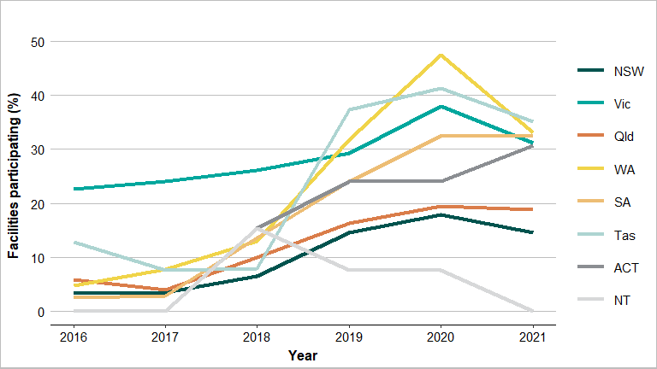

Sources: 1. Facility form (Appendix 1) and 2. Aged Care service list: 2016 to 2021, Australian Institute of Health and Welfare (AIHW) GEN Aged Care Data.

Participation within each of the 3 provider groups varied: government (55.4%), not for profit (25.0%) and private (8.3%) (Figure 2 and Appendix 3: Tables A1 and A2). The government group included 120 public aged care facilities in Victoria that, as previously noted, were required by their state government to participate.

Figure 2: Percentage of participating facilities by provider type, Aged Care NAPS contributors, 2016–2021

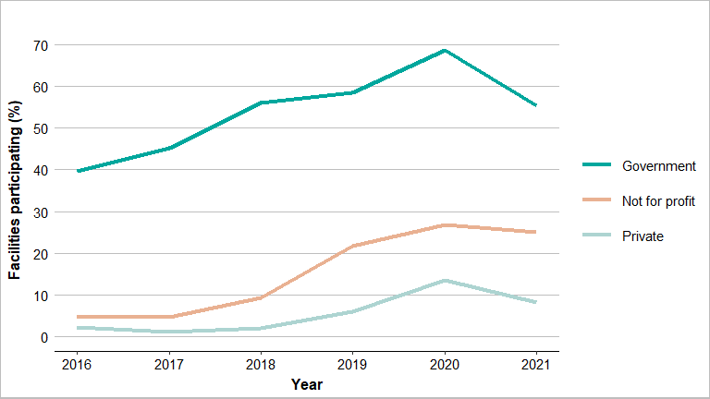

Sources: 1. Facility form (Appendix 1) and 2. Aged Care service list: 2016 to 2021, AIHW GEN Aged Care Data.

Compared to 2020, fewer aged care facilities participated in the 2021 Aged Care NAPS. It is highly likely this decline was due to the ongoing significant workload in aged care facilities associated with the response to the COVID-19 pandemic15 and increased reporting requirements for other initiatives (e.g., the National Aged Care Mandatory Quality Indicator Program).16

## 3.2 Prevalence of infections and antimicrobial use

In comparison to previous years, the prevalence of residents who had signs and/or symptoms of at least one suspected infection on the survey day remained constant, whereas those prescribed at least one antimicrobial notably increased. In 2021 the prevalence of residents who had signs and/or symptoms of at least one suspected infection on the survey day was 3.1% (n=1,248). The prevalence of residents prescribed at least one antimicrobial on the survey day was 13.7% (n=5,555). If all topical antimicrobials or if all PRN orders not administered in the last 7 days were excluded, the prevalence of residents prescribed at least one antimicrobial on the survey day was 6.4% (n=2,577) and 9.4% (n=3,810) respectively (Figure 3 and Appendix 3: Table A4).

Figure 3: Prevalence of suspected infections and antimicrobial use on the survey day, Aged Care NAPS contributors, 2016–2021

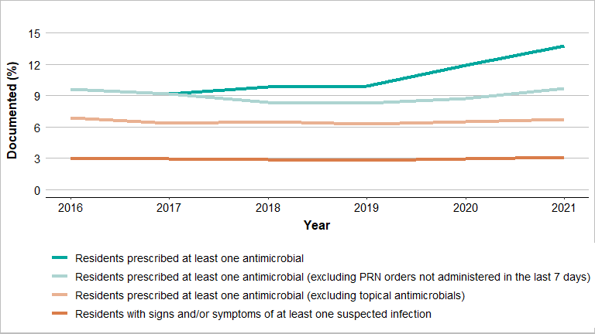

Sources: 1. Facility form (Appendix 1) and 2: Antimicrobial and infection form (Appendix 2).PRN = pro re nata (as required).

For the 337 facilities that participated annually from 2019 to 2021, there was no observable notable change in the prevalence of residents with signs and/or symptoms of at least one suspected infection on the survey day. However, there was an increase in the prevalence of residents prescribed one or more antimicrobials (Figure 4 and Appendix 3: Table A5).

Figure 4: Prevalence of suspected infections and antimicrobial use on the survey day for facilities that have participated annually, Aged Care NAPS contributors, 2019–2021

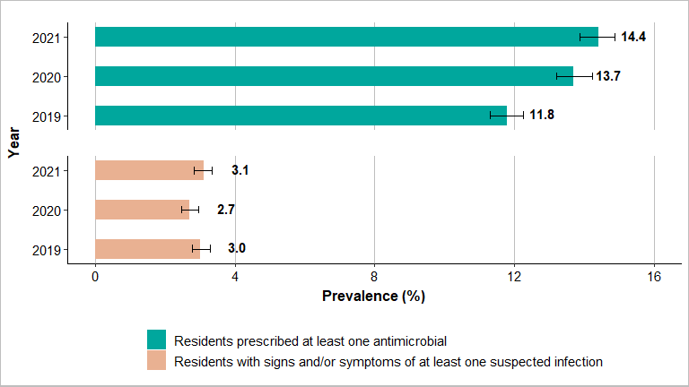

Sources: 1. Facility form (Appendix 1) and 2: Antimicrobial and infection form (Appendix 2).

## 3.3 Suspected infections on the survey day

Older people are especially vulnerable to infections and may not have typical signs and symptoms of infection.17 In the 2021 Aged Care NAPS, a total of 1,248 residents were reported to have a total of 1,296 suspected infections on the survey day. Suspected skin or soft tissue (52.6%), urinary tract (22.1%) and respiratory tract (11.8%) infections were most commonly reported. About one-third (33.3%) met the McGeer et al. infection surveillance definitions (Table 1).

Table 1: Number and percentage of suspected infections by body system, Aged Care NAPS contributors, 2021

|  |  |  |  |  |  |  |  |  |
| --- | --- | --- | --- | --- | --- | --- | --- | --- |
| Body system | Suspected infections | | Suspected infections that met McGeer et al. definition | | ACF associated suspected infections | | ACF associated suspected infections that met McGeer et al. definition | |
| No. | % | No. | % | No. | % | No. | % |
| Skin/soft tissue | 682 | 52.6 | 237 | 34.8 | 668 | 52.7 | 233 | 34.9 |
| Respiratory tract | 153 | 11.8 | 36 | 23.5 | 149 | 11.8 | 36 | 24.2 |
| Urinary tract | 287 | 22.1 | 25 | 8.7 | 278 | 21.9 | 25 | 9.0 |
| Eye | 80 | 6.2 | 66 | 82.5 | 79 | 6.2 | 66 | 83.5 |
| Oral | 31 | 2.4 | 4 | 12.9 | 31 | 2.4 | 4 | 12.9 |
| Other systems | 63 | 4.9 | 63 | 100 | 62 | 4.9 | 62 | 100 |
| Total | 1,296 | 100 | 431 | 33.3 | 1,267 | 100 | 426 | 33.6 |

Source: Antimicrobial and infection form Section 5, Method 1 data (Appendix 2).

ACF = aged care facility (aged care home or multipurpose service). ACF associated suspected infection = infection that developed in resident 48 hours post (re)admission.

## 3.4 Antimicrobial use

Antimicrobial use data collected by both Method 1 and Method 2 were combined for the analyses presented in this section, unless otherwise stated. The unit of analysis is antimicrobial prescriptions.

A total of 6,477 residents were prescribed 7,633 antimicrobials (excluding methenamine hippurate), of which 6,357 were still prescribed on the survey day; 1,276 antimicrobials had been prescribed during the previous month but ceased prior to the survey day.

## 3.5 Adverse events

A total of 1,501 residents prescribed an antimicrobial had a documented history of an adverse reaction to one or more antimicrobials. The most common antimicrobials (class) for which an adverse reaction was reported were penicillins (35.5%), trimethoprim (9.4%) and cefalexin (8.1%).

## 3.6 Duration

In general, the shortest possible duration of therapy, consistent with the condition being treated and the resident’s clinical response, should be used. Prolonged duration of antimicrobial therapy is associated with an increased risk of adverse outcomes including antimicrobial resistance.18

The start date was unknown for 1.9% (n*=*143) of the antimicrobial prescriptions. Of antimicrobials still prescribed on the survey day, 42.1% (n=2,679) were commenced more than 6 months prior. The most common antimicrobials in this category were clotrimazole (43.1%), cefalexin (11.9%) and Ketacomb® (6.6%). Of antimicrobials still prescribed on the survey day that had a known start date and were prescribed less than 6 months prior to the survey day, 31.2% (n=1,985) had been commenced more than 7 days prior to the survey day.

## 3.7 Most commonly prescribed antimicrobials

Most antimicrobials were prescribed for oral (n=3,869, 50.7%) or topical (n=3,693, 48.4%) administration. About one-fifth (n=1,701, 22.3%) of prescriptions were for prophylactic use. As in previous surveys, clotrimazole (n=2,160, 28.3%) and cefalexin (n=1,393, 18.2%) were the most frequently prescribed antimicrobials (Figure 5 and Appendix 3: Table A6).

Figure 5: Most commonly prescribed antimicrobials, Aged Care NAPS contributors, 2019–2021

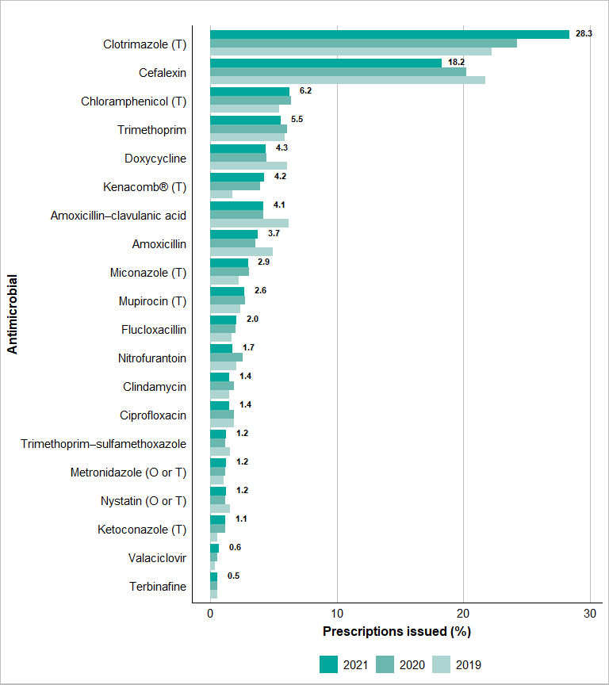

Source: Antimicrobial and infection form Section 2, Method 1 and 2 data (Appendix 2).

Only the top 20 antimicrobials prescribed are listed (excluding methenamine hippurate).

Denominator = all antimicrobials prescribed (n=7,633).

O = oral; T = topical.

Kenacomb® contains triamcinolone, neomycin, nystatin and gramicidin.

It is probable that many of the clotrimazole prescriptions were combination topical antifungal and corticosteroid preparations such as Hydrozole®. These combination products should only be used until inflammation subsides and then replaced with an antifungal alone to complete the treatment. This is to avoid complications of prolonged corticosteroid use such as thinning of the skin.

Cefalexin (60.9%) and clotrimazole (89.3%) were most commonly prescribed for therapeutic use (Table 2).

Table 2: Cefalexin and clotrimazole prescriptions, therapeutic and prophylactic use, Aged Care NAPS contributors, 2021

|  |  |  |  |  |  |  |
| --- | --- | --- | --- | --- | --- | --- |
| Antimicrobial | Category | No. | % | % of therapeutic prescriptions (n=5,932) | % of prophylactic prescriptions (n=1,701) | % of total prescriptions (n=7,633) |
| Cefalexin (n=1,393) | Therapeutic | 848 | 60.9 | 14.3 | – | 11.1 |
| Prophylactic | 545 | 39.1 | – | 32.0 | 7.1 |
| Clotrimazole (n=2,160) | Therapeutic | 1,929 | 89.3 | 32.5 | – | 25.3 |
| Prophylactic | 231 | 10.7 | – | 13.6 | 3.0 |

Source: Antimicrobial and infection form Section 2, Method 1 and 2 data (Appendix 2).

PRN prescribing of antimicrobials is not recommended as it encourages sporadic use, which may be harmful and ineffective. Clinical review of residents by the prescriber may be reduced if PRN antimicrobials are periodically administered without their knowledge.

Just over one-third (n=2,232, 35.1%) of antimicrobials still prescribed on the survey day (n=6,357) were for PRN administration; the majority of these (n=2,060, 92.3%) were topical antimicrobials, most commonly clotrimazole (n=1,455, 65.2%). Furthermore, approximately 3 in 10 (n=644, 28.9%) had been prescribed for durations of between one week and 6 months. Of those administered on the survey day or in the 6 days prior, there was an approximate 0.1% reduction from 2020 to 2021 (Table 3).

Table 3: Antimicrobials prescribed for PRN administration, duration of prescription and administration on the survey day or in the 6 days prior, Aged Care NAPS contributors, 2020–2021

|  |  |  |  |  |  |  |
| --- | --- | --- | --- | --- | --- | --- |
| Duration of prescription | 2020 | | | 2021 | | |
| Number of antimicrobials prescribed for PRN administration | Administration on survey day or 6 days prior | | Number of antimicrobials prescribed for PRN administration | Administration on survey day or 6 days prior | |
| No. | % | No. | % |
| Less than 1 week | 48 | 18 | 37.5 | 62 | 28 | 45.2 |
| 1 week – 6 months | 629 | 70 | 11.1 | 644 | 72 | 11.2 |
| Greater than 6 months | 1,376 | 85 | 6.2 | 1,485 | 82 | 5.5 |
| Unknown | 38 | 2 | 5.3 | 41 | 4 | 9.8 |
| Total | 2,091 | 175 | 8.4 | 2,232 | 186 | 8.3 |

Source: Antimicrobial and infection form Section 2, ‘Still prescribed today’, antimicrobial prescriptions only (Appendix 2).

PRN = pro re nata.

## 3.8 Quality indicators

Complete and accurate documentation ensures that all those involved in resident care have access to consistent and current information. For example, when a resident is prescribed an antimicrobial, the indication, active ingredient, dose, frequency and route of administration, and the intended duration or review plan should be documented in their healthcare record. Where electronic healthcare records are being used, flags and reminders in the record management system can be incorporated to support documentation in all relevant fields.19 Use of paper or electronic medication charts that are consistent with the Australian Commission on Safety and Quality in Health Care (ACSQHC) National Residential Medication Chart is recommended.20

In 2021 compared to 2020 (76.4%) there was a decrease in the percentage of antimicrobial prescriptions (n=5,610, 73.5%) that had a documented indication for prescribing an antimicrobial. At the same time, compared to 2020 (45.7%) there was a decrease in the percentage of antimicrobial prescriptions (n=3,414, 44.7%) that had a documented review or stop date (Figure 6 and Appendix 3: Table A7).

Figure 6: Key quality indicators for all participating facilities, Aged Care NAPS contributors, 2016–2021

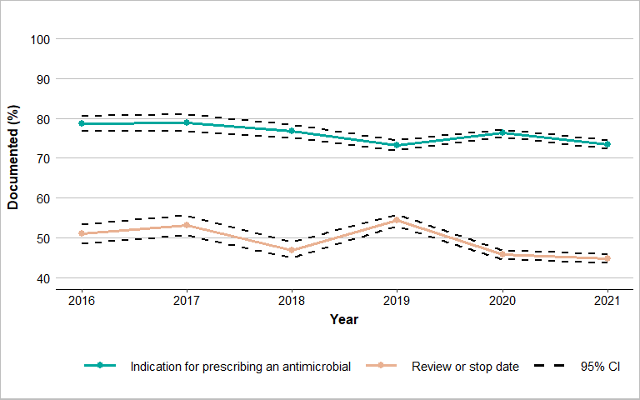

Source: Antimicrobial and infection form Section 2, Method 1 and 2 data (Appendix 2).

CI = confidence interval.

For the 337 facilities that participated annually from 2019 to 2021, in the last year, there was a decrease in the documentation of an indication for prescribing an antimicrobial (n=2,450, 73.5%) and a slight increase in the recording of the review or stop date (n=1,342, 40.2%) (Figure 7 and Appendix 3: Table A8).

Figure 7: Key quality indicators for facilities that have participated annually, Aged Care NAPS contributors, 2019–2021

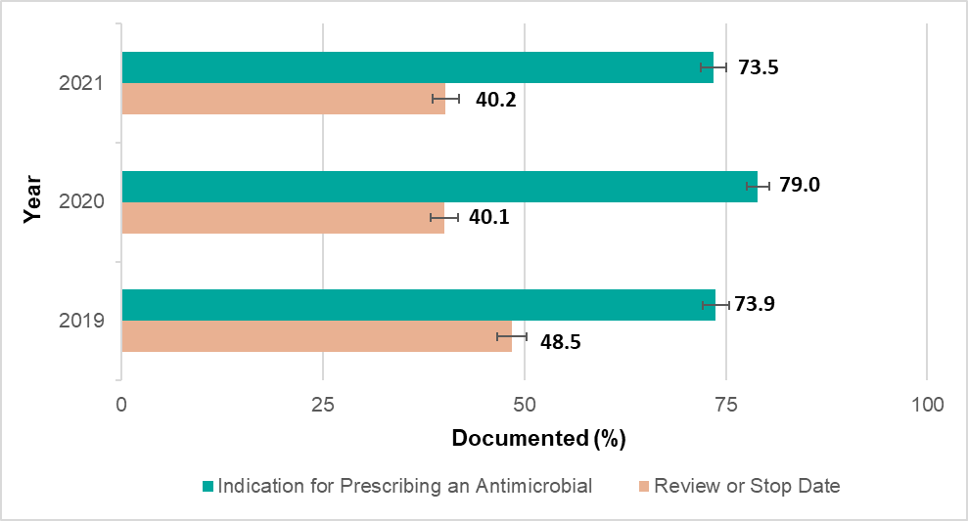

Source: Antimicrobial and infection form Section 2, Method 1 and 2 data (Appendix 2).

## 3.9 Common indications for prescribing antimicrobials

The top 5 known indications for prescribing antimicrobials were other – skin, soft tissue or mucosal; cystitis; tinea; wound infection (non-surgical); and cellulitis (Figure 8 and Appendix 3: Table A9). There were no prescriptions where the indication was reported as unknown.

Figure 8: Most common indications for antimicrobial prescriptions, Aged Care NAPS contributors, 2019–2021

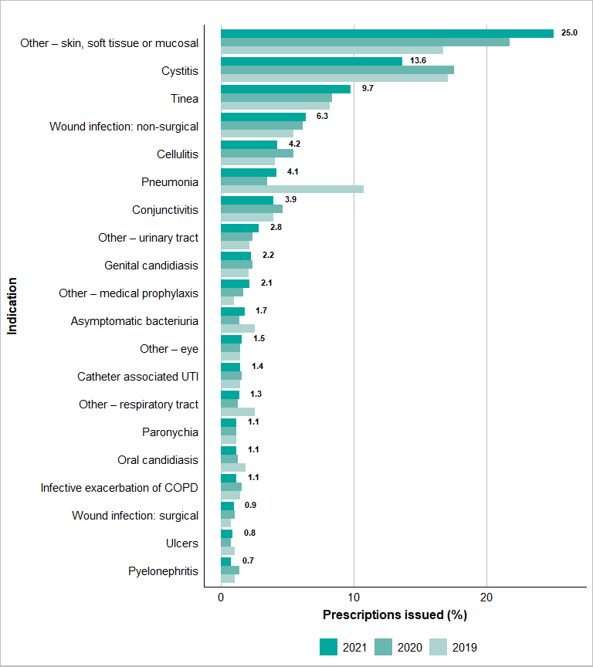

Source: Antimicrobial and infection form Section 2, Method 1 and 2 data (Appendix 2).

Only the top 20 indications for antimicrobial prescriptions are listed.

Unknown indications for commencing an antimicrobial are excluded.

UTI = urinary tract infection; COPD = chronic obstructive pulmonary disease.

Antimicrobials were consistently and most commonly prescribed for prophylactic indications associated with the urinary tract. In 2021, over one-third of the 1,701 prophylactic prescriptions were for cystitis (21.3%); other – urinary tract (8.7%); asymptomatic bacteriuria (4.1%); and catheter-associated urinary tract infection (1.5%) (Figure 9 and Appendix 3: Table A10).

Figure 9: Most common prophylactic indications for antimicrobial prescriptions, Aged Care NAPS contributors, 2019–2021

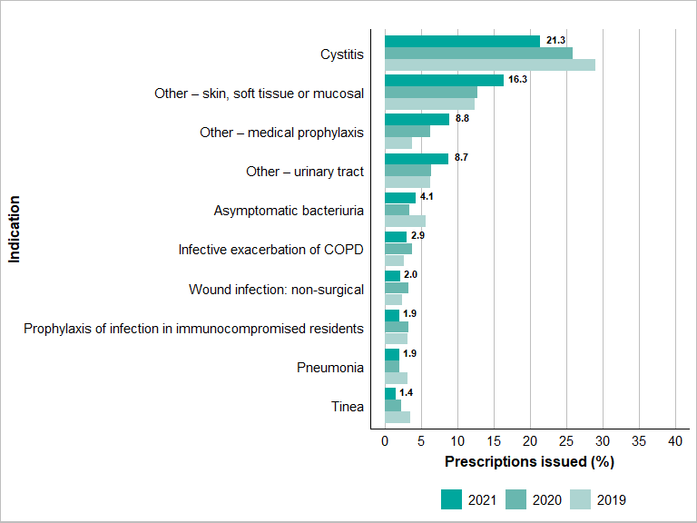

Source: Antimicrobial and infection form Section 2, Method 1 and 2 data (Appendix 2).

Only the top 10 indications for prophylactic antimicrobial prescriptions are listed.

Unknown indications for commencing an antimicrobial are excluded.

COPD = chronic obstructive pulmonary disease.

Prophylactic antimicrobial therapy for urinary tract infections (UTIs) should only be (re)considered when the resident has been diagnosed with confirmed recurrent UTIs based on consistent clinical and microbiological criteria; non-antimicrobial strategies (e.g., dehydration correction) have been trialled; the benefit of the therapy outweighs any potential adverse effects or harm (e.g., candidiasis); and advance care plans have been checked to ensure therapy is consistent with the expressed goals of the resident. Patient-initiated treatment (antimicrobials taken at the onset of symptoms) instead of continuous prophylactic therapy may reduce overall use.18

For cystitis, just under two-thirds of the antimicrobials prescribed (n=1,039) were for therapeutic (n=676, 65.1%) indications (Figure 10 and Appendix 3: Table A11).

Figure 10: Comparison of therapeutic and prophylactic antimicrobial prescriptions for common indications, Aged Care NAPS contributors, 2021

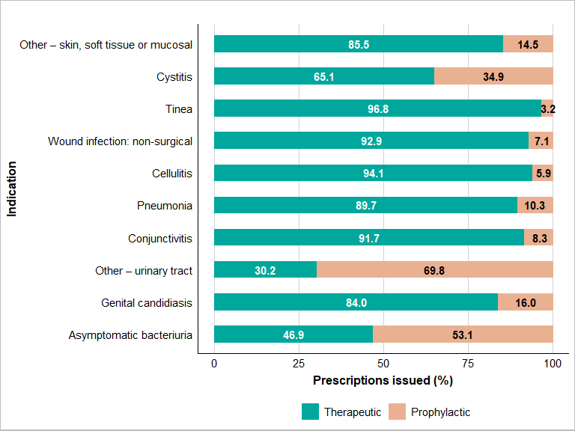

Source: Antimicrobial and infection form Section 2, Method 1 and 2 data (Appendix 2).

Only the top 10 indications for prophylactic antimicrobial prescriptions are listed.

Medical prophylaxis and unknown indications for commencing an antimicrobial are excluded.

## 3.10 Most commonly prescribed antimicrobials for common indications

The most commonly prescribed antimicrobials for cystitis, tinea and wound infection (non-surgical) were cefalexin (47.4%), clotrimazole (79.3%) and cefalexin (29.1%) respectively (Table 4).

Table 4: Commonly prescribed antimicrobials for cystitis, tinea and wound infection (non-surgical), Aged Care NAPS contributors, 2021

|  |  |  |  |  |  |  |  |  |
| --- | --- | --- | --- | --- | --- | --- | --- | --- |
| Cystitis (n=1,039) | | | Tinea (n=739) | | | Wound infection: non-surgical (n=478) | | |
| Antimicrobial | No. | % | Antimicrobial | No. | % | Antimicrobial | No. | % |
| Cefalexin | 492 | 47.4 | Clotrimazole | 586 | 79.3 | Cefalexin | 139 | 29.1 |
| Trimethoprim | 295 | 28.4 | Miconazole | 76 | 10.3 | Mupirocin | 72 | 15.1 |
| Nitrofurantoin | 86 | 8.3 | Ketoconazole | 18 | 2.4 | Kenacomb® | 43 | 9.0 |
| Amoxicillin–clavulanic acid | 52 | 5.0 | Terbinafine | 15 | 2.0 | Flucloxacillin | 38 | 7.9 |
| Amoxicillin | 35 | 3.4 | Kenacomb® | 15 | 2.0 | Doxycycline | 30 | 6.3 |

Source: Antimicrobial and infection form Section 2, Method 1 and 2 data (Appendix 2).

## 3.11 Microbiology

A microbiology specimen was collected for about-one quarter (23.8%) of antimicrobial prescriptions where the start date was known and less than 6 months prior to the survey date. The time frame for the collection of this specimen was on the antimicrobial start date or in the 6 days before or 3 days after the antimicrobial start date (Table 5).

Table 5: Microbiology specimen collection, Aged Care NAPS contributors, 2021

|  |  |  |
| --- | --- | --- |
| Category | No. | % |
| Collected | 1,134 | 23.8 |
| Not collected | 3,636 | 76.2 |
| Total | 4,770 | 100 |
| Skin/wound swab | 262 | 23.1 |
| Urine | 734 | 64.7 |
| Sputum | 36 | 3.2 |
| Respiratory swab | 74 | 6.5 |
| Other | 56 | 4.9 |

Source: Antimicrobial and infection form Section 4, Method 1 and 2 data (Appendix 2).

# 4 Conclusion

In 2021, about one quarter (n=689) of Australian aged care facilities completed the Aged Care NAPS at least once during the official 7-month time frame; since 2019 about half (n=337) of these facilities had participated annually. This level of participation indicates the value of participating in a national standardised survey that enables monitoring and benchmarking of infections and antimicrobial use. Findings can be used to improve resident outcomes and help facilities meet Aged Care Quality Standards 3(3)(g) and 8(3)(e).

The 2021 Aged Care NAPS identified issues in relation to infections and antimicrobial use that were similar to those identified in previous annual surveys, including:

* high numbers of suspected skin and soft tissue, urinary tract and respiratory tract infections
* high prevalence of residents prescribed at least one antimicrobial; this includes those residing in facilities that have consistently participated in the Aged Care NAPS
* prolonged duration of antimicrobial prescriptions
* extensive prescribing of topical antimicrobials, especially clotrimazole
* frequent prescribing of pro re nata antimicrobials
* continuous prophylactic antimicrobial therapy, especially for urinary tract infections
* incomplete documentation of indication and review and stop dates.

The seriousness and consistency of the identified issues reinforce the need for aged care facilities to develop and implement **effective** IPC and AMS programs that will lead to improvements in resident safety. There are nationally accepted guidelines that facilities should reference and use, such as the Australian Guidelines for the Prevention and Control of Infection,21 Therapeutic Guidelines: Antibiotic2 and AMS Clinical Care Standard.3 The Aged Care Quality and Safety Commission and the ACSQHC have both published strategies that specifically support IPC and AMS in aged care facilities.22,23 The NCAS and VICNISS provide a range of useful educational resources accessible via their websites.24,25

As of early 2021, all aged care facilities must have employed one or more trained IPC Leads.26 It is expected these IPC Leads will play a pivotal role in supporting their facility’s IPC and AMS programs. In one 70-bed aged care facility (Appendix 4) the IPC Lead was prompted by the facility’s Aged Care NAPS report to initiate AMS strategies to investigate and improve Hydrozole® use; this included developing a toolbox to assist clinical staff with optimal skin care of susceptible residents. Following implementation of these strategies, inappropriate Hydrozole® use notably decreased.

Alongside on-site and visiting staff, residents and their carers should be actively engaged too. The possibility of direct communication via a national newsletter, for example, is to be explored. Residents have the right to influence how their care and services (IPC and AMS strategies included) are delivered.12

# Appendix 1: Facility form

(Previously ‘Aged care home form’)

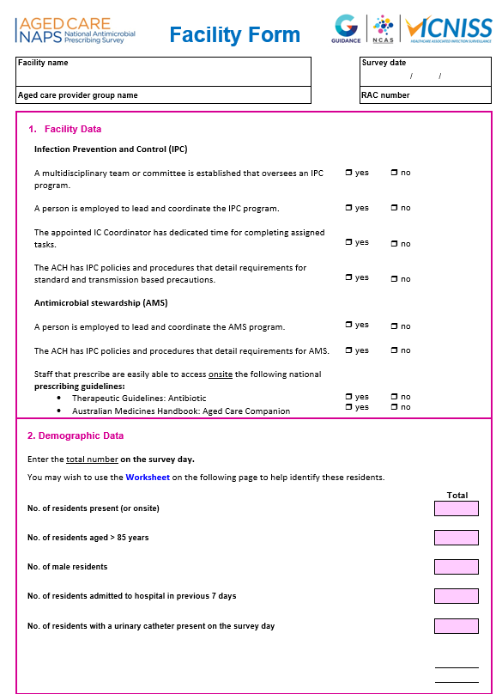

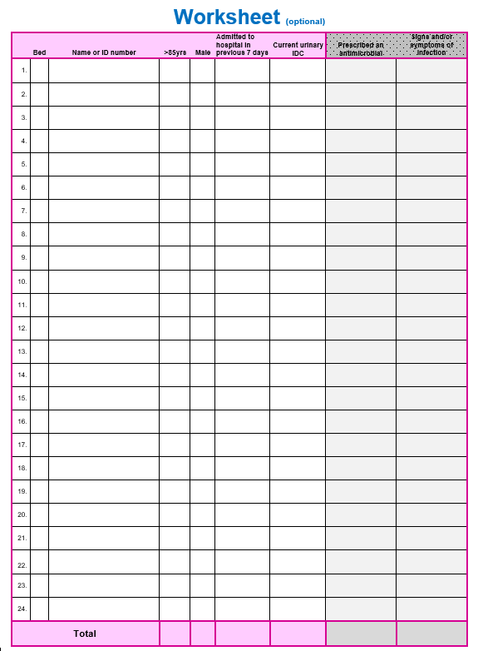

# Appendix 2: Antimicrobial and infection form

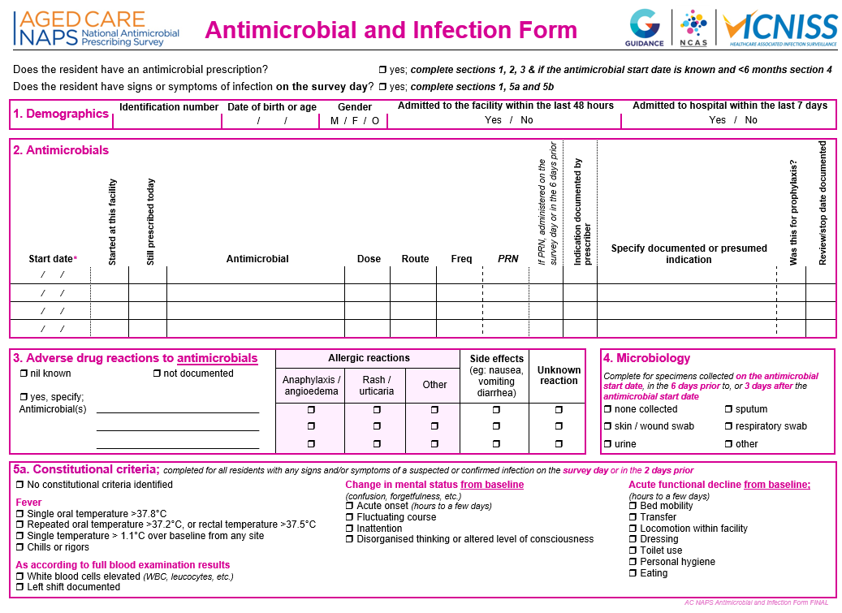

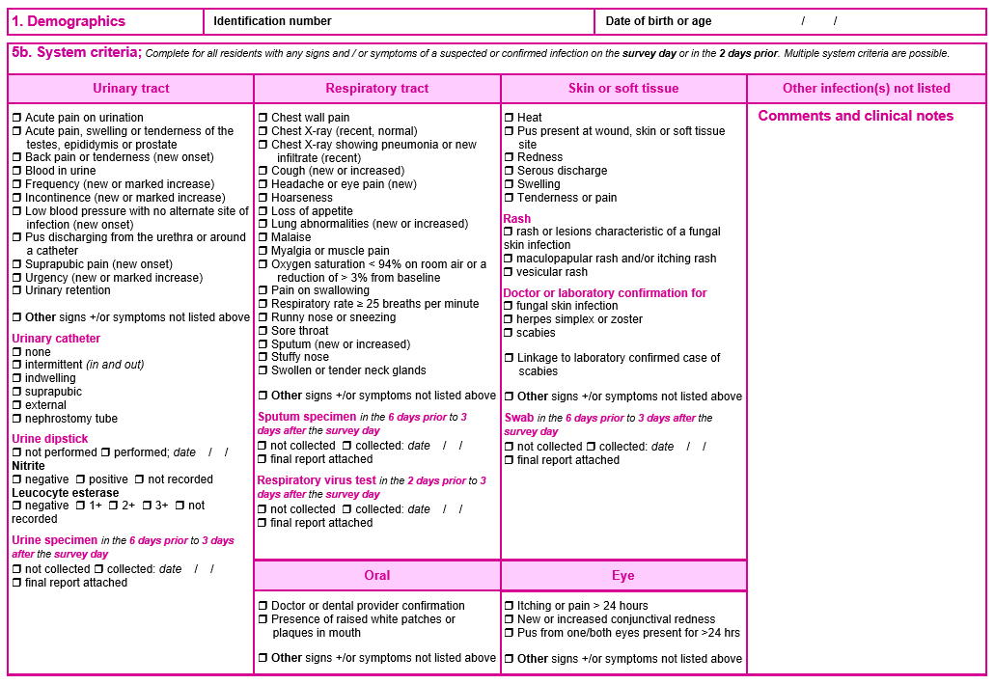

# Appendix 3: Additional data on infections and antimicrobials

Table A1: Facilities by state, remoteness area classification and provider type, Aged Care NAPS contributors, 2021

|  |  |  |  |  |  |  |
| --- | --- | --- | --- | --- | --- | --- |
| Category | | Residents audited | Participating facilities | | Facilities in reporting group | Participating facilities in reporting group |
| No. | No. | % | No. | % |
| State and territory | ACT | 910 | 8 | 1.2 | 26 | 30.8 |
| NSW | 7,394 | 136 | 19.7 | 934 | 14.6 |
| NT | 0 | 0 | 0.0 | 13 | 0.0 |
| Qld | 6,932 | 97 | 14.1 | 513 | 18.9 |
| SA | 5,335 | 87 | 12.6 | 267 | 32.6 |
| Tas | 1,771 | 26 | 3.8 | 74 | 35.1 |
| Vic | 12,443 | 240 | 34.8 | 769 | 31.2 |
| WA | 5,685 | 95 | 13.8 | 287 | 33.1 |
| Remoteness | Major cities | 24,332 | 313 | 45.4 | 1,694 | 18.5 |
| Inner regional | 11,202 | 208 | 30.2 | 674 | 30.9 |
| Outer regional | 4,463 | 137 | 19.9 | 402 | 33.8 |
| Remote | 342 | 24 | 3.5 | 73 | 34.2 |
| Very remote | 131 | 7 | 1.0 | 40 | 17.5 |
| Provider type | Not for profit | 28,983 | 385 | 55.9 | 1,542 | 25.0 |
| Private | 5,787 | 77 | 11.2 | 931 | 8.3 |
| Government | 5,700 | 227 | 32.9 | 410 | 55.4 |
| Total | | 40,470 | 689 | 100 | 2,883 | 23.9 |

Sources: 1. Facility form and 2. Aged care service list: 30 June 2021 AIHW GEN Aged Care Data.

See Figures 1 and 2 for graphical presentation.

Transition care, innovative pool, national Aboriginal and Torres Strait Islander and short-term restorative care services are excluded.

Table A2: Participating facilities by state/territory and provider type, Aged Care NAPS contributors, 2016–2020

|  |  |  |  |  |  |  |  |  |  |  |  |  |  |  |  |  |  |
| --- | --- | --- | --- | --- | --- | --- | --- | --- | --- | --- | --- | --- | --- | --- | --- | --- | --- |
| Category | | 2016 | | | | 2017 | | | 2018 | | | 2019 | | | 2020 | | |
| No. of PF | | No. of facilities in RG | % of PF in RG | No. of PF | No. of facilities in RG | % of PF in RG | No. of PF | No. of facilities in RG | % of PF in RG | No. of PF | No. of facilities in RG | % of PF in RG | No. of PF | No. of facilities in RG | % of PF in RG |
| State and territory | ACT | | 0 | 26 | 0.0 | 0 | 26 | 0.0 | 4 | 26 | 15.4 | 6 | 25 | 24.0 | 6 | 25 | 24.0 |
| NSW | | 32 | 935 | 3.4 | 33 | 944 | 3.5 | 62 | 946 | 6.6 | 137 | 943 | 14.5 | 170 | 946 | 18.0 |
| NT | | 0 | 13 | 0.0 | 0 | 13 | 0.0 | 2 | 13 | 15.4 | 1 | 13 | 7.7 | 1 | 13 | 7.7 |
| Qld | | 28 | 477 | 5.9 | 19 | 479 | 4.0 | 49 | 490 | 10.0 | 82 | 503 | 16.3 | 99 | 509 | 19.4 |
| SA | | 7 | 279 | 2.5 | 8 | 272 | 2.9 | 37 | 272 | 13.6 | 66 | 275 | 24.0 | 88 | 271 | 32.5 |
| Tas | | 10 | 78 | 12.8 | 6 | 78 | 7.7 | 6 | 76 | 7.9 | 28 | 75 | 37.3 | 31 | 75 | 41.3 |
| Vic | | 172 | 761 | 22.6 | 184 | 767 | 24.0 | 201 | 771 | 26.1 | 228 | 779 | 29.3 | 295 | 777 | 38.0 |
| WA | | 13 | 276 | 4.7 | 21 | 271 | 7.7 | 36 | 278 | 12.9 | 90 | 283 | 31.8 | 135 | 284 | 47.5 |
| Provider type | Not for profit | | 74 | 1,560 | 4.7 | 71 | 1,552 | 4.6 | 145 | 1,552 | 9.3 | 340 | 1,562 | 21.8 | 416 | 1,556 | 26.7 |
| Private | | 20 | 862 | 2.3 | 10 | 878 | 1.1 | 19 | 904 | 2.1 | 56 | 920 | 6.1 | 127 | 933 | 13.6 |
| Government | | 168 | 423 | 39.7 | 190 | 420 | 45.2 | 233 | 416 | 56.0 | 242 | 414 | 58.5 | 282 | 411 | 68.6 |
| Total | | | 262 | 2,845 | 9.2 | 271 | 2,850 | 9.5 | 397 | 2,872 | 13.8 | 638 | 2,896 | 22.0 | 825 | 2,900 | 28.4 |

Sources: 1. Facility form and 2. Aged care service list: 2016 to 2020 AIHW GEN Aged Care Data.

See Figures 1 and 2 for graphical presentation.

PF = participating facilities; RG = reporting group.

See Table A1 for 2021 data.

Table A3: Number and characteristics of all residents on the survey day, Aged Care NAPS contributors, 2016–2021

|  |  |  |  |  |  |  |  |  |  |  |  |  |
| --- | --- | --- | --- | --- | --- | --- | --- | --- | --- | --- | --- | --- |
| Measurement | 2016 | | 2017 | | 2018 | | 2019 | | 2020 | | 2021 | |
| No. | % | No. | % | No. | % | No. | % | No. | % | No. | % |
| Present on survey day | 12,599 | – | 11,418 | – | 19,443 | – | 35,271 | – | 47,144 | – | 40,470 | – |
| Aged >85 years | 6,846 | 54.3 | 6,540 | 57.3 | 11,544 | 59.4 | 20,597 | 58.4 | 27,339 | 58.0 | 23,659 | 58.5 |
| Male | 4,216 | 33.5 | 3,867 | 33.9 | 6,364 | 32.7 | 11,376 | 32.3 | 15,240 | 32.3 | 13,457 | 33.3 |
| Admitted to hospital in previous 7 days | 0 | 0 | 0 | 0 | 1 | 0.0 | 3 | 0.0 | 725 | 1.5 | 711 | 1.8 |
| Indwelling urinary catheter present | 489 | 3.9 | 407 | 3.6 | 732 | 3.8 | 1,270 | 3.6 | 1,652 | 3.5 | 1,449 | 3.6 |

Source: Facility form.

Table A4: Prevalence of suspected infections and antimicrobial use on the survey day, Aged Care NAPS contributors, 2016–2021

|  |  |  |  |  |  |  |  |  |  |  |  |  |
| --- | --- | --- | --- | --- | --- | --- | --- | --- | --- | --- | --- | --- |
| On survey day | 2016 | | 2017 | | 2018 | | 2019 | | 2020 | | 2021 | |
| No. | % | No. | % | No. | % | No. | % | No. | % | No. | % |
| Residents prescribed at least one antimicrobial | 1,207 | 9.6 | 1,047 | 9.2 | 1,913 | 9.8 | 3,499 | 9.9 | 5,601 | 11.9 | 5,555 | 13.7 |
| Residents prescribed at least one antimicrobial (excluding PRN orders not administered in the last 7 days) | 1,207 | 9.6 | 1,047 | 9.2 | 1,593 | 8.2 | 2,873 | 8.1 | 3,999 | 8.5 | 3,810 | 9.4 |
| Residents prescribed at least one antimicrobial (excluding topical antimicrobials) | 838 | 6.7 | 692 | 6.1 | 1,207 | 6.2 | 2,124 | 6.0 | 2,870 | 6.1 | 2,577 | 6.4 |
| Residents with signs and/or symptoms of at least one suspected infection | 384 | 3.0 | 334 | 2.9 | 561 | 2.9 | 982 | 2.8 | 1,371 | 2.9 | 1,248 | 3.1 |
| Residents with signs and/or symptoms of at least one ACF associated suspected infection | – | – | – | – | – | – | – | – | – | – | 1,222 | 3.0 |
| Number of residents present | 12,599 | – | 11,418 | – | 19,443 | – | 35,271 | – | 47,144 | – | 40,470 | – |

Sources: 1. Facility form and 2: Antimicrobial and infection form.

See Figure 3 for graphical presentation.

PRN = pro re nata.

ACF = aged care facility (aged care home or multipurpose service). ACF associated suspected infection = infection that developed in resident 48 hours post (re)admission.

Table A5: Prevalence of suspected infections and antimicrobial use on the survey day for facilities that have participated annually, Aged Care NAPS contributors, 2019–2021*

|  |  |  |  |  |  |  |  |  |  |
| --- | --- | --- | --- | --- | --- | --- | --- | --- | --- |
| On survey day | 2019 | | | 2020 | | | 2021 | | |
| No. | % | 95% CI | No. | % | 95% CI | No. | % | 95% CI |
| Residents prescribed at least one antimicrobial | 2,128 | 11.8 | 11.3 – 12.2 | 2,498 | 13.7 | 13.2 – 14.2 | 2,626 | 14.4 | 13.9 – 14.9 |
| Residents prescribed at least one antimicrobial (excluding topicals) | 1,231 | 6.8 | 6.4 – 7.2 | 1,182 | 6.5 | 6.1 – 6.9 | 1,211 | 6.6 | 6.3 – 7 |
| Residents with signs and/or symptoms of at least one suspected infection | 549 | 3.0 | 2.8 – 3.3 | 493 | 2.7 | 2.5 – 3 | 562 | 3.1 | 2.8 – 3.3 |
| Residents with signs and/or symptoms of at least one ACF associated suspected infection | – | – | – | – | – | – | 542 | 3.0 | 2.7 – 3.2 |
| Number of residents present | 18,090 | – | – | 18,223 | – | – | 18,283 | – | – |

Sources:1 Facility form (Appendix 1) and 2: Antimicrobial and infection form (Appendix 2).

See Figure 4 for graphical presentation.

* 337 aged care facilities participated annually between 2019 and 2021.

CI = confidence interval.

ACF = aged care facility (aged care home or multipurpose service). ACF associated suspected infection = infection that developed in resident 48 hours post (re)admission.

Table A6: Most commonly prescribed antimicrobials, Aged Care NAPS contributors, 2019–2021

|  |  |  |  |  |  |  |
| --- | --- | --- | --- | --- | --- | --- |
| Antimicrobial | 2019 (n=4,619) | | 2020 (n=7,571) | | 2021 (n=7,633) | |
| No. | % | No. | % | No. | % |
| Clotrimazole (T) | 1,025 | 22.2 | 1,832 | 24.2 | 2,160 | 28.3 |
| Cefalexin | 1,002 | 21.7 | 1,531 | 20.2 | 1,393 | 18.2 |
| Chloramphenicol (T) | 249 | 5.4 | 480 | 6.3 | 477 | 6.2 |
| Trimethoprim | 269 | 5.8 | 458 | 6.0 | 421 | 5.5 |
| Doxycycline | 275 | 6.0 | 332 | 4.4 | 331 | 4.3 |
| Kenacomb® (T) | 77 | 1.7 | 292 | 3.9 | 321 | 4.2 |
| Amoxicillin–­clavulanic acid | 281 | 6.1 | 307 | 4.1 | 312 | 4.1 |
| Amoxicillin | 228 | 4.9 | 263 | 3.5 | 280 | 3.7 |
| Miconazole (T) | 102 | 2.2 | 228 | 3.0 | 219 | 2.9 |
| Mupirocin (T) | 105 | 2.3 | 201 | 2.7 | 200 | 2.6 |
| Flucloxacillin | 76 | 1.6 | 146 | 1.9 | 156 | 2.0 |
| Nitrofurantoin | 91 | 2.0 | 188 | 2.5 | 130 | 1.7 |
| Ciprofloxacin | 85 | 1.8 | 140 | 1.8 | 109 | 1.4 |
| Clindamycin | 65 | 1.4 | 137 | 1.8 | 109 | 1.4 |
| Trimethoprim–sulfamethoxazole | 68 | 1.5 | 87 | 1.1 | 94 | 1.2 |
| Metronidazole (O or T) | 45 | 1.0 | 80 | 1.1 | 92 | 1.2 |
| Nystatin (O or T) | 71 | 1.5 | 87 | 1.1 | 92 | 1.2 |
| Ketoconazole (T) | 22 | 0.5 | 87 | 1.1 | 83 | 1.1 |
| Valaciclovir | 13 | 0.3 | 39 | 0.5 | 44 | 0.6 |
| Terbinafine | 22 | 0.5 | 41 | 0.5 | 40 | 0.5 |

Source: Antimicrobial and infection form Section 2, Method 1 and 2 data (Appendix 2). See Figure 5 for graphical presentation.

Only the top 20 antimicrobials prescribed are listed.

O = oral; T = topical.

Kenacomb® contains triamcinolone, neomycin, nystatin and gramicidin.

Table A7: Key quality indicators for all participating facilities, Aged Care NAPS contributors, 2016–2021

|  |  |  |  |  |  |  |  |  |  |  |  |  |
| --- | --- | --- | --- | --- | --- | --- | --- | --- | --- | --- | --- | --- |
| Indicator | 2016 | | 2017 | | 2018 | | 2019 | | 2020 | | 2021 | |
| No. | % | No. | % | No. | % | No. | % | No. | % | No. | % |
| Indication for prescribing an antimicrobial | | | | | | | | | | | | |
| Documented | 1,373 | 78.7 | 1,152 | 78.9 | 1,895 | 76.8 | 3,381 | 73.2 | 5,782 | 76.4 | 5,610 | 73.5 |
| Not documented | 371 | 21.3 | 308 | 21.1 | 574 | 23.2 | 1,238 | 26.8 | 1,789 | 23.6 | 2,023 | 26.5 |
| Review or stop date | | | | | | | | | | | | |
| Documented | 888 | 50.9 | 776 | 53.2 | 1,157 | 46.9 | 2,508 | 54.3 | 3,458 | 45.7 | 3,414 | 44.7 |
| Not documented | 856 | 49.1 | 684 | 46.8 | 1,312 | 53.1 | 2,111 | 45.7 | 4,113 | 54.3 | 4,219 | 55.3 |
| Total | 1,744 | – | 1,460 | – | 2,469 | – | 4,619 | – | 7,571 | – | 7,633 | – |

Source: Antimicrobial and infection form Section 2, Method 1 and 2 data (Appendix 2).

See Figure 6 for graphical presentation.

Table A8:  Key quality indicators for facilities that have participated annually, Aged Care NAPS contributors, 2019–2021*

|  |  |  |  |  |  |  |  |  |  |
| --- | --- | --- | --- | --- | --- | --- | --- | --- | --- |
| Indicator | 2019 | | | 2020 | | | 2021 | | |
| No. | % | 95% CI | No. | % | 95% CI | No. | % | 95% CI |
| Indication for prescribing an antimicrobial | | | | | | | | |  |
| Documented | 2,064 | 73.9 | 72.2 – 75.5 | 2,583 | 79.0 | 77.6 – 80.4 | 2,450 | 73.5 | 71.9 – 75.0 |
| Not documented | 730 | 26.1 | 24.5 – 27.8 | 687 | 21.0 | 19.6 – 22.4 | 885 | 26.5 | 25.0 – 28.1 |
| Review or stop date | | | | | | | | |  |
| Documented | 1,355 | 48.5 | 46.6 – 50.4 | 1,311 | 40.1 | 38.4 - 41.8 | 1,342 | 40.2 | 38.6 – 41.9 |
| Not documented | 1,439 | 51.5 | 49.6 – 53.4 | 1,959 | 59.9 | 58.2 - 61.6 | 1,993 | 59.8 | 58.1 – 61.4 |
| Total | 2,794 | – | – | 3,270 | – | – | 3,335 | – | – |

Source: Antimicrobial and infection form Section 2, Method 1 and 2 data (Appendix 2).

See Figure 7 for graphical presentation.

* 337 aged care facilities participated annually between 2019 and 2021.

CI = confidence interval.

Table A9: Most common indications for antimicrobial prescriptions, Aged Care NAPS contributors, 2019–2021

|  |  |  |  |  |  |  |
| --- | --- | --- | --- | --- | --- | --- |
| Indication | 2019 (n=4,359) | | 2020 (n=7,571) | | 2021 (n=7,633) | |
| No. | % | No. | % | No. | % |
| Other – skin, soft tissue or mucosal | 729 | 16.7 | 1,645 | 21.7 | 1,912 | 25.0 |
| Cystitis | 742 | 17.0 | 1,323 | 17.5 | 1,039 | 13.6 |
| Tinea | 354 | 8.1 | 627 | 8.3 | 739 | 9.7 |
| Wound infection: non-surgical | 235 | 5.4 | 462 | 6.1 | 478 | 6.3 |
| Cellulitis | 174 | 4.0 | 411 | 5.4 | 320 | 4.2 |
| Pneumonia | 465 | 10.7 | 258 | 3.4 | 311 | 4.1 |
| Conjunctivitis | 171 | 3.9 | 350 | 4.6 | 301 | 3.9 |
| Other – urinary tract | 93 | 2.1 | 172 | 2.3 | 212 | 2.8 |
| Genital candidiasis | 89 | 2.0 | 174 | 2.3 | 169 | 2.2 |
| Other – medical prophylaxis | 38 | 0.9 | 122 | 1.6 | 159 | 2.1 |
| Asymptomatic bacteriuria | 108 | 2.5 | 98 | 1.3 | 130 | 1.7 |
| Other – eye | 61 | 1.4 | 107 | 1.4 | 116 | 1.5 |
| Catheter associated UTI | 63 | 1.4 | 115 | 1.5 | 104 | 1.4 |
| Other – respiratory tract | 110 | 2.5 | 93 | 1.2 | 101 | 1.3 |
| Oral candidiasis | 80 | 1.8 | 89 | 1.2 | 86 | 1.1 |
| Paronychia | 49 | 1.1 | 80 | 1.1 | 86 | 1.1 |
| Infective exacerbation of COPD | 59 | 1.4 | 113 | 1.5 | 84 | 1.1 |
| Wound infection: surgical | 31 | 0.7 | 78 | 1.0 | 69 | 0.9 |
| Ulcers | 44 | 1.0 | 55 | 0.7 | 61 | 0.8 |
| Pyelonephritis | 43 | 1.0 | 96 | 1.3 | 55 | 0.7 |

Source: Antimicrobial and infection form Section 2, Method 1 and 2 data (Appendix 2).

See Figure 8 for graphical presentation.

Only the top 20 indications for antimicrobial prescriptions are listed.

Unknown indications for commencing an antimicrobial are excluded.

UTI = urinary tract infection; COPD = chronic obstructive pulmonary disease.

Table A10: Most common prophylactic indications for antimicrobial prescriptions, Aged Care NAPS contributors, 2019–2021

|  |  |  |  |  |  |  |
| --- | --- | --- | --- | --- | --- | --- |
| Indication | 2019 (n=1,026) | | 2020 (n=1,812) | | 2021 (n=1,701) | |
| No. | % | No. | % | No. | % |
| Cystitis | 297 | 28.9 | 467 | 25.8 | 363 | 21.3 |
| Other – skin, soft tissue or mucosal | 126 | 12.3 | 228 | 12.6 | 277 | 16.3 |
| Other – medical prophylaxis | 38 | 3.7 | 111 | 6.1 | 150 | 8.8 |
| Other – urinary tract | 64 | 6.2 | 114 | 6.3 | 148 | 8.7 |
| Asymptomatic bacteriuria | 56 | 5.5 | 59 | 3.3 | 69 | 4.1 |
| Infective exacerbation of COPD | 26 | 2.5 | 67 | 3.7 | 49 | 2.9 |
| Wound infection: non-surgical | 24 | 2.3 | 58 | 3.2 | 34 | 2.0 |
| Pneumonia | 31 | 3.0 | 35 | 1.9 | 32 | 1.9 |
| Prophylaxis of infection in immunocompromised residents | 31 | 3.0 | 57 | 3.1 | 32 | 1.9 |
| Tinea | 35 | 3.4 | 40 | 2.2 | 24 | 1.4 |

Source: Antimicrobial and infection form Section 2, Method 1 and 2 data (Appendix 2).

See Figure 9 for graphical presentation.

Only the top 10 prophylactic indications for antimicrobial prescriptions are listed.

Unknown indications for commencing an antimicrobial are excluded.

COPD = chronic obstructive pulmonary disease.

Table A11: Comparison of therapeutic and prophylactic antimicrobial prescriptions for common indications, Aged Care NAPS contributors, 2021

|  |  |  |  |  |  |
| --- | --- | --- | --- | --- | --- |
| Indication | Therapeutic | | Prophylactic | | Total |
| No. | % | No. | % |
| Other – skin, soft tissue or mucosal | 1,635 | 85.5 | 277 | 14.5 | 1,912 |
| Cystitis | 676 | 65.1 | 363 | 34.9 | 1,039 |
| Tinea | 715 | 96.8 | 24 | 3.2 | 739 |
| Wound infection: non-surgical | 444 | 92.9 | 34 | 7.1 | 478 |
| Cellulitis | 301 | 94.1 | 19 | 5.9 | 320 |
| Pneumonia | 279 | 89.7 | 32 | 10.3 | 311 |
| Conjunctivitis | 276 | 91.7 | 25 | 8.3 | 301 |
| Other – urinary tract | 64 | 30.2 | 148 | 69.8 | 212 |
| Genital candidiasis | 142 | 84.0 | 27 | 16.0 | 169 |
| Asymptomatic bacteriuria | 61 | 46.9 | 69 | 53.1 | 130 |

Source: Antimicrobial and infection form Section 2, Method 1 and 2 data (Appendix 2).

See Figure 10 for graphical presentation.

Only the top 10 indications for antimicrobial prescription are listed.

Unknown and medical prophylaxis indications for commencing an antimicrobial are excluded.

# Appendix 4: Case study – improvement of topical antimicrobial use

**Blue Cross Chelsea Manor**, a 70-bed aged care home located in Victoria, has twice participated in the Aged Care NAPS (2020 and 2021). Its 2021 dashboard report highlighted an increase in topical antimicrobial use since its previous survey (50% of antimicrobial prescriptions in 2021 compared with 14% in 2020).

Notably too, it was reported that PRN or regular Hydrozole® cream had been prescribed for 7 residents. Hydrozole® contains both clotrimazole (an antifungal) and hydrocortisone (a corticosteroid). It may, for example, be prescribed for candidal infections where there is inflammation on the skin, fungal infected dermatitis, and tinea infections such as jock itch and athlete’s foot. The usual treatment is for the cream to be consistently applied for up to 7 days at the same time each day.

Prompted by the Aged Care NAPS results, the Aged Care Infection Prevention and Control (IPC) Lead, supported by her team leaders, further investigated and found:

* Residents prescribed PRN or regular Hydrozole® had a recurrent history of skin excoriation.
* Immobile residents with multiple comorbidities and fragile skin were especially prone to skin excoriation.
* There were inconsistent skin care practices for susceptible residents.
* Best care practices for effective management of skin conditions were not clear to staff.

**To improve hydrozole use, strategies commenced in September 2021 included:**

* nurses on general practitioner (GP) rounds requesting GPs cease PRN/regular Hydrozole® prescriptions
* the clinical manager discussing with GPs the residential aged care facility’s preference for not prescribing PRN Hydrozole®
* directly communicating with nurses why Hydrozole® should only be prescribed for short-term courses
* disseminating a memorandum to all clinical staff that outlined optimal skin care practices; requested that any (new) redness or inflammation be reported to team leaders (TLs) immediately; and, importantly, invited staff to share any suggestions that might improve antimicrobial prescribing
* developing a toolbox to assist clinical staff with optimal skin care of susceptible residents
* disseminating information sheets about topical antifungal use
* undertaking (and publishing) monthly medication chart audits to monitor Hydrozole® use
* promoting optimal skin care of high-risk residents at handovers.

**Results after the implementation of the initial improvement plan were:**

* Hydrozole® use significantly decreased from September 2021 onward; no resident was prescribed Hydrozole® in the month of October 2021.
* Between September 2021 and January 2022, 7 residents developed redness or inflammation; 3 were appropriately prescribed Hydrozole®.

**To sustain improvement:**

* Another toolbox has been developed
* A memorandum has been published, advising the changes in practice, including:
  + TL to physically review the skin when a personal care attendant reports any redness or inflammation of the skin
  + TL to create a task in their resident management software program for each shift for 6 days to attend to optimal skin care including washing and drying skin folds and applying barrier cream each shift
  + TL to create another task on day 6 to review the skin and determine the need for GP review if it is not improving with non-pharmacological strategies
  + GP to be requested to physically review the skin prior to prescribing short-term anti-fungal.

# Appendix 5: Abbreviations

|  |  |
| --- | --- |
| Abbreviation | Meaning |
| ACSQHC | Australian Commission on Safety and Quality in Health Care |
| Aged Care NAPS | Aged Care National Antimicrobial Prescribing Survey |
| AMS | Antimicrobial stewardship |
| AURA | Antimicrobial Use and Resistance in Australia |
| IPC | Infection prevention and control |
| NAPS | National Antimicrobial Prescribing Survey |
| NCAS | National Centre for Antimicrobial Stewardship |
| PRN | Pro Re Nata (as required) |
| VICNISS | Victorian Healthcare Associated Infection Surveillance System |

# References

1. National Health and Medical Research Council. Australian Guidelines for the Prevention and Control of Infection in Healthcare. Canberra: NHMRC; 2019.
2. Antibiotic Expert Group. Therapeutic Guidelines: Antibiotic. Version 16. Melbourne: Therapeutic Guidelines Limited; 2019.
3. Australian Commission on Safety and Quality in Health Care. Antimicrobial Stewardship Clinical Care Standard. 2nd ed. Sydney: ACSQHC; 2020.
4. National Centre for Antimicrobial Stewardship and Australian Commission on Safety and Quality in Health Care. Antimicrobial prescribing and infections in Australian residential aged care facilities: Results of the 2015 Aged Care National Antimicrobial Prescribing Survey pilot. Sydney: ACSQHC; 2016.
5. European Centre for Disease Prevention and Control. Healthcare associated infections in long-term care facilities in Europe: The HALT project. Available from: <https://ecdc.europa.eu/en/healthcare-associated-infections-long-term-care-facilities> [accessed May 2022].
6. National Centre for Antimicrobial Stewardship and Australian Commission on Safety and Quality in Health Care. Aged Care National Antimicrobial Prescribing Survey 2016. Sydney: ACSQHC; 2017.
7. National Centre for Antimicrobial Stewardship and Australian Commission on Safety and Quality in Health Care. Antimicrobial prescribing and infections in Australian aged care homes: Results of the 2017 Aged Care National Antimicrobial Prescribing Survey. Sydney: ACSQHC; 2018.
8. National Centre for Antimicrobial Stewardship and Australian Commission on Safety and Quality in Health Care. Antimicrobial prescribing and infections in Australian residential aged care facilities: Results of the 2019 Aged Care National Antimicrobial Prescribing Survey. Sydney: ACSQHC; 2020.
9. National Centre for Antimicrobial Stewardship and Australian Commission on Safety and Quality in Health Care. Antimicrobial prescribing and infections in Australian aged care homes: Results of the 2018 Aged Care National Antimicrobial Prescribing Survey. Sydney: ACSQHC; 2019.
10. Commonwealth of Australia. 2019–20 Report on the Operation of the Aged Care Act 1997. Canberra: Department of Health; 2020.
11. Australian Institute of Health and Welfare. GEN Aged Care Data. Available from: <https://www.gen-agedcaredata.gov.au/Topics> [accessed November 2022].
12. Aged Care Quality and Safety Commission. Aged Care Quality Standards 2019. Available from: <https://www.agedcarequality.gov.au/providers/standards> [accessed April 2021].
13. Lee BS, Bhuta T, Simpson JM, Craig JC. Methenamine hippurate for preventing urinary tract infections. Cochrane Database Syst Rev. 2012; 10.
14. Stone ND, Ashraf MS, Calder J, Crnich CJ, Crossley K, Drinka PJ, Gould CV, Juthani-Mehta M, Lautenbach E, Loeb M, Maccannell T, Malani PN, Mody L, Mylotte JM, Nicolle LE, Roghmann MC, Schweon SJ, Simor AE, Smith PW, Stevenson KB, Bradley SF. Surveillance definitions of infections in long-term care facilities: revisiting the McGeer criteria. Infect Control Hosp Epidemiol. 2012; 33(10): 965–77.
15. Royal Commission into Aged Care Quality and Safety. Aged care and COVID-19: a special report. Available from: <https://agedcare.royalcommission.gov.au/publications/aged-care-and-covid-19-special-report> [accessed November 2022].
16. Aged Care Quality and Safety Commission. National Mandatory Aged Care Quality Indicator Program. Available from: <https://www.agedcarequality.gov.au/providers/national-aged-care-mandatory-quality-indicator-program> [accessed November 2022].
17. Juthani-Mehta M, Quagliarello VJ. Infectious diseases in the nursing home setting: challenges and opportunities for clinical investigation. Clin Infect Dis. 2010; 51(8): 931–6.
18. Antibiotic Expert Group. Therapeutic Guidelines: Antibiotic. Version 16. Melbourne: Therapeutic Guidelines Limited; 2019. Available from: <https://www.tg.org.au/>
19. Australian Commission on Safety and Quality in Health Care. Antimicrobial Stewardship Clinical Care Standard. 2nd ed. Sydney: ACSQHC; 2020.
20. Australian Commission on Safety and Quality in Health Care. National Residential Medication Chart 2014. Available from: <https://www.safetyandquality.gov.au/our-work/medication-safety/national-residential-medication-chart> [accessed May 2021].
21. National Health and Medical Research Council. Australian Guidelines for the Prevention and Control of Infection in Healthcare. Canberra: NHMRC; 2019.
22. Aged Care Quality and Safety Commission. Antimicrobial stewardship. Available from: <https://www.agedcarequality.gov.au/antimicrobial-stewardship> [accessed November 2022].
23. Australian Commission on Safety and Quality in Health Care. Antimicrobial stewardship in Australian health care. Sydney: ACSQHC; 2018.
24. National Centre for Antimicrobial Stewardship. Antimicrobial stewardship resources. Available from: <https://www.ncas-australia.org/resources2> [accessed November 2022].
25. Victorian Healthcare Associated Infection Surveillance System Coordinating Centre. Aged Care IPC Lead resources. Available from: <https://www.vicniss.org.au/resources/aged-care-ipc-lead-resources/> [accessed November 2022].
26. Australian Government. Infection prevention and control leads. Department of Health; 2021. Available from: <https://www.health.gov.au/initiatives-and-programs/infection-prevention-and-control-leads> [accessed May 2021].

# Acknowledgements

**Contributing facilities**

On behalf of the NCAS and VICNISS, we would like to thank all contributing aged care facilities and auditors for their time and effort in collecting and entering the data and contributing to the AURA Surveillance System report, and for their continued commitment to improving safety and quality across the Australian healthcare system.

**National Centre for Antimicrobial Stewardship and the Guidance Group**

Professor Karin Thursky – Director NCAS, Infectious Diseases Physician

Professor Kirsty Buising – Deputy Director NCAS, Infectious Diseases Physician

Dr Rodney James – Director of Clinical Services, Guidance Group

Associate Professor Noleen Bennett – Senior Infection Control Consultant

Dr Courtney Ierano – NAPS Program Manager

Ms Caroline Chen – NAPS Project Officer

Mr Pramode Varghese – Director of Technical Services, Guidance Group

Mr Logesh Palani – Software Developer, Guidance Group

**VICNISS Coordinating Centre**

Associate Professor Leon Worth – Acting Director, Infectious Diseases Physician

Dr Ann Bull – Operations Director, Epidemiologist

Associate Professor Noleen Bennett – Infection Control Consultant

Dr Michael Malloy – Biostatistician

Ms Andrea Brebner – Administrator

amr.gov.au



All information in this publication is correct as at July 2023