Antimicrobial prescribing practice in Australian hospitals

Results of the 2021 Hospital National Antimicrobial Prescribing Survey

Published by the Australian Government Department of Health and Aged Care

For issues regarding the content of the report:

Email: support@naps.org.au

Website: : https://www.naps.org.au/

ISBN: 978-1-74186-083-2

© Australian Government Department of Health and Aged Care

All material and work produced by the Department of Health and Aged Care is protected by copyright. The Department reserves the right to set out the terms and conditions for the use of such material.

Enquiries about the licence and any use of this publication are welcome and can be sent to AMR@health.gov.au

**Preferred citation**

Royal Melbourne Hospital and the National Centre for Antimicrobial Stewardship. Antimicrobial prescribing practice in Australian hospitals. Results of the 2021 Hospital National Antimicrobial Prescribing Survey Canberra: Department of Health and Aged Care; 2024.

**Disclaimer**

This document is not intended to provide guidance on particular healthcare choices. You should contact your healthcare provider for advice on particular healthcare choices.

# This document includes the views or recommendations of its authors and third parties. Royal Melbourne Hospital, the National Centre for Antimicrobial Stewardship and the Department of Health and Aged Care do not accept any legal liability for any injury, loss or damage incurred by the use of, or reliance on, this document.

Contents

Summary 4

Key findings 4

Implications for clinical practice 5

1 Introduction 6

2 Methodology 8

2.1 Methods 8

2.2 Analyses 10

3 Key results 11

3.1 Considerations for data interpretation 11

3.2 Participation 12

3.3 Key performance indicators 15

3.4 Compliance with guidelines 17

3.5 Appropriateness 18

3.6 Most commonly prescribed antimicrobials 23

3.7 Most common indications for antimicrobial prescribing 28

3.8 Impact of COVID-19 on the 2021 Hospital NAPS 34

4 Implications for clinical practice 35

4.1 Documentation 35

4.2 Clinical areas for improvement 35

4.3 Updated clinical care standards 35

5 Conclusion 36

Appendix 1: Results 37

Appendix 2: Data collection form 47

Appendix 3: Hospital NAPS appropriateness definitions 48

Appendix 4: Compliance with guidelines assessment criteria 49

Appendix 5: Access, Review, Curb and Contain (ARCC) classification system 50

Appendix 6: List of abbreviations 51

Acknowledgements 52

References 53

# Summary

Since it was first introduced 9 years ago, the Hospital National Antimicrobial Prescribing Survey (Hospital NAPS) has grown to be a widely adopted and valued tool to assess the quality of antimicrobial prescribing across Australian hospitals. It is a key contributor to Australia’s National Antimicrobial Resistance Strategy[1] and the Antimicrobial Use and Resistance in Australia (AURA) program,[2] and also addresses many of the key indicators in the Antimicrobial Stewardship Clinical Care Standard.[3] Its focus on providing meaningful data for action with clear data visualisation for contributing hospitals has led to continued high participation from all Australian hospitals, funding types, peer groups and remoteness classifications.

During 2021, 407 hospitals (291 public and 116 private) submitted data on 29,305 prescriptions to the Hospital NAPS database. Analyses are also presented of trends from 2015 to 2021.

## Key findings of the 2021 Hospital NAPS

There have been long-term improvements in 3 key indicators of appropriateness of antimicrobial prescribing monitored by the Hospital NAPS:

* Documentation of indication increased to 85.7% in 2021 compared with 72.0% in 2015.
* Documentation of review or stop date was 50.8% in 2021, compared with 34.8% in 2015. This is still unacceptably low and should be a key focus for antimicrobial stewardship (AMS) programs into the future.
* Overall non-compliance with guidelines was 26.3%, which, despite some minor fluctuations, has remained stable for several years.
* Overall inappropriateness was 22.0%, which has also remained relatively unchanged over the years. However, the trend by peer group for public hospitals has shown an improvement in appropriateness as AMS programs mature and AMS principles become further embedded into routine practice.

Whilst these improvements are encouraging, concerning patterns regarding other aspects of antimicrobial prescribing appropriateness over time were seen:

* Compliance with the Therapeutic Guidelines[4] or local guidelines has not improved over time; in fact there was a decline from 70.0% in 2015 to 67.5% in 2021.
* Rates of non-compliance with guidelines and inappropriateness for specific indications remained high, particularly for chronic obstructive pulmonary disease (COPD) and surgical prophylaxis.
* There continued to be inappropriate prescribing of broad-spectrum, high-use antimicrobials, particularly cefalexin, amoxicillin–clavulanic acid and ceftriaxone.
* Although the overall appropriateness of prescribing has essentially remained static since 2015, a deep dive into the data revealed that the quality of prescribing is improving across all public hospital peer groups. Conversely, appropriateness is decreasing across private hospital peer groups; however, this is likely due to increasing private hospital participation each year and the tendency that prescribing quality is often lower in the first years of conducting the Hospital NAPS audit.
* There were substantially higher rates of inappropriateness for antimicrobials in the Priority Antibacterial List for Antimicrobial Resistance Containment9 Curb category (26.8% inappropriate) compared with the lower risk Access category (19.2%) and high-risk Contain category (12.1%). Antimicrobials in the Curb category are commonly prescribed with high rates of inappropriateness for indications such as surgical prophylaxis and respiratory illnesses.

## Implications for clinical practice

There are a number of opportunities for improvement of practice:

* Continued improvement of documentation of indication and of review and stop dates is required to reach the best practice target of greater than 95%. This is expected to continue to improve as more hospitals implement electronic medication management systems.
* There is a need for improved prescribing and guideline adherence in the areas of surgical prophylaxis (particularly with regard to extended duration of prophylaxis), respiratory tract infections such as COPD and community-acquired pneumonia, acute cholecystitis and the management of wound infections. The 2019 update of the Therapeutic Guidelines expanded and clarified recommendations in these areas, and future Hospital NAPS will be analysed to see whether improvements have occurred.
* The 2020 update of the Antimicrobial Stewardship Clinical Care Standard expanded indicators in the areas of documentation of indication and review or stop date, surgical prophylaxis, adverse drug reactions and antimicrobial review. The Hospital NAPS will be updated in the future to specifically incorporate these indicators as data collection fields.

# Introduction

The judicious use of antimicrobials is a key component of good patient care across all health settings. Australia’s National Antimicrobial Resistance Strategy1 has recommended the adoption of antimicrobial stewardship (AMS) programs, with the aim of enhancing patient healthcare outcomes whilst reducing the emergence and spread of antimicrobial resistance.

The National Antimicrobial Prescribing Survey (NAPS) has been adopted as an important platform to support AMS programs in hospitals and residential aged care homes, and to provide data for the Antimicrobial Use and Resistance in Australia (AURA) Surveillance System.2 The NAPS program has been through a process of continuous improvement since its inception in 2013 and now comprises 4 modules: the Hospital NAPS, the Surgical NAPS, the Aged Care NAPS and the Quality Improvement NAPS.

Despite the voluntary nature of the survey activities, participation has continued to increase across public and private institutions. Globally, it is still the only national audit platform that measures, reports and benchmarks the quality of use of antimicrobials in facilities of all sizes and classifications across the hospital and aged care sectors. Its methodology has been demonstrated to be both feasible and acceptable, and supports data collection of all antimicrobials including topical agents, antivirals and antifungals.

The Hospital NAPS directly supports Australian health service organisations, state and territory health departments and private health service provider organisations to develop and conduct AMS programs by:

* facilitating effective audit and review of antimicrobial use, including compliance with prescribing guidelines and prescribing appropriateness
* facilitating effective communication regarding antimicrobial use and identifying key targets for interventions
* supporting workforce education and training
* supporting the implementation of AMS practices across all hospitals – public, private, major city, regional and remote
* providing flexible and useful benchmarking within hospitals, across units and wards, and between hospitals and jurisdictions.

Participation in the Hospital NAPS assists health service organisations to demonstrate that they meet the AMS action requirements of the National Safety and Quality Health Service (NSQHS) Standards[5] and the recently expanded Antimicrobial Stewardship Clinical Care Standard,3 specifically:

* Indicator 2a: the proportion of antimicrobial prescriptions that are in accordance with the current Therapeutic Guidelines or evidence-based, locally endorsed guidelines
* Indicator 2b: the proportion of prescriptions for restricted antimicrobials that are in accordance with the locally endorsed approval policy
* Indicator 6a: the proportion of prescriptions for which the indication for prescribing the antimicrobial is documented
* Indicator 6b: the proportion of prescriptions for which the duration, stop date or review date for prescribing the antimicrobial is documented
* Indicator 8a: the proportion of patients for whom the perioperative prophylactic antimicrobial is prescribed in accordance with the current Therapeutic Guidelines or evidence-based, locally endorsed guidelines
* Indicator 8b: the proportion of patients for whom the perioperative prophylactic antimicrobial dose is prescribed in accordance with the current Therapeutic Guidelines or evidence-based, locally endorsed guidelines
* Indicator 8d: the proportion of patients who were prescribed prolonged antimicrobials following a surgery or procedure that is discordant with the current Therapeutic Guidelines or evidence-based, locally endorsed guidelines.

The Australian Government Department of Health and Aged Care provides funding for the National Centre for Antimicrobial Stewardship (NCAS) to conduct the Hospital NAPS and contribute data to the AURA Surveillance System.2

# Methodology

## 2.1 Methods

The NAPS is a standardised auditing tool available to Australian health service organisations to assess the quality of their antimicrobial prescribing.

### 2.1.1 Timing

The Hospital NAPS module is open for data entry and reporting all year round; for the 2021 audit, participants could enter data from 1 January to 31 December 2021. This allows hospitals to complete the survey whenever time and staffing levels permit. All finalised data that were audited in 2021 have been included for analysis in this report.

### 2.1.2 Recruitment and eligibility

Using the NAPS registration database, individuals from more than 900 hospitals were invited via email to participate in the 2021 Hospital NAPS. Further promotion by NCAS occurred throughout the year via its website, Twitter and the NAPS newsletter.

All hospitals offering overnight stays can participate in the Hospital NAPS. Facilities such as same-day services, sleep clinics and other private specialty clinics without overnight stay are ineligible.

### 2.1.3 Undertaking the survey

The Hospital NAPS is a web-based survey. Participants who register are granted access to the NAPS portal where they can submit their data. Data can be entered directly into the database or collected on a paper-based data collection form first (Appendix 2).

Participants are advised that the assessments of guideline compliance and appropriateness should ideally be performed by multidisciplinary teams. The membership of the auditing team is determined by each participating facility, depending on its staffing resources, and can consist of any combination of infectious diseases physicians, clinical microbiologists, other interested physicians, pharmacists, infection prevention and control practitioners, or nurses. It is recommended that at least 2 members provide assessments whenever possible, as this facilitates discussion about more challenging assessments. Preferably, members providing assessments should have a sound clinical knowledge of antimicrobial prescribing and any local prescribing guidelines. If an on-site assessment team is not available, participants are encouraged to seek support from other appropriately experienced clinicians available within their hospital network. The NAPS support team is also available to provide additional clinical advice for facilities without infectious diseases expertise.

### 2.1.4 Data collection methodology

Depending on the hospital size and the staffing resources available, participants can choose to conduct their survey using one of the following methodologies.

**Option 1: Hospital-wide point prevalence survey (preferred)**

This methodology requires all inpatients to be assessed so that prevalence of antimicrobial use can be calculated. Data are collected on both the number of inpatients on antimicrobials (numerator) and the total number of inpatients (denominator). It is recommended that the data collection be completed on a single calendar day; however, if this is not possible, wards can be surveyed on separate days provided that all patients are surveyed once only.

**Option 2: Repeat point prevalence surveys (for smaller hospitals)**

For small hospitals (those with fewer than 100 acute beds), Option 1 may not allow enough data to be collected to meaningfully reflect prescribing practices. Therefore, small hospitals can conduct repeat point prevalence surveys whereby a whole-hospital survey is conducted multiple times, with surveys at least one week apart, until at least 30 antimicrobial prescriptions have been collected. All inpatients should be included in the repeat surveys, including those who have been surveyed previously, as the appropriateness of their respective antimicrobial prescriptions may change over time.

**Option 3: Random sampling point prevalence survey (for hospitals with ≥100 acute beds)**

For large hospitals where a whole-hospital point prevalence survey cannot be undertaken due to resource limitations, data can be collected from a random sample of inpatients provided the following guidelines are adhered to:

* A random sampling method should only be used in hospitals with ≥100 acute beds.
* The random sampling should include patients from all wards in the hospital.
* The proportion of patients sampled must be at least 50% of the inpatient population.
* The random sampling is based on inpatients, not antimicrobial prescriptions.

### 2.1.5 Support for auditors

Auditors are able to access the following online resources to promote accurate data collection and prescription assessment and to assist with the reporting and feedback process:

* a user guide
* appropriateness definitions (Appendix 3)
* case examples
* an eLearning module
* reporting templates to help hospitals communicate survey results locally
* links to useful AMS-related presentations and posters.

The NAPS support team also provides direct support throughout the data collection period in the form of:

* webinar training sessions
* helpdesk support via phone and email
* a remote expert assessment service
* assistance with the assessment of guideline compliance and prescription appropriateness for hospitals without access to infectious diseases or AMS specialists.

### 2.1.6 eLearning module

The Hospital NAPS online eLearning program is available on the NAPS website at any time. The package provides users with information regarding setting up the survey, data collection, and assessments of compliance with guidelines and appropriateness.

Hospital NAPS participants must achieve a pass mark of 80% or more before they can finalise patient data and generate reports. The pass mark is kept high to promote consistency amongst auditors when performing their data collection and prescription assessments. Users who fail to pass the eLearning program within 3 attempts are encouraged to contact the NAPS support helpdesk to discuss any difficulties they may be experiencing.

## 2.2 Analyses

Hospitals that conducted whole-hospital audits, including single point prevalence surveys, repeat point prevalence surveys and randomised sample surveys, were included in the analyses. To avoid issues with systematic bias, all other Hospital NAPS survey methodologies, including directed surveys of selected antimicrobials, indications, specialties or wards, were excluded.

De-identified hospital data are analysed by funding type (public or private), state or territory, the Australian Bureau of Statistics remoteness classificationsand the Australian Institute of Health and Welfare (AIHW) peer group classifications.[6],[7] Key performance indicators are analysed and reported for these categories.

The Hospital NAPS database is live, and participating hospitals are free to amend, add or remove their data at any time. For the delivery of the annual national reports, the database is accessed and analysed each year; therefore this report may contain some small differences in results compared with the previously published NAPS reports.

# 3 Key results

## 3.1 Considerations for data interpretation

The nature of the Hospital NAPS is such that only patients who are **prescribed** antimicrobials are included in the survey; therefore, patients who are **not** receiving antimicrobials are excluded. It is important to understand that the survey does not describe the prescribing behaviour for an indication in the context of a whole patient population. Therefore, for indications where the usual recommended therapy is for no antimicrobial treatment, only patients who are receiving antimicrobials are included; hence the reported results may appear worse than they actually are for a given indication.

For example, patients undergoing surgical procedures who are receiving no surgical antimicrobial prophylaxis (high rate of appropriateness) are excluded from the survey. Therefore, the surgical prophylaxis greater than 24 hours metric, together with appropriateness and guideline compliance for this indication, may appear higher than if all patients undergoing a surgical procedure were included.

The Surgical NAPS module is specifically designed for assessing the quality of surgical antimicrobial prophylaxis and includes all patients undergoing a procedure, not just procedures where antimicrobial prophylaxis was administered. For more representative in-depth analysis, please refer to the Surgical NAPS report 2021.[8]

### ****3.1.1 Representativeness****

Whilst participation in the Hospital NAPS is still voluntary, there is now a high degree of representativeness across many hospital peer groups, especially for large public hospitals. Therefore, the results can be confidently presumed to be a true reflection of prescribing practices across most public hospitals.

### ****3.1.2 Comparison with previous surveys****

In addition to the 2021 Hospital NAPS results, this report references elements of the 2015–2020 surveys. The ability to directly compare results from year to year is limited as a result of changes over time to the inclusion criteria, methodology and distribution of participating hospitals.

Data from 2013 and 2014 have been mostly removed from this report. The distribution of participating hospitals was substantially different in these early years, when the hospital accreditation criteria for monitoring the quality of antimicrobial prescribing had not yet become widely enforced. Furthermore, substantial revisions to the data collection fields and methodology occurred in 2015.

### ****3.1.3 Subjective nature of assessments****

The NAPS has a mandatory eLearning module, detailed user guides, standardised appropriateness definitions and remote expert support to assist facilities to conduct their assessments. Nevertheless, individual auditors at each facility are ultimately responsible for assessing antimicrobial prescribing appropriateness and compliance with guidelines, and there is some degree of interpretation involved.

### ****3.1.4 Use of alternative audit tools****

The NAPS program provides a suite of auditing tools to meet the needs of hospital AMS programs. Depending on local AMS issues, case mix and resources, hospitals may have chosen to use other modules, such as the Surgical NAPS or Quality Improvement NAPS. This may have impacted on the number of hospitals that chose to participate in the 2021 Hospital NAPS.

## 3.2 Participation

This report analyses the data submitted by 407 hospitals (291 public and 116 private) that met the Hospital NAPS inclusion criteria. Compared with 2020, the number of public hospitals participating slightly increased and the number of private hospitals decreased (Figure 1).

Figure 1: Number of public and private hospitals that contributed to the Hospital NAPS, 2015–2021

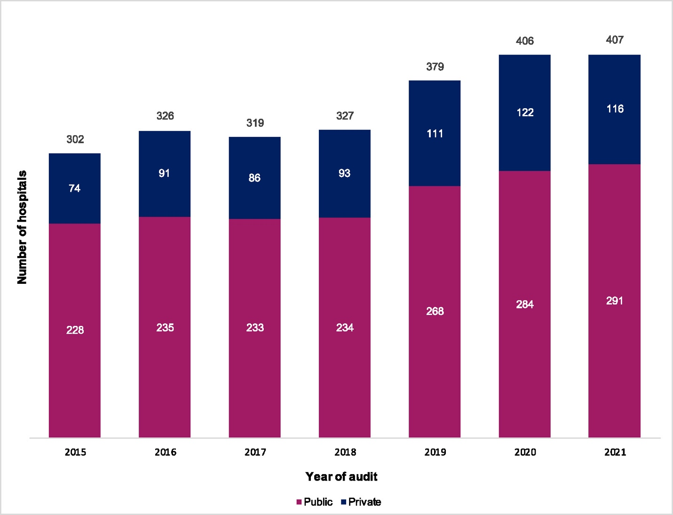

Overall, 42.1% of all eligible hospitals participated in the survey, with slightly higher participation from public hospitals (42.9%, 291 of 678) compared with private hospitals (40.3%, 116 of 288). All Australian states and territories were represented (Figure 2).

The full analysis of hospital participation by funding type, state and territory, peer group and remoteness classification can be found in Appendix 1: Figure 1A and Tables 1A and 1B.

Figure 2: Percentage of public and private hospitals that contributed to the Hospital NAPS by state and territory, 2021*

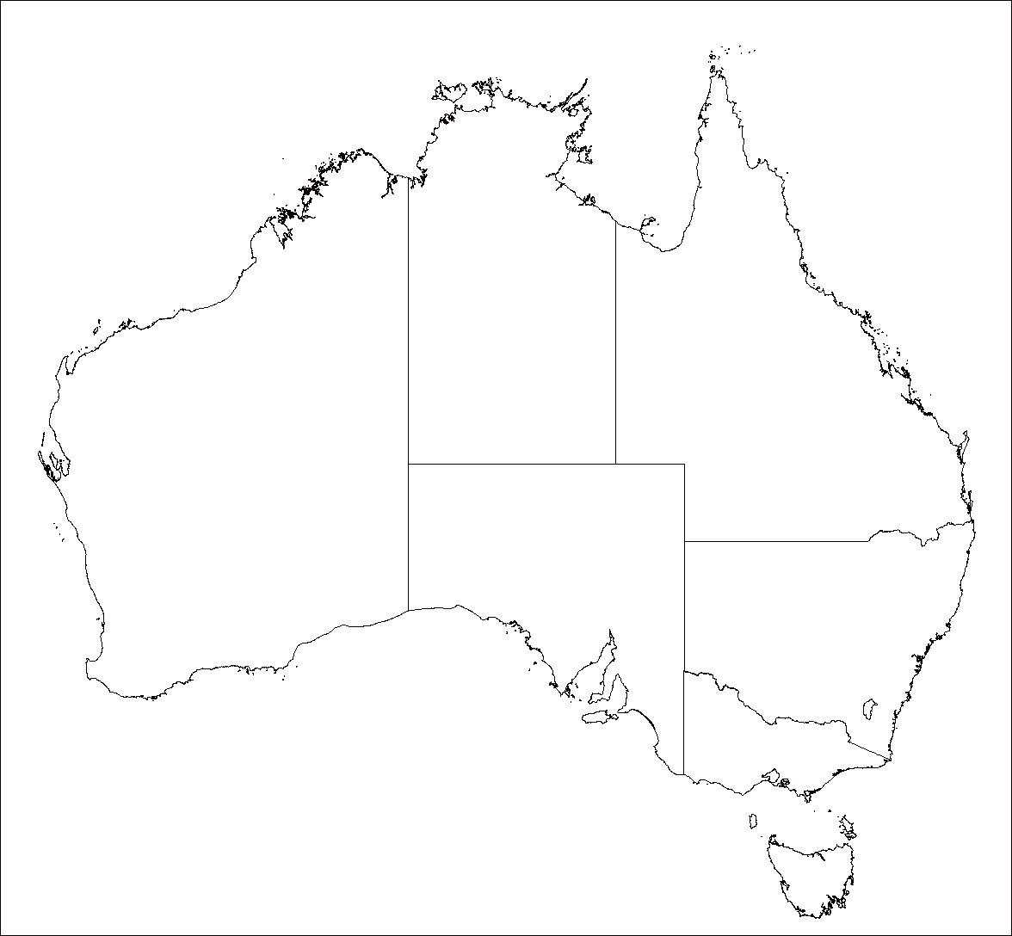

NT

Public **80% (n=4)** Private **100% (n=1)**

QLD

Public **30% (n=37)**

Private **25% (n=15)**

NSW

Public **54%(n=116)**

Private **40% (n=37)**

ACT

Public **100% (n=2)** Private **50% (n=2)**

VIC

Public **56% (n=80)**

Private **58% (n=44)**

TAS

Public **17% (n=4)** Private **33% (n=2)**

SA

Public **34% (n=26)**

Private **14% (n=4)**

WA

Public **24% (n=22)**

Private **55% (n=11)**

* Refer to Appendix 1: Table 1A for the total number of hospitals in each jurisdiction.

Data from 20,473 patients were submitted, generating 29,305 prescriptions for analysis. The majority of prescriptions were gathered from Victoria and New South Wales, which together represented 62.7% of all prescriptions submitted (Appendix 1: Table 1C).

The majority of auditing occurred in the months of October and November, which is consistent with previous years’ surveys (Figure 3). There was also a moderate amount of auditing activity in May, June and September. A substantial reduction, particularly for Victorian hospitals, was seen in July, which coincided with the state-wide lockdown that occurred in Victoria due to the COVID-19 pandemic.

Figure 3: Distribution of prescription audit days amongst hospitals contributing to the Hospital NAPS, 2021

## 3.3 Key performance indicators

The 5 key indicators described in Figure 4 have been collected consistently since 2015.

Figure 4: Hospital NAPS key indicators, for assessable prescriptions, 2015–2021

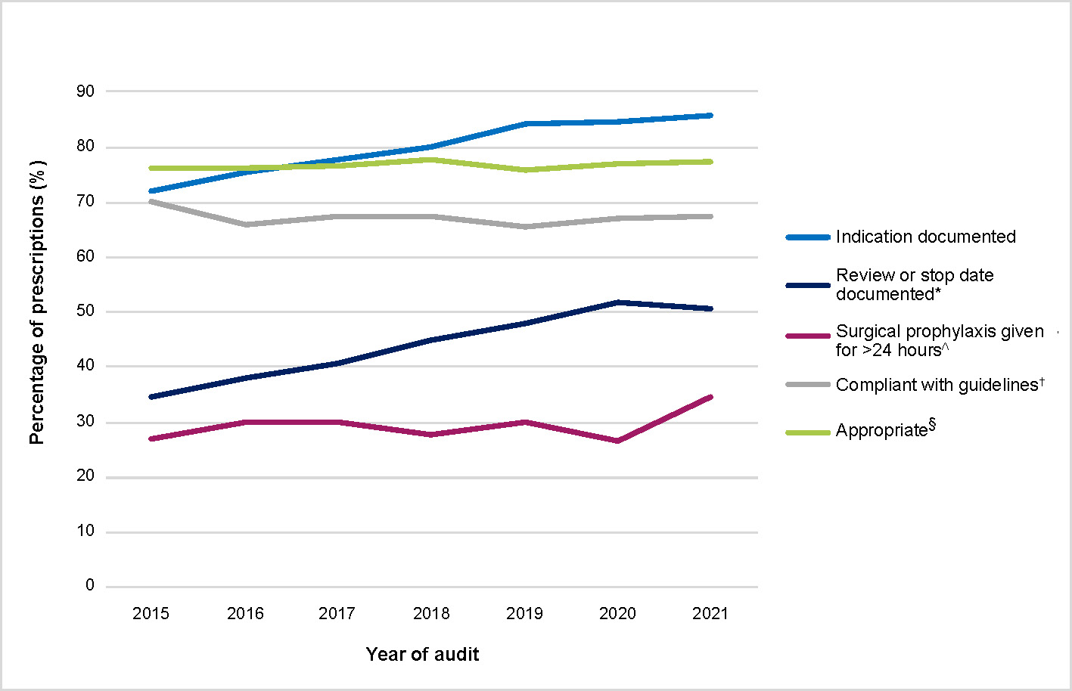

* The ‘Review or stop date documented’ indicator was introduced partway through 2015; the 2015 result excludes prescriptions where this measure was not specified (3,789 of 26,165 prescriptions).

^ Where surgical prophylaxis was selected as the indication (n=3,531 in 2021).

† Prescriptions for which compliance was assessable (n=23,677 in 2021). Excludes prescriptions for which guidelines were not available, as well as prescriptions that were ‘directed therapy’ or ‘not assessable’. Refer to Appendix 4 for definitions.

§ Prescriptions for which appropriateness was assessable (n=28,253 in 2021). Excludes prescriptions deemed to be ‘not assessable’. Refer to Appendix 3 for definitions.

See Appendix 1: Tables 1C and 1D for the breakdown of Hospital NAPS key indicators by funding type, state and territory, peer group and remoteness classification.

Appendix 1: Table 1E shows the changes over time for the different guideline compliance and appropriateness categories for Hospital NAPS prescriptions.

### 3.3.1 Documentation of indication

Encouragingly, the vast majority of antimicrobial prescriptions had an indication documented in the patient medical history. This measure has continued to improve year on year, from 72.0% in 2015 to 85.7% in 2021 (Figure 4).

The documentation rate in public hospitals was high, at 89.9%, which is approaching the best practice target of 95% that has been adopted by NCAS for the Hospital NAPS. In private hospitals, 68.9% of prescriptions had an indication documented, which is a slight decrease compared with 70.1% in 2020 (Appendix 1: Table 1C).

### 3.3.2 Documentation of review or stop date

There had previously been a consistent improvement in the documentation of antimicrobial review or stop date since the measure was first introduced in 2015. However, the 2021 data revealed a slight reduction (50.8%) compared with 2020 (51.8%). This reduction was seen in both public and private hospitals, although overall private hospitals generally performed better than public hospitals (56.3% compared with 49.5%; Appendix 1: Table 1C).

### 3.3.3 Surgical prophylaxis greater than 24 hours

There appears to have been a considerable increase in the proportion of surgical antimicrobial prophylaxis prescriptions with a duration of greater than 24 hours (34.5% in 2021 compared with 26.6% in 2020).

However, this result should be interpreted carefully as there was also a marked reduction in the number of surgical antimicrobial prophylaxis prescriptions audited in 2021 compared with 2020 (3,531 prescriptions compared with 4,759 in 2020).

Furthermore, the results of the 2021 Surgical NAPS show that 26.9% of procedures had antimicrobial prophylaxis that continued beyond 24 hours. The Surgical NAPS has a more accurate methodology for capturing surgical antimicrobial prophylaxis data. Further in-depth analyses of the types and durations of post-operative surgical prophylaxis procedures can be found in the 2021 Surgical NAPS report.8

## 3.4 Compliance with guidelines

A detailed breakdown of the compliance with guidelines assessment is shown in Figure 5.

Figure 5: Compliance with guidelines for all prescriptions in the Hospital NAPS, 2015–2021

2019 release of new Therapeutic Guidelines antimicrobial recommendations

2016 release of new Therapeutic Guidelines antimicrobial recommendations

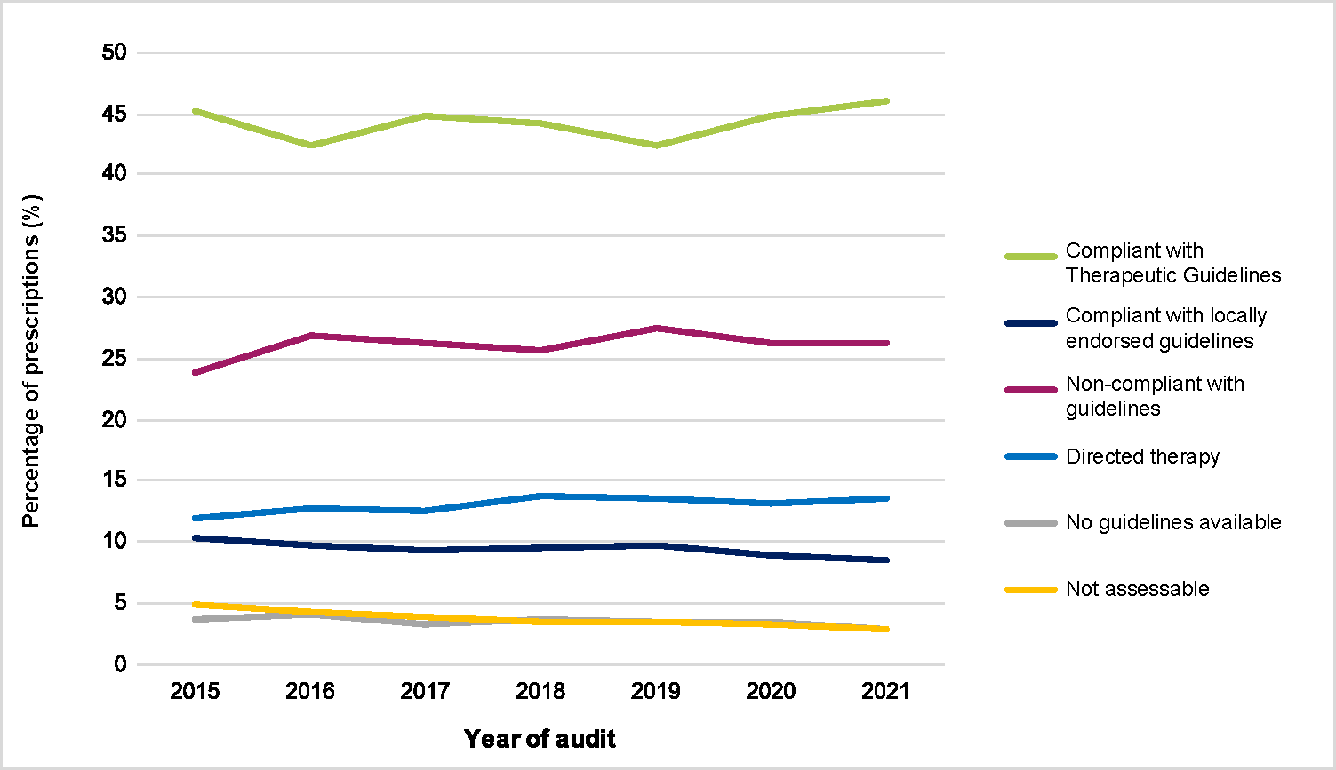

The release of the new Therapeutic Guidelinesantimicrobial recommendations in 2019 saw an associated drop in the proportion of prescriptions deemed compliant with the Therapeutic Guidelines. Encouragingly, there was a continued improvement in this measure from 42.3% in 2019 to 46.1% in 2021, coupled with an associated improvement in appropriateness from 72.9% in 2019 to 74.5% in 2021 (Figure 6). This pattern is not surprising as it takes time for new guidelines to be disseminated throughout hospital systems and for clinicians to change their prescribing behaviour. A similar pattern was seen after the 2016 update of the Therapeutic Guidelines.

There continues to be a gradual reduction in compliance with locally endorsed guidelines, which may be because each successive update of the Therapeutic Guidelines provides recommendations for an increasingly broad range of clinical conditions, which in turn may reduce a hospital’s need to produce local guidelines.

Unfortunately, despite some minor fluctuations, the rate of non-compliance with guidelines remained at approximately 26%.

The percentage of prescriptions assessed as directed therapy has effectively remained the same over the years and has not been influenced by the release of different versions of the Therapeutic Guidelines.

## 3.5 Appropriateness

Compared with 2020, the 2021 results show essentially unchanged rates of overall appropriateness (Optimal plus Adequate prescribing - 74.5% in 2021; 74.0% in 2020) and inappropriateness (22.0% in both years) (Figure 6). Appropriateness was generally higher amongst public hospitals compared with private hospitals (76.3% and 67.0% respectively; Appendix 1: Table 1D).

A detailed breakdown of the assessment of appropriateness is shown in Figure 6.

Figure 6: Appropriateness of all prescriptions in the Hospital NAPS, 2015–2021

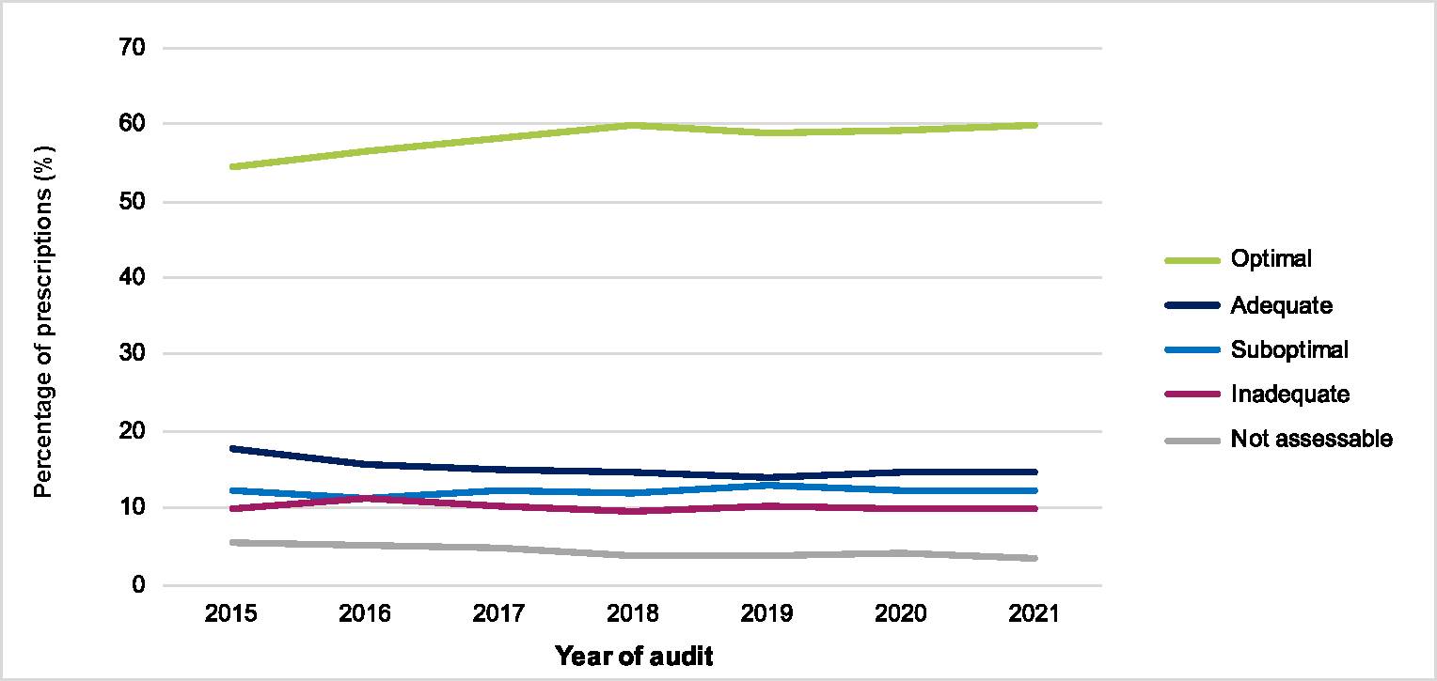

Although the rates of appropriateness appear to be generally stagnant, a more in-depth analysis of the data reveals the changing quality of prescribing within peer groups (Figure 7 and Figure 8).

Amongst public hospitals, principal referral hospitals, women’s and children’s hospitals and group D hospitals showed improved results compared with 2020. There was unfortunately a reduction in appropriateness amongst group A, B and C hospitals, although the overall trend line still shows improvement across time (Figure 7). The reasons for this are unclear, and future results will be carefully analysed to determine whether the trend of improvement continues.

Figure 7: Appropriateness of antimicrobial prescribing across public healthcare facilities in the Hospital NAPS, 2013–2021

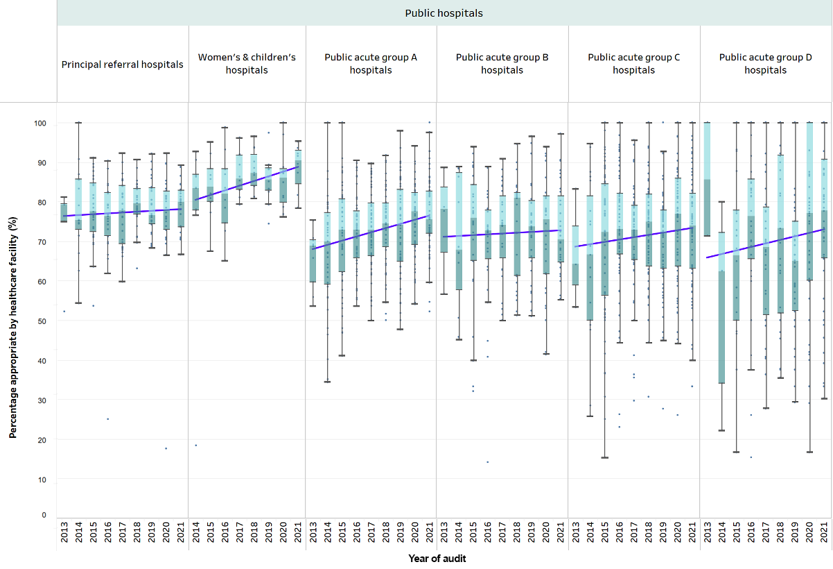

Source: AIHW 7 and NAPS.

Amongst private hospitals, the trend line indicates that appropriateness of prescribing within peer groups appears to be decreasing over the years (Figure 8). However, it is important to emphasise the changing mix of participating private hospitals over time; those performing the survey in the earlier years consisted of larger, well-founded hospitals with established AMS services. Over the years, smaller private hospitals joining the survey may have negatively impacted on the overall appropriateness of prescribing because they are early on in the process of establishing their AMS services and it takes time to implement initiatives to improve prescribing once they have been identified. Nonetheless, prescribing appropriateness improved in 2021 compared with 2020 for group A, B and C private hospitals.

Figure 8: Appropriateness of antimicrobial prescribing by private healthcare facilities in the Hospital NAPS, 2013–2021

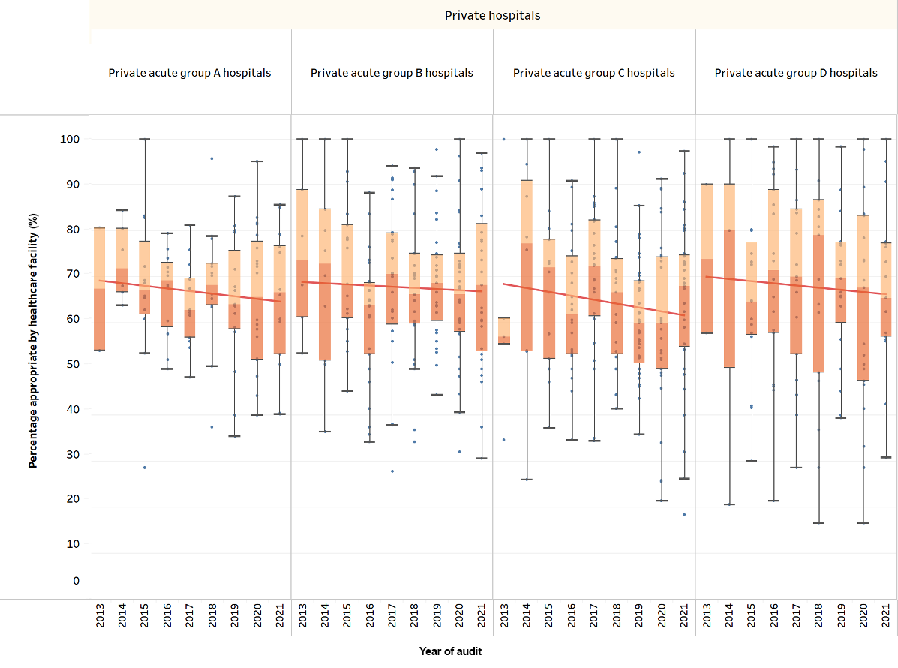

Source: AIHW.7

### 3.5.1 Reasons for inappropriateness

The Hospital NAPS allows users to specify the reason why a prescription has been deemed inappropriate.

Figure 9: Reasons for inappropriateness for all prescriptions in the Hospital NAPS, 2021

This figure has two sections. On top, a data flowchart showing,  where a prescription from a contributing hospital in 2021 was deemed inappropriate, the proportion and number of those prescriptions for which there was an indication. The bottom section is a bar graph showing the reason for a prescription subsequently being assessed as inappropriate.  

* Each prescription is assessed against each quality indicator and thus can be represented in more than one category.

Of the 29,305 prescriptions, 6,432 (22.0%) were assessed as inappropriate (suboptimal and inadequate) by the auditors. Of those, 77 (1.2%) were identified as having an allergy mismatch and 360 (5.6%) as having a microbiology mismatch. These low rates are consistent with findings in the previous years.

A substantial proportion of inappropriate prescriptions (22.5%) were for conditions that do not require antimicrobial therapy. The remaining reasons for inappropriateness (Figure 9) were primarily due to the antimicrobial spectrum being too broad, incorrect dose or frequency, and incorrect duration.

### 3.5.2 Appropriateness of antimicrobials on the Priority Antibacterial List

The Priority Antibacterial List for Antimicrobial Resistance Containment (the Priority Antibacterial List) was developed by the Australian Commission on Safety and Quality in Health Care to support local and national antimicrobial usage surveillance. Antibiotics are grouped into 3 categories (Appendix 5: Figure 5A and Figure 5B)[9]:

* Access – first-line antimicrobials with low potential for resistance
* Curb – first-line antimicrobials with high resistance potential
* Contain – antimicrobials with high resistance potential; these are not recommended as first-line therapy.

The appropriateness of prescribing of antibiotics grouped according to each of these categories is shown in Figure 10.

Figure 10: Appropriateness of prescribing for antibiotics on the Priority Antibacterial List, Hospital NAPS 2021

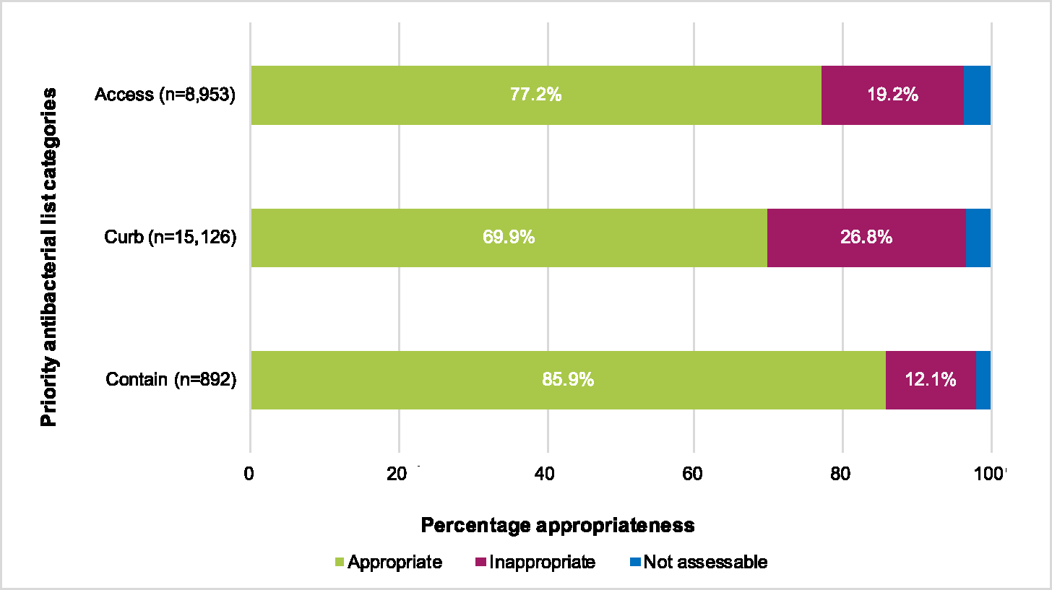

A significantly higher proportion of antibiotic prescribing in the Curb category was assessed to be inappropriate (26.8%) compared to antibiotics in the Contain (12.1%) and Access (19.2%) categories (Figure 10). Antimicrobials in the Access category are often used as first-line therapy according to guidelines and hence more often deemed appropriate. Antimicrobials in the Contain category are often prescribed by or used in accordance with advice from specified infectious disease services, resulting in the high proportion of prescriptions being assessed as appropriate.

In contrast, antimicrobials in the Curb category are commonly used for indications that are often assessed as inappropriate – for example, cefazolin in surgical prophylaxis and ceftriaxone in treating respiratory illnesses including COPD. Of the Curb antimicrobials, cefazolin, ceftriaxone, cefalexin, amoxicillin–clavulanic acid and piperacillin–tazobactam make up 83.4% of all the inappropriate prescriptions. Therefore, targeting these antimicrobials, perhaps through a combination of restrictive policies and educational initiatives, will support improvement of antimicrobial prescribing appropriateness nationally.

## 3.6 Most commonly prescribed antimicrobials

Figure 11 shows the 20 most common antimicrobials prescribed by NAPS contributor hospitals in 2021. This distribution of antimicrobials has remained relatively consistent in NAPS results over the years. Cefazolin continues to be the most frequently prescribed antimicrobial, although there was a noticeable reduction in 2021 compared with 2020 (11.5% in 2021; 13.9% in 2020). This is likely due to the corresponding reduction in surgical prophylaxis prescribing seen in the 2021 results (surgical prophylaxis comprised 68.7% of all cefazolin prescriptions).

Figure 11: The 20 most common antimicrobials prescribed by Hospital NAPS contributor hospitals, 2015–2021

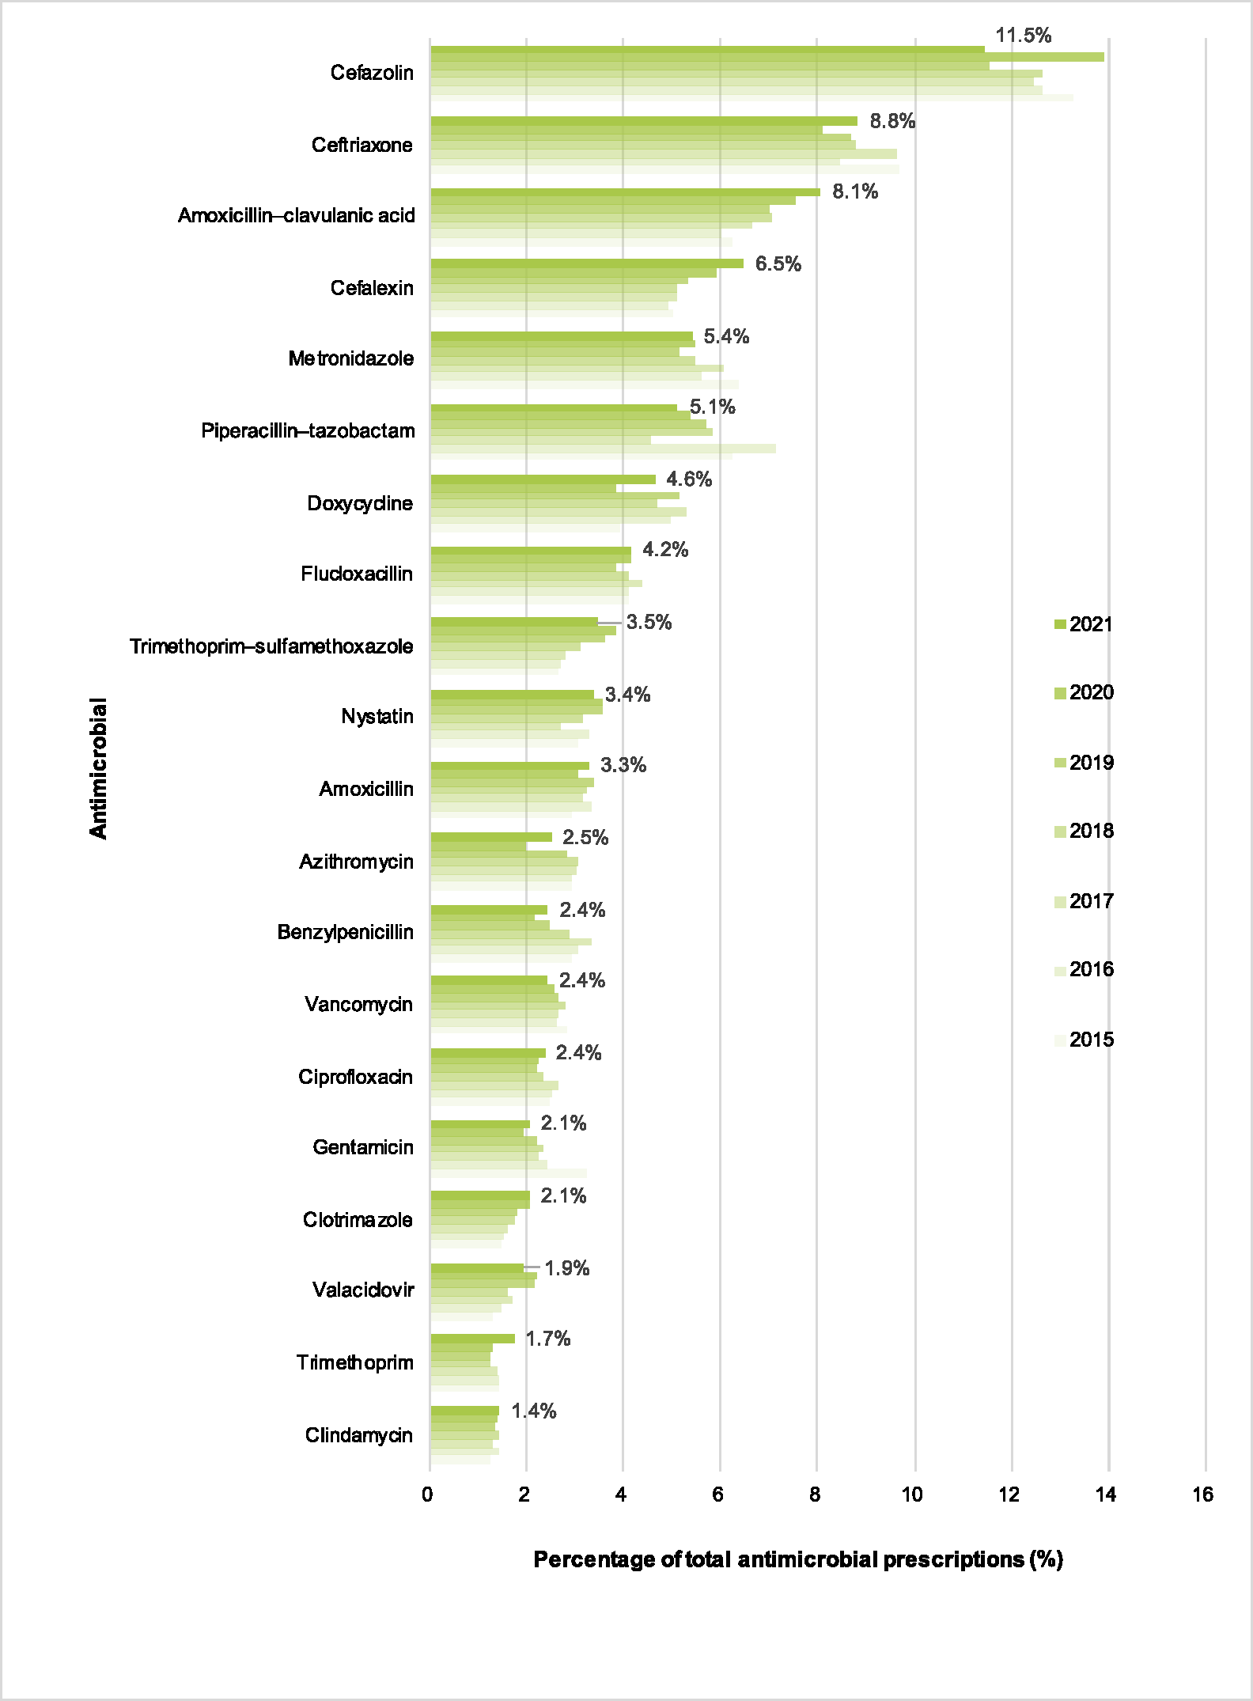

### 3.6.1 Appropriateness of the most commonly prescribed antimicrobials

The 5 most commonly prescribed antimicrobials (cefazolin, ceftriaxone, amoxicillin–clavulanic acid, cefalexin and metronidazole) also had amongst the highest rates of inappropriateness (Figure 12). These results are relatively consistent compared with 2020 and other previous years’ results.

Figure 12: Appropriateness of the 20 most commonly prescribed antimicrobials in Hospital NAPS contributor hospitals, 2021

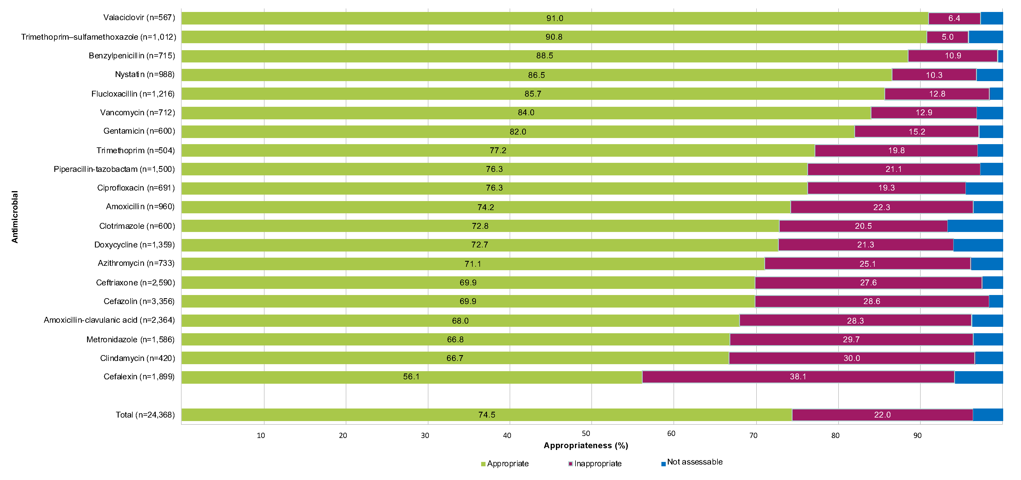

#### Cefalexin

The most inappropriately prescribed antimicrobial continued to be cefalexin, with 38.1% of all prescriptions deemed to be inappropriate.

The most common indications for which cefalexin was prescribed were cystitis (31.1%), surgical prophylaxis (17.2%) and cellulitis (12.5%). For these indications, 88.0% of surgical prophylaxis prescriptions were deemed to be inappropriate, which is not surprising given that cefalexin is not in any surgical prophylaxis recommendations in the Therapeutic Guidelines. The inappropriateness of cystitis prescriptions was 26.3%, followed by 20.3% for cellulitis prescriptions.

#### Metronidazole

Almost 30% of metronidazole prescriptions were assessed as being inappropriate. The most common reasons for metronidazole use were surgical prophylaxis (15.1%), diverticulitis (10.7%) and acute cholecystitis (7.5%). Of these surgical prophylaxis prescriptions, 42.3% were inappropriate, with the most common reasons being prolonged duration and that therapy was not required at all. Almost 40% of acute cholecystitis prescriptions were inappropriate. In the vast majority of cases, this was because the spectrum of therapy was too broad.

#### Amoxicillin–clavulanic acid

Amoxicillin–clavulanic acid was the third most commonly prescribed antimicrobial (8.1%, 2,364 prescriptions), and had the fourth highest rate of inappropriateness (28.3%) of the top 20 antimicrobials. Amoxicillin–clavulanic acid can be prescribed either orally or intravenously. The intravenous formulation only became widely available in Australia from 2017. Since that time, there has been a consistent increase in the proportion of intravenous amoxicillin–clavulanic acid prescriptions seen in the NAPS, from 8.6% of total amoxicillin–clavulanic acid prescriptions in 2017 to 28.4% in 2021. Its place in therapy is still emerging; however, it is seen as an alternative to piperacillin–tazobactam in patients with severe infections where specific cover against *Pseudomonas aeruginosa* is not required.

Interestingly, a substantially higher proportion of oral amoxicillin–clavulanic acid prescriptions were inappropriate compared with intravenous prescriptions (32.0% and 20.1% respectively). The most common reasons for prescription of oral amoxicillin–clavulanic acid were community-acquired pneumonia, cystitis, and hospital-acquired pneumonia. Approximately half of community-acquired pneumonia prescriptions were inappropriate, followed by 30.0% of cystitis and 13.3% of hospital-acquired pneumonia prescriptions.

The most common reasons for prescription of intravenous amoxicillin–clavulanic acid were aspiration pneumonia, non-surgical wound infection, and appendicitis. Interestingly, the rate of inappropriateness is increasing over time. In 2017, when this formulation was first introduced, only 13.7% of prescriptions were deemed inappropriate; this is likely because its newness meant that hospitals had more controls placed around it and only specialist prescribers were familiar enough to prescribe it. Since then, it has become more widely utilised by prescribers who are less familiar with its appropriate use.

## 3.7 Most common indications for antimicrobial prescribing

The 20 most common indications for antimicrobial prescribing seen in the 2021 survey are shown in Figure 13.

There have been some noticeable shifts in the proportions of indications for prescribing compared with 2020. The percentage of antimicrobials prescribed for surgical prophylaxis reduced noticeably from 15.2% in 2020 to 12.1% in 2021. The reasons for this are unclear. However, the continued impact of the COVID-19 pandemic in 2021 meant that there was a reduction in elective surgeries being performed, which in turn may have contributed to this reduction in surgical prophylaxis indications. It is also possible that surgical hospitals chose to instead perform the Surgical NAPS as it provides more tailored and meaningful data for that patient mix.

The 2020 survey saw a substantial reduction in the proportion of antimicrobials prescribed for community-acquired pneumonia compared with what had been observed in previous years. It was hypothesised that this may have been due to the pandemic lockdown measures limiting the transmission of respiratory-related illnesses. Whilst lockdown measures continued in 2021, there was nonetheless a correction in this figure, with community-acquired pneumonia accounting for 8.1% of prescriptions, an increase from 6.6% in 2020.

Figure 13: The 20 most common indications for antimicrobial prescribing in Hospital NAPS contributors, 2015–2021

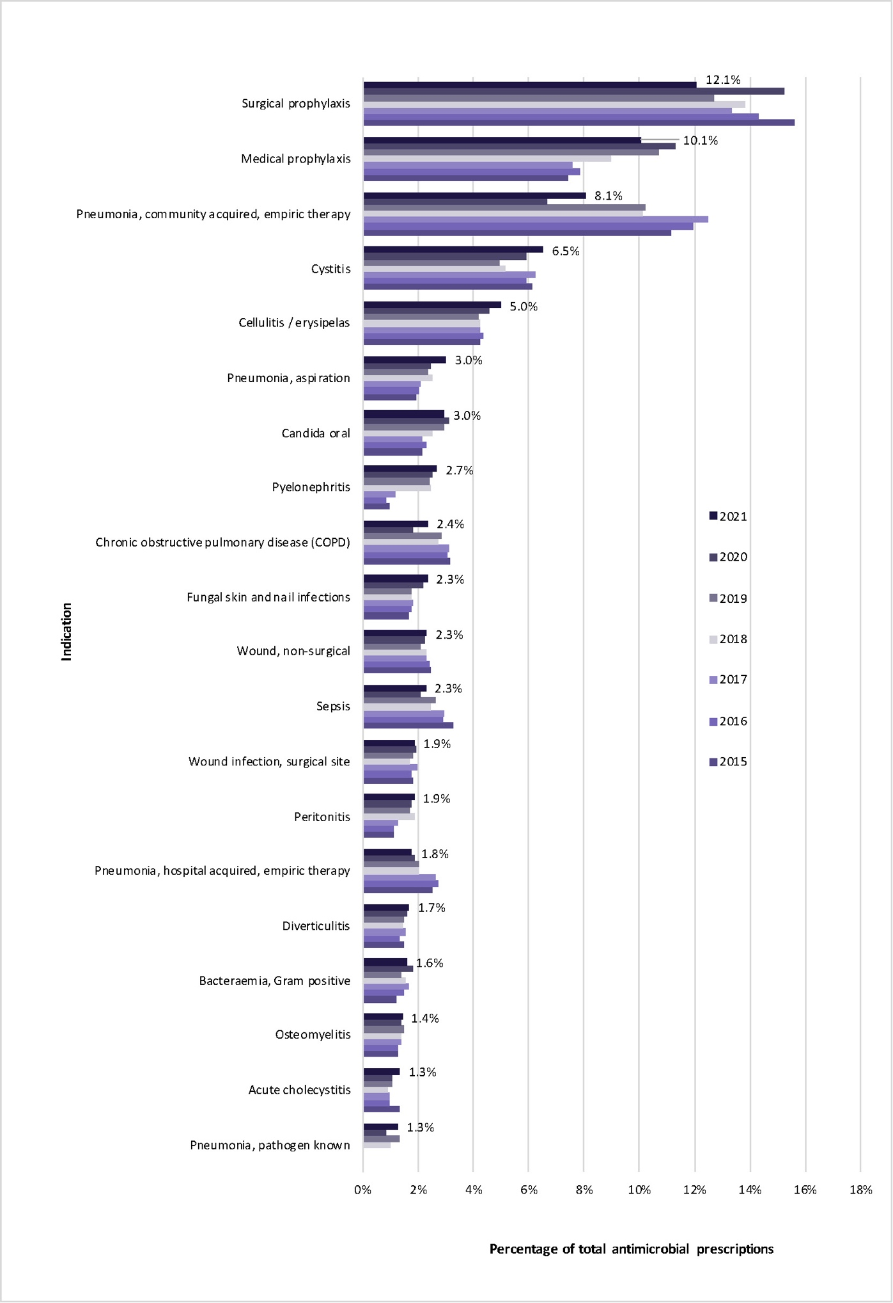

### 3.7.1 Appropriateness of prescribing for the 20 most common indications

Of the 20 most common indications in 2021, the 3 indications with the most inappropriate prescribing continued to be COPD, surgical prophylaxis and acute cholecystitis (Figure 14); this distribution has remained unchanged for several years. Interestingly, very few surgical prophylaxis prescriptions were deemed to be not assessable (possibly due to the heavily protocolised nature of this indication), yet there were still very high rates of inappropriate prescribing.

In contrast, other indications with clear prescribing protocols, such as medical prophylaxis, had very high rates of appropriate prescribing. Gram-positive bacteraemia and osteomyelitis also had high rates of appropriate prescribing, likely due to the specialised infectious diseases oversight required for the management of these patients.

Figure 14: Appropriateness of prescribing for the 20 most common indications, Hospital NAPS contributors, 2021*

* Excludes prescriptions where the indication for prescribing was unknown (n=564).

### 3.7.2 Compliance with guidelines for the 20 most common indications

Of the top 20 most common indications, the average rate of non-compliance (neither Therapeutic Guidelines nor locally endorsed guidelines) was 26.3%.

Figure 15: Compliance with guidelines for the 20 indications most commonly requiring antimicrobials in Hospital NAPS contributors, 2021*

* Excludes prescriptions where the indication for prescribing was unknown (n=564).

Indications with the highest rates of non-compliance were COPD, surgical prophylaxis and acute cholecystitis (Figure 15). Both COPD and surgical prophylaxis have consistently remained areas of high non-compliance; not surprisingly, these were also the indications with the highest rates of inappropriateness (Figure 14). These findings have remained consistent across many years of NAPS surveys despite the existence of clear national guidelines and a substantial revision to the antimicrobial recommendations in the Therapeutic Guidelines in 2019. This suggests there is still considerable work to be done in supporting and educating prescribers in good antimicrobial prescribing. It is also possible that the continued impact of COVID-19 meant that many hospital stewardship services did not have the resources to implement education initiatives on the new guidelines for the relevant medical teams.

In previous years, the treatment of wound infections (both surgical and non-surgical) had consistently high rates of non-compliance with guidelines. Whilst the rates of non-compliance are still relatively high, prescribing for these conditions appears to have slightly improved in 2021 compared with 2020 and therefore did not feature as prominently as in previous years (surgical site wound infections: 22.5% non-compliant in 2021 compared with 26.2% in 2020; non-surgical wound infections: 31.3% non-compliant in 2021 compared with 34.5% in 2020).

Conditions where prescribing is often guided by microbiology and susceptibility results, such as bacteraemia and osteomyelitis, had high rates of being categorised as directed therapy and had correspondingly high levels of appropriateness. Similarly, other indications with well-implemented protocols and guidelines, such as medical prophylaxis, were also more likely to be assessed as appropriate.

## 3.8 Impact of COVID-19 on the 2021 Hospital NAPS

The global pandemic of COVID-19, caused by the novel severe acute respiratory syndrome coronavirus 2 (SARS-CoV-2), significantly impacted on human health and the daily life of people across the world. Although there was limited community transmission in Australia compared to other parts of the world, COVID-19 continued to significantly impact on the Australian healthcare system both directly and indirectly in 2021.

The strain on the healthcare workforce caused by COVID-19 in 2020 may have continued in 2021 and therefore impacted on the resources available to conduct the Hospital NAPS and also to implement AMS quality initiatives. Nonetheless, the overall number of facilities participating in the Hospital NAPS remained steady compared with 2020, and there was even a slight increase compared with pre-pandemic 2019 (Figure 1). Victoria had the most stringent and most prolonged lockdown of any state or territory in Australia, with a total of 113 days in lockdown, primarily between July and October 2021. However, this does not appear to have had an impact on participation, as there was an increase in participation of Victorian hospitals (124 compared with 113 in 2020).

# 4 Implications for clinical practice

## 4.1 Documentation

Accurate documentation of an antimicrobial’s indication and review or stop date is a vital AMS measure to ensure that all clinicians treating the patient clearly understand the reasons for the antimicrobial and when it should be reassessed or ceased. Encouragingly, there was continued improvement in these 2 key performance indicators. Whilst there is still some work to be done before the best practice target of 95% documentation is reached, this improvement is nonetheless to be commended and demonstrates the positive impact of having nationally endorsed AMS standards as well as the NAPS program itself.

It is expected that the continued adoption of electronic medication management systems across many Australian hospitals will help to improve documentation into the future. These systems can be configured to require clinicians to document the indication and a review or stop date at the point of prescribing.

## 4.2 Clinical areas for improvement

Five key antimicrobials – cefazolin, ceftriaxone, amoxicillin–clavulanic acid, cefalexin and metronidazole – have been the most commonly prescribed and most inappropriately prescribed agents across many survey years. These agents have been closely coupled with the most common indications seen and their reasons for inappropriateness.

There were higher rates of guideline non-compliance and inappropriateness observed for respiratory tract infections (particularly COPD and community-acquired pneumonia), surgical prophylaxis, wound infections and acute cholecystitis.

These clinical areas have been consistently identified in all previous years’ NAPS reports. The revised antimicrobial guidelines in the Therapeutic Guidelines released in 2019 considerably expanded recommendations in these areas. Nonetheless, it takes time for new guidelines to disseminate through hospitals and for practice change to occur. It is possible that, due to the COVID-19 pandemic’s impact on hospital staffing, hospitals may not have had the resources required to implement quality initiatives based on these recommendations. Nonetheless, there have been improvements in compliance and appropriateness since the initial dip in 2019. We will await the results of future surveys to further analyse these trends.

## 4.3 Updated clinical care standards

The new version of the Antimicrobial Stewardship Clinical Care Standard (CCS) was released in mid-2020 with expanded indicators in several of the problem areas identified in previous NAPS: documentation of indication and review or stop date, surgical prophylaxis measures such as guideline compliance, dosage and prolonged therapy, adverse drug reactions, and antimicrobial review at 48 hours.3

Given that the CCS is now a key requirement in hospital accreditation standards, the NAPS will be updated in 2022 to explicitly incorporate the CCS indicators as part of the survey data collection fields.

# 5 Conclusion

Despite the ongoing challenges arising from the COVID-19 pandemic, participation in the Hospital NAPS across public and private hospitals remained high in 2021. The results showed some improvements in several key indicators such as documentation of indication and compliance with the Therapeutic Guidelines, as well as ongoing themes of poor prescribing in areas such as surgical prophylaxis, respiratory tract infections and wound infections. Additionally, higher inappropriateness was observed for frequently prescribed antimicrobials such as cefalexin, amoxicillin–clavulanic acid and ceftriaxone.

Whilst overall appropriateness of prescribing has remained steady for several years, in-depth analysis of the peer groups shows that appropriateness is improving across most public hospital peer groups. Whilst appropriateness remains lower in private hospitals, there was an observed improvement in 2021 compared with 2020 in the large private hospital peer groups. This improvement is expected to continue into the future as more private hospitals participate and their antimicrobial stewardship programs mature and become embedded into practice.

There have been some recent expansions in national guidelines and quality standards, particularly the expanded antimicrobial recommendations in the Therapeutic Guidelines and expanded indicators in the Antimicrobial Stewardship CCS. Many of these updates directly address problem areas identified in previous NAPS. We will await the results of future surveys to determine longer term impact.

# Appendix 1: Results

Figure 1A: Public and private hospital participation in the Hospital NAPS by peer group classification, 2015–2021

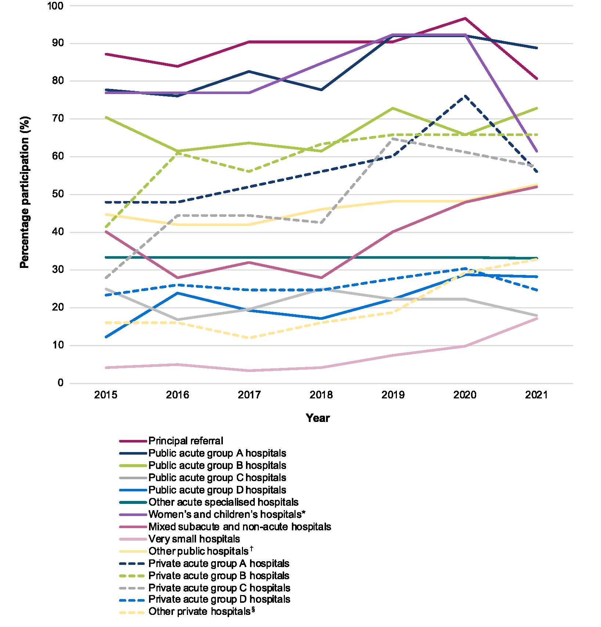

**Public hospitals**

**Private hospitals**



* This category includes public children’s hospitals, women’s hospitals, and women’s and children’s hospitals.

† This category includes public rehabilitation and geriatric evaluation and management hospitals, psychiatric hospitals and unpeered hospitals.

§ This category includes private rehabilitation hospitals, acute psychiatric hospitals and other acute specialised hospitals.

Table 1A: Public and private hospitals that contributed to the Hospital NAPS by state and territory and remoteness area, 2021

|  |  |  |  |  |  |  |  |  |
| --- | --- | --- | --- | --- | --- | --- | --- | --- |
| **Participating hospitals** | | **Funding type** | **Number of participating hospitals (n)** | **Number of hospitals in reporting group^*  (n)** | **Representative participation (%)** | **Number of participating hospitals (n)** | **Number of hospitals in reporting group^*  (n)** | **Representative participation (%)** |
| **State or territory** | ACT | Public | 2 | 2 | 100.0 | 4 | 6 | 66.7 |
| Private | 2 | 4 | 50.0 |
| NSW | Public | 116 | 213 | 54.5 | 153 | 306 | 50.0 |
| Private | 37 | 93 | 39.8 |
| NT | Public | 4 | 5 | 80.0 | 5 | 6 | 83.3 |
| Private | 1 | 1 | 100.0 |
| Qld | Public | 37 | 122 | 30.3 | 52 | 181 | 28.7 |
| Private | 15 | 59 | 25.4 |
| SA | Public | 26 | 77 | 33.8 | 30 | 106 | 28.3 |
| Private | 4 | 29 | 13.8 |
| Tas | Public | 4 | 23 | 17.4 | 6 | 29 | 20.7 |
| Private | 2 | 6 | 33.3 |
| Vic | Public | 80 | 144 | 55.6 | 124 | 220 | 56.4 |
| Private | 44 | 76 | 57.9 |
| WA | Public | 22 | 92 | 23.9 | 33 | 112 | 29.5 |
| Private | 11 | 20 | 55.0 |
| **Remoteness** | Major cities | Public | 102 | 170 | 60.0 | 194 | 389 | 49.9 |
| Private | 92 | 219 | 42.0 |
| Inner regional | Public | 102 | 190 | 53.7 | 121 | 244 | 49.6 |
| Private | 19 | 54 | 35.2 |
| Outer regional | Public | 74 | 208 | 35.6 | 79 | 224 | 35.3 |
| Private | 5 | 16 | 31.3 |
| Remote | Public | 11 | 60 | 18.3 | 11 | 60 | 18.3 |
| Private | N/A | N/A | N/A |
| Very remote | Public | 2 | 50 | 4.0 | 2 | 50 | 4.0 |
| Private | N/A | N/A | N/A |
| **Total** | | **Public** | **291** | **678** | **42.9** | **407** | **966** | **42.1** |
| **Private** | **116** | **288** | **40.3** |

^ Numbers represent all eligible hospitals in the AIHW reporting groups for public and private, states and territories, and remoteness classifications.6,7

* Excludes early parenting centres, same-day hospitals and outpatient hospitals.

N/A = not applicable.

Table 1B: Public and private hospitals that contributed to the Hospital NAPS by peer group, 2021

|  |  |  |  |  |
| --- | --- | --- | --- | --- |
| **Participating hospitals** | | **Number of participating hospitals  (n)** | **Number of hospitals in reporting group^* (n)** | **Participation  (%)** |
| **Public hospital peer groups\*** | Principal referral | 25 | 31 | 80.6 |
| Public acute group A hospitals | 56 | 63 | 88.9 |
| Public acute group B hospitals | 32 | 44 | 72.7 |
| Public acute group C hospitals | 74 | 141 | 52.5 |
| Public acute group D hospitals | 53 | 188 | 28.2 |
| Other acute specialised hospitals | 1 | 3 | 33.3 |
| Children’s hospitals | 3 | 6 | 50.0 |
| Women’s and children’s hospitals | 5 | 7 | 71.4 |
| Mixed subacute and non-acute hospitals | 13 | 25 | 52.0 |
| Rehabilitation and GEM hospitals† | 5 | 13 | 38.5 |
| Very small hospitals | 21 | 123 | 17.1 |
| Psychiatric hospitals | 2 | 23 | 8.7 |
| Unpeered hospitals | 1 | 9 | 11.1 |
| **Private hospital peer groups§** | Private acute group A hospitals | 14 | 25 | 56.0 |
| Private acute group B hospitals | 27 | 41 | 65.9 |
| Private acute group C hospitals | 31 | 54 | 57.4 |
| Private acute group D hospitals | 17 | 69 | 24.6 |
| Other acute specialised hospitals | 5 | 18 | 27.8 |
| Private rehabilitation hospitals | 17 | 25 | 68.0 |
| Private acute psychiatric hospitals | 3 | 30 | 10.0 |
| Women’s hospitals | 1 | 2 | 50.0 |
| Haematology and oncology clinics | 1 | 10 | 10.0 |
| **TOTAL** |  | 407 | 950 | 42.8 |

^ Numbers represent all eligible hospitals in the AIHW reporting groups for public and private, states and territories, and remoteness classifications. 6,7

* Excludes early parenting centres, same-day hospitals and outpatient hospitals.

† GEM = geriatric evaluation and management.

§ Excludes ineligible private hospitals.

Table 1C: Hospital NAPS key indicator results by state and territory, remoteness area and peer group^, 2021

|  | | **Number of participating hospitals  (n)** | **Percentage of all participating hospitals  (%)** | **Number of prescriptions (n)** | **Percentage of all prescriptions (%)** | **Indication documented (%)** | **Review or stop date documented (%)** | **Surgical prophylaxis >24 hours  (%)\*** |
| --- | --- | --- | --- | --- | --- | --- | --- | --- |
| **State or territory** | ACT | 4 | 1.0 | 548 | 1.9 | 77.0 | 32.1 | 57.5 |
| NSW | 153 | 37.6 | 10,171 | 34.7 | 88.0 | 51.0 | 45.9 |
| NT | 5 | 1.2 | 517 | 1.8 | 93.8 | 58.0 | 46.2 |
| Qld | 52 | 12.8 | 4,332 | 14.8 | 87.1 | 46.3 | 29.1 |
| SA | 30 | 7.4 | 1,885 | 6.4 | 77.6 | 46.9 | 19.2 |
| Tas | 6 | 1.5 | 507 | 1.7 | 79.1 | 45.8 | 25.4 |
| Vic | 124 | 30.5 | 8,217 | 28.0 | 86.1 | 55.9 | 31.6 |
| WA | 33 | 8.1 | 3,128 | 10.7 | 81.9 | 48.2 | 25.0 |
| **Remoteness** | Major cities | 194 | 47.7 | 19,068 | 65.1 | 84.9 | 53.0 | 34.3 |
| Inner regional | 121 | 29.7 | 6,238 | 21.3 | 86.5 | 48.1 | 34.2 |
| Outer regional | 79 | 19.4 | 3,370 | 11.5 | 88.6 | 44.6 | 42.6 |
| Remote | 11 | 2.7 | 479 | 1.6 | 86.9 | 41.1 | 16.7 |
| Very remote | 2 | 0.5 | 150 | 0.5 | 97.3 | 56.7 | 12.5 |
| **Public hospital peer group** | Principal referral | 25 | 6.1 | 7,370 | 25.1 | 91.0 | 48.9 | 37.5 |
| Public acute group A hospitals | 56 | 13.8 | 6,872 | 23.4 | 89.8 | 48.4 | 36.9 |
| Public acute group B hospitals | 32 | 7.9 | 2,074 | 7.1 | 88.4 | 50.3 | 47.0 |
| Public acute group C hospitals | 74 | 18.2 | 3,794 | 12.9 | 87.9 | 49.1 | 30.1 |
| Public acute group D hospitals | 53 | 13.0 | 1,344 | 4.6 | 87.9 | 38.1 | 100.0 |
| Other acute specialised hospitals | 1 | 0.2 | 134 | 0.5 | 98.5 | 33.6 | 75.0 |
| Children’s hospitals | 3 | 0.7 | 346 | 1.2 | 80.1 | 43.4 | 60.0 |
| Women’s and children’s hospitals | 5 | 1.2 | 144 | 0.5 | 97.2 | 38.9 | 21.1 |
| Women’s hospitals | 4 | 1.0 | 247 | 0.8 | 96.4 | 85.4 | 19.3 |
| Mixed subacute and non-acute hospitals | 13 | 3.2 | 436 | 1.5 | 94.7 | 78.0 | 66.7 |
| Rehabilitation and GEM hospitals† | 5 | 1.2 | 162 | 0.6 | 98.8 | 67.3 | 66.7 |
| Very small hospitals | 21 | 5.2 | 270 | 0.9 | 92.6 | 65.9 | 0.0 |
| Psychiatric hospitals | 2 | 0.5 | 318 | 1.1 | 93.1 | 58.5 | 100.0 |
| Unpeered hospitals | 1 | 0.2 | 32 | 0.1 | 68.8 | 56.3 | N/A |
| **Private hospital peer group** | Private acute group A hospitals | 14 | 3.4 | 1,707 | 5.8 | 73.6 | 58.1 | 29.9 |
| Private acute group B hospitals | 27 | 6.6 | 1,541 | 5.3 | 63.6 | 51.7 | 37.4 |
| Private acute group C hospitals | 31 | 7.6 | 1,147 | 3.9 | 66.9 | 58.6 | 31.9 |
| Private acute group D hospitals | 17 | 4.2 | 584 | 2.0 | 64.0 | 53.9 | 27.8 |
| Other acute specialised hospitals | 5 | 1.2 | 225 | 0.8 | 56.9 | 50.7 | 25.2 |
| Private rehabilitation hospitals | 17 | 4.2 | 414 | 1.4 | 81.2 | 60.9 | 92.9 |
| Private acute psychiatric hospitals | 3 | 0.7 | 56 | 0.2 | 80.4 | 53.6 | N/A |
| Women's hospitals§ | 1 | 0.2 | 22 | 0.1 | – | – | – |
| Haematology and oncology clinics | 1 | 0.2 | 66 | 0.2 | 95.5 | 81.8 | 0.0 |
| **Funding type** | Public | 291 | 71.5 | 23,543 | 80.3 | 89.9 | 56.3 | 37.4 |
| Private | 116 | 28.5 | 5,762 | 19.7 | 68.9 | 49.5 | 32.5 |
| **Combined national result** | | **407** | **100** | **29,305** | **100** | **85.7** | **50.8** | **34.5** |

^ Categorised according to the AIHW reporting groups for public and private, states and territories, and remoteness classifications. 6,7

* Where surgical prophylaxis was selected as the indication (n=3,531 in 2020).

† GEM = geriatric evaluation and management.

§ Results are not displayed if there are fewer than 30 prescriptions.

N/A = not applicable.

Table 1D: Compliance with guidelines and prescription appropriateness in Hospital NAPS contributors by state and territory, remoteness area and peer group^, 2021

|  | | **% Compliance with guidelines§** | | | | | **% Appropriateness** | | |
| --- | --- | --- | --- | --- | --- | --- | --- | --- | --- |
| **Compliant** | **Non-compliant** | **Directed therapy** | **Not available** | **Not assessable** | **Appropriate** | **Inappropriate** | **Not assessable** |
| **State or territory** | ACT | 52.4 | 24.8 | 14.6 | 4.6 | 3.7 | 75.6 | 20.6 | 3.8 |
| NSW | 52.2 | 27.1 | 16.3 | 1.8 | 2.6 | 73.6 | 23.4 | 3.1 |
| NT | 64.6 | 18.2 | 14.9 | 1.6 | 0.8 | 85.3 | 13.2 | 1.6 |
| Qld | 59.1 | 23.3 | 12.4 | 3.0 | 2.3 | 76.1 | 20.6 | 3.3 |
| SA | 57.9 | 25.8 | 12.2 | 2.2 | 1.9 | 79.8 | 16.8 | 3.4 |
| Tas | 50.1 | 29.2 | 10.1 | 6.1 | 4.5 | 73.0 | 21.5 | 5.5 |
| Vic | 54.7 | 28.2 | 9.7 | 3.8 | 3.5 | 72.0 | 23.5 | 4.5 |
| WA | 52.8 | 23.9 | 17.3 | 3.2 | 2.9 | 76.7 | 20.0 | 3.4 |
| **Remoteness** | Major cities | 54.0 | 25.1 | 14.5 | 3.4 | 3.1 | 74.3 | 22.0 | 3.7 |
| Inner regional | 55.4 | 28.4 | 11.0 | 2.3 | 3.0 | 74.2 | 21.8 | 4.0 |
| Outer regional | 55.6 | 28.0 | 13.5 | 1.4 | 1.5 | 75.4 | 22.0 | 2.6 |
| Remote | 55.7 | 32.2 | 10.4 | 0.6 | 1.0 | 74.3 | 24.2 | 1.5 |
| Very remote | 64.7 | 22.0 | 10.7 | 0.0 | 2.7 | 86.0 | 13.3 | 0.7 |
| **Public hospital  peer group** | Principal referral | 54.0 | 20.8 | 19.0 | 4.0 | 2.2 | 78.5 | 18.9 | 2.6 |
| Public acute group A hospitals | 54.9 | 25.6 | 13.8 | 3.1 | 2.6 | 75.7 | 21.2 | 3.1 |
| Public acute group B hospitals | 50.3 | 30.3 | 13.2 | 2.8 | 3.4 | 72.0 | 24.8 | 3.2 |
| Public acute group C hospitals | 57.0 | 28.7 | 11.2 | 0.9 | 2.2 | 75.1 | 22.2 | 2.7 |
| Public acute group D hospitals | 49.9 | 36.8 | 11.0 | 0.5 | 1.9 | 69.6 | 27.2 | 3.1 |
| Other acute specialised hospitals | 86.6 | 7.5 | 4.5 | 1.5 | 0.0 | 91.0 | 9.0 | 0.0 |
| Children’s hospitals | 71.7 | 12.4 | 5.2 | 10.1 | 0.6 | 85.8 | 13.0 | 1.2 |
| Women’s and children’s hospitals | 73.6 | 4.9 | 9.7 | 7.6 | 4.2 | 89.6 | 6.9 | 3.5 |
| Women’s hospitals | 84.2 | 10.9 | 3.2 | 1.2 | 0.4 | 89.1 | 10.1 | 0.8 |
| Mixed subacute and non-acute hospitals | 48.6 | 25.7 | 17.9 | 3.7 | 4.1 | 74.5 | 21.1 | 4.4 |
| Rehabilitation and GEM hospitals* | 54.3 | 17.9 | 20.4 | 3.7 | 3.7 | 81.5 | 14.2 | 4.3 |
| Very small hospitals | 58.9 | 32.2 | 7.0 | 0.0 | 1.9 | 70.0 | 27.4 | 2.6 |
| Psychiatric hospitals | 60.4 | 34.0 | 0.6 | 2.2 | 2.8 | 79.9 | 16.7 | 3.5 |
| Unpeered hospitals | 56.3 | 6.3 | 25.0 | 0.0 | 12.5 | 84.4 | 3.1 | 12.5 |
| **Private hospital  peer group** | Private acute group A hospitals | 45.9 | 33.6 | 13.4 | 3.6 | 3.5 | 66.9 | 27.7 | 5.5 |
| Private acute group B hospitals | 50.7 | 31.9 | 10.1 | 2.9 | 4.5 | 66.8 | 27.1 | 6.1 |
| Private acute group C hospitals | 51.6 | 34.4 | 7.5 | 1.8 | 4.6 | 62.4 | 29.7 | 7.9 |
| Private acute group D hospitals | 65.6 | 22.1 | 5.7 | 0.7 | 6.0 | 68.2 | 24.8 | 7.0 |
| Other acute specialised hospitals | 78.7 | 20.4 | 0.9 | 0.0 | 0.0 | 78.2 | 21.8 | 0.0 |
| Private rehabilitation hospitals | 51.2 | 22.2 | 16.2 | 2.4 | 8.0 | 70.3 | 19.1 | 10.6 |
| Private acute psychiatric hospitals | 51.8 | 26.8 | 10.7 | 1.8 | 8.9 | 75.0 | 14.3 | 10.7 |
| Women’s hospitals† | – | – | – | – | – | – | – | – |
| Haematology and oncology clinics | 57.6 | 24.2 | 10.6 | 0.0 | 7.6 | 75.8 | 16.7 | 7.6 |
| **Funding type** | Public | 55.1 | 25.2 | 14.4 | 2.9 | 2.4 | 76.3 | 20.8 | 2.9 |
| Private | 52.3 | 30.6 | 10.2 | 2.5 | 4.5 | 67.0 | 26.5 | 6.5 |
| **Combined national result** | | 54.5 | 26.3 | 13.5 | 2.8 | 2.8 | 74.5 | 22.0 | 3.6 |

^ Categorised according to the AIHW reporting groups for public and private, states and territories, and remoteness classifications. 6,7

* GEM = geriatric evaluation and management.

† Results are not displayed if there are fewer than 30 prescriptions.

§ Compliance with guidelines: aggregate of ‘Compliant with Therapeutic Guidelines’ and ‘Compliant with locally endorsed guidelines’.

Table 1E: Hospital NAPS compliance with guidelines and prescription appropriateness, for all antimicrobial prescriptions, 2015–2021

|  |  |  |  |  |  |  |  |  |
| --- | --- | --- | --- | --- | --- | --- | --- | --- |
| **Key indicator** | | **Percentage of total prescriptions (%)** | | | | | | |
| **2015** | **2016** | **2017** | **2018** | **2019** | **2020** | **2021** |
| **Compliance with guidelines** | Compliant with Therapeutic Guidelines | 45.2 | 42.4 | 44.8 | 44.2 | 42.3 | 44.8 | 46.1 |
| Compliant with local guidelines | 10.4 | 9.7 | 9.3 | 9.5 | 9.8 | 8.9 | 8.4 |
| Non-compliant | 23.8 | 26.9 | 26.2 | 25.7 | 27.5 | 26.3 | 26.3 |
| Directed therapy | 12 | 12.7 | 12.5 | 13.7 | 13.7 | 13.2 | 13.5 |
| No guideline available | 3.7 | 4 | 3.3 | 3.6 | 3.4 | 3.4 | 2.8 |
| Not assessable | 4.9 | 4.4 | 3.8 | 3.4 | 3.4 | 3.3 | 2.8 |
| **Appropriateness** | Optimal | 54.5 | 56.6 | 58.1 | 60 | 58.8 | 59.3 | 59.9 |
| Adequate | 17.8 | 15.6 | 14.9 | 14.8 | 14.1 | 14.7 | 14.6 |
| Suboptimal | 12.3 | 11.3 | 12.2 | 11.9 | 13 | 12.2 | 12.2 |
| Inadequate | 10 | 11.2 | 10.2 | 9.5 | 10.3 | 9.8 | 9.8 |
| Not assessable | 5.4 | 5.3 | 4.7 | 3.8 | 3.8 | 4 | 3.6 |

# Appendix 2: Data collection form

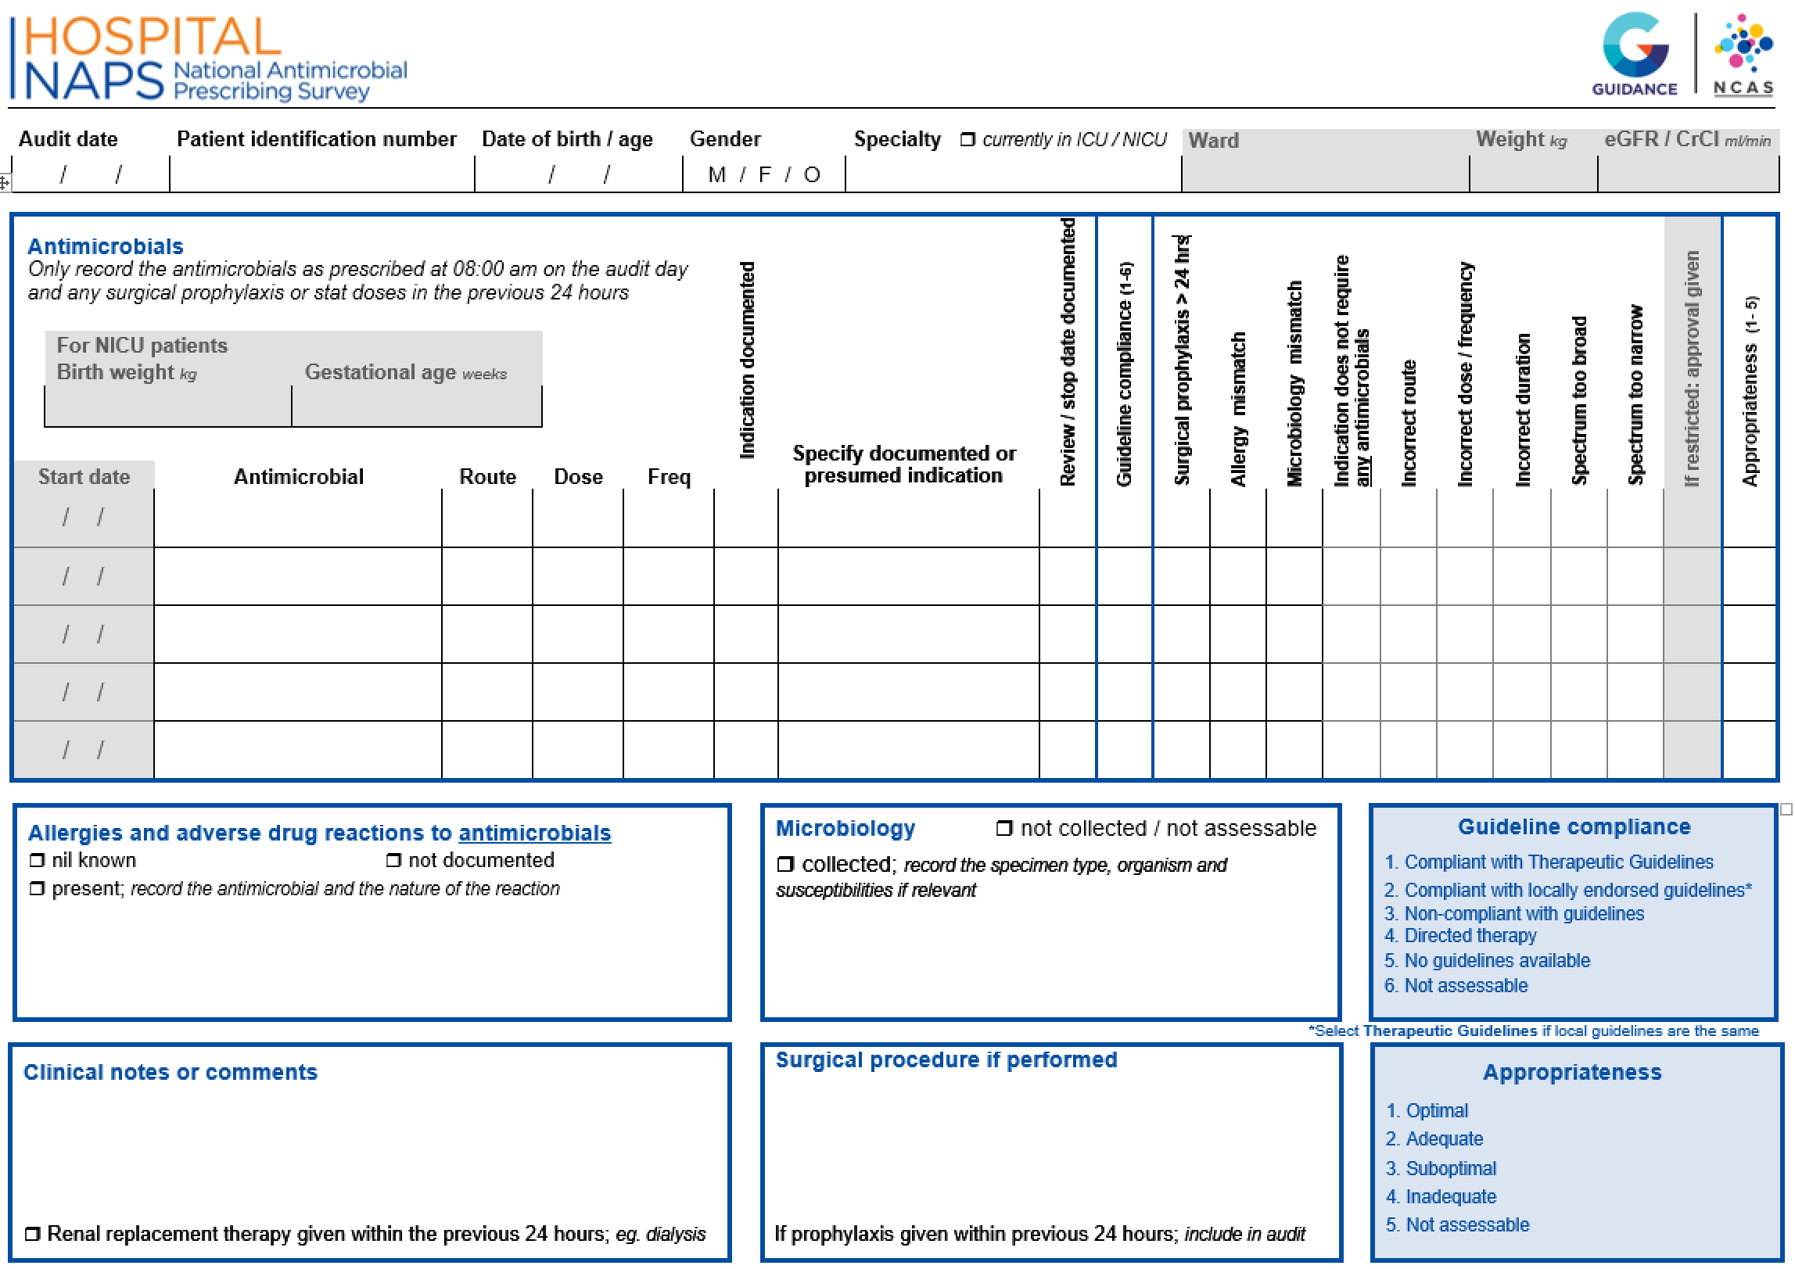

# Appendix 3: Appropriateness definitions

This table shows the Hospital NAPS appropriateness definitions.


# Appendix 4: Compliance with guidelines assessment criteria

|  |  |
| --- | --- |
| Compliance with guidelines (only choose one of the following five criteria) | |
| Compliant with Therapeutic Guidelines1 | * The prescription complies with the current Therapeutic Guidelines1, including:   + *route, dose, frequency*   **AND**   * + *takes into account acceptable alterations due to age, weight, renal function, allergies, other prescribed medications etc.* |
| Compliant with locally endorsed guidelines2 | * The prescription complies with an officially endorsed local guideline, including:   + *route, dose, frequency*   **AND**   * + *takes into account acceptable alterations due to age, weight, renal function, allergies, other prescribed medications etc.* * This does not include individual, departmental, or historical guidelines that do not have executive or drug and therapeutic committee approval * If the local guidelines are based exactly on the Therapeutic Guidelines1, then choose the ‘*Therapeutic Guidelines*’ in preference to ‘*Local guidelines*’ |
| Non-compliant with guidelines | * There is non-compliance with both Therapeutic Guidelines1 and local guidelines.   **UNLESS**  *the prescription takes into account acceptable alterations due to age, weight, renal function, allergies, other prescribed medications etc.* |
| Directed therapy | * The prescription has changed from empiric to directed therapy with microbiology culture or susceptibility results available |
| No guidelines available | * There are no guidelines available for the documented or presumed indication |
| Not assessable | * The medical records are not comprehensive enough to determine a documented or presumed indication   **OR**   * It is difficult to assess if there is compliance |

1. Antibiotic Expert Group. Therapeutic Guidelines: Antibiotic. Version 16 (2019). Melbourne <http://online.tg.org.au/ip/>
2. Local guidelines must be authorised and readily available on wards or on the hospital intranet. They cannot be a web link to international guidelines or other non-approved sites. Exceptions include paediatric and neonatal guidelines from an Australian children’s hospital and links to other official guidelines within a hospital’s network.

# Appendix 5: Access, Review, Curb and Contain (ARCC) classification system

Figure 5A: ARCC classification for first-line recommended agents9

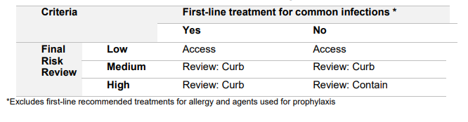

Figure 5B: Priority Antibacterial List based on ARCC classification9

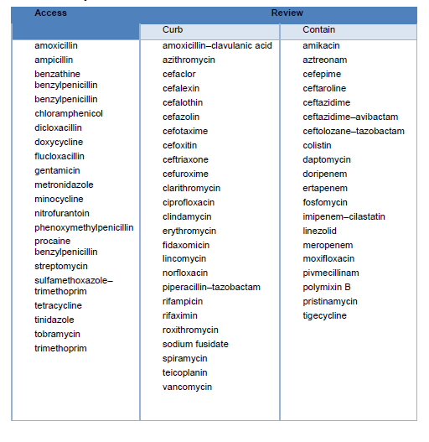

# Appendix 6: List of abbreviations

|  |  |
| --- | --- |
| Abbreviation | Definition |
| ACSQHC | Australian Commission on Safety and Quality in Health Care |
| AIHW | Australian Institute of Health and Welfare |
| AMS | Antimicrobial stewardship |
| ARCC | Access, Review, Curb and Contain |
| AURA | Antimicrobial Use and Resistance in Australia |
| CCS | Clinical Care Standard |
| COPD | Chronic obstructive pulmonary disease |
| COVID-19 | Coronavirus-19 |
| GEM | Geriatric evaluation and management |
| NAPS | National Antimicrobial Prescribing Survey |
| NCAS | National Centre for Antimicrobial Stewardship |
| NSQHS | National Safety and Quality Health Service |

# Acknowledgements

**Contributing facilities**

On behalf of the NCAS, we would like to thank all contributing facilities and auditors for their time and effort in collecting and entering the data and contributing to the AURA Surveillance System report, and for their continued commitment to improving safety and quality across the Australian healthcare system.

**National Centre for Antimicrobial Stewardship and the Guidance Group**

Professor Karin Thursky – Director, NCAS

Professor Kirsty Buising – Deputy Director, NCAS

Dr Rodney James – Director of Clinical Services, Guidance Group

Dr Courtney Ierano – NAPS Program Manager

Ms Caroline Chen – NAPS Project Officer

Associate Professor Noleen Bennett – Senior Infection Control Consultant

Mr Pramode Varghese – Director of Technical Services, Guidance Group

Mr Logesh Palani – Software Developer, Guidance Group

# References

1. Australian Government. Australia’s National Antimicrobial Resistance Strategy: 2020 and beyond. Canberra: Department of Health and Department of Agriculture, Water and the Environment; 2020. [Australia’s National Antimicrobial Resistance Strategy – 2020 and beyond | Antimicrobial resistance (amr.gov.au)](https://www.amr.gov.au/resources/australias-national-antimicrobial-resistance-strategy-2020-and-beyond)
2. Department of Health and Aged Care. Antimicrobial Use and Resistance in Australia Surveillance System. Available from: [Surveillance of antimicrobial use and resistance in human health | Antimicrobial resistance (amr.gov.au)](https://secure-web.cisco.com/1guvrsBTwWC38SofGjiRMllbd98013wzYUglTeMbo-uTL1AVGSjFvvMfJqB6TZ3lweNZtjSSeqNRyf1uVlrQh2iG2bHWmHTU0C73FporQpw6mfpuct8kB3M4wX-XPyE8Bj85xUM4-N76OIl835q1d9arWqgamTj00UvXZDL2_ahVg3boAsBCcKbxDkeeofU1y1O_pVC8ThHsF58ZmqB26F0GNybHqvB8Z_Pkq9T_meiprXJOproe0Gi9KWAas-EAEpjJqnvYAQEfTbhfeMolPso0IizOsaFClCeXsa-S7dy3PWanEKob5A_xVBo27WwC-/https%3A%2F%2Fwww.amr.gov.au%2Faustralias-response%2Fobjective-5-integrated-surveillance-and-response-resistance-and-usage%2Fsurveillance-antimicrobial-use-and-resistance-human-health%23antimicrobial-use-and-resistance-in-australia-aura) [accessed May 2022].
3. Australian Commission on Safety and Quality in Health Care. Antimicrobial Stewardship Clinical Care Standard. 2nd ed. Sydney: ACSQHC; 2020.
4. Therapeutic Guidelines. Melbourne: Therapeutic Guidelines Limited. Available from: <https://tgldcdp.tg.org.au/etgcomplete> [accessed July 2022].
5. Australian Commission on Safety and Quality in Health Care. National Safety and Quality Health Service Standards. 2nd ed. Sydney: ACSQHC; 2017.
6. Australian Bureau of Statistics. 1270.0.55.005 – Australian Statistical Geography Standard (ASGS): Volume 5 – Remoteness Structure, July 2016. Canberra: ABS; 2018. Available from: <https://www.abs.gov.au/ausstats/abs@.nsf/mf/1270.0.55.005> [accessed September 2020].
7. Australian Institute of Health and Welfare. Hospitals at a glance 2017–18. Canberra: AIHW; 2019. Available from: [https://www.aihw.gov.au/reports/hospitals/hospitals-at-a-glance-2017- 18](https://www.aihw.gov.au/reports/hospitals/hospitals-at-a-glance-2017-%2018). [accessed September 2020].
8. Australian Government Department of Health and Aged Care. Surgical prophylaxis prescribing in Australian hospitals: Results of the 2021 Surgical National Antimicrobial Prescribing Survey: 2024.
9. Australian Commission on Safety and Quality in Health Care. Priority Antibacterial List for Antimicrobial Resistance Containment: A stewardship resource for human health. Sydney: ACSQHC; 2020. Available from: <https://www.safetyandquality.gov.au/sites/default/files/2020-04/priority_antibacterial_list_for_amr_containment_-_mar_2020.pdf> [accessed July 2022].