Surgical prophylaxis prescribing in Australian hospitals

Results of the 2021 Surgical National Antimicrobial Prescribing Survey



Published by the Australian Government Department of Health and Aged Care

For issues regarding the content of the report:

Email: support@naps.org.au

Website: : https://www.naps.org.au/

ISBN: 978-1-74186-082-5

© Australian Government Department of Health and Aged Care

All material and work produced by the Department of Health and Aged Care is protected by copyright. The Department reserves the right to set out the terms and conditions for the use of such material.

Enquiries about the licence and any use of this publication are welcome and can be sent to AMR@health.gov.au

**Preferred citation**

Royal Melbourne Hospital and the National Centre for Antimicrobial Stewardship. Surgical prophylaxis prescribing in Australian hospitals. Results of the 2021 Surgical National Antimicrobial Prescribing Survey Canberra: Department of Health and Aged Care; 2024.

**Disclaimer**

This document is not intended to provide guidance on particular healthcare choices. You should contact your healthcare provider for advice on particular healthcare choices.

This document includes the views or recommendations of its authors and third parties. Royal Melbourne Hospital, the National Centre for Antimicrobial Stewardship and the Department of Health and Aged Care do not accept any legal liability for any injury, loss or damage incurred by the use of, or reliance on, this document.

# Contents

Summary 4

Key findings of the 2021 Surgical NAPS 4

1 Introduction 5

2 Methodology 7

2.1 Data collection 7

2.2 Auditor education and support 8

2.3 Data cleaning 8

2.4 Data analysis 8

3 Key findings 12

3.1 Overall findings 12

3.2 Key performance indicators 15

3.3 Impact of SARS-CoV-2 on the Surgical NAPS in 2021 24

4 Implications for clinical practice 25

5 Conclusion 27

Appendix 1: Limitations and considerations for interpretation of results 29

Sampling and selection bias 29

Survey methodology not defined 29

Subjective nature of assessments 29

Comparison of data over time 29

Appendix 2: Supplementary data 30

Appendix 3: Additional analyses 36

Antimicrobial choice 36

Route of administration 38

Prescribing by facility funding type 39

Procedure group analysis 40

Appendix 4: Comparative data analysis 45

Appendix 5: Procedure groups 52

Appendix 6: Surgical NAPS data collection form 53

Appendix 7: Surgical NAPS appropriateness definitions 55

Appendix 8: Glossary 56

Appendix 9: Abbreviations 59

References 60

Acknowledgements 62

# Summary

Now in its sixth year, the Surgical National Antimicrobial Prescribing Survey (Surgical NAPS) continues to be a widely adopted and valued tool to assess the quality of antimicrobial prescribing across Australian hospitals. It is a key contributor towards Australia’s National Antimicrobial Resistance Strategy1 and the Antimicrobial Use and Resistance in Australia (AURA) Surveillance System.2 Its focus on providing meaningful data for action with clear data visualisation for contributing hospitals has led to the continued high participation from Australian hospitals, funding types, peer groups and remoteness classifications.

During 2021, 181 hospitals (90 public and 91 private) submitted data on 10,927 surgical episodes with 9,599 procedural doses and 5,634 post-procedural prescriptions to the Surgical NAPS database. Analyses are also presented of trends from 2016 to 2021.

## Key findings of the 2021 Surgical NAPS

Consistent with findings from previous surveys of surgical prophylaxis, the 2021 Surgical NAPS identified ongoing concerning inappropriate use of surgical prophylaxis in contributor hospitals. Issues which require urgent and specific attention include:

* suboptimal documentation of the time of antimicrobial administration (90.8%) and incision time (76.6%)
* low rates of compliance with prescribing guidelines for procedural (68.3%) and post-procedural (57.2%) antimicrobial prophylaxis in relation to timing, dosage and duration of use
* inappropriate procedural prescribing (>30%) for dentoalveolar surgery, urological surgery, cardiac surgery and gynaecological surgery, in particular
* inappropriate post-procedural prescribing (>30%) for thoracic surgery, vascular surgery, dentoalveolar surgery, breast surgery, neurosurgery and cardiac surgery, in particular.

Other key findings from the 2021 Surgical NAPS include:

* Antimicrobial prescribing was assessed as appropriate in 56.5% of all surgical episodes.
* Reasons for inappropriate procedural prescribing were most commonly incorrect timing (50.2%) and the antimicrobial spectrum being too broad (22.4%).
* Post-procedurally, the most common reasons for inappropriate prescribing were incorrect duration (75.0%) and incorrect dose or frequency (20.7%).
* Antimicrobials prescribed post-procedurally continued for greater than 24 hours for 68.9% of prescriptions, and 42.4% continued for greater than 48 hours.
* Three procedure groups accounted for 53.7% of all surgical prophylaxis for up to or greater than 48 hours: orthopaedic surgery, ophthalmology, and plastic and reconstructive surgery.

The ongoing success of the Surgical NAPS is reflected in this report’s inclusion of over 6 years of data, with many hospitals continuing to participate over that period. A comparative data analysis is provided in Appendix 4.

# Introduction

The Surgical National Antimicrobial Prescribing Survey (Surgical NAPS) is a standardised tool that allows Australian health service organisations to audit and report antimicrobial use in incisional and non-incisional surgical procedures, and to investigate procedural and post-procedural surgical prophylaxis prescribing practices. It is designed to be a useful, practical and generalisable audit tool, providing some flexibility to fit the workflow of different facilities and to suit a range of auditors including pharmacists, nurses and medical practitioners.

The Surgical NAPS supports Australian health service organisations, states and territories and private health service provider organisations to develop and conduct antimicrobial stewardship (AMS) programs by:

* facilitating effective audit and review of antimicrobial use associated with surgical procedures, including compliance with prescribing guidelines and prescribing appropriateness
* facilitating effective communication regarding antimicrobial use and identifying key targets for interventions
* supporting workforce education and training
* supporting the implementation of antimicrobial stewardship practices across facilities where surgical procedures are performed.

Participation in the Surgical NAPS may assist health service organisations to demonstrate that they meet the antimicrobial stewardship actions of the National Safety and Quality Health Service (NSQHS) Preventing and Controlling Healthcare-Associated Infection Standard. This standard requires AMS programs to take action to improve prescribing, and to report to clinicians on appropriateness of prescribing and compliance with guidelines.3

An advisory statement (AS18/08) from the Australian Commission on Safety and Quality in Health Care (ACSQHC) was published in 2021 to update the NSQHS Standards to ensure hospitals address surgical prophylaxis as part of their AMS programs to maintain their national accreditation.4

To ensure this requirement is met, the statement advises monitoring the performance of surgical antimicrobial prophylaxis prescribing against the following indicators from the Antimicrobial Stewardship Clinical Care Standard (ASCCS) (revised 2020)5:

* Indicator 6a: the proportion of prescriptions for which the indication for prescribing the antimicrobial is documented.
* Indicator 6b: the proportion of prescriptions for which the duration, stop date or review date for the antimicrobial is documented.
* Indicator 8a: the proportion of patients for whom the perioperative prophylactic antimicrobial is prescribed in accordance with the current Therapeutic Guidelines10 or evidence-based, locally endorsed guidelines.
* Indicator 8b: the proportion of patients for whom the perioperative prophylactic antimicrobial dose is prescribed in accordance with the current Therapeutic Guidelines10 or evidence-based, locally endorsed guidelines.
* Indicator 8c: the proportion of patients who are administered prophylactic antimicrobials within the recommended time peri-operatively.
* Indicator 8d: the proportion of patients who were prescribed prolonged antimicrobials following a surgery or procedure that is discordant with the current Therapeutic Guidelines10 or evidence-based, locally endorsed guidelines.

The advisory statement also endorsed the utilisation of the NAPS online auditing platform and the National Antimicrobial Utilisation Surveillance Program (NAUSP) for monitoring appropriateness and usage respectively.4 The Surgical NAPS provides a means for assessing antimicrobial use; however, the onus is on the contributing facility to take action to address its local audit results.

Since 2016, ACSQHC and the Australian Government Department of Health and Aged Care (DHAC) have provided funding for the National Centre for Antimicrobial Stewardship (NCAS) to conduct the Surgical NAPS and contribute data to the Antimicrobial Use and Resistance in Australia (AURA) Surveillance System.6,7 Funding for AURA is provided by DHAC and state and territory health departments.

The Surgical NAPS methods are described in Chapter 2, and the limitations of and considerations for interpretation of results are outlined in Appendix 1.

# Methodology

## 2.1 Data collection

### 2.1.1 Data collection period

Data submitted through the online data entry portal from 1 January to 31 December 2021 were eligible for inclusion in the 2021 public report. Auditors may decide to audit from a different time period i.e., prior to 2021. This data is not included in the 2021 public report, but will influence the total number of facilities that have contributed data per year over time.

### 2.1.2 Recruitment

The Surgical NAPS module was available to all users registered for the NAPS. All registered users of the NAPS program were notified, and it was also marketed on social media via Twitter by the NCAS and ACSQHC.

### 2.1.3 Inclusion criteria

Any procedure type can be audited, including both incisional and non-incisional procedures.

### 2.1.4 Audit methodology

Auditors could choose a variety of methods to perform the survey, depending on the size of the facility and available resources. Data could be collected on paper data collection forms, then entered into the online portal (see Appendix 6 for data fields) or could be entered directly into the online portal. The data collection form was standardised across both paper and online platforms.

Retrospective audit

Retrospective audit was the recommended methodology, where possible. This survey could be performed over any chosen time frame; however, a minimum of one week or 30 consecutive procedures or surgical episodes was recommended. Ideally, theatre lists were obtained for each day to capture all procedures during this time frame. For those wanting to collect 30-day outcome follow-up data, it was recommended to perform retrospective chart and record review at least 30 days after the theatre list date.

#### Prospective audit

This survey could be performed over any chosen time frame; however, a minimum of one week or 30 consecutive procedures or surgical episodes was recommended. To capture all procedures during this time frame, a theatre list was obtained for each day during the selected audit time frame. Patients who underwent a procedure or surgical episode were followed prospectively for data collection purposes (refer to Appendix 8 for definitions). This process began once the patient left the operation suite/theatre and continued until post-operative antimicrobials had been ceased, or at 30-day follow-up (if collecting 30-day outcome follow-up data).

#### Other audit types

Smaller, directed surveys are useful to examine the routine practice of a surgical specialty or a particular procedure. This may be particularly relevant following a survey where an issue has been identified, such as over-prescription of an antimicrobial agent compared to the national average, or when a specialty is not prescribing in accordance with guidelines.

## 2.2 Auditor education and support

A data collection form (see Appendix 6), a user guide, Surgical NAPS appropriateness definitions (see Appendix 7) and worked case examples were made available to users through the resources page of the Surgical NAPS online portal. The NAPS support team provided telephone and email support during the survey period, as it does for all NAPS programs. A guide to the timing and duration of surgical prophylaxis was created to help with the assessment of appropriateness regarding these issues. Following the release of the newly designed Surgical NAPS reports for participating facilities on the online NAPS platform and the provision of early feedback regarding the complex nature of the reports, a written guide to interpreting these reports was also developed to assist users to understand their results.

### 2.2.1 Development of templates

A standardised reporting template and an example report were developed as a guide to help facilities communicate local survey results. Links to useful presentations and posters were also provided.

### 2.2.2 Expert assessments

An expert assessment service was provided by the NAPS support team. Facilities without access to infectious diseases specialists were offered assistance with the assessment of guideline compliance and prescription appropriateness. All facilities could request assessment support if they felt it would improve the quality of their audit.

## 2.3 Data cleaning

Following the 2019 Surgical NAPS, improvement in data validation was undertaken by the NAPS support team, particularly around data entry of dates. This helped to ensure data accuracy, particularly with respect to duration of surgical prophylaxis calculation. This improvement has reduced the requirement for extensive data cleaning, as was performed prior to the 2019 data analysis.

The data are cleaned and reviewed annually prior to analysis. For the 2021 dataset, antimicrobials prescribed with a duration of 31 days or greater were reviewed to confirm correct data entry of dates. Only 11 antimicrobial prescriptions required review, of which 4 (36%) required amendment by the NAPS support team following internal review and discussion. No facilities had to be contacted directly to review and amend their records.

## 2.4 Data analysis

The Surgical NAPS database is live and participating hospitals are free to amend, add or remove their data at any time. For the delivery of the annual national reports, the database is accessed and analysed each year; therefore, previous years’ data may have some small discrepancies in results compared with the previously published NAPS reports.

### 2.4.1 Procedural antimicrobial prophylaxis

Procedural antimicrobial prophylaxis is defined as any antimicrobial administered either immediately prior to or during the procedure for purposes of prophylaxis. Throughout this report, for procedural antimicrobials, each dose of the antimicrobial administered is recorded and reported individually.

### 2.4.2 Post-procedural antimicrobial prophylaxis

Post-procedural antimicrobial prophylaxis is defined as any antimicrobial given immediately following the surgical procedure for the purpose of surgical prophylaxis. Throughout this report, for post-procedural antimicrobials, each prescription course of the antimicrobial is recorded and reported, including any inpatient or discharge scripts.

Of the 10,927 surgical episodes audited, 609 had post-procedural antimicrobials prescribed only for treatment of infection or were not assessable. These were excluded from the post-procedural prophylaxis analysis, leaving 10,318 surgical episodes.

### 2.4.3 Appropriateness assessments

For reporting purposes, ‘optimal’ and ‘adequate’ are deemed to be appropriate, while ‘suboptimal’ and ‘inadequate’ are deemed to be inappropriate (see Appendix 7 for definitions of appropriateness). Each surgical episode was given an overall assessment of inappropriate if any single aspect of the procedural or post-procedural prescribing was deemed inappropriate by the auditor. This included allergy or microbiology mismatch; incorrect antimicrobial timing, dose, route, frequency or duration; if the antimicrobial spectrum was too broad or too narrow; or if the procedure did not require any antimicrobials (see Appendix 7 for detailed definitions).

### 2.4.4 Calculation of duration of surgical prophylaxis

Duration of surgical prophylaxis was calculated from the surgical incision date and time, if recorded; otherwise the surgery start date and time was used. These dates and times were used as a surrogate measure for the more accurate measure of administration date and time of the first procedural antimicrobial prescribed, which could not be determined for 852 (9.2%) of the prescribed initial procedural doses (n=9,262). The end date and time for the last prophylactic antimicrobial prescribed was then used to determine the end date and time of surgical prophylaxis. For calculation of duration of surgical prophylaxis greater than 24 and 48 hours, the required dates and times were consistently completed, and these could be calculated accurately. For days of therapy calculations, any incomplete administration time for the last dose of therapy did not affect these overall calculations.

### 2.4.5 Calculation of participation rates

In order to define the denominator for participation rates by different reporting groups (states and territories, peer groups and remoteness classifications), the Australian Institute of Health and Welfare (AIHW) peer group classification system was used.8 Hospital peer groups that would not be expected to perform surgical procedures were excluded from the denominator calculation.

### 2.4.6 Peer group inclusions and exclusions

The peer groups **included** for determination of denominator numbers for rates of participation were:

| **Public facilities** | **Private facilities** |
| --- | --- |
| Children’s hospitals  Combined women’s and children’s hospitals  Mixed day procedure hospitals  Other day procedure hospitals  Principal referral hospitals  Public acute group A hospitals  Public acute group B hospitals  Public acute group C hospitals  Public acute group D hospitals  Women’s hospitals  Women’s and children’s hospitals | Combined women’s and children’s hospitals  Endoscopy centres  Eye surgery centres  Gynaecology day hospitals  Mixed day procedure hospitals  Oral and maxillofacial surgery centres  Other acute specialised hospitals  Other specialist day hospitals  Other women’s and children’s hospitals  Plastic and reconstructive surgery centres  Private acute group A hospitals  Private acute group B hospitals  Private acute group C hospitals  Private acute group D hospitals  Women’s hospitals |

The peer groups **excluded** for determination of denominator numbers for rates of participation were:

| **Public facilities** | **Private facilities** |
| --- | --- |
| Drug and alcohol hospitals  Early parenting centres  Mixed subacute and non-acute hospitals  Other acute specialised hospitals  Other public acute specialised hospitals  Outpatient hospitals  Public acute psychiatric hospitals  Public child, adolescent and young adult psychiatric hospitals  Public forensic psychiatric hospitals  Public rehabilitation hospitals  Public subacute and non-acute psychiatric hospitals  Unpeered hospitals  Very small hospitals | Cardiovascular health centres  Dialysis clinics  Drug and alcohol hospitals  Fertility clinics  Haematology and oncology clinics  Hyperbaric health centres  Mixed subacute and non-acute hospitals  Private acute psychiatric hospitals  Private rehabilitation hospitals  Reproductive health centres  Same-day hospitals  Sleep centres  Unpeered hospitals  Very small hospitals |

# Key findings

Analyses of the 2021 Surgical NAPS data are presented below.

## Overall findings

### 3.1.1 Contributing facilities

There were 181 facilities that contributed data to the Surgical NAPS 2021 report, an increase of 24 facilities compared to 2020 (Figure 1). The 2021 cohort included public and private facilities from all states and territories (Table 1), covering a range of hospital peer groups8 and remoteness classifications9 (Tables A2.1, A2.2 and A2.3).

**Figure 1:** Surgical NAPS participation by public and private facilities, 2016–2021

Over time, participation in the Surgical NAPS has increased for all states and territories; however, participation notably decreased in 2021 for the Northern Territory and Tasmania (Figure A2.1) The greatest increase in participation from 2016 to 2021 was by facilities in Victoria (15.7%) (Figure A2.1) and by public acute group B hospitals, eye surgery centres and private acute group B hospitals (Figure A2.2).

We postulate that the noted decline in participation of principal referral hospitals may have been associated with the concurrent workload of Surgical NAPS auditors at these facilities due to the COVID-19 pandemic (Figure A2.2). Overwhelmingly, participants are from major city and inner regional areas (Figure A2.3), which is expected because this is where facilities that offer surgical procedures are most likely to be located.

Table 1: Number and percentage of contributing public and private facilities, by state and territory, Surgical NAPS 2021

| State/ territory | Contributing public facilities | Contributing private facilities | Total | Percentage of contributing facilities | Number of eligible peer group classifications nationally | Percentage of eligible peer group classifications |
| --- | --- | --- | --- | --- | --- | --- |
|  | (n) | (n) | (n) | (%) | (n) | (%) |
| ACT | – | 2 | 2 | 1.1 | 10 | 20.0 |
| NSW | 29 | 25 | 54 | 29.8 | 281 | 19.2 |
| NT | 1 | – | 1 | 0.6 | 7 | 14.3 |
| Qld | 9 | 16 | 25 | 13.8 | 179 | 14.0 |
| SA | 6 | 9 | 15 | 8.3 | 95 | 15.8 |
| Tas | 1 | 1 | 2 | 1.1 | 20 | 10.0 |
| Vic | 29 | 30 | 59 | 32.6 | 197 | 29.9 |
| WA | 15 | 8 | 23 | 12.7 | 82 | 28.0 |
| Total | 90 | 91 | 181 | 100 | 871 | 20.8 |

### 3.1.2 Surgical episodes

A total of 10,927 surgical episodes were included in the 2021 Surgical NAPS analyses. Characteristics of those episodes include:

* More episodes were analysed for female patients (n=6,142; 56.2%) compared to male patients (n=4,774, 43.7%).
* The majority (n=10,645, 97.4%) were initial surgeries, and 282 (2.6%) were subsequent surgeries.
* Most episodes (n=10,150, 92.9%) involved an incisional procedure.
* More elective procedures were performed (n=9,436, 86.4%) than emergency procedures (n=1,432, 13.1%).
* Over one-third (n=4,068, 37.2%) were for insertion or removal of prosthetic material.
* A very small number (n=437, 4.0%) were trauma related.

Figure 2 shows the breakdown of antimicrobial prescribing for surgical episodes reported to the 2021 Surgical NAPS, by procedural and post-procedural characteristics, to assist with understanding the analyses presented.

Figure 2: Surgical episodes by procedural and post-procedural prescribing characteristics, Surgical NAPS 2021

**Legend**

**Episode** – an individual procedure or set of procedures performed together during one surgical session and the subsequent post-procedural care associated with the procedure(s)

**Dose** – an individual antimicrobial dose administered either immediately prior to or during or after the surgical procedure

**Prescription** – any antimicrobial prescribed either as a single dose or as a course following the surgical procedure

**Existing antimicrobial** – an antimicrobial prescribed for treatment or prophylaxis in the 24 hours prior (72 hours if on dialysis) to the procedure, used to determine the appropriateness of whether procedural antimicrobials were given or not given

**Procedural antimicrobial** – an antimicrobial administered either immediately prior to or during the surgical procedure for the purpose of prophylaxis; each initial and repeat dose of the antimicrobial administered is recorded individually

**Post-procedural antimicrobial** – an antimicrobial prescribed following, but directly relating to, the procedure; each prescription of the antimicrobial is recorded, including any inpatient or discharge scripts

**Initial dose** – the first dose of an antimicrobial administered either immediately prior to or during the surgical procedure for the purpose of prophylaxis

**Repeat dose** – any subsequent dose of an antimicrobial administered during the surgical procedure for the purpose of prophylaxis

**Prophylaxis** – an antimicrobial prescribed for the prevention of surgery-related infection

**Treatment** – an antimicrobial prescribed for the treatment of infection related to the procedure

**Episodes where no prescriptions were for prophylaxis** – any episode where all prescribed antimicrobials are recorded as for ‘treatment’ and/or ‘not assessable’

### 3.1.3 Procedure groups

The highest number of procedures reported in the Surgical NAPS in 2021 were for orthopaedic surgery (21.0%) (Figure 3). Ophthalmology procedures accounted for 8.3% of reported procedures. This continues to be the specialty group with the largest change since the Surgical NAPS 2016 pilot,6 with an increase from 3.4% (Figure A4.1). The proportion of facilities contributing data for procedure groups ranged from 11.6% (21 facilities) for thoracic surgery to 65.7% (119 facilities) for plastic and reconstructive surgery (Table A2.2).

Figure 3: Percentage of surgical episodes for each surgical procedure group*, Surgical NAPS contributor facilities, 2021

Note: Where there were multiple procedures per surgical episode, only the primary procedure group was included.

* n=10,927 surgical episodes.

## 3.2 Key performance indicators

### 3.2.1 Documentation

A consistent theme over the last 6 years is the suboptimal documentation of surgical incision and antimicrobial administration times.

Of the 10,150 incisional procedures reported, over three-quarters had a time of incision documented (n=7,774, 76.6%).

Of the 9,262 initial procedural doses prescribed, 25.2% were recorded to the exact minute, and 65.6% to the nearest 15 minutes. The remainder (9.2%) did not have a documented administration time.

The timing of surgical prophylaxis is important to ensure high concentrations of antimicrobials at the time of surgical incision. Ensuring documentation of both incision and antimicrobial administration times may improve antimicrobial administration times and help prevent surgical site infections.

As electronic medical records are progressively implemented in Australia over time, we anticipate that this may support improvements in the documentation of surgical incision and antimicrobial administration times. In comparison to paper-based systems, electronic medical record systems have the capacity to prompt and require information that is otherwise routinely omitted (i.e., time of surgical incision and antimicrobial administration), as identified by the Surgical NAPS, to be entered.

### 3.2.2 Compliance with prescribing guidelines

#### Procedural prescribing

When no procedural antimicrobials were prescribed (n=2,610), guideline compliance (either with the Therapeutic Guidelines10 or with local guidelines) was high (85.7%). Compliance with prescribing guidelines was lower when antimicrobials were prescribed (68.3%) (Figure 4). Compliance increased to 71.1% when ‘directed therapy’, ‘no guidelines available’ and ‘not assessable’ doses were excluded (n=9,215).

Figure 4: Percentage of procedural antimicrobial doses* that were compliant with guidelines, Surgical NAPS contributor facilities, 2021

* n=9,599 procedural antimicrobial doses.

† Antibiotic Expert Group. Therapeutic Guidelines: Antibiotic. Version 16. Melbourne: Therapeutic Guidelines Limited; 2019. <https://www.tg.org.au/>

#### Post-procedural prescribing

When no post-procedural antimicrobials were prescribed, non-compliance with guidelines was infrequent (0.4%). When they were prescribed, over half (57.2%) of post-procedural antimicrobial prophylaxis was non-compliant with guidelines (Figure 5). Non-compliance increased to 59.4%, when ‘directed therapy’, ‘no guidelines available’ and ‘not assessable’ prescriptions were excluded.

Compliance with national prescribing guidelines10 continues to be poor, generally due to prolonged durations of oral, ocular and topical antimicrobials post-procedurally. These represent niche targeted areas for antimicrobial stewardship and quality improvement intervention.

Post-procedural extended use of oral or topical antimicrobials is not recommended by these guidelines and should be discouraged. Antimicrobials should only be prescribed when the evidence supports their use.

In the absence of other nationally or locally endorsed guidelines, recommendations for optimal use of surgical antimicrobial prophylaxis in Australia are available in the Therapeutic Guidelines: Antibiotic.10

Figure 5: Percentage of post-procedural prophylactic antimicrobial doses* that were compliant with guidelines, Surgical NAPS contributor facilities, 2021

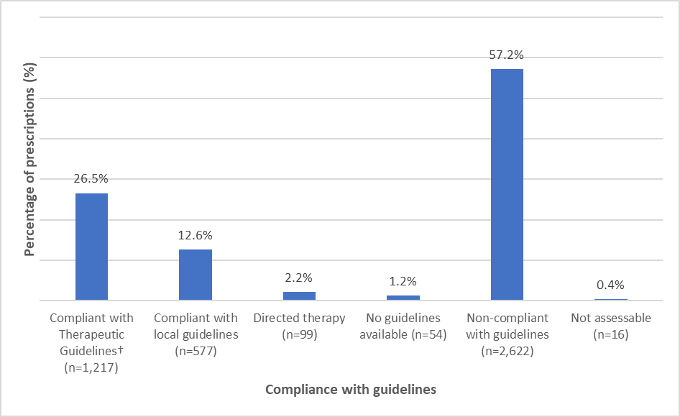

* n=4,585 prescriptions for post-procedural prophylaxis.

† Antibiotic Expert Group. Therapeutic Guidelines: Antibiotic. Version 16. Melbourne: Therapeutic Guidelines Limited; 2019. <https://www.tg.org.au/>

### 3.2.3 Overall appropriateness of prescribing

Prescribing was assessed as inappropriate for 38.3% of all surgical episodes (Figure 6). The percentage of episodes deemed inappropriate varied by procedure group, ranging from 1.7% for gastrointestinal endoscopic procedures, to 58.6% for breast surgery. All procedure groups had an inappropriateness rate greater than 25%, apart from gastrointestinal endoscopic procedures.

High rates of appropriateness for gastrointestinal endoscopic procedures are consistent every year and are expected as surgical antimicrobial prophylaxis is not routinely required. Only 3.6% of all gastrointestinal endoscopic procedures included at least one antimicrobial dose (Table A3.7).

In comparison to the 2020 report, inappropriateness of dentoalveolar surgery increased from 36.5% to 55.9%. This is largely due to the reduction in doses deemed ‘not assessable’ (5.0% compared to 34.1% in 2020). Potential reasons for this may be improvements in auditor assessments and clinical documentation over time.

Figure 6: Percentage of episodes by appropriateness* of prescribing for each   
surgical procedure group, Surgical NAPS contributor facilities, 2021

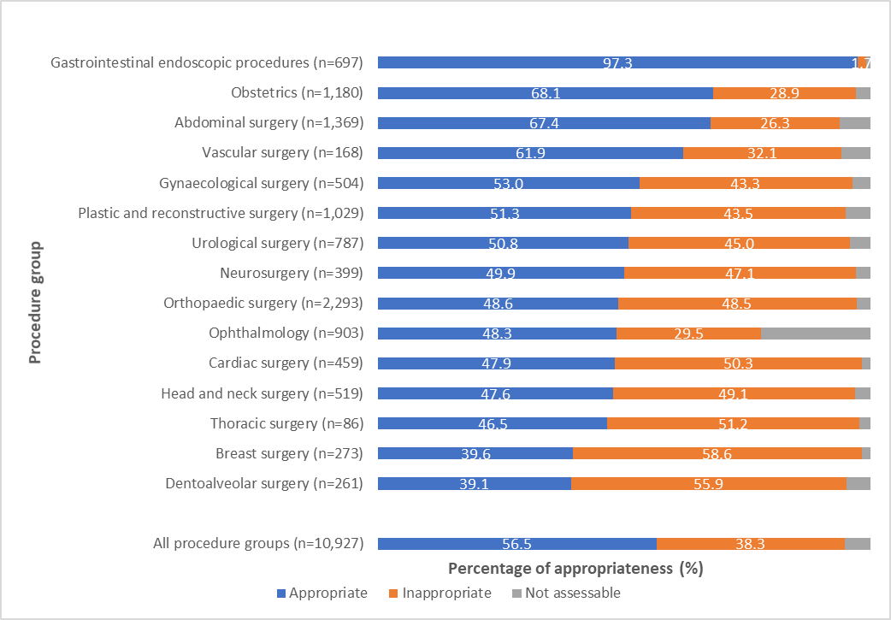

* For appropriateness definitions, refer to Appendix 7.

#### Procedural prescribing

Approximately one-quarter (24.5%) of all procedural prescribing was assessed as inappropriate (Table 2). The proportion of episodes for which prescribing was deemed inappropriate was higher when antimicrobials were prescribed than when they were not prescribed (29.5% and 8.2% respectively). Antimicrobials were prescribed when not required in 8.7% of episodes. Additional analyses can be found in Appendix 3.

When procedural antimicrobials were prescribed, appropriateness was higher, with 65.8% deemed optimal (Figure A2.4). When no procedural antimicrobials were prescribed, inappropriateness was low (8.2%). Overall, 29.1% of all procedural prescribing was deemed inappropriate when non-assessable doses were excluded (n=9,326).

Table 2: Appropriateness* of procedural prescribing of antimicrobials for surgical episodes and antimicrobial doses, Surgical NAPS contributor facilities, 2021

|  |  |  |  |  |  |  |  |
| --- | --- | --- | --- | --- | --- | --- | --- |
| Procedural prophylaxis | Total | Appropriate | | Inappropriate | | Not assessable | |
| (n) | (n) (%) | | (n) (%) | | (n) (%) | |
| Surgical episodes | 10,927 | 8,293 | 75.9 | 2,681 | 24.5 | 377 | 3.5 |
| Antimicrobial prescribed | 8,317 | 5,615 | 67.5 | 2,452 | 29.5 | 250 | 3.0 |
| * when required* | *7,490* | *5,615* | *75.0* | *1,634* | *21.8* | *241* | *3.2* |
| * when not required* | *951* | *–* | *–* | *937* | *98.5* | *14* | *1.5* |
| No antimicrobial prescribed | 2,610 | 2,268 | 86.9 | 215 | 8.2 | 127 | 4.9 |
| * when required* | *259* | *51* | *19.7* | *201* | *77.6* | *7* | *2.7* |
| * when not required* | *2,351* | *2,217* | *94.3* | *14* | *0.6* | *120* | *5.1* |
|  |  |  |  |  |  |  |  |
| Antimicrobial doses | 9,599 | 6,909 | 68.9 | 2,717 | 28.3 | 273 | 2.8 |
| Initial dose | 9,262 | 6,395 | 69.1 | 2,599 | 28.1 | 268 | 2.9 |
|  *when required* | *8,265* | *6,395* | *77.4* | *1,613* | *19.5* | *257* | *3.1* |
|  *when not required* | *997* | *–* | *–* | *986* | *98.9* | *11* | *1.1* |
| Repeat dose | 337 | 214 | 63.5 | 118 | 35.0 | 5 | 1.5 |
|  *when required* | *322* | *214* | *66.5* | *103* | *32.0* | *5* | *1.6* |
|  *when not required* | *15* | *–* | *–* | *15* | *100.0* | *–* | *–* |
|  *not given when required*† | *36* | *–* | *–* | *36* | *100.0* | *–* | *–* |

* The overall appropriateness of prescribing for a surgical episode was determined by taking the lowest ranked assessment of the individual doses, including all episodes where antimicrobials were prescribed as well as those where none were prescribed.

† Excluded from total antimicrobial doses, as these are doses that were not given.

##### Reasons for inappropriate procedural prescribing

There were 2,717 procedural doses deemed inappropriate. Of these, 1,001 (36.8%), were deemed not required. For procedural doses, where antimicrobials were recommended by guidelines (n=8,587), 20.0% (n=1,716) were deemed inappropriate.

The most common reasons for this inappropriate prescribing were incorrect timing, ‘spectrum too broad’ and incorrect dosing (50.2%, 22.4% and 19.5% respectively) (Figure 7).

Figure 7: Reasons for inappropriateness*, by percentage of required procedural antimicrobial doses†, Surgical NAPS contributor facilities, 2021

* For appropriateness definitions, refer to Appendix 7.

† n=1,716 antimicrobial doses.

##### Timing of administration

Incorrect timing was the reason for 50.2% of required procedural doses being deemed inappropriate (Figure 7).

As 9.1% of procedural doses did not have a recorded administration time, when these were excluded, incorrect timing accounted for 9.9% of all required procedural doses.

Given the small improvement in appropriateness of procedural prescribing over time (Figure A4.2), a greater focus on practical and effective interventions is needed to sustain and enhance these improvements. Simple AMS interventions, with the focus on improving documentation and timing of incision and antimicrobial administration, require consistent implementation and organisational support from health services to support their sustainability. Such measures could lead to reductions in surgical site infections and in complications from antimicrobial use. These interventions do not require complex AMS or infectious diseases advice, so they should be feasible to implement rapidly for most health service organisations that perform surgical procedures.

Further clarity from current guidelines may be required to support optimal prescribing and guideline adoption, particularly in relation to the need for intra-operative re-dosing; the timing of post-procedural doses, if indicated; and the inclusion of prophylaxis recommendations for specific surgical procedures (i.e., the most commonly performed). To support Surgical NAPS end users, the NCAS developed the ‘Timing and duration of surgical prophylaxis recommendations 2020’ resource, which includes clinically relevant cases that examine complex surgical antimicrobial use – i.e., patients also receiving existing antimicrobials and intra-operative re-dosing.11

#### Post-procedural prescribing

Post-procedural prophylaxis was deemed inappropriate in 23.9% of the 10,927 surgical episodes audited (Table 3). The 55.2% of episodes where no post-procedural antimicrobials were prescribed were mostly deemed appropriate (98.0%). Of the surgical episodes that had at least one post-procedural antimicrobial prescribed for prophylaxis, 59.7% were deemed inappropriate. Antimicrobials were prescribed when not required for 12.1% (n=1,325) of episodes (Table 3). Additional analyses can be found in Appendix 3.

Almost half of post-procedural antimicrobial prophylaxis prescriptions were deemed inadequate (46.7%), with 35.5% being assessed as optimal (Figure A2.5). Post-procedural prophylaxis was deemed inappropriate for 60.5% of prescriptions, when the non-assessable prescriptions were excluded.

Table 3: Appropriateness* of post-procedural prophylactic prescribing of antimicrobials for surgical episodes and antimicrobial prescriptions#, Surgical NAPS contributor facilities, 2021

|  |  |  |  |  |  |  |  |
| --- | --- | --- | --- | --- | --- | --- | --- |
| Post-procedural prophylaxis | Total | Appropriate | | Inappropriate | | Not assessable | |
| (n) | (n) (%) | | (n) (%) | | (n) (%) | |
| Surgical episodes | 10,927 | 7,965 | 72.9 | 2,616 | 23.9 | 222 | 2 |
| Antimicrobial prescribed | 3,978 | 1,566 | 39.4 | 2,358 | 59.3 | 54 | 1.4 |
|  *when required* | *2,744* | *1,565* | *57.0* | *1,147* | *41.8* | *32* | *1.1* |
|  *when not required* | *1,325* | *3* | *0.2* | *1,300* | *98.1* | *22* | *1.7* |
| No antimicrobial  prescribed | 6,030 | 5,909 | 98.0 | 34 | 0.6 | 87 | 1.4 |
| 9 *when required* | *28* | *13* | *46.4* | *11* | *39.3* | *4* | *14.3* |
| 9 *when not required* | *6002* | *5896* | *98.2* | *23* | *0.4* | *83* | *1.4* |
| Not assessable | 310 | – | – | – | – | 310 | 100 |
|  |  |  |  |  |  |  |  |
| Antimicrobial prescriptions | 4,715 | 1,748 | 37.1 | 2,904 | 61.6 | 63 | 1.3 |
| Prophylaxis | 4,585 | 1,790 | 39.0 | 2,739 | 59.7 | 56 | 1.2 |
|  *when required* | *3,037* | *1,789* | *58.9* | *1,214* | *40.0* | *34* | *1.1* |
|  *when not required* | *1,548* | *1* | *0.1* | *1,525* | *98.5* | *22* | *1.4* |
| Treatment | 97 | 61 | 62.9 | 28 | 28.9 | 8 | 8.2 |
| Not assessable | 33 | 8 | 24.2 | 14 | 42.4 | 11 | 33.3 |

* The overall appropriateness of prescribing for a surgical episode was determined by taking the lowest ranked assessment of the individual post-procedural prescriptions.

# 609 surgical episodes had only post-procedural antimicrobials prescribed for treatment of infection or were not assessable and were excluded from the analysis.

##### Reasons for inappropriate post-procedural prescribing

There were 2,739 post-procedural prophylaxis prescriptions deemed inappropriate. Of these, 1,525 (55.7%) were deemed not required (n=2,739).

For post-procedural prophylactic prescriptions, where prophylaxis was recommended by guidelines, 40.0% were deemed inappropriate (n=1,214).

The majority of inappropriate prescriptions were due to incorrect duration (75.0%); dose and frequency inconsistencies were the next most common reason (20.7%) (Figure 8).

Figure 8: Reasons for inappropriateness*, by percentage of required post-procedural prophylactic antimicrobial prescriptions†, Surgical NAPS contributor facilities, 2021

* For appropriateness definitions, refer to Appendix 7.

† n=1,214 prescriptions where post-procedural antimicrobial prophylaxis was required and deemed inappropriate.

##### Duration greater than 24 hours

Of all post-procedural prescriptions, 68.9% involved prophylaxis for greater than 24 hours (Table 4). Of those prescribed for up to or greater than 48 hours (42.4%), 5 of the 15 procedural groups had rates greater than 70%. These were dentoalveolar surgery (96.9%), gastrointestinal endoscopic procedures (75.0%), plastic and reconstructive surgery (74.9%), ophthalmology (73.0%), and head and neck surgery (71.9%).

When the burden of episodes audited is considered, 53.7% of all prescriptions up to or greater than 48 hours are accounted for by 3 procedure groups: ophthalmology (n=491 prescriptions), plastic and reconstructive surgery (n=299 prescriptions) and orthopaedic surgery (n=253 prescriptions).

In comparison to the 2020 report, there is noticeable improvement for orthopaedic surgery, in which post-procedural antimicrobial prescriptions with a duration greater than 48 hours reduced from 39.1% (2020) to 14.8% (2021). In contrast, plastic and reconstructive surgery prescriptions increased from 35.9% (2020) to 74.9% (2021), and dentoalveolar surgery prescriptions increased from 39.7% (2020) to 96.9% (2021).

Table 4: Duration of surgical prophylaxis and percentage prescribed for greater than 24 and 48 hours, by procedure group, Surgical NAPS contributor facilities, 2021

|  |  |  |  |  |  |  |  |
| --- | --- | --- | --- | --- | --- | --- | --- |
| Procedure group | Antimicrobial  prescriptions | Duration range | Duration median | Duration | | Duration | |
| >24 hours | | >48 hours | |
| (n) | (days) | (days) | (n) (%) | | (n) (%) | |
| Orthopaedic surgery | 1,713 | 1–23 | 1 | 891 | 52.0 | 253 | 14.8 |
| Ophthalmology | 673 | 1–36 | 6 | 545 | 81.0 | 491 | 73 |
| Plastic and reconstructive surgery | 399 | 1–29 | 5 | 333 | 83.5 | 299 | 74.9 |
| Cardiac surgery | 355 | 1–12 | 2 | 245 | 69.0 | 146 | 41.1 |
| Head and neck surgery | 253 | 1–22 | 5 | 230 | 90.9 | 182 | 71.9 |
| Abdominal surgery | 247 | 1–19 | 2 | 194 | 78.5 | 133 | 53.8 |
| Neurosurgery | 215 | 1–15 | 1 | 147 | 68.4 | 32 | 14.9 |
| Breast surgery | 186 | 1–49 | 5 | 142 | 76.3 | 118 | 63.4 |
| Urological surgery | 178 | 1–30 | 2 | 141 | 79.2 | 90 | 50.6 |
| Dentoalveolar surgery | 130 | 1–15 | 5 | 127 | 97.7 | 126 | 96.9 |
| Gynaecological surgery | 78 | 1–12 | 1 | 60 | 76.9 | 31 | 39.7 |
| Obstetrics | 75 | 1–7 | 1 | 48 | 64.0 | 18 | 24 |
| Thoracic surgery | 49 | 1–7 | 1 | 33 | 67.3 | 13 | 26.5 |
| Vascular surgery | 30 | 1–9 | 1 | 21 | 70.0 | 9 | 30 |
| Gastrointestinal endoscopic procedures | 4 | 2–4 | 3 | 4 | 100.0 | 3 | 75 |
| Total | 4,585 | 1–49 | 1 | 3,161 | 68.9 | 1,944 | 42.4 |

It is promising that the range of duration of surgical prophylaxis has reduced over time. The overall range of duration for 2021 was 1–49 days, compared to 1–65 days in the 2016 report.

Despite the strong evidence of recent randomised controlled trials and systematic reviews to advocate for single-dose surgical antimicrobial prophylaxis,12-14 improvements in post-procedural prescribing may be more challenging to achieve as this will require de-implementation of current practices, despite their inappropriateness. To support optimisation of post-procedural antimicrobial use, engagement with the relevant surgical specialties is critical. This may include co-design and leadership of initiatives targeted to their surgical specialty unit. Peer review of prescribing practices and benchmarking of outcomes may contribute to changes in practice. Nurse, pharmacist or anaesthetist led automatic stop orders may be useful if extended duration of antimicrobial use is impacted by the frequency of antimicrobial review. AMS programs in Surgical NAPS contributor organisations can develop targeted initiatives informed by analyses of their own data. Local data evaluation will assist AMS programs to identify which specialties they should target to improve surgical prophylaxis prescribing, and where return on investment is likely to be greatest based on the volume of procedures and the appropriateness of prescribing.

The summary analyses included in this report for procedure groups (see Appendix 3) are intended to support focused quality improvement approaches, such as local benchmarking of surgical antimicrobial prophylaxis by specialty and targeted interventions. These include orthopaedic, abdominal, plastic and reconstructive, ophthalmic, breast and urological surgery, because of either increased surgical procedure volume in these specialties, or high rates of inappropriate prescribing in specific circumstances.

For many procedures, there is no evidence that prophylactic antimicrobial use procedurally or post-procedurally is of benefit in reducing post-operative infections; therefore, it is not recommended by guidelines for these procedures. There are very few procedures or clinical situations where available evidence supports antimicrobial use for other than a single pre-operative dose. Even in these situations, the total duration of antimicrobial prophylaxis should not exceed 24 hours. An exception to this is ophthalmic surgery, for which use of chloramphenicol for up to a week post-procedurally may be considered.10

## 3.3 Impact of SARS-CoV-2 on the Surgical NAPS in 2021

The global coronavirus disease 19 (COVID-19) pandemic, caused by SARS-CoV-2, had a significant impact on the Australian healthcare system in 2021. During periods of high community transmission, elective surgery was cancelled within both the public and private systems. This had a major impact on the ability of hospitals to perform the Surgical NAPS, particularly within the Victorian public system, where there was a prolonged period of lockdown (82 days) and a total of 113 days of lockdown in 2021, with few to no surgical procedures being performed.

Nationally, lockdowns have had a flow-on impact on the public hospital elective surgery waiting lists and admissions.15 There were 688,000 admissions to hospital from the public elective surgery waiting lists in the 2019–20 financial year (the beginning of the COVID-19 pandemic), which was lower than the 758,000 admissions in the 2018–19 financial year. Suspension of surgeries in 2020 then contributed to a backlog of delayed surgeries and a subsequent increase in admissions in 2020–21 (754,600 admissions).15

The strain on the healthcare workforce caused by the COVID-19 pandemic is also likely to have impacted on the resources available to conduct the Surgical NAPS, as demonstrated in the 2020 report. However, for 2021 there was an increase in contributing facilities. Most states and territories remained stable in terms of the number of contributing health care facilities, with the greatest increase in Victorian hospitals (n=22 more facilities) (Figure A2.1).

Comparing the 2019, 2020 and 2021 Surgical NAPS report data, the number of elective surgical procedures audited increased but the proportions remained similar (2019: n=7,971, 85.6%; 2020: n=7,857, 87.3%; 2021: n=9,436, 86.4%). Additionally, the rates of trauma-related surgical episodes audited in 2020 and 2021 were also similar (2020: n=249, 3.1%; 2021: n=437, 4.0%).

# 4 Implications for clinical practice

#### Suboptimal documentation

Documentation is an important component of comprehensive medical care as it allows timely and accurate communication between members of the clinical care team and contributes to effective safety and quality of patient care. Failure to document important components of surgical care was reported for between 1 in 4 surgical procedures for incision time, and 1 in 10 surgical procedures for administration time.

Correct timing of antimicrobial administration ensures a high concentration of antimicrobial at the time of surgical incision, which reduces the risk of surgical site infection and the need for post-operative antimicrobials. Improving documentation is an important step in ensuring appropriate timing of antimicrobial administration and should be addressed in targeted improvement strategies.

#### Compliance with guidelines and appropriateness of prescribing

Compliance with guidelines for surgical antimicrobial prophylaxis, and consequently appropriateness of prescribing, continues to be poor overall, but even more so for post-procedural prescriptions. This relates to prescription of antimicrobials that are not required and prolonged duration of antimicrobial use. Procedurally, inappropriate antimicrobial use is primarily due to suboptimal timing of administration.

In practice, for many procedures there is no evidence that prophylactic antimicrobial use, either procedurally or post-procedurally, reduces post-operative infections. Unnecessary surgical antimicrobial prophylaxis has been shown to cause harm to patients such as drug-related toxicities (e.g., renal failure) and other adverse reactions; and likely contributes to antimicrobial resistance. Reducing inappropriate surgical antimicrobial prophylaxis balances the unintended harms of antimicrobial use with the benefits of evidence-based care.

#### Surgical specialty specific issues

There are specific patterns of inappropriate prescribing for some surgical specialities, such as prolonged duration of use, or choice of antimicrobials. Targeting specialties with high rates of inappropriate prescribing, such as thoracic surgery, vascular surgery, dentoalveolar surgery, breast surgery, neurosurgery and cardiac surgery is a priority for AMS programs.

Similarly, it is important to consider targeting specialties that are audited at higher volumes – such as orthopaedic surgery, abdominal surgery and obstetrics – to generate greater impact. Additional specific targets include the surgical specialties that together represented 53.7% of all surgical prophylaxis use for up to or greater than 48 hours: orthopaedic surgery, ophthalmology, and plastic and reconstructive surgery.

Ensuring that these specialties have patient care aligned with prescribing guidelines and are supported to engage in the quality improvement process to improve prescribing will help to deliver consistent high-quality care and improve the use of surgical antimicrobial prophylaxis in Australian health service organisations.

#### Recommendations for potential actionable items

To address the ongoing patient safety issues relating to inappropriate prescribing of surgical antimicrobial prophylaxis, we recommend:

* continued collaboration with the Royal Australasian College of Surgeons, and engagement with surgical specialty societies and other key stakeholders to develop improvement strategies for prescribing of surgical antimicrobial prophylaxis
* engagement with colleges, surgical specialty societies, states and territories and private health service providers via provision of specific information on prescribing appropriateness for selected procedural specialties
* continued promotion of compliance with Australian prescribing guidelines
* continued collaboration with the states and territories and the private sector to promote ongoing surveillance of appropriateness of surgical antimicrobial prophylaxis in Australian health service organisations
* engagement with digital health clinicians and experts to discuss quality improvement works that capitalise on the capabilities of electronic medical record systems
* ongoing promotion of the adoption of surveillance data to develop and implement targeted improvement programs.

# 5 Conclusion

Surgical prophylaxis, when prescribed appropriately, has the benefit of reducing the development of post-operative infections, including surgical site infections, pneumonia, and urinary tract infections.10 Use of antimicrobials for the prevention of such infections must be balanced against complications associated with their use, including allergic and adverse drug reactions, and the development of antimicrobial resistance. Surgical antimicrobial prophylaxis should be reserved for procedures or clinical situations where there is strong evidence that the benefit outweighs potential harm.

For the Surgical NAPS in 2021, which was the sixth year the audit has been conducted, the increase in uptake, compared with 2020 survey and in relation to the restrictions placed on elective surgery due to the COVID-19 pandemic, was extremely encouraging. The number of contributing facilities has doubled since the inception of the Surgical NAPS in 2016 (181 in 2021 compared with 84 in 2016). As the Surgical NAPS is voluntary and is resource intensive compared with the Hospital NAPS and the Quality Improvement NAPS, this continual increase suggests that the survey is regarded as a valuable tool to identify opportunities to improve surgical antimicrobial prophylaxis. Ongoing annual contributions to the Surgical NAPS continue to provide benefits to end users to support further improvements and assess the efficacy and impact of implemented interventions in terms of guideline compliance and appropriateness. Despite variation in participation rates and the specialty focus between contributors, consistent themes for quality improvement are evident.

With over 6 years of Surgical NAPS data collected over time, longitudinal trend analysis of the Surgical NAPS needs to be undertaken with due consideration of the variation in the cohort that occurs each year in relation to the procedure groups audited, the peer groups that voluntarily contribute data, and intermittent participation in the Surgical NAPS by individual facilities. However, over the 6 years in which the Surgical NAPS has been conducted, there has been an increase in the appropriateness of procedural prescribing, which may be due to improved timing of administration and dosage of antimicrobials. There have been no discernible changes in appropriateness of post-procedural prescribing over the 6 years, as evidenced by ongoing high rates of extended post-procedural antimicrobial prophylaxis. Encouragingly the 2020 and 2021 Surgical NAPS reports demonstrate lower ranges of surgical antimicrobial prophylaxis duration than previous years (Table 4). However, there is still significant room for quality improvement, as a range of 49 days for surgical prophylaxis remains of concern.

To continue to engage and support Surgical NAPS end users, the NCAS also provides a range of clinical and educational resources on its website16 and collaborates with the ACSQHC and relevant professional surgical bodies (i.e., the Royal Australasian College of Surgeons and the Royal Australian and New Zealand College of Ophthalmologists) to provide support regarding interventions to improve antimicrobial prescribing practices. For example, in August 2021 the ACSQHC published the Cataract Clinical Care Standard, with case studies highlighting the ability to optimise patient care and post-procedural antimicrobial use while utilising data from the Surgical NAPS.17

In summary, and consistent with findings from previous surveys of surgical prophylaxis, the 2021 Surgical NAPS identified ongoing concerning inappropriate use of surgical prophylaxis in contributor hospitals. The issues involved require urgent attention from all stakeholders to improve antimicrobial stewardship in the operative setting.

# Appendix 1: Limitations and considerations for interpretation of results

The results presented in this report should be interpreted in the context of the following limitations and considerations.

## Sampling and selection bias

The facilities that participated were not a randomised sample, because participation was voluntary. Therefore, the results might not be representative of all Australian facilities where surgery is performed.Each hospital could choose how to perform the Surgical NAPS audit. Audits may have been conducted as prevalence surveys (consecutive or random patients), directed surveys (particular surgical specialties or procedures) or other types of audits; therefore it is not possible to determine the exact prevalence of the surgical procedures or antimicrobials prescribed.

## Survey methodology not defined

For the Surgical NAPS, each hospital could decide how it performed the survey and which patients, or surgical specialties, were audited. If directed surveys were performed, patient sampling may not have been random, and auditors may have targeted problem or higher volume surgical units.

## Subjective nature of assessments

Individual auditors at each contributing facility were responsible for assessing the compliance with guidelines and appropriateness of antimicrobial prescribing. These assessments are not completely objective, as they involve some degree of interpretation, although the Surgical NAPS appropriateness definitions resource (Appendix 7) improves this objectivity. This is further supplemented by the NAPS support team and online training resources. Remote expert assessments could also be conducted by the NAPS support team on request.

## Comparison of data over time

Care is required in relation to comparisons of Surgical NAPS data from one year to another, as the cohort of contributors varies from year to year, along with the proportions of surgical procedure groups represented.

# Appendix 2: Supplementary data

Table A2.1: Number and percentage of contributing public and private facilities by remoteness classification*, Surgical NAPS 2021

|  |  |  |  |  |  |  |
| --- | --- | --- | --- | --- | --- | --- |
| Remoteness classification | Public | Private | Total | Percentage of contributing facilities | Number in remoteness classification group | Percentage of remoteness classification group |
| (n) | (n) | (n) | (%) | (n) | (%) |
| Major cities | 36 | 71 | 107 | 59.1 | 417 | 25.7 |
| Inner regional | 32 | 15 | 47 | 26.0 | 216 | 21.8 |
| Outer regional | 20 | 4 | 24 | 13.3 | 166 | 14.5 |
| Remote | 3 | – | 3 | 1.7 | 45 | 6.7 |
| Very remote | – | – | – | – | 27 | – |
| Total | 91 | 90 | 181 |  | 871 |  |

* Australian Bureau of Statistics. 1270.0.55.005 – Australian Statistical Geography Standard (ASGS): Volume 5 – Remoteness Structure, July 2016. Canberra: ABS; 2018.

Table A2.2: Number and percentage of Surgical NAPS contributor facilities by funding type*, by surgical procedure group, 2021

|  |  |  |  |  |
| --- | --- | --- | --- | --- |
| Procedure group | Public facilities | Private facilities | Contributing  facilities | |
| (n) | (n) | (n) (%) | |
| Plastic and reconstructive surgery | 62 | 57 | 119 | 65.7 |
| Orthopaedic surgery | 49 | 61 | 110 | 60.8 |
| Abdominal surgery | 65 | 53 | 118 | 65.2 |
| Urological surgery | 51 | 48 | 99 | 54.7 |
| Head and neck surgery | 51 | 42 | 93 | 51.4 |
| Gynaecological surgery | 49 | 32 | 81 | 44.8 |
| Obstetrics | 57 | 31 | 88 | 48.6 |
| Gastrointestinal endoscopic procedures | 51 | 27 | 78 | 43.1 |
| Ophthalmology | 24 | 31 | 55 | 30.4 |
| Vascular surgery | 18 | 16 | 34 | 18.8 |
| Neurosurgery | 16 | 27 | 43 | 23.8 |
| Breast surgery | 20 | 34 | 54 | 29.8 |
| Cardiac surgery | 11 | 18 | 29 | 16 |
| Dentoalveolar surgery | 15 | 24 | 39 | 21.5 |
| Thoracic surgery | 12 | 9 | 21 | 11.6 |

* n=181 facilities.

Figure A2.1: Percentage of contributing facilities, by state and territory, of all eligible peer group classifications*, Surgical NAPS 2016-2021

* Australian Institute of Health and Welfare. Australian hospital peer groups. Health services series no. 66. Cat. no. HSE 170. Canberra: AIHW; 2015.

Figure A2.2: Percentage of contributing facilities, by peer group classification*, Surgical NAPS 2016-2021

* Australian Institute of Health and Welfare. Australian hospital peer groups. Health services series no. 66. Cat. no. HSE 170. Canberra: AIHW; 2015.

Figure A2.3: Percentage of contributing facilities, by remoteness classification*, Surgical NAPS 2016-2021

* Australian Bureau of Statistics. 1270.0.55.005 – Australian Statistical Geography Standard (ASGS): Volume 5 – Remoteness Structure, July 2016. Canberra: ABS; 2018.

Table A2.3: Number and percentage of contributing public and private facilities, by peer group classification*, Surgical NAPS 2021

|  |  |  |  |  |
| --- | --- | --- | --- | --- |
| Peer group classification | Number | Percentage of participating facilities | Number in peer group classification | Percentage of peer group classification |
| (n) | (%) | (n) | (%) |
| **Public facilities** | **90** | **49.7** | **493** | **18.3** |
| Principal referral hospitals | 9 | 5.0 | 29 | 31.0 |
| Public acute group A hospitals | 24 | 13.3 | 62 | 38.7 |
| Public acute group B hospitals | 18 | 9.9 | 44 | 40.9 |
| Public acute group C hospitals | 31 | 17.1 | 143 | 21.7 |
| Public acute group D hospitals | 1 | 0.6 | 191 | 0.5 |
| Women’s hospitals | 3 | 1.7 | 5 | 60.0 |
| Children’s hospitals | 1 | 0.6 | 6 | 16.7 |
| Other acute specialised hospitals | 2 | 1.1 | 3 | 66.7 |
| Unpeered hospitals | 1 | 0.6 | 10 | 10.0 |
|  |  |  |  |  |
| **Private facilities** | **91** | **50.3** | **316** | **28.8** |
| Private acute group A hospitals | 9 | 5.0 | 22 | 40.9 |
| Private acute group B hospitals | 18 | 9.9 | 36 | 50.0 |
| Private acute group C hospitals | 21 | 11.6 | 49 | 42.9 |
| Private acute group D hospitals | 17 | 9.4 | 69 | 24.6 |
| Mixed day procedure hospitals | 5 | 2.8 | 53 | 9.4 |
| Other day procedure hospitals | 1 | 0.6 | 4 | 25.0 |
| Eye surgery centres | 11 | 6.1 | 42 | 26.2 |
| Plastic and reconstructive surgery  centres | 1 | 0.6 | 26 | 3.8 |
| Other acute specialised hospitals | 8 | 4.4 | 15 | 53.3 |
| Total | 181 | 100 | 809 | 22.4 |

* Australian Institute of Health and Welfare. Australian hospital peer groups. Health services series no. 66. Cat. no. HSE 170. Canberra: AIHW; 2015.

Figure A2.4: Percentage of appropriateness* for procedural antimicrobial dose†, Surgical NAPS contributor facilities, 2021

* Refer to Appendix 7: Surgical NAPS appropriateness definitions.

† n=9,599 procedural antimicrobial doses.

Figure A2.5: Percentage of appropriateness* for post-procedural prophylactic antimicrobial prescriptions†, Surgical NAPS contributor facilities, 2021

* Refer to Appendix 7: Surgical NAPS appropriateness definitions.

† n=4,585 prescriptions for post-procedural prophylaxis.

# Appendix 3: Additional analyses

## Antimicrobial choice

Cefazolin was the most commonly prescribed antimicrobial, accounting for 81.0% of prescriptions of procedural and 55.9% of post-procedural prescriptions in 2021.

### Procedural

The top 5 procedural antimicrobials prescribed accounted for 93.6% of all antimicrobials: cefazolin (81.0%), metronidazole (5.7%), gentamicin (3.4%), vancomycin (2.1%) and chloramphenicol (1.4%), as shown in Table A3.1. Prescribing for cefazolin and metronidazole was associated with low rates of inappropriateness (23.0% and 29.7% respectively). Rates of prescribing deemed inappropriate were greater than 70% for amoxicillin, piperacillin–tazobactam, ceftriaxone and trimethoprim.

Table A3.1: Percentage and inappropriateness of procedural antimicrobial doses*, Surgical NAPS contributor facilities, 2021

|  |  |  |  |  |
| --- | --- | --- | --- | --- |
| Antimicrobial | Total doses prescribed | | Inappropriate | |
| (n) (%) | | (n) (%) | |
| Cefazolin | 7,778 | 81.0 | 1,791 | 23.0 |
| Metronidazole | 546 | 5.7 | 162 | 29.7 |
| Gentamicin | 330 | 3.4 | 185 | 56.1 |
| Vancomycin | 197 | 2.1 | 120 | 60.9 |
| Chloramphenicol | 133 | 1.4 | 91 | 68.4 |
| Clindamycin | 107 | 1.1 | 65 | 60.7 |
| Ceftriaxone | 101 | 1.1 | 72 | 71.3 |
| Piperacillin–tazobactam | 68 | 0.7 | 58 | 85.3 |
| Amoxicillin–clavulanic acid | 46 | 0.5 | 18 | 39.1 |
| Ampicillin | 41 | 0.4 | 28 | 68.3 |
| Ciprofloxacin | 40 | 0.4 | 23 | 57.5 |
| Amoxicillin | 34 | 0.4 | 27 | 79.4 |
| Teicoplanin | 33 | 0.3 | 6 | 18.2 |
| Lincomycin | 32 | 0.3 | 15 | 46.9 |
| Cefalexin | 21 | 0.2 | 4 | 19.0 |
| Flucloxacillin | 18 | 0.2 | 9 | 50.0 |
| Trimethoprim | 15 | 0.2 | 15 | 100.0 |
| Others | 59 | 0.6 | 28 | 47.5 |
| Total | 9,599 | 100 | 2,717 | 28.3 |

* Data are not shown for antimicrobials where n <10.

### Post-procedural

The 5 most frequently prescribed post-procedural antimicrobials accounted for 87.6% of all antimicrobials prescribed: cefazolin (55.9%), cefalexin (12.9%), chloramphenicol (10.5%), metronidazole (4.3%), and amoxicillin–clavulanic acid (4.0%), as shown in Table A3.2. All antimicrobials had relatively high rates of prescribing deemed inappropriate. Rates of prescribing deemed inappropriate were greater than 80% for cefalexin, amoxicillin–clavulanic acid, ciprofloxacin, piperacillin–tazobactam, vancomycin, amoxicillin, ceftriaxone, gentamicin, trimethoprim, doxycycline and ampicillin.

Table A3.2: Post-procedural prophylactic prescribing of antimicrobials and percentage   
inappropriate*, Surgical NAPS contributor facilities, 2021

|  |  |  |  |  |
| --- | --- | --- | --- | --- |
| Antimicrobial | Total prescriptions | | Inappropriate | |
| (n) (%) | | (n) (%) | |
| Cefazolin | 2,561 | 55.9 | 1,252 | 48.9 |
| Cefalexin | 592 | 12.9 | 501 | 84.6 |
| Chloramphenicol | 481 | 10.5 | 224 | 46.6 |
| Metronidazole | 199 | 4.3 | 144 | 72.4 |
| Amoxicillin–clavulanic acid | 185 | 4.0 | 154 | 83.2 |
| Ciprofloxacin | 89 | 1.9 | 76 | 85.4 |
| Piperacillin–tazobactam | 74 | 1.6 | 74 | 100.0 |
| Vancomycin | 64 | 1.4 | 56 | 87.5 |
| Clindamycin | 49 | 1.1 | 37 | 75.5 |
| Amoxicillin | 49 | 1.1 | 46 | 93.9 |
| Ceftriaxone | 48 | 1.0 | 44 | 91.7 |
| Tobramycin | 44 | 1.0 | 28 | 63.6 |
| Ofloxacin | 23 | 0.5 |  | 0.0 |
| Gentamicin | 21 | 0.5 | 17 | 81.0 |
| Trimethoprim | 13 | 0.3 | 13 | 100.0 |
| Doxycycline | 11 | 0.2 | 9 | 81.8 |
| Ampicillin | 10 | 0.2 | 8 | 80.0 |
| Others | 72 | 1.6 | 56 | 77.8 |
| Total | 4,585 | 100 | 2,739 | 59.7 |

* Data are not shown for antimicrobials where n <10.

## Route of administration

### Procedural antimicrobial prophylaxis

Procedural antimicrobial doses were predominantly administered by the intravenous (90.3%) and ocular (6.6%) routes. Topical antimicrobials accounted for 2.5% of prescribing, despite not being recommended as an appropriate route for use in procedural surgical antimicrobial prophylaxis. More than two-thirds (68.9%) of procedural doses for topical antimicrobial use were deemed inappropriate.

### Post-procedural antimicrobial prophylaxis

Post-procedural antimicrobial prescriptions were predominantly for intravenous (62.4%) and oral (20.8%) administration. As for procedural prescribing, if post-procedural prophylaxis is required, guidelines almost always recommend intravenous administration; therefore a large proportion of post-procedural oral antimicrobials (85.8%) were deemed inappropriate. As topical antimicrobials for ophthalmic procedures may be appropriately prescribed post-procedurally, when these were excluded, over three-quarters of the remaining topical antimicrobials (76.5%) were deemed inappropriate.

The route of administration also had an impact on duration of therapy. There was a median of one day of therapy for intravenously administered antimicrobials, compared to 6 days of therapy administered via the topical route. There were also prolonged durations for oral administration, which had a median of 5 days of therapy (Table A3.3). Episodes where antimicrobials were prescribed for up to or greater than 24 hours generally continued past 48 hours for all administration routes, except intravenous and ocular.

Table A3.3: Duration of surgical prophylaxis and percentage prescribed for greater than 24 and 48 hours, by route of administration, Surgical NAPS contributor facilities, 2021

|  |  |  |  |  |  |  |  |
| --- | --- | --- | --- | --- | --- | --- | --- |
| Route of administration | Antimicrobial prescriptions | Duration range | Duration median | Duration | | Duration | |
| >24 hours | | >48 hours | |
| (n) | (days) | (days) | (n) (%) | | (n) (%) | |
| Intravenous | 2,863 | 1–20 | 1 | 1,610 | 56.2 | 489 | 17.1 |
| Oral/enteral | 953 | 1–30 | 5 | 916 | 96.1 | 882 | 92.5 |
| Topical | 597 | 1–49 | 6 | 579 | 56.2 | 560 | 93.8 |
| Ocular | 169 | 1–29 | 1 | 56 | 33.1 | 13 | 7.7 |
| Rectal | 3 | 1 | 1 | 0 | 0 | 0 | 0 |
| Total | 4,585 | 1-49 | 1 | 3,161 | 68.9 | 1,944 | 42.4 |

## Prescribing by facility funding type

### Procedural

The rate of prescribing for procedural antimicrobials was significantly higher in private facilities than public facilities (81.6% and 68.4% respectively). However, this was not reflected in rates of inappropriate procedural antimicrobial prescribing between private and public facilities, with 27.7% and 29.2% respectively being deemed inappropriate (Table A3.4).

Table A3.4: Appropriateness of procedural antimicrobial prescribing, by funding type, Surgical NAPS contributor facilities, 2021

|  |  |  |  |  |  |  |
| --- | --- | --- | --- | --- | --- | --- |
| Funding type | Surgical episodes | At least one antimicrobial prescribed | | Total  doses | Inappropriate | |
| (n) | (n) (%) | | (n) | (n) (%) | |
| Public facilities | 4,538 | 3,102 | 68.4 | 3,700 | 1,082 | 29.2 |
| Private facilities | 6,389 | 5,215 | 81.6 | 5,899 | 1,635 | 27.7 |
| Total | 10,927 | 8,317 | 76.1 | 9,599 | 2,717 | 28.3 |

### Post-procedural

The rate of prescribing at least one post-procedural antimicrobial was almost double in private facilities than public facilities (46.3% and 25.2% respectively). However, a slightly higher proportion of prescriptions were deemed inappropriate in public facilities (62.9%) compared to private facilities (58.5%) (Table A3.5).

Table A3.5: Post-procedural prophylactic antimicrobials by funding type, Surgical NAPS contributor facilities, 2021

|  |  |  |  |  |  |  |
| --- | --- | --- | --- | --- | --- | --- |
| Funding type | Surgical episodes | At least one prophylactic  antimicrobial prescribed | | Total  doses | Inappropriate | |
| (n) | (n) (%) | | (n) | (n) (%) | |
| Public facilities | 4,446 | 1,119 | 25.2 | 1,323 | 832 | 62.9 |
| Private facilities | 6,171 | 2,859 | 46.3 | 3,262 | 1,907 | 58.5 |
| Total | 10,617 | 3,978 | 37.5 | 4,585 | 2,739 | 59.7 |

The range for the duration of surgical prophylaxis prescribing differed between public and private facilities due to an outlier of one prescription at a public facility for 49 days. The corresponding median duration of prescribing was higher for private compared to public facilities: 2 days and 1 day respectively (Table A3.6). Similarly, the proportion of surgical prophylaxis prescribed for greater than 24 hours was higher in private facilities (71.9%) compared to public facilities (61.8%).

Table A3.6: Duration of surgical prophylaxis and percentage prescribed for greater than 24 and 48 hours, by funding type, Surgical NAPS contributor facilities, 2021

| Funding type | Antimicrobial prescriptions | Duration range | Duration median | Duration | | Duration | |
| --- | --- | --- | --- | --- | --- | --- | --- |
| >24 hours | | >48 hours | |
| (n) | (days) | (days) | (n) (%) | | (n) (%) | |
| Public facilities | 1,323 | 1–49 | 1 | 817 | 61.8 | 522 | 39.5 |
| Private facilities | 3,262 | 1–36 | 2 | 2,344 | 71.9 | 1,422 | 43.6 |
| Total | 4,585 | 1–9 | 2 | 3,161 | 68.9 | 1,944 | 42.4 |

## Procedure group analysis

### Procedural

Almost a quarter (24.4%) of all procedural prescribing for surgical episodes was assessed as inappropriate, including procedures for which no antimicrobial was prescribed (Figure A3.1). Dentoalveolar surgery, urological surgery and cardiac surgery had the highest proportions of surgical episodes deemed inappropriate (41.0%, 37.1% and 36.2% respectively).

Figure A3.1: Percentage of procedural prescribing appropriateness for surgical episodes by procedure group, Surgical NAPS contributor facilities, 2021

The procedure groups with the highest rates of prescribing at least one procedural antimicrobial were orthopaedic surgery, breast surgery and cardiac surgery (93.9%, 92.7% and 87.4% respectively), as shown in Table A3.7. Overall, the range of inappropriate prescribing varied across the procedure groups (19.4%–55.3%). The majority of prescriptions deemed inappropriate were for orthopaedic surgery (n=629 doses), abdominal surgery (n=328 doses), urological surgery (n=327 doses), plastic and reconstructive surgery (n=308 doses) and obstetrics (n=296 doses). These 5 procedure groups accounted for 59.9% of all inappropriate procedural doses.

Table A3.7: Percentage of surgical episodes prescribed an antimicrobial, number of doses prescribed and inappropriateness of procedural prescribing by procedure group, Surgical NAPS contributor facilities, 2021

|  |  |  |  |  |  |  |
| --- | --- | --- | --- | --- | --- | --- |
| Procedure group | Surgical episodes | At least one antimicrobial prescribed | | Total doses | Inappropriate | |
| (n) | (n) (%) | | (n) | (n) (%) | |
| Orthopaedic surgery | 2,293 | 2,152 | 93.9 | 2,370 | 629 | 26.5 |
| Abdominal surgery | 1,369 | 1,158 | 84.6 | 1,399 | 328 | 23.4 |
| Obstetrics | 1,180 | 969 | 82.1 | 1,013 | 296 | 29.2 |
| Plastic and reconstructive surgery | 1,029 | 705 | 68.5 | 746 | 308 | 41.3 |
| Ophthalmology | 903 | 658 | 72.9 | 756 | 147 | 19.4 |
| Urological surgery | 787 | 626 | 79.5 | 736 | 327 | 44.4 |
| Gastrointestinal endoscopic procedures | 697 | 25 | 3.6 | 31 | 12 | 38.7 |
| Head and neck surgery | 519 | 292 | 56.3 | 441 | 244 | 55.3 |
| Gynaecological surgery | 504 | 342 | 67.9 | 472 | 236 | 50.0 |
| Cardiac surgery | 459 | 401 | 87.4 | 546 | 217 | 39.7 |
| Neurosurgery | 399 | 327 | 82.0 | 362 | 130 | 35.9 |
| Breast surgery | 273 | 253 | 92.7 | 302 | 111 | 36.8 |
| Dentoalveolar surgery | 261 | 204 | 78.2 | 207 | 106 | 51.2 |
| Vascular surgery | 168 | 136 | 81.0 | 141 | 34 | 24.1 |
| Thoracic surgery | 86 | 69 | 80.2 | 77 | 28 | 36.4 |
| Total | 10,927 | 8,317 | 76.1 | 9,599 | 3,153 | 32.8 |

### Post-procedural

Almost a quarter (23.9%) of all episodes were assessed as inappropriate, including when antimicrobials were prescribed and not prescribed post-procedurally (Figure A3.2). The procedure groups with the most post-procedural prescribing deemed inappropriate overall were breast surgery, dentoalveolar surgery and orthopaedic surgery (50.8%, 44.3% and 38.5% respectively).

Figure A3.2: Percentage of post-procedural prophylactic prescribing appropriateness for surgical episodes by procedure group, Surgical NAPS contributor facilities, 2021

The procedure groups with the highest rates of prescribing at least one post-procedural antimicrobial for prophylaxis were orthopaedic surgery, cardiac surgery and ophthalmology (70.6%, 65.1% and 62.9% respectively), as shown in Table A3.8. Three procedure groups – orthopaedic surgery (n=934 prescriptions), plastic and reconstructive surgery (n=308 prescriptions) and ophthalmology (n=245 prescriptions) – accounted for over half (52.6%) of all inappropriate post-procedural antimicrobial prescriptions.

Table A3.8: Post-procedural prophylactic prescribing of antimicrobials and percentage inappropriate, by procedure group*, Surgical NAPS contributor facilities, 2021

| Procedure group | Surgical episodes | At least one antimicrobial prescribed | | Total prescrip-tions | Inappropriate | |
| --- | --- | --- | --- | --- | --- | --- |
| (n) | (n) (%) | | (n) | (n) (%) | |
| Orthopaedic surgery | 2,293 | 1,619 | 70.6 | 1,713 | 934 | 54.5 |
| Abdominal surgery | 1,369 | 172 | 12.6 | 247 | 180 | 72.9 |
| Obstetrics | 1,180 | 49 | 4.2 | 75 | 63 | 84.0 |
| Plastic and reconstructive surgery | 1,029 | 323 | 31.4 | 399 | 308 | 77.2 |
| Ophthalmology | 903 | 568 | 62.9 | 673 | 245 | 36.4 |
| Urological surgery | 787 | 140 | 17.8 | 178 | 159 | 89.3 |
| Gastrointestinal endoscopic procedures | 697 | 4 | – | 4 | – | – |
| Head and neck surgery | 519 | 203 | 39.1 | 253 | 218 | 86.2 |
| Gynaecological surgery | 504 | 52 | 10.3 | 78 | 76 | 97.4 |
| Cardiac surgery | 459 | 299 | 65.1 | 355 | 199 | 56.1 |
| Neurosurgery | 399 | 201 | 50.4 | 215 | 113 | 52.6 |
| Breast surgery | 273 | 143 | 52.4 | 186 | 172 | 92.5 |
| Dentoalveolar surgery | 261 | 128 | 49.0 | 130 | 111 | 85.4 |
| Vascular surgery | 168 | 29 | 17.3 | 30 | 19 | 63.3 |
| Thoracic surgery | 86 | 48 | 55.8 | 49 | 30 | 61.2 |
| Total | 10,927 | 3,978 | 36.4 | 4,585 | 2,828 | 61.7 |

* Percentages are not shown for antimicrobials where n <10.

### Duration of prophylaxis

Of all surgical episodes, prophylaxis was prescribed in over a quarter (26.9%) for up to or greater than 24 hours, and in 16.5% for up to or greater than 48 hours (Table A3.9). Three procedure groups accounted for 58.0% of all episodes with prescriptions up to or greater than 24 hours: orthopaedic surgery (n=863 episodes), ophthalmology (n=541 episodes) and plastic and reconstructive surgery (n=299 episodes). Of these, the greatest reductions in episodes where prophylaxis was prescribed were for neurosurgery, from 35.3% at 24 hours to 7.8% at 48 hours; and for orthopaedic surgery, from 37.6% at 24 hours to 10.5% at 48 hours.

Table A3.9: Percentage of surgical prophylaxis prescribed for greater than 24 and 48 hours, by surgical episode*, Surgical NAPS contributor facilities, 2021

| Procedure group | Surgical episodes | Duration | | Duration | |
| --- | --- | --- | --- | --- | --- |
| >24 hours | | >48 hours | |
| (n) | (n) (%) | | (n) (%) | |
| Orthopaedic surgery | 2,293 | 863 | 37.6 | 240 | 10.5 |
| Abdominal surgery | 1,369 | 150 | 11.0 | 102 | 7.5 |
| Obstetrics | 1,180 | 35 | 3.0 | 14 | 1.2 |
| Plastic and reconstructive surgery | 1,029 | 299 | 29.1 | 269 | 26.1 |
| Ophthalmology | 903 | 541 | 59.9 | 489 | 54.2 |
| Urological surgery | 787 | 128 | 16.3 | 86 | 10.9 |
| Gastrointestinal endoscopic procedures | 697 | 4 | – | 3 | – |
| Head and neck surgery | 519 | 192 | 37.0 | 159 | 30.6 |
| Gynaecological surgery | 504 | 41 | 8.1 | 24 | 4.8 |
| Cardiac surgery | 459 | 229 | 49.9 | 133 | 29.0 |
| Neurosurgery | 399 | 141 | 35.3 | 31 | 7.8 |
| Breast surgery | 273 | 134 | 49.1 | 110 | 40.3 |
| Dentoalveolar surgery | 261 | 127 | 48.7 | 126 | 48.3 |
| Vascular surgery | 168 | 21 | 12.5 | 9 | 5.4 |
| Thoracic surgery | 86 | 32 | 37.2 | 12 | 14.0 |
| Total | 10,927 | 2,937 | 26.9 | 1,807 | 16.5 |

* Percentages are not shown for antimicrobials where n <10.

# Appendix 4: Comparative data analysis

## Comparisons to previous Surgical NAPS data: 2016 to 2021

Caution is required when comparing the results of analyses from year to year (see Methodology), as each dataset may comprise different proportions of surgical procedure groups, which have different requirements for surgical antimicrobial prescribing. This is influenced by the facility participation rates and survey methodologies auditors have chosen to employ. Overall comparisons should be limited to within specific surgical procedure groups (see Appendix 5), although some comparative analysis between the datasets from 2016 to 2021 has been provided below.

### Procedure group participation

Overall, the proportional contribution of procedure groups to the Surgical NAPS dataset was relatively stable from 2016 to 2021 (Figure A4.1). The highest proportion of audits has been completed for orthopaedics each year since 2016. Consistently, the smallest proportion of data has been submitted for thoracic surgery. Contribution of data has continued to increase since 2016 for ophthalmology and obstetrics.

Figure A4.1: Percentage of surgical episodes* for each surgical procedure group, Surgical NAPS contributor facilities, 2016–2021

Note: Where there were multiple procedures per surgical episode, only the primary procedure group was included.

* n=10,927 surgical episodes in 2021.

### Compliance with guidelines and appropriateness

#### Procedural prescribing

For surgical episodes, including when procedural antimicrobials were and were not prescribed, both compliance with guidelines and appropriateness increased by 7.4% and 7.2% respectively from 2016 to 2021 (Figure A4.2). When antimicrobials were prescribed, both compliance with guidelines and appropriateness for procedural doses improved by approximately 14.3% and 12.9% respectively from 2016 to 2021 (Figure A4.3).

Figure A4.2: Percentage of surgical episodes by compliance with guidelines, when available*, and appropriateness, when assessable†, for procedural prescribing, Surgical NAPS contributor facilities, 2016–2021§

* n=10,482 episodes in 2021, excluding ‘directed therapy’, ‘no guidelines available’ and ‘not assessable’ options for compliance with guidelines.

† n=10,550 episodes in 2021, excluding ‘not assessable’ option for appropriateness.

§ Includes ‘compliant with Therapeutic Guidelines’ and ‘compliant with local guidelines’. Antibiotic Expert Group. Therapeutic Guidelines: Antibiotic. Version 16. Melbourne: Therapeutic Guidelines Limited; 2019. <https://www.tg.org.au/>

Figure A4.3: Percentage of antimicrobial doses by compliance with guidelines, when available*, and appropriateness, when assessable†, for procedural prescribing, Surgical NAPS contributor facilities, 2016–2021§

* n=9,215 antimicrobial doses in 2021, excluding ‘directed therapy’, ‘no guidelines available’ and ‘not assessable’ options for compliance with guidelines.

† n=9,326 antimicrobial doses in 2021, excluding ‘not assessable’ option for appropriateness.

§ Includes ‘compliant with Therapeutic Guidelines’ and ‘compliant with local guidelines’. Antibiotic Expert Group. Therapeutic Guidelines: Antibiotic. Version 16. Melbourne: Therapeutic Guidelines Limited; 2019. <https://www.tg.org.au/>

#### Post-procedural prescribing

For surgical episodes, including when post-procedural antimicrobials were and were not prescribed, there was no discernible change in compliance with guidelines and appropriateness from 2016 to 2021 (Figure A4.4). When antimicrobials were prescribed, both compliance with guidelines and appropriateness for post-procedural doses were higher in 2021, similar to 2020, compared to 2016 to 2019 (Figure A4.5).

Figure A4.4: Percentage of surgical episodes by compliance with guidelines, when available*, and appropriateness, when assessable†, for post-procedural prescribing, Surgical NAPS contributor facilities, 2016–2021§

* n=9,769 episodes in 2021, excluding ‘directed therapy’, ‘no guidelines available’ and ‘not assessable’ options for compliance with guidelines.

† n=9,867 episodes in 2021, excluding ‘not assessable’ option for appropriateness.

§ Includes ‘compliant with Therapeutic Guidelines’ and ‘compliant with local guidelines’. Antibiotic Expert Group. Therapeutic Guidelines: Antibiotic. Version 16. Melbourne: Therapeutic Guidelines Limited; 2019. <https://www.tg.org.au/>

Figure A4.5: Percentage of antimicrobial prescriptions by compliance with guidelines, when available*, and appropriateness, when assessable†, for post-procedural prescribing, Surgical NAPS contributor facilities, 2016–2021§

* n=4,416 antimicrobial prescriptions in 2021, excluding ‘directed therapy’, ‘no guidelines available’ and ‘not assessable’ options for compliance with guidelines.

† n=4,395 antimicrobial prescriptions in 2021, excluding ‘not assessable’ option for appropriateness.

§ Includes ‘compliant with Therapeutic Guidelines’ and ‘compliant with local guidelines’. Antibiotic Expert Group. Therapeutic Guidelines: Antibiotic. Version 16. Melbourne: Therapeutic Guidelines Limited; 2019. <https://www.tg.org.au/>

### Reasons for inappropriateness

The percentage of antimicrobials not required when prescribed for procedural doses increased by approximately 12% from 2016–2021, while the percentage for post-procedural prescriptions decreased by approximately 8% over the same period (Figure A4.6).

Figure A4.6: Percentage of antimicrobials deemed not required for procedural doses* and post-procedural prescriptions†, Surgical NAPS contributor facilities, 2016–2021

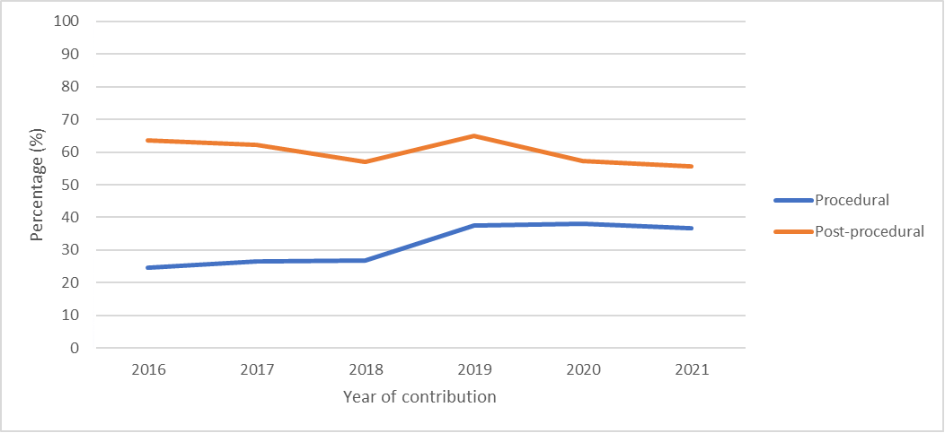

* n=2,717 antimicrobial doses in 2021.

† n=2,739 antimicrobial prescriptions in 2021.

The reasons for deeming procedural antimicrobials inappropriate have changed over time, although incorrect timing has remained the most common reason for inappropriate prescribing when an antimicrobial is required. There was a decrease of almost 12% in incorrect procedural dose from 2016 to 2021. There were also recent increases in incorrect timing (Figure A4.7).

The reasons for deeming post-procedural antimicrobials inappropriate when required have not changed discernibly over time (Figure A4.8). The exception is ‘spectrum too broad’, for which there was an approximate 9% increase from 2020 to 2021. Over the years there has been a decrease in ‘incorrect dose or frequency’ by approximately 15% (2016–2021).

Figure A4.7: Reasons for inappropriateness, by percentage of required procedural antimicrobial doses*, Surgical NAPS contributor facilities, 2016–2021

* n=1,716 antimicrobial doses in 2021.

Figure A4.8: Reasons for inappropriateness, by percentage of required post-procedural antimicrobial prescriptions*, Surgical NAPS contributor facilities, 2016–2021

* n=1,214 antimicrobial prescriptions in 2021.

# Appendix 5: Procedure groups

The procedures listed in the Surgical NAPS database have been adopted from the Royal Australasian College of Surgeons Morbidity Audit and Logbook tool.18

The surgical procedure groups listed are:

|  |  |
| --- | --- |
| * Abdominal surgery   – anorectal  – bariatric and other  – biliary  – colorectal  – gastro-oesophageal  – hepatic  – pancreas and duodenum   * Breast surgery * Cardiac surgery * Dentoalveolar surgery * Gastrointestinal endoscopic procedures * Gynaecological surgery * Head and neck surgery   – laryngology  – otology  – rhinology | * Neurosurgery   – cerebrovascular  – peripheral nerve  – spinal  – other   * Obstetrics * Ophthalmology * Orthopaedic surgery * Plastic and reconstructive surgery * Thoracic surgery * Urological surgery   – endoscopic procedures  – laparoscopic procedures  – open procedures  – other   * Vascular surgery   – dialysis access |

# Appendix 6: Surgical NAPS data collection form

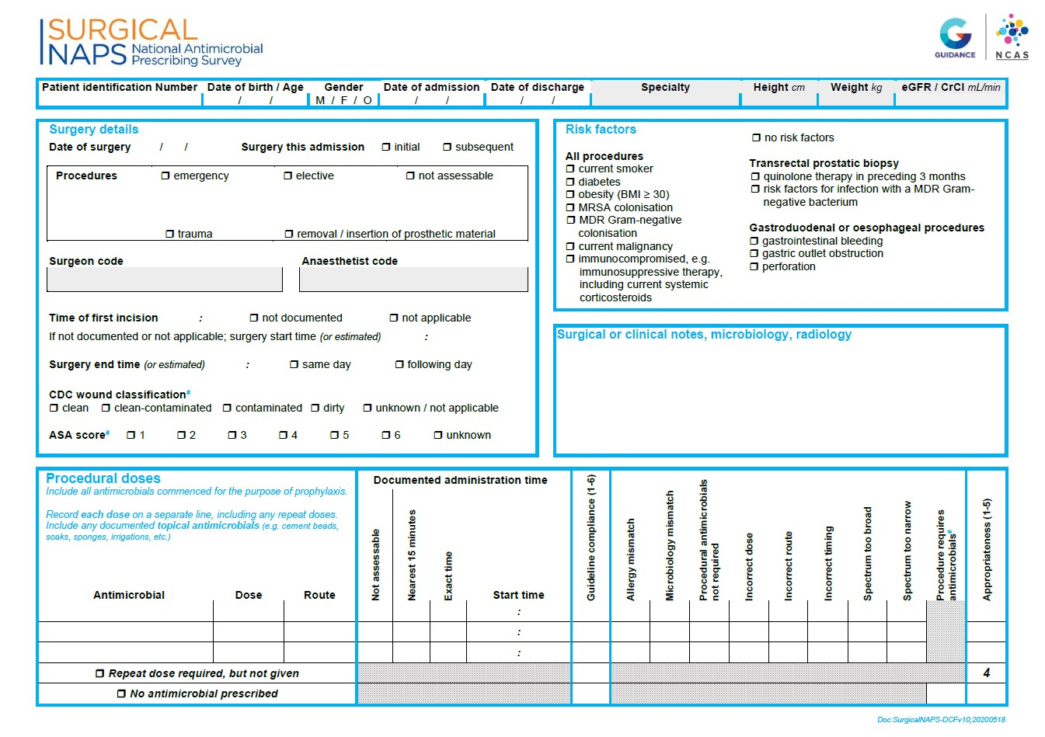

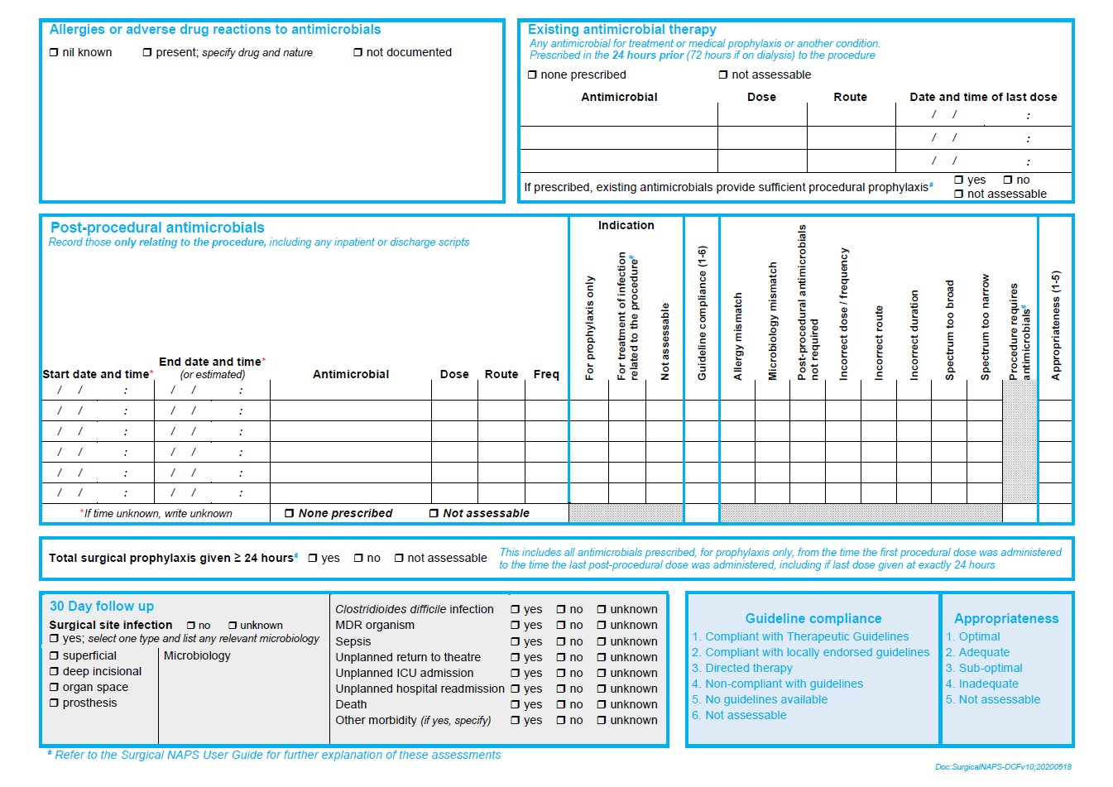

# Appendix 7: Surgical NAPS appropriateness definitions

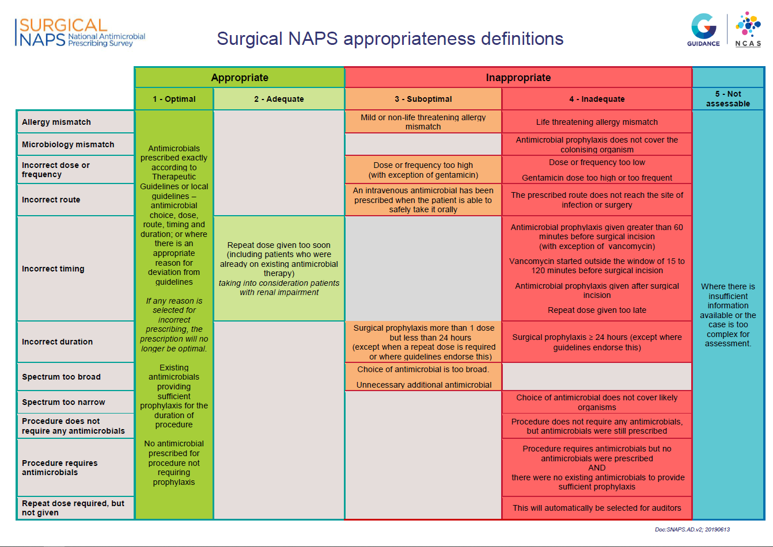

# Appendix 8: Glossary

|  |  |
| --- | --- |
| Term | Definition |
| Adequate prescribing | A prescription that is deemed **adequate** by the Surgical NAPS appropriateness definitions; see Appendix 7. |
| Appropriate prescribing | A prescription that is deemed **appropriate** (optimal or adequate) by the Surgical NAPS appropriateness definitions; see Appendix 7. |
| Directed therapy | There are microbiology culture and susceptibility results available to guide prophylaxis or treatment. |
| Dose | An individual antimicrobial dose administered either immediately prior to or during the surgical procedure. |
| Elective surgery | Surgery that can be booked in advance as a result of a specialist clinical assessment resulting in placement on an elective surgery waiting list. |
| Emergency surgery | Surgery to treat trauma or acute illness subsequent to an emergency presentation, including unplanned surgery for admitted patients and unplanned surgery for patients already awaiting an elective surgery*.* |
| Episode | An individual procedure or a set of procedures performed together during the one surgical session and the subsequent post-procedural care associated with the procedure(s). |
| Episode where no prophylaxis prescribed | Any episode where all prescribed antimicrobials are recorded as for ‘treatment’ and/or ‘not assessable’. |
| Existing antimicrobial therapy | Any antimicrobial prescribed for treatment or prophylaxis in the 24 hours prior (72 hours if on dialysis) to the procedure; these are not analysed individually but can be considered when assessing the appropriateness of whether procedural antimicrobials were given or not given. |
| Inadequate prescribing | A prescription that is deemed **inadequate** by the Surgical NAPS appropriateness definitions; see Appendix 7. |
| Inappropriate prescribing | A prescription that is deemed **inappropriate** (suboptimal or inadequate) by the Surgical NAPS appropriateness definitions; see Appendix 7. |
| Initial dose | The first dose of an antimicrobial administered either immediately prior to or during the surgical procedure for the purpose of prophylaxis. |
| Local guidelines | Local guidelines must be authorised and readily available on wards or on the hospital intranet; exceptions include paediatric and neonatal guidelines from an Australian children’s hospital and links to other official guidelines within a facility’s network. |
| Not assessable prescribing | A prescription that is deemed **not assessable** by the Surgical NAPS appropriateness definitions; see Appendix 7. |
| Optimal prescribing | A prescription that is deemed **optimal** by the Surgical NAPS appropriateness definitions; see Appendix 7. |
| Peer group8 | A hospital peer group supports comparisons that reflect the purpose, resources and role of each hospital and is defined by the type and nature of the services provided. It is based on data from a broad range of sources, intended to be multipurpose, and stable over time. |
| Post-procedural antimicrobial | An antimicrobial prescribed following, but directly relating to, the procedure; each prescription of the antimicrobial is recorded, including any inpatient or discharge scripts. |
| Post-procedural antimicrobial prophylaxis | All antimicrobials prescribed following, but directly relating to, the procedure for the purposes of prophylaxis; each prescription course of the antimicrobial is recorded and reported, including any inpatient or discharge scripts. |
| Prescription | Any antimicrobial prescribed, either as a single dose or as a course, following the surgical procedure. |
| Procedural antimicrobial | An antimicrobial administered either immediately prior to or during the surgical procedure for the purpose of prophylaxis; each initial and repeat dose of the antimicrobial administered is recorded individually. |
| Procedural antimicrobial prophylaxis | All antimicrobials administered either immediately prior to or during the surgical procedure for the purpose of prophylaxis; each dose of the antimicrobial administered is recorded and reported individually. |
| Procedure | The procedure(s) performed during the surgical episode, as documented on the procedure form or in the medical record; any procedure can be included, e.g. colonoscopies, radiological procedures. |
| Procedure group | The specialty group under which each procedure is classed for reporting; see Appendix 5*.* |
| Prophylaxis | An antimicrobial prescribed for the prevention of surgery-related infections. |
| Remoteness classification9 | The Australian Standard Geographical Classification – Remoteness Area was developed in 2001 by the Australian Bureau of Statistics as a statistical geography that allows quantitative comparisons based on remoteness of a point based on the physical road distance to the nearest urban centre. |
| Repeat dose | Any subsequent dose of an antimicrobial administered during the surgical procedure for the purpose of prophylaxis. |
| Suboptimal prescribing | A prescription that is deemed **suboptimal** by the Surgical NAPS appropriateness definitions; see Appendix 7. |
| Surgical episode | Any individual procedure or set of procedures performed together during one session and the subsequent post-procedural care associated with the procedure(s). |
| Therapeutic Guidelines10 | Antibiotic Expert Group. Therapeutic Guidelines: Antibiotic. Version 16. Melbourne: Therapeutic Guidelines Limited; 2019. <https://www.tg.org.au/> |
| Treatment | An antimicrobial prescribed for the treatment of infection related to the procedure. |

# Appendix 9: Abbreviations

|  |  |
| --- | --- |
| Abbreviation | Meaning |
| ASCCS | Antimicrobial Stewardship Clinical Care Standard |
| AURA | Antimicrobial Use and Resistance in Australia |
| NAPS | National Antimicrobial Prescribing Survey |
| NCAS | National Centre for Antimicrobial Stewardship |
| Surgical NAPS | Surgical National Antimicrobial Prescribing Survey |

# References

Australian Government. Australia’s National Antimicrobial Resistance Strategy: 2020 and beyond. Canberra: Department of Health and Department of Agriculture, Water and the Environment; 2020.

Australian Government. Surveillance of antimicrobial use and resistance in human health [Internet]. www.amr.gov.au. Australian Government Department of Health and Aged Care; 2023 [cited 2023 Sep 29]. Available from: <https://www.amr.gov.au/australias-response/objective-5-integrated-surveillance-and-response-resistance-and-usage/surveillance-antimicrobial-use-and-resistance-human-health>

Australian Commission on Safety and Quality in Health Care. National Safety and Quality Health Service Standards. 2nd ed. Sydney: ACSQHC; 2017.

Australian Commission on Safety and Quality in Health Care. Advisory no: A18/08. Antimicrobial Stewardship. Sydney: ACSQHC; 2021.

Australian Commission on Safety and Quality in Health Care. Antimicrobial Stewardship Clinical Care Standard. 2nd ed. Sydney: ACSQHC; 2020.

National Centre for Antimicrobial Stewardship and Australian Commission on Safety and Quality in Health Care. Surgical National Antimicrobial Prescribing Survey: Results of the 2016 pilot. Sydney: ACSQHC; 2017.

National Centre for Antimicrobial Stewardship. Surgical prophylaxis prescribing in Australian hospitals: Results of the 2017 and 2018 Surgical National Antimicrobial Prescribing Surveys. Public report. Melbourne: NCAS; 2019.

Australian Institute of Health and Welfare. Australian hospital peer groups. Health services series no. 66. Cat. no. HSE 170. Canberra: AIHW; 2015.

Australian Bureau of Statistics. 1270.0.55.005 – Australian Statistical Geography Standard (ASGS): Volume 5 – Remoteness Structure, July 2016. Canberra: ABS; 2018.

Antibiotic Expert Group. Therapeutic Guidelines: Antibiotic. Version 16. Melbourne: Therapeutic Guidelines Limited; 2019. Available from: <https://www.tg.org.au/>

National Centre for Antimicrobial Stewardship. Timing and duration of surgical prophylaxis: Recommendations 2020. Melbourne: NCAS; 2020. Available from: <https://www.ncas-australia.org/timing-and-duration-of-surgical-prophylaxis>

de Jonge SW, Boldingh QJ, Solomkin JS, Dellinger EP, Egger M, Salanti G, Allegranzi B, Boermeester MA. Effect of postoperative continuation of antibiotic prophylaxis on the incidence of surgical site infection: a systematic review and meta-analysis. *The Lancet Infectious Diseases* 2020; 20(10): 1182–92.

Allegranzi B, Zayed B, Bischoff P, Kubilay NZ, de Jonge S, de Vries F et al. New WHO recommendations on intraoperative and postoperative measures for surgical site infection prevention: an evidence-based global perspective. *The Lancet Infectious Diseases* 2016; 16(12): e288–e303.

Berríos-Torres SI, Umscheid CA, Bratzler DW, Leas B, Stone EC, Kelz RR et al. Centers for Disease Control and Prevention guideline for the prevention of surgical site infection, 2017. *JAMA Surgery* 2017; 152(8): 784–91.

Australian Institute of Health and Welfare. Public hospitals worked to clear elective surgery backlog during 2020–21 [media release]. Canberra: AIHW; 25 January 2022. Available from: https://www.aihw.gov.au/news-media/media-releases/2021/january-1/public-hospitals-worked-to-clear-elective-surgery

National Centre for Antimicrobial Stewardship. Clinical fact sheets. Melbourne: NCAS; 2020. Available from: <https://www.ncas-australia.org/Education>

Australian Commission on Safety and Quality in Health Care. Cataract Clinical Care Standard. Sydney: ACSQHC; 2021.

Royal Australasian College of Surgeons. Morbidity Audit and Logbook tool. Available at: <https://www.surgeons.org/en/research-audit/morbidity-audits/morbidity-audit-and-logbook-tool> [accessed 2015].

# Acknowledgements

**Contributing facilities**

On behalf of the NCAS, we would like to thank all contributing facilities and auditors for their time and effort in collecting and entering the data and contributing to the AURA Surveillance System, and for their continued commitment to improving safety and quality across the Australian healthcare system.

**National Centre for Antimicrobial Stewardship and the Guidance Group**

Professor Karin Thursky – Director, NCAS

Professor Kirsty Buising – Deputy Director, NCAS

Dr Rodney James – Director of Clinical Services, Guidance Group

Dr Courtney Ierano – NAPS Program Manager

Ms Caroline Chen – NAPS Project Officer

Associate Professor Noleen Bennett – Senior Infection Control Consultant

Mr Pramode Varghese – Director of Technical Services, Guidance Group

Mr Logesh Palani – Software Developer, Guidance Group





amr.gov.au

All information in this publication is correct as at June 2024