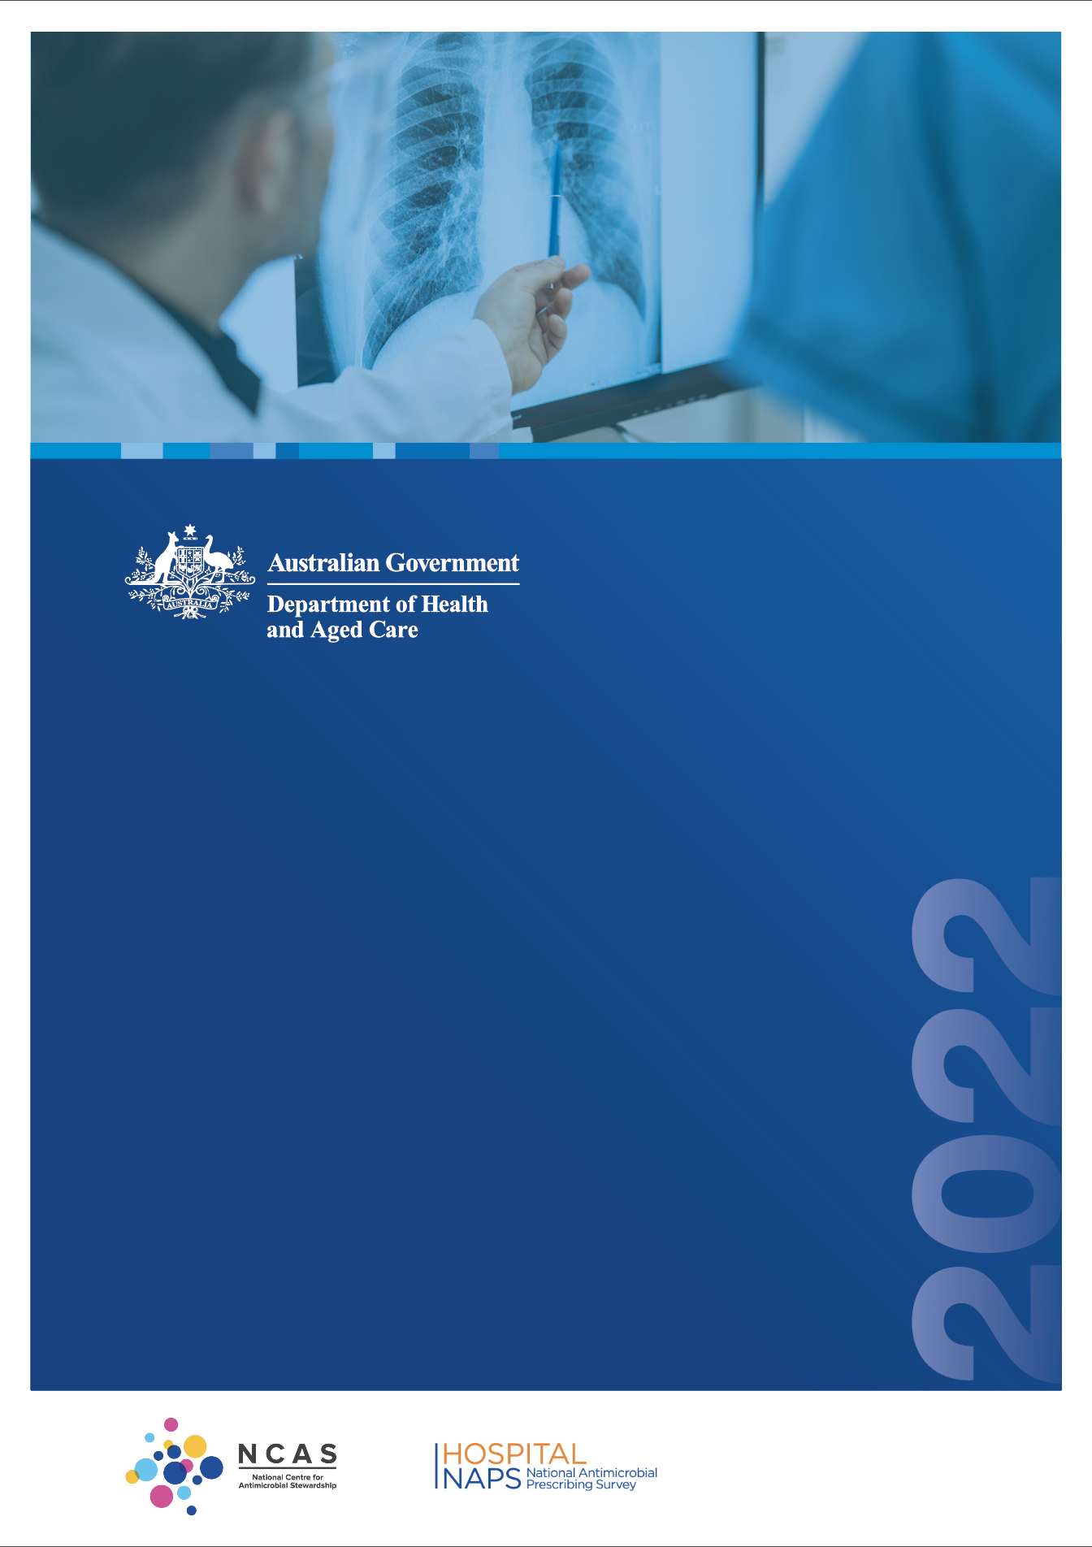

**Antimicrobial prescribing practice   
in Australian hospitals**

Results of the 2022 Hospital National Antimicrobial Prescribing Survey

Published by the Australian Government Department of Health and Aged Care

For issues regarding the content of the report:

Email: [support@naps.org.au](mailto:support@naps.org.au) Website: [https://www.naps.org.au](https://www.naps.org.au/)

ISBN: 978-1-74186-089-4

© Australian Government Department of Health and Aged Care

All material and work produced by the Department of Health and Aged Care is protected by copyright. The Department reserves the right to set out the terms and conditions for the use of such material.

Enquiries about the licence and any use of this publication are welcome and can be sent to [AMR@health.gov.au](mailto:AMR@health.gov.au)

#### Preferred citation

Royal Melbourne Hospital and the National Centre for Antimicrobial Stewardship. Antimicrobial prescribing practice in Australian hospitals. Results of the 2022 Hospital National Antimicrobial Prescribing Survey. Canberra: Department of Health and Aged Care; 2024.

#### Disclaimer

This document is not intended to provide guidance on particular healthcare choices. You should contact your healthcare provider for advice on particular healthcare choices.

This document includes the views or recommendations of its authors and third parties. Royal Melbourne Hospital, the National Centre for Antimicrobial Stewardship and the Department of Health and Aged Care do not accept any legal liability for any injury, loss or damage incurred by the use of, or reliance on, this document.

Table of contents

Preface iv

Acknowledgements iv

Abbreviations iv

Summary v

1. Introduction 1
2. Results 2
   1. Participation 2
   2. Key indicators 3
   3. Most commonly prescribed antimicrobials 6
   4. Most common indications for antimicrobial prescribing 7
3. Conclusion 9

Appendix 10

References 15

# Preface

This report is best interpreted when read in conjunction with the National Antimicrobial Prescribing Survey Technical Supplement 2022.

# Acknowledgements

Contributing facilities

On behalf of the National Centre for Antimicrobial Stewardship (NCAS) and the Royal Melbourne Hospital (RMH) Guidance Group, we would like to thank all contributing facilities and auditors for their time and effort in collecting and entering the data, in contributing data to this report and to the Antimicrobial Use and Resistance in Australia (AURA) Surveillance System, and for their continued commitment to improving safety and quality across the Australian healthcare system.

NCAS and the RMH Guidance Group

Professor Karin Thursky   
Dr Rodney James

Dr Courtney Ierano   
Ms Caroline Chen

Associate Professor Noleen Bennett   
Associate Professor Lisa Hall

Mr Pramode Varghese   
Mr Logesh Palani

Mr Abukari Yakubu   
Mr Simon Burrell

# Abbreviations

|  |  |
| --- | --- |
| **Abbreviation** | **Definition** |
| AIHW | Australian Institute of Health and Welfare |
| AMS | Antimicrobial stewardship |
| AURA | Antimicrobial Use and Resistance in Australia |
| COPD | Chronic obstructive pulmonary disease |
| EMM | Electronic medication management |
| GEM | Geriatric evaluation and management |
| Hospital NAPS | Hospital National Antimicrobial Prescribing Survey |
| NAPS | National Antimicrobial Prescribing Survey |
| NCAS | National Centre for Antimicrobial Stewardship |
| RMH | Royal Melbourne Hospital |

# Summary

The Hospital National Antimicrobial Prescribing Survey (Hospital NAPS) continues to play a pivotal role in the antimicrobial stewardship programs of hospitals across Australia. The survey’s focus on the measurement of antimicrobial prescribing quality, combined with clear data visualisation and clinical program support, means that it provides meaningful data for action for all participating facilities.

A total of 411 hospitals participated in the 2022 survey – a number which has remained stable over the last few years. Approximately three-quarters were public hospitals and one-quarter were private hospitals. This represented 42.1% of all eligible Australian hospitals.

Results for key indicators

* **Documentation of indication** has reached a high standard: indications were documented for 85.3% of antimicrobial prescriptions. Hospitals with an electronic medication management (EMM) system had substantially higher rates of documentation (92.3%) compared with non-EMM hospitals (77.5%).
* **Documentation of review and stop date** was steady at 53.7% of prescriptions. Whilst documentation was better in EMM hospitals (54.9%) compared with non-EMM hospitals (45.0%), both are still well below the expected best practice target of 95%.
* Of those audited prescriptions that were for **surgical prophylaxis**, 30.9% extended beyond 24 hours.
* There was a continued improvement in the rate of **non-compliance with prescribing guidelines**, with 24.8% of prescriptions deemed as non-compliant. Although this has consistently improved since 2019, it continues to be an issue. Indications with the highest rates of guideline non-compliance were surgical prophylaxis, cystitis and chronic obstructive pulmonary disease (COPD).
* Approximately three-quarters of all prescriptions were deemed to be **appropriate**. Despite minor fluctuations, this metric has remained unchanged over the years. Indications with the poorest rates of appropriateness were surgical prophylaxis and COPD.

Implications for clinical practice

The steady improvement in documentation rates year on year is an encouraging sign that hospital antimicrobial stewardship (AMS) programs and prescribers attribute importance to continually improving this metric. Nonetheless, documentation of review and stop date remains poor despite this being a fundamental principle for ensuring that prescribed antimicrobials are reviewed in a timely manner to ensure their optimal efficacy and minimise unnecessary treatment. As more hospitals adopt an EMM system, we expect these measures to increase.

Despite the presence of clear national prescribing guidelines, consistently high rates of guideline

non-compliance and inappropriateness in the prescribing of antimicrobials for surgical prophylaxis and COPD have persisted throughout multiple years of the NAPS. This suggests there is still considerable work to be done in supporting and educating prescribers to make good prescribing choices for these indications.

Further in-depth analysis, and education of target areas for practice improvement will be incorporated into upcoming clinical circulars which will provide more in-depth analysis into the prescribing of antimicrobials for specific clinical conditions.

# Introduction

The judicious use of antimicrobials is a key component of good patient care across all health settings. Australia’s National Antimicrobial Resistance Strategy has recommended the adoption of antimicrobial stewardship (AMS) programs, with the aim of enhancing patient healthcare outcomes whilst reducing the emergence and spread of antimicrobial resistance.1

Now in its 10th year, the Hospital National Antimicrobial Prescribing Survey (Hospital NAPS) has been adopted as an important platform to support the AMS programs in hospitals by facilitating meaningful measurement, reporting and benchmarking of the quality of antimicrobial prescribing. NAPS program staff also continue to provide clinical program support and training for participants. Internationally, it remains the only tool to measure appropriateness of antimicrobial prescribing.

Furthermore, participation in the Hospital NAPS assists health service organisations to demonstrate that they meet the AMS action requirements of the National Safety and Quality Health Service (NSQHS) Standards and the Antimicrobial Stewardship Clinical Care Standard.2,3

The Australian Government Department of Health and Aged Care provides funding for the Royal Melbourne Hospital (RMH) Guidance Group and the National Centre for Antimicrobial Stewardship (NCAS) to conduct the Hospital NAPS and contribute data to the Antimicrobial Use and Resistance in Australia (AURA) Surveillance System.4

For details on definitions, survey methodology, analysis methodology and considerations for data interpretation, please refer to the National Antimicrobial Prescribing Survey Technical Supplement 2022.5

# Results

## Participation

The Hospital NAPS remains a voluntary program; nonetheless there has been consistent participation by hospitals across all Australian states and territories, remoteness areas6 and funding types since the program’s initiation.

This report analyses the data submitted by 411 hospitals (300 public and 111 private) that met the Hospital NAPS inclusion criteria. Participation has remained steady the last few years with 411 hospitals (295 public, 116 private) in 2021 and 409 hospitals (285 public, 124 private) in 2020.

Overall, 42.1% of all eligible Australian hospitals participated in the survey, with slightly higher participation from public hospitals (44.2%, 300 of 678) compared with private hospitals (38.3%, 111 of 288). All Australian states and territories were represented (Figure 1).

#### Figure 1: Representative participation of hospitals that contributed to the Hospital NAPS by state and territory, 2022*

**WA**

32.1% (36 of 112)

**NT**

83.3% (5 of 6)

**SA**

45.3% (48 of 106)

**QLD**

32.0% (58 of 181)

**NSW**

46.4% (142 of 306)

#### Total representative participation: 42.1%

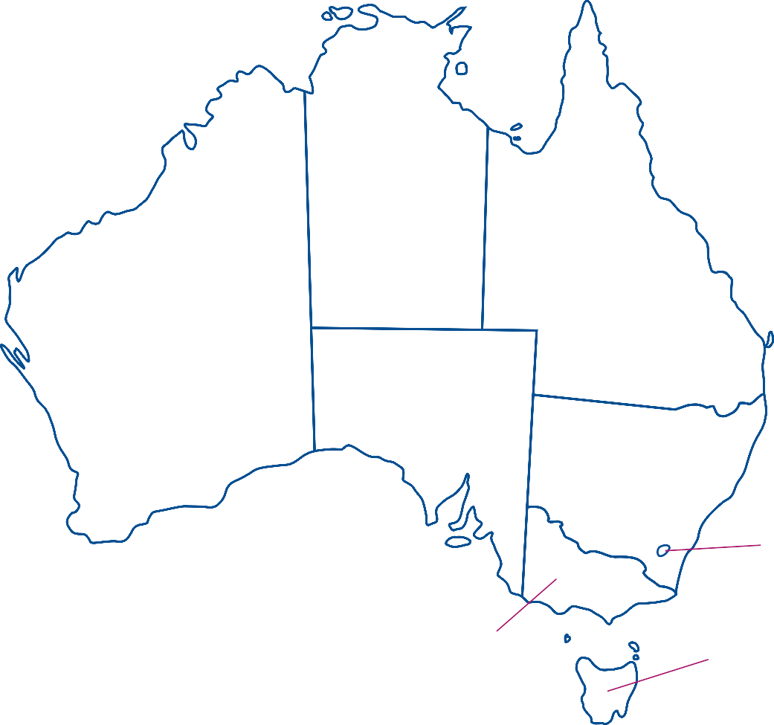(411 of 966 hospitals)

**ACT**

33.3% (2 of 6)

**VIC**

50.9% (112 of 220) **TAS**

27.6% (8 of 29)

* Total numbers of hospitals in each state and territory represent all eligible hospitals in the Australian Institute of Health and Welfare reporting groups for public and private, states and territories, and remoteness classifications.6,7

Data from 23,645 patients were submitted, generating 34,105 prescriptions for analysis. The majority of prescriptions were gathered from Victorian and NSW hospitals, which together represented 60.7% of all prescriptions submitted. The majority of auditing was performed in September, October and November, which is consistent with previous years’ surveys.

## Key indicators

Results for the key indicators are summarised in Table 1. Encouragingly, the vast majority of antimicrobial prescriptions had an indication documented in the patient medical history. This measure has continued to improve year on year from 72.0% in 2015 to 85.3% in 2022.

As expected, indication documentation was substantially higher in hospitals with an electronic medication management (EMM) system (92.3%) than in those without EMM (77.5%). This is not surprising given that most EMM systems require indication as a mandatory field before the antimicrobial prescription can be confirmed.

Documentation was also higher in public hospitals (88.6%) compared with private hospitals, (71.0%).

#### Table 1: Hospital NAPS key indicators, for assessable prescriptions, 2022

|  |  |
| --- | --- |
| **Key indicator\*** | **Result** |
| Indication documented  Best practice target >95% | 85.3% |
| Review or stop date documented  Best practice target >95% | 53.7% |
| Surgical prophylaxis >24hrs† | 30.9% |
| Compliant with guidelines^ | 69.2% |
| Appropriate# | 77.4% |

* Refer to Technical Supplement for definitions.5

† Where surgical prophylaxis was selected as the indication (n=4,056).

^ Prescriptions for which compliance was assessable (n=27,549). Excludes prescriptions for which guidelines were not available, as well as prescriptions that were ‘directed therapy’ or ‘not assessable’.

# Prescriptions for which appropriateness was assessable (n=32,685). Excludes prescriptions deemed to be ‘not assessable’.

For a full breakdown of Hospital NAPS key indicators by funding type, state and territory, peer group and remoteness classification, refer to the Appendix.

### Documentation of review or stop date

There has been a consistent improvement in the documentation of antimicrobial review or stop date since the measure was first introduced in 2015, when it was documented in only 29.7% of prescriptions. The 2022 result of 53.7% is the highest rate recorded to date. Private hospitals performed better than public hospitals (57.2% and 52.9% respectively).

Interestingly, whilst documentation of review or stop date was better in EMM hospitals (54.9%) compared with non-EMM hospitals (45.0%), these results are still well below the expected best practice level of 95%.

### Surgical prophylaxis greater than 24 hours

The point prevalence nature of the Hospital NAPS methodology limits the meaningful interpretation of surgical prophylaxis results.5 This is because post-operative antimicrobial prophylaxis is not required in the majority of procedures and hence these patients do not meet the inclusion criteria for the Hospital NAPS.

Nonetheless, of those audited prescriptions that were for surgical prophylaxis, 30.9% extended beyond 24 hours. This remains a concern given that it is now widely accepted that administration of antimicrobials for surgical prophylaxis should not continue beyond 24 hours after the procedure.8

The Surgical NAPS has a more accurate methodology for capturing surgical antimicrobial prophylaxis data. Further in-depth analyses of the types and durations of post-operative surgical prophylaxis procedures can be found in the 2022 Surgical NAPS report.9

### Compliance with guidelines

Encouragingly, there has been a continued reduction in the rate of non-compliance with prescribing guidelines for the last few years (Figure 2). The release of the new Therapeutic Guidelines antimicrobial recommendations in 20188 saw an associated peak in the rate of non-compliance with guidelines; this is not surprising as it takes time for clinicians to digest new prescribing recommendations and change their prescribing behaviour. A similar pattern was observed after the 2014 update of the Therapeutic Guidelines.

#### Figure 2: Non-compliance with guidelines for all prescriptions in the Hospital NAPS, 2015–2022*

28%

27.5%

26.9%

27%

26.2%

26.3%

26.2%

26%

25.7%

25%

24.8%

23.8%

24%

23%

22%

21%

2015

2016

2017

2018

2019

2020

2021

2022

**Year**

**Non-compliance with guidelines**

* There may be small differences in results compared with the previously published NAPS reports. This is because participants are free to amend their data at any time and the historical data is reanalysed each year

#### Appropriateness

The percentage of prescriptions deemed to be appropriate5 in 2022 was 74.1%, a figure which has essentially remained unchanged over many years. Appropriateness was generally higher in public hospitals compared with private hospitals (76.1% vs 65.7%).

#### Reasons for inappropriateness

Of all prescriptions, 21.7% were assessed as inappropriate (suboptimal and inadequate) by the auditors. Nearly one-quarter of inappropriate prescriptions (23.3%) were for conditions that do not require any antimicrobial therapy. The remaining reasons for inappropriateness (Table 2) were primarily antimicrobial spectrum being too broad, incorrect dose or frequency, and incorrect duration.

#### Table 2: Reasons for inappropriateness for all prescriptions assessed as being inappropriate* in the Hospital NAPS, 2022

|  |  |  |
| --- | --- | --- |
| **Reason for inappropriateness** | | **Number of prescriptions\*** |
| Microbiology mismatch | | 495 (6.7%) |
| Allergy mismatch | | 174 (1.3%) |
| Indication does *not* require any antimicrobials | | 1,720 (23.3%) |
| Indication *does* require antimicrobials | Spectrum too broad | 1,954 (34.4%) |
| Incorrect dose/frequency | 1,626 (28.6%) |
| Incorrect duration | 1,602 (28.2%) |
| Spectrum too narrow | 574 (10.1%) |
| Incorrect route | 360 (6.3%) |

* Each prescription is assessed against each quality indicator and thus can be represented in more than one category. There were a total of 7,398 reasons for inappropriateness.

## Most commonly prescribed antimicrobials

Figure 3 shows the 10 most commonly prescribed antimicrobials and their corresponding appropriateness assessment. This distribution of antimicrobials has remained relatively consistent throughout previous NAPS results.

The 5 most commonly prescribed antimicrobials (cefazolin, ceftriaxone, amoxicillin-clavulanic acid, cefalexin and piperacillin–tazobactam) also had amongst the highest rates of inappropriateness (Figure 3). These results are relatively consistent compared with previous years’ results.

#### Figure 3: The 10 most commonly prescribed antimicrobials and associated appropriateness assessment, Hospital NAPS, 2022

2,792

1,064

77

Cefazolin (11.5%)

2,165

872

144

Ceftriaxone (9.3%)

1,835

835

107

Amoxicillin–clavulanic acid (8.1%)

1,112

751

121

Cefalexin (5.8%)

1,306

514 79

Piperacillin–tazobactam (5.6%)

1,102

432 71

Metronidazole (4.7%)

1,190

315 97

Doxycycline (4.7%)

1,157

159 30

Flucloxacillin (3.9%)

Trimethoprim– sulfamethoxazole (3.7%)

1,145

69 39

891

268 33

Amoxicillin (3.5%)

0

500

1000 1500 2000 2500 3000 3500 4000

**Number of prescriptions**

Appropriate

Inappropriate

Not assessable

**Antimicrobial (% of all prescriptions)**

## Most common indications for antimicrobial prescribing

The 10 most common indications for antimicrobial prescribing are shown in Figure 4.

Amongst these, the indications with the most inappropriate prescribing continue to be surgical prophylaxis and chronic obstructive pulmonary disease (COPD).

Surgical prophylaxis is a clinical area with heavily protocolised prescribing, yet inappropriateness remains high. In contrast, other indications with clear prescribing protocols such as medical prophylaxis had very high rates of appropriate prescribing.

#### Figure 4: The 10 most common indications for antimicrobial prescribing and their associated appropriateness assessment, Hospital NAPS contributors, 2022

2,349

1,607

100

Surgical prophylaxis (11.9%)

3,233

335 144

Medical prophylaxis (10.9%)

Pneumonia, community acquired,

empiric therapy (9.7%)

2,537

756 18

1,471

445 19

Cystitis (5.7%)

1,232

313 17

Cellulitis/erysipelas (4.6%)

833

2593

Pneumonia, aspiration (3.2%)

762

92 24

Candida oral (2.6%)

701 157 11

Pyelonephritis (2.6%)

712 110 16

Pneumonia, pathogen known (2.5%)

Chronic obstructive pulmonary disease (2.4%)

443 342 22

0

500 1,000 1,500 2,000 2,500 3,000 3,500 4,000

**Number of prescriptions**

Appropriate

Inappropriate

Not assessable

**Indication (% of all prescriptions)**

### Compliance with guidelines

Indications with the highest rates of guideline non-compliance were COPD, surgical prophylaxis and cystitis (Figure 5). Both COPD and surgical prophylaxis have consistently remained areas of high non- compliance; not surprisingly these were also the indications with the highest rates of inappropriateness (Figure 4). These findings have remained consistent across many years of NAPS surveys despite the existence of clear national guidelines and a substantial revision to the antimicrobial recommendations in the Therapeutic Guidelines in 2019. This suggests there is still considerable work to be done in supporting and educating prescribers in good antimicrobial prescribing.

In contrast, indications such as oral candida, medical prophylaxis and pneumonia with a known pathogen had high levels of guideline-concordant prescribing.

#### Figure 5: Compliance with guidelines* for the 10 indications^ most commonly requiring antimicrobials in Hospital NAPS contributors, 2022

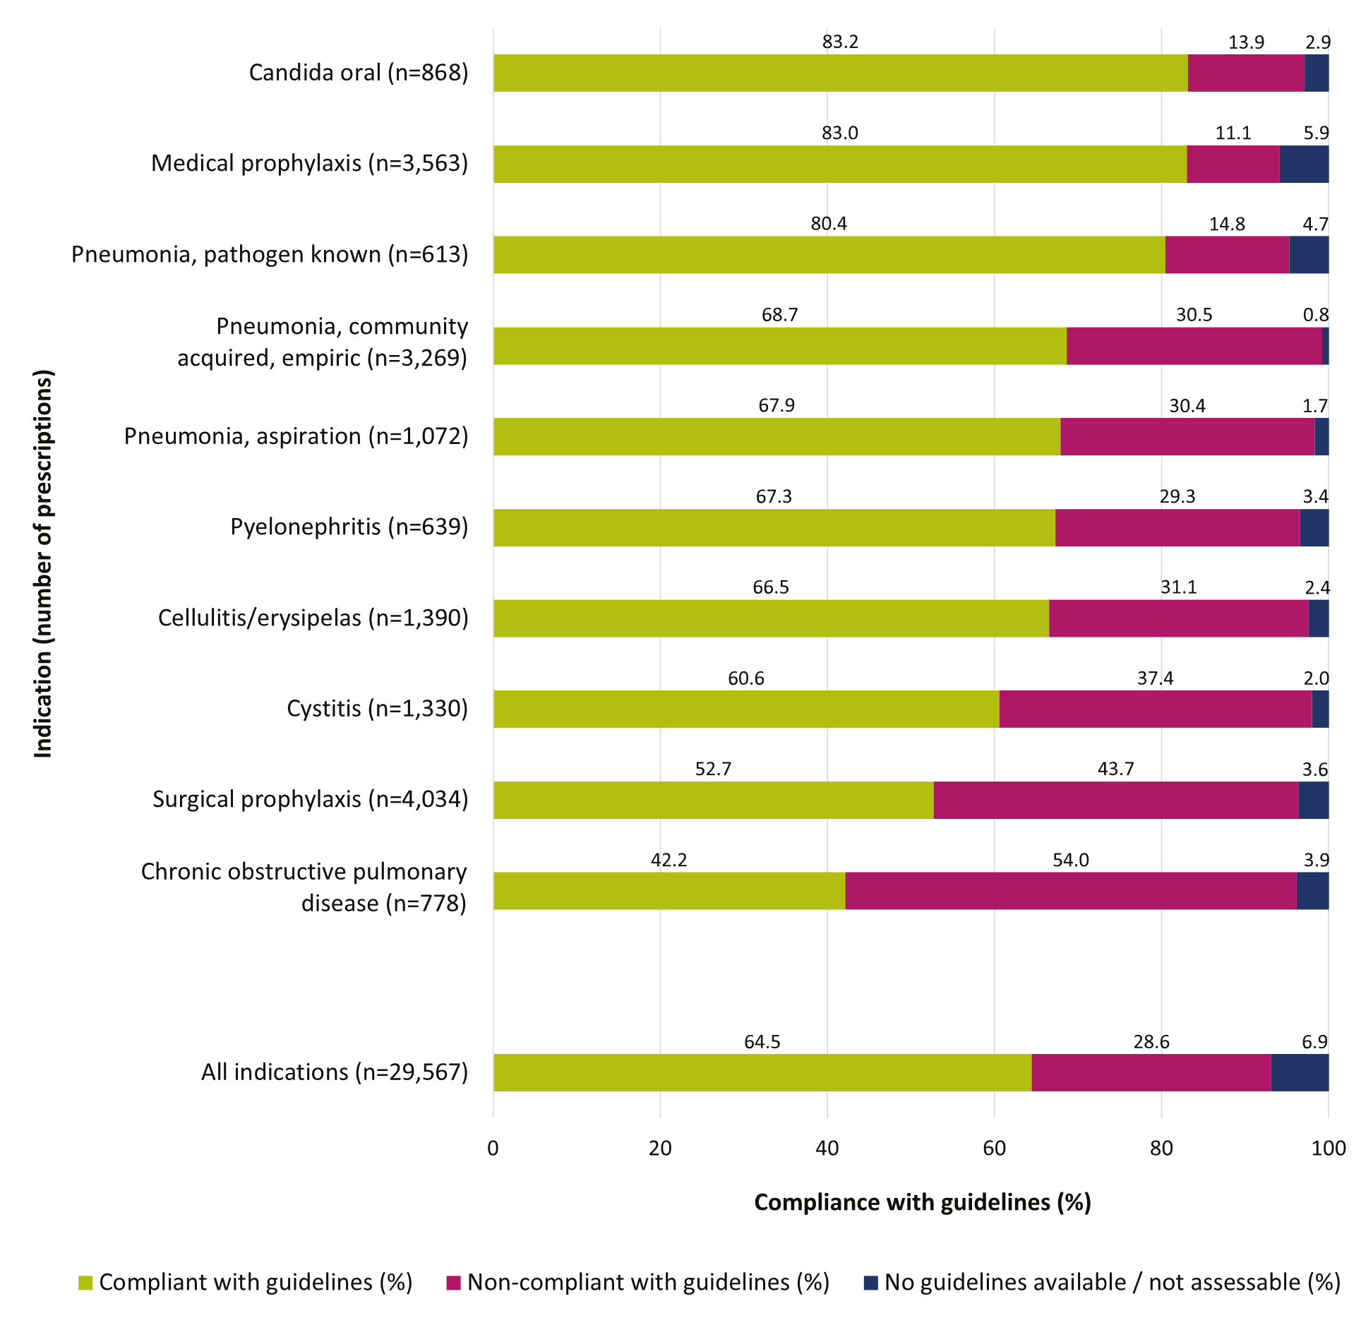

* Excludes prescriptions marked as ‘Directed therapy’ (n=4,505)

^ Excludes prescriptions where the indication for prescribing was unknown (n=887).

# Conclusion

Now in its 10th year, the Hospital NAPS continues to have strong adoption by hospitals around Australia. There have been some encouraging signs of continued prescribing improvement, particularly in the areas of documentation of indication and review and stop dates. Similarly, rates of non-compliance with guidelines have fallen over the last several years.

There are some areas of antimicrobial prescribing that continue to be done poorly – namely, the prescribing of antimicrobials for COPD and surgical prophylaxis. Rectifying these issues will require purposeful, large-scale interventions to improve the quality of prescribing.

# Appendix

#### Table A1: Results for key indicators in Hospital NAPS contributors, by state and territory, remoteness area^, AIHW peer group^^ and funding type, 2022

|  |  |  |  |  |  |  |  |  |
| --- | --- | --- | --- | --- | --- | --- | --- | --- |
|  | | **Number of participating hospitals**  **(n)** | **Percentage of participating hospitals**  **(%)** | **Number of prescriptions (n)** | **Percentage of prescriptions (%)** | **Indication documented (%)** | **Review or stop date documented (%)** | **Surgical prophylaxis**  **>24 hours (%)\*** |
| State or territory | ACT | 2 | 0.5 | 215 | 0.6 | 91.6 | 51.6 | 46.9 |
| NSW | 142 | 34.6 | 11,421 | 33.5 | 89.8 | 58.4 | 36.9 |
| NT | 5 | 1.2 | 460 | 1.3 | 97.4 | 58.7 | 84.6 |
| QLD | 58 | 14.1 | 5,626 | 16.5 | 84.8 | 44.1 | 31.3 |
| SA | 48 | 11.7 | 2,989 | 8.8 | 77.2 | 51.7 | 17.6 |
| TAS | 8 | 2.0 | 681 | 2.0 | 71.2 | 46.7 | 28.8 |
| VIC | 112 | 27.3 | 9,282 | 27.2 | 85.6 | 56.3 | 32.4 |
| WA | 36 | 8.8 | 3,431 | 10.1 | 78.6 | 49.1 | 21.8 |
| Remoteness^ | Major cities | 187 | 45.5 | 22,378 | 65.6 | 85.7 | 55.6 | 29.2 |
| Inner regional | 116 | 28.2 | 6,026 | 17.7 | 84.9 | 56.2 | 29.5 |
| Outer regional | 94 | 22.9 | 5,157 | 15.1 | 83.9 | 44.2 | 48.3 |
| Remote | 11 | 2.7 | 454 | 1.3 | 91.4 | 34.8 | N/A |
| Very remote | 3 | 0.7 | 90 | 0.3 | 85.6 | 51.1 | N/A |
| Public hospital peer group^^ | Principal referral | 28 | 6.8 | 9,267 | 33.4 | 90.6 | 51.3 | 36.4 |
| Public acute group A hospitals | 53 | 12.9 | 7,268 | 26.2 | 88.9 | 52.7 | 37.1 |
| Public acute group B hospitals | 34 | 8.3 | 2,234 | 8.1 | 85.8 | 49.7 | 34.6 |
| Public acute group C hospitals | 85 | 20.7 | 4,765 | 17.2 | 82.9 | 51.3 | 51.7 |
| Public acute group D hospitals | 52 | 12.7 | 1,445 | 5.2 | 89.4 | 54.9 | 71.4 |
| Other acute specialised hospitals | 1 | 0.2 | 100 | 0.4 | 98.0 | 78.0 | N/A |
| Children’s hospitals | 6 | 1.5 | 1,052 | 3.8 | 91.5 | 54.7 | 51.2 |
| Women’s and children’s hospitals | 1 | 0.2 | 128 | 0.5 | 96.1 | 35.2 | 17.6 |
| Women’s hospitals | 4 | 1.0 | 312 | 1.1 | 99.4 | 71.5 | 18.7 |
| Mixed subacute and non-acute hospitals | 9 | 2.2 | 267 | 1.0 | 94.8 | 78.3 | N/A |
| Rehabilitation and GEM hospitals | 6 | 1.5 | 352 | 1.3 | 86.9 | 61.4 | N/A |
| Very small hospitals | 18 | 4.4 | 266 | 1.0 | 95.8 | 59.4 | N/A |
| Psychiatric hospitals | 2 | 0.5 | 224 | 0.8 | 96.0 | 88.4 | N/A |
| Unpeered | 1 | 0.2 | 50 | 0.2 | 86.0 | 58.0 | N/A |

|  |  |  |  |  |  |  |  |  |
| --- | --- | --- | --- | --- | --- | --- | --- | --- |
|  | | **Number of participating hospitals**  **(n)** | **Percentage of participating hospitals**  **(%)** | **Number of prescriptions (n)** | **Percentage of prescriptions (%)** | **Indication documented (%)** | **Review or stop date documented (%)** | **Surgical prophylaxis**  **>24 hours (%)\*** |
| Private hospital peer group^^ | Private acute group A hospitals | 18 | 4.4 | 2,412 | 37.8 | 70.4 | 47.1 | 28.2 |
| Private acute group B hospitals | 29 | 7.1 | 1,585 | 24.9 | 71.6 | 57.7 | 32.6 |
| Private acute group C hospitals | 30 | 7.3 | 1,169 | 18.3 | 63.7 | 69.2 | 21.0 |
| Private acute group D hospitals | 16 | 3.9 | 589 | 9.2 | 72.7 | 57.6 | N/A |
| Other acute specialised hospitals | 2 | 0.5 | 185 | 2.9 | 75.1 | 75.7 | 3.8 |
| Private rehabilitation hospitals | 10 | 2.4 | 295 | 4.6 | 87.8 | 69.5 | N/A |
| Private acute psychiatric hospitals | 4 | 1 | 112 | 1.8 | 85.7 | 69.6 | N/A |
| Women’s hospitals | 1 | 0.2 | N/A | N/A | N/A | N/A | N/A |
| Mixed subacute and non-acute hospitals | 1 | 0.2 | N/A | N/A | N/A | N/A | N/A |
| Funding type | Public | 300 | 73.0 | 27,730 | 81.3 | 88.6 | 52.9 | 38.3 |
| Private | 111 | 27.0 | 6,375 | 18.7 | 71.0 | 57.2 | 25.8 |
| **Combined national result** | | **411** | **100.0** | **34,105** | **100.0** | **85.3** | **53.7** | **30.9** |

^ Remoteness category as per the Australian Bureau of Statistics.6

^^ Australian Institute of Health and Welfare (AIHW).7

* Where surgical prophylaxis was selected as the indication (n=4,056). N/A = Not applicable as there were fewer than 30 prescriptions.

GEM = Geriatric evaluation and management.

#### Table A2: Compliance with guidelines and prescription appropriateness in Hospital NAPS contributors, by state and territory, remoteness area^, AIHW peer group^^ and funding type, 2022

|  |  |  |  |  |  |  |  |  |  |  |  |  |
| --- | --- | --- | --- | --- | --- | --- | --- | --- | --- | --- | --- | --- |
|  | | **% Compliance with guidelines** | | | | | | **% Appropriateness** | | | | |
| **Therapeutic guidelines8 compliant** | **Local guidelines compliant** | **Non- compliant** | **Directed therapy** | **Not available** | **Not assessable** | **Optimal** | **Adequate** | **Suboptimal** | **Inadequate** | **Not assessable** |
| State or territory | ACT | 43.7 | 5.1 | 26.5 | 14.0 | 8.4 | 2.3 | 60.5 | 10.2 | 16.7 | 9.3 | 3.3 |
| NSW | 46.7 | 7.3 | 25.5 | 16.2 | 1.9 | 2.4 | 59.5 | 14.3 | 13.2 | 10.0 | 3.1 |
| NT | 50.9 | 15.4 | 14.8 | 17.0 | 0.9 | 1.1 | 70.2 | 10.7 | 14.3 | 4.8 | 0.0 |
| QLD | 48.8 | 6.0 | 24.1 | 13.5 | 3.3 | 4.3 | 60.7 | 12.2 | 12.5 | 9.3 | 5.3 |
| SA | 53.3 | 8.0 | 26.7 | 8.8 | 2.0 | 1.2 | 62.6 | 14.1 | 12.8 | 8.3 | 2.3 |
| TAS | 46.8 | 6.0 | 28.0 | 10.7 | 4.6 | 3.8 | 57.7 | 16.2 | 14.8 | 7.0 | 4.3 |
| VIC | 47.6 | 11.3 | 23.8 | 9.3 | 2.4 | 5.6 | 58.8 | 15.0 | 11.2 | 9.0 | 6.0 |
| WA | 38.3 | 13.2 | 25.6 | 17.0 | 3.1 | 2.7 | 62.2 | 13.3 | 9.7 | 11.5 | 3.3 |
| Remoteness^ | Major cities | 43.9 | 11.3 | 24.8 | 14.0 | 2.8 | 3.2 | 61.5 | 12.6 | 11.9 | 10.2 | 3.8 |
| Inner regional | 52.4 | 4.5 | 27.1 | 11.1 | 1.7 | 3.3 | 60.1 | 13.5 | 14.3 | 8.1 | 4.0 |
| Outer regional | 53.5 | 3.7 | 22.1 | 13.0 | 2.2 | 5.4 | 54.7 | 19.8 | 11.3 | 8.0 | 6.1 |
| Remote | 53.5 | 7.3 | 30.6 | 5.5 | 2.2 | 0.9 | 57.3 | 20.9 | 12.6 | 8.6 | 0.7 |
| Very remote | 66.7 | 1.1 | 15.6 | 10.0 | 1.1 | 5.6 | 52.2 | 24.4 | 11.1 | 4.4 | 7.8 |

|  |  |  |  |  |  |  |  |  |  |  |  |  |
| --- | --- | --- | --- | --- | --- | --- | --- | --- | --- | --- | --- | --- |
|  | | **% Compliance with guidelines** | | | | | | **% Appropriateness** | | | | |
| **Therapeutic guidelines8 compliant** | **Local guidelines compliant** | **Non- compliant** | **Directed therapy** | **Not available** | **Not assessable** | **Optimal** | **Adequate** | **Suboptimal** | **Inadequate** | **Not assessable** |
| Public hospital peer group^^ | Principal referral | 42.1 | 12.5 | 22.8 | 17.2 | 3.1 | 2.5 | 64.4 | 11.9 | 12.4 | 8.8 | 2.5 |
| Public acute group A hospitals | 45.9 | 8.3 | 25.0 | 14.6 | 3.4 | 2.8 | 61.5 | 13.2 | 13.2 | 9.0 | 3.1 |
| Public acute group B hospitals | 50.0 | 5.8 | 26.1 | 13.5 | 2.1 | 2.5 | 61.9 | 14.8 | 14.2 | 6.2 | 2.9 |
| Public acute group C hospitals | 58.3 | 3.5 | 23.0 | 8.0 | 1.3 | 5.9 | 54.6 | 20.7 | 11.7 | 6.1 | 6.8 |
| Public acute group D hospitals | 47.1 | 2.4 | 32.5 | 16.5 | 1.0 | 0.6 | 54.6 | 13.9 | 19.4 | 10.5 | 1.5 |
| Other acute specialised hospitals | 60.0 | 24.0 | 10.0 | 5.0 | 1.0 | 0.0 | 82.0 | 5.0 | 4.0 | 8.0 | 1.0 |
| Children’s hospitals | 27.7 | 39.0 | 10.2 | 17.5 | 4.1 | 1.6 | 70.0 | 15.3 | 7.2 | 5.1 | 2.4 |
| Women’s and children’s hospitals | 46.1 | 27.3 | 3.1 | 17.2 | 5.5 | 0.8 | 87.5 | 4.7 | 4.7 | 0.0 | 3.1 |
| Women’s hospitals | 43.6 | 36.5 | 6.4 | 5.1 | 5.4 | 2.9 | 84.9 | 5.8 | 3.5 | 3.5 | 2.2 |
| Mixed subacute and non-acute hospitals | 53.9 | 1.9 | 15.7 | 24.7 | 0.4 | 3.4 | 70.8 | 10.9 | 8.6 | 4.9 | 4.9 |
| Rehabilitation and GEM hospitals | 44.0 | 5.1 | 29.0 | 15.6 | 0.3 | 6.0 | 59.4 | 9.9 | 15.6 | 8.8 | 6.3 |
| Very small hospitals | 66.9 | 2.6 | 22.2 | 7.5 | 0.0 | 0.8 | 63.9 | 20.7 | 7.1 | 7.1 | 1.1 |
| Psychiatric hospitals | 83.5 | 1.8 | 9.4 | 0.4 | 1.3 | 3.6 | 75.0 | 13.4 | 5.8 | 1.8 | 4.0 |
| Unpeered | 38.0 | 16.0 | 18.0 | 14.0 | 0.0 | 14.0 | 64.0 | 0.0 | 16.0 | 6.0 | 14.0 |

|  |  |  |  |  |  |  |  |  |  |  |  |  |
| --- | --- | --- | --- | --- | --- | --- | --- | --- | --- | --- | --- | --- |
|  | | **% Compliance with guidelines** | | | | | | **% Appropriateness** | | | | |
| **Therapeutic guidelines8 compliant** | **Local guidelines compliant** | **Non- compliant** | **Directed therapy** | **Not available** | **Not assessable** | **Optimal** | **Adequate** | **Suboptimal** | **Inadequate** | **Not assessable** |
| Private hospital  peer group^^ | Private acute group A hospitals | 43.5 | 4.1 | 34.0 | 9.2 | 2.6 | 6.6 | 49.4 | 15.7 | 11.8 | 14.8 | 8.4 |
| Private acute group B hospitals | 46.6 | 4.7 | 31.3 | 10.7 | 1.8 | 4.9 | 51.7 | 14.1 | 10.0 | 18.0 | 6.1 |
| Private acute group C hospitals | 44.8 | 3.4 | 37.6 | 6.4 | 1.1 | 6.6 | 49.7 | 8.6 | 12.5 | 20.8 | 8.5 |
| Private acute group D hospitals | 51.3 | 9.0 | 28.2 | 6.3 | 2.2 | 3.1 | 54.5 | 14.1 | 9.8 | 16.6 | 4.9 |
| Other acute specialised hospitals | 77.8 | 5.9 | 10.3 | 5.4 | 0.0 | 0.5 | 85.9 | 3.2 | 1.1 | 9.2 | 0.5 |
| Private rehabilitation hospitals | 56.9 | 6.4 | 18.6 | 13.2 | 1.4 | 3.4 | 61.7 | 11.9 | 13.6 | 8.1 | 4.7 |
| Private acute psychiatric hospitals | 61.6 | 14.3 | 18.8 | 3.6 | 0.0 | 1.8 | 60.7 | 21.4 | 6.3 | 8.0 | 3.6 |
| Women’s hospitals | N/A | N/A | N/A | N/A | N/A | N/A | N/A | N/A | N/A | N/A | N/A |
| Mixed subacute and non-acute hospitals | N/A | N/A | N/A | N/A | N/A | N/A | N/A | N/A | N/A | N/A | N/A |
| Funding type | Public | 47.0 | 9.8 | 23.3 | 14.2 | 2.6 | 3.1 | 52.4 | 13.3 | 10.9 | 16.3 | 3.5 |
| Private | 47.2 | 4.9 | 31.7 | 8.7 | 2.0 | 5.4 | 61.9 | 14.1 | 12.5 | 7.9 | 7.1 |
| **Combined national result** | | **47.0** | **8.9** | **24.8** | **13.2** | **2.5** | **3.5** | **60.2** | **14.0** | **12.2** | **9.5** | **4.2** |

^ Remoteness category as per the Australian Bureau of Statistics.6

^^ Australian Institute of Health and Welfare.7

N/A = Not applicable as there were fewer than 30 prescriptions. GEM = Geriatric evaluation and management.

# References

1. Australian Government. Australia’s National Antimicrobial Resistance Strategy: 2020 and beyond. Canberra: Department of Health and Department of Agriculture; 2020.
2. Australian Commission on Safety and Quality in Health Care. National Safety and Quality Health Service Standards. 2nd ed. Sydney: ACSQHC; 2017.
3. Australian Commission on Safety and Quality in Health Care. Antimicrobial Stewardship Clinical Care Standard. 2nd ed. Sydney; 2020.
4. Australian Government. Surveillance of antimicrobial use and resistance in human health. Antimicrobial Resistance. Department of Health and Aged Care; 2023. Accessed October 2023, at [https://www.amr.gov.au/australias-response/objective-5-integrated-surveillance-and-response-](https://www.amr.gov.au/australias-response/objective-5-integrated-surveillance-and-response-resistance-and-usage/surveillance-antimicrobial-use-and-resistance-human-health#antimicrobial-use-and-resistance-in-australia-aura) [resistance-and-usage/surveillance-antimicrobial-use-and-resistance-human-health#antimicrobial-](https://www.amr.gov.au/australias-response/objective-5-integrated-surveillance-and-response-resistance-and-usage/surveillance-antimicrobial-use-and-resistance-human-health#antimicrobial-use-and-resistance-in-australia-aura) [use-and-resistance-in-australia-aura](https://www.amr.gov.au/australias-response/objective-5-integrated-surveillance-and-response-resistance-and-usage/surveillance-antimicrobial-use-and-resistance-human-health#antimicrobial-use-and-resistance-in-australia-aura)
5. Royal Melbourne Hospital and the National Centre for Antimicrobial Stewardship. National Antimicrobial Prescribing Survey: Technical Supplement 2022. Canberra: NCAS; 2024.
6. Australian Bureau of Statistics. 1270.0.55.005 – Australian Statistical Geography Standard. Canberra: ABS; 2016.
7. Australian Institute of Health and Welfare. Australian hospital peer groups. Health services series no. 66, cat. no. HSE 170 ed. Canberra: AIHW; 2015.
8. Antibiotic Expert Group. Therapeutic Guidelines: Antibiotic. 16th ed. Melbourne: Therapeutic Guidelines Limited; 2019.
9. Royal Melbourne Hospital and the National Centre for Antimicrobial Stewardship. Surgical prophylaxis prescribing in Australian hospitals. Results of the 2022 Surgical National Antimicrobial Prescribing Survey. Canberra: NCAS; 2024.



All information in this publication is correct as at October 2023

#### [amr.gov.au](http://www.amr.gov.au/)