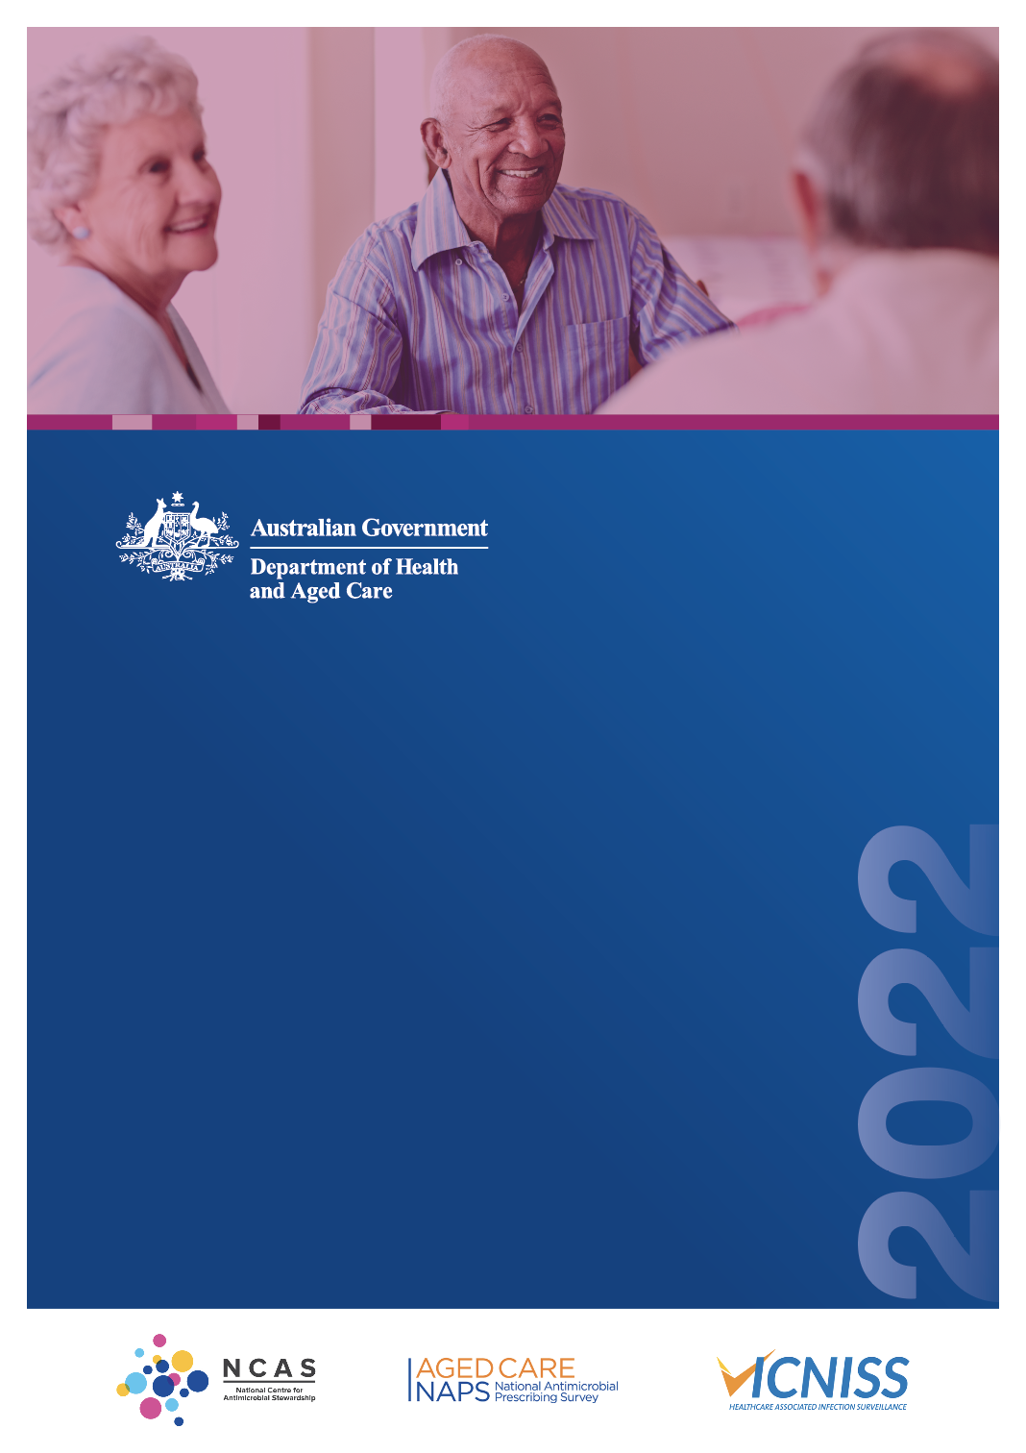

**Infections and antimicrobial prescribing in Australian residential aged care facilities**

Results of the 2022 Aged   
Care National Antimicrobial Prescribing Survey

Published by the Australian Government Department of Health and Aged Care

For issues regarding the content of the report:

Email: [support@naps.org.au](mailto:support@naps.org.au) Website: [https://www.naps.org.au](https://www.naps.org.au/)

ISBN: 978-1-74186-088-7

© Australian Government Department of Health and Aged Care

All material and work produced by the Department of Health and Aged Care is protected by copyright. The Department reserves the right to set out the terms and conditions for the use of such material.

Enquiries about the licence and any use of this publication are welcome and can be sent to [AMR@health.gov.au](mailto:AMR@health.gov.au)

### Preferred citation

Royal Melbourne Hospital and the National Centre for Antimicrobial Stewardship. Infections and antimicrobial prescribing in Australian residential aged care facilities. Results of the 2022 Aged Care National Antimicrobial Prescribing Survey. Canberra: Department of Health and Aged Care; 2024.

### Disclaimer

This document is not intended to provide guidance on particular healthcare choices. You should contact your healthcare provider for advice on particular healthcare choices.

This document includes the views or recommendations of its authors and third parties. Royal Melbourne Hospital, the National Centre for Antimicrobial Stewardship and the Department of Health and Aged Care do not accept any legal liability for any injury, loss or damage incurred by the use of, or reliance on, this document.

Table of contents

Preface iv

Acknowledgements iv

Abbreviations v

Summary vi

1. Introduction 1
2. Results 2
   1. Participation 2
   2. Prevalence of infections and antimicrobial use 4
   3. Suspected infections on the survey day 5
   4. Most commonly prescribed antimicrobials 5
   5. Common indications for prescribing antimicrobials 7
   6. Most commonly prescribed antimicrobials for common indications 9
   7. Quality indicators 9
   8. Duration 10
   9. Microbiology 11
3. Conclusion 12

Appendix 13

References 18

# Preface

This report is best interpreted when read in conjunction with the National Antimicrobial Prescribing Survey Technical Supplement 2022.

# Acknowledgements

Contributing facilities

On behalf of the National Centre for Antimicrobial Stewardship (NCAS), Royal Melbourne Hospital (RMH) Guidance Group and the Victorian Healthcare Associated Infection Surveillance System (VICNISS) Co-ordinating Centre, we would like to thank all contributing residential aged care facilities and auditors for their time and effort in collecting and entering the data, in contributing data to this report and to the Antimicrobial Use and Resistance in Australia (AURA) Surveillance System, and for their continued commitment to improving safety and quality across the Australian healthcare system.

NCAS and RMH Guidance Group

Professor Karin Thursky Dr Rodney James

Associate Professor Noleen Bennett Dr Courtney Ierano

Associate Professor Lisa Hall Ms Caroline Chen

Mr Simon Burrell

Mr Pramode Varghese Mr Logesh Palani

Mr Abukari Yakubu

VICNISS Coordinating Centre

Associate Professor Leon Worth Dr Ann Bull

Associate Professor Noleen Bennett Dr Michael Malloy

# Abbreviations

|  |  |
| --- | --- |
| **Abbreviation** | **Definition** |
| Aged Care NAPS | Aged Care National Antimicrobial Prescribing Survey |
| AMS | Antimicrobial stewardship |
| AURA | Antimicrobial Use and Resistance in Australia |
| IPC | Infection prevention and control |
| NAPS | National Antimicrobial Prescribing Survey |
| NCAS | National Centre for Antimicrobial Stewardship |
| PRN | Pro re nata |
| RACF | Residential aged care facility |
| RMH | Royal Melbourne Hospital |
| VICNISS | Victorian Healthcare Associated Infection Surveillance System |

# Summary

The Aged Care National Antimicrobial Prescribing Survey (Aged Care NAPS) continues to play a pivotal role in Australian residential aged care facilities (RACFs) as part of their infection prevention and control (IPC) and antimicrobial stewardship (AMS) programs. The Aged Care NAPS is a standardised tool that can be used to monitor the prevalence of infections and antimicrobial use, provide feedback to key clinicians and administrators and measure the effectiveness of IPC and AMS initiatives.

A total of 743 RACFs participated in 2022, an increased number from 2021 (n=690). The ongoing large number of Aged Care NAPS contributors indicates that Australian RACFs value the opportunity to participate in this point prevalence survey. All provider states and territories (except the Northern Territory), remoteness areas and provider groups (government, not-for-profit and private) were represented.

Key results

* On the survey day, the prevalence of residents who had signs and/or symptoms of at least one suspected infection was 3.0%; the prevalence of residents prescribed at least one antimicrobial (current/active medication order) was 12.5%.
* On the survey day, suspected skin or soft tissue (45.7%), urinary tract (21.8%) and respiratory tract (20.3%) infections continued to be the most commonly reported; only 32.8% met surveillance definitions for confirmed infections.
* Clotrimazole (21.7%) and cefalexin (19.5%) continued to be the most commonly prescribed antimicrobials; molnupiravir (5.5%), an antiviral agent provisionally approved in Australia for treatment of mild to moderate COVID-19 in January 2022, was reported for the first time in this year’s Aged Care NAPS.
* Documentation of indication for an antimicrobial prescription remained constant compared with 2021 (78.4%).
* The most common indication (therapeutic or prophylactic) for prescribing antimicrobials was ‘other skin, soft tissue or mucosal infection’ (22.1%) – that is, all skin, soft tissue or mucosal infections not specifically listed as an Aged Care NAPS indication.
* Documentation of review or stop date for an antimicrobial prescription slightly improved (55.4%) compared with 2021 but still remains well below the expected best practice target of 95%.
* For those antimicrobials still prescribed on the survey day, over one-third (37.6%) were commenced

>6 months prior.

* A microbiology specimen was collected for less than one-quarter (22.6%) antimicrobial prescriptions where the start date was known and <6 months prior to the survey date.

Recommendations

The Aged Care NAPS key results again demonstrate that there are significant opportunities   
for improvement.

Recommendations for those working at a local or national level include:

* advocating that all Australian RACFs participate in the Aged Care NAPS
* continuing training and helpdesk support to participating RACF staff to ensure accurate Aged Care NAPS data collection and submission
* sharing Aged Care NAPS results with administrators and clinicians such as general practitioners, pharmacists and nurses, and using these results to develop targeted IPC and AMS improvement strategies
* enhancing the level of IPC training among RACF staff, focusing on evidence-based strategies that prevent and control common infections such as skin or soft tissue, urinary tract and respiratory infections
* tailoring RACF AMS programs to improve antimicrobial prescribing. This could include, for example, ensuring the documentation of key prescribing elements (including indication and review or stop date for an antimicrobial prescription), rationalising antimicrobial prescriptions for prophylactic use and promoting appropriate microbiological sampling.

# Introduction

This report presents analyses of data collected for the 2022 Aged Care National Antimicrobial Prescribing Survey (Aged Care NAPS) and includes comparisons with previous annual (2016 to 2021) Aged Care NAPS data. It supersedes all previous Aged Care NAPS reports.1-6 Data for 2016 to 2021 included in the analyses for this report differ from data in previous reports; some data were retrospectively entered and an extensive data cleaning process was undertaken before commencing the 2022 analysis.7

Monitoring of infections and antimicrobial use in residential aged care facilities (RACFs) is an important safety and quality activity as there is longstanding evidence of residents being colonised or infected by multidrug-resistant organisms and of inappropriate antimicrobial use.

The Aged Care NAPS, first piloted in 2015, was modelled on the European Centre for Disease Prevention and Control Healthcare-Associated Infection in Long-Term Care Facilities (HALT) study.8 The Aged Care NAPS has subsequently been conducted annually. Coordination of the Aged Care NAPS is overseen by the National Centre for Antimicrobial Stewardship (NCAS), the Royal Melbourne Hospital (RMH) Guidance Group and the Victorian Healthcare Associated Infection Surveillance System (VICNISS) Coordinating Centre. In 2022, funding was provided by the Australian Government Department of Health and Aged Care. Aged Care NAPS data are included in Antimicrobial Use and Resistance in Australia (AURA) Surveillance System reports;9 AURA is a comprehensive and coordinated national surveillance system of antimicrobial use and antimicrobial resistance in human health.10

The Aged Care NAPS is a standardised surveillance tool that all Australian residential aged care facilities (RACFs) – that is, aged care homes and multipurpose services – can use to monitor the prevalence of infections and antimicrobial use, provide feedback to key clinicians and administrators, and measure the effectiveness of infection prevention and control (IPC) and antimicrobial stewardship (AMS) programs.11-13 It is recommended that RACFs participate at least once on their nominated single ‘survey day’ during the official time frame; each year since 2020 the official time frame has been from June to December. Participation assists facilities to demonstrate that they meet the action requirements of the Aged Care Quality Standards. Standard 3(3)(g) specifically aims to minimise infection-related risks by implementing standard and transmission-based precautions and practices to promote appropriate antimicrobial use. Standard 8(3)(e) notes that where clinical care is provided a clinical governance framework must include AMS.11

For details on the Aged Care NAPS methodology (methods 1 and 2), 2 data collection forms (Facility data collection form and Antimicrobial and infection data collection form), analyses and considerations for data interpretation, please refer to the National Antimicrobial Prescribing Survey Technical Supplement 2022.7

# Results

## Participation

In 2021, 690 RACFs collected and submitted Aged Care NAPS data at least once during the official time frame. In 2022, an increased number of RACFs (743 RACFs, comprising 665 aged care homes and 78 multipurpose services) similarly collected and submitted Aged Care NAPS data. Twenty-five facilities participated more than once. Since 2020, 428 facilities have participated at least once each year during the official data collection period (Table 1).

Most participating facilities were located in Victoria (36.2%) or New South Wales (21.4%). About half (52.5%) were located in major cities. About half (49.3%) were operated by not-for-profit providers (Table 1).

Participation of eligible RACFs within different states/territories, remoteness areas and provider groups varied from 0% in the Northern Territory (where there were only 10 eligible RACFs) to 47.7% in Western Australia, from 23.5% in major cities to 32.8% in outer regional areas, and from 15.5% of private RACFs to 58.2% of government RACFs (Table 1).

See Figure 1 and Table A1 for annual participation data from 2016 to 2021.

### Table 1: Facilities by state, remoteness area classification and provider type, Aged Care NAPS contributors, 2022

|  |  |  |  |  |  |  |
| --- | --- | --- | --- | --- | --- | --- |
| **Category n** | | **Residents audited** | **Participating facilities** | | **Facilities in reporting group** | **Participating facilities in reporting group** |
| **n** | **%** | **n** | **%** | **%** |
| State or territory | ACT | 973 | 9 | 1.2 | 26 | 34.6 |
| NSW | 10,414 | 159 | 21.4 | 912 | 17.4 |
| NT | 0 | 0 | 0.0 | 10 | 0.0 |
| QLD | 6,784 | 95 | 12.8 | 497 | 19.1 |
| SA | 3,917 | 63 | 8.5 | 259 | 24.3 |
| TAS | 1,007 | 14 | 1.9 | 69 | 20.3 |
| VIC | 13,215 | 269 | 36.2 | 761 | 35.3 |
| WA | 7,383 | 134 | 18.0 | 281 | 47.7 |
| Remoteness* | Major cities | 29,634 | 390 | 52.5 | 1,661 | 23.5 |
| Inner regional | 9,991 | 199 | 26.8 | 669 | 29.7 |
| Outer regional | 3,701 | 125 | 16.8 | 381 | 32.8 |
| Remote | 187 | 19 | 2.6 | 67 | 28.4 |
| Very remote | 180 | 10 | 1.3 | 37 | 27.0 |
| Provider type | Government | 5,537 | 233 | 31.4 | 400 | 58.2 |
| Not-for-profit | 26,965 | 366 | 49.3 | 1,488 | 24.6 |
| Private | 11,191 | 144 | 19.4 | 927 | 15.5 |
| **Total** | | **43,693** | **743** | **100** | **2,815** | **26.4** |

Sources: 1. Facility data collection form and 2. Aged care service list: 30 June 2022, Australian Institute of Health and Welfare (AIHW) GEN Aged Care Data.

* Remoteness category as per the Australian Bureau of Statistics.14 See Figure 1 for graphical presentation of provider type.

Transition care, innovative pool, national Aboriginal and Torres Strait Islander and short-term restorative care services are excluded.

### Figure 1: Percentage of participating facilities within different provider types, Aged Care NAPS contributors, 2016–2022

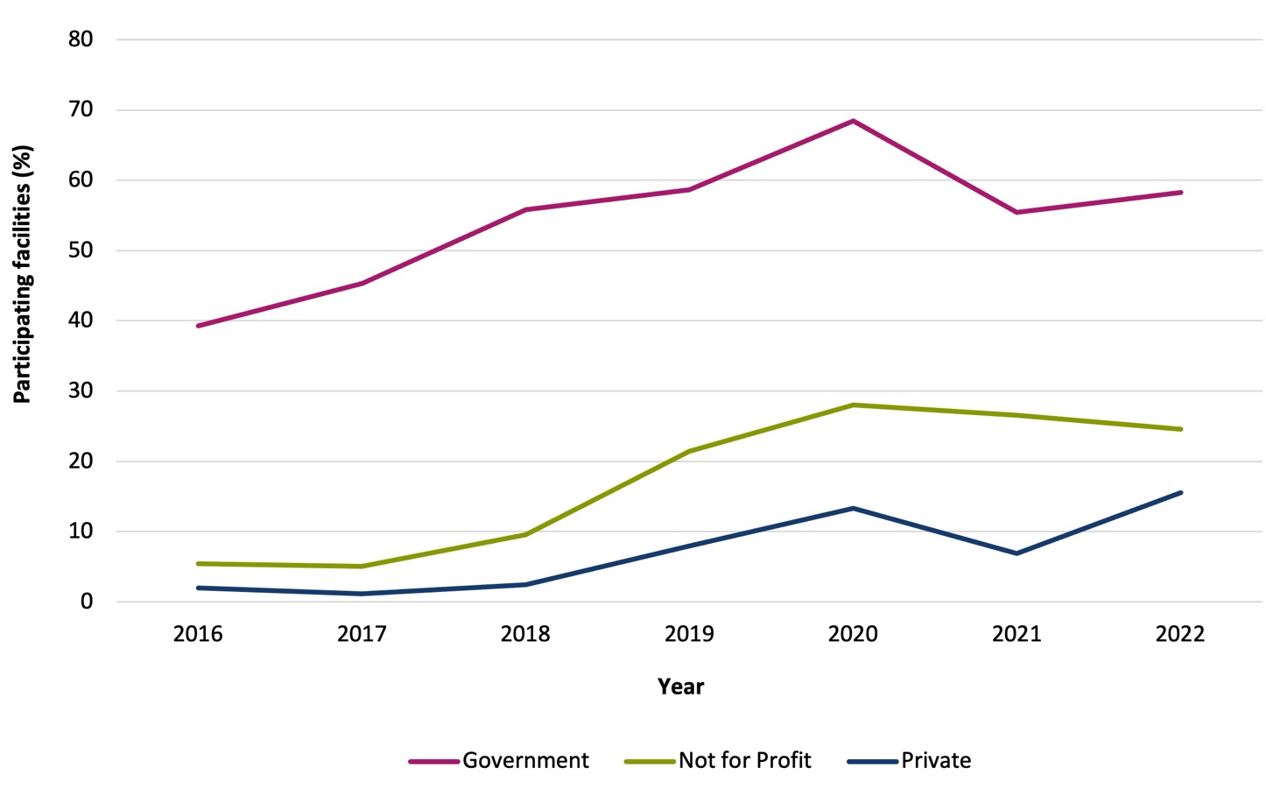

Sources: 1. Facility data collection form and 2. Aged care service list: 30 June 2016 to 2022, AIHW GEN Aged Care Data.

In 2022, over half (58.3%) of the residents were aged >85 years and about one-third (33.8%) were male on the survey day (Table 2).

### Table 2: Number and characteristics of all residents on the survey day, Aged Care NAPS contributors, 2022

|  |  |  |
| --- | --- | --- |
| **Measurement** | **2022** | |
| **n** | **%** |
| Present on survey day | 43,693 | – |
| Aged >85 years | 25,483 | 58.3 |
| Male | 14,787 | 33.8 |
| Admitted to hospital in previous 7 days | 667 | 1.5 |
| Indwelling urinary catheter present | 1,525 | 3.5 |

## Prevalence of infections and antimicrobial use

On the survey day in 2022, the prevalence of residents who had signs and/or symptoms of at least one suspected infection was 3.0% (n=1,293). The prevalence of residents prescribed at least one antimicrobial (current/active medication order) was 12.5% (n=5,441). If all topical antimicrobials or if all pro re nata (PRN) orders not administered in the previous 7 days were excluded, the prevalence of residents prescribed at least one antimicrobial on the survey day was 6.9% and 9.6% respectively (Table A2).

The same prevalence measurements for those RACFs that have participated each year since 2020 are presented in Figure 2 and Table A3.

### Figure 2: Prevalence of suspected infections and antimicrobial use on the survey day, Aged Care NAPS contributors that have participated each year 2020–2022 (n=428)

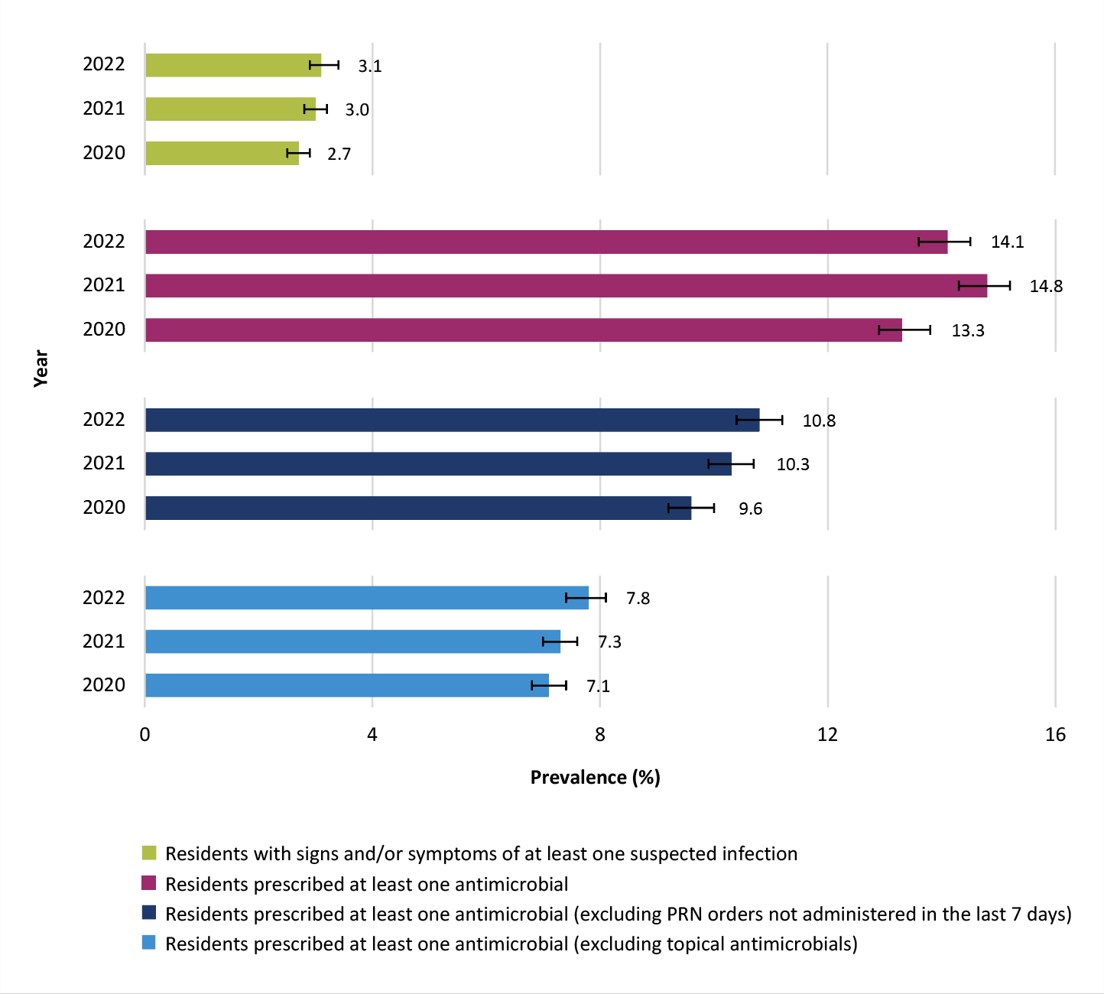

Sources: 1. Facility data collection form and 2: Antimicrobial and infection data collection form.

## Suspected infections on the survey day

Older people are especially vulnerable to infections and may not have typical signs and symptoms of infection. In 2022, a total of 1,293 residents were reported to have a total of 1,391 suspected infections on the survey day. Suspected skin or soft tissue (45.8%), urinary tract (21.8%) and respiratory tract (20.3%) infections were most commonly reported (Table 3). Only 32.8% met the McGeer et al. infection surveillance definitions15 specifically for use in RACFs; these definitions have been designed to increase the likelihood that events captured are confirmed infections.

### Table 3: Number and percentage of suspected infections by body system, Aged Care NAPS contributors, 2022

|  |  |  |  |  |
| --- | --- | --- | --- | --- |
| **Body system** | **Suspected infections** | | **RACF associated suspected infections\*** | |
| **n** | **%** | **n** | **%** |
| Skin or soft tissue | 637 | 45.8 | 628 | 45.6 |
| Respiratory tract | 282 | 20.3 | 280 | 20.3 |
| Urinary tract | 303 | 21.8 | 301 | 21.9 |
| Eye | 78 | 5.6 | 77 | 5.6 |
| Oral | 34 | 2.4 | 33 | 2.4 |
| Other systems | 58 | 4.2 | 57 | 4.1 |
| **Total** | **1,392** | **100** | **1,376** | **100** |

Source: Antimicrobial and infection data collection form Section 5, Method 1 data.

* RACF associated suspected infection = infection that developed in resident 48 hours post (re)admission.

## Most commonly prescribed antimicrobials

Most antimicrobials were prescribed for oral (58.6%) or topical (40.3%) administration. About one-fifth (19.0%) of prescriptions were for prophylactic use. As in previous surveys, clotrimazole (21.7%) and cefalexin (19.5%) were the most frequently prescribed antimicrobials. Notably, prescribing of molnupiravir (5.5%), an antiviral agent provisionally approved in Australia for treatment of mild to moderate COVID-19 in January 2022, was reported for the first time in the 2022 NAPS (Figure 3, Table A4).

### Figure 3: Most commonly prescribed antimicrobials, Aged Care NAPS contributors, 2020–2022

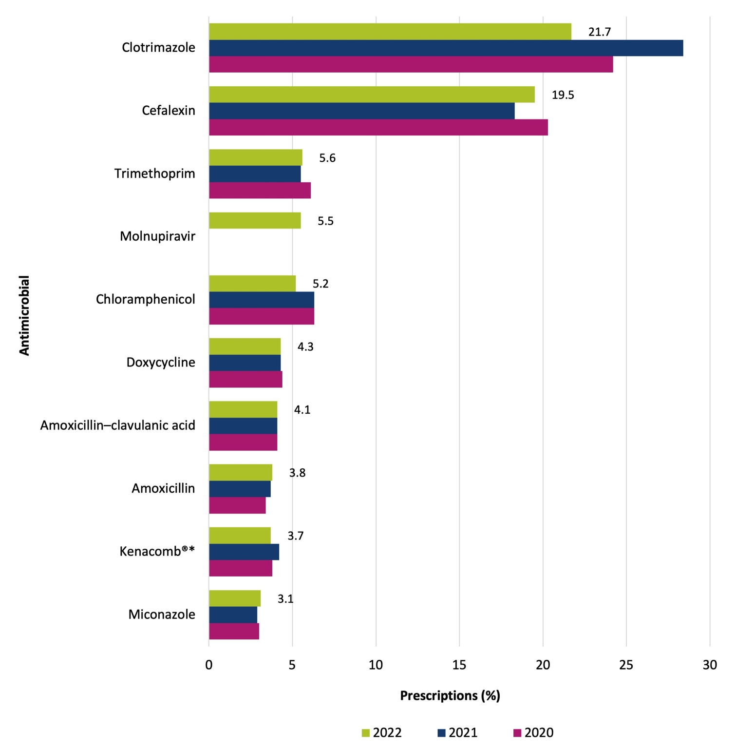

Source: Antimicrobial and infection data collection form Section 2, Method 1 and 2 data.

Only the top 10 antimicrobials prescribed are listed (methenamine hippurate, an antibacterial *antiseptic*, was excluded).

* Kenacomb® contains triamcinolone, neomycin, nystatin and gramicidin.

Clotrimazole (92.9%) and cefalexin (64.9%) were mostly prescribed for therapeutic indications   
(Table 4).

### Table 4: Clotrimazole and cefalexin prescriptions, therapeutic and prophylactic use, Aged Care NAPS contributors, 2022

|  |  |  |  |  |
| --- | --- | --- | --- | --- |
| **Antimicrobial** | **Category** | **n** | **%** | **% of total prescriptions (n=8,373)** |
| Clotrimazole (n=1,819) | Therapeutic | 1,690 | 92.9 | 20.2 |
| Prophylactic | 129 | 7.1 | 1.5 |
| Cefalexin (n=1,63) | Therapeutic | 1,062 | 64.9 | 12.7 |
| Prophylactic | 574 | 35.1 | 6.9 |

Source: Antimicrobial and infection data collection form Section 2, Method 1 and 2 data.

## Common indications for prescribing antimicrobials

The most commonly reported indications for antimicrobial prescriptions (therapeutic and prophylactic) was ‘other – skin, soft tissue or mucosal’ (22.1%) (Figure 4, Table A5). The most commonly reported indication for prophylactically prescribing antimicrobials was ‘cystitis’ (24.3%) (Figure 5, Tables A6

and A7).

### Figure 4: Most common indications for all antimicrobial prescriptions, Aged Care NAPS contributors, 2020–2022

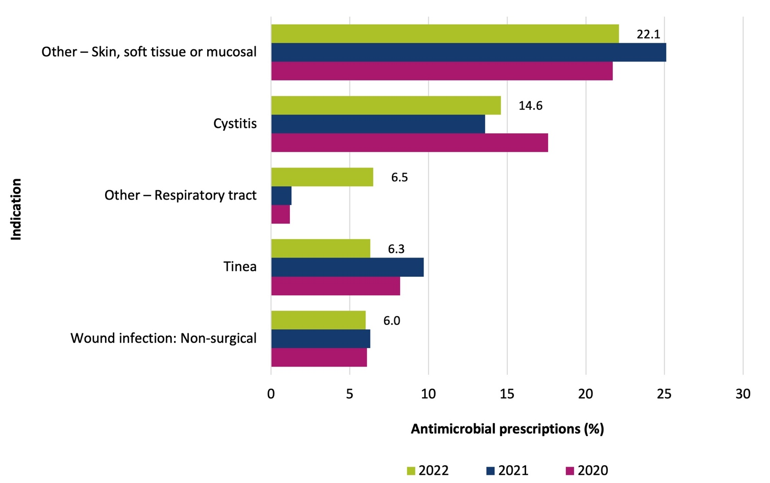

Source: Antimicrobial and infection data collection form Section 2, Method 1 and 2 data. See Table A5 for tabular presentation of data.

Only the top 5 indications for antimicrobial prescriptions are listed.

### Figure 5: Most common indications for prophylactic antimicrobial prescriptions, Aged Care NAPS contributors, 2020–2022

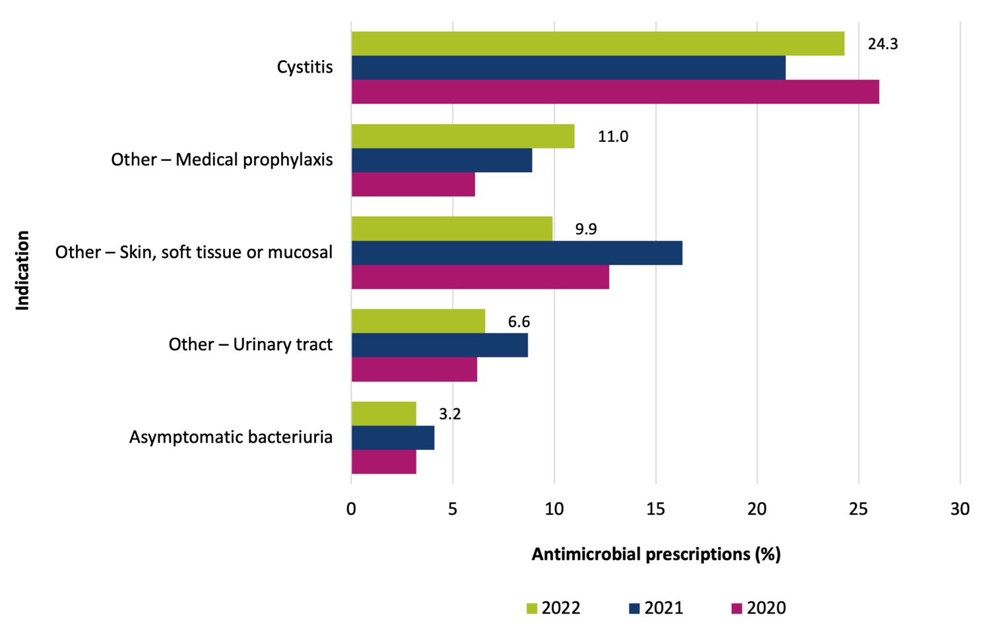

Source: Antimicrobial and infection data collection form Section 2, Method 1 and 2 data. See Table A6 for tabular presentation of data.

Only the top 5 indications for prophylactic antimicrobial prescriptions are listed.

## Most commonly prescribed antimicrobials for common indications

The most commonly prescribed antimicrobials for cystitis, tinea and wound infection (non-surgical) (the top 3 specific indications) were cefalexin (48.4%), clotrimazole (69.2%) and cefalexin (33.9%) respectively (Table 5).

### Table 5: Commonly prescribed antimicrobials for cystitis, tinea and wound infection (non-surgical), Aged Care NAPS contributors, 2022

|  |  |  |  |  |  |  |  |  |
| --- | --- | --- | --- | --- | --- | --- | --- | --- |
| **Cystitis (n=1,224)** | | | **Tinea (n=529)** | | | **Wound infection: non-surgical (n=505)** | | |
| **Antimicrobial** | **n** | **%** | **Antimicrobial** | **n** | **%** | **Antimicrobial** | **n** | **%** |
| Cefalexin | 592 | 48.4 | Clotrimazole | 366 | 69.2 | Cefalexin | 171 | 33.9 |
| Trimethoprim | 339 | 27.7 | Miconazole | 96 | 18.1 | Mupirocin | 76 | 15.0 |
| Nitrofurantoin | 103 | 8.4 | Terbinafine | 26 | 4.9 | Flucloxacillin | 61 | 12.1 |
| Amoxicillin–clavulanic acid | 56 | 4.6 | Ketoconazole | 12 | 2.3 | Kenacomb® | 26 | 5.1 |
| Amoxicillin | 40 | 3.3 | Kenacomb® | 10 | 1.9 | Clindamycin | 25 | 5.0 |

Source: Antimicrobial and infection data collection form Section 2, Method 1 and 2 data.

## Quality indicators

Complete and accurate documentation ensures that all those involved in resident care have access to consistent and current information. When, for example, a resident is prescribed an antimicrobial, the indication, active ingredient, dose, frequency and route of administration, and the intended duration or review plan should be documented in their healthcare record. Where electronic healthcare records are being used, flags and reminders in the record management system can be incorporated to support documentation in all relevant fields.16

For facilities that have participated each year since 2020, in 2022 compared with previous years there was an increase in the percentage of antimicrobial prescriptions that had a documented indication for prescribing an antimicrobial (78.4%) and a documented review or stop date (55.4%) (Figure 6, Table A8, Table A9).

### Figure 6: Key quality indicators, Aged Care NAPS contributors that have participated each year 2020–2022 (n=428)

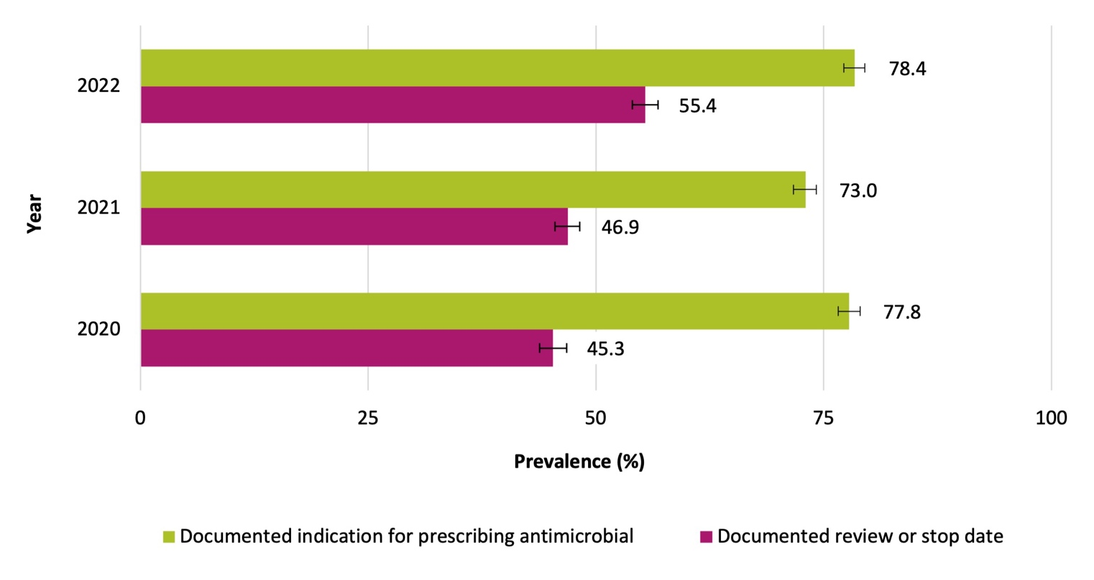

Source: Antimicrobial and infection data collection form Section 2, Method 1 and 2 data.

## Duration

In general, the shortest possible duration of therapy, consistent with the condition being treated and the resident’s clinical response, should be used. Prolonged duration of antimicrobial therapy is associated with an increased risk of adverse outcomes including antimicrobial resistance.17

In 2022, for antimicrobials still prescribed on the survey day, the start date was unknown for 1.8% of prescriptions, and 37.6% of prescriptions had commenced >6 months prior to the survey day. The most common antimicrobials in this category were clotrimazole (37.3%), cefalexin (14.5%) and Kenacomb® (gramicidin–neomycin–nystatin–triamcinolone) (6.2%). For antimicrobials still prescribed on the survey day, with a known start date and prescribed <6 months prior to the survey day, 31.5% had commenced >7 days prior to the survey day.

## Microbiology

For antimicrobials still prescribed on the survey day, with a known start date and prescribed <6 months prior to the survey day, a microbiology specimen was collected for less than one-quarter (22.6%) of prescriptions (Table 6). For one prescription, more than one specimen type could be taken.

### Table 6: Microbiology specimen collection, Aged Care NAPS contributors, 2022

|  |  |  |
| --- | --- | --- |
| **Specimen type** | **n** | **%** |
| Urine | 843 | 44.6 |
| Skin / wound swab | 308 | 16.3 |
| Respiratory swab | 591 | 31.3 |
| Sputum | 39 | 2.1 |
| Other | 110 | 5.8 |
| **Total** | **1,891** | **100** |

Source: Antimicrobial and infection data collection form Section 2, Method 1 and 2 data.

# Conclusion

Now in its seventh year, the Aged Care NAPS continues to play a pivotal role in RACFs as part of their IPC and AMS programs. This year’s key results again demonstrate that there are significant opportunities for improvement. Updated priorities for those working in the sector at a local or national level include (at least):

* advocating that all Australian RACFs participate in the Aged Care NAPS
* continuing training and helpdesk support for participating RACF staff to ensure accurate Aged Care NAPS data collection and submission
* sharing Aged Care NAPS results with administrators and clinicians such as general practitioners, pharmacists, nurses and aged care IPC leads, and using these results to develop targeted IPC and AMS improvement strategies
* enhancing the level of IPC training among RACF staff, focusing on evidence-based strategies that prevent and control common infections such as skin or soft tissue, urinary tract and respiratory infections
* tailoring RACF AMS programs to improve antimicrobial prescribing. This could include, for example, ensuring the documentation of key prescribing elements (indication and review or stop included), rationalising antimicrobial prescriptions for prophylactic use, and promoting appropriate microbiological sampling.

# Appendix

### Table A1: Participation of eligible facilities within state and territory and provider groups, Aged Care NAPS contributors, 2016–2021

|  |  |  |  |  |  |  |  |  |  |  |  |  |  |  |  |  |  |  |  |
| --- | --- | --- | --- | --- | --- | --- | --- | --- | --- | --- | --- | --- | --- | --- | --- | --- | --- | --- | --- |
| **Category** | | **2016** | | | **2017** | | | **2018** | | | **2019** | | | **2020** | | | **2021** | | |
| **PF**  **(n)** | **No. of facilities in RG** | **% of PF in the RG** | **PF**  **(n)** | **No. of facilities in RG** | **% of PF in the RG** | **PF**  **(n)** | **No. of facilities in RG** | **% of PF in the RG** | **PF**  **(n)** | **No. of facilities in RG** | **% of PF in the RG** | **PF**  **(n)** | **No. of facilities in RG** | **% of PF in the RG** | **PF**  **(n)** | **No. of facilities in RG** | **% of PF in the R****G** |
| State or territory | ACT | 0 | 25 | 0.0 | 0 | 25 | 0.0 | 4 | 25 | 16.0 | 6 | 24 | 25.0 | 6 | 24 | 25.0 | 8 | 25 | 32.0 |
| NSW | 32 | 927 | 3.5 | 37 | 936 | 4.0 | 63 | 939 | 6.7 | 137 | 936 | 14.6 | 171 | 939 | 18.2 | 136 | 928 | 14.7 |
| NT | 0 | 10 | 0.0 | 0 | 10 | 0.0 | 2 | 10 | 20.0 | 1 | 10 | 10.0 | 1 | 10 | 10.0 | 0 | 10 | 0.0 |
| QLD | 28 | 467 | 6.0 | 19 | 471 | 4.0 | 49 | 475 | 10.3 | 84 | 489 | 17.2 | 102 | 496 | 20.6 | 97 | 501 | 19.4 |
| SA | 7 | 274 | 2.6 | 8 | 268 | 3.0 | 35 | 268 | 13.1 | 66 | 270 | 24.4 | 89 | 267 | 33.3 | 88 | 262 | 33.6 |
| TAS | 10 | 73 | 13.7 | 6 | 73 | 8.2 | 6 | 72 | 8.3 | 28 | 71 | 39.4 | 31 | 71 | 43.7 | 26 | 69 | 37.7 |
| VIC | 174 | 759 | 22.9 | 184 | 765 | 24.1 | 203 | 769 | 26.4 | 229 | 776 | 29.5 | 296 | 774 | 38.2 | 240 | 765 | 31.4 |
| WA | 14 | 274 | 5.1 | 22 | 269 | 8.2 | 36 | 276 | 13.0 | 90 | 281 | 32.0 | 135 | 282 | 47.9 | 95 | 285 | 33.3 |
| Provider type | Government | 165 | 420 | 39.3 | 189 | 417 | 45.3 | 231 | 414 | 55.8 | 241 | 411 | 58.6 | 280 | 409 | 68.5 | 225 | 406 | 55.4 |
| Not-for-profit | 83 | 1,529 | 5.4 | 77 | 1,523 | 5.1 | 145 | 1,517 | 9.6 | 327 | 1,527 | 21.4 | 427 | 1,522 | 28.1 | 401 | 1,509 | 26.6 |
| Private | 17 | 860 | 2.0 | 10 | 877 | 1.1 | 22 | 903 | 2.4 | 73 | 919 | 7.9 | 124 | 932 | 13.3 | 64 | 930 | 6.9 |
| **Total** | | **265** | **2,809** | **9.4** | **276** | **2,817** | **9.8** | **398** | **2,834** | **14.0** | **641** | **2,857** | **22.4** | **831** | **2,863** | **29.0** | **690** | **2,845** | **24.3** |

Sources: 1. Facility data collection form and 2. Aged care service list: 30 June 2016 to 2022, AIHW GEN Aged Care Data. PF= participating facilities; RG = reporting group.

See Table 1 for 2022 data.

### Table A2: Prevalence of suspected infections and antimicrobial use on the survey day, Aged Care NAPS contributors, 2016–2022

|  |  |  |  |  |  |  |  |  |  |  |  |  |  |  |
| --- | --- | --- | --- | --- | --- | --- | --- | --- | --- | --- | --- | --- | --- | --- |
| **On survey day** | **2016** | | **2017** | | **2018** | | **2019** | | **2020** | | **2021** | | **2022** | |
| **n** | **%** | **n** | **%** | **n** | **%** | **n** | **%** | **n** | **%** | **n** | **%** | **n** | **%** |
| Residents with signs and/or symptoms of at least one suspected infection* | 385 | 3.0 | 338 | 2.9 | 562 | 2.9 | 984 | 2.8 | 1,383 | 2.9 | 1,248 | 3.1 | 1,293 | 3.0 |
| Residents with signs and/or symptoms of at least one residential aged care facility associated suspected infection* | – | – | – | – | – | – | – | – | – | – | 1,222 | 3.0 | 1,277 | 2.9 |
| Residents prescribed at least one antimicrobial | 1,214 | 9.6 | 1,050 | 9.0 | 1,914 | 9.9 | 3,503 | 9.9 | 5,625 | 11.8 | 5,561 | 13.7 | 5,441 | 12.5 |
| Residents prescribed at least one antimicrobial (excluding PRN orders not administered in the previous 7 days) | 1,214 | 9.6 | 1,049 | 9.0 | 1,626 | 8.4 | 2,932 | 8.3 | 4,148 | 8.7 | 3,923 | 9.7 | 4,201 | 9.6 |
| Residents prescribed at least one antimicrobial (excluding topical antimicrobials) | 870 | 6.9 | 723 | 6.2 | 1,264 | 6.5 | 2,208 | 6.2 | 3,066 | 6.4 | 2,733 | 6.7 | 3,003 | 6.9 |
| Number of residents present | 12,693 | – | 11,652 | – | 19,423 | – | 35,354 | – | 47,647 | – | 40,511 | – | 43,693 | – |

Sources: 1. Facility data collection form and 2. Antimicrobial and infection data collection form.

* See Technical Supplement for definition of (residential aged care facility associated) suspected infection.7 PRN = pro re nata.

### Table A3: Prevalence of suspected infections and antimicrobial use on the survey day,

### Aged Care NAPS contributors that have participated each year 2020–2022 (n=428)

|  |  |  |  |  |  |  |  |  |  |
| --- | --- | --- | --- | --- | --- | --- | --- | --- | --- |
| **On survey day** | **2020** | | | **2021** | | | **2022** | | |
| **n** | **%** | **95% CI** | **n** | **%** | **95% CI** | **n** | **%** | **95% CI** |
| Residents with signs and/or symptoms of at least one suspected infection* | 647 | 2.7 | 2.5 – 2.9 | 717 | 3.0 | 2.8 – 3.2 | 742 | 3.1 | 2.9 – 3.4 |
| Residents prescribed at least one antimicrobial | 3,185 | 13.3 | 12.9 – 13.8 | 3,520 | 14.8 | 14.3 – 15.2 | 3,316 | 14.1 | 13.6 – 14.5 |
| Residents prescribed at least one antimicrobial, excluding PRN orders not administered in the last 7 days | 2,293 | 9.6 | 9.2 – 10.0 | 2,454 | 10.3 | 9.9 – 10.7 | 2,535 | 10.8 | 10.4 – 11.2 |
| Residents prescribed at least one antimicrobial, excluding topical antimicrobials | 1,689 | 7.1 | 6.7 – 7.4 | 1,735 | 7.3 | 7.0 – 7.6 | 1,837 | 7.8 | 7.5 – 8.1 |
| Number of residents present | 23,905 | – | – | 23,841 | – | – | 23,570 | – | – |

Sources:1 Facility data collection form and 2: Antimicrobial and infection data collection form. See Figure 2 for graphical presentation

*See Technical Supplement for definition of (residential aged care facility associated) suspected infection7 CI = confidence interval.

### Table A4: Most commonly prescribed antimicrobials, Aged Care NAPS contributors, 2020–2022

|  |  |  |  |  |  |  |
| --- | --- | --- | --- | --- | --- | --- |
| **Antimicrobial** | **Prescriptions** | | | | | |
| **2020**  **(n=7,602)** | | **2021**  **(n=7,640)** | | **2022 (n=8,373)** | |
| **n** | **%** | **n** | **%** | **n** | **%** |
| Clotrimazole | 1,837 | 24.2 | 2,166 | 28.4 | 1,819 | 21.7 |
| Cefalexin | 1,541 | 20.3 | 1,397 | 18.3 | 1,636 | 19.5 |
| Trimethoprim | 461 | 6.1 | 423 | 5.5 | 473 | 5.6 |
| Molnupiravir | 0 | 0.0 | 0 | 0.0 | 464 | 5.5 |
| Chloramphenicol | 480 | 6.3 | 478 | 6.3 | 435 | 5.2 |
| Doxycycline | 334 | 4.4 | 330 | 4.3 | 361 | 4.3 |
| Amoxicillin–clavulanic acid | 311 | 4.1 | 310 | 4.1 | 347 | 4.1 |
| Amoxicillin | 262 | 3.4 | 280 | 3.7 | 316 | 3.8 |
| Kenacomb®* | 292 | 3.8 | 321 | 4.2 | 313 | 3.7 |
| Miconazole | 228 | 3.0 | 220 | 2.9 | 260 | 3.1 |

Source: Antimicrobial and infection form Section 2, Method 1 and 2 data. See Figure 3 for graphical presentation.

Only the top 10 antimicrobials prescribed are listed.

* Kenacomb® contains triamcinolone, neomycin, nystatin and gramicidin.

### Table A5: Most common indications for all antimicrobial prescriptions (therapeutic and prophylactic), Aged Care NAPS contributors, 2020–2022

|  |  |  |  |  |  |  |
| --- | --- | --- | --- | --- | --- | --- |
| **Indication** | **2020**  **(n=7,602)** | | **2021**  **(n=7,640)** | | **2022 (n=8,373)** | |
| **n** | **%** | **n** | **%** | **n** | **%** |
| Other – skin, soft tissue or mucosal | 1,649 | 21.7 | 1,914 | 25.1 | 1,851 | 22.1 |
| Cystitis | 1,337 | 17.6 | 1,041 | 13.6 | 1,224 | 14.6 |
| Other – respiratory tract | 94 | 1.2 | 100 | 1.3 | 541 | 6.5 |
| Tinea | 627 | 8.2 | 741 | 9.7 | 529 | 6.3 |
| Wound infection: non-surgical | 466 | 6.1 | 479 | 6.3 | 505 | 6.0 |

Source: Antimicrobial and infection data collection form Section 2, Method 1 and 2 data. See Figure 4 for graphical presentation.

Only the top 5 indications for antimicrobial prescriptions are listed.

### Table A6: Most common indications for prophylactic antimicrobial prescriptions, Aged Care NAPS contributors, 2020–2022

|  |  |  |  |  |  |  |
| --- | --- | --- | --- | --- | --- | --- |
| **Indication** | **2020 (n=1,824)** | | **2021 (n=1,703)** | | **2022 (n=1,574)** | |
| **n** | **%** | **n** | **%** | **n** | **%** |
| Cystitis | 474 | 26.0 | 365 | 21.4 | 382 | 24.3 |
| Other – medical prophylaxis | 111 | 6.1 | 152 | 8.9 | 173 | 11.0 |
| Other – skin, soft tissue or mucosal | 231 | 12.7 | 277 | 16.3 | 156 | 9.9 |
| Other – urinary tract | 114 | 6.2 | 148 | 8.7 | 104 | 6.6 |
| Asymptomatic bacteriuria | 59 | 3.2 | 69 | 4.1 | 50 | 3.2 |

Source: Antimicrobial and infection form Section 2, Method 1 and 2 data. See Figure 5 for graphical presentation.

Only the top 5 indications for prophylactic antimicrobial prescriptions are listed.

### Table A7: Comparison of therapeutic and prophylactic antimicrobial prescriptions for common indications, Aged Care NAPS contributors, 2022

|  |  |  |  |  |  |
| --- | --- | --- | --- | --- | --- |
| **Indication** | **Therapeutic**  **(n=6,781)** | | **Prophylactic**  **(n=1,592)** | | **Total (n=8,373)** |
| **n** | **%** | **n** | **%** |
| Other – skin, soft tissue or mucosal | 1,695 | 91.6 | 156 | 8.4 | 1,851 |
| Cystitis | 842 | 68.8 | 382 | 31.2 | 1,224 |
| Other – respiratory tract | 517 | 95.6 | 24 | 4.4 | 541 |
| Tinea | 509 | 96.2 | 20 | 3.8 | 529 |
| Wound infection: non-surgical | 484 | 95.8 | 21 | 4.2 | 505 |
| Pneumonia | 413 | 93.9 | 27 | 6.1 | 440 |
| Cellulitis | 337 | 92.8 | 26 | 7.2 | 363 |
| Conjunctivitis | 258 | 92.1 | 22 | 7.9 | 280 |
| Other – urinary tract | 70 | 40.2 | 104 | 59.8 | 174 |
| Paronychia | 120 | 88.2 | 16 | 11.8 | 136 |

Source: Antimicrobial and infection data collection form Section 2, Method 1 and 2 data. Only the top 10 indications for antimicrobial prescription are listed.

Unknown and medical prophylaxis indications for commencing an antimicrobial are excluded.

### Table A8: Key quality indicators, Aged Care NAPS contributors, 2016–2022

|  |  |  |  |  |  |  |  |  |  |  |  |  |  |  |
| --- | --- | --- | --- | --- | --- | --- | --- | --- | --- | --- | --- | --- | --- | --- |
| **Indicator** | **2016** | | **2017** | | **2018** | | **2****019** | | **2020** | | **2021** | | **2022** | |
| **n** | **%** | **n** | **%** | **n** | **%** | **n** | **%** | **n** | **%** | **n** | **%** | **n** | **%** |
| Indication for prescribing an antimicrobial | | | | | | | | | | | | | | |
| Documented | 1,382 | 78.9 | 1,181 | 79.2 | 1,907 | 76.9 | 3,391 | 73.2 | 5,811 | 76.4 | 5,623 | 73.6 | 6,721 | 80.3 |
| Not documented | 370 | 21.1 | 310 | 20.8 | 572 | 23.1 | 1,242 | 26.8 | 1,791 | 23.6 | 2,017 | 26.4 | 1,652 | 19.7 |
| Review or stop date | | | | | | | | | | | | | | |
| Documented | 893 | 51.0 | 782 | 52.4 | 1,169 | 47.2 | 2,520 | 54.4 | 3,482 | 45.8 | 3,413 | 44.7 | 4,739 | 56.6 |
| Not documented | 859 | 49.0 | 709 | 47.6 | 1,310 | 52.8 | 2,113 | 45.6 | 4,120 | 54.2 | 4,227 | 55.3 | 3,634 | 43.4 |
| **Total** | **1,752** | **–** | **1,491** | **–** | **2,479** | **–** | **4,633** | **–** | **7,602** | **–** | **7,640** | **–** | **8,373** | **–** |

Source: Antimicrobial and infection data collection form Section 2, Method 1 and 2 data.

### Table A9: Key quality indicators, Aged Care NAPS contributors that have participated each year 2020–2022 (n=428)

|  |  |  |  |  |  |  |  |  |  |
| --- | --- | --- | --- | --- | --- | --- | --- | --- | --- |
| **Indicator** | **2020** | | | **2021** | | | **2****022** | | |
| **n** | **%** | **95% CI** | **n** | **%** | **95% CI** | **n** | **%** | **95% CI** |
| Indication for prescribing an antimicrobial | | | | | | | | | |
| Documented | 3,470 | 77.8 | 76.6 – 79.0 | 3,650 | 73.0 | 71.7 – 74.2 | 3,885 | 78.4 | 77.2 – 79.5 |
| Not documented | 988 | 22.2 | 21.0 – 23.4 | 1,351 | 27.0 | 25.8 – 28.3 | 1,073 | 21.6 | 20.5 – 22.8 |
| Review or stop date | | | | | | | | | |
| Documented | 2,019 | 45.3 | 43.8 – 46.8 | 2,343 | 46.9 | 45.5 – 48.2 | 2,747 | 55.4 | 54.0 – 56.8 |
| Not documented | 2,439 | 54.7 | 53.2 – 56.2 | 2,658 | 53.1 | 51.8 – 54.5 | 2,211 | 44.6 | 43.2 – 46.0 |
| **Total** | **4,458** | **–** | **–** | **5,001** | **–** | **–** | **4,958** | **–** | **–** |

Source: Antimicrobial and infection data collection form Section 2, Method 1 and 2 data. See Figure 6 for graphical presentation.

CI= confidence interval.

# References

1. Royal Melbourne Hospital and the National Centre for Antimicrobial Stewardship. Antimicrobial prescribing in Australian residential aged care facilities. Results of the 2020 Aged Care National Antimicrobial Prescribing Survey. Canberra: NCAS; 2023.
2. Royal Melbourne Hospital and the National Centre for Antimicrobial Stewardship. Antimicrobial prescribing in Australian residential aged care facilities. Results of the 2021 Aged Care National Antimicrobial Prescribing Survey. Canberra: NCAS; 2023.
3. National Centre for Antimicrobial Stewardship and Australian Commission on Safety and Quality in Health Care. 2019 Aged Care National Antimicrobial Prescribing Survey Report. Sydney (Australia); 2020.
4. National Centre for Antimicrobial Stewardship and Australian Commission on Safety and Quality in Health Care. Antimicrobial prescribing and infections in Australian aged care homes: Results of the 2018 Aged Care National Antimicrobial Prescribing Survey. Sydney (Australia); 2019.
5. National Centre for Antimicrobial Stewardship and Australian Commission on Safety and Quality in Health Care. Antimicrobial prescribing and infections in Australian aged care homes. Results of the 2017 Aged Care National Antimicrobial Prescribing Survey. Sydney: ACSQHC; 2018.
6. National Centre for Antimicrobial Stewardship and Australian Commission on Safety and Quality in Health Care. Aged Care National Antimicrobial Prescribing Survey 2016. Sydney: ACSQHC; 2017.
7. Royal Melbourne Hospital and the National Centre for Antimicrobial Stewardship. National Antimicrobial Prescribing Survey: Technical Supplement 2022. Canberra: NCAS; 2024.
8. European Centre for Disease Prevention and Control. Point prevalence survey of healthcare- associated infections and antimicrobial use in European long-term care facilities. April–May 2013. Stockholm: European Centre for Disease Prevention and Control; 2014.
9. Australian Commission on Safety and Quality in Health Care. AURA 2021: Fourth Australian report on antimicrobial use and resistance in human health. Sydney: ACSQHC; 2021.
10. Australian Government. Surveillance of antimicrobial use and resistance in human health. Antimicrobial Resistance. Canberra: Department of Health and Aged Care; 2023. Accessed October 2023, at https://[www.amr.gov.au/australias-response/objective-5-integrated-surveillance-](http://www.amr.gov.au/australias-response/objective-5-integrated-surveillance-) and-response-resistance-and-usage/surveillance-antimicrobial-use-and-resistance-human- health#antimicrobial-use-and-resistance-in-australia-aura
11. Aged Care Quality and Safety Commission. Guidance and resources for providers to support the Aged Care Quality Standards 14th ed. Sydney: ACQSC; 2023.
12. Aged Care Quality and Safety Commission. Aged Care Quality Standards. Canberra: ACQSC; 2021.
13. Centers for Disease Prevention and Control. The core elements of antibiotic stewardship for nursing homes. Atlanta GA; 2015.
14. Australian Bureau of Statistics. 1270.0.55.005 – Australian Statistical Geography Standard. Canberra: ABS; 2016.
15. Stone ND, Ashraf MS, Calder J et al. Surveillance definitions of infections in long-term care facilities: revisiting the McGeer criteria. Infection Control and Hospital Epidemiology 2012; 33(10): 965–77.
16. Australian Commission on Safety and Quality in Health Care. Antimicrobial Stewardship Clinical Care Standard. 2nd ed. Sydney: ACQSC; 2020.
17. Antibiotic Expert Group. Therapeutic Guidelines: Antibiotic. 16th ed. Melbourne: Therapeutic Guidelines Limited; 2019.



All information in this publication is correct as at October 2023

### [amr.gov.au](http://www.amr.gov.au/)