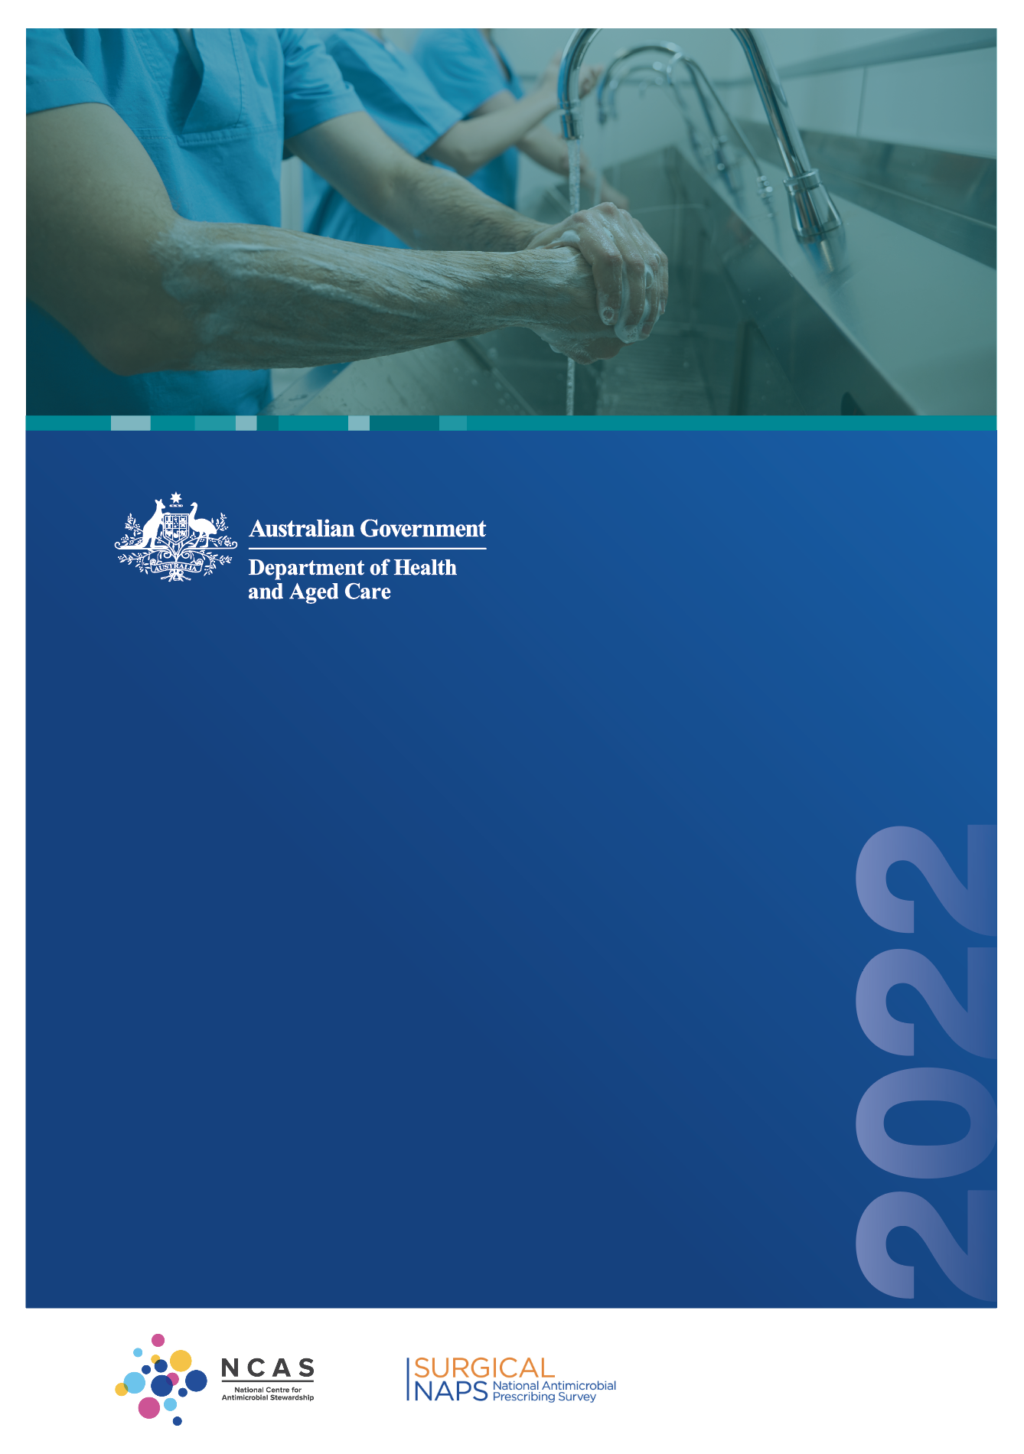

**Surgical prophylaxis prescribing in   
Australian hospitals**

Results of the 2022 Surgical National Antimicrobial Prescribing Survey

Published by the Australian Government Department of Health and Aged Care

For issues regarding the content of the report:

Email: [support@naps.org.au](mailto:support@naps.org.au) Website: [https://www.naps.org.au](https://www.naps.org.au/)

ISBN: 978-1-74186-090-0

© Australian Government Department of Health and Aged Care

All material and work produced by the Department of Health and Aged Care is protected by copyright. The Department reserves the right to set out the terms and conditions for the use of such material.

Enquiries about the licence and any use of this publication are welcome and can be sent to [AMR@health.gov.au](mailto:AMR@health.gov.au)

#### Preferred citation

Royal Melbourne Hospital and the National Centre for Antimicrobial Stewardship. Surgical prophylaxis prescribing in Australian hospitals. Results of the 2022 Surgical National Antimicrobial Prescribing Survey. Canberra: Department of Health and Aged Care; 2024.

#### Disclaimer

This document is not intended to provide guidance on particular healthcare choices. You should contact your healthcare provider for advice on particular healthcare choices.

This document includes the views or recommendations of its authors and third parties. Royal Melbourne Hospital, the National Centre for Antimicrobial Stewardship and the Department of Health and Aged Care do not accept any legal liability for any injury, loss or damage incurred by the use of, or reliance on, this document.

Table of contents

Preface iv

Acknowledgements iv

Abbreviations iv

Summary v

1. Introduction 1
2. Results 2
   1. Participation 2
   2. Surgical episodes 3
   3. Key indicators 5
   4. Procedural prophylaxis prescribing 7
   5. Post-procedural prescribing 12
3. Conclusion 18

Appendix 19

References 25

# Preface

This report is best interpreted when read in conjunction with the National Antimicrobial Prescribing Survey Technical Supplement 2022.

# Acknowledgements

Contributing facilities

On behalf of the National Centre for Antimicrobial Stewardship (NCAS) and the Royal Melbourne Hospital (RMH) Guidance Group, we would like to thank all contributing facilities and auditors for their time and effort in collecting and entering the data, in contributing data to this report and to the Antimicrobial Use and Resistance in Australia (AURA) Surveillance System, and for their continued commitment to improving safety and quality across the Australian healthcare system.

NCAS and the RMH Guidance Group

Professor Karin Thursky   
Dr Rodney James

Dr Courtney Ierano   
Ms Caroline Chen

Associate Professor Noleen Bennett   
Associate Professor Lisa Hall

Mr Pramode Varghese   
Mr Logesh Palani

Mr Abukari Yakubu   
Mr Simon Burrell

# Abbreviations

|  |  |
| --- | --- |
| **Abbreviation** | **Definition** |
| AIHW | Australian Institute of Health and Welfare |
| AMS | Antimicrobial stewardship |
| AURA | Antimicrobial Use and Resistance in Australia |
| NAPS | National Antimicrobial Prescribing Survey |
| NCAS | National Centre for Antimicrobial Stewardship |
| Surgical NAPS | Surgical National Antimicrobial Prescribing Survey |
| RMH | Royal Melbourne Hospital |

# Summary

The Surgical National Antimicrobial Prescribing Survey (Surgical NAPS) continues to be a widely adopted and valued tool to assess the quality of antimicrobial prescribing across Australian facilities. It is a key contributor towards Australia’s National Antimicrobial Resistance Strategy1 and the Antimicrobial Use and Resistance in Australia (AURA) Surveillance System.2 Its focus on providing meaningful data for action with clear data visualisation for contributing hospitals has led to the continued high participation from Australian facilities, representing a wide variety of funding types, peer groups and remoteness classifications.

During 2022, 186 hospitals (100 public and 86 private) submitted data on 10,218 surgical episodes with 8,694 procedural doses and 4,091 post-procedural prescriptions to the Surgical NAPS database.

Results for key indicators

* **Documentation of incision time and the time of antimicrobial administration** continues to improve (76.8% and 91.0% respectively), presumably due to hospitals increasing their adoption of electronic medication management systems.
* **Overall rate of appropriateness** per surgical episode remained low (55.3%).
* The difference between **overall prophylactic procedural and post-procedural dose appropriateness** remained noticeable (61.2% and 36.6% respectively).
* **Procedure groups with the lowest prophylactic procedural appropriateness** were head and neck surgery (34.0%), dentoalveolar surgery (42.7%) and urological surgery (43.0%).
* **Procedure groups with the lowest prophylactic post-procedural appropriateness** were gynaecological surgery (3.8%), head and neck surgery (6.0%) and breast surgery (9.5%).
* **Duration** remains the most pertinent issue regarding post-procedural prophylaxis appropriateness. Of all prophylactic post-procedural prescriptions, 40.4% had a duration greater than 48 hours.

Implications for clinical practice

### Suboptimal documentation

Documentation is an important component of comprehensive medical care as it allows timely and accurate communication between members of the clinical care team and contributes to effective safety and quality of patient care. Failure to document important components of surgical care was reported for 1 in 4 surgical procedures for **incision time**, and 1 in 10 surgical procedures for **time of antimicrobial administration**.

### Compliance with guidelines and appropriateness of prescribing

Compliance with guidelines for surgical antimicrobial prophylaxis, and consequently appropriateness of prescribing, continues to be poor overall, but even more so for prophylactic post-procedural prescriptions. This relates to prescription of antimicrobials that are not required and prolonged duration of antimicrobial use. Procedurally, inappropriate antimicrobial use is primarily due to suboptimal timing of administration.

For many procedures there is no evidence that prophylactic antimicrobial use, either procedurally or post-procedurally, reduces post-operative infections. Reducing inappropriate surgical antimicrobial prophylaxis balances the unintended harms of antimicrobial use with the benefits of evidence- based care.

# Introduction

The judicious use of antimicrobials is a key component of good patient care across all health settings. Australia’s National Antimicrobial Resistance Strategy1 has recommended the adoption of antimicrobial stewardship (AMS) programs, with the aim of enhancing patient healthcare outcomes whilst reducing the emergence and spread of antimicrobial resistance.

Now in its seventh year, the Surgical National Antimicrobial Prescribing Survey (Surgical NAPS) has been adopted as an important platform to support the AMS programs in hospitals by facilitating meaningful measurement, reporting and benchmarking of the quality of antimicrobial prescribing. NAPS program staff also continue to provide clinical program support and training for participants. Internationally, it remains the only tool to measure appropriateness of antimicrobial prescribing.

Furthermore, participation in the Surgical NAPS assists health service organisations to demonstrate that they meet the AMS action requirements of the National Safety and Quality Health Service (NSQHS) Standards3 and the Antimicrobial Stewardship Clinical Care Standard.4

The Australian Government Department of Health and Aged Care provides funding for the Royal Melbourne Hospital (RMH) Guidance Group and the National Centre for Antimicrobial Stewardship (NCAS) to conduct the Surgical NAPS and contribute data to the Antimicrobial Use and Resistance in Australia (AURA) Surveillance System.2

For details on survey methodology, analysis methodology and considerations for data interpretation, please refer to the National Antimicrobial Prescribing Survey Technical Supplement 2022.5

# Results

## Participation

The Surgical NAPS remains a voluntary program; nonetheless there has been consistent participation by acute care facilities across all Australian states and territories, remoteness areas and funding types since the program’s initiation.

This report analyses the data submitted by 186 hospitals (100 public and 86 private) that met the Surgical NAPS inclusion criteria. Participation has remained steady the last few years, with 187 hospitals (95 public, 92 private) in 2021 and 158 hospitals (76 public, 82 private) in 2020. The 2022 cohort included public and private facilities from most states and territories, covering a range of Australian Institute of Health and Welfare (AIHW) hospital peer groups6 and Australian Bureau of Statistics remoteness classifications7 (Figure 1). Tasmania did not contribute any data for 2022. For further information regarding inclusion criteria and definitions, refer to the Technical Supplement.

#### Figure 1: Facilities that contributed to the Surgical NAPS by state and territory, 2022

**WA**

9 private

16 public

**NT**

0 private

2 public

**SA**

8 private

12 public

**VIC**

23 private

25 public

**QLD**

15 private

9 public

**NSW**

29 private

36 public

#### Total participation: 186 facilities

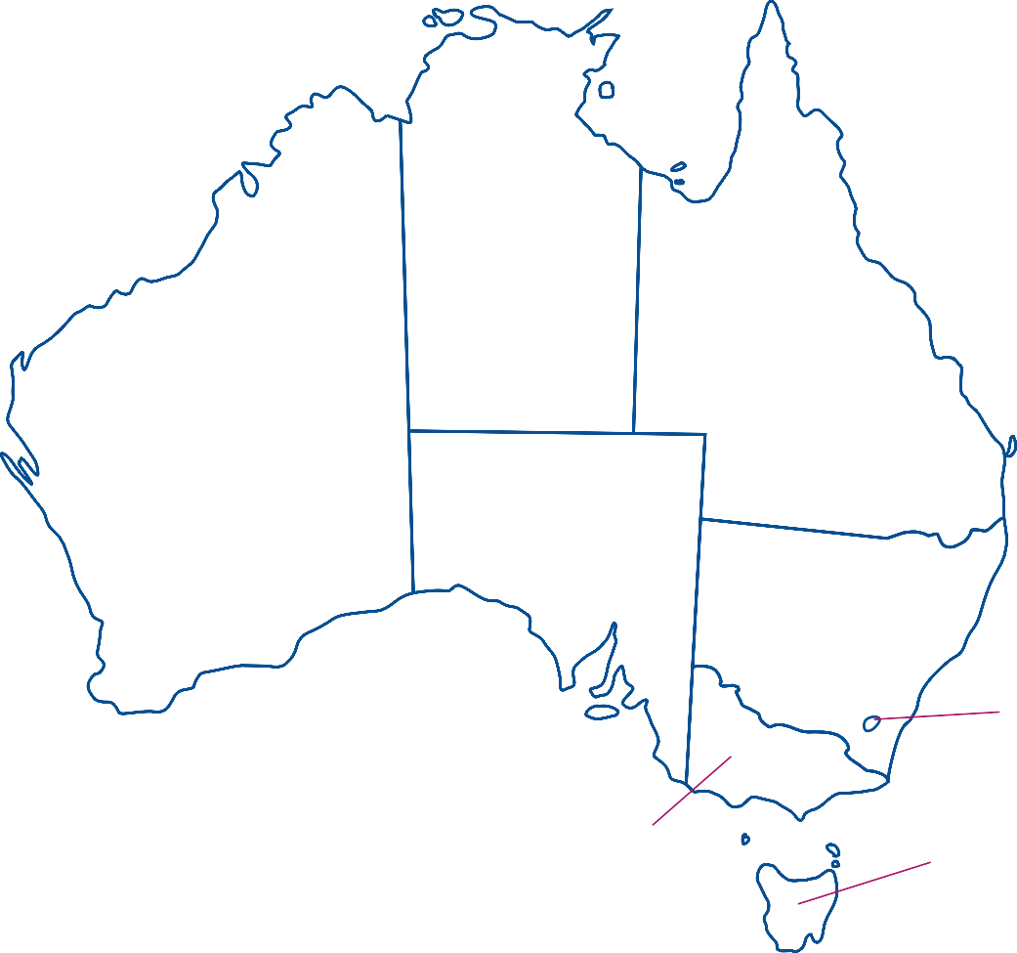**ACT**

2 private

0 public

**TAS**

0 private

0 public

## Surgical episodes

A total of 10,218 surgical episodes were included in the 2022 Surgical NAPS analyses. Most of the surgical episodes were for initial surgeries (98.0%) rather than subsequent procedures (2.0%), and this did not differ significantly when comparing public and private hospitals (96.7% and 98.5% initial surgeries respectively). Elective surgical procedures remained the most common type for all episodes (87.6%), with a greater proportion in private hospitals compared with public hospitals (96.3% and 72.2% respectively).

The presence of trauma in surgery remains low (5.7%), with a higher proportion in public hospitals (9.5%) compared with private hospitals (3.5%). Conversely, the removal or insertion of prosthetic material accounted for greater than a third of all surgical episodes (37.3%), with a higher proportion in private hospitals (44.6%) compared with public hospitals (24.4%).

For a full breakdown of the characteristics of surgical episodes, procedural doses and prophylactic post-procedural prescriptions by hospital funding type, state and territory, peer group and remoteness classification, refer to the Appendix.

Figure 2 shows the breakdown of antimicrobial prescribing for surgical episodes reported to the 2022 Surgical NAPS, by procedural and prophylactic post-procedural characteristics, to assist with understanding the analyses presented.

#### Figure 2: Surgical episodes by procedural and post-procedural prescribing characteristics, Surgical NAPS 2022

**186 facilities**

10,218 episodes

**Existing antimicrobials**

801 antimicrobials prescribed

No further analysis

**Procedural antimicrobials**

**Post-procedural antimicrobials**

None prescribed

2,530 episodes*

Prescribed

7,688 episodes

8,694 doses

None prescribed

5,770 episodes

Prescribed

4,170 episodes

4,958 prescriptions

Not assessable

278 episodes

Initial doses

8,530 doses

Repeat doses

164 doses

Episodes where Episodes where at least one no prescriptions prescription were for

was for prophylaxis

prophylaxis 565 episodes

3,605 episodes 824 prescriptions 4,134 prescriptions No further analysis

Prophylaxis

4,091 prescriptions

Treatment

28 prescriptions

No further analysis

Not assessable

15 prescriptions

No further analysis

* There were 25 repeat doses indicated but not prescribed

**Legend**

**Episode** – an individual procedure or set of procedures performed together during one surgical session and the subsequent post-procedural care (i.e., antimicrobials prescribed) associated with the procedure(s)

**Dose** – an individual antimicrobial dose administered either immediately prior to or during or after the surgical procedure

**Prescription** – any antimicrobial prescribed either as a single dose or as a course following the surgical procedure

**Existing antimicrobial** – an antimicrobial prescribed for treatment or prophylaxis in the 24 hours prior (72 hours if on dialysis) to the procedure, used to determine the appropriateness of whether procedural antimicrobials were given or not given

**Procedural antimicrobial** – an antimicrobial administered either immediately prior to or during the surgical procedure for the purpose of prophylaxis; each initial and repeat dose of the antimicrobial administered is recorded individually

**Post-procedural antimicrobial** – an antimicrobial prescribed following, but directly relating to, the procedure; each prescription of the antimicrobial is recorded, including any inpatient or discharge scripts

**Initial dose** – the first dose of an antimicrobial administered either immediately prior to or during the surgical procedure for the purpose of prophylaxis

**Repeat dose** – any subsequent dose of an antimicrobial administered during the surgical procedure for the purpose of prophylaxis

**Prophylaxis** – an antimicrobial prescribed for the prevention of surgery-related infection

**Treatment** – an antimicrobial prescribed for the treatment of infection related to the procedure

**Episodes where no prescriptions were for prophylaxis** – any episode where all prescribed antimicrobials are recorded as for ‘treatment’ and/or ‘not assessable’

## Key indicators

Results for the indicators are summarised in Table 1.

#### Table 1: Surgical NAPS key indicators, for assessable prescriptions, 2022

|  |  |
| --- | --- |
| **Key indicator\*** | **Result** |
| Incision time documented | 76.8% |
| Administration time documented† | 91.0% |
| Overall appropriateness of surgical episodes | 55.3% |
| Overall procedural dose appropriateness | 61.2% |
| Overall post-procedural prescription appropriateness | 36.6% |
| Post-procedural prescription duration >48 hours | 40.4% |

* Refer to Technical Supplement for definitions.5

† Calculation includes both ‘exact minute’ and ‘nearest 15 minutes’ documentation.

### Documentation

A consistent theme over the last 7 years is the suboptimal documentation of surgical incision and antimicrobial administration times.

Of the 9,658 incisional procedures reported in 2022, over three-quarters had a time of incision documented (n=7,421, 76.8%).

Of the 8,530 initial procedural doses prescribed, 27.9% were recorded to the exact minute, and 63.1% to the nearest 15 minutes. The remainder (9.0%) did not have a documented administration time.

Documentation of incision time was higher in private hospitals (81.5%) compared with public hospitals (61.4%). Conversely, exact documentation of administration time was reported less frequently in private hospitals (18.0%) compared with public hospitals (50.6%).

The timing of surgical prophylaxis is important to ensure high concentrations of antimicrobials at the time of surgical incision. Ensuring documentation of both incision and antimicrobial administration times may improve appropriateness of antimicrobial administration times and help prevent surgical site infections for those episodes in which antimicrobial prophylaxis is indicated.

As electronic medical records are progressively implemented in Australia, we anticipate that this may support improvements in the documentation of surgical incision and antimicrobial administration times. In comparison to paper-based systems, electronic medical record systems have the capacity to prompt and require information that is otherwise routinely omitted (i.e., time of surgical incision and antimicrobial administration), as identified by the Surgical NAPS, to be entered.

### Overall appropriateness

The overall appropriateness, inclusive of all procedural and post-procedural antimicrobial prescribing across a surgical episode, has not shown improvement from previous years. Of the 10,218 surgical episodes reported in 2022, 55.3% were deemed appropriate, similar to 2021 (56.5%). Overall appropriateness differed slightly between public and private hospitals (61.2% and 51.9% respectively).

The percentage of episodes deemed inappropriate varied by procedure group, ranging from 1.1% for gastrointestinal endoscopic procedures to 52.4% for breast surgery. All procedure groups had an inappropriateness rate greater than 25%, apart from gastrointestinal endoscopic procedures.

High rates of appropriateness for gastrointestinal endoscopic procedures are consistent every year and are expected as surgical antimicrobial prophylaxis is not routinely required. Only 3.4% of all gastrointestinal endoscopic procedures included at least one procedural antimicrobial dose.

Dentoalveolar surgery had the highest proportion of ‘not assessable’ episodes (25.9%), suggesting that auditors may require further clarifications from guidelines and improvement in the clinical documentation to accurately assess these episodes.

#### Figure 3: Percentage of episodes by appropriateness* of prescribing for each surgical procedure group, Surgical NAPS contributor facilities, 2022

55.2

39.0

5.8

All procedure groups

35.7

38.4

25.9

Dentoalveolar surgery (n=370)

40.0

52.4

7.6

Breast surgery (n=170)

46.2

46.7

7.2

Urological surgery (n=613)

Plastic and reconstructive

surgery (n=1,236)

Ophthalmology (n=1,072)

47.0

47.4

5.6

48.5

43.0

8.5

48.5 46.8 4.6

Orthopaedic surgery (n=2,158)

49.2

49.2

1.6

Thoracic surgery (n=63)

49.5

43.6

6.9

Head and neck surgery (n=566)

50.8

48.6

0.6

Neurosurgery (n=360)

53.3

39.2

7.5

Vascular surgery (n=120)

59.3

39.5

1.1

Cardiac surgery (n=263)

62.9

33.0

4.1

Gynaecological surgery (n=439)

64.1

31.4

4.6

Abdominal surgery (n=1,185)

69.2

27.1

3.7

Obstetrics (n=1,040)

Gastrointestinal endoscopic procedures (n=563)

96.8

1.1 2.1

0 20 40 60 80 100

**Percentage of appropriateness (%)**

Appropriate

Inappropriate

Not assessable

**Procedure group**

* Refer to Technical Supplement for appropriateness definitions.5

The measure of appropriateness differed greatly when comparing overall procedural doses and overall post-procedural prescriptions. Of the 8,694 prescribed procedural doses, 61.2% (n=5,319) were deemed appropriate. In contrast, of the 4,091 post-procedural prophylaxis prescriptions, 36.6% (n=1,499) were deemed appropriate.

Prolonged durations remain an issue for post-procedural prophylaxis, with 40.4% (n=1,654) of these prescriptions having a duration greater than 48 hours. There are no recommendations in Australian guidelines recommending surgical antimicrobial prophylaxis for greater than 48 hours.8

## Procedural prophylaxis prescribing

Approximately one-quarter (26.3%) of all procedural prophylaxis prescribing was assessed as inappropriate (Table 2). The proportion of episodes deemed inappropriate was higher when antimicrobials were prescribed than when they were not prescribed (32.0% and 9.1% respectively). Antimicrobials were prescribed when not required in 11.3% of episodes.

When procedural antimicrobials were prescribed, appropriateness was similar for both initial and repeat doses (65.6% and 68.3% respectively). Overall, 32.0% of all procedural dose prescribing was deemed inappropriate when non-assessable doses were excluded (n=2,683/8,391).

#### Table 2: Appropriateness* of procedural prophylaxis prescribing of antimicrobials for surgical episodes and antimicrobial doses, Surgical NAPS contributor facilities, 2022

|  |  |  |  |  |  |  |  |
| --- | --- | --- | --- | --- | --- | --- | --- |
| **Procedural prophylaxis** | **Total** | **Appropriate** | | **Inappropriate** | | **Not assessable** | |
| **(n)** | **(n) (%)** | | **(n) (%)** | | **(n) (%)** | |
| Surgical episodes | 10,218 | 7,174 | 70.2 | 2,690 | 26.3 | 354 | 3.5 |
| Antimicrobial prescribed | 7,688 | 4,932 | 64.1 | 2,459 | 32.0 | 297 | 3.9 |
| * when required | 6,688 | 4,932 | 73.7 | 1,471 | 22.0 | 285 | 4.3 |
| * when not required | 1,158 | 0 | 0.0 | 1,144 | 98.9 | 14 | 1.2 |
| No antimicrobial prescribed | 2,530 | 2,242 | 88.6 | 231 | 9.1 | 57 | 2.3 |
| * when required | 269 | 53 | 19.7 | 213 | 79.2 | 3 | 1.1 |
| * when not required | 2,261 | 2,189 | 96.8 | 18 | 0.8 | 54 | 2.4 |
| Antimicrobial doses | 8,694 | 5,708 | 65.7 | 2,683 | 30.9 | 303 | 3.5 |
| Initial dose | 8,530 | 5,596 | 65.6 | 2,635 | 30.9 | 299 | 3.5 |
| * when required | 7,347 | 5,596 | 76.2 | 1,466 | 20.0 | 285 | 3.9 |
| * when not required | 1,183 | 0 | 0.0 | 1,169 | 98.8 | 14 | 1.2 |
| Repeat dose | 164 | 112 | 68.3 | 48 | 29.3 | 4 | 2.4 |
| * when required | 152 | 112 | 73.7 | 36 | 23.7 | 4 | 2.6 |
| * when not required | 12 | 0 | 0.0 | 12 | 100 | 0 | 0.0 |
| * not given when required† | 25 | 0 | 0.0 | 25 | 100 | 0 | 0.0 |

* The overall appropriateness of prescribing for a surgical episode was determined by taking the lowest ranked assessment of the individual doses/prescriptions, including all episodes where antimicrobials were prescribed as well as those where none were prescribed.

† Excluded from total antimicrobial doses, as these are doses that were not given.

### Reasons for inappropriate procedural prophylaxis prescribing

There were 2,683 procedural doses deemed inappropriate. Of these, 1,181 (44.0%), were deemed not required. For procedural doses, where antimicrobials were recommended by guidelines (n=7,499), 20.0% (n=1,502) were deemed inappropriate. A procedural prophylaxis dose can have more than one reason for inappropriateness. The most common reasons for this inappropriate prescribing were incorrect timing and incorrect dosing (43.1% and 31.0% respectively) (Figure 4).

#### Figure 4: Reasons for inappropriateness*, by percentage of required procedural prophylaxis antimicrobial doses†, Surgical NAPS contributor facilities, 2022

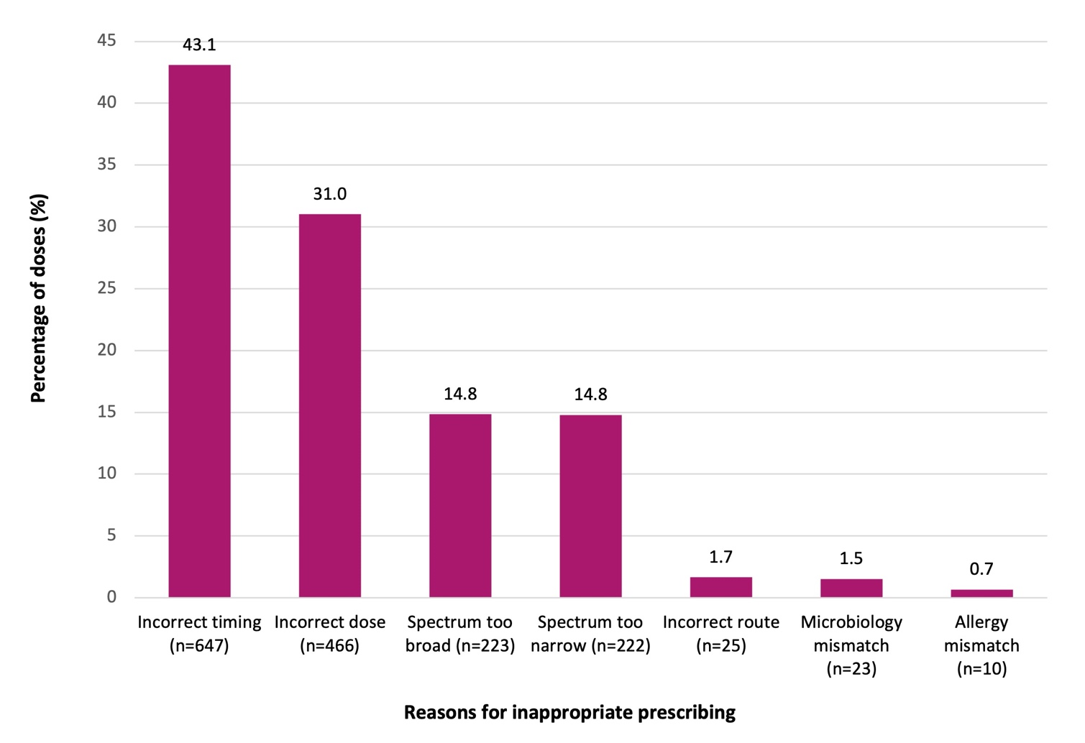

* Refer to Technical Supplement5 for appropriateness definitions.

† n=1,502 antimicrobial doses. A procedural prophylaxis dose can have more than one reason for inappropriateness.

Incorrect timing was the most common reason for inappropriateness of required procedural doses (43.1%, 1,616 reasons of 1,502 doses) (Figure 4). Comparatively, incorrect timing accounted for 8.0% of all (7,763) required procedural doses (when omitting 767 doses that did not have a recorded administration time).

Cefazolin was the most prescribed antimicrobial with incorrect dosing (61.6%), followed by gentamicin (24.7%) and vancomycin (8.8%).

### Guideline compliance

When no procedural antimicrobials were prescribed (n=2,025), guideline compliance (either with the Therapeutic Guidelines8 or with local guidelines) was high (87.1%). Compliance with prescribing guidelines was lower when antimicrobials were prescribed (66.4%) (Figure 5). Compliance increased to 69.1% when ‘directed therapy’, ‘no guidelines available’ and ‘not assessable’ doses were excluded (n=8,364).

#### Figure 5: Percentage of procedural prophylaxis antimicrobial doses* that were compliant with guidelines, Surgical NAPS contributor facilities, 2022

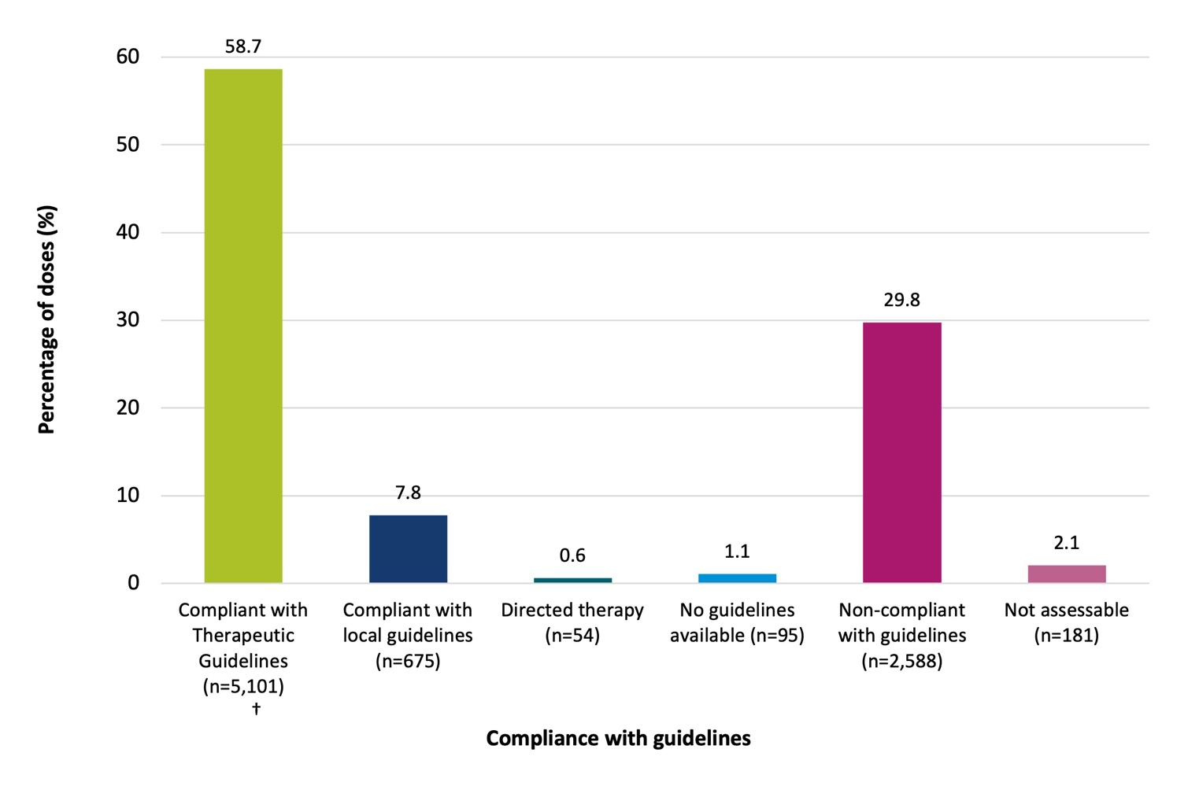

* n=8,694 procedural antimicrobial doses.

† Antibiotic Expert Group. Therapeutic Guidelines: Antibiotic. Version 16. Melbourne: Therapeutic Guidelines Limited; 2019. <https://www.tg.org.au/>8

### Antimicrobial choice

Cefazolin was the most prescribed antimicrobial, accounting for 83.0% of prescriptions of procedural doses in 2022 (Table 3).

The top 5 procedural antimicrobials prescribed accounted for 95.2% of all antimicrobials: cefazolin (83.0%), metronidazole (4.9%), gentamicin (3.5%), vancomycin (1.9%) and chloramphenicol (1.9%), as shown in Table 3. Prescribing for cefazolin and metronidazole was associated with low rates of inappropriateness (25.7% and 32.0% respectively). Rates of prescribing deemed inappropriate were greater than 70% for ampicillin, amoxicillin, chloramphenicol, ceftriaxone and ciprofloxacin.

#### Table 3: Proportion and inappropriateness of procedural prophylaxis antimicrobial doses*, Surgical NAPS contributor facilities, 2022

|  |  |  |  |  |
| --- | --- | --- | --- | --- |
| **Antimicrobial** | **Total doses prescribed** | | **Inappropriate** | |
| **(n)** | **(%)** | **(n)** | **(%)** |
| Cefazolin | 7,214 | 83.0 | 1,851 | 25.7 |
| Metronidazole | 422 | 4.9 | 135 | 32.0 |
| Gentamicin | 302 | 3.5 | 198 | 65.6 |
| Vancomycin | 169 | 1.9 | 90 | 53.3 |
| Chloramphenicol | 168 | 1.9 | 145 | 86.3 |
| Clindamycin | 87 | 1.0 | 50 | 57.5 |
| Ceftriaxone | 55 | 0.6 | 47 | 85.5 |
| Ampicillin | 50 | 0.6 | 48 | 96.0 |
| Amoxicillin–clavulanic acid | 48 | 0.6 | 16 | 33.3 |
| Ciprofloxacin | 32 | 0.4 | 24 | 75.0 |
| Piperacillin–tazobactam | 26 | 0.3 | 11 | 42.3 |
| Amoxicillin | 25 | 0.3 | 23 | 92.0 |
| Teicoplanin | 24 | 0.3 | 7 | 29.2 |
| Flucloxacillin | 13 | 0.1 | 2 | 15.4 |
| Meropenem | 10 | 0.1 | 3 | 30.0 |
| Others† | 49 | 0.6 | 33 | 67.3 |
| **Total** | **8,694** | **100** | **2,683** | **30.9** |

* Data are not shown for antimicrobial doses where n <10.

† Others = 16 antimicrobials.

### Procedure groups

The procedure groups with the highest rates of prescribing at least one procedural antimicrobial were breast surgery, orthopaedic surgery and neurosurgery (95.3%, 92.5% and 88.6% respectively), as shown in Table 4. Overall, the range of inappropriate prescribing varied across the procedure groups (22.7%–62.6%). The majority of prescriptions deemed inappropriate were for orthopaedic surgery (n=685 doses), plastic and reconstructive surgery (n=438 doses), abdominal surgery (n=313 doses) and ophthalmology (307 doses). These 4 procedure groups accounted for 57.2% of all inappropriate procedural doses.

#### Table 4: Percentage of surgical episodes prescribed an antimicrobial, number of

#### doses prescribed and inappropriateness of procedural prescribing by procedure group, Surgical NAPS contributor facilities, 2022

|  |  |  |  |  |  |  |
| --- | --- | --- | --- | --- | --- | --- |
| **Procedure group** | **Surgical episodes** | **At least one antimicrobial prescribed** | | **Total doses** | **Inappropriate doses** | |
| **(n)** | **(n) (%)** | | **(n)** | **(n) (%)** | |
| Orthopaedic surgery | 2,158 | 1,997 | 92.5 | 2,211 | 685 | 31.0 |
| Plastic and reconstructive surgery | 1,236 | 861 | 69.7 | 910 | 438 | 48.1 |
| Abdominal surgery | 1,185 | 994 | 83.9 | 1,174 | 313 | 26.7 |
| Ophthalmology | 1,072 | 756 | 70.5 | 891 | 307 | 34.5 |
| Obstetrics | 1,040 | 846 | 81.3 | 882 | 226 | 25.6 |
| Urological surgery | 613 | 458 | 74.7 | 537 | 278 | 51.8 |
| Head and neck surgery | 566 | 299 | 52.8 | 318 | 199 | 62.6 |
| Gastrointestinal endoscopic procedures | 563 | 19 | 3.4 | 25 | 6 | 24.0 |
| Gynaecological surgery | 439 | 280 | 63.8 | 412 | 155 | 37.6 |
| Dentoalveolar surgery | 370 | 323 | 87.3 | 330 | 124 | 37.6 |
| Neurosurgery | 360 | 319 | 88.6 | 337 | 111 | 32.9 |
| Cardiac surgery | 263 | 231 | 87.8 | 339 | 109 | 32.2 |
| Breast surgery | 170 | 162 | 95.3 | 176 | 40 | 22.7 |
| Vascular surgery | 120 | 96 | 80.0 | 101 | 35 | 34.7 |
| Thoracic surgery | 63 | 47 | 74.6 | 51 | 21 | 41.2 |
| **Total** | **10,218** | **7,688** | **75.2** | **8,694** | **3,047** | **35.0** |

## Post-procedural prescribing

Post-procedural prophylaxis was deemed inappropriate in 20.8% of the 10,218 surgical episodes audited (Table 5). The 56.4% of episodes where no post-procedural antimicrobials were prescribed were mostly deemed appropriate (97.2%). For the surgical episodes that had at least one post- procedural antimicrobial prescribed for prophylaxis, 59.7% of prescriptions were deemed inappropriate. Antimicrobials were prescribed when not required for 12.1% (n=1,238) of episodes (Table 5). Post- procedural prophylaxis was deemed inappropriate for 62.0% of prescriptions, when the non-assessable prescriptions were excluded.

#### Table 5: Appropriateness* of post-procedural prophylactic prescribing of antimicrobials for surgical episodes and antimicrobial prescriptions†, Surgical NAPS contributor facilities, 2022

|  |  |  |  |  |  |  |  |
| --- | --- | --- | --- | --- | --- | --- | --- |
| **Post-procedural prophylaxis** | **Total** | **Appropriate** | | **Inappropriate** | | **Not assessable** | |
| **(n)** | **(n)** | **(%)** | **(n)** | **(%)** | **(n)** | **(%)** |
| Surgical episodes | 10,218 | 6,994 | 68.5 | 2,125 | 20.8 | 254 | 2.5 |
| Antimicrobial prescribed | 3,605 | 1,390 | 38.6 | 2,075 | 57.6 | 140 | 3.9 |
| * when required | 2,424 | 1,390 | 57.3 | 933 | 38.5 | 101 | 4.2 |
| * when not required | 1,238 | 3 | 0.2 | 1,193 | 96.4 | 42 | 3.4 |
| No antimicrobial prescribed | 5,768 | 5,604 | 97.2 | 50 | 0.9 | 114 | 2.0 |
| * when required | 36 | 13 | 36.1 | 19 | 52.8 | 4 | 11.1 |
| * when not required | 5,732 | 5,591 | 97.5 | 31 | 0.5 | 110 | 1.9 |
| Not assessable | 278 | 0 | 0.0 | 0 | 0.0 | 278 | 100 |
| Antimicrobial prescriptions | 4,134 | 1,613 | 39.0 | 2,375 | 57.5 | 146 | 3.5 |
| Prophylaxis | 4,091 | 1,597 | 39.0 | 2,350 | 57.4 | 144 | 3.5 |
| * when required | 2,655 | 1,597 | 60.2 | 953 | 35.9 | 105 | 4.0 |
| * when not required | 1,436 | 0 | 0.0 | 1,397 | 97.3 | 39 | 2.7 |
| Treatment | 28 | 12 | 42.9 | 15 | 53.6 | 1 | 3.6 |
| * Not assessable | 15 | 4 | 26.7 | 10 | 66.7 | 1 | 6.7 |

* The overall appropriateness of prescribing for a surgical episode was determined by taking the lowest ranked assessment of the individual post-procedural prescriptions.

† 567 surgical episodes had only post-procedural antimicrobials prescribed for treatment of infection or were not assessable and were excluded from the analysis.

### Reasons for inappropriate post-procedural prophylaxis prescribing

There were 2,350 post-procedural prophylaxis prescriptions deemed inappropriate. Of these, 1,397 (59.4%) were deemed not required. For post-procedural prophylactic prescriptions, where prophylaxis was recommended by guidelines (n=2,655), 35.9% were deemed inappropriate (n=953). A post- procedural prophylaxis prescription can have more than one reason for inappropriateness. The majority of inappropriate prescriptions were due to incorrect duration (80.0%); dose and frequency inconsistencies were the next most common reason (15.2%)   
(Figure 6).

#### Figure 6: Reasons for inappropriateness*, by percentage of required post-procedural prophylactic antimicrobial prescriptions†, Surgical NAPS contributor facilities, 2022

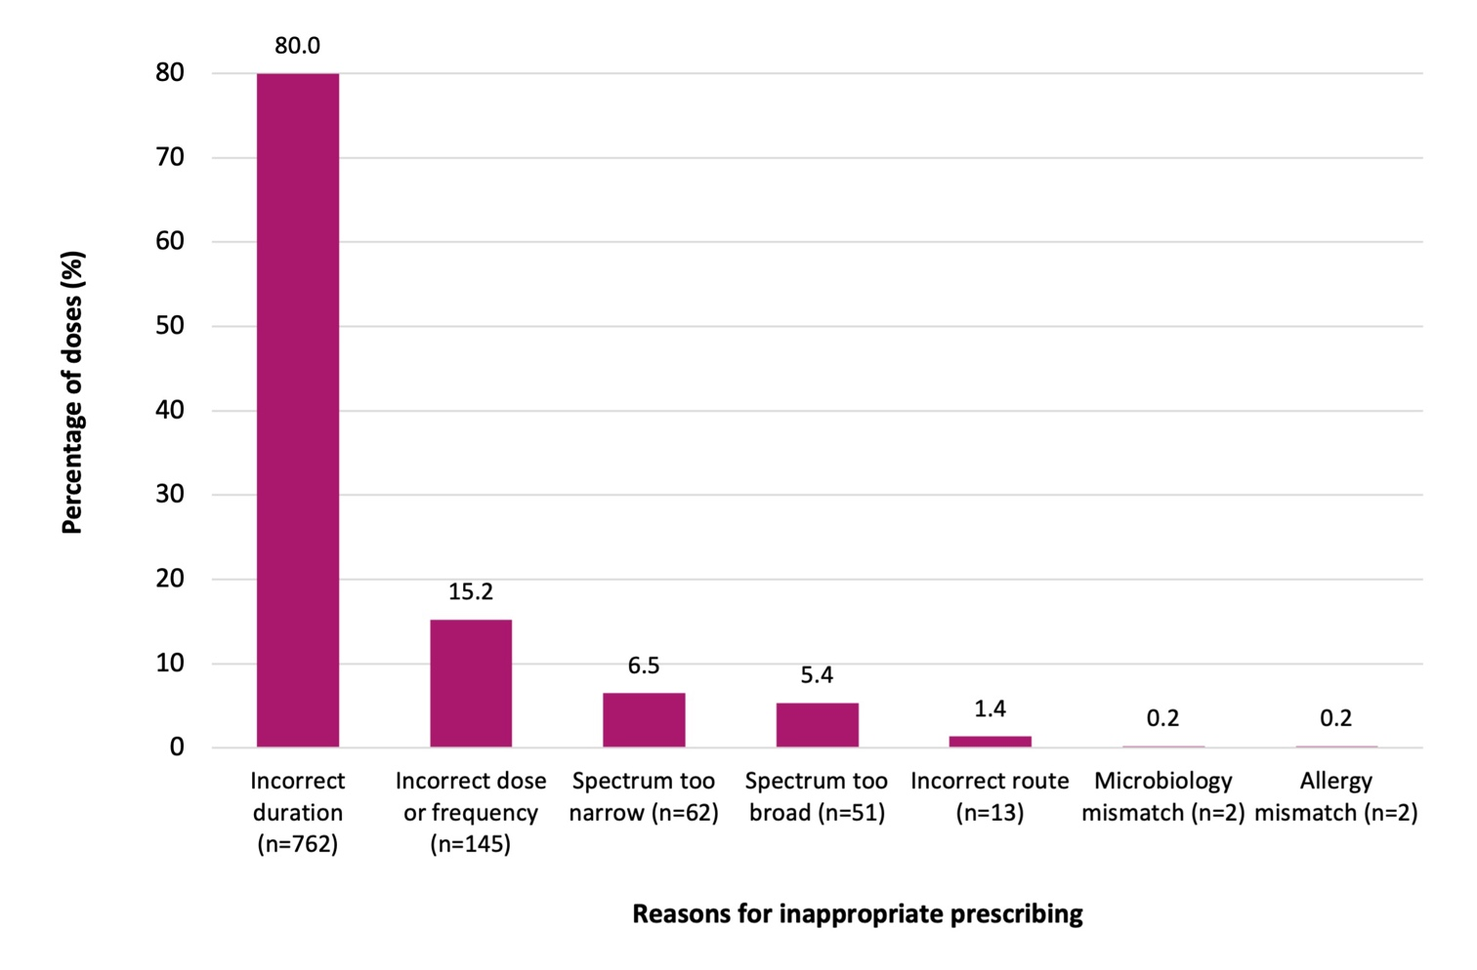

* Refer to Technical Supplement for appropriateness definitions.5

† n=953 prescriptions where post-procedural antimicrobial prophylaxis was required and deemed inappropriate. A post- procedural prophylaxis prescription can have more than one reason for inappropriateness. Total reasons for inappropriateness were 1,037.

Of all post-procedural prescriptions, 57.0% involved prophylaxis for greater than 24 hours (Table 6).

Of those prescribed for equal to or greater than 48 hours (40.4%), 3 of the 15 procedural groups had prescribing rates greater than 80%. These were dentoalveolar surgery (99.2%), head and neck surgery (83.3%) and plastic and reconstructive surgery (80.3%).

When the volume of episodes audited is considered, 66.3% of all prescriptions for equal to or greater than 48 hours are accounted for by 3 procedure groups: ophthalmology (n=586 prescriptions), plastic and reconstructive surgery (n=362 prescriptions) and orthopaedic surgery (n=149 prescriptions).

In comparison to the 2020 and 2021 reports, there is noticeable improvement for orthopaedic surgery, in which post-procedural antimicrobial prescriptions with a duration greater than 48 hours reduced from 39.1% (2020) and 14.8% (2021) to 9.5% in 2022. In contrast, plastic and reconstructive surgery prescriptions increased from 35.9% (2020) and 74.9% (2021) to 80.3% in 2022. Similarly, dentoalveolar surgery prescriptions increased from 39.7% (2020) and 96.9% (2021) to 99.2% in 2022.

#### Table 6: Duration of surgical prophylaxis prescribed for greater than 24 and 48 hours, by procedure group, Surgical NAPS contributor facilities, 2022

|  |  |  |  |  |  |  |  |
| --- | --- | --- | --- | --- | --- | --- | --- |
| **Procedure group** | **Antimicrobial prescriptions** | **Duration range** | **Duration median** | **Duration**  **>24 hours** | | **Duration**  **>48 hours** | |
| **(n)** | **(days)** | **(days)** | **(n)** | **(%)** | **(n)** | **(%)** |
| Orthopaedic surgery | 1,519 | 1–42 | 1 | 474 | 31.2 | 149 | 9.8 |
| Ophthalmology | 888 | 1–32 | 7 | 664 | 74.8 | 586 | 66.0 |
| Plastic and reconstructive surgery | 451 | 1–36 | 5 | 389 | 86.3 | 362 | 80.3 |
| Abdominal surgery | 189 | 1–10 | 1 | 105 | 55.6 | 75 | 39.7 |
| Neurosurgery | 184 | 1–27 | 1 | 67 | 36.4 | 19 | 10.3 |
| Cardiac surgery | 182 | 1–6 | 2 | 136 | 74.7 | 61 | 33.5 |
| Head and neck surgery | 126 | 1–29 | 5 | 114 | 90.5 | 105 | 83.3 |
| Dentoalveolar surgery | 126 | 1–9 | 5 | 126 | 100.0 | 125 | 99.2 |
| Urological surgery | 117 | 1–26 | 4 | 88 | 75.2 | 68 | 58.1 |
| Obstetrics | 97 | 1–14 | 1 | 38 | 39.2 | 26 | 26.8 |
| Breast surgery | 96 | 1–27 | 5 | 68 | 70.8 | 55 | 57.3 |
| Gynaecological surgery | 44 | 1–12 | 1 | 23 | 52.3 | 9 | 20.5 |
| Thoracic surgery | 37 | 1–3 | 1 | 16 | 43.2 | 2 | 5.4 |
| Vascular surgery | 32 | 1–13 | 1 | 20 | 62.5 | 10 | 31.3 |
| Gastrointestinal endoscopic procedures | 3 | 1–5 | N/A | N/A | N/A | N/A | N/A |
| **Total** | **4,091** | **1–42** | **1** | **2,330** | **57.0** | **1,654** | **40.4** |

* Data are not shown for antimicrobial prescriptions where n < 10.

### Guideline compliance

When no post-procedural antimicrobials were prescribed, non-compliance with guidelines was infrequent (0.7%). When they were prescribed, over half (56.8%) of post-procedural antimicrobial prophylaxis was non-compliant with guidelines (Figure 7). Non-compliance increased to 58.3% when ‘directed therapy’, ‘no guidelines available’ and ‘not assessable’ prescriptions were excluded.

Compliance with national prescribing guidelines8 continues to be poor, generally due to prolonged durations of oral, ocular and topical antimicrobials post-procedurally. These represent niche targeted areas for antimicrobial stewardship and quality improvement intervention.

Of all post-procedural prescriptions (n=4,091), 56.2% were administered via the intravenous route, followed by 19.4% oral, 18.1% topical and 6.3% ocular routes. Non-compliance with guidelines was highest for antimicrobials administered via the oral route (78.7%), followed by topical administration (64.1%).

Post-procedural extended use of prophylactic oral or topical antimicrobials is not recommended by the guidelines and should be discouraged. Antimicrobials should only be prescribed prophylactically when the evidence supports their use.

#### Figure 7: Percentage of post-procedural prophylactic antimicrobial prescriptions* that were compliant with guidelines, Surgical NAPS contributor facilities, 2022

60

55.8

50

40

30

27.6

20

12.2

10

2.0

1.2

1.1

0

Compliant with Therapeutic Guidelines† (n= 1,129)

Compliant with local guidelines (n= 500)

Directed therapy (n= 83)

No guidelines

Non-compliant with Not assessable

available (n= 50) guidelines (n=2,282) (n= 47)

**Compliance with guidelines**

**Percentage of prescriptions (%)**

* n=4,091 antimicrobial prescriptions for post-procedural prophylaxis.

† Antibiotic Expert Group. Therapeutic Guidelines: Antibiotic. Version 16. Melbourne: Therapeutic Guidelines Limited; 2019. <https://www.tg.org.au/>8

### Antimicrobial choice

The 5 most frequently prescribed post-procedural antimicrobials accounted for 89.6% of all antimicrobials prescribed prophylactically: cefazolin (55.6%), chloramphenicol (14.2%), cefalexin (13.4%), amoxicillin–clavulanic acid (3.6%) and metronidazole (2.7%), as shown in Table 7. All antimicrobials had relatively high rates of prescribing deemed inappropriate. Rates of prescribing deemed inappropriate were greater than 80% for trimethoprim, ofloxacin, gentamicin, vancomycin, tobramycin, amoxicillin and ceftriaxone.

#### Table 7: Post-procedural prophylactic prescribing of antimicrobials and percentage inappropriate*, Surgical NAPS contributor facilities, 2022

|  |  |  |  |  |
| --- | --- | --- | --- | --- |
| **Antimicrobial** | **Total prescriptions** | | **Inappropriate** | |
| **(n)** | **(%)** | **(n)** | **(%)** |
| Cefazolin | 2,276 | 55.6 | 1,036 | 45.5 |
| Chloramphenicol | 581 | 14.2 | 383 | 65.9 |
| Cefalexin | 550 | 13.4 | 434 | 78.9 |
| Amoxicillin–clavulanic acid | 146 | 3.6 | 90 | 61.6 |
| Metronidazole | 111 | 2.7 | 81 | 73.0 |
| Ciprofloxacin | 85 | 2.1 | 34 | 40.0 |
| Tobramycin | 56 | 1.4 | 50 | 89.3 |
| Vancomycin | 53 | 1.3 | 48 | 90.6 |
| Ofloxacin | 43 | 1.1 | 40 | 93.0 |
| Amoxicillin | 37 | 0.9 | 30 | 81.1 |
| Clindamycin | 33 | 0.8 | 25 | 75.8 |
| Ceftriaxone | 30 | 0.7 | 24 | 80.0 |
| Trimethoprim | 19 | 0.5 | 18 | 94.7 |
| Gentamicin | 13 | 0.3 | 12 | 92.3 |
| Others† | 58 | 1.4 | 45 | 77.6 |
| **Total** | **4,091** | **100.0** | **2,350** | **57.4** |

* Data are not shown for antimicrobial prescriptions where n <10.

† Others = 18 antimicrobials.

### Procedure groups

The procedure groups with the highest rates of prescribing at least one post-procedural antimicrobial for prophylaxis were orthopaedic surgery, ophthalmology and cardiac surgery (67.6%, 66.5% and 55.9% respectively), as shown in Table 8. Three procedure groups – orthopaedic surgery (n=793 prescriptions), ophthalmology (n=463 prescriptions) and plastic and reconstructive surgery (n=373 prescriptions) – accounted for over two-thirds (66.7%) of all inappropriate post-procedural antimicrobial prescriptions.

#### Table 8: Post-procedural prophylactic prescribing and percentage inappropriate, by procedure group, Surgical NAPS contributor facilities, 2022

|  |  |  |  |  |  |  |
| --- | --- | --- | --- | --- | --- | --- |
| **Procedure group** | **Surgical episodes** | **At least one antimicrobial prescribed** | | **Total prescriptions** | **Inappropriate prescriptions** | |
| **(n)** | **(n) (%)** | | **(n)** | **(n) (%)** | |
| Orthopaedic surgery | 2,158 | 1,459 | 67.6 | 1,519 | 793 | 52.2 |
| Plastic and reconstructive surgery | 1,236 | 400 | 32.4 | 451 | 373 | 82.7 |
| Abdominal surgery | 1,185 | 141 | 11.9 | 189 | 135 | 71.4 |
| Ophthalmology | 1,072 | 713 | 66.5 | 888 | 463 | 52.1 |
| Obstetrics | 1,040 | 65 | 6.3 | 97 | 57 | 58.8 |
| Urological surgery | 613 | 93 | 15.2 | 117 | 103 | 88.0 |
| Head and neck surgery | 566 | 116 | 20.5 | 126 | 113 | 89.7 |
| Gastrointestinal endoscopic procedures | 563 | 3 | 0.5 | 3 | N/A | N/A |
| Gynaecological surgery | 439 | 26 | 5.9 | 44 | 42 | 95.5 |
| Dentoalveolar surgery | 370 | 126 | 34.1 | 126 | 56 | 44.4 |
| Neurosurgery | 360 | 176 | 48.9 | 184 | 107 | 58.2 |
| Cardiac surgery | 263 | 147 | 55.9 | 182 | 82 | 45.1 |
| Breast surgery | 170 | 74 | 43.5 | 96 | 89 | 92.7 |
| Vascular surgery | 120 | 37 | 30.8 | 37 | 11 | 29.7 |
| Thoracic surgery | 63 | 29 | 46.0 | 32 | 20 | 62.5 |
| **Total** | **10,218** | **3,605** | **35.3** | **4,091** | **2,444** | **59.7** |

* Data are not shown for antimicrobial prescriptions where n < 10.

# Conclusion

Now in its seventh year, the Surgical NAPS continues to have strong adoption from both public and private hospitals around Australia. The number of contributing facilities has more than doubled since the inception of the Surgical NAPS in 2016 (186 in 2022 compared with 84 in 2016).

As the Surgical NAPS is voluntary and is resource intensive compared with the Hospital NAPS and the Quality Improvement NAPS, this continual increase suggests that the survey is regarded as a valuable tool to identify opportunities to improve surgical antimicrobial prophylaxis. Ongoing annual contributions to the Surgical NAPS continue to provide benefits to end users to support further improvements and assess the efficacy and impact of implemented interventions in terms of guideline compliance and appropriateness. Despite variation in participation rates and the specialty focus between contributors, consistent themes for quality improvement are evident.

There have been some encouraging signs of continued improvement, particularly in the areas of documentation of incision and antimicrobial administration time. Similarly, non-compliance with guidelines appears to have decreased over the last several years.

Targeted improvement is required to address the ongoing issue of duration, the most pertinent issue regarding post-procedural prophylaxis appropriateness. Over two-fifths of post-procedural

prescriptions had a duration greater than 48 hours. Procedure groups with the lowest post-procedural appropriateness were gynaecological surgery (3.8%), head and neck surgery (6.0%) and breast surgery (9.5%), representative of key procedural targets for quality improvement.

In summary, and consistent with findings from previous surveys of surgical prophylaxis, the 2022 Surgical NAPS identified ongoing concerning inappropriate use of surgical prophylaxis in participating hospitals. The issues involved require urgent attention from all stakeholders to improve antimicrobial stewardship in the operative setting.

# Appendix

#### Table A1: Prescribing patterns of Surgical NAPS contributors, by state and territory, remoteness area^, AIHW peer group^^ and funding type, 2022

|  |  |  |  |  |  |  |  |
| --- | --- | --- | --- | --- | --- | --- | --- |
|  | | **Number of participating facilities**  **(n)** | **Percentage of participating facilities**  **(%)** | **Number of surgical episodes**  **(n)** | **Percentage of surgical episodes**  **(%)** | **Surgical episodes with procedural dose(s) prescribed**  **n (%)** | **Surgical episodes with post- procedural prophylaxis prescribed**  **n (%)** |
| State or territory* | ACT | 2 | 1.1 | 154 | 1.5 | 150 (97.4) | 140 (90.9) |
| NSW | 65 | 34.9 | 2,568 | 25.1 | 1,765 (68.7) | 980 (38.2) |
| NT | 2 | 1.1 | 92 | 0.9 | 64 (69.6) | 15 (16.3) |
| QLD | 24 | 12.9 | 1,591 | 15.6 | 1,327 (83.4) | 733 (46.1) |
| SA | 20 | 10.8 | 705 | 6.9 | 533 (75.6) | 235 (33.3) |
| VIC | 48 | 25.8 | 2,853 | 27.9 | 2,009 (70.4) | 749 (26.3) |
| WA | 25 | 13.4 | 2,255 | 22.1 | 1,840 (81.6) | 753 (33.4) |
| Remoteness^ | Major cities | 89 | 47.8 | 5,376 | 52.6 | 3,895 (72.5) | 1,809 (33.6) |
| Inner regional | 53 | 28.5 | 2,853 | 27.9 | 2,201 (77.1) | 1,091 (38.2) |
| Outer regional | 37 | 19.9 | 1,809 | 17.7 | 1,481 (81.9) | 681 (37.6) |
| Remote | 5 | 2.7 | 151 | 1.5 | 94 (62.3) | 22 (14.6) |
| Very remote | 2 | 1.1 | 29 | 0.3 | 17 (58.6) | 2 (6.9) |
| Public hospital peer group^^ | Principal referral | 5 | 5.0 | 348 | 9.4 | 275 (79.0) | 100 (28.7) |
| Public acute group A hospitals | 18 | 18.0 | 1,172 | 31.7 | 836 (71.3) | 233 (19.9) |
| Public acute group B hospitals | 15 | 15.0 | 498 | 13.5 | 312 (62.7) | 147 (29.5) |
| Public acute group C hospitals | 57 | 57.0 | 1,408 | 38.1 | 854 (60.7) | 360 (25.6) |
| Children’s hospitals | 1 | 1.0 | 81 | 2.2 | 42 (51.9) | 20 (24.7) |
| Women’s hospitals | 3 | 3.0 | 155 | 4.2 | 94 (60.6) | 16 (10.3) |
| Unpeered | 1 | 1.0 | 30 | 0.8 | 9 (30.0) | 5 (16.7) |

|  |  |  |  |  |  |  |  |
| --- | --- | --- | --- | --- | --- | --- | --- |
|  | | **Number of participating facilities**  **(n)** | **Percentage of participating facilities**  **(%)** | **Number of surgical episodes**  **(n)** | **Percentage of surgical episodes**  **(%)** | **Surgical episodes with procedural dose(s) prescribed**  **n (%)** | **Surgical episodes with post- procedural prophylaxis prescribed**  **n (%)** |
| Private hospital peer group^^ | Private acute group A hospitals | 4 | 4.7 | 331 | 5.1 | 256 (77.3) | 93 (28.1) |
| Private acute group B hospitals | 17 | 19.8 | 1,740 | 26.7 | 1,503 (86.4) | 730 (42.0) |
| Private acute group C hospitals | 21 | 24.4 | 1,630 | 25.0 | 1,353 (83.0) | 731 (44.8) |
| Private acute group D hospitals | 15 | 17.4 | 947 | 14.5 | 744 (78.6) | 352 (37.2) |
| Other acute specialised hospitals | 5 | 5.8 | 130 | 2.0 | 93 (71.5) | 53 (40.8) |
| Eye surgery centres | 11 | 12.8 | 317 | 4.9 | 139 (43.8) | 204 (64.4) |
| Mixed day procedure hospitals | 9 | 10.5 | 1,315 | 20.2 | 1,087 (82.7) | 539 (41.0) |
| Mixed subacute and  non-acute hospitals | 1 | 1.2 | 21 | 0.3 | 21 (100) | 0 (0.0) |
| Plastic and reconstructive surgery centres | 2 | 2.3 | 65 | 1.0 | 51 (78.5) | 20 (95.2) |
| Women’s hospitals | 1 | 1.2 | 30 | 0.5 | 19 (63.6) | 2 (6.7) |
| Funding type | Public | 100 | 53.8 | 3,692 | 36.1 | 2,422 (31.5) | 881 (24.4) |
| Private | 86 | 46.2 | 6,526 | 63.9 | 5,266 (68.5) | 2,724 (75.6) |
| **Combined national result** | | **186** | **100.0** | **10,218** | **100.0** | **7,688** | **3,605** |

^ Remoteness category as per the Australian Bureau of Statistics.7

^^ Australian Institute of Health and Welfare.6

* Tasmania did not contribute any data for 2022.

#### Table A2: Procedural dose compliance with guidelines and appropriateness in Surgical NAPS contributors, by state and territory, remoteness area^, AIHW peer group^^ and funding type, 2022

|  |  |  |  |  |  |  |  |  |  |  |  |  |  |
| --- | --- | --- | --- | --- | --- | --- | --- | --- | --- | --- | --- | --- | --- |
|  |  | **Total (n)** | **% Compliance with guidelines** | | | | | | **% Procedural appropriateness** | | | | |
| **Therapeutic Guidelines8 compliant** | **Local guidelines compliant** | **Non- compliant** | **Directed therapy** | **Not available** | **Not assessable** | **Optimal** | **Adequate** | **Suboptimal** | **Inadequate** | **Not assessable** |
| State or territory* | ACT | 258 | 30.2 | 0.4 | 69.0 | 0.0 | 0.0 | 0.4 | 31.0 | 0.8 | 66.7 | 1.6 | 0.0 |
| NSW | 1,936 | 44.9 | 21.5 | 30.3 | 0.9 | 0.5 | 1.9 | 64.9 | 2.4 | 5.8 | 25.5 | 1.3 |
| NT | 75 | 68.0 | 6.7 | 16.0 | 9.3 | 0.0 | 0.0 | 76.0 | 4.0 | 9.3 | 10.7 | 0.0 |
| QLD | 1,437 | 71.5 | 3.0 | 18.8 | 0.2 | 1.4 | 5.1 | 68.4 | 2.3 | 2.8 | 18.4 | 8.1 |
| SA | 642 | 67.1 | 8.4 | 22.4 | 0.5 | 0.0 | 1.6 | 70.4 | 3.3 | 7.0 | 17.6 | 1.7 |
| VIC | 2,311 | 59.1 | 5.5 | 32.2 | 0.6 | 1.5 | 1.2 | 60.5 | 3.2 | 7.7 | 27.3 | 1.2 |
| WA | 2,035 | 62.9 | 1.4 | 32.1 | 0.5 | 1.5 | 1.7 | 62.8 | 1.0 | 3.0 | 27.1 | 6.0 |
| Remote- ness^ | Major cities | 4,487 | 50.9 | 13.5 | 32.1 | 0.9 | 1.2 | 1.5 | 60.0 | 3.2 | 10.4 | 24.4 | 2.0 |
| Inner regional | 2,425 | 69.8 | 2.1 | 24.0 | 0.3 | 0.8 | 3.0 | 70.2 | 1.5 | 3.3 | 21.5 | 3.5 |
| Outer regional | 1,646 | 64.0 | 1.0 | 31.0 | 0.4 | 1.3 | 2.3 | 63.2 | 1.0 | 3.6 | 24.7 | 7.5 |
| Remote | 117 | 47.9 | 1.7 | 47.0 | 0.0 | 0.0 | 3.4 | 45.3 | 5.1 | 9.4 | 36.8 | 3.4 |
| Very remote | 19 | 78.9 | 0.0 | 10.5 | 5.3 | 0.0 | 5.3 | 84.2 | 0.0 | 5.3 | 5.3 | 5.3 |
| Public hospital peer group^^ | Principal referral | 318 | 64.8 | 11.0 | 16.0 | 3.8 | 4.4 | 0.0 | 73.9 | 6.6 | 6.9 | 12.3 | 0.3 |
| Public acute group A hospitals | 915 | 58.1 | 5.5 | 30.5 | 1.2 | 3.2 | 1.5 | 62.3 | 2.0 | 9.0 | 23.6 | 3.2 |
| Public acute group B hospitals | 349 | 63.9 | 3.2 | 29.5 | 0.0 | 1.7 | 1.7 | 56.2 | 2.9 | 6.6 | 26.1 | 8.3 |
| Public acute group C hospitals | 912 | 64.1 | 1.0 | 31.1 | 0.1 | 0.5 | 3.1 | 61.5 | 2.1 | 8.1 | 24.8 | 3.5 |
| Children’s hospitals | 47 | 4.3 | 34.0 | 55.3 | 0.0 | 6.4 | 0.0 | 42.6 | 2.1 | 8.5 | 46.8 | 0.0 |
| Women’s hospitals | 135 | 68.9 | 11.9 | 17.8 | 0.0 | 0.0 | 1.5 | 77.8 | 3.0 | 3.7 | 14.8 | 0.7 |
| Unpeered | 9 | N/A | N/A | N/A | N/A | N/A | N/A | N/A | N/A | N/A | N/A | N/A |

|  |  |  |  |  |  |  |  |  |  |  |  |  |  |
| --- | --- | --- | --- | --- | --- | --- | --- | --- | --- | --- | --- | --- | --- |
|  |  | **Total (n)** | **% Compliance with guidelines** | | | | | | **% Procedural appropriateness** | | | | |
| **Therapeutic Guidelines8 compliant** | **Local guidelines compliant** | **Non- compliant** | **Directed therapy** | **Not available** | **Not assessable** | **Optimal** | **Adequate** | **Suboptimal** | **Inadequate** | **Not assessable** |
| Private hospital peer group^^ | Private acute group A hospitals | 313 | 55.9 | 5.1 | 30.4 | 0.0 | 4.5 | 4.2 | 57.5 | 0.0 | 4.5 | 31.3 | 6.7 |
| Private acute group B hospitals | 1,860 | 47.6 | 15.6 | 35.2 | 0.9 | 0.1 | 0.7 | 62.2 | 1.1 | 12.3 | 24.2 | 0.2 |
| Private acute group C hospitals | 1,475 | 62.4 | 5.6 | 28.5 | 0.1 | 0.3 | 3.1 | 65.3 | 0.7 | 4.4 | 26.4 | 3.2 |
| Private acute group D hospitals | 779 | 61.1 | 7.6 | 24.9 | 0.8 | 0.1 | 5.5 | 66.2 | 1.4 | 4.0 | 23.4 | 5.0 |
| Other acute specialised hospitals | 113 | 54.9 | 20.4 | 23.0 | 0.0 | 0.9 | 0.9 | 54.0 | 20.4 | 18.6 | 6.2 | 0.9 |
| Eye surgery centres | 146 | 57.5 | 36.3 | 4.8 | 0.7 | 0.0 | 0.7 | 65.1 | 29.5 | 3.4 | 1.4 | 0.7 |
| Mixed day procedure hospitals | 1,225 | 63.9 | 1.1 | 32.3 | 0.1 | 1.4 | 1.1 | 63.9 | 1.2 | 2.9 | 23.9 | 8.1 |
| Mixed subacute and non-acute hospitals | 21 | 100.0 | 0.0 | 0.0 | 0.0 | 0.0 | 0.0 | 100.0 | 0.0 | 0.0 | 0.0 | 0.0 |
| Plastic and reconstructive surgery centres | 55 | 63.6 | 0.0 | 27.3 | 9.1 | 0.0 | 0.0 | 52.7 | 10.9 | 0.0 | 36.4 | 0.0 |
| Women’s hospitals | 22 | 72.7 | 0.0 | 27.3 | 0.0 | 0.0 | 0.0 | 63.6 | 0.0 | 27.3 | 9.1 | 0.0 |
| Funding type | Public | 2,685 | 61.2 | 5.1 | 28.9 | 0.9 | 2.1 | 1.9 | 62.9 | 2.7 | 7.8 | 23.2 | 3.4 |
| Private | 6,009 | 57.6 | 9.0 | 30.2 | 0.5 | 0.6 | 2.2 | 63.5 | 2.1 | 6.8 | 24.0 | 3.5 |
| **Combined national result** | | **8,964** | **58.7** | **7.8** | **29.8** | **0.6** | **1.1** | **2.1** | **63.3** | **2.3** | **7.1** | **23.8** | **3.5** |

^ Remoteness category as per the Australian Bureau of Statistics.7

^^ Australian Institute of Health and Welfare.6

* Tasmania did not contribute any data for 2022.

N/A = Not applicable as there were fewer than 10 prescriptions.

#### Table A3: Post-procedural prophylaxis prescription compliance with guidelines and appropriateness in Surgical NAPS contributors, by state and territory, remoteness area^, AIHW peer group^^ and funding type, 2022

|  |  |  |  |  |  |  |  |  |  |  |  |  |  |
| --- | --- | --- | --- | --- | --- | --- | --- | --- | --- | --- | --- | --- | --- |
|  | | **Total (n)**  **Total (n)** |  | **% Compliance with guidelines** | | | | | **% Post-procedural appropriateness** | | | | |
| **Therapeutic Guidelines8 compliant** | **Local guidelines compliant** | **Non- compliant** | **Directed therapy** | **Not available** | **Not assessable** | **Optimal** | **Adequate** | **Suboptimal** | **Inadequate** | **Not assessable** |
| State or territory* | ACT | 154 | 3.9 | 0.7 | 94.8 | 0.0 | 0.0 | 0.6 | 3.2 | 0.0 | 44.8 | 51.9 | 0.0 |
| NSW | 1,208 | 22.8 | 24.8 | 51.2 | 0.4 | 0.7 | 0.2 | 43.0 | 3.6 | 7.5 | 45.2 | 0.7 |
| NT | 19 | 63.2 | 0.0 | 36.8 | 0.0 | 0.0 | 0.0 | 57.9 | 10.5 | 10.5 | 21.1 | 0.0 |
| QLD | 761 | 41.0 | 5.7 | 48.5 | 4.1 | 0.1 | 0.7 | 39.4 | 5.3 | 7.4 | 45.9 | 2.1 |
| SA | 300 | 26.7 | 9.0 | 63.0 | 0.0 | 0.0 | 1.3 | 25.7 | 5.0 | 14.3 | 53.7 | 1.3 |
| VIC | 865 | 36.9 | 10.5 | 50.6 | 0.7 | 0.5 | 0.8 | 43.5 | 3.0 | 15.4 | 36.9 | 1.3 |
| WA | 784 | 15.9 | 5.0 | 65.6 | 5.2 | 4.7 | 3.6 | 18.9 | 4.3 | 6.8 | 56.8 | 13.3 |
| Remote- ness^ | Major cities | 2,110 | 23.2 | 18.0 | 55.4 | 2.1 | 0.6 | 0.7 | 35.5 | 3.6 | 11.6 | 48.2 | 1.0 |
| Inner regional | 1,235 | 41.2 | 6.6 | 50.1 | 0.4 | 0.2 | 1.5 | 43.6 | 3.1 | 12.6 | 37.9 | 2.8 |
| Outer regional | 710 | 18.5 | 5.6 | 64.9 | 4.5 | 4.6 | 1.8 | 21.0 | 6.2 | 5.1 | 55.6 | 12.1 |
| Remote | 33 | 0.0 | 0.0 | 90.9 | 3.0 | 3.0 | 3.0 | 0.0 | 3.0 | 27.3 | 63.6 | 6.1 |
| Very remote | 3 | N/A | N/A | N/A | N/A | N/A | N/A | N/A | N/A | N/A | N/A | N/A |
| Public hospital peer group^^ | Principal referral | 123 | 13.8 | 9.8 | 74.0 | 0.0 | 0.0 | 2.4 | 22.0 | 1.6 | 4.9 | 69.1 | 2.4 |
| Public acute group A hospitals | 251 | 25.1 | 13.6 | 58.2 | 0.8 | 1.6 | 0.8 | 33.5 | 3.6 | 18.7 | 42.6 | 1.6 |
| Public acute group B hospitals | 183 | 26.2 | 9.3 | 62.8 | 0.5 | 0.5 | 0.5 | 30.1 | 1.6 | 15.8 | 51.4 | 1.1 |
| Public acute group C hospitals | 472 | 46.0 | 2.3 | 46.8 | 0.8 | 0.4 | 3.6 | 42.8 | 10.0 | 10.2 | 32.6 | 4.4 |
| Children’s hospitals | 24 | 0.0 | 33.3 | 62.5 | 0.0 | 4.2 | 0.0 | 33.3 | 0.0 | 16.7 | 50.0 | 0.0 |
| Women’s hospitals | 19 | 52.6 | 21.1 | 15.8 | 0.0 | 0.0 | 10.5 | 68.4 | 5.3 | 5.3 | 10.5 | 10.5 |
| Unpeered | 5 | N/A | N/A | N/A | N/A | N/A | N/A# | N/A | N/A | N/A | N/A | N/A |

|  |  |  |  |  |  |  |  |  |  |  |  |  |  |
| --- | --- | --- | --- | --- | --- | --- | --- | --- | --- | --- | --- | --- | --- |
|  | | **Total (n)**  **Total (n)** |  | **% Compliance with guidelines** | | | | | **% Post-procedural appropriateness** | | | | |
| **Therapeutic Guidelines8 compliant** | **Local guidelines compliant** | **Non- compliant** | **Directed therapy** | **Not available** | **Not assessable** | **Optimal** | **Adequate** | **Suboptimal** | **Inadequate** | **Not assessable** |
| Private hospital peer group^^† | Private acute group A  hospitals | 111 | 12.6 | 1.8 | 83.8 | 0.0 | 0.9 | 0.9 | 13.5 | 0.0 | 16.2 | 68.5 | 1.8 |
| Private acute group B  hospitals | 844 | 8.5 | 26.8 | 64.1 | 0.4 | 0.1 | 0.1 | 33.3 | 0.6 | 17.4 | 48.7 | 0.0 |
| Private acute group C hospitals | 785 | 27.0 | 4.7 | 66.9 | 0.3 | 0.6 | 0.5 | 29.3 | 1.1 | 4.5 | 63.9 | 1.1 |
| Private acute group D hospitals | 361 | 49.0 | 13.9 | 27.7 | 8.6 | 0.0 | 0.8 | 57.9 | 3.6 | 9.1 | 25.8 | 3.6 |
| Other acute specialised hospitals | 56 | 41.1 | 28.6 | 30.4 | 0.0 | 0.0 | 0.0 | 39.3 | 7.1 | 32.1 | 19.6 | 1.8 |
| Eye surgery centres | 268 | 75.8 | 22.0 | 1.9 | 0.4 | 0.0 | 0.0 | 77.6 | 11.9 | 10.4 | 0.0 | 0.0 |
| Mixed day procedure hospitals | 565 | 12.4 | 4.3 | 69.7 | 5.1 | 6.2 | 2.3 | 14.5 | 6.0 | 4.8 | 59.3 | 15.4 |
| Plastic and reconstructive surgery centres | 20 | 15.0 | 0.0 | 35.0 | 50.0 | 0.0 | 0.0 | 5.0 | 5.0 | 5.0 | 85.0 | 0.0 |
| Women’s hospitals | 4 | N/A | N/A | N/A | N/A | N/A | N/A | N/A | N/A | N/A | N/A | N/A |
| Funding type | Public | 1,077 | 33.0 | 8.0 | 55.3 | 0.6 | 0.7 | 2.3 | 36.1 | 5.8 | 12.5 | 42.6 | 3.0 |
| Private | 3,014 | 25.7 | 13.7 | 55.9 | 2.5 | 1.4 | 0.7 | 34.8 | 3.3 | 10.3 | 47.9 | 3.7 |
| **Combined national result** | | **8,964** | **27.6** | **12.2** | **55.8** | **0.6** | **1.1** | **2.1** | **35.1** | **3.9** | **10.9** | **46.5** | **3.5** |

^ Remoteness category as per the Australian Bureau of Statistics.7

^^ Australian Institute of Health and Welfare.6

* Tasmania did not contribute any data for 2022.

† Mixed subacute and non-acute hospitals did not contribute any post-procedural prescription data for 2022.

N/A = Not applicable as there were fewer than 10 prescriptions.

# References

1. Australian Government. Australia’s National Antimicrobial Resistance Strategy: 2020 and beyond. Canberra: Department of Health and Department of Agriculture; 2020.
2. Australian Government. Surveillance of antimicrobial use and resistance in human health. Antimicrobial Resistance. Canberra: Department of Health and Aged Care; 2023. Accessed October 2023, at https://[www.amr.gov.au/australias-response/objective-5-integrated-surveillance-](http://www.amr.gov.au/australias-response/objective-5-integrated-surveillance-) and-response-resistance-and-usage/surveillance-antimicrobial-use-and-resistance-human- health#antimicrobial-use-and-resistance-in-australia-aura
3. Australian Commission on Safety and Quality in Health Care. National Safety and Quality Health Service Standards. 2nd ed. Sydney: ACSQHC; 2017.
4. Australian Commission on Safety and Quality in Health Care. Antimicrobial Stewardship Clinical Care Standard. 2nd ed. Sydney: ACQSC; 2020.
5. Royal Melbourne Hospital and the National Centre for Antimicrobial Stewardship. National Antimicrobial Prescribing Survey: Technical Supplement 2022. Canberra: NCAS; 2024.
6. Australian Institute of Health and Welfare. Hospital resources 2020–21 data tables. Canberra: AIHW; 2021. Accessed June 2023 at https://[www.aihw.gov.au/getmedia/e0e946d9-3d84-48b3-](http://www.aihw.gov.au/getmedia/e0e946d9-3d84-48b3-) 954a-e97f96814c0a/Hospital-resources-tables-2020-21.xls.aspx
7. Australian Bureau of Statistics. 1270.0.55.005 – Australian Statistical Geography Standard. Canberra: ABS; 2016.
8. Antibiotic Expert Group. Therapeutic Guidelines: Antibiotic. 16th ed. Melbourne: Therapeutic Guidelines Limited; 2019.

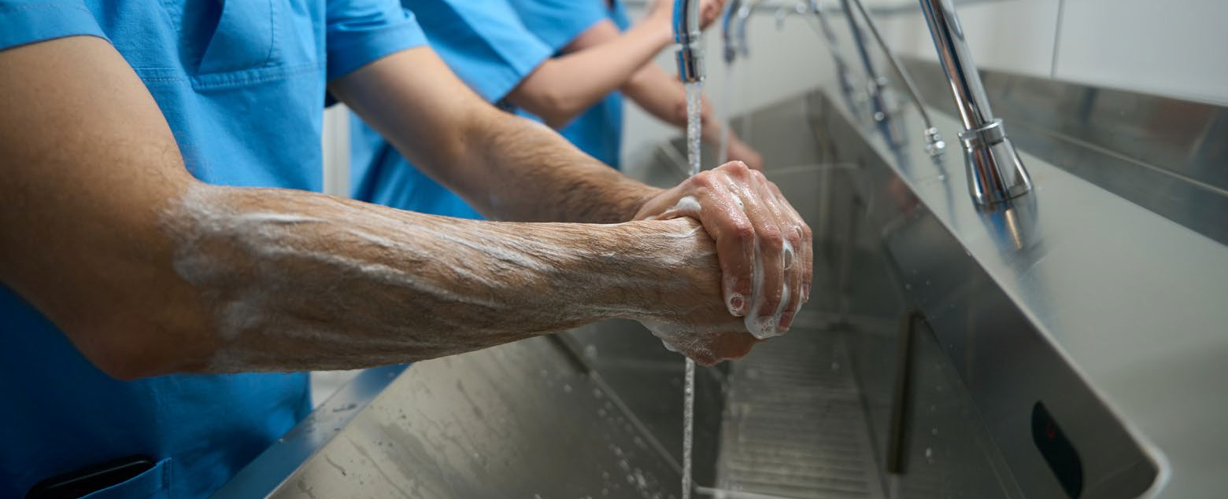

All information in this publication is correct as at October 2023

#### [amr.gov.au](http://www.amr.gov.au/)