S**urgical prophylaxis prescribing in Australian hospitals**



**2020**

Results of the 2020 Surgical National Antimicrobial Prescribing Survey



Published by the Australian Government Department of Health and Aged Care For issues regarding the content of the report:

Email: [support@naps.org.au](mailto:%20support@naps.org.au)

Website: <https://www.naps.org.au/>

ISBN: 978-1-76007-352-7

© Australian Government Department of Health and Aged Care

All material and work produced by the Department of Health and Aged Care is protected by copyright. The Department reserves the right to set out the terms and conditions for the use of such material.

Enquiries about the licence and any use of this publication are welcome and can be sent to [AMR@health.gov.au](mailto:%20AMR@health.gov.au)

**Preferred citation**

Royal Melbourne Hospital and the National Centre for Antimicrobial Stewardship. Surgical prophylaxis prescribing in Australian hospitals. Results of the 2020 Surgical National Antimicrobial Prescribing Survey Canberra: Department of Health and Aged Care; 2023.

**Disclaimer**

This document is not intended to provide guidance on particular healthcare choices. You should contact your healthcare provider for advice on particular healthcare choices.

This document includes the views or recommendations of its authors and third parties. Royal Mebourne Hospital, the National Centre for Antimicrobial Stewardship and the Department of Health and Aged Care do not accept any legal liability for any injury, loss or damage incurred by the use of, or reliance on, this document.

Table of contents

Summary 4

Key Findings 4

Implications for patient safety 5

1. Introduction 7
2. Key results 8

Contributing facilities 8

Surgical episodes 10

Procedure groups 11

Key performance indicators 12

Impact of SARS-CoV-2 on the Surgical NAPS in 2020 19

1. Discussion 20

Appendix 1: Methodology 23

Data collection 23

Auditor education and support 24

Data cleaning 24

Data analysis 24

Appendix 2: Limitations and considerations for interpretation of results 27

Sampling and selection bias 27

Survey methodology was not defined 27

Subjective nature of assessments 27

Comparison of data over time 27

Appendix 3: Supplementary data 28

Appendix 4: Additional analyses 32

Antimicrobial choice 32

Route of administration 34

Prescribing by facility funding type 34

Procedure group analysis 36

Duration of prophylaxis 40

Appendix 5: Comparative data analysis 41

Comparisons to previous Surgical NAPS data: 2016 to 2020 41

Procedure group participation 41

Compliance with guidelines and appropriateness 43

Reasons for inappropriateness 45

Appendix 6: Procedure groups 47

Appendix 7: Data collection form 48

Appendix 8: Appropriateness definitions 50

Appendix 9: Glossary 51

Appendix 10: Abbreviations 53

References 54

Acknowledgements 55

Contributing facilities 55

# Summary

Surgical antimicrobial prophylaxis is important for the provision of safe care to patients who undergo surgical procedures. When used appropriately, surgical antimicrobial prophylaxis can reduce the risk of surgery-related infections. As the appropriate use of antimicrobials is also a key factor for the prevention and control of antimicrobial resistance, improving antimicrobial use for surgical prophylaxis should be a key focus area for antimicrobial stewardship and quality improvement, both locally and nationally

The Surgical National Antimicrobial Prescribing Survey (Surgical NAPS) is a standardised audit that Australian health service organisations can use to monitor and report on the appropriateness of antimicrobial use for surgical prophylaxis. In 2020, 149 public and private facilities contributed data for the Surgical NAPS report.

## Key Findings

Consistent with findings from previous surveys of surgical prophylaxis, the 2020 Surgical NAPS identified ongoing concerning inappropriate use of surgical prophylaxis in contributor hospitals. Issues which require urgent and specific attention include:

* Suboptimal documentation of the time of antimicrobial administration (85.7%) and the incision time (71.7%)
* Low rates of compliance with prescribing guidelines for procedural (67.9%) and post-procedural (49.7%) antimicrobial prophylaxis in relation to timing, dosage and duration of use
* Inappropriate procedural prescribing for orthopaedic surgery, abdominal surgery, plastic and reconstructive surgery, urological surgery and ophthalmology, in particular
* Inappropriate post-procedural prescribing for orthopaedic surgery, plastic and reconstructive surgery, ophthalmology, neurosurgery and breast surgery, in particular.

Other key findings from the 2020 Surgical NAPS include:

* Antimicrobial prescribing was assessed as appropriate in 54.3% of all surgical episodes.
* Reasons for inappropriate procedural prescribing were most commonly incorrect timing (46.6%) and incorrect dosage (22.5%).
* Post-procedurally, the most common reasons for inappropriate prescribing were incorrect duration (71.3%) and incorrect dose or frequency (33.5%).
* Antimicrobials prescribed post-procedurally continued for greater than 24 hours for 64.2% of prescriptions, and 42.2% continued for greater than 48 hours.
* Three procedure groups accounted for 62.1%% of all surgical prophylaxis for up to or greater than 48 hours: orthopaedic surgery, ophthalmology and plastic and reconstructive surgery.

The ongoing success of the Surgical NAPS is reflected in this report’s inclusion of over 5 years of data, with a comparative data analysis included in Appendix 5.

## Implications for patient safety

### Suboptimal documentation

Documentation is an important component of comprehensive medical care as it allows timely and accurate communication between members of the clinical care team and contributes to effective safety and quality of patient care. Failure to document important components of surgical care was reported for 1 in 3 surgical procedures for incision time, and 1 in 6 surgical procedures for administration time.

Correct timing of antimicrobial administration ensures a high concentration of antimicrobial at the time of surgical incision, which reduces the risk of surgical site infection and the need for post-operative antimicrobials. Improving documentation is an important step in ensuring appropriate timing of antimicrobial administration, and should be addressed in targeted improvement strategies.

The progressive implementation of electronic medical records in Australian hospitals may support improvement of this aspect of prescribing. Electronic medical record systems can be designed to prompt and require information that has been identified by the Surgical NAPS as commonly omitted, such as time of surgical incision and antimicrobial administration, to be entered.

### Compliance with guidelines and appropriateness of prescribing

Compliance with guidelines for surgical antimicrobial prophylaxis, and consequently appropriateness of prescribing, continues to be poor overall, but is particularly low for post-procedural prescriptions. This relates to prescription of antimicrobials that are not required and the prolonged duration of antimicrobial use. Procedurally, inappropriate antimicrobial use is primarily due to suboptimal timing of administration.

In practice, for many procedures there is no evidence that prophylactic antimicrobial use, either procedurally or post-procedurally, reduces post-operative infections. Unnecessary surgical antimicrobial prophylaxis has been shown to cause harm to patients such as drug-related toxicities (e.g., renal failure) and other adverse reactions, and likely contributes to antimicrobial resistance. Reducing inappropriate surgical antimicrobial prophylaxis balances the unintended harm of antimicrobial use with the benefits of evidence-based care.

### Surgical specialty specific issues

There are specific patterns of inappropriate prescribing for some surgical specialities, such as prolonged duration of use, or inappropriate choice of antimicrobials. Targeting specialties with the highest rates of inappropriate prescribing, such as orthopaedic surgery, urological surgery, abdominal surgery, and plastic and reconstructive surgery is a priority for antimicrobial stewardship programs. Additional specific targets include surgical specialties that represented 62.1% of all surgical prophylaxis use for up to or greater than 48 hours: orthopaedic surgery, ophthalmology and plastic and reconstructive surgery.

Ensuring that these specialties have patient care aligned with prescribing guidelines and are supported to improve prescribing will help to deliver consistent high-quality care and improve use of surgical antimicrobial prophylaxis in Australian health service organisations.

### Recommendations for potential actionable items

To address the ongoing patient safety issues relating to inappropriate prescribing of surgical antimicrobial prophylaxis, we recommend:

* continued collaboration with the Royal Australasian College of Surgeons, and engagement with surgical specialty societies and other key stakeholders to develop improvement strategies for prescribing of surgical antimicrobial prophylaxis
* engagement with colleges, surgical specialty societies, states and territories and private health service providers via provision of specific information on prescribing appropriateness for selected procedural specialties
* continued promotion of compliance with Australian prescribing guidelines
* continued collaboration with the states and territories and the private sector to promote ongoing surveillance of appropriateness of surgical antimicrobial prophylaxis in Australian health service organisations
* ongoing promotion of the adoption of surveillance data to develop and implement targeted improvement programs

# Introduction

The Surgical National Antimicrobial Prescribing Survey (Surgical NAPS) is a standardised tool that allows Australian health service organisations to audit and report antimicrobial use in incisional and non- incisional surgical procedures, and to investigate procedural and post-procedural surgical prophylaxis prescribing practices. It is designed to be a useful, practical and generalisable audit tool, providing some flexibility to fit the workflow of different facilities and to suit a range of auditors including pharmacists, nurses and medical practitioners.

The Surgical NAPS supports Australian health service organisations, states and territories and private health service provider organisations to develop and conduct antimicrobial stewardship programs by:

* + facilitating effective audit and review of antimicrobial use associated with surgical procedures, including compliance with prescribing guidelines and prescribing appropriateness
  + facilitating effective communication regarding antimicrobial use and identifying key targets for interventions
  + supporting workforce education and training
  + supporting the implementation of antimicrobial stewardship practices across facilities where surgical procedures are performed.

Participation in the Surgical NAPS may assist health service organisations to demonstrate that they meet the antimicrobial stewardship actions of the National Safety and Quality Health Service Preventing and Controlling Healthcare-Associated Infection Standard.1

Since 2016, the Australian Commission on Safety and Quality in Health Care (ACSQHC) and the Australian Government Department of Health have provided funding for the National Centre for Antimicrobial Stewardship (NCAS) to conduct the Surgical NAPS and contribute data to the Antimicrobial Use and Resistance in Australia (AURA) Surveillance System.2,3 Funding for AURA is provided by the Australian Government Department of Health and state and territory health departments.

The Surgical NAPS methods are described in Appendix 1, and the limitations and considerations for interpretation of results are outlined in Appendix 2.

The Surgical NAPS 2020 differs from previous reports (2016–2019) due to the COVID-19 pandemic. To ensure the health system maintained adequate capacity to manage the COVID-19 pandemic, the

National Cabinet applied restrictions to elective surgeries from 26 March 2020.4 Under these restrictions, only Category 1 and exceptional Category 2 procedures could be undertaken. These restrictions were eased (but not fully lifted) from 29 April 2020, allowing all Category 2 and some important Category 3 procedures to be performed.4 These restrictions led to an overall decrease in admissions from elective surgery waiting lists of 9.2% between 2018–19 and 2019–20 and impacted waiting times for elective surgery.4

Following the second outbreak of COVID-19 in June 2020, restrictions on elective surgery continued over the 2020–21 period in some jurisdictions. However, due to the methodology of the Surgical NAPS, we did not anticipate a significant change in practice to be impacted by the COVID-19 pandemic as there were no changes to the way contributing facilities collected data.

The potential impact was thought to be a reduction in contributing facilities due to the impact of the COVID-19 pandemic on the concurrent workload of Surgical NAPS auditors. However, this was not the case: the number (8,063) of surgical episodes included in the 2019 Surgical NAPS report is similar to the number (7,935) of surgical episodes included in this 2020 Surgical NAPS report.

# Key results

Analyses of the 2020 Surgical NAPS data are presented below.

## Contributing facilities

There were 155 facilities that contributed data to the Surgical NAPS during 2020, an increase of 11 facilities compared to the 2019 report, although, 6 facilities chose to audit surgical procedures from 2019. This was possibly as a result of the COVID-19 pandemic and the consequent reduction in surgeries being performed during 2020 (discussed in Impact of SARS-CoV-2 on the Surgical NAPS in 2020 and Appendix 1). These have been added into the 2019 cohort (but are not included in our already published 2019 report5) (see Figure 1) and are not included in the analysis of 2020 results in this report. As a result, there were 149 facilities contributing data to the 2020 Surgical NAPS report. For the 2020 cohort, participants included public and private facilities from all states and territories (Table 1), a range of hospital peer groups6 and a range of remoteness classifications7 (Tables A3.1, A3.2 and A3.3).

##### Figure 1: Surgical NAPS participation by public and private facilities, 2016–2020

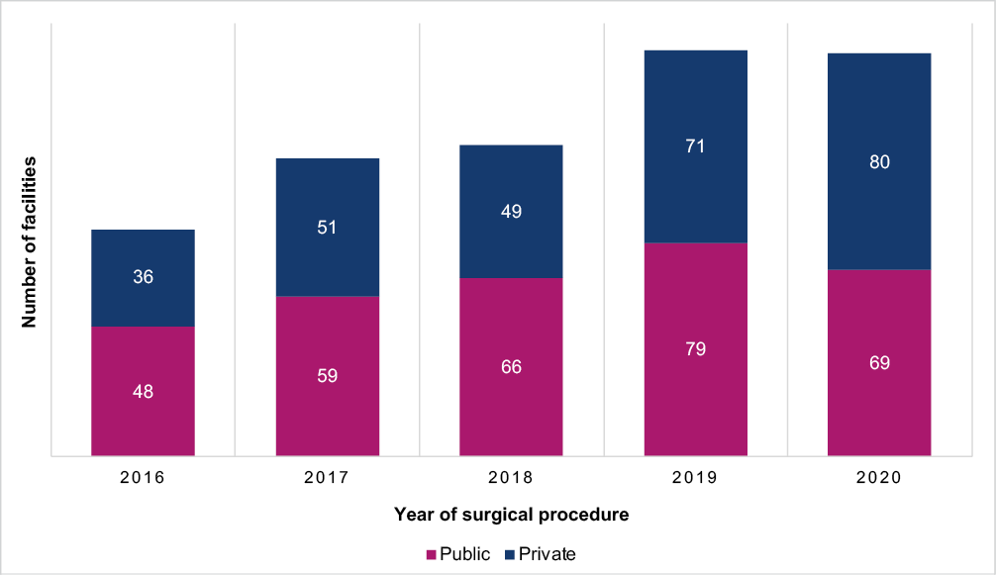

Over time, participation in the Surgical NAPS has either been stable or increased for all states and territories, except the Australian Capital Territory (Figure A3.1). The greatest increase in participation from 2016 to 2020 has been by facilities from the Northern Territory and New South Wales, and eye

surgery centres and private acute group B hospitals (Figure A3.2). We postulate that the noted decline in participation of principal referral hospitals and public acute group A may have been associated with the concurrent workload of Surgical NAPS auditors at these facilities due to the COVID-19 pandemic (Figure A3.2). Overwhelmingly, participants are from major city and inner regional areas (Figure A3.3), which is expected because this is where facilities that offer surgical procedures are most likely to be located.

##### Table 1: Number and percentage of contributing public and private facilities, by state and territory, Surgical NAPS 2020

|  |  |  |  |  |  |  |
| --- | --- | --- | --- | --- | --- | --- |
| **State/ territory** | **Contributing public facilities** | **Contributing private facilities** | **Total** | **Percentage of contributing facilities** | **Number of eligible peer group**  **classifications nationally** | **Percentage of eligible peer group**  **classifications** |
| **No.** | **No.** | **No.** | **%** | **No.** | **%** |
| ACT | – | 1 | 1 | 0.7 | 10 | 10.0 |
| NSW | 27 | 25 | 52 | 34.9 | 281 | 18.5 |
| NT | 2 | – | 2 | 1.3 | 7 | 28.6 |
| Qld | 7 | 14 | 21 | 14.1 | 179 | 11.7 |
| SA | 7 | 9 | 16 | 10.7 | 95 | 16.8 |
| Tas | – | 1 | 1 | 0.7 | 20 | 5.0 |
| Vic | 18 | 18 | 36 | 24.2 | 197 | 18.3 |
| WA | 8 | 12 | 20 | 13.4 | 82 | 24.4 |
| **Total** | **69** | **80** | **149** | **100** | **871** | **17.1** |

## Surgical episodes

A total of 7,935 surgical episodes are included in the 2020 Surgical NAPS analyses. Characteristics of those episodes include:

* + More episodes were analysed for females (n=4,458, 56.2%) compared to males (n=3,470, 43.7%).
  + The majority (n=7,631, 96.2%) were initial surgeries, and 304 (3.8%) were subsequent surgeries.
  + Most episodes (n=7,477, 94.2%) involved an incisional procedure.
  + More elective procedures were performed (n=7,018, 88.4%) than emergency procedures (n=903, 11.4%).
  + Over one-third (n=3,009, 37.9%) were for insertion or removal of prosthetic material.
  + A very small number (n=249, 3.1%) were trauma related.

Figure 2 shows the breakdown of antimicrobial prescribing for surgical episodes reported to the 2020 Surgical NAPS, by procedural and post-procedural characteristics, to assist with understanding the analyses presented.

##### Figure 2: Surgical episodes by procedural and post-procedural prescribing characteristics, Surgical NAPS 2020

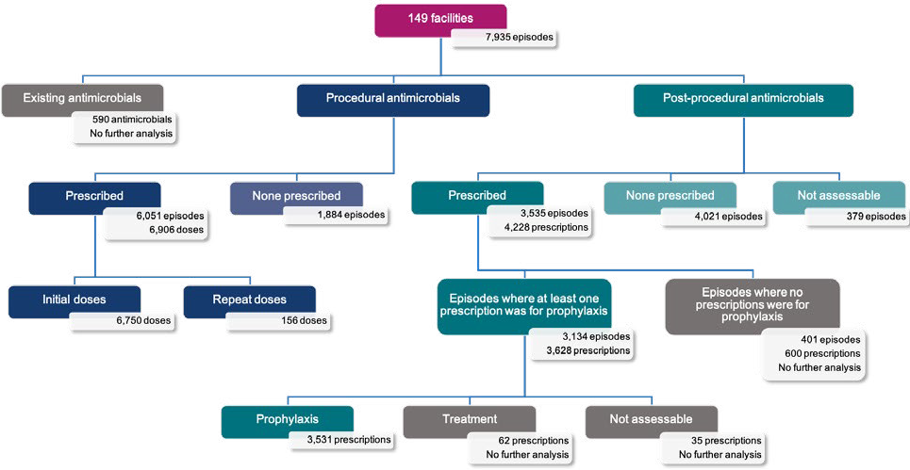

##### Legend

**Episode** – an individual procedure or set of procedures performed together during one surgical session and the subsequent post-procedural care associated with the procedure(s)

**Dose** – an individual antimicrobial dose administered either immediately prior to or during or after the surgical procedure

**Prescription** – any antimicrobial prescribed either as a single dose or as a course following the surgical procedure

**Existing antimicrobial** – an antimicrobial prescribed for treatment or prophylaxis in the 24 hours prior (72 hours if on dialysis) to the procedure, used to determine the appropriateness of whether procedural antimicrobials were given or not given

**Procedural antimicrobial** – an antimicrobial administered either immediately prior to or during the surgical procedure for the purpose of prophylaxis; each initial and repeat dose of the antimicrobial administered is recorded individually

**Post-procedural antimicrobial** – an antimicrobial prescribed following, but directly relating to, the procedure; each prescription of the antimicrobial

is recorded, including any inpatient or discharge scripts

**Initial dose** – the first dose of an antimicrobial administered either immediately prior to or during the surgical procedure for the purpose of prophylaxis

**Repeat dose** – any subsequent dose of an antimicrobial administered during the surgical procedure for the purpose of prophylaxis

**Prophylaxis** – an antimicrobial prescribed for the prevention of surgery-related infection

**Treatment** – an antimicrobial prescribed for the treatment of infection related to the procedure

**Episodes where no prescriptions were for prophylaxis** – any episode where all prescribed antimicrobials are recorded as for ‘treatment’ and/or ‘not assessable’

## Procedure groups

The highest number of procedures reported in the Surgical NAPS in 2020 was for orthopaedic surgery (Figure 3). Ophthalmology procedures accounted for 9.8% of reported procedures. This continues to be the specialty group with the largest change since the 2016 pilot2, with an increase from 3.4% (Figure A5.1). The proportion of facilities contributing data for procedure groups ranged from 7.4% (11 facilities) for thoracic surgery to 62.4% (93 facilities) for plastic and reconstructive surgery (Table A3.2).

##### Figure 3: Percentage of surgical episodes for each surgical procedure group*, Surgical NAPS contributor facilities, 2020

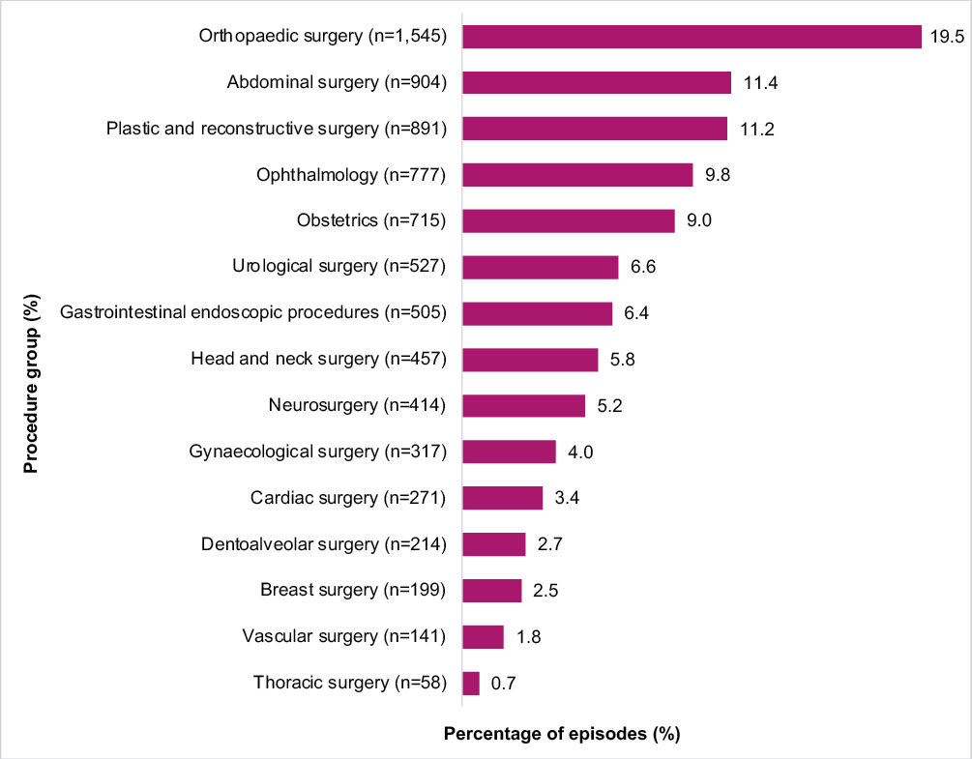

Note: Where there were multiple procedures per surgical episode, only the primary procedure group was included.

* n=7,935 surgical episodes.

## Key performance indicators

### Documentation

Of the 7,477 incisional procedures reported, over two-thirds had a time of incision documented (n=5,360, 71.7%).

Of the 6,750 initial procedural doses prescribed, 24.1% were recorded to the exact minute, and 61.6% to the nearest 15 minutes. The remainder (14.3%) did not have a documented administration time.

### Compliance with prescribing guidelines

### Procedural

When no procedural antimicrobials were prescribed, guideline compliance (either with the Therapeutic Guidelines8 or local guidelines) was high (85.5%). Compliance with prescribing guidelines was lower when antimicrobials were prescribed (67.9%) (Figure 4). Compliance increased to 72.0% when ‘directed therapy’, ‘no guidelines available’ and ‘not assessable’ doses were excluded (n=6,514).

##### Figure 4: Percentage of procedural antimicrobial doses* that were compliant with guidelines, Surgical NAPS contributor facilities, 2020

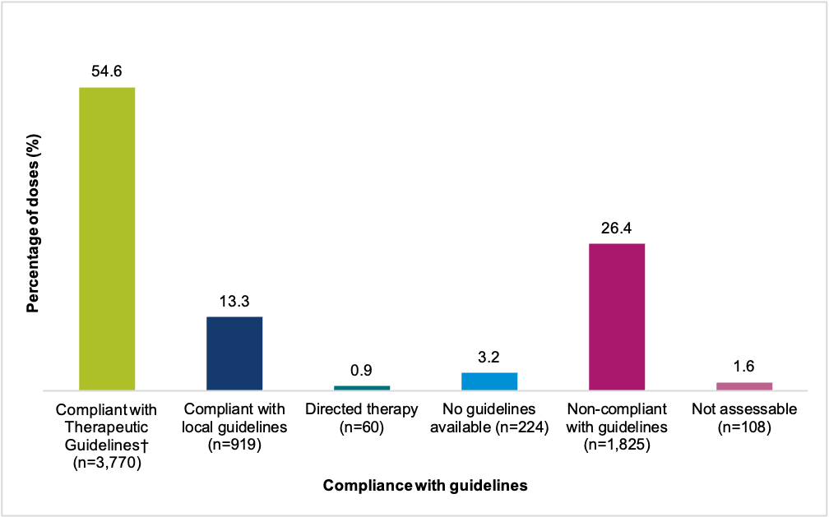

* n=6,906 procedural antimicrobial doses.

† Antibiotic Expert Group. Therapeutic Guidelines: Antibiotic (version 16). Melbourne: Therapeutic Guidelines Limited; 2019. <https://www.tg.org.au/>

### Post-procedural

When no post-procedural antimicrobials were prescribed, non-compliance with guidelines was infrequent (0.3%). When prescribed, almost half (49.7%) of post-procedural antimicrobial prophylaxis was non-compliant with guidelines (Figure 5). Non-compliance increased to 52.2%, when ‘directed therapy’, ‘no guidelines available’ and ‘not assessable’ prescriptions were excluded.

##### Figure 5: Percentage of post-procedural prophylactic antimicrobial prescriptions* that were compliant with guidelines, Surgical NAPS contributor facilities, 2020

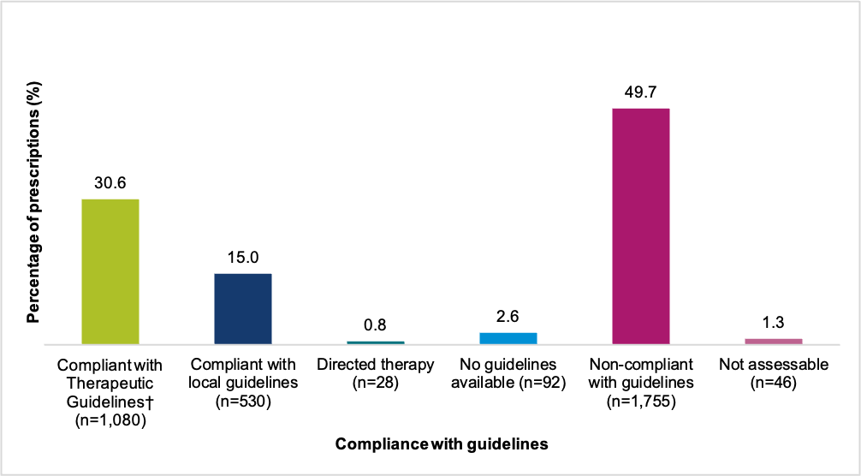

* n=3,531 prescriptions for post-procedural prophylaxis.

† Antibiotic Expert Group. Therapeutic Guidelines: Antibiotic (version 16). Melbourne: Therapeutic Guidelines Limited; 2019. <https://www.tg.org.au/>

### Overall appropriateness of prescribing

Prescribing was assessed as inappropriate for 36.5% of all surgical episodes (Figure 6). The percentage of episodes deemed inappropriate varied by procedure group, ranging from 3.0% for gastrointestinal endoscopic procedures, to 54.8% for breast surgery. All procedure groups had an inappropriateness rate greater than 30%, apart from gastrointestinal endoscopic procedures and ophthalmology.

##### Figure 6: Percentage of episodes by appropriateness* of prescribing for each surgical procedure group, Surgical NAPS contributor facilities, 2020

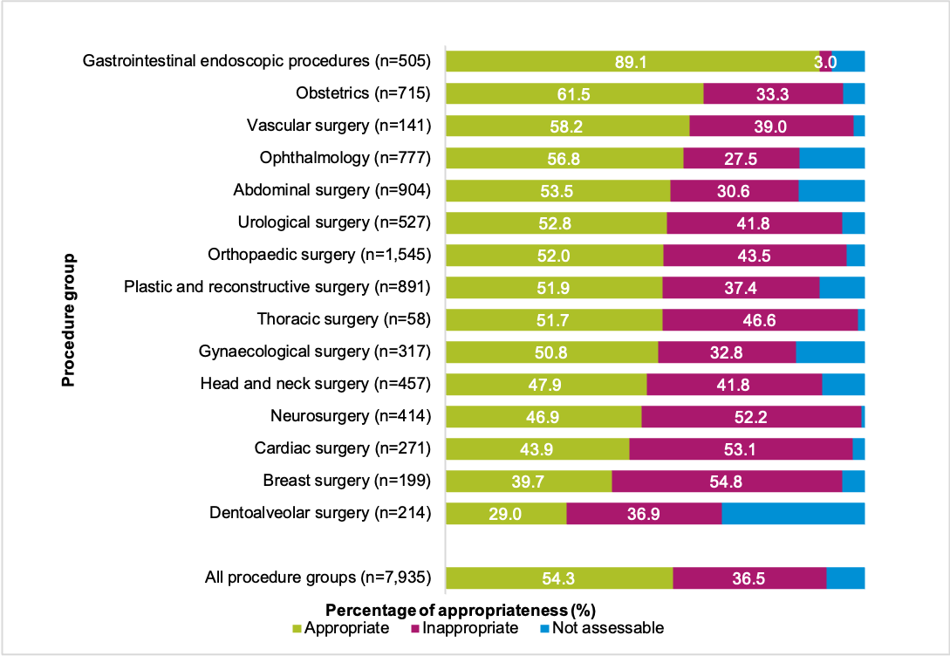

* The overall appropriateness considers each antimicrobial prescribed, including all procedural doses and all post-procedural prophylaxis prescriptions, taking the most inappropriate assessment as the overall appropriateness for that surgical episode.

### Procedural prescribing

Approximately one-quarter (23.7%) of all procedural prescribing was assessed as inappropriate (Table 2). The proportion of episodes deemed inappropriate was higher when antimicrobials were prescribed, than when they were not prescribed (28.5% and 8.2% respectively). Antimicrobials were prescribed when not required in 8.8% of episodes. Additional analyses can be found in Appendix 4.

When procedural antimicrobials were prescribed, appropriateness was higher, with 64.4% deemed optimal (Figure A3.4). When no procedural antimicrobials were prescribed, inappropriateness was low (8.2%). Overall, 28.8% of all procedural prescribing was deemed inappropriate when non-assessable doses were excluded (n=6,622).

##### Table 2: Appropriateness* of procedural prescribing of antimicrobials for surgical episodes and antimicrobial doses, Surgical NAPS contributor facilities, 2020

|  |  |  |  |  |  |  |  |
| --- | --- | --- | --- | --- | --- | --- | --- |
| **Procedural prophylaxis** | **Total** | **Appropriate** | | **Inappropriate** | | **Not assessable** | |
| **No.** | **No.** | **%** | **No.** | **%** | **No.** | **%** |
| **Surgical episodes** | **7,935** | **6,022** | **75.9** | **1,887** | **23.7** | **361** | **4.5** |
| **Antimicrobial prescribed** | 6,051 | 4,386 | 72.5 | 1,723 | 28.5 | 267 | 4.9 |
|  when required | 5,479 | 4,386 | 80.1 | 1,053 | 19.2 | 267 | 4.9 |
|  when not required | 695 | – | – | 695 | 100 | – | – |
| **No antimicrobial prescribed** | 1,884 | 1,636 | 86.8 | 154 | 8.2 | 94 | 5.0 |
|  when required | 198 | 48 | 24.1 | 149 | 74.9 | 2 | 1.0 |
|  when not required | 1,685 | 1,588 | 94.2 | 5 | 0.3 | 92 | 5.5 |
| **Antimicrobial doses** | **6,906** | **4,749** | **68.8** | **1,873** | **27.1** | **284** | **4.1** |
| **Initial dose** | 6,750 | 4,666 | 69.1 | 1,804 | 26.7 | 280 | 4.2 |
|  when required | 6,047 | 4,666 | 77.2 | 1,101 | 18.2 | 280 | 4.6 |
|  when not required | 703 | – | – | 703 | 100 | – | – |
| **Repeat dose** | 156 | 83 | 53.2 | 69 | 44.2 | 4 | 2.6 |
|  when required | 135 | 83 | 61.5 | 48 | 35.6 | 4 | 3.0 |
|  when not required | 21 | – | – | 21 | 100 | – | – |
|  not given when required† | 23 | – | – | 23 | 100 | – | – |

* The overall appropriateness of prescribing for a surgical episode was determined by taking the lowest ranked assessment of the individual doses, including all episodes where antimicrobials were prescribed as well as where none were prescribed.

† Excluded from total antimicrobial doses, as these are doses that were not given.

#### Reasons for inappropriate procedural prescribing

Of antimicrobials that were prescribed procedurally, 724 (38.6%) were deemed not required (n=1,873). For procedural doses, where antimicrobials were recommended by guidelines, 18.6% were deemed inappropriate. The most common reasons for this inappropriate prescribing were incorrect timing, incorrect dosage, and ‘spectrum too broad’ (46.6%, 22.5% and 21.7% respectively) (Figure 7).

##### Figure 7: Reasons for inappropriateness, by percentage of required procedural antimicrobial doses*, Surgical NAPS contributor facilities, 2020

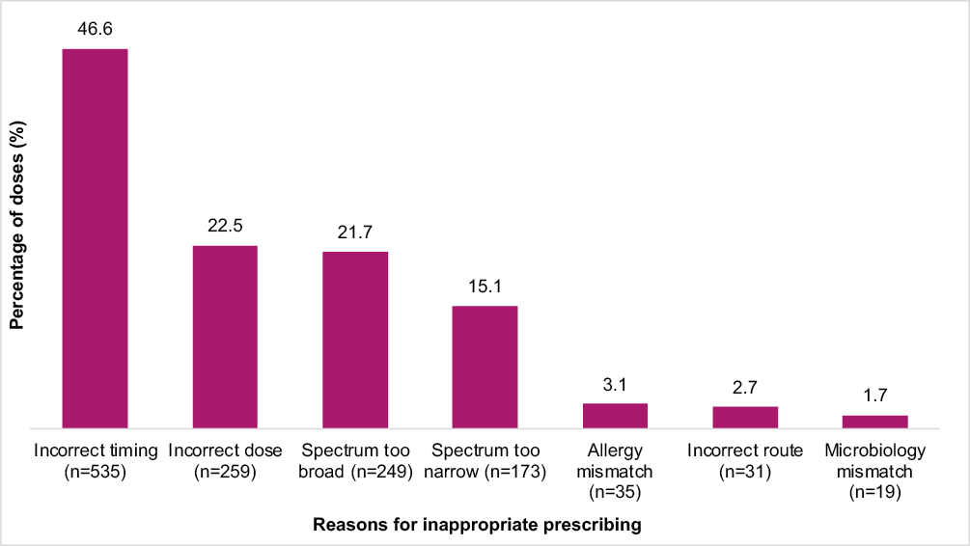

* n=1,149 antimicrobial doses.

#### Timing of administration

Incorrect timing was the reason for 46.6% of required procedural doses being deemed inappropriate (Figure 7). As 14.3% of procedural doses did not have a recorded administration time, when these were excluded, incorrect timing accounted for 9.0% of all required procedural doses.

### Post-procedural prescribing

Post-procedural prophylaxis was deemed inappropriate in 20.6% of the 7,935 surgical episodes audited (Table 3). For the 50.7% of episodes where no post-procedural antimicrobials were prescribed, this was mostly deemed appropriate (94.0%). Of the surgical episodes that had at least one post-procedural antimicrobial prescribed for prophylaxis, 51.7% were deemed inappropriate. Antimicrobials were prescribed when not required for 10.9% (n=864) of episodes (Table 3). Additional analyses can be found in Appendix 4.

Almost half of post-procedural antimicrobial prophylaxis prescriptions were deemed inadequate (47.1%), with 38.6% being assessed as optimal (Figure A3.5). Post-procedural prophylaxis was deemed inappropriate for 54.7% of prescriptions, when the non-assessable prescriptions were excluded.

##### Table 3: Appropriateness* of post-procedural prophylactic prescribing of antimicrobials for surgical episodes and antimicrobial prescriptions#, Surgical NAPS contributor facilities, 2020

|  |  |  |  |  |  |  |  |
| --- | --- | --- | --- | --- | --- | --- | --- |
| **Post-procedural prophylaxis** | **Total** | **Appropriate** | | **Inappropriate** | | **Not assessable** | |
| **No.** | **No.** | **%** | **No.** | **%** | **No.** | **%** |
| **Surgical episodes** | **7,935** | **5,195** | **65.5** | **1,636** | **20.6** | **703** | **8.9** |
| **Antimicrobial prescribed** | 3,134 | 1,415 | 45.1 | 1,620 | 51.7 | 99 | 3.2 |
| 9 when required | 2,375 | 1,414 | 59.5 | 862 | 36.3 | 99 | 4.2 |
| 9 when not required | 864 | 6 | 0.7 | 854 | 98.8 | 4 | 0.5 |
| **No antimicrobial prescribed** | 4,021 | 3,780 | 94.0 | 16 | 0.4 | 225 | 5.6 |
| 9 when required | 20 | 10 | 50.0 | 9 | 45.0 | 1 | 5.0 |
| 9 when not required | 4,001 | 3,770 | 94.2 | 7 | 0.2 | 224 | 5.6 |
| **Not assessable** | 379 | – | – | – | – | 379 | 100 |
| **Antimicrobial prescriptions** | **3,628** | **1,594** | **43.9** | **1,902** | **52.4** | **132** | **3.6** |
| **Prophylaxis** | 3,531 | 1,550 | 43.9 | 1,869 | 52.9 | 112 | 3.2 |
| 9 when required | 2,517 | 1,549 | 61.5 | 856 | 34.0 | 112 | 4 |
| 9 when not required | 1,014 | 1 | 0.1 | 1,013 | 99.9 | – | – |
| **Treatment** | 62 | 40 | 64.5 | 19 | 30.6 | 3 | 4.8 |
| **Not assessable** | 35 | 4 | 11.4 | 14 | 40.0 | 17 | 48.6 |

* The overall appropriateness of prescribing for a surgical episode was determined by taking the lowest ranked assessment of the individual post-procedural prescriptions.

# 401 surgical episodes had only post-procedural antimicrobials prescribed for treatment of infection or were not assessable and were excluded from the analysis.

#### Reasons for inappropriate post-procedural prescribing

When antimicrobials were prescribed for post-procedural prophylaxis, 1,013 (54.2%) were deemed not required (n=1,869). For post-procedural prophylactic prescriptions, where prophylaxis was recommended by guidelines, 34.0% were deemed inappropriate. The majority of inappropriate prescribing was due to incorrect duration (71.3%); dose and frequency inconsistencies were the next most common reason (33.5%) (Figure 8).

##### Figure 8: Reasons for inappropriateness, by percentage of required post-procedural prophylactic antimicrobial prescriptions*, Surgical NAPS contributor facilities, 2020

This figure shows the level of inappropriate prescribing of required post-procedural prophylactic antimicrobial prescriptions reported to the 2020 Surgical NAPS, and the reason they were deemed inappropriate, expressed as a percentage of the total required post-procedural prophylactic antimicrobial prescriptions.   

* n=856, prescriptions where post-procedural antimicrobial prophylaxis was required and deemed inappropriate.

#### Duration greater than 24 hours

Of all post-procedural prescriptions, 64.2% involved prophylaxis for up to or greater than 24 hours (Table 4). For those prescribed for up to or greater than 48 hours (42.2%), 5 of the procedural groups had rates greater than 50%. These were breast surgery, head and neck surgery, abdominal surgery, ophthalmology and cardiac surgery (53.9%, 53.5% 52.8%, 52.6% and 50.9% respectively). When burden of episodes audited is considered, 59.9% of all prescriptions up to or greater than 48 hours are accounted for by 3 procedure groups: orthopaedic surgery (n=477 prescriptions), ophthalmology (n=275 prescriptions) and plastic and reconstructive surgery (n=140 prescriptions).

##### Table 4: Duration of surgical prophylaxis and percentage prescribed for greater than 24 and 48 hours, by procedure group, Surgical NAPS contributor facilities, 2020

|  |  |  |  |  |  |  |  |
| --- | --- | --- | --- | --- | --- | --- | --- |
| **Procedure group** | **Antimicrobial prescriptions** | **Duration range** | **Duration median** | **Duration**  **>24 hours** | | **Duration**  **>48 hours** | |
| **No.** | **(days)** | **(days)** | **No.** | **%** | **No.** | **%** |
| Orthopaedic surgery | 1,220 | 1–33 | 2 | 604 | 49.5 | 477 | 39.1 |
| Ophthalmology | 523 | 1–33 | 9 | 482 | 92.2 | 275 | 52.6 |
| Plastic and reconstructive surgery | 390 | 1–29 | 6 | 308 | 79.0 | 140 | 35.9 |
| Neurosurgery | 289 | 1–31 | 2 | 124 | 42.9 | 112 | 38.8 |
| Cardiac surgery | 212 | 1–13 | 2 | 122 | 57.5 | 108 | 50.9 |
| Breast surgery | 154 | 1–27 | 6 | 119 | 77.3 | 83 | 53.9 |
| Head and neck surgery | 144 | 1–29 | 6 | 108 | 75.0 | 77 | 53.5 |
| Abdominal surgery | 144 | 1–30 | 3 | 98 | 68.1 | 76 | 52.8 |
| Obstetrics | 127 | 1–14 | 2 | 95 | 74.8 | 46 | 36.2 |
| Urological surgery | 121 | 1–18 | 6 | 76 | 62.8 | 35 | 28.9 |
| Dentoalveolar surgery | 78 | 1–14 | 6 | 64 | 82.1 | 31 | 39.7 |
| Gynaecological surgery | 47 | 1–14 | 2 | 26 | 55.3 | 13 | 27.7 |
| Thoracic surgery | 45 | 2–15 | 2 | 24 | 53.3 | 13 | 28.9 |
| Vascular surgery | 35 | 1–16 | 2 | 17 | 48.6 | 4 | 11.4 |
| Gastrointestinal endoscopic procedures | 2 | 2–2 | 2 | <5 | – | – | – |
| **Total** | **3,531** | **1–33** | **3** | **2,268** | **64.2** | **1,490** | **42.2** |

## Impact of SARS-CoV-2 on the Surgical NAPS in 2020

The global coronavirus disease 19 (COVID-19) pandemic, caused by SARS-CoV-2, had a significant impact on the Australian healthcare system in 2020. During periods of high community transmission, elective surgery was cancelled within both the public and private systems. This had a major impact on the ability of hospitals to perform the Surgical NAPS, particularly within the Victorian public system, where there was a prolonged period of lockdown (112 days) with few to no surgical procedures being performed. The strain on the healthcare workforce caused by COVID-19 is also likely to have reduced the resources available to conduct the Surgical NAPS, with Victoria demonstrating a 5.1% decrease in participation rate in 2020 compared to 2019 (Figure A3.1). Comparing the 2019 and 2020 Surgical NAPS report data, the numbers and proportions of elective surgical procedures were similar: n=7,092 (88.0%) and n=7,018 (88.4%) respectively. The rates of trauma-related surgical episodes in 2019 and 2020 were also similar: n=295 (3.7%) and n=249 (3.1%) respectively. Although there was an overall increase (by 5 facilities) in the participation rate in 2020 compared to 2019, an additional 6 facilities contributed data in 2020 from surgeries performed in 2019. This was possibly due to the lack of surgeries being performed in 2020 and auditors choosing instead to perform the Surgical NAPS on retrospective data from 2019 (see Appendix 1).

# Discussion

Surgical prophylaxis, when prescribed appropriately, has the benefit of reducing the development of post-operative infections, including surgical site infections, pneumonia, and urinary tract infections.8 Use of antimicrobials for the prevention of such infections must be balanced against complications associated with their use, including allergic and adverse drug reactions, and the development of antimicrobial resistance. Surgical antimicrobial prophylaxis should be reserved for procedures or clinical situations where there is strong evidence that the benefit outweighs potential harm.

For the Surgical NAPS in 2020, which was the fifth year the audit has been conducted, the increase in uptake, compared with the 2019 survey and despite the restrictions placed on elective surgery due to the COVID-19 pandemic, was extremely encouraging. As the Surgical NAPS is voluntary and is resource intensive compared with the Hospital NAPS and the Quality Improvement NAPS, this increase suggests that the survey is regarded as a valuable tool to identify opportunities to improve surgical antimicrobial prophylaxis. Ongoing annual contributions to the Surgical NAPS continue to provide benefits to end users to support further improvements and assess the efficacy and impact of implemented interventions in terms of guideline compliance and appropriateness. Despite variation in participation rates and the specialty focus between contributors, consistent themes for quality improvement are evident.

A consistent theme over the last 5 years is the suboptimal documentation of surgical incision and antimicrobial administration times. Incision time was not documented for 1 in 3 procedures, and administration time was not documented for 1 in 6 procedures for which data were submitted to the 2020 Surgical NAPS. The timing of surgical prophylaxis is important to ensure high concentrations of antimicrobials at the time of surgical incision. Ensuring documentation of both incision and antimicrobial administration times may improve antimicrobial administration times and help prevent surgical site infections.

As electronic medical records are progressively implemented in Australia over time, we anticipate that this may support improvements in the documentation of surgical incision and antimicrobial administration times. In comparison to paper-based systems, electronic medical record systems can be designed to prompt and require information that is routinely omitted (i.e., time of surgical incision and antimicrobial administration) to be entered.

Compliance with national prescribing guidelines8 continues to be poor, generally due to prolonged durations of oral, ocular and topical antimicrobials post-procedurally. These represent niche targeted areas for antimicrobial stewardship and quality improvement intervention. Post-procedural extended use of oral or topical antimicrobials is not recommended by these guidelines, and should be discouraged.

Antimicrobials should only be prescribed when the evidence supports their use. In the absence of other nationally or locally endorsed guidelines, recommendations for optimal use of surgical antimicrobial prophylaxis in Australia are available in the Therapeutic Guidelines: Antibiotic.8

The antimicrobial stewardship criterion of the National Safety and Quality Health Service Preventing and Controlling Healthcare-Associated Infection Standard1 requires health service organisations to provide access to, and promote use of, evidence-based Australian therapeutic guidelines. This standard also requires antimicrobial stewardship programs to take action to improve prescribing, and to report to clinicians on appropriateness of prescribing and compliance with guidelines. In addition to this, the ACSQHC released an advisory statement to highlight the need to specifically address surgical antimicrobial prophylaxis use as part of its antimicrobial stewardship program for national hospital accreditation.9 The Surgical NAPS provides a means for assessing antimicrobial use; however, the onus is on the contributing facility to take action to address its local audit results.

The NCAS also provides a range of clinical and educational resources to support Surgical NAPS end users on its website,10 and collaborates with the ACSQHC and relevant professional surgical bodies (i.e., the Royal Australasian College of Surgeons and the Royal Australian and New Zealand College of Ophthalmologists) to provide support regarding interventions to improve antimicrobial prescribing practices.

For example, cataract is the most common elective surgery diagnosis in Australia11 and thus represents a key area in which to optimise post-operative care, inclusive of antimicrobial use. The ACSQHC recently published the Cataract Clinical Care Standard with case studies highlighting the ability to optimise patient care and post-procedural antimicrobial use.11 One case study highlighted how an Australian hospital utilised its Surgical NAPS audit findings of inappropriate post-operative topical antibiotics in ophthalmology to drive a quality improvement project that led to a notable reduction in chloramphenicol use at their local service.11

With over 5 years of Surgical NAPS data collected over time, longitudinal trend analysis of the Surgical NAPS needs to be undertaken with due consideration to the variation in the cohort that occurs each year in relation to the procedure groups audited, the peer groups that voluntarily contribute data, and intermittent participation in Surgical NAPS by individual facilities. However, over the 5 years in which the Surgical NAPS has been conducted, there has been an increase in the appropriateness of procedural prescribing, which may be due to improved timing of administration and dosage of antimicrobials. There have been no discernible changes in appropriateness of post-procedural prescribing over the 5 years, as evidenced by ongoing high rates of extended post-procedural antimicrobial prophylaxis.

Given the small improvement in appropriateness of procedural prescribing over time, a greater focus on practical and effective interventions is needed to sustain and enhance these improvements.

Implementation of simple antimicrobial stewardship interventions with the focus on improving documentation and timing of incision and antimicrobial administration requires consistency and organisational support from health services to support their sustainability. Such measures could lead to improvements in surgical site infection rates and reduced complications from antimicrobial use.

These interventions do not require complex antimicrobial stewardship or infectious diseases advice, so they should be feasible to implement rapidly for most health service organisations that perform surgical procedures.

Further clarity from current guidelines may be required to support optimal prescribing and guideline adoption, particularly in relation to the need for intra-operative re-dosing and the timing of post- procedural doses, if indicated, and the inclusion of prophylaxis recommendations for specific surgical procedures (i.e., the most commonly performed). To support Surgical NAPS end users, the NCAS developed the ‘Timing and duration of surgical prophylaxis: Recommendations 2020’ resource, which includes clinically relevant cases that involve complex surgical antimicrobial use –i.e., patients also receiving existing antimicrobials and intra-operative re-dosing.12

Despite the strong evidence of recent randomised-controlled trials and systematic reviews to advocate for single-dose surgical antimicrobial prophylaxis,13-15 improvements in post-procedural prescribing may be more challenging to achieve as this requires a de-implementation of current practices, albeit their inappropriateness. To support optimisation of post-procedural antimicrobial use, engagement with the relevant surgical specialties is critical. This may include co-design and leadership of initiatives targeted to their surgical specialty unit. Peer review of prescribing practices and benchmarking of outcomes may contribute to changes in practice. Nurse, pharmacist or anaesthetist led automatic stop orders may be useful if extended duration of antimicrobial use is impacted by the frequency of antimicrobial review. Antimicrobial stewardship programs in Surgical NAPS contributor organisations can develop targeted initiatives informed by analyses of their own data. Local data evaluation will assist antimicrobial stewardship programs to identify which specialties they should target to improve surgical prophylaxis prescribing, and where return on investment is likely to be greatest based on the volume of procedures and the rate of appropriateness.

The summary analyses included in this report for specific procedure groups (see Appendix 4) are intended to support focused quality improvement approaches, such as local benchmarking of surgical antimicrobial prophylaxis by specialty and targeted interventions. These include orthopaedic, abdominal, plastic and reconstructive, ophthalmic, breast and urological surgery, because of either increased surgical procedure volume in these specialties or high rates of inappropriate prescribing in specific circumstances.

For many procedures, there is no evidence that prophylactic antimicrobial use procedurally or post-procedurally is of benefit in reducing post-operative infections; therefore, it is not recommended by guidelines for these procedures. There are very few procedures or clinical situations where available evidence supports antimicrobial use for other than a single pre-operative dose. Even in these situations, the total duration of antimicrobial prophylaxis should not exceed 24 hours. An exception to this is ophthalmic surgery, for which use of chloramphenicol for up to a week post-procedurally may be considered.8

In summary, and consistent with findings from previous surveys of surgical prophylaxis, the 2020 Surgical NAPS identified ongoing concerning inappropriate use of surgical prophylaxis in contributor hospitals. The issues involved require urgent attention from all stakeholders in order to improve antimicrobial stewardship in the operative setting.

# Appendix 1: Methodology

## Data collection

### Data collection period

Data submitted through the online data entry portal from 1 January to 31 December 2020 were eligible for inclusion in the 2020 public report.

### Recruitment

The Surgical NAPS module was available to all users registered for the NAPS. All registered users of the NAPS program were notified, and it was also marketed on social media via Twitter by NCAS and ACSQHC.

### Inclusion criteria

Any procedure type could be audited, including both incisional and non-incisional procedures.

### Audit methodology

Auditors could choose a variety of methods to perform the survey, depending on the size of the facility and available resources. Data could be collected on paper data collection forms, then entered into the online portal (see Appendix 7 for data fields), or could be entered directly into the online portal. The data collection form is standardised across both paper and online platforms.

### Retrospective audit

Retrospective audit was the recommended methodology, where possible. This survey could be performed over any chosen time frame; however, a minimum of one week or 30 consecutive procedures or surgical episodes was recommended. Ideally, theatre lists were obtained for each day to capture all procedures during this time frame. For those wanting to collect 30-day outcome follow-up data, it was recommended to perform retrospective chart and record review at least 30 days after the theatre list date.

### Prospective audit

This survey could be performed over any chosen time frame; however, a minimum of one week or 30 consecutive procedures or surgical episodes was recommended. To capture all procedures during this time frame, a theatre list was obtained for each day during the selected audit time frame. Patients who underwent a procedure or surgical episode were followed prospectively for data collection purposes. This process began once the patient left the operation suite/theatre and continued until post-operative antimicrobials had been ceased, or at 30-day follow-up (if collecting 30-day outcome follow-up data).

### Other audit types

Smaller, directed surveys are useful to examine the routine practice of a surgical specialty or a particular procedure. This may be particularly relevant following a survey where an issue has been identified, such as overprescription of an antimicrobial agent compared to the national average, or when a specialty is not prescribing in accordance with guidelines.

## Auditor education and support

A data collection form (see Appendix 7), a Surgical NAPS user guide, Surgical NAPS appropriateness definitions (see Appendix 8) and worked case examples were made available to users through the resources page of the Surgical NAPS online portal. The NAPS support team provided telephone and email support during the survey period, as it does for all NAPS programs. A guide to the timing and duration of surgical prophylaxis was created to help with the assessment of appropriateness regarding these issues. With the release of the newly designed Surgical NAPS reports and based on early feedback regarding the complex nature of the reports, a written guide to interpreting these reports was also developed to assist users to understand their results.

### Development of templates

A standardised reporting template and an example report were developed as a guide to help facilities communicate local survey results. Links to useful presentations and posters were also provided.

### Expert assessments

An expert assessment service was provided by the NAPS support team. Facilities without access to infectious diseases specialists were offered assistance with the assessment of guideline compliance and prescription appropriateness. All facilities could request assessment support if they felt it would improve the quality of their audit.

## Data cleaning

Following the 2019 Surgical NAPS, improvement in data validation was undertaken by the NAPS support team, particularly around data entry of dates. This helped to ensure data accuracy, particularly with respect to duration of surgical prophylaxis calculation. This improvement then reduced the requirement for extensive data cleaning, as was performed prior to the 2019 data analysis. After screening of the 2019 data, 254 patient records were identified for review; these involved dates presumed to be entered incorrectly, resulting in durations of therapy greater than anticipated. The data were carefully examined for errors, and 66 (26%) of these patient records were identified for correction. The majority of these changes were identified and amended by the NAPS support team following internal review and discussion, with 4 facilities needing to be contacted directly to review and amend their records.

## Data analysis

The Surgical NAPS database is live and participating hospitals are free to amend, add or remove their data at any time. For the delivery of the annual national reports, the database is accessed and analysed each year; therefore, previous years’ data may have some small discrepancies in results compared with the previously published NAPS reports.

### Procedural antimicrobial prophylaxis

Procedural antimicrobial prophylaxis was defined as any antimicrobial administered either immediately prior to or during the procedure for purposes of prophylaxis. Throughout this report, for procedural antimicrobials, each dose of the antimicrobial administered is recorded and reported individually.

### Post-procedural antimicrobial prophylaxis

Post-procedural antimicrobial prophylaxis was defined as any antimicrobial given immediately following the surgical procedure for the purpose of surgical prophylaxis. Throughout this report, for post- procedural antimicrobials, each prescription course of the antimicrobial is recorded and reported, including any inpatient or discharge scripts.

Of the 7,935 surgical episodes audited, 401 had post-procedural antimicrobials prescribed only for treatment of infection or were not assessable. These were excluded from the post-procedural prophylaxis analysis, leaving 7,534 surgical episodes.

### Appropriateness assessments

For reporting purposes, ‘optimal’ and ‘adequate’ are deemed to be appropriate, while ‘suboptimal’ and ‘inadequate’ are deemed to be inappropriate (see Appendix 8 for more information on definitions of appropriateness). Each surgical episode was given an overall assessment of inappropriate if any single aspect of the procedural or post-procedural prescribing was deemed inappropriate by the auditor. This included allergy or microbiology mismatch; incorrect antimicrobial timing, dose, route, frequency or duration; if the antimicrobial spectrum was too broad or too narrow; or if the procedure did not require any antimicrobials (see Appendix 8 for detailed definitions).

### Calculation of duration of surgical prophylaxis

Duration of surgical prophylaxis was calculated from the surgical incision date and time, if recorded; otherwise the surgery start date and time was used. These dates and times were used as a surrogate measure for the more acute measure of administration date and time of the first procedural antimicrobial prescribed, could not be determined for 965 (14.3%) of the prescribed initial procedural doses (n=6,750).

The end date and time for the last prophylactic antimicrobial prescribed was then used to determine the end date and time of surgical prophylaxis. For calculation of duration of surgical prophylaxis greater than 24 and 48 hours, the required dates and times were consistently completed, and these could be calculated accurately. For days of therapy calculations, any incomplete administration time for the last dose of therapy did not affect these overall calculations.

### Calculation of participation rates

In order to define the denominator for participation rates by different reporting groups (states and territories, peer groups and remoteness classifications), the Australian Institute of Health and Welfare (AIHW) peer group classification system was used.4 Hospital peer groups that would not be expected to perform surgical procedures were excluded from the denominator calculation.

The peer groups included for determination of denominator numbers for rates of participation were:

|  |  |
| --- | --- |
| **Public facilities** | **Private facilities** |
| Children’s hospitals  Combined women’s and children’s hospitals  Mixed day procedure hospitals  Other day procedure hospitals  Principal referral hospitals  Public acute group A hospitals Public acute group B hospitals Public acute group C hospitals Public acute group D hospitals Women’s hospitals  Women’s and children’s hospitals | Combined women’s and children’s hospitals Endoscopy centres  Eye surgery centres Gynaecology day hospitals Mixed day procedure hospitals  Oral and maxillofacial surgery centres Other acute specialised hospitals Other specialist day hospitals  Other women’s and children’s hospitals Plastic and reconstructive surgery centres Private acute group A hospitals  Private acute group B hospitals Private acute group C hospitals Private acute group D hospitals  Women’s hospitals |

The peer groups **excluded** for determination of denominator numbers for rates of participation were:

|  |  |
| --- | --- |
| **Public facilities** | **Private facilities** |
| Drug and alcohol hospitals Early parenting centres  Mixed subacute and non-acute hospitals Other acute specialised hospitals  Other public acute specialised hospitals Outpatient hospitals  Public acute psychiatric hospitals  Public child, adolescent and young adult psychiatric hospitals  Public forensic psychiatric hospitals Public rehabilitation hospitals  Public subacute and non-acute psychiatric hospitals  Unpeered hospitals Very small hospitals | Cardiovascular health centres Dialysis clinics  Drug and alcohol hospitals Fertility clinics  Haematology and oncology clinics Hyperbaric health centres  Mixed subacute and non-acute hospitals Private acute psychiatric hospitals Private rehabilitation hospitals Reproductive health centres  Same day hospitals Sleep centres Unpeered hospitals Very small hospitals |

# Appendix 2: Limitations and considerations for interpretation of results

The results presented in this report should be interpreted in the context of the following limitations and considerations:

## Sampling and selection bias

The facilities that participated were not a randomised sample, because participation was voluntary. Therefore, the results might not be representative of all Australian facilities where surgery is performed. Each hospital could choose how to perform the Surgical NAPS audit. Audits may have been conducted as prevalence surveys (consecutive or random patients), directed surveys (particular surgical specialties or procedures) or other types of audits; therefore it is not possible to determine the exact prevalence of the surgical procedures or antimicrobials prescribed.

## Survey methodology was not defined

For the Surgical NAPS, each hospital could decide how it performed the survey and which patients, or surgical specialties, were audited. If directed surveys were performed, patient sampling may not have been random, and auditors may have targeted problem or higher volume surgical units.

## Subjective nature of assessments

Individual auditors at each contributing facility were responsible for assessing the compliance with guidelines and appropriateness of antimicrobial prescribing. These assessments are not completely objective, as they involve some degree of interpretation, although the Surgical NAPS appropriateness definitions (Appendix 8) improves objectivity. This is further supplemented by the NAPS support team and online training resources. Remote expert assessments could also be conducted by the NAPS support team on request.

## Comparison of data over time

Care is required in relation to comparisons of Surgical NAPS data from one year to another, as the cohort of contributors varies from year to year, along with the proportions of surgical procedure groups represented.

# Appendix 3: Supplementary data

##### Table A3.1: Number and percentage of contributing public and private facilities, by remoteness classification*, Surgical NAPS 2020

|  |  |  |  |  |  |  |
| --- | --- | --- | --- | --- | --- | --- |
| **Remoteness classification** | **Public** | **Private** | **Total** | **Percentage of contributing facilities** | **Number in remoteness classification group** | **Percentage of remoteness classification group** |
| **No.** | **No.** | **No.** | **%** | **No.** | **%** |
| Major cities | 25 | 66 | 91 | 61.1 | 417 | 21.8 |
| Inner regional | 27 | 10 | 37 | 24.8 | 216 | 17.1 |
| Outer regional | 14 | 4 | 18 | 12.1 | 166 | 10.8 |
| Remote | 3 | – | 3 | 2.0 | 45 | 6.7 |
| Very remote | – | – | – | – | 27 | – |
| **Total** | **69** | **80** | **149** | **100** | **871** | **17.1** |

* Australian Bureau of Statistics. 1270.0.55.005 – Australian Statistical Geography Standard (ASGS): Volume 5 – remoteness structure, July 2016. Canberra: ABS; 2018.

##### Table A3.2: Number and percentage of Surgical NAPS contributor facilities by funding type*, by surgical procedure group, 2020

|  |  |  |  |  |
| --- | --- | --- | --- | --- |
| **Procedure group** | **Public facilities** | **Private facilities** | **Contributing facilities** | |
| **No.** | **No.** | **No.** | **%** |
| Plastic and reconstructive surgery | 49 | 44 | 93 | 62.4 |
| Abdominal surgery | 50 | 38 | 88 | 59.1 |
| Orthopaedic surgery | 36 | 49 | 85 | 57.0 |
| Urological surgery | 41 | 33 | 74 | 49.7 |
| Head and neck surgery | 39 | 29 | 68 | 45.6 |
| Obstetrics | 35 | 23 | 58 | 38.9 |
| Gynaecological surgery | 31 | 26 | 57 | 38.3 |
| Gastrointestinal endoscopic procedures | 34 | 20 | 54 | 36.2 |
| Ophthalmology | 19 | 23 | 42 | 28.2 |
| Breast surgery | 15 | 27 | 42 | 28.2 |
| Neurosurgery | 14 | 18 | 32 | 21.5 |
| Dentoalveolar surgery | 11 | 19 | 30 | 20.1 |
| Vascular surgery | 17 | 9 | 26 | 17.4 |
| Cardiac surgery | 6 | 14 | 20 | 13.4 |
| Thoracic surgery | 6 | 5 | 11 | 7.4 |

* n=149 facilities.

##### Figure A3.1: Percentage of contributing facilities, by state and territory, of all eligible peer group classifications, Surgical NAPS 2016-2020

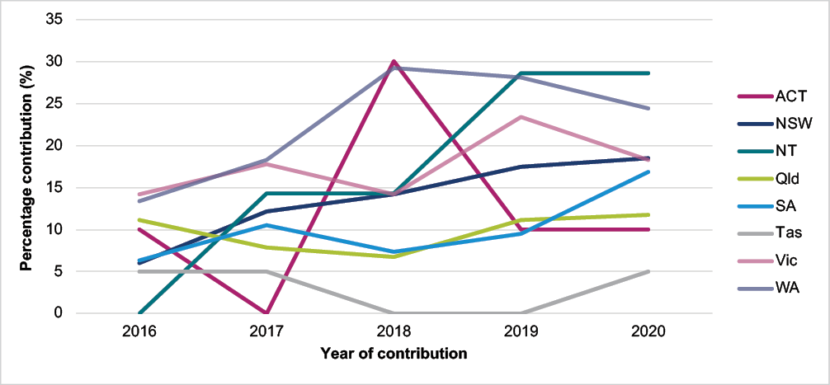

##### Figure A3.2: Percentage of contributing facilities, by peer group classification*, Surgical NAPS 2016-2020

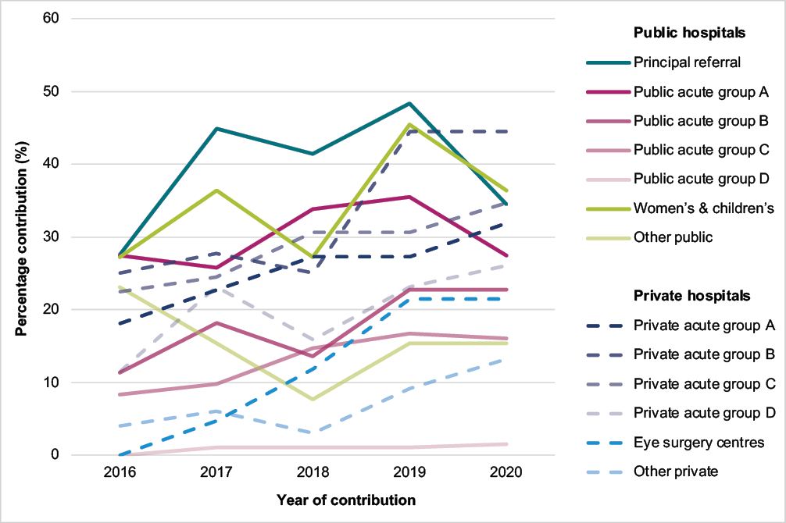

* Australian Institute of Health and Welfare. Australian hospital peer groups. Health services series no. 66. Cat. no. HSE 170. Canberra: AIHW; 2015.

##### Figure A3.3: Percentage of contributing facilities, by remoteness classification*, Surgical NAPS 2016-2020

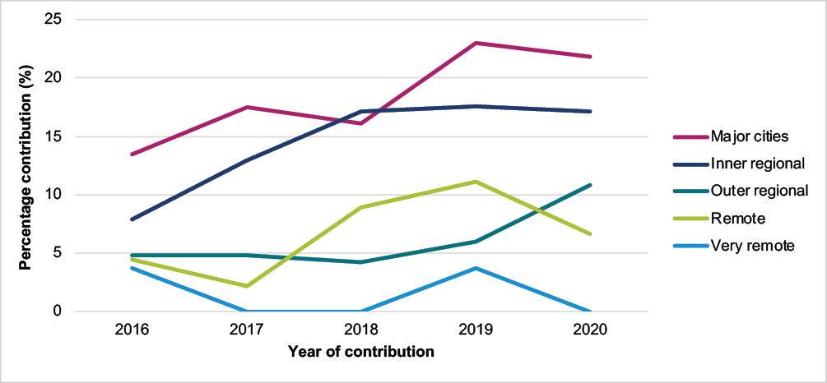

* Australian Bureau of Statistics. 1270.0.55.005 – Australian Statistical Geography Standard (ASGS): Volume 5 – remoteness structure, July 2016. Canberra: ABS; 2018.

##### Table A3.3: Number and percentage of contributing public and private facilities, by peer group classification*, Surgical NAPS 2020

|  |  |  |  |  |
| --- | --- | --- | --- | --- |
| **Peer group classification** | **Number** | **Percentage of participating facilities** | **Number in peer group classification** | **Percentage of peer group classification** |
| **No.** | **%** | **No.** | **%** |
| **Public facilities** | **69** | **46.3** | **493** | **14.0** |
| Principal referral hospitals | 10 | 6.7 | 29 | 34.5 |
| Public acute group A hospitals | 17 | 11.4 | 62 | 27.4 |
| Public acute group B hospitals | 10 | 6.7 | 44 | 22.7 |
| Public acute group C hospitals | 23 | 15.4 | 143 | 16.1 |
| Public acute group D hospitals | 3 | 2.0 | 191 | 1.6 |
| Women’s hospitals | 2 | 1.3 | 5 | 40.0 |
| Children’s hospitals | 2 | 1.3 | 6 | 33.3 |
| Other acute specialised hospitals | 2 | 1.3 | 3 | 66.7 |
| **Private facilities** | **80** | **53.7** | **316** | **25.3** |
| Private acute group A hospitals | 7 | 4.7 | 22 | 31.8 |
| Private acute group B hospitals | 16 | 10.7 | 36 | 44.4 |
| Private acute group C hospitals | 17 | 11.4 | 49 | 34.7 |
| Private acute group D hospitals | 18 | 12.1 | 69 | 26.1 |
| Mixed day procedure hospitals | 6 | 4.0 | 53 | 11.3 |
| Other day procedure hospital | 1 | 0.7 | 4 | 25.0 |
| Eye surgery centres | 9 | 6.0 | 42 | 21.4 |
| Plastic and reconstructive surgery centres | 2 | 1.3 | 26 | 7.7 |
| Other acute specialised hospitals | 4 | 2.7 | 15 | 26.7 |
| **Total** | **149** | **100** | **809** | **18.4** |

* Australian Institute of Health and Welfare. Australian hospital peer groups. Health services series no. 66. Cat. no. HSE 170. Canberra: AIHW; 2015.

##### Figure A3.4: Percentage of appropriateness* for procedural antimicrobial dose†, Surgical NAPS contributor facilities, 2020

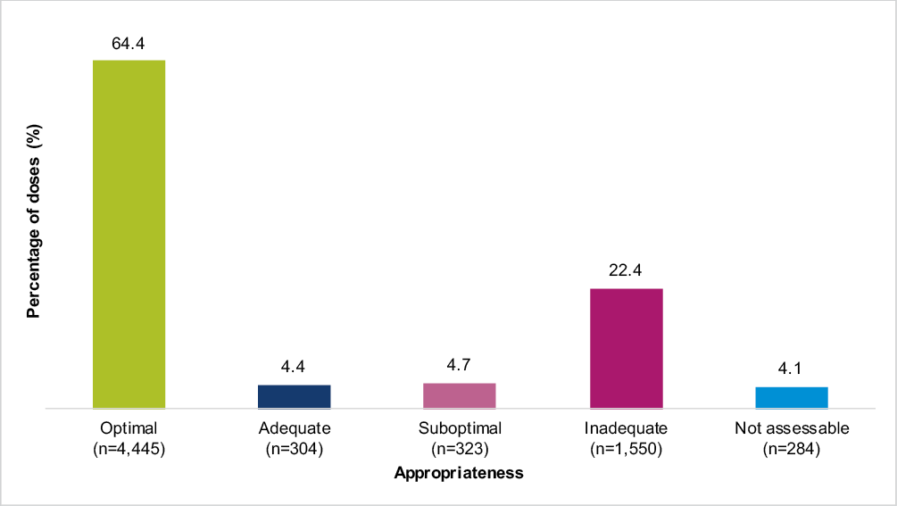

* Refer to Appendix 8 for the appropriateness definitions.

† n=6,906 procedural antimicrobial doses.

##### Figure A3.5: Percentage of appropriateness* for post-procedural prophylactic antimicrobial prescriptions†, Surgical NAPS contributor facilities, 2020

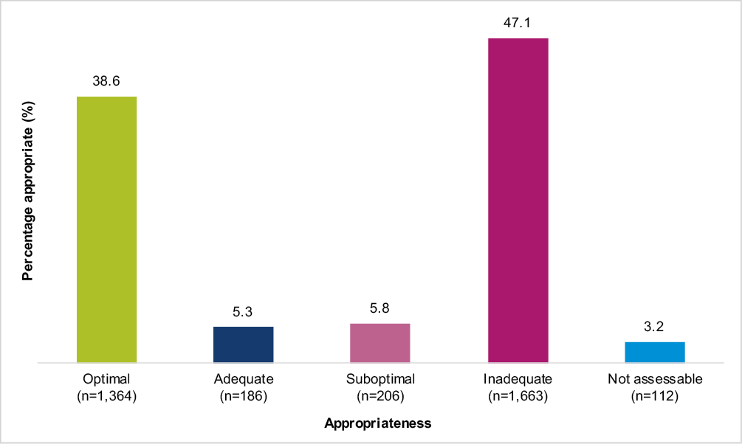

* Refer to Appendix 8 for the appropriateness definitions.

† n=3,531 prescriptions for post-procedural prophylaxis.

# Appendix 4: Additional analyses

## Antimicrobial choice

Cefazolin was the most commonly prescribed antimicrobial, accounting for 82.8% of procedural prescriptions and 56.2% of post-procedural prescriptions in 2020.

### Procedural

The top 5 procedural antimicrobials prescribed accounted for 94.4% of all antimicrobials: cefazolin (82.8%), metronidazole (3.9%), gentamicin (3.5%), chloramphenicol (2.4%) and vancomycin (1.9%), as shown in Table A4.1. Prescribing for cefazolin and metronidazole had low rates of inappropriateness (22.1% and 33.5% respectively). Rates of prescribing deemed inappropriate were greater than 80% for amoxicillin and ceftriaxone.

##### Table A4.1: Percentage and inappropriateness of procedural antimicrobial doses*, Surgical NAPS contributor facilities, 2020

|  |  |  |  |  |
| --- | --- | --- | --- | --- |
| **Antimicrobial** | **Total doses prescribed** | | **Inappropriate** | |
| **No.** | **%** | **No.** | **%** |
| Cefazolin | 5,717 | 82.8 | 1,265 | 22.1 |
| Metronidazole | 266 | 3.9 | 89 | 33.5 |
| Gentamicin | 243 | 3.5 | 128 | 52.7 |
| Chloramphenicol | 165 | 2.4 | 91 | 55.2 |
| Vancomycin | 128 | 1.9 | 60 | 46.9 |
| Clindamycin | 76 | 1.1 | 50 | 65.8 |
| Ceftriaxone | 66 | 1.0 | 54 | 81.8 |
| Ciprofloxacin | 36 | 0.5 | 21 | 58.3 |
| Lincomycin | 27 | 0.4 | 17 | 63.0 |
| Cefalexin | 23 | 0.3 | 12 | 52.2 |
| Tobramycin | 19 | 0.3 | 11 | 57.9 |
| Amoxicillin | 18 | 0.3 | 15 | 83.3 |
| Piperacillin–tazobactam | 18 | 0.3 | 7 | – |
| Amoxicillin–clavulanic acid | 16 | 0.2 | 4 | – |
| Cefotaxime | 12 | 0.2 | 7 | – |
| Teicoplanin | 12 | 0.2 | 4 | – |
| Ampicillin | 11 | 0.2 | 9 | – |
| Flucloxacillin | 11 | 0.2 | 6 | – |
| Ofloxacin | 10 | 0.1 | 3 | – |
| Others | 32 | 0.5 | 20 | 62.5 |
| **Total** | **6,906** | **100** | **1,873** | **27.1** |

* Data are not shown for antimicrobials where n <10.

### Post-procedural

The 5 most frequently prescribed post-procedural antimicrobials accounted for 88.5% of all antimicrobials prescribed: cefazolin (56.2%), cefalexin (14.8%), chloramphenicol (12.4%), ciprofloxacin (2.7%), and amoxicillin–clavulanic acid (2.4%), as shown in Table A4.2. All antimicrobials had relatively high rates of prescribing deemed inappropriate. Rates of prescribing deemed inappropriate were greater than 80% for amoxicillin, gentamicin, ceftriaxone and trimethoprim.

##### Table A4.2: Post-procedural prophylactic prescribing of antimicrobials and percentage inappropriate*, Surgical NAPS contributor facilities, 2020

|  |  |  |  |  |
| --- | --- | --- | --- | --- |
| **Antimicrobial** | **Total prescriptions** | | **Inappropriate** | |
| **No.** | **%** | **No.** | **%** |
| Cefazolin | 1,985 | 56.2 | 978 | 49.3 |
| Cefalexin | 524 | 14.8 | 349 | 66.6 |
| Chloramphenicol | 439 | 12.4 | 180 | 41.0 |
| Ciprofloxacin | 95 | 2.7 | 44 | 46.3 |
| Amoxicillin–clavulanic acid | 83 | 2.4 | 59 | 71.1 |
| Metronidazole | 82 | 2.3 | 52 | 63.4 |
| Clindamycin | 46 | 1.3 | 30 | 65.2 |
| Vancomycin | 44 | 1.2 | 28 | 63.6 |
| Amoxicillin | 37 | 1.0 | 37 | 100 |
| Tobramycin | 27 | 0.8 | 9 | – |
| Ceftriaxone | 27 | 0.8 | 23 | 85.2 |
| Trimethoprim | 24 | 0.7 | 20 | 83.3 |
| Gentamicin | 21 | 0.6 | 18 | 85.7 |
| Ofloxacin | 12 | 0.3 | 1 | – |
| Fluconazole | 10 | 0.3 | 1 | – |
| Cefalothin | 10 | 0.3 | – | – |
| Others | 65 | 1.8 | 40 | 61.5 |
| **Total** | **3,531** | **100** | **1,869** | **52.9** |

* Data are not shown for antimicrobials where n <10.

## Route of administration

### Procedural

Procedural antimicrobial doses were predominantly administered by the intravenous (85.8%) and ocular (9.1%) routes. Topical antimicrobials accounted for 4.5% of prescribing, despite not being recommended as an appropriate route for use in procedural surgical antimicrobial prophylaxis. More than half (51.4%) of prescriptions for topical antimicrobial use were deemed inappropriate.

### Post-procedural

Post-procedural antimicrobial prescriptions were predominantly for intravenous (62.8%) and oral (20.7%) administration. As for procedural prescribing, if post-procedural prophylaxis is required, guidelines almost always recommend intravenous administration; therefore a large proportion of post-procedural oral antimicrobials (69.4%) were deemed inappropriate. As topical antimicrobials for ophthalmic procedures may be appropriately prescribed post-procedurally, when these were excluded, almost two-thirds of all topical antimicrobials (67.2%) were deemed inappropriate.

The route of administration also had an impact on duration of therapy. There was a median of 2 days of therapy for intravenously administered antimicrobials, compared to 15 days of therapy for antimicrobials administered via the topical route. There were also prolonged durations for ocular and oral administration, which had a median of 8 and 6 days of therapy respectively (Table A4.3). Episodes where antimicrobials were prescribed for up to or greater than 24 hours generally continued past 48 hours for all administration routes, except for those prescribed intravenously.

##### Table A4.3: Duration of surgical prophylaxis and percentage prescribed for greater than 24 and 48 hours, by route of administration*, Surgical NAPS contributor facilities, 2020

|  |  |  |  |  |  |  |  |
| --- | --- | --- | --- | --- | --- | --- | --- |
| **Route of administration** | **Antimicrobial prescriptions** | **Duration range** | **Duration median** | **Duration**  **>24 hours** | | **Duration**  **>48 hours** | |
| **No.** | **(days)** | **(days)** | **No.** | **%** | **No.** | **%** |
| Intravenous | 2,216 | 1–33 | 2 | 1,030 | 46.5 | 273 | 12.3 |
| Oral | 731 | 1–31 | 6 | 695 | 95.1 | 679 | 92.9 |
| Topical | 459 | 1–33 | 15 | 448 | 97.6 | 443 | 96.5 |
| Ocular | 123 | 1–31 | 8 | 93 | 75.6 | 93 | 75.6 |
| **Total** | **3,529** | **1–33** | **3** | **2,266** | **64.2** | **1,488** | **42.2** |

* Data are not shown for routes where n <10.

## Prescribing by facility funding type

### Procedural

The rate of prescribing for procedural antimicrobials was significantly higher in private facilities than public facilities (84.7% and 64.7% respectively). However, this was not reflected in rates of inappropriate procedural antimicrobial prescribing between private and public facilities, with 25.3% and 30.3% being deemed inappropriate respectively (Table A4.4).

##### Table A4.4: Appropriateness of procedural antimicrobial prescribing, by funding type, Surgical NAPS contributor facilities, 2020

|  |  |  |  |  |  |  |
| --- | --- | --- | --- | --- | --- | --- |
| **Funding type** | **Surgical episodes** | **At least one antimicrobial prescribed** | | **Total doses** | **Inappropriate** | |
| **No.** | **No.** | **%** | **No.** | **No.** | **%** |
| Public facilities | 3,350 | 2,166 | 64.7 | 2,476 | 750 | 30.3 |
| Private facilities | 4,585 | 3,885 | 84.7 | 4,430 | 1,123 | 25.3 |
| **Total** | **7,935** | **6,051** | **76.3** | **6,906** | **1,873** | **27.1** |

### Post-procedural

The rate of prescribing at least one post-procedural antimicrobial was more than double in private facilities compared to public facilities (52.8% and 25.6% respectively). However, a higher proportion of prescriptions were deemed inappropriate in public facilities (60.1%) compared to private facilities (50.3%) (Table A4.5).

##### Table A4.5: Post-procedural prophylactic antimicrobials by funding type, Surgical NAPS contributor facilities, 2020

|  |  |  |  |  |  |  |
| --- | --- | --- | --- | --- | --- | --- |
| **Funding type** | **Surgical episodes** | **At least one prophylactic antimicrobial prescribed** | | **Total doses** | **Inappropriate** | |
| **No.** | **No.** | **%** | **No.** | **No.** | **%** |
| Public facilities | 3,098 | 794 | 25.6 | 942 | 566 | 60.1 |
| Private facilities | 4,436 | 2,340 | 52.8 | 2,589 | 1,303 | 50.3 |
| **Total** | **7,534** | **3,134** | **41.6** | **3,531** | **1,869** | **52.9** |

The range for the duration of surgical prophylaxis prescribing was the same for public and private facilities (1–32 days), with the corresponding median duration of prescribing being higher for public compared to private facilities: 3 and 2 days respectively (Table A4.6). This was also demonstrated by the proportion of surgical prophylaxis prescribed for greater than 24 hours in in public and private facilities (65.1% and 63.9% respectively).

##### Table A4.6: Duration of surgical prophylaxis and percentage prescribed for greater than 24 and 48 hours, by funding type, Surgical NAPS contributor facilities, 2020

|  |  |  |  |  |  |  |  |
| --- | --- | --- | --- | --- | --- | --- | --- |
| **Funding type** | **Antimicrobial prescriptions** | **Duration range** | **Duration median** | **Duration**  **>24 hours** | | **Duration**  **>48 hours** | |
| **No.** | **(days)** | **(days)** | **No.** | **%** | **No.** | **%** |
| Public facilities | 942 | 1–32 | 3 | 613 | 65.1 | 457 | 48.5 |
| Private facilities | 2,589 | 1–32 | 2 | 1,655 | 63.9 | 1,033 | 39.9 |
| **Total** | **3,531** | **1–32** | **3** | **2,268** | **64.2** | **1,490** | **42.2** |

## Procedure group analysis

### Procedural

Almost a quarter (23.8%) of all procedural prescribing for surgical episodes was assessed as inappropriate, including procedures for which no antimicrobial was prescribed (Figure A4.1). Cardiac surgery, dentoalveolar surgery and urological surgery had the highest proportions of surgical episodes deemed inappropriate (35.8%, 35.1% and 33.8% respectively).

##### Figure A4.1: Percentage of procedural prescribing appropriateness for surgical episodes by procedure group, Surgical NAPS contributor facilities, 2020

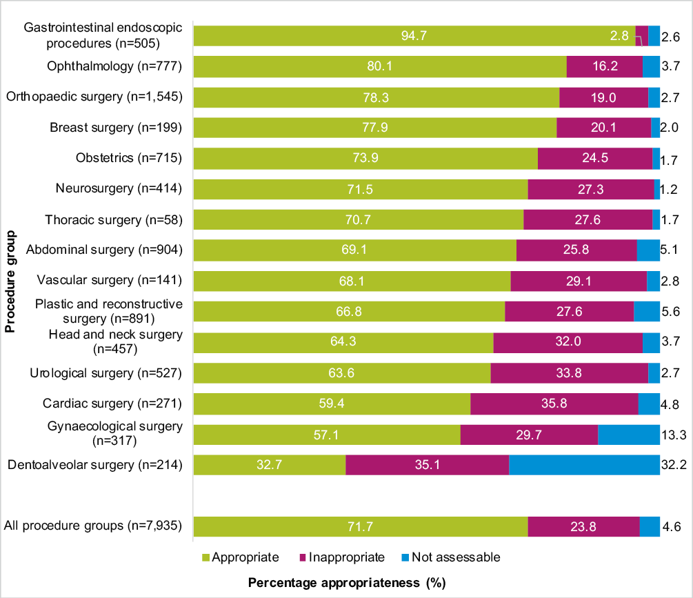

The procedure groups with the highest rates of prescribing at least one procedural antimicrobial were breast surgery, neurosurgery and orthopaedic surgery (96.5%, 95.2% and 93.3% respectively), as shown in Table A4.7. Despite, in some cases, lower overall proportions of antimicrobial doses deemed inappropriate, the majority of inappropriate prescribing was for orthopaedic surgery (n=397 doses), abdominal surgery (n=257 doses), plastic and reconstructive surgery (n=236 doses), urological surgery (n=208 doses) and ophthalmology (n=206 doses). These 5 procedure groups accounted for 58.8% of all inappropriate procedural doses.

##### Table A4.7: Procedural prescribing of antimicrobials and percentage inappropriate, by procedure group*, Surgical NAPS contributor facilities, 2020

|  |  |  |  |  |  |  |
| --- | --- | --- | --- | --- | --- | --- |
| **Procedure group** | **Surgical episodes** | **At least one antimicrobial prescribed** | | **Total doses** | **Inappropriate** | |
| **No.** | **No.** | **%** | **No.** | **No.** | **%** |
| Orthopaedic surgery | 1,545 | 1,442 | 93.3 | 1,644 | 397 | 24.1 |
| Abdominal surgery | 904 | 784 | 86.7 | 908 | 257 | 28.3 |
| Plastic and reconstructive surgery | 891 | 563 | 63.2 | 590 | 236 | 40.0 |
| Ophthalmology | 777 | 676 | 87.0 | 838 | 206 | 24.6 |
| Obstetrics | 715 | 596 | 83.4 | 620 | 161 | 26.0 |
| Urological surgery | 527 | 376 | 71.3 | 455 | 208 | 45.7 |
| Gastrointestinal endoscopic procedures | 505 | 19 | 3.8 | 22 | 11 | 50.0 |
| Head and neck surgery | 457 | 257 | 56.2 | 274 | 154 | 56.2 |
| Neurosurgery | 414 | 394 | 95.2 | 415 | 125 | 30.1 |
| Gynaecological surgery | 317 | 216 | 68.1 | 272 | 109 | 40.1 |
| Cardiac surgery | 271 | 227 | 83.8 | 296 | 142 | 48.0 |
| Dentoalveolar surgery | 214 | 149 | 69.6 | 152 | 76 | 50.0 |
| Breast surgery | 199 | 192 | 96.5 | 241 | 71 | 29.5 |
| Vascular surgery | 141 | 109 | 77.3 | 113 | 40 | 35.4 |
| Thoracic surgery | 58 | 51 | 87.9 | 66 | 24 | 36.4 |
| **Total** | **7,935** | **6,051** | **76.3** | **6,906** | **2,217** | **32.1** |

### Post-procedural

Almost a quarter (22.9%) of all post-procedural prescribing for surgical episodes was assessed as inappropriate, including when antimicrobials were prescribed and not prescribed post-procedurally (Figure A4.2). The procedure groups with the most post-procedural prescribing deemed inappropriate overall were breast surgery, neurosurgery and cardiac surgery (53.6%, 38.8% and 35.7% respectively).

##### Figure A4.2: Percentage of post-procedural prophylactic prescribing appropriateness for surgical episodes by procedure group, Surgical NAPS contributor facilities, 2020

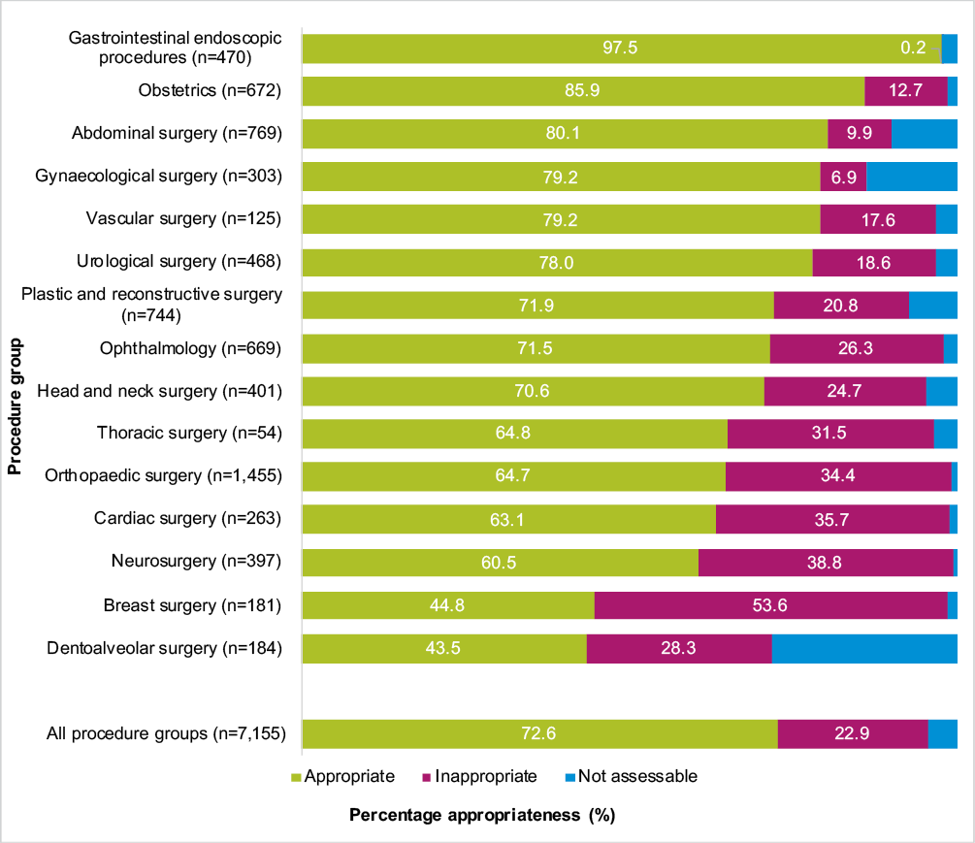

The procedure groups with the highest rates of prescribing at least one post-procedural antimicrobial for prophylaxis were thoracic surgery, orthopaedic surgery and cardiac surgery (79.6%, 76.0% and 73.1% respectively), as shown in Table A4.8. Orthopaedic surgery (n=576 prescriptions), plastic and reconstructive surgery (n=224 prescriptions), ophthalmology (n=176) and neurosurgery (n=169 prescriptions) accounted for over half (57.9%) of all inappropriate post-procedural antimicrobial prescriptions.

##### Table A4.8: Post-procedural prophylactic prescribing of antimicrobials and percentage inappropriate, by procedure group*, Surgical NAPS contributor facilities, 2020

|  |  |  |  |  |  |  |
| --- | --- | --- | --- | --- | --- | --- |
| **Procedure group** | **Surgical episodes** | **At least one antimicrobial prescribed** | | **Total doses** | **Inappropriate** | |
| **No.** | **No.** | **%** | **No.** | **No.** | **%** |
| Orthopaedic surgery | 1,491 | 1,133 | 76.0 | 1,245 | 576 | 46.3 |
| Abdominal surgery | 818 | 102 | 12.5 | 156 | 121 | 77.6 |
| Plastic and reconstructive surgery | 789 | 319 | 40.4 | 409 | 224 | 54.8 |
| Ophthalmology | 773 | 496 | 64.2 | 525 | 176 | 33.5 |
| Obstetrics | 702 | 98 | 14.0 | 130 | 108 | 83.1 |
| Gastrointestinal endoscopic procedures | 497 | 2 | – | 2 | – | – |
| Urological surgery | 492 | 101 | 20.5 | 126 | 107 | 84.9 |
| Head and neck surgery | 430 | 125 | 29.1 | 147 | 120 | 81.6 |
| Neurosurgery | 400 | 274 | 68.5 | 291 | 169 | 58.1 |
| Gynaecological surgery | 311 | 32 | 10.3 | 47 | 26 | 55.3 |
| Cardiac surgery | 264 | 193 | 73.1 | 232 | 108 | 46.6 |
| Dentoalveolar surgery | 199 | 78 | 39.2 | 78 | 52 | 66.7 |
| Breast surgery | 188 | 109 | 58.0 | 155 | 143 | 92.3 |
| Vascular surgery | 126 | 29 | 23.0 | 35 | 27 | 77.1 |
| Thoracic surgery | 54 | 43 | 79.6 | 50 | 19 | 38.0 |
| **Total** | **7,534** | **3,134** | **41.6** | **3,628** | **1,977** | **54.5** |

* Percentages are not shown for antimicrobials where n <10.

## Duration of prophylaxis

Of all surgical episodes, prophylaxis was prescribed in over a quarter (26.1%) for up to or greater than 24 hours, and in 17.6% for up to or greater than 48 hours (Table A4.9). Three procedure groups accounted for 63.5% of all episodes with prescriptions up to or greater than 24 hours: orthopaedic surgery (n=565 episodes), ophthalmology (n=480 episodes) and plastic and reconstructive surgery (n=270 episodes). Of these, the greatest reduction in episodes where prophylaxis was prescribed was for orthopaedic surgery, from 36.6% at 24 hours to 8.7% at 48 hours.

##### Table A4.9: Percentage of surgical prophylaxis prescribed for equal to or greater than 24 and 48 hours, by surgical episode*, Surgical NAPS contributor facilities, 2020

|  |  |  |  |  |  |
| --- | --- | --- | --- | --- | --- |
| **Procedure group** | **Surgical episodes** | **Duration**  **≥24 hours** | | **Duration**  **≥48 hours** | |
| **No.** | **No.** | **%** | **No.** | **%** |
| Orthopaedic surgery | 1,545 | 565 | 36.6 | 134 | 8.7 |
| Abdominal surgery | 904 | 73 | 8.1 | 60 | 6.6 |
| Plastic and reconstructive surgery | 891 | 270 | 30.3 | 256 | 28.7 |
| Ophthalmology | 777 | 480 | 61.8 | 475 | 61.1 |
| Obstetrics | 715 | 43 | 6.0 | 20 | 2.8 |
| Urological surgery | 527 | 87 | 16.5 | 80 | 15.2 |
| Gastrointestinal endoscopic procedures | 505 | 1 | – | – | – |
| Head and neck surgery | 457 | 104 | 22.8 | 99 | 21.7 |
| Neurosurgery | 414 | 101 | 24.4 | 32 | 7.7 |
| Gynaecological surgery | 317 | 18 | 5.7 | 12 | 3.8 |
| Cardiac surgery | 271 | 118 | 43.5 | 41 | 15.1 |
| Dentoalveolar surgery | 214 | 76 | 35.5 | 76 | 35.5 |
| Breast surgery | 199 | 99 | 49.7 | 95 | 47.7 |
| Vascular surgery | 141 | 21 | 14.9 | 11 | 7.8 |
| Thoracic surgery | 58 | 16 | 27.6 | 3 | – |
| **Total** | **7,935** | **2,072** | **26.1** | **1,394** | **17.6** |

* Percentages are not shown for antimicrobials where n <10.

# Appendix 5: Comparative data analysis

## Comparisons to previous Surgical NAPS data: 2016 to 2020

Caution is required when comparing the results of analyses from year to year (see Appendix 2), as each dataset may comprise different proportions of surgical procedure groups, which have different requirements for surgical antimicrobial prescribing. This is influenced by the facility participation rates and survey methodologies auditors have chosen to employ. Overall comparisons should be limited to within specific surgical procedure groups (see Appendix 6), although some comparative analysis between the 2016 and 2020 datasets has been provided below.

## Procedure group participation

Overall, the proportional contribution of procedure groups to the Surgical NAPS dataset has been relatively stable from 2016 to 2020 (Figure A5.1). The highest proportion of audits has been completed for orthopaedics each year since 2016. Consistently, the smallest proportion of data has been submitted for thoracic surgery. Contribution of data from 2016 continues to increase for ophthalmology.

##### 

##### Figure A5.1: Percentage of surgical episodes* for each surgical procedure group, Surgical NAPS contributor facilities, 2016–2020

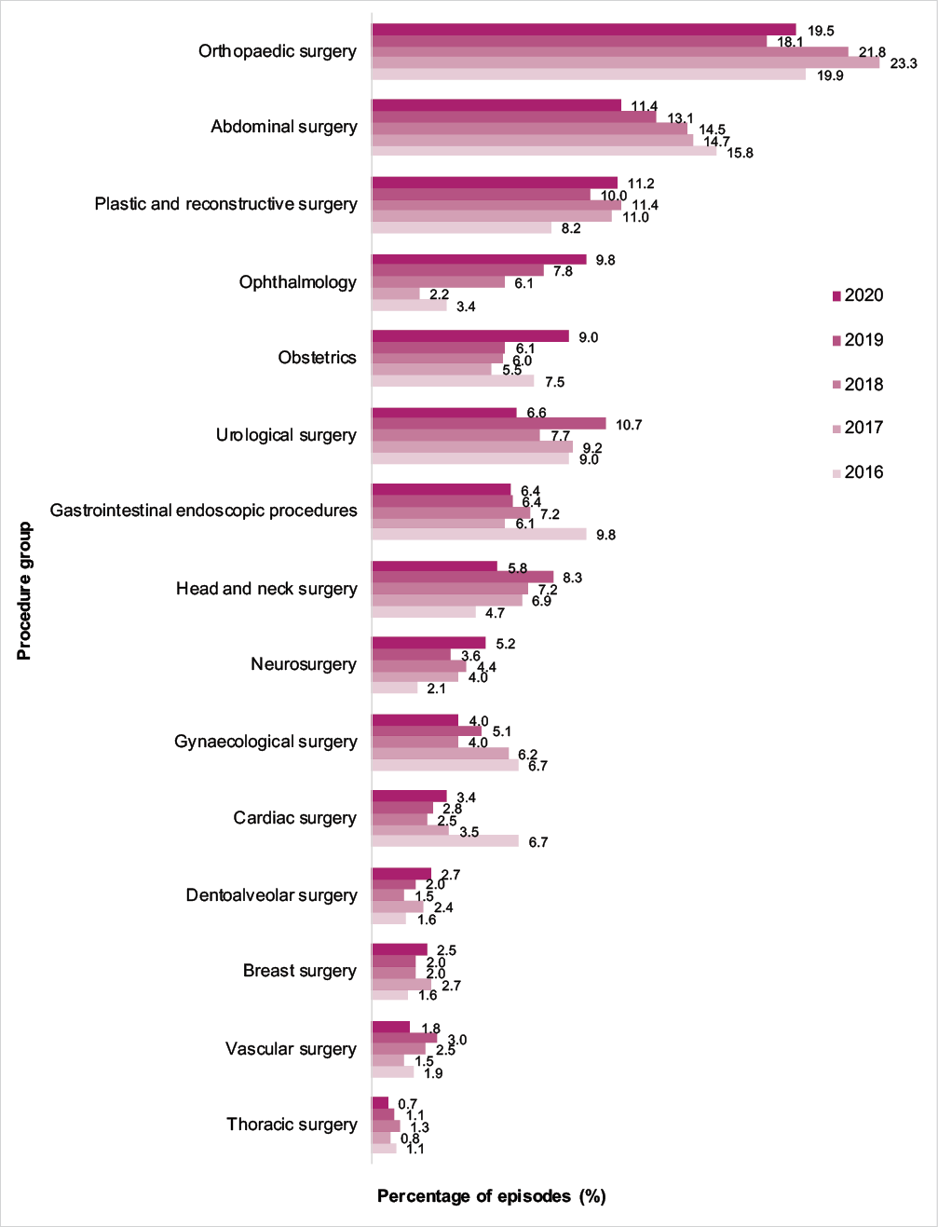

Note: Where there were multiple procedures per surgical episode, only the primary procedure group was included.

* n=7,935 surgical episodes in 2020.

## Compliance with guidelines and appropriateness

### Procedural prescribing

For episodes, including when procedural antimicrobials were and were not prescribed, both compliance with guidelines and appropriateness increased by 8.5% and 7.6% respectively from 2016 to 2020 (Figure A5.2). When antimicrobials were prescribed, both compliance with guidelines and appropriateness for procedural doses improved by approximately 15% (Figure A5.3).

##### Figure A5.2: Percentage of surgical episodes by compliance with guidelines, when available*, and appropriateness, when assessable†, for procedural prescribing, Surgical NAPS contributor facilities, 2016–2020

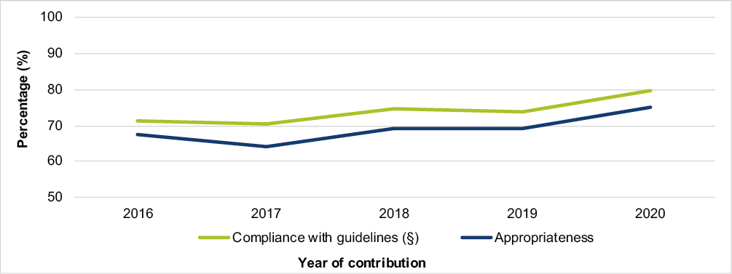

* n=7,474 episodes in 2020, excluding ‘directed therapy’, ‘no guidelines available’ and ‘not assessable’ options for compliance with guidelines.

† n=7,574 episodes in 2020, excluding ‘not assessable’ option for appropriateness.

§ Includes ‘compliant with Therapeutic Guidelines’ and ‘compliant with local guidelines’. Antibiotic Expert Group. Therapeutic Guidelines: Antibiotic (version 16). Melbourne: Therapeutic Guidelines Limited; 2019. <https://www.tg.org.au/>

##### Figure A5.3: Percentage of antimicrobial doses by compliance with guidelines, when available*, and appropriateness, when assessable†, for procedural prescribing, Surgical NAPS contributor facilities, 2016–2020

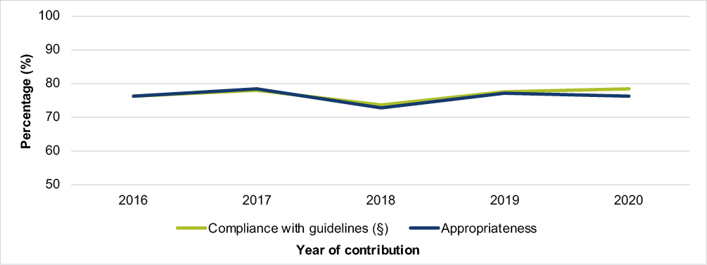

* n=6,514 antimicrobial doses in 2020, excluding ‘directed therapy’, ‘no guidelines available’ and ‘not assessable’ options for compliance with guidelines.

† n=6,622 antimicrobial doses in 2020, excluding ‘not assessable’ option for appropriateness.

§ Includes ‘compliant with Therapeutic Guidelines’ and ‘compliant with local guidelines’. Antibiotic Expert Group. Therapeutic Guidelines: Antibiotic (version 16). Melbourne: Therapeutic Guidelines Limited; 2019. <https://www.tg.org.au/>

### Post-procedural prescribing

For surgical episodes, including when post-procedural antimicrobials were and were not prescribed, there has been no discernible change in compliance with guidelines and appropriateness from 2016 to 2020 (Figure A5.4). When antimicrobials were prescribed, both compliance with guidelines and appropriateness for post-procedural doses improved significantly in 2020 compared to 2016 to 2019 (Figure A5.5).

##### Figure A5.4: Percentage of surgical episodes by compliance with guidelines, when available*, and appropriateness, when assessable†, for post-procedural prescribing, Surgical NAPS contributor facilities, 2016–2020

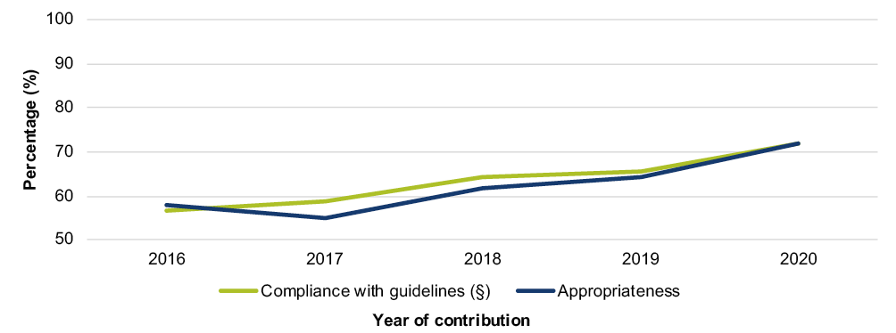

* n=6,789 episodes in 2020, excluding ‘directed therapy’, ‘no guidelines available’ and ‘not assessable’ options for compliance with guidelines.

† n=6,831episodes in 2020, excluding ‘not assessable’ option for appropriateness.

§ Includes ‘compliant with Therapeutic Guidelines’ and ‘compliant with local guidelines’. Antibiotic Expert Group. Therapeutic Guidelines: Antibiotic (version 16). Melbourne: Therapeutic Guidelines Limited; 2019. <https://www.tg.org.au/>

##### Figure A5.5: Percentage of antimicrobial prescriptions by compliance with guidelines, when available*, and appropriateness, when assessable†, for post-procedural prescribing, Surgical NAPS contributor facilities, 2016–2020

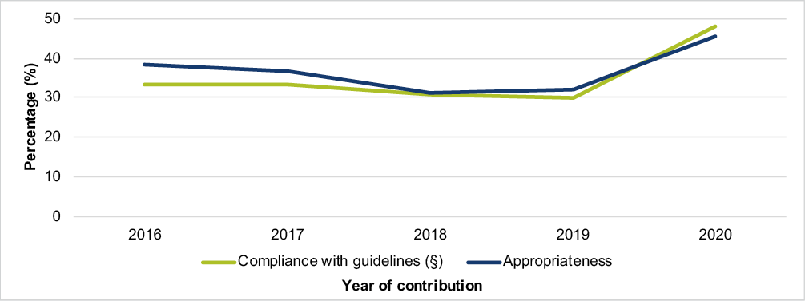

* n=3,365 antimicrobial prescriptions in 2020, excluding ‘directed therapy’, ‘no guidelines available’ and ‘not assessable’ options for compliance with guidelines.

† n=3,419 antimicrobial prescriptions in 2020, excluding ‘not assessable’ option for appropriateness.

§ Includes ‘compliant with Therapeutic Guidelines’ and ‘compliant with local guidelines’. Antibiotic Expert Group. Therapeutic Guidelines: Antibiotic (version 16). Melbourne: Therapeutic Guidelines Limited; 2019. <https://www.tg.org.au/>

## Reasons for inappropriateness

The percentage of antimicrobials not required when prescribed for procedural doses increased approximately 15% from 2016 to 2020, while post-procedural prescriptions decreased by approximately 10% over the same period (Figure A5.6).

##### Figure A5.6: Percentage of antimicrobials deemed not required for procedural doses* and post-procedural prescriptions†, Surgical NAPS contributor facilities, 2016–2020

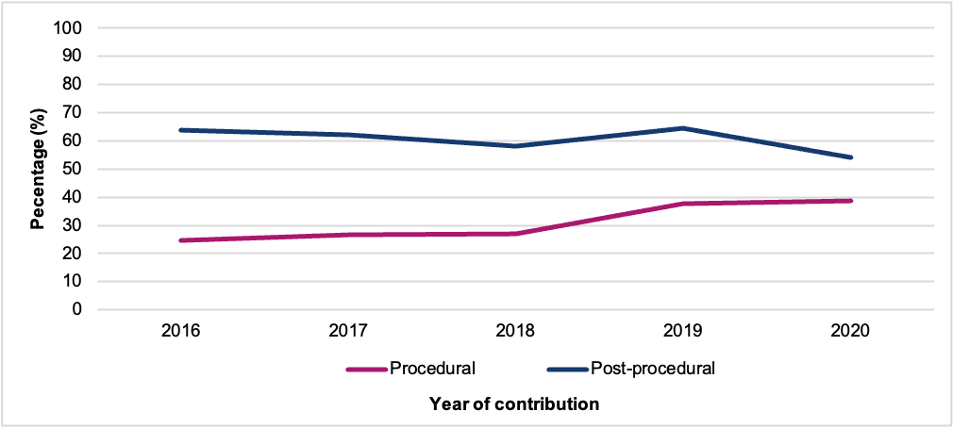

* n=1,873 antimicrobial doses in 2020.

† n=1,869 antimicrobial prescriptions in 2020.

The reasons for deeming procedural antimicrobials inappropriate have changed over time, although incorrect timing has remained the most common reason for inappropriate prescribing when an antimicrobial is required. There was a decrease of almost 10% in incorrect procedural dose from 2016 to 2020. There were also recent increases in ‘spectrum too broad’ and ‘spectrum too narrow’ (Figure A5.7).

The reasons for deeming post-procedural antimicrobials inappropriate when required have not changed discernibly over time (Figure A5.8). The exception is the incorrect duration of therapy, for which there was an approximate 15% increase from 2019 to 2020.

##### Figure A5.7: Reasons for inappropriateness, by percentage of required procedural antimicrobial doses*, Surgical NAPS contributor facilities, 2016–2020

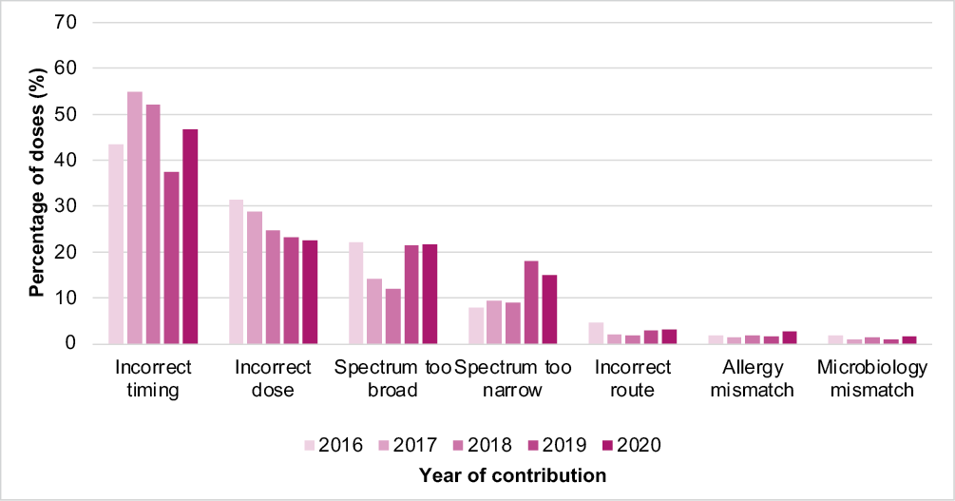

* n=1,149 antimicrobial doses in 2020.

##### Figure A5.8: Reasons for inappropriateness, by percentage of required post-procedural antimicrobial prescriptions*, Surgical NAPS contributor facilities, 2016–2020

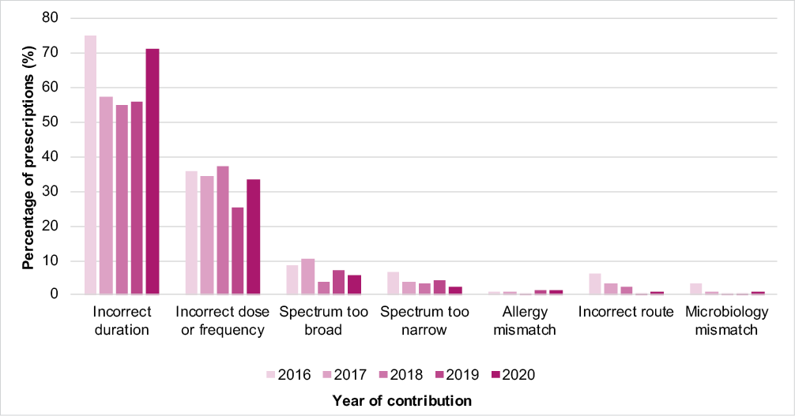

* n=865 antimicrobial prescriptions in 2020.

# Appendix 6: Procedure groups

The procedures listed in the Surgical NAPS database have been adopted from the Royal Australasian College of Surgeons Morbidity Audit and Logbook Tool.7

The surgical procedure groups listed are:

* Abdominal surgery
  + anorectal
  + bariatric and other
  + biliary
  + colorectal
  + gastro-oesophageal
  + hepatic
  + pancreas and duodenum
* Breast surgery
* Cardiac surgery
* Dentoalveolar surgery
* Gastrointestinal endoscopic procedures
* Gynaecological surgery
* Head and neck surgery
  + laryngology
  + otology
  + rhinology
* Neurosurgery
  + cerebrovascular
  + peripheral nerve
  + spinal
  + other
* Obstetrics
* Ophthalmology
* Orthopaedic surgery
* Plastic and reconstructive surgery
* Thoracic surgery
* Urological surgery
  + endoscopic procedures
  + laparoscopic procedures
  + open procedures
  + other
* Vascular surgery
  + dialysis access

Appendix 7: Data collection form

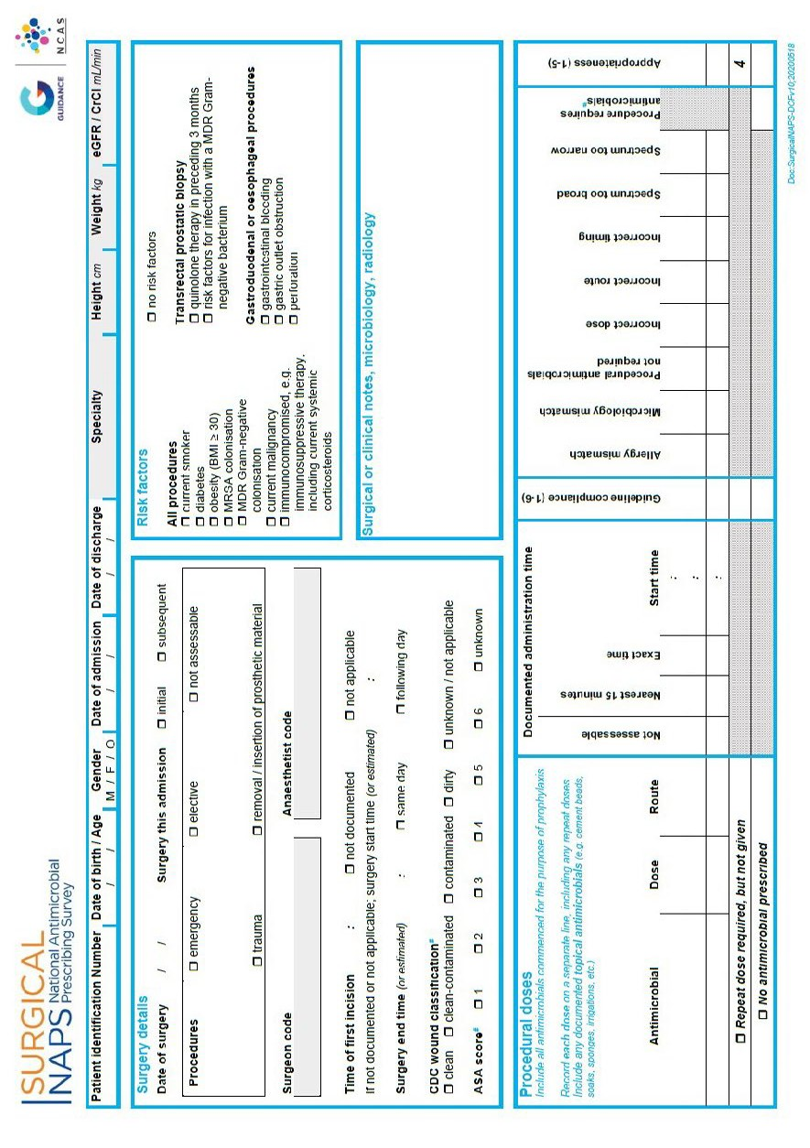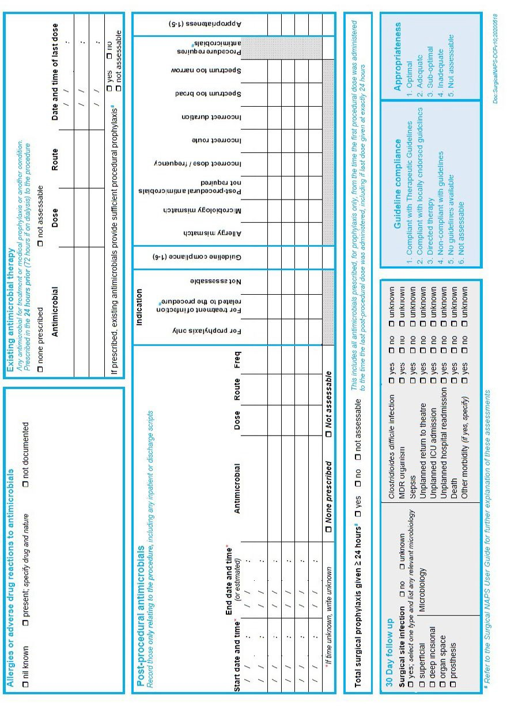

Appendix 8: Appropriateness definitions

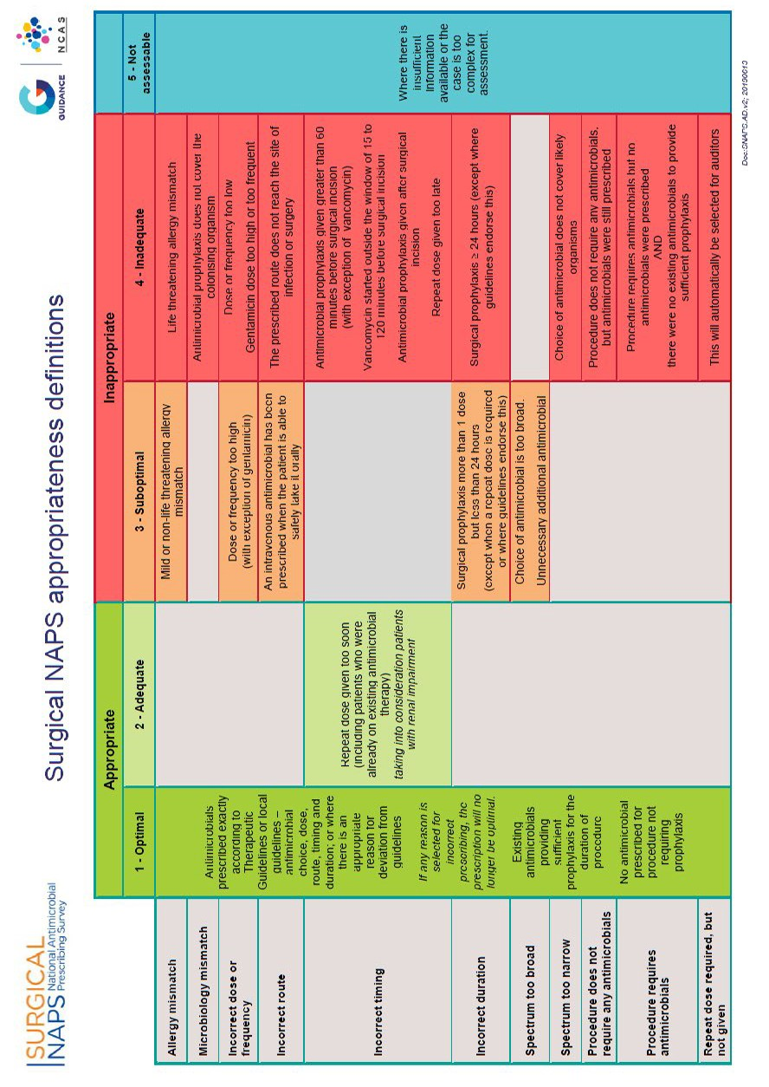

# Appendix 9: Glossary

|  |  |
| --- | --- |
| **Term** | **Definition** |
| Adequate prescribing | A prescription that is deemed **adequate** by the Surgical NAPS appropriateness definitions; see Appendix 8. |
| Appropriate prescribing | A prescription that is deemed **appropriate** (optimal or adequate) by the Surgical NAPS appropriateness definitions; see Appendix 8. |
| Directed therapy | There are microbiology culture and susceptibility results available to guide prophylaxis or treatment. |
| Dose | An individual antimicrobial dose administered either immediately prior to or during the surgical procedure. |
| Elective surgery | Surgery that can be booked in advance as a result of a specialist clinical assessment, resulting in placement on an elective surgery waiting list. |
| Emergency surgery | Surgery to treat trauma or acute illness subsequent to an emergency presentation, including unplanned surgery for admitted patients and unplanned surgery for patients already awaiting an elective surgery. |
| Episode | An individual procedure or a set of procedures performed together during one surgical session, and the subsequent post-procedural care associated with the procedure(s). |
| Episode where no prophylaxis prescribed | Any episode where all prescribed antimicrobials are recorded as for ‘treatment’ and/or ‘not assessable’. |
| Existing antimicrobial therapy | Any antimicrobial prescribed for treatment or prophylaxis in the 24 hours prior (72 hours if on dialysis) to the procedure; these are not analysed individually but can be considered when assessing the appropriateness of whether procedural antimicrobials were given or not given. |
| Inadequate prescribing | A prescription that is deemed **inadequate** by the Surgical NAPS appropriateness definitions; see Appendix 8. |
| Inappropriate prescribing | A prescription that is deemed **inappropriate** (suboptimal or inadequate) by the Surgical NAPS appropriateness definitions; see Appendix 8. |
| Initial dose | The first dose of an antimicrobial administered either immediately prior to or during the surgical procedure for the purpose of prophylaxis. |
| Local guidelines | Local guidelines must be authorised and readily available on wards or on the hospital intranet; exceptions include paediatric and neonatal guidelines from an Australian children’s hospital and links to other official guidelines within a facility’s network. |
| Not assessable prescribing | A prescription that is deemed **not assessable** by the Surgical NAPS appropriateness definitions; see Appendix 8. |
| Optimal prescribing | A prescription that is deemed **optimal** by the Surgical NAPS appropriateness definitions; see Appendix 8. |
| Peer group | A hospital peer group supports comparisons that reflect the purpose, resources and role of each hospital and is defined by the type and nature of the services provided. It is based on data from a broad range of sources, intended to be multipurpose, and stable over time. |
| Post-procedural antimicrobial | An antimicrobial prescribed following, but directly relating to, the procedure; each prescription of the antimicrobial is recorded, including any inpatient or discharge scripts. |
| Post-procedural antimicrobial prophylaxis | All antimicrobials prescribed following, but directly relating to, the procedure for the purposes of prophylaxis; each prescription course of the antimicrobial is recorded and reported, including any inpatient or discharge scripts. |
| Prescription | Any antimicrobial prescribed, either as a single dose or as a course, following the surgical procedure. |

|  |  |
| --- | --- |
| **Term** | **Definition** |
| Procedural antimicrobial | An antimicrobial administered either immediately prior to or during the surgical procedure for the purpose of prophylaxis; each initial and repeat dose of the antimicrobial administered is recorded individually. |
| Procedural antimicrobial prophylaxis | All antimicrobials administered either immediately prior to or during the surgical procedure for the purpose of prophylaxis; each dose of the antimicrobial administered is recorded and reported individually. |
| Procedure | The procedure(s) performed during the surgical episode, as documented on the procedure form or in the medical record; any procedure can be included, e.g. colonoscopies, radiological procedures. |
| Procedure group | The specialty group under which each procedure is classed for reporting; see Appendix 6. |
| Prophylaxis | An antimicrobial prescribed for the prevention of surgery-related infections. |
| Remoteness classification | The Australian Statistical Geographical Classification – Remoteness Area was developed in 2011 by the Australian Bureau of Statistics as a statistical geography that allows quantitative comparisons based on remoteness of a point based on the physical road distance to the nearest urban centre. |
| Repeat dose | Any subsequent dose of an antimicrobial administered during the surgical procedure for the purpose of prophylaxis. |
| Suboptimal prescribing | A prescription that is deemed **suboptimal** by the Surgical NAPS appropriateness definitions; see Appendix 8. |
| Surgical episode | Any individual procedure or set of procedures performed together during one session and the subsequent post-procedural care associated with the procedure(s). |
| Therapeutic Guidelines | Antibiotic Expert Group. Therapeutic Guidelines: Antibiotic (version 16). Melbourne: Therapeutic Guidelines Limited; 2019. <https://www.tg.org.au/> |
| Treatment | An antimicrobial prescribed for the treatment of infection related to the procedure. |

# Appendix 10: Abbreviations

|  |  |
| --- | --- |
| **Abbreviation** | **Definition** |
| ACSQHC | Australian Commission on Safety and Quality in Health Care |
| AIHW | Australian Institute of Health and Welfare |
| AURA | Antimicrobial Use and Resistance in Australia |
| NAPS | National Antimicrobial Prescribing Survey |
| NCAS | National Centre for Antimicrobial Stewardship |
| Surgical NAPS | Surgical National Antimicrobial Prescribing Survey |

# References

1. Australian Commission on Safety and Quality in Health Care. National Safety and Quality Health Service Standards. 2nd ed. Sydney: ACSQHC; 2017.
2. National Centre for Antimicrobial Stewardship and Australian Commission on Safety and Quality in Health Care. Surgical National Antimicrobial Prescribing Survey: Results of the 2016 pilot. Sydney: ACSQHC; 2017.
3. National Centre for Antimicrobial Stewardship. Surgical prophylaxis prescribing in Australian hospitals: Results of the 2017 and 2018 Surgical National Antimicrobial Prescribing Surveys. Public report. Melbourne: NCAS; 2019.
4. Australian Institute of Health and Welfare. Elective surgery activity. Canberra: AIHW; 2022. Available from: <https://www.aihw.gov.au/reports-data/myhospitals/intersection/activity/eswt>.
5. National Centre for Antimicrobial Stewardship and Australian Commission on Safety and Quality in Health Care. Surgical prophylaxis prescribing in Australian hospitals: Results of the 2019 Surgical National Antimicrobial Prescribing Survey. Sydney: ACSQHC; 2020.
6. Australian Institute of Health and Welfare. Australian hospital peer groups. Health services series no.66. Cat. no. HSE 170. Canberra: AIHW; 2015.
7. Australian Bureau of Statistics. 1270.0.55.005 – Australian Statistical Geography Standard (ASGS): Volume 5 – remoteness structure, July 2016. Canberra: ABS; 2018.
8. Antibiotic Expert Group. Therapeutic Guidelines: Antibiotic (version 16). Melbourne: Therapeutic Guidelines Limited; 2019. <https://www.tg.org.au/>.
9. Australian Commission on Safety and Quality in Health Care. Advisory no: A17/01. Antimicrobial stewardship. Sydney: ACSQHC; 2017.
10. National Centre for Antimicrobial Stewardship. Clinical fact sheets. Melbourne: NCAS; 2020. Available from: <https://www.ncas-australia.org/Education>
11. Australian Commission on Safety and Quality in Health Care. Cataract Clinical Care Standard. Sydney: ACSQHC; 2019.
12. National Centre for Antimicrobial Stewardship. Timing and duration of surgical prophylaxis: Recommendations 2020 [Internet]. Melbourne: NCAS; 2020. Available from: [https://www.ncas-](https://www.ncas-australia.org/timing-and-duration-of-surgical-prophylaxis) [australia.org/timing-and-duration-of-surgical-prophylaxis](https://www.ncas-australia.org/timing-and-duration-of-surgical-prophylaxis).
13. de Jonge SW, Boldingh QJ, Solomkin JS, Dellinger EP, Egger M, Salanti G, Allegranzi B, Boermeester MA. Effect of postoperative continuation of antibiotic prophylaxis on the incidence of surgical site infection: a systematic review and meta-analysis. *Lancet Infect Dis*. 2020; 20(10): 1182-92.
14. Allegranzi B, Zayed B, Bischoff P, Kubilay NZ, de Jonge S, de Vries F, et al. New WHO recommendations on intraoperative and postoperative measures for surgical site infection prevention: an evidence-based global perspective. *Lancet Infect Dis*. 2016; 16(12): e288-e303.
15. Berríos-Torres SI, Umscheid CA, Bratzler DW, Leas B, Stone EC, Kelz RR, et al. Centers for Disease Control and Prevention guideline for the prevention of surgical site infection, 2017. *JAMA Surg*. 2017; 152(8): 784-91
16. Royal Australasian College of Surgeons. Morbidity Audit and Logbook Tool. Available at: <https://www.surgeons.org/research-audit/morbidity-audits/morbidity-audit-and-logbook-tool>. [Accessed 2015].

# Acknowledgements

##### National Centre for Antimicrobial Stewardship and the Guidance Group

Professor Karin Thursky – Director NCAS A/Professor Kirsty Buising – Deputy Director NCAS

Dr Rodney James – Director of Clinical Services Guidance Group Ms Robyn Ingram – NAPS Program Manager

Ms Xin Fang – NAPS Project Officer

Dr Courtney Ierano – NAPS Project Officer

Ms Renukadevi Padhmanaban – Director of Technical Services Guidance Group Mr Jegadeesh Sakthivel – Software developer Guidance Group

Mr Logesh Palani – Software developer Guidance Group

## Contributing facilities

On behalf of the NCAS, we would like to thank all contributing facilities and auditors for their time and effort in collecting and entering the data and in contributing to the AURA Surveillance System report, and for their continued commitment to improving safety and quality across the Australian healthcare system.

DT0002451 January 2023



All information in this publication is correct as at January 2023

##### amr.gov.au

Surgical prophylaxis prescribing in Australian hospitals 2020 **56**