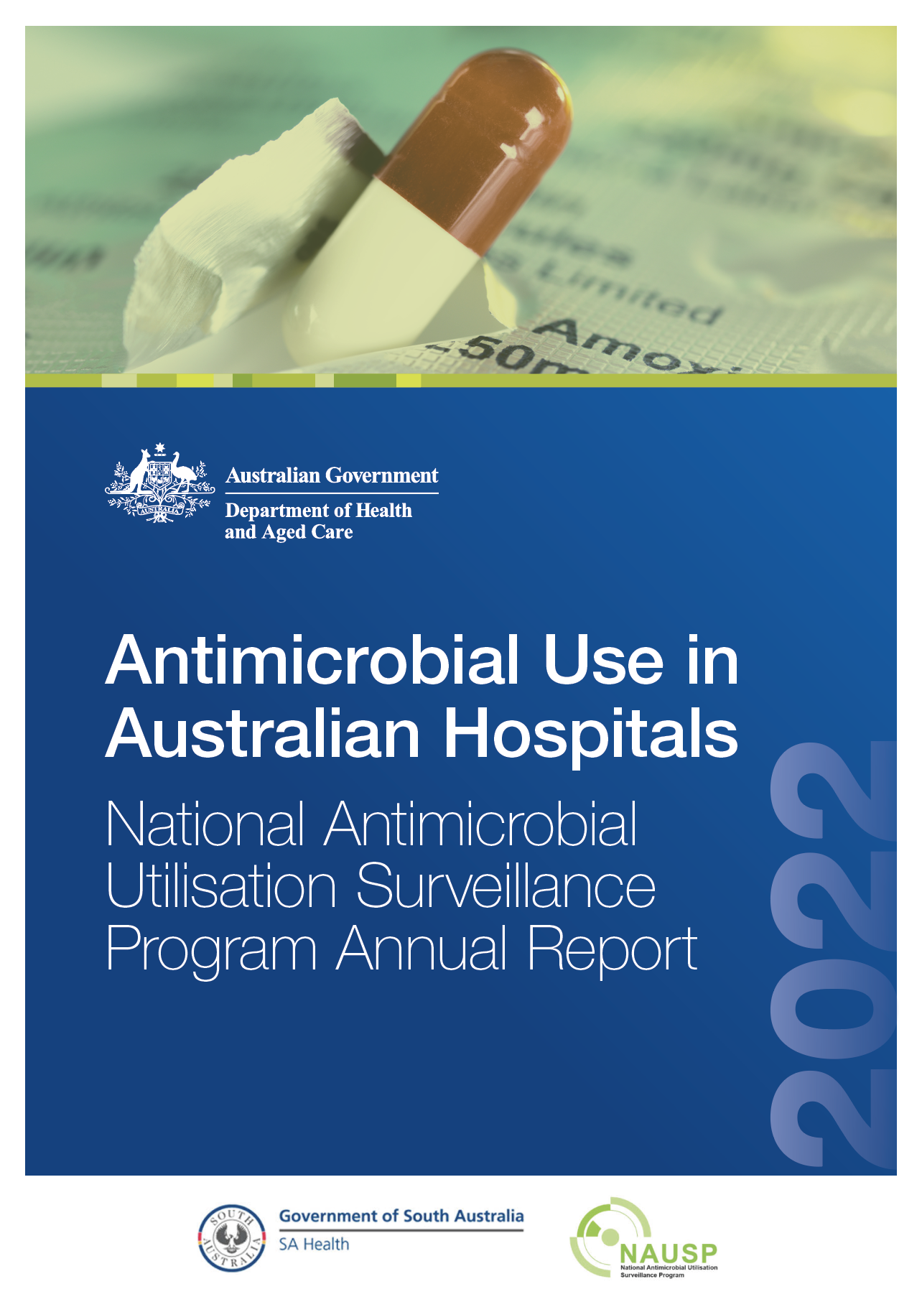
Published by the Australian Government Department of Health and Aged Care
For issues regarding the content of the report:
Email: NAUSPhelp@sa.gov.au
Website: www.sahealth.sa.gov.au/nausp
ISBN: 978-1-74186-102-0
© Australian Government Department of Health and Aged Care 2024
All material and work produced by the Department of Health and Aged Care is protected by copyright. The Department reserves the right to set out the terms and conditions for the use of such material.
Enquiries about the licence and any use of this publication are welcome and can be sent to AMR@health.gov.au
Preferred citation
SA Health. National Antimicrobial Utilisation Surveillance Program: 2022 Annual Report. Canberra: Department of Health and Aged Care; 2024.
Disclaimer
This document is not intended to provide guidance on particular healthcare choices. You should contact your healthcare provider for advice pertaining to individual circumstances.
This document includes the views or recommendations of its authors and third parties. SA Health and the Australian Government Department of Health and Aged Care do not accept any legal liability for any injury, loss or damage incurred by the use of, or reliance on, this document.

Table of contents

Summary 6
Implications for antimicrobial stewardship 6
What action should be taken? 7
Introduction 8
Changes to reporting methodology in 2021 11
Annual usage rates for all antibacterial classes 12
Antibacterial usage rates by state and territory 14
Emergency department antibacterial usage 17
Antibacterial usage in the operating theatre 22
Glycopeptide use in the theatre and recovery setting 25
Priority Antibacterial List 27
Usage by Priority Antibacterial List category – by state and territory, 2018–2022 28
Usage by Priority Antibacterial List category – critical care versus non-critical care 30
Usage by Priority Antibacterial List category – public versus private hospitals 33
Longitudinal antibacterial usage rates 35
Usage rates for high-volume oral antibacterials, 2018–2022 35
Usage rates for intravenous broad-spectrum antibacterials, 2018–2022 38
Usage rates for reserve-line antibacterials 44
Antifungal usage rates 48
National antifungal usage rates 48
Antifungal use in Australian hospitals by state and territory 50
Hospital antifungal use by specialty setting or location 51
Topical antimicrobials 54
High-volume topical antimicrobials 54
Hospital in the Home 57
Surveillance pilot projects in other settings 60
Residential aged care facilities 60
Hospital outpatients / discharge settings 60
Prison and correctional facilities 60
Discussion and conclusions 61
Appendix 1: Contributors 63
Appendix 2: Methods 70
Data elements 70
Data quality 70
Measurement of consumption rates 70
Appendix 3: Limitations 72
Appendix 4: Antimicrobial agents – World Health Organization Anatomical
Therapeutic Classification for antimicrobial agents included in NAUSP analyses 73
Appendix 5: Antibacterials included in the Priority Antibacterial List, according
to the Access, Curb and Contain classification 79
Appendix 6: Glossary 80
References 82
Acknowledgements 85

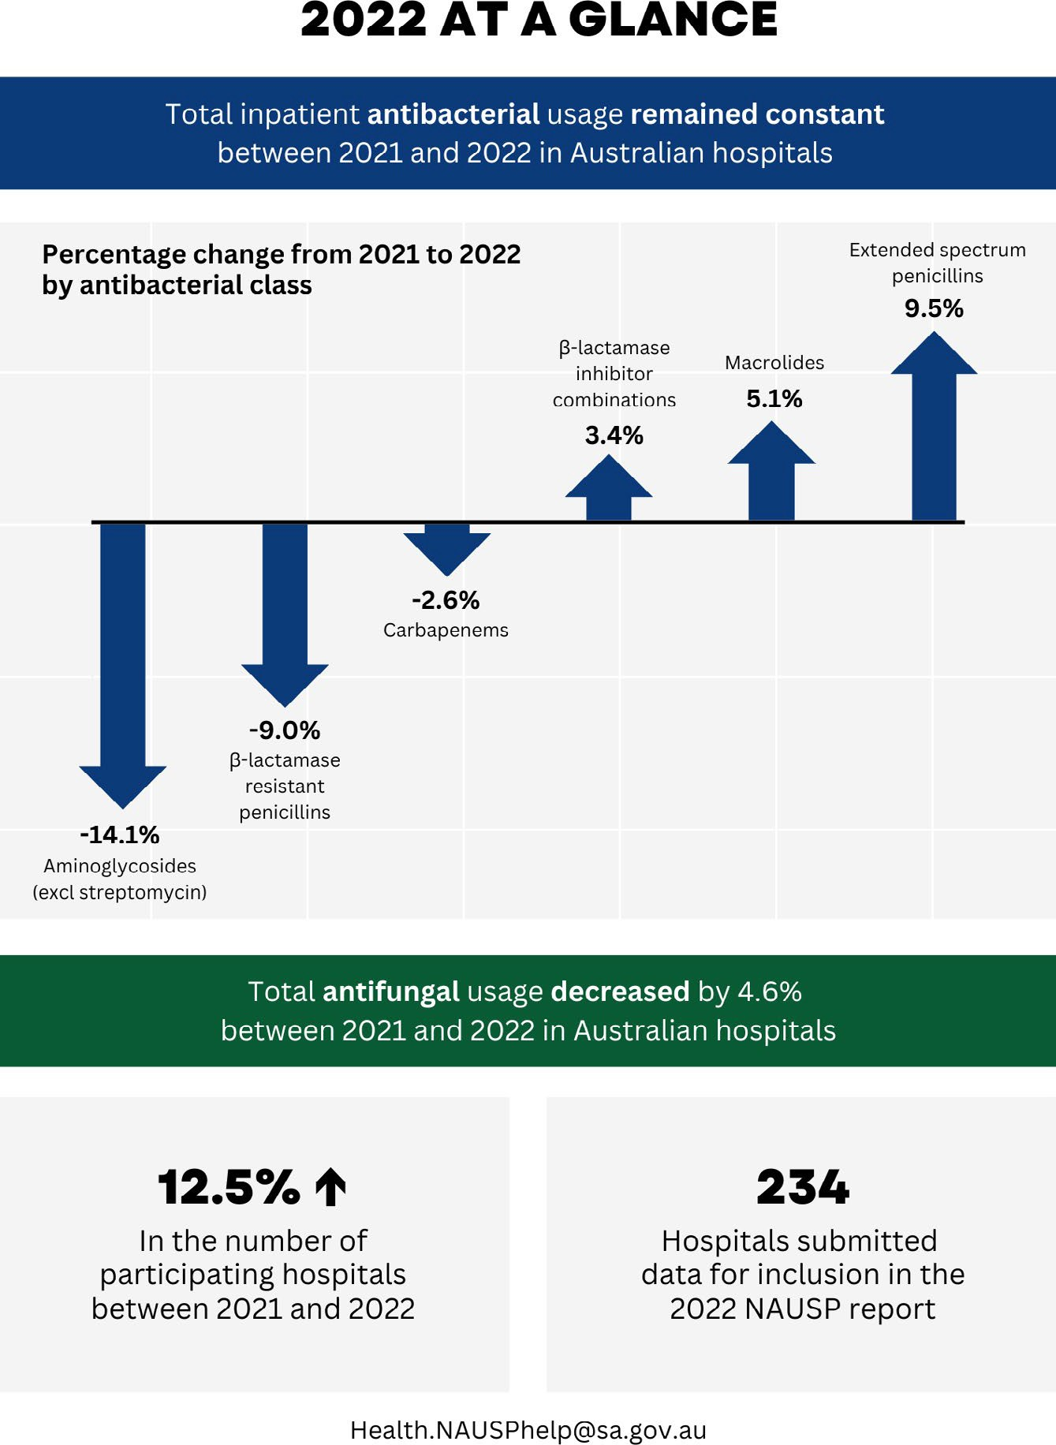

Summary
This 2022 annual report of the National Antimicrobial Utilisation Surveillance Program (NAUSP) presents a summary of analyses of antimicrobial usage data submitted by participating public and private hospitals across all Australian states and territories. Longitudinal trends for antibacterial and antifungal usage are provided for the 5-year period 2018 to 2022.
Key findings of the analyses of the 2022 NAUSP data include:
- There was no substantial difference in the acute inpatient antibacterial usage rate, outside of the emergency department and operating theatre, in NAUSP contributor hospitals between 2021 and 2022.
- On a defined daily dose (DDD) per 1,000 occupied bed days (OBD) basis, the antibacterial class with the highest usage rate in 2022 was ß-lactamase inhibitor combinations, which includes amoxicillin – clavulanic acid and piperacillin–tazobactam. The second highest acute usage rate outside of the emergency department and operating theatre, by antibacterial class, was the first- generation cephalosporins. Cefalexin and cefazolin are the 2 main first-generation cephalosporins.
- Nationally, there were substantial decreases in the acute inpatient usage rates for the aminoglycosides, metronidazole and the ß-lactamase resistant penicillins (flucloxacillin and dicloxacillin) between 2021 and 2022. Usage of these antimicrobial classes fell by 14.1%, 12.3% and 9.0% respectively.
- In contrast, the usage rate for extended-spectrum penicillins (amoxicillin and ampicillin) increased by 9.5% in NAUSP contributor hospitals.
- Use of reserved, last-line antimicrobials such as colistin, daptomycin and linezolid remains low, with the average monthly usage rates in 2022 being 0.19, 3.1 and 1.0 DDD/1,000 OBD respectively. The average monthly usage rate for pristinamycin, a broad-spectrum, last-line oral antibacterial, was 0.44 DDD/1,000 OBD in 2022.
- The annual systemic antifungal usage rate increased annually between 2019 and 2021; however, between 2021 and 2022, an overall decrease of 4.6% was observed in NAUSP contributor hospitals.

Implications for antimicrobial stewardship
Findings from NAUSP data help to strengthen antimicrobial stewardship (AMS) programs by increasing awareness of prescribing and usage patterns, providing data for education of prescribers and enabling targeted quality improvement and monitoring of performance over time.
Previous NAUSP reports have highlighted a period of increasing antibacterial usage between 2016 and 2019 in contributing hospitals, with a small decrease reported between 2019 and 2020 coinciding with the onset of the COVID-19 pandemic.1,2 This reported period of increasing annual usage was also a period where more private facilities with high proportionate rates of day surgery were enrolling in the program. A limitation of NAUSP methodology whereby dispensing data is used as a surrogate measure for actual inpatient antimicrobial consumption is that usage in day patients is difficult to identify. The changes implemented to NAUSP methodology from January 2021 – where usage in the emergency department and operating theatre are reported separately from other acute inpatient usage – has allowed a more accurate estimate of acute inpatient usage rates. Analysis of aggregate usage rates shows that the overall inpatient usage rate has not changed between 2021 and 2022. However, for some antibacterials, there remains substantial variation in the usage rates between jurisdictions and between contributing sites, indicating considerable variation in clinical practice. The substantial variation in clinical practice seen between the states and territories has been highlighted in previous reports.1-4 States and territories can, and should, utilise this information to investigate appropriateness of prescribing and support local AMS teams to implement interventions to improve practice where required.
In 2022, the annual systemic aggregate antifungal usage rate fell to 4.6% following 3 years of consecutive increasing usage. Antifungal stewardship efforts are increasing in Australia and have been bolstered by the 2021 publication of updated consensus guidelines for the use of antifungal agents in the haematology and oncology settings.5

What action should be taken?
Volume-based surveillance of antimicrobial use in Australian hospitals provides an understanding of usage over time and allows early identification of concerning trends in usage at a jurisdictional or facility level. Monitoring usage data over time can highlight settings or changes in use where appropriateness of prescribing should be assessed and identifies areas for future investigation or further research.
At a facility level, NAUSP data should ideally be interpreted in conjunction with qualitative data obtained from the National Antimicrobial Prescribing Survey, which assesses appropriateness of usage. The application of user-driven, web-based analytic tools to enable real-time data visualisations should be explored to investigate the impact on engagement by prescribers and antimicrobial stewards. Investment in decision support tools for prescribers at the point of care may assist in improving antimicrobial choice as well as duration of treatment.
The proposed One Health surveillance system for antimicrobial resistance and antimicrobial use would offer an opportunity for further research on possible associations between antimicrobial consumption and development of resistance. While NAUSP currently provides an estimate of antimicrobial usage in various inpatient settings, gaps remain in the hospital sector where usage is not readily captured. Pilot projects investigating and monitoring usage in hospital outpatient or discharge settings, as well as in correctional services and prisons, are currently being undertaken by NAUSP. These projects will enable quantification of estimated usage not captured in existing surveillance structures. Outcomes of these pilot programs will enable consideration of the feasibility and utility of capturing these data as part of the One Health surveillance of antimicrobial use in Australia.
In order to optimise the use of surveillance data to inform stewardship, at a jurisdictional level there needs to be sufficient and guaranteed ongoing resourcing to implement targeted strategies. Health service organisations accredited to the National Safety and Quality Health Service Standards are required to meet the AMS actions of those standards (Actions 3.18 and 3.19).6 State and territory governments should encourage health service organisations within their jurisdictions to review their NAUSP results against those of their peers on a regular basis and disseminate findings to prescribers in an easy to interpret format.

Introduction
The National Antimicrobial Utilisation Surveillance Program (NAUSP) is funded by the Australian Government Department of Health and Aged Care. It was established in 2004 in response to recommendations arising from the Joint Expert Technical Advisory Committee on Antimicrobial Resistance report.7 Surveillance of antimicrobial use was identified in the report as an essential mechanism to monitor the effectiveness of policies and other interventions to rationalise antimicrobial use. Australia’s National Antimicrobial Resistance Strategy – 2020 and Beyond also recognises the importance of real-time surveillance of usage across all sectors as a key tool to support stewardship and prioritise action and resources to minimise the risk of antimicrobial resistance (AMR).8
Since 2014, NAUSP has been a collaborative partner of the Antimicrobial Use and Resistance in Australia (AURA) surveillance program, playing a pivotal role in supporting antimicrobial stewardship (AMS) and informing local, state, territory and national policy to contain AMR. Participation in NAUSP is voluntary; however, hospitals are encouraged to contribute in order to meet the AMS requirements of the National Safety and Quality Health Service Standards.6
NAUSP aims to collect, collate and report ongoing, nationally representative data on antimicrobial usage in adult acute care Australian hospitals to:
- provide contributing hospitals with timely access to standardised usage rates and benchmarking reports to enable examination and identification of prescribing trends to inform local interventions
- examine trends in inpatient hospital use at a jurisdictional and national level to inform large-scale interventions to optimise hospital antimicrobial prescribing
- provide an Australian peer group benchmark to enable comparisons with international data
- support AMS programs with a validated method of monitoring the outcomes of specific interventions to rationalise use.
The number of hospitals registered to participate in NAUSP continues to increase, particularly from the private sector (Figure 1). Since January 2021, rehabilitation and day surgical sites have been eligible
to participate in NAUSP to monitor their usage over time, with their usage data categorised to the corresponding NAUSP capture area. (For example, day surgery centres will only submit and report to ‘theatre and recovery’.) Subacute usage rates, however, are not included in the aggregated inpatient usage rates in this report.
Not all hospitals registered with NAUSP have consistently provided data for the duration of their participation in the program, and others may have participated intermittently depending upon local resourcing. Hospitals that did not contribute at least 6 months’ data in 2022 have been excluded from the analyses in this 2022 annual report. A complete list of the 234 hospitals that contributed data for this report is provided in Appendix 1.

Figure 1: Number of hospitals or healthcare facilities registered to participate in the National Antimicrobial Utilisation Surveillance Program, 2008–2022

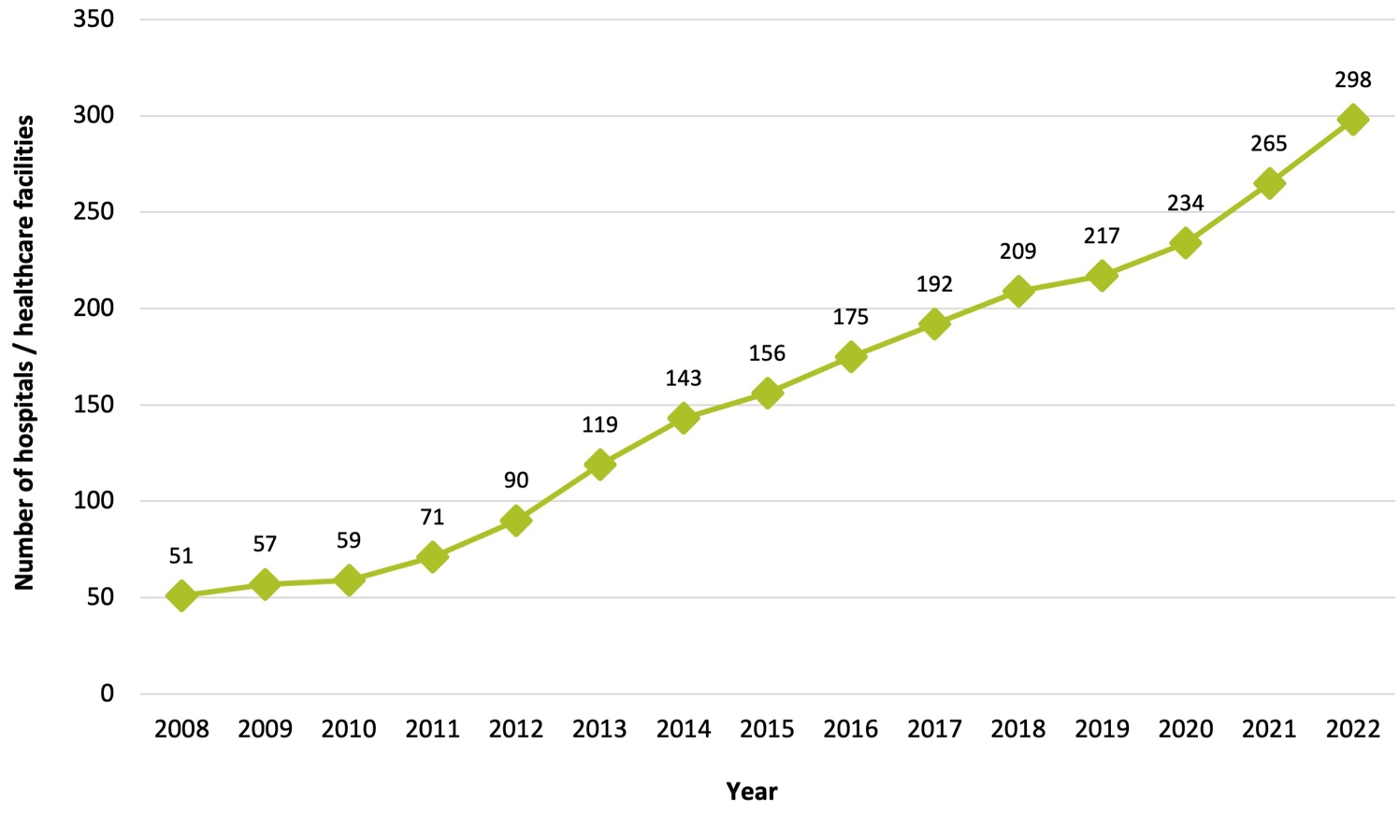

Note: Not all hospitals registered to participate have provided validated data consistently for the duration of their registration with the program. Participant numbers in this chart do not reflect the number of sites included in this report.

Table 1 shows the number of hospitals or healthcare facilities as classified by their Australian Institute of Health and Welfare (AIHW) peer group (see Glossary (Appendix 6) for a description of AIHW peer groups) by state or territory. Note that contributing hospitals assigned to each AIHW peer group may vary from previous NAUSP reports due to the restructure of health services or changes in the acuity of patients treated resulting in reclassification by the AIHW. In addition, some sites have not yet been reclassified but have had sufficient changes to meet the definition of another peer group. Where NAUSP has been notified of these changes, data from those contributors have been analysed in accordance with meeting a new AIHW definition.
Due to low numbers of hospitals participating in NAUSP from the 2 Australian territories, they have been grouped with larger states for the purposes of this report. For usage rates reported at a jurisdictional level, hospitals in the Northern Territory (NT) have been grouped with Queensland; and hospitals in the Australian Capital Territory (ACT) have been grouped with New South Wales (NSW).

Table 1: Hospitals or healthcare facilities registered to participate in the National Antimicrobial Utilisation Surveillance Program by state or territory, 2022
Hospital AIHW peer group | NSW and ACT* | Qld and NT* | SA | Tasmania | Victoria | WA
Principal referral | 12 | 7 | 2 | 1 | 6 | 3
Public Acute Group A | 21 | 13 | 3 | 2 | 15 | 5
Private Acute Group A | 2 | 8 | 2 | 1 | 3 | 1
Public Acute Group B | 16 | 7 | 4 | 1 | 7 | 4
Private Acute Group B | 9 | 4 | 4 | 0 | 2 | 2
Public Acute Group C | 29 | 9 | 10 | 0 | 3 | 14
Private Acute Group C | 6 | 5 | 1 | 1 | 3 | 2
Public Acute Group D | 4 | 1 | 6 | 0 | 1 | 1
Private Acute Group D | 2 | 2 | 2 | 0 | 0 | 0
Women’s / Combined women’s and children’s | 0 | 1 | 1 | 0 | 1 | 1
Very small hospitals | 0 | 0 | 2 | 0 | 0 | 0
Unpeered hospitals | 1 | 1 | 0 | 0 | 2 | 1
Public rehabilitation hospitals | 4 | 0 | 1 | 0 | 1 | 0
Other acute specialised hospitals | 1 | 0 | 0 | 0 | 2 | 0
Mixed subacute/non-acute hospitals | 0 | 1 | 0 | 0 | 2 | 0
Mixed day procedure hospitals | 0 | 1 | 0 | 0 | 1 | 0
Public psychiatric hospitals | 3 | 0 | 0 | 0 | 0 | 0
Private acute psychiatric hospitals | 0 | 0 | 0 | 0 | 1 | 0
Total | 110 | 60 | 38 | 6 | 50 | 34
* Due to small numbers of hospitals participating in NAUSP in the 2 Australian territories, they have been grouped with larger states for the purposes of this report. For usage rates reported at a jurisdictional level, hospitals in the Northern Territory have been grouped with Queensland; and hospitals in the Australian Capital Territory have been grouped with New South Wales.
Note: Not all hospitals registered to participate have provided validated data consistently for the duration of their registration with the program. Therefore, participant numbers in this table do not reflect the number of sites contributing data to this report.
ACT = Australian Capital Territory; AIHW = Australian Institute of Health and Welfare; NSW = New South Wales;
NT = Northern Territory; SA = South Australia; Qld = Queensland; WA = Western Australia.

Changes to reporting methodology in 2021
Standardised usage density rates, based on the World Health Organization’s (WHO) Anatomical Therapeutic Chemical (ATC) standards for ‘defined daily dose’ (DDD) are used for the analysis in this report. For inpatient settings outside of the emergency department (ED) and operating theatre, the denominator is the internationally accepted metric of inpatient ‘occupied bed days’ (OBD).
From January 2021, the analysis of antimicrobial usage in the ED and the operating theatre was stratified from antimicrobial use in other acute inpatient settings. New denominators were introduced to calculate antimicrobial usage rates in these settings where OBD was not an accurate measure of hospital activity. Figure 2 illustrates NAUSP data stratification for reporting purposes from January 2021.

Figure 2: NAUSP data stratification for reporting purposes
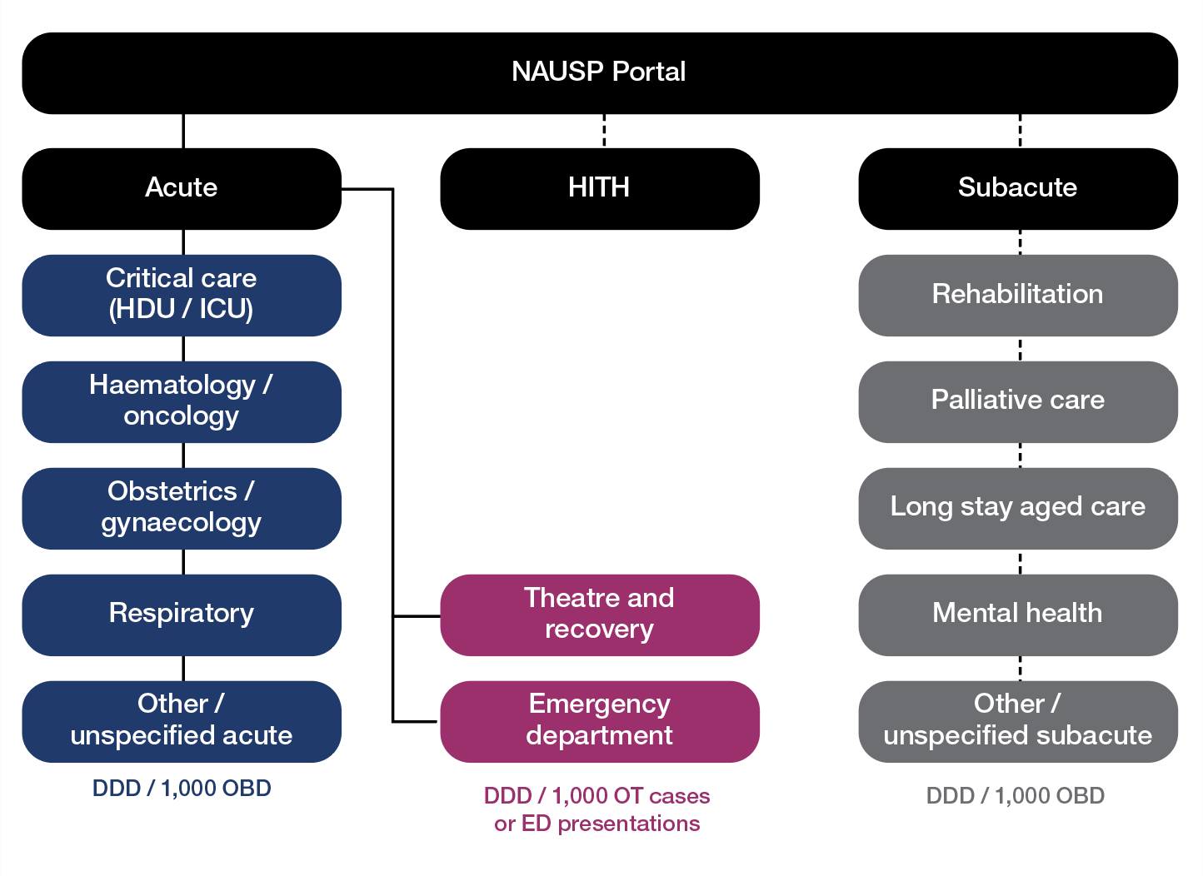
Note: Solid line represents compulsory data inclusions by NAUSP contributors and Dashed line represents voluntary data inclusions.
DDD = defined daily dose; ED = emergency department; HDU/ICU = high dependency unit / intensive care unit;
HITH = Hospital in the Home; NAUSP = National Antimicrobial Utilisation Surveillance Program; OBD = occupied bed days; OT = operating theatre.

This report is intended to give jurisdictions and healthcare professionals an overview of inpatient antimicrobial use by NAUSP contributors for the period January 2018 to December 2022. Further details on the methodology utilised for this report can be found in Appendix 2, and limitations are described in Appendix 3.

Annual usage rates for all
antibacterial classes
Hospitals or other eligible healthcare facilities have been included in the national aggregated antibacterial usage rates in this report if they contributed at least 6 months of validated data during 2022, are able to stratify their data if they have an ED or operating theatre, and are not solely rehabilitation sites.
Table 2 provides the annual aggregated inpatient usage rates for all antibacterial classes reported by NAUSP contributor hospitals from 2018 to 2022. The total aggregate inpatient usage rate remained constant between 2021 and 2022 at 745.1 DDD/1,000 OBD; however, there were substantial changes in the national usage rates for some antibacterial classes.

Table 2: Annual inpatient systemic antibacterial usage rates (DDD/1,000 OBD) by class in NAUP contributor hospitals, 2018–2022
Antibacterial class | 2018 n=189 | 2019 n=200 | 2020 n=211 | 2021 n=228 | 2022 n=234 | %  change 2021 to  2022
Alimentary antibiotics | 9.4 | 12.6 | 16.0 | 18.0 | 18.4 | 2.5%
Aminoglycosides (excl. streptomycin) | 31.7 | 29.0 | 28.7 | 12.4 | 10.7 | -14.1%
ß-lactamase inhibitor combinations | 128.2 | 133.2 | 131.5 | 129.1 | 133.6 | 3.4%
ß-lactamase resistant penicillins | 97.0 | 92.6 | 88.8 | 78.1 | 71.1 | -9.0%
ß-lactamase sensitive penicillins | 33.6 | 29.8 | 26.5 | 25.2 | 24.4 | -3.2%
Carbapenems | 14.5 | 14.8 | 15.3 | 16.0 | 15.6 | -2.6%
Extended-spectrum penicillins | 52.8 | 58.3 | 54.0 | 50.3 | 55.1 | 9.5%
First-generation cephalosporins | 155.0 | 161.9 | 168.5 | 115.2 | 112.8 | -2.0%
Fluoroquinolones | 29.4 | 27.5 | 26.6 | 25.1 | 24.6 | -2.1%
Fourth-generation cephalosporins | 5.9 | 4.5 | 4.9 | 5.8 | 5.6 | -3.7%
Glycopeptides | 26.3 | 25.9 | 25.4 | 23.4 | 21.5 | -8.1%
Metronidazole | 37.3 | 33.0 | 32.5 | 26.5 | 23.2 | -12.3%
Lincosamides | 13.5 | 13.1 | 13.5 | 11.6 | 11.2 | -3.1%
Macrolides | 52.6 | 52.3 | 43.9 | 36.0 | 37.8 | 5.1%
Sulfonamide–trimethoprim | 18.3 | 19.2 | 19.4 | 19.5 | 20.1 | 2.9%
Tetracyclines | 78.9 | 89.0 | 70.1 | 60.8 | 64.4 | 5.9%
Third-generation cephalosporins | 61.6 | 62.0 | 61.9 | 54.0 | 55.7 | 3.2%
Trimethoprim | 13.0 | 12.2 | 12.1 | 9.4 | 9.5 | 1.3%
Other* | 22.8 | 27.9 | 27.4 | 28.7 | 29.8 | 3.7%
Grand total | 882.1 | 898.8 | 866.9 | 745.1 | 745.1 | 0.0%
* ‘Other’: combination products for the eradication of Helicobacter pylori, cefiderocol, ceftaroline, ceftolozane–tazobactam, cycloserine, daptomycin, faropenem, fosfomycin, linezolid, monobactams, nitrofurans, polymyxins, rifabutin, rifampicin, sodium fusidate, streptogramins and tedizolid.
Note: Shaded area includes data from operating theatre and emergency departments. From January 2021, usage in operating theatres and emergency departments is reported separately.
DDD = defined daily dose; NAUSP = National Antimicrobial Utilisation Surveillance Program; OBD = occupied bed days.

There were notable decreases in the annual inpatient usage rates for aminoglycosides and for metronidazole between 2021 and 2022 (Figure 3). The aminoglycoside usage rate fell 14.1%, from
12.4 DDD/1,000 OBD in 2021 to 10.7 DDD/1,000 OBD in 2022; and the metronidazole usage rate fell 12.3% from 26.5 DDD/1,000 OBD in 2021 to 23.2 DDD/1,000 OBD in 2022. The annual aggregated inpatient usage of ß-lactamase resistant penicillins (flucloxacillin and dicloxacillin) also decreased substantially, falling 9.0% from 78.1 DDD/1,000 OBD in 2021 to 71.1 DDD/1,000 OBD in 2022.

Figure 3: Annual inpatient systemic antibacterial usage rates (DDD/1,000 OBD) by class in NAUSP contributor hospitals, 2018–2022

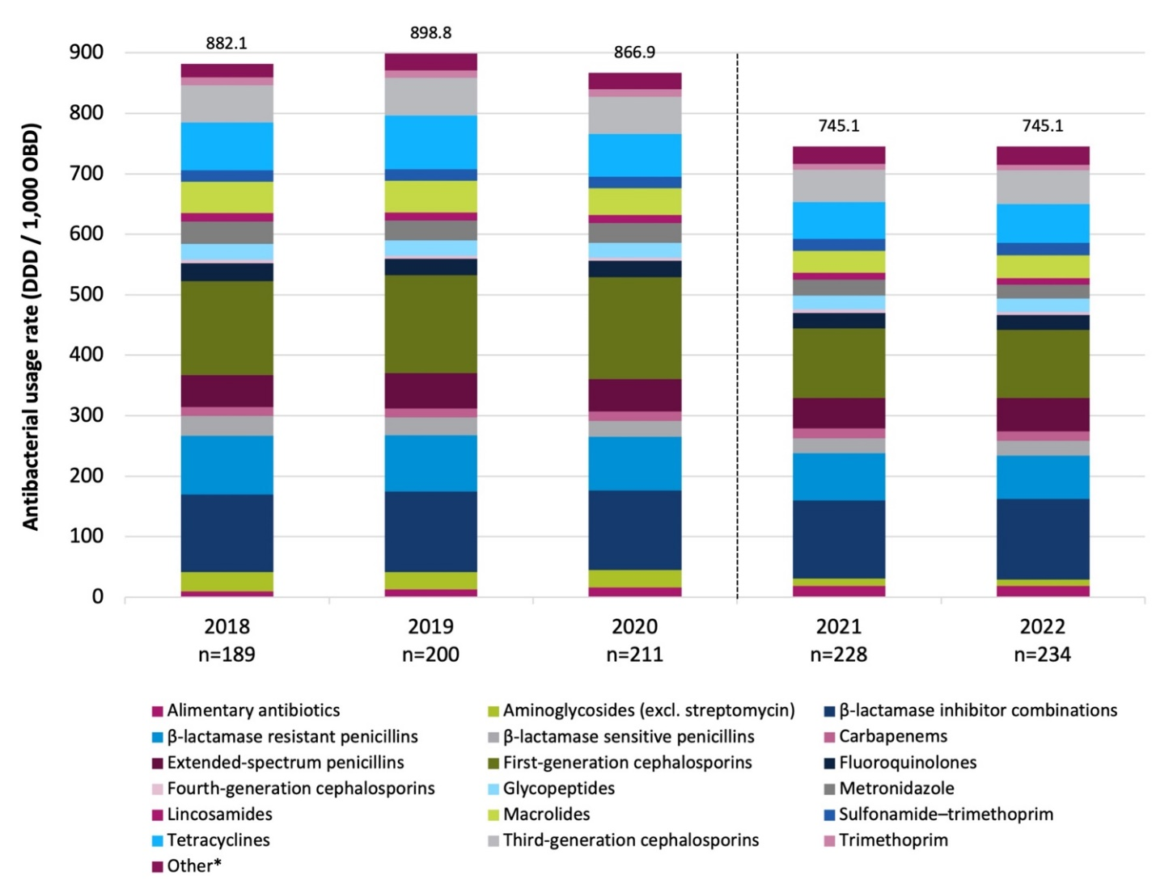

* ‘Other’: combination products for the eradication of H. pylori, cefiderocol, ceftaroline, ceftolozane–tazobactam, cycloserine, daptomycin, faropenem, fosfomycin, linezolid, monobactams, nitrofurans, polymyxins, rifabutin, rifampicin, sodium fusidate, streptogramins and tedizolid.
Note: Dashed line denotes exclusion of emergency department and operating theatre usage rates from acute inpatient usage rates.
DDD = defined daily dose; NAUSP = National Antimicrobial Utilisation Surveillance Program; OBD = occupied bed days.

Note that 2021 and 2022 aggregate rates do not include usage from EDs or operating theatres. From January 2021, usage rates in these 2 settings have been reported separately relative to presentations or cases. This represents a ‘reset’ of the NAUSP dataset and, for this reason, comparisons should not be made between aggregate rates (both national and jurisdictional) published prior to, and post, the 2021 program updates. Further information on NAUSP methodology can be found in Appendix 2.
The antibacterial class where the greatest increase in annual usage was seen was the extended- spectrum penicillins – amoxicillin and ampicillin. The inpatient rate for this antibacterial class increased 9.5%, from 50.3 DDD/1,000 OBD in 2021 to 55.1 DDD/1,000 OBD in 2022. Tetracycline (predominantly doxycycline) and macrolide use also increased by 5.9% and 5.1% respectively between 2021 and 2022.

Antibacterial usage rates by state and territory
Figure 4 illustrates aggregated annual inpatient antibacterial usage rates for NAUSP contributor hospitals nationally, and by Australian state and territory, for 2021 and 2022.

Figure 4: Aggregate inpatient antibacterial usage rates (DDD/1,000 OBD) by class in NAUSP contributor hospitals, by state and territory, 2021–2022
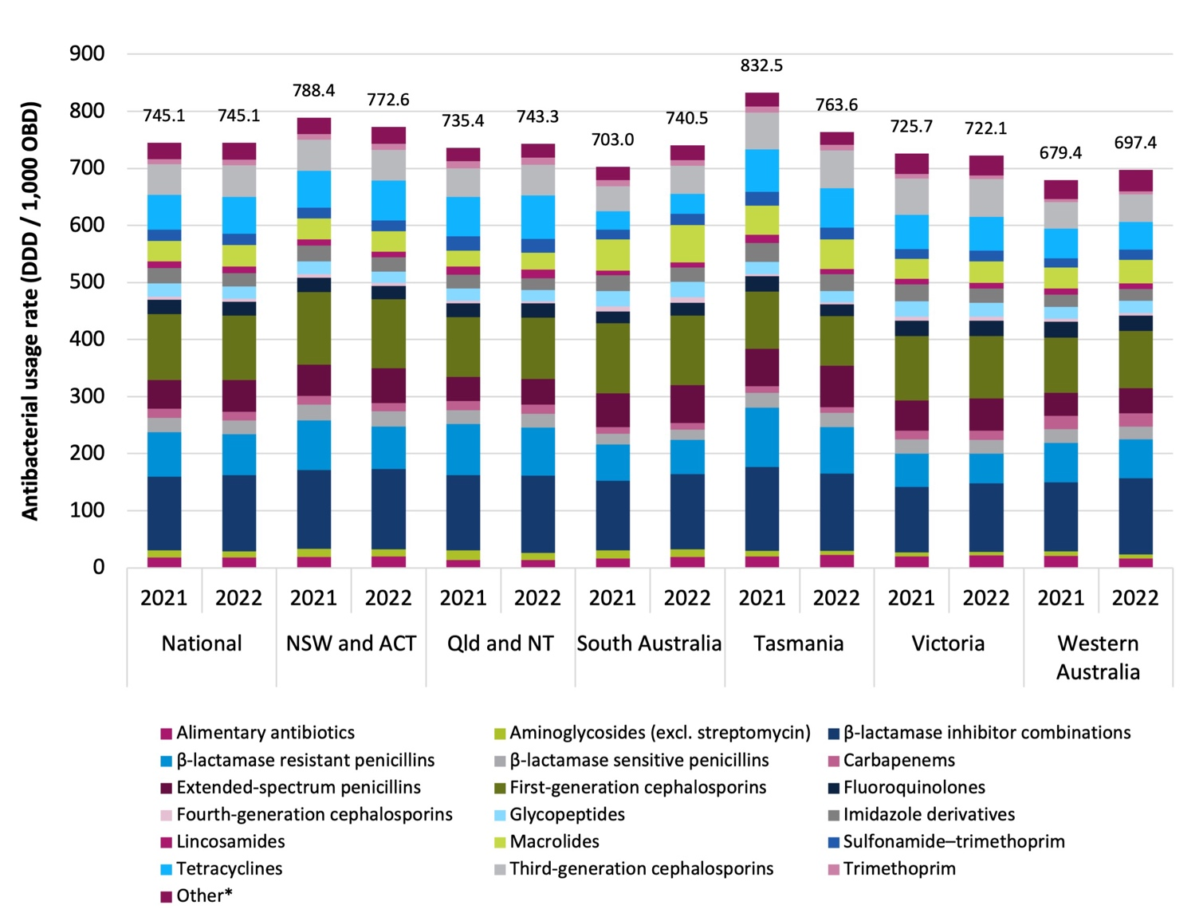

* ‘Other’: combination products for the eradication of H. pylori, cefiderocol, ceftaroline, ceftolozane–tazobactam, cycloserine, daptomycin, faropenem, fosfomycin, linezolid, monobactams, nitrofurans, polymyxins, rifabutin, rifampicin, sodium fusidate, streptogramins and tedizolid.
ACT = Australian Capital Territory; DDD = defined daily dose; NAUSP = National Antimicrobial Utilisation Surveillance Program; NSW = New South Wales; NT = Northern Territory; OBD = occupied bed days; Qld = Queensland.

Despite there being no observed change in the national total aggregated inpatient usage rate between 2021 and 2022, some states and territories showed a marked change in usage rates. The greatest rate increase was seen in South Australia, with a 5.3% rise from 703.0 DDD/1,000 OBD in 2021 to 740.5 DDD/1,000 OBD in 2022. NSW/ACT had the highest inpatient antibacterial usage rate in 2022 (772.6 DDD/1,000 OBD) which is 4.0% higher than the national aggregate usage rate of 745.1 DDD/1,000 OBD. Tasmania had the highest aggregate inpatient usage rate in 2021; however, an
8.3% decrease in antibacterial usage was observed in 2022 (832.5 DDD/1,000 OBD to 763.6 DDD/1,000 OBD).

Table 3 shows aggregate inpatient usage rates for all states and territories, by antibacterial class, for 2021 and 2022. During this period the following was observed:
- Aminoglycoside use fell in all states and territories, with the greatest decrease seen in Queensland/NT, where usage fell 26.0%, from 16.9 DDD/1,000 OBD in 2021 to 12.5 DDD/1,000 OBD in 2022. Tasmania saw a similar decrease of 23.9%, from 10.1 DDD/1,000 OBD in 2021 to 7.7 DDD/1,000 OBD in 2022.
- The annual inpatient usage of ß-lactamase inhibitor combinations (amoxicillin – clavulanic acid and piperacillin–tazobactam) increased by 10.2% and 8.1% in Western Australia and South Australia respectively. The actual usage rate for these broad-spectrum antimicrobials, however, is highest in NSW/ACT; in 2022 the annual aggregate inpatient usage rate was 140.1 DDD/1,000 OBD, representing an increase of 1.2% from 2021.
- Inpatient usage of ß-lactamase resistant penicillins (flucloxacillin and dicloxacillin) decreased in all states and territories in 2022. The largest decrease was seen in Tasmania, where a drop of 21.7% was observed (from 103.7 DDD/1,000 OBD in 2021 to 81.2 DDD/1,000 OBD in 2022). Large decreases were also seen in NSW/ACT and Victoria, where the annual usage rate fell 13.2% and 9.6% respectively.
- Carbapenem usage increased by 7.2% in South Australia (10.9 DDD/1,000 OBD in 2021 to
11.7 DDD/1,000 OBD in 2022). Carbapenem usage remains highest in Western Australia, where the annual aggregate usage rate for NAUSP contributor hospitals was 23.1 DDD/1,000 OBD. This was 46% higher than the national aggregate rate of 15.6 DDD/1,000 OBD in 2022.
- Usage rates for extended-spectrum penicillins (amoxicillin and ampicillin) increased across all states and territories between 2021 and 2022. The largest increase was observed in South Australia, with a 12.1% rise (59.4 DDD/1,000 OBD in 2021 to 66.6 DDD/1,000 OBD in 2022).
- Despite a slight decline in fluoroquinolone inpatient use nationally between 2021 and 2022, increased statewide aggregate usage rates were seen in 4 states and territories. South Australia had the largest increase in usage – up 7.8% to 22.6 DDD/1,000 OBD. Queensland/NT, Victoria and Western Australia reported smaller increases in 2022 of 2.4%, 1.0 % and 0.1% respectively.
- Glycopeptide usage fell in all states and territories except Western Australia, where an increase of 4.2% from 20.6 DDD/1,000 OBD to 21.4 DDD/1,000 OBD was observed. South Australian rates did not change between 2021 and 2022.
- Inpatient macrolide usage is highest in South Australia: the 2022 aggregate usage rate was
65.3 DDD/1,000 OBD, representing an increase of 19.8% from 2021. The annual usage rate in South Australia is 72.8% higher than the national aggregate usage rate of 37.8 DDD/1,000 OBD.

Table 3: Aggregated inpatient antibacterial usage rates (DDD/1,000 OBD) by class in NAUSP contributor hospitals, by state and territory, 2021–2022

Antibacterial class | National |  | NSW and ACT |  | Qld and NT |  | SA |  | Tas |  | Vic |  | WA
 | 2021 | 2022 | 2021 | 2022 | 2021 | 2022 | 2021 | 2022 | 2021 | 2022 | 2021 | 2022 | 2021 | 2022
Alimentary antibiotics | 18.0 | 18.4 | 19.2 | 20.0 | 13.3 | 13.8 | 16.0 | 18.6 | 19.8 | 22.1 | 20.3 | 21.9 | 20.9 | 16.4
Aminoglycosides (excl. streptomycin) | 12.4 | 10.7 | 13.9 | 12.5 | 16.9 | 12.5 | 14.7 | 13.8 | 10.1 | 7.7 | 6.5 | 6.0 | 7.9 | 7.2
ß-lactamase inhibitor combinations | 129.1 | 133.6 | 138.5 | 140.1 | 131.9 | 135.5 | 121.6 | 131.4 | 146.8 | 135.2 | 115.3 | 119.8 | 121.0 | 133.4
ß-lactamase resistant penicillins | 78.1 | 71.1 | 86.6 | 75.1 | 89.6 | 84.1 | 63.8 | 60.1 | 103.7 | 81.2 | 58.1 | 52.5 | 69.0 | 67.8
ß-lactamase sensitive penicillins | 25.2 | 24.4 | 27.8 | 26.7 | 24.1 | 24.1 | 19.3 | 17.9 | 26.5 | 25.7 | 25.0 | 23.9 | 23.9 | 22.8
Carbapenems | 16.0 | 15.6 | 15.2 | 14.0 | 16.4 | 16.4 | 10.9 | 11.7 | 11.0 | 9.6 | 15.3 | 15.8 | 23.6 | 23.1
Extended-spectrum penicillins | 50.3 | 55.1 | 54.7 | 60.8 | 42.1 | 44.7 | 59.4 | 66.6 | 66.0 | 72.7 | 52.7 | 57.0 | 40.0 | 43.8
First-generation cephalosporins | 115.2 | 112.8 | 127.6 | 121.8 | 105.4 | 107.5 | 122.4 | 121.7 | 99.9 | 86.9 | 113.2 | 109.1 | 97.4 | 100.2
Fluoroquinolones | 25.1 | 24.6 | 24.6 | 22.7 | 24.2 | 24.8 | 21.0 | 22.6 | 27.5 | 20.4 | 27.0 | 27.3 | 27.6 | 27.7
Fourth-generation cephalosporins | 5.8 | 5.6 | 6.2 | 5.6 | 4.0 | 4.0 | 9.3 | 9.9 | 3.0 | 4.0 | 6.7 | 6.6 | 4.9 | 4.5
Glycopeptides | 23.4 | 21.5 | 22.6 | 20.0 | 21.8 | 19.8 | 27.1 | 27.1 | 21.8 | 19.3 | 26.8 | 24.3 | 20.6 | 21.4
Imidazole derivatives | 26.5 | 23.2 | 27.4 | 24.4 | 23.9 | 20.3 | 27.7 | 24.7 | 33.4 | 29.1 | 29.5 | 25.0 | 21.7 | 20.7
Lincosamides | 11.6 | 11.2 | 11.5 | 10.2 | 14.6 | 15.0 | 7.9 | 9.0 | 14.5 | 9.8 | 10.1 | 10.1 | 10.4 | 9.8
Macrolides | 36.0 | 37.8 | 36.5 | 35.7 | 27.3 | 29.7 | 54.5 | 65.3 | 50.7 | 51.2 | 35.3 | 37.7 | 37.0 | 40.5
Sulfonamide–trimethoprim | 19.5 | 20.1 | 19.0 | 18.8 | 25.1 | 24.3 | 16.8 | 19.7 | 24.2 | 21.3 | 16.6 | 18.4 | 16.0 | 18.2
Tetracyclines | 60.8 | 64.4 | 64.5 | 70.0 | 69.1 | 75.9 | 32.8 | 34.6 | 74.6 | 68.6 | 60.0 | 59.9 | 51.9 | 48.3
Third-generation cephalosporins | 54.0 | 55.7 | 54.7 | 54.1 | 50.7 | 54.2 | 43.3 | 49.6 | 63.9 | 66.1 | 64.0 | 65.5 | 47.0 | 48.6
Trimethoprim | 9.4 | 9.5 | 9.7 | 10.0 | 12.0 | 12.3 | 11.4 | 10.2 | 10.7 | 10.4 | 7.4 | 7.0 | 5.1 | 5.7
Other* | 0.0 | 0.0 | 0.0 | 0.0 | 0.0 | 0.0 | 0.0 | 0.0 | 0.0 | 0.0 | 0.0 | 0.0 | 0.0 | 0.0
Grand total | 745.1 | 745.1 | 788.4 | 772.6 | 735.4 | 743.3 | 703.0 | 740.5 | 832.5 | 763.6 | 725.7 | 722.1 | 679.4 | 697.4
* ‘Other’: combination products for the eradication of H. pylori, cefiderocol, ceftaroline, ceftolozane–tazobactam, cycloserine, daptomycin, faropenem, fosfomycin, linezolid, monobactams, nitrofurans, polymyxins, rifabutin, rifampicin, sodium fusidate, streptogramins and tedizolid.
Note: Usage rates exclude usage in the emergency department and operating theatre.
ACT = Australian Capital Territory; DDD = defined daily dose; NAUSP = National Antimicrobial Utilisation Surveillance Program; NSW = New South Wales; NT = Northern Territory;
OBD = occupied bed days; Qld = Queensland; SA = South Australia; Tas = Tasmania; Vic = Victoria; WA = Western Australia.

National Antimicrobial Utilisation Surveillance Program Annual Report 2022 16

Emergency department antibacterial usage
In 2022, 189 hospitals or healthcare facilities contributed stratified ED antibacterial usage data to NAUSP. The national aggregate rate in the ED in 2022 was 208.1 DDD/1,000 ED presentations. This is a 13.1% increase from 184.0 DDD/1,000 presentations in 2021. Of note, the classes showing the greatest increase from 2021 are macrolides (up 24.2% to 21.0 DDD/1,000 presentations), third-generation cephalosporins (up 22.2% to 26.8 DDD/1,000 presentations) and tetracyclines (up 21.0% to 23.3 DDD/1,000 presentations). Table 4 shows the aggregated annual usage rates for 2021 and 2022 and the percentage change for all antibacterial classes.
Table 4: Annual aggregated emergency department antibacterial usage rate (DDD/1,000 ED presentations) by class in NAUSP contributor hospitals, 2021–2022
Antibacterial class | National |  | % change 2021 to 2022#
 | 2021 | 2022
Alimentary antibiotics | 1.0 | 1.3 | 34.2%
Aminoglycosides (excl. streptomycin) | 20.0 | 20.4 | 1.7%
ß-lactamase inhibitor combinations | 20.9 | 24.1 | 15.1%
ß-lactamase resistant penicillins | 18.8 | 20.0 | 6.0%
ß-lactamase sensitive penicillins | 6.0 | 6.9 | 15.0%
Carbapenems | 0.5 | 0.6 | 23.8%
Extended-spectrum penicillins | 13.4 | 14.6 | 9.0%
First-generation cephalosporins | 24.9 | 26.2 | 5.3%
Fluoroquinolones | 2.5 | 3.2 | 24.0%
Fourth-generation cephalosporins | 0.3 | 0.3 | 33.2%
Glycopeptides | 2.3 | 2.6 | 12.7%
Metronidazole | 5.4 | 5.5 | 0.7%
Lincosamides | 1.8 | 2.1 | 11.7%
Macrolides | 16.9 | 21.0 | 24.2%
Sulfonamide–trimethoprim | 2.0 | 2.5 | 20.9%
Tetracyclines | 19.2 | 23.3 | 21.0%
Third-generation cephalosporins | 22.0 | 26.8 | 22.2%
Trimethoprim | 4.6 | 4.7 | 3.3%
Other* | 1.4 | 2.1 | 51.8%
Grand total | 184.0 | 208.1 | 13.1%
* ‘Other’: combination products for the eradication of H. pylori, cefiderocol, ceftaroline, ceftolozane–tazobactam, cycloserine, daptomycin, faropenem, fosfomycin, linezolid, monobactams, nitrofurans, polymyxins, rifabutin, rifampicin, sodium fusidate, streptogramins and tedizolid.
# % change calculated on usage rates prior to rounding.
DDD = defined daily dose; ED = emergency department; NAUSP = National Antimicrobial Utilisation Surveillance Program.
Figure 5 shows the aggregate antibacterial usage in the ED by state and territory. Victoria and Western Australia are consistently lower than other jurisdictions, while Tasmania is higher. This marked variation may reflect different policies and practices regarding supply of antimicrobials from the ED. It must be noted, however, that the number of hospitals registered to contribute ED data in Tasmania is small, with only 4 sites included.
Figure 5: Annual aggregated emergency department antibacterial usage (DDD/1,000 ED presentations) by class in NAUSP contributor hospitals, by state and territory, 2021–2022
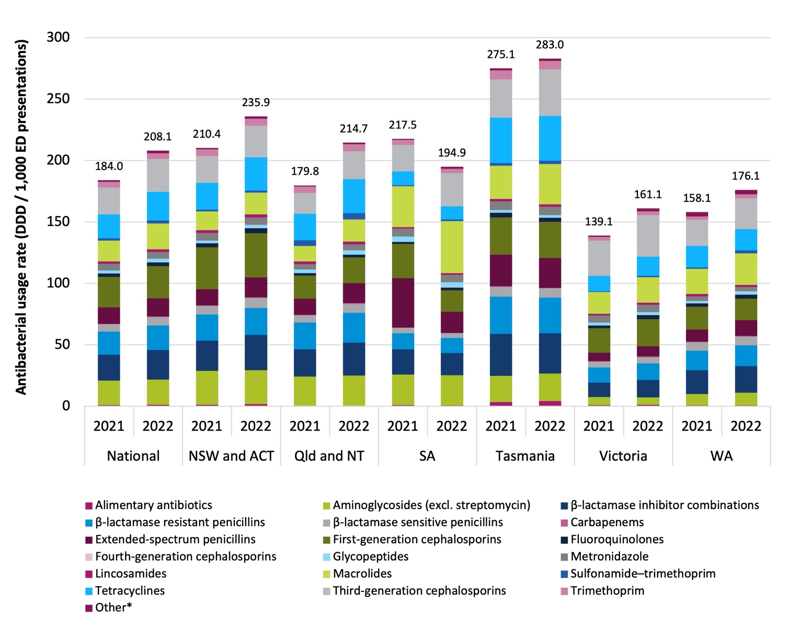
* ‘Other’: combination products for the eradication of H. pylori, cefiderocol, ceftaroline, ceftolozane–tazobactam, cycloserine, daptomycin, faropenem, fosfomycin, linezolid, monobactams, nitrofurans, polymyxins, rifabutin, rifampicin, sodium fusidate, streptogramins and tedizolid.
ACT = Australian Capital Territory; DDD = defined daily dose; ED = emergency department; NAUSP = National Antimicrobial Utilisation Surveillance Program; NSW = New South Wales; NT = Northern Territory; Qld = Queensland;
SA = South Australia; WA = Western Australia.
Stratified usage rates for antimicrobial use in the ED setting have been available to NAUSP contributors for 2 full reporting years. One of the primary challenges of capturing usage in this area is differentiating distributions that are intended for patients onsite and those that are supplied on discharge or for take-home use. Pre-packed antimicrobials are common in many facilities around Australia, and many EDs provide pre-packed antimicrobials to patients without admitting them for an overnight stay. The ED is also an area of high antimicrobial stock movement (‘borrowing’) to other hospital areas. Therefore, while the reported distributions are attributed to the ED, actual consumption may occur elsewhere in the hospital.
Another challenge regarding data capture in the ED is the timely availability of denominator data. While a count of ED presentations is a metric routinely reported to the AIHW (see the Glossary in Appendix 6 for a definition of an ‘ED presentation’), some sites have expressed difficulty in obtaining access to validated data. Further, larger EDs may have overnight stay areas co-located in the department. If these beds are serviced by a separate imprest supply from pharmacy, usage in these sub-areas of the ED may be reported under the ‘other acute’ component of NAUSP and therefore not as part of ED usage rates. Individual sites hold the ultimate decision on how data are reported to
NAUSP, given that workflow and practices are unique and not always compatible with data capture methods. This has led to some data capture inconsistencies across and within NAUSP contributor hospitals, which may account for some of the variation in usage rates between sites and jurisdictions. This is a limitation of using pharmacy distribution as a surrogate for actual use; however, the impending possibility of quantifying usage using electronic medical administration (eMAR) data will allow a more accurate representation of actual consumption in the future.
Australian hospitals are classified into peer groups according to size and acuity by the AIHW.9 In 2022, all acute hospital peer groups except Public Acute Group C demonstrated an increase in aggregate ED usage rates compared with 2021. The largest increases in 2022 were seen in Public Acute Group B (22.9%) and Private Acute Group A (18.9%) hospitals.
Figure 6: Annual aggregated emergency department antibacterial usage (DDD/1,000 ED presentations) by class in NAUSP contributor hospitals, by AIHW peer group, 2021–2022
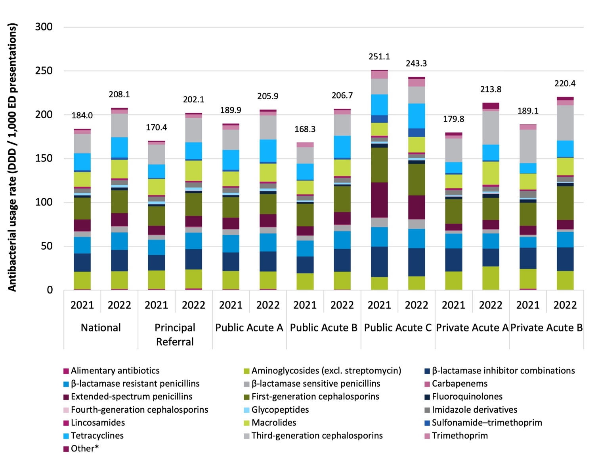
* ‘Other’: combination products for the eradication of H. pylori, cefiderocol, ceftaroline, ceftolozane–tazobactam, cycloserine, daptomycin, faropenem, fosfomycin, linezolid, monobactams, nitrofurans, polymyxins, rifabutin, rifampicin, sodium fusidate, streptogramins and tedizolid.
AIHW = Australian Institute of Health and Welfare; DDD = defined daily dose; ED = emergency department; NAUSP = National Antimicrobial Utilisation Surveillance Program.

Parenteral antibacterial use in the ED setting is relatively similar across all AIHW hospital remoteness categories, although usage is slightly higher in hospitals located in major cities (Figure 7).
Stratifying NAUSP contributor hospitals by AIHW remoteness categories demonstrates that both the volume of oral distributions (measured in DDD/1,000 ED presentations) and the proportion of oral-to- parenteral use increase as sites become more remote. It was postulated that EDs in smaller remote settings were acting as a proxy for general practice clinics, with GPs attending to patients at the hospital. While this certainly may be the case at some sites, examining clusters of regional and remote hospitals returned mixed results – state average use was higher for some and lower for others.
Figure 7: Annual aggregated emergency department antibacterial usage (DDD/1,000 ED presentations) by class in NAUSP contributor hospitals, by AIHW remoteness criteria, parenteral versus oral, 2021–2022
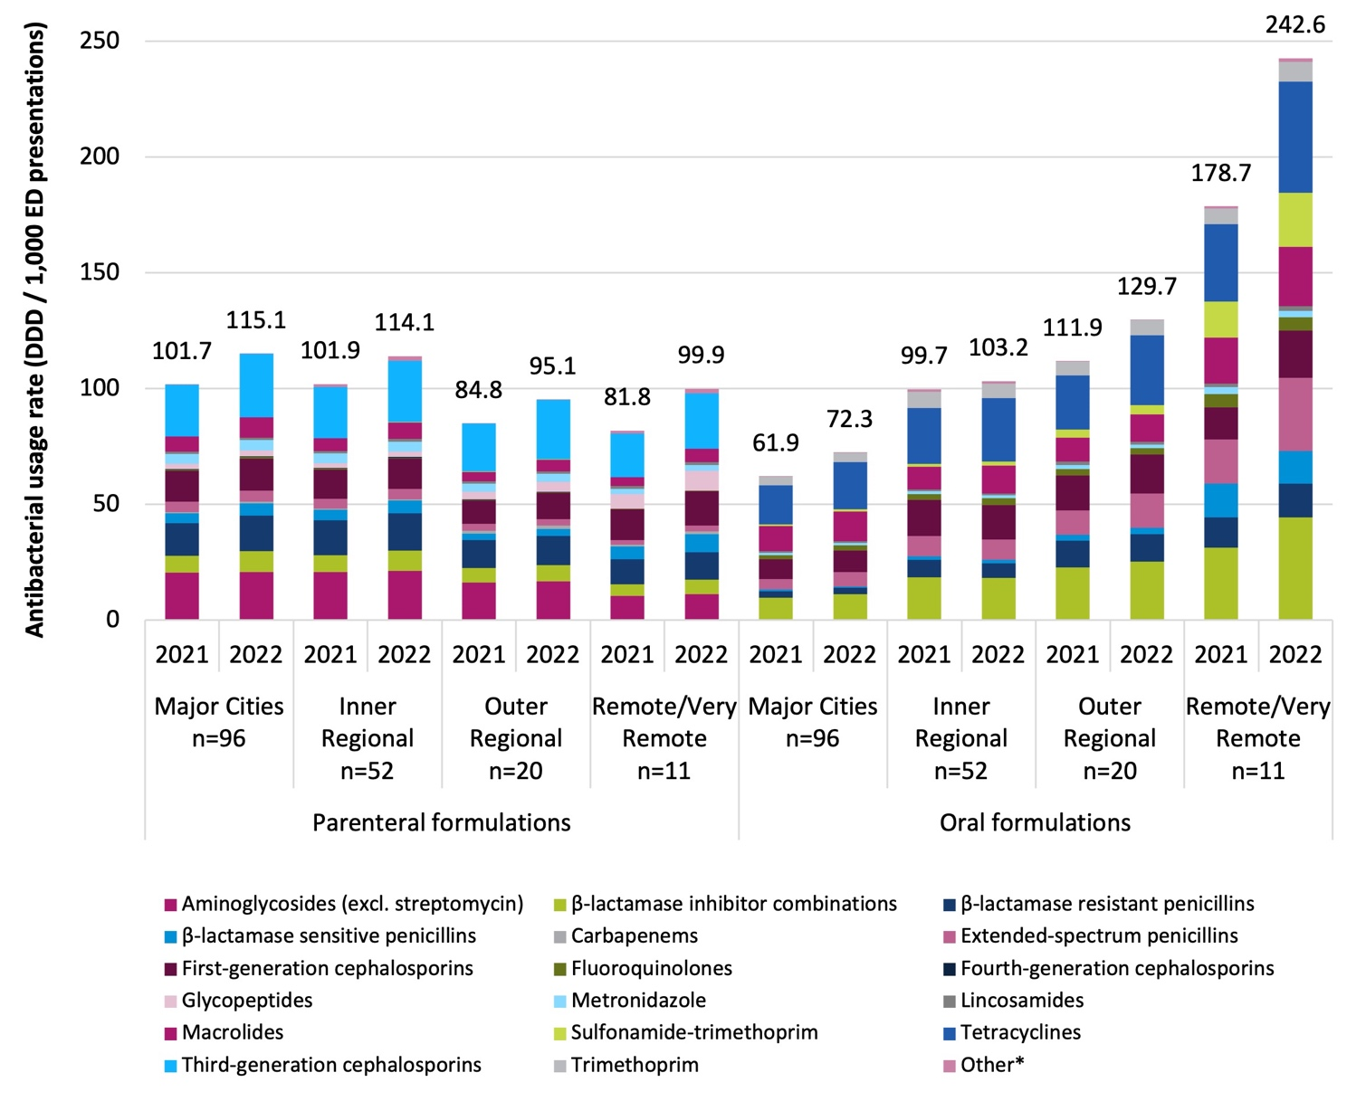
* ‘Other’: combination products for the eradication of H. pylori, cefiderocol, ceftaroline, ceftolozane–tazobactam, cycloserine, daptomycin, faropenem, fosfomycin, linezolid, monobactams, nitrofurans, polymyxins, rifabutin, rifampicin, sodium fusidate, streptogramins and tedizolid.
AIHW = Australian Institute of Health and Welfare; DDD = defined daily dose; ED = emergency department; NAUSP = National Antimicrobial Utilisation Surveillance Program.

Doxycycline and oral azithromycin are used in high volume in the ED setting (Figure 8) and are commonly used for the treatment of community-acquired pneumonia. All states use comparatively more doxycycline than azithromycin, except for South Australia, where the use of azithromycin is more than double the national aggregate rate. This may be due to overuse of oral azithromycin for the treatment of low- or moderate-severity community-acquired pneumonia in patients where a penicillin-based regimen would be effective and safe.
Figure 8: Aggregate emergency department usage rates (DDD/1,000 ED presentations) for oral doxycycline and oral azithromycin in NAUSP contributor hospitals, by state and territory, 2021–2022 (3-month moving average)
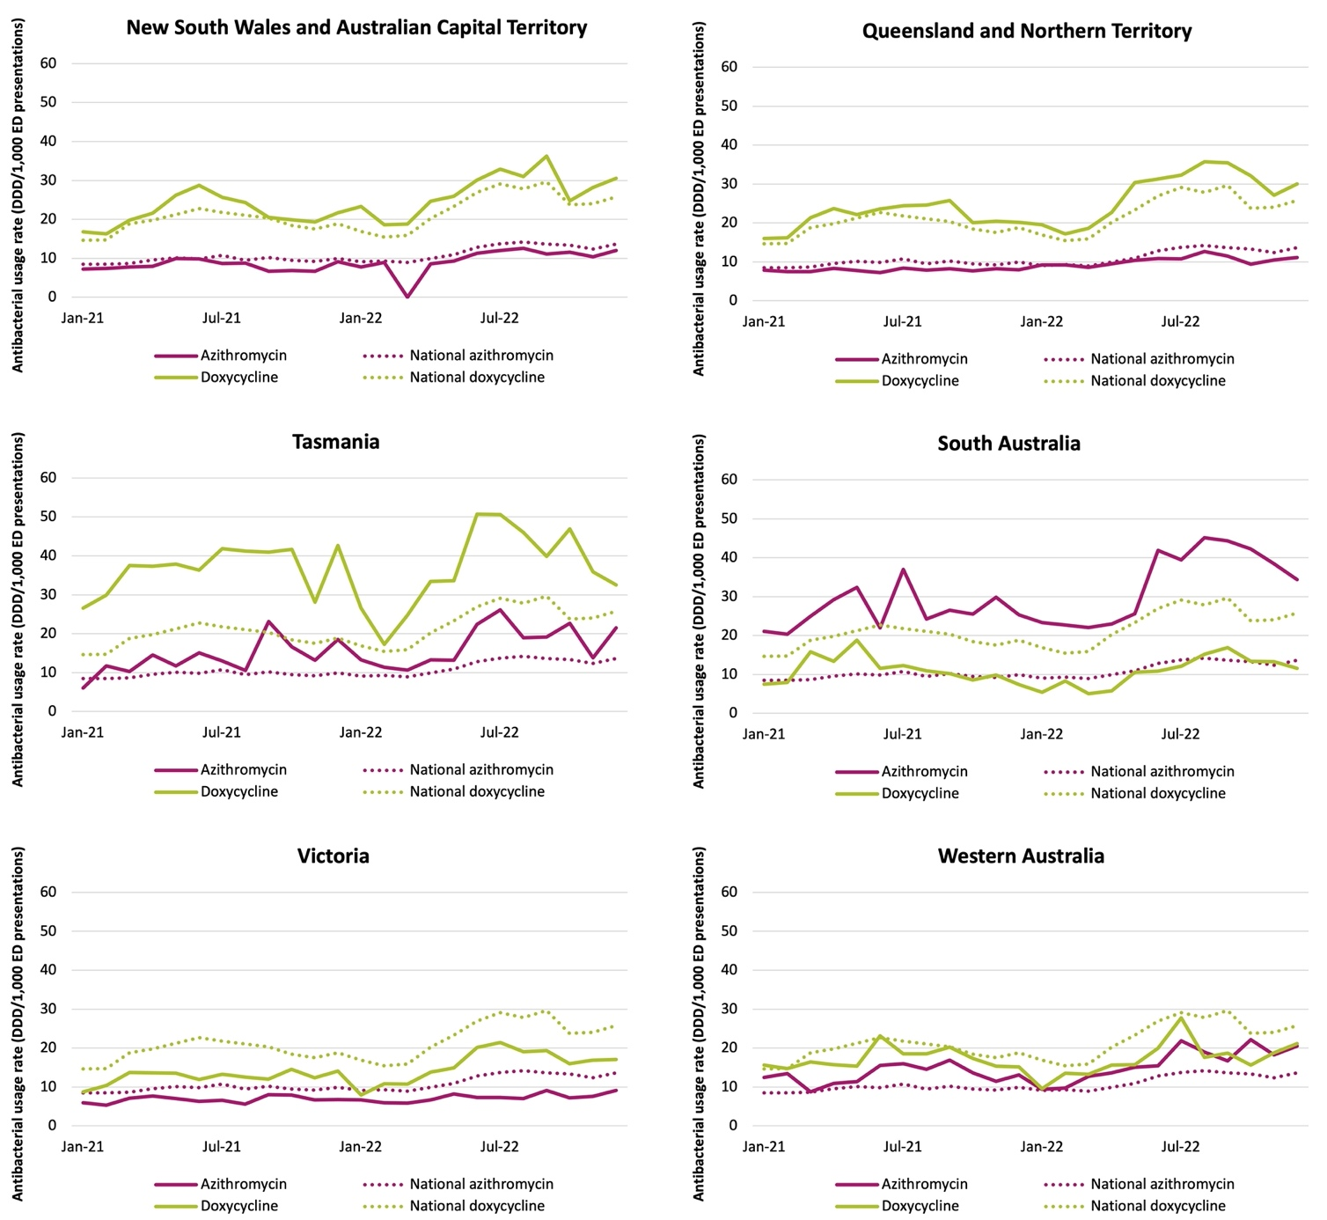
DDD = defined daily dose; ED = emergency department; NAUSP = National Antimicrobial Utilisation Surveillance Program.

Antibacterial usage in the operating theatre
Two hundred and twenty-two contributors provided stratified theatre data for inclusion in this report – an increase of 18.7% from 2021 (2021, n=187). Figure 9 illustrates the proportionate use of antibacterials in the theatre and recovery setting, both nationally and by state and territory. Similar to the 2021 NAUSP report, cefazolin is the most commonly used antibacterial in the operating theatre; cefazolin comprised 78.2% of antimicrobial usage (as a proportion of total DDDs) in this setting nationally. A high rate of cefazolin use in the theatre setting is expected given that it is recommended as a first-line antimicrobial for surgical prophylaxis.10
Figure 9: Proportionate theatre and recovery antibacterial use (DDD) by antibacterial agent in NAUSP contributor hospitals, by state and territory, 2021–2022 (n=222)
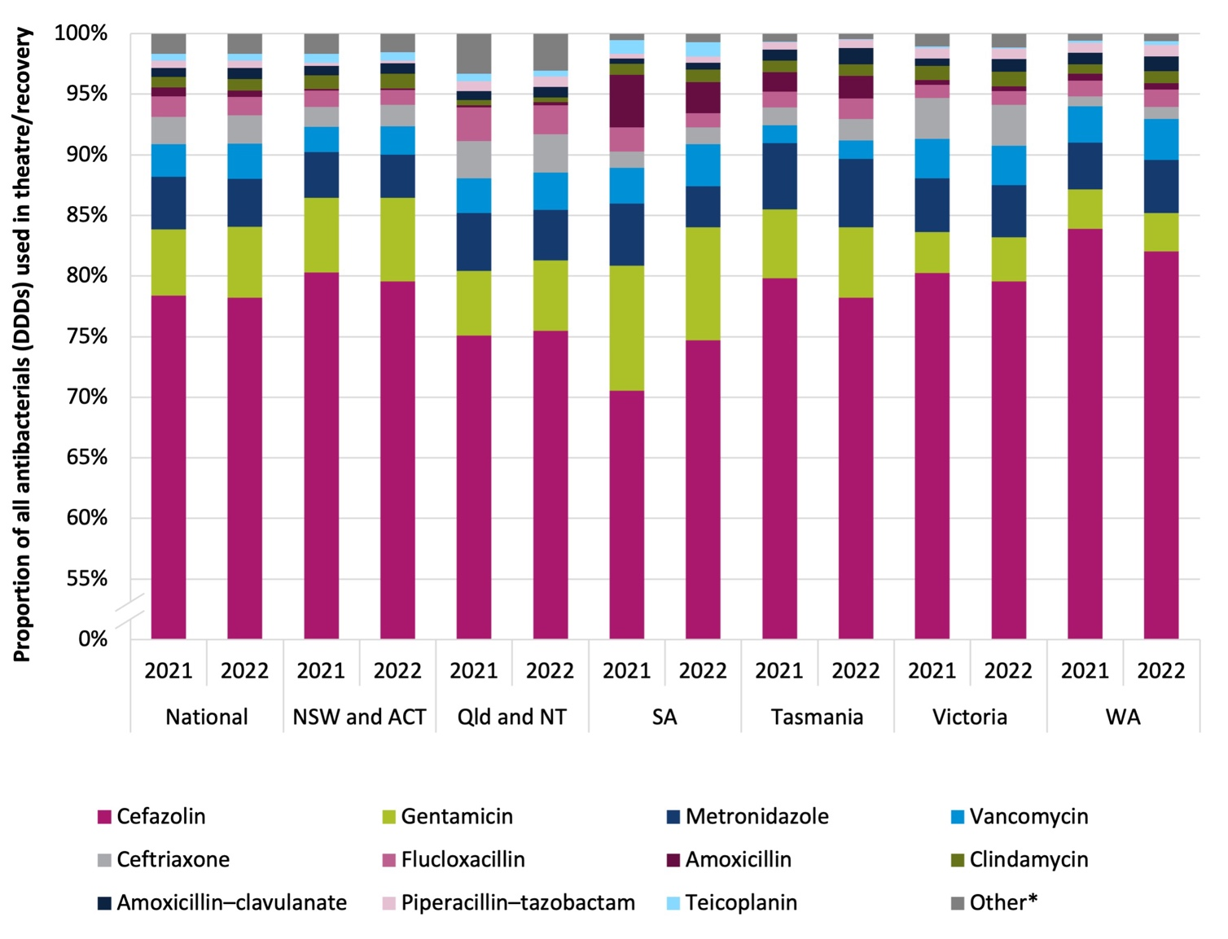
* ‘Other’: ampicillin, lincomycin, benzylpenicillin, cefoxitin, rifampicin, meropenem, azithromycin, ciprofloxacin, erythromycin, cefotaxime, cefepime, ceftazidime, tobramycin, daptomycin, sulfamethoxazole–trimethoprim, amikacin, ertapenem, moxifloxacin, linezolid, doxycycline, aztreonam, imipenem–cilastatin, tigecycline, benzathine benzylpenicillin, colistin, ceftazidime–avibactam, ceftaroline, ceftolozane–tazobactam.
ACT = Australian Capital Territory; DDD = defined daily dose; NAUSP = National Antimicrobial Utilisation Surveillance Program; NSW = New South Wales; NT = Northern Territory; Qld = Queensland.

Figure 10 illustrates total cefazolin use in theatre and recovery by state and territory, as a proportion of all antibacterial use in theatre, shown as a percentage of use. South Australia has the lowest proportionate use of cefazolin in the theatre setting (74.7% of total antibacterial DDDs used in 2022). However, this was an increase from 70.5% of all theatre usage in 2021.
Figure 10: Cefazolin usage as a proportion of total annual theatre and recovery usage (percentage of total DDDs) in NAUSP contributor hospitals, by state and territory, 2021–2022
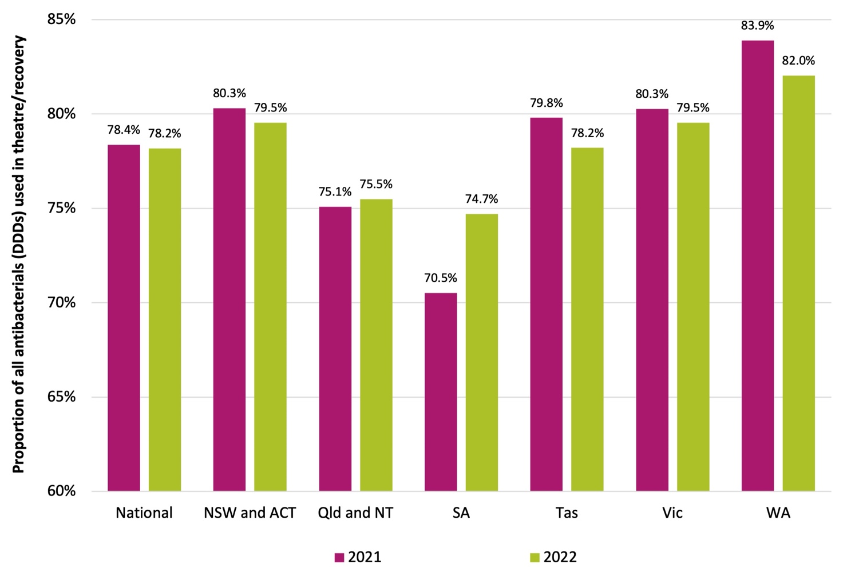
ACT = Australian Capital Territory; DDD = defined daily dose; NAUSP = National Antimicrobial Utilisation Surveillance Program; NSW = New South Wales; NT = Northern Territory; Qld = Queensland; SA = South Australia; Tas = Tasmania;
Vic = Victoria; WA = Western Australia.
Table 5 shows the full list of antibacterial agents recording any parenteral use in the theatre and recovery setting (by total DDDs) and proportionate use (percentage of total annual usage in the theatre setting for 2021 and 2022).
It is important to note that not all antimicrobials used in theatre are for the purpose of surgical prophylaxis; patients receiving treatment in this area may already have commenced courses of antimicrobials unrelated to their procedure and require dosing/adminstration while in theatre or recovery.

Table 5: National theatre and recovery parenteral antimicrobial use (total DDD) by antibacterial agent in NAUSP contributors, 2021–2022
Antibacterial | Sum of DDD |  | % of total annual use
 | 2021 | 2022 | 2021 | 2022
Cefazolin | 645,091.19 | 687,879.37 | 78.4% | 78.2%
Gentamicin | 45,213.85 | 51,426.87 | 5.5% | 5.8%
Metronidazole | 35,731.99 | 34,798.64 | 4.3% | 4.0%
Vancomycin | 22,146.50 | 25,623.26 | 2.7% | 2.9%
Ceftriaxone | 18,359.25 | 20,590.25 | 2.2% | 2.3%
Flucloxacillin | 13,899.75 | 13,395.00 | 1.7% | 1.5%
Clindamycin | 7,385.10 | 8,459.25 | 0.9% | 1.0%
Amoxicillin – clavulanic acid | 5,980.45 | 7,857.97 | 0.7% | 0.9%
Piperacillin–tazobactam | 5,003.43 | 5,527.68 | 0.6% | 0.6%
Amoxicillin | 6,032.64 | 4,677.97 | 0.7% | 0.5%
Teicoplanin | 4,476.00 | 4,658.00 | 0.5% | 0.5%
Ampicillin | 4,042.22 | 4,388.72 | 0.5% | 0.5%
Lincomycin | 2,102.34 | 2,441.01 | 0.3% | 0.3%
Benzylpenicillin | 1,437.01 | 1,735.67 | 0.2% | 0.2%
Cefoxitin | 1,554.68 | 1,452.18 | 0.2% | 0.2%
Rifampicin | 1,609.00 | 1,406.00 | 0.2% | 0.2%
Meropenem | 661.48 | 606.81 | 0.1% | 0.1%
Ciprofloxacin | 413.50 | 588.75 | 0.1% | 0.1%
Erythromycin | 366.00 | 481.00 | 0.0% | 0.1%
Azithromycin | 583.00 | 364.00 | 0.1% | 0.0%
Cefepime | 202.75 | 317.75 | 0.0% | 0.0%
Cefotaxime | 305.00 | 227.00 | 0.0% | 0.0%
Tobramycin | 95.01 | 186.01 | 0.0% | 0.0%
Ceftazidime | 140.25 | 158.00 | 0.0% | 0.0%
Daptomycin | 79.29 | 123.75 | 0.0% | 0.0%
Sulfamethoxazole–trimethoprim | 53.00 | 72.75 | 0.0% | 0.0%
Amikacin | 57.00 | 65.50 | 0.0% | 0.0%
Moxifloxacin | 15.00 | 31.00 | 0.0% | 0.0%
Ertapenem | 40.00 | 28.00 | 0.0% | 0.0%
Linezolid | 14.50 | 16.50 | 0.0% | 0.0%
Doxycycline | 14.00 | 12.00 | 0.0% | 0.0%
Aztreonam | 6.25 | 11.75 | 0.0% | 0.0%
Benzathine benzylpenicillin | 2.50 | 7.25 | 0.0% | 0.0%
Imipenem–cilastatin | 9.25 | 6.75 | 0.0% | 0.0%
Tigecycline | 8.00 | 4.00 | 0.0% | 0.0%
Colistin | 7.00 | 2.50 | 0.0% | 0.0%
Ceftazidime–avibactam | 0.00 | 2.08 | 0.0% | 0.0%
Ceftaroline | 1.00 | 1.00 | 0.0% | 0.0%
Ceftolozane–tazobactam | 0.00 | 0.67 | 0.0% | 0.0%
Grand total | 823,139.16 | 879,632.64 | 100.0% | 100.0%
DDD = defined daily dose; NAUSP = National Antimicrobial Utilisation Surveillance Program.

Glycopeptide use in the theatre and recovery setting
Glycopeptide antibiotics – vancomycin and teicoplanin – are less effective than cefazolin at preventing post-operative infections with methicillin-susceptible Staphylococcus aureus. However, they are used in patients at increased risk of infections caused by resistant strains (methicillin-resistant Staphylococcus aureus (MRSA)). Vancomycin is the most commonly used glycopeptide in the theatre and recovery setting; however, some hospitals prefer teicoplanin.10
Figure 11 illustrates proportional use of teicoplanin compared to vancomycin in theatre and recovery across the jurisdictions. Because of long infusion times, some vancomycin used for surgical prophylaxis may be commenced on the ward and may not be captured in the theatre usage data. This is a limitation to be considered when interpreting theatre usage data. As a proportion of glycopeptide use for surgical prophylaxis, teicoplanin is more frequently used in NSW/ACT and in South Australia than in other states and territories. Across all NAUSP contributors nationally that contributed theatre usage data in 2021 and 2022, teicoplanin comprised 16.1% of the monthly average glycopeptide use reported in this setting.
Figure 11: Proportionate teicoplanin and vancomycin theatre and recovery use (percentage of DDD) in NAUSP contributor hospitals, by state or territory, 2021–2022 (3-month moving average)
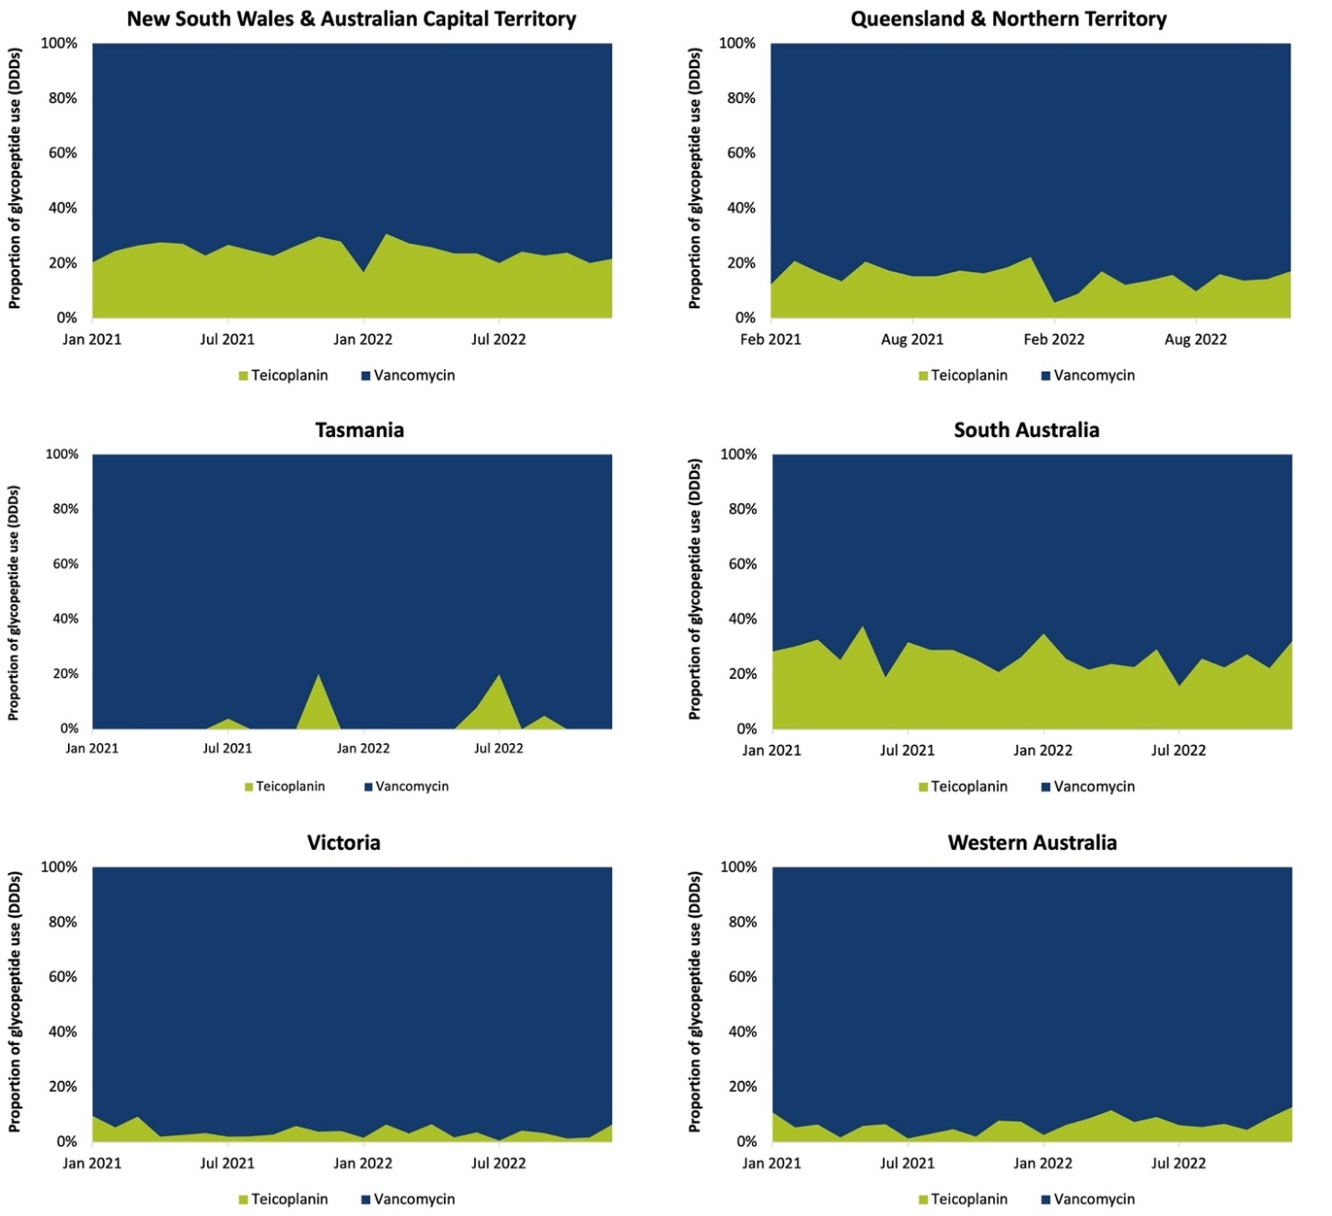
DDD = defined daily dose; NAUSP = National Antimicrobial Utilisation Surveillance Program.

How should we compare theatre and recovery activity?
To measure relative usage of antimicrobials between different healthcare facilities in the theatre and recovery setting, an accurate metric of theatre activity is required.
Data on surgical procedures undertaken in the operating room are collected by the Australian Institute of Health and Welfare (AIHW). ‘Other debridement of skin and subcutaneous tissue’ is the most common non-elective emergency surgical procedure performed. This activity may (or may not) be conducted within the operating theatre.
‘Surgery’ is defined by the AIHW as a ‘physical medical intervention, often called an operation, to treat or investigate a disease or injury that is listed in the surgical operations section of the Medicare Benefits Schedule (MBS), excluding specific procedures frequently done by non-surgical clinicians’. Depending on how procedures are defined in the MBS, an ‘operation’ may consist of more than one ‘procedure’. Additionally, some sites may perform some ‘procedures’ outside of the operating theatre proper but include them as theatre cases in periodical activity counts.
Figure 12: Annual reported theatre activity from NAUSP contributors, by AIHW peer group, 2022 (with outliers)
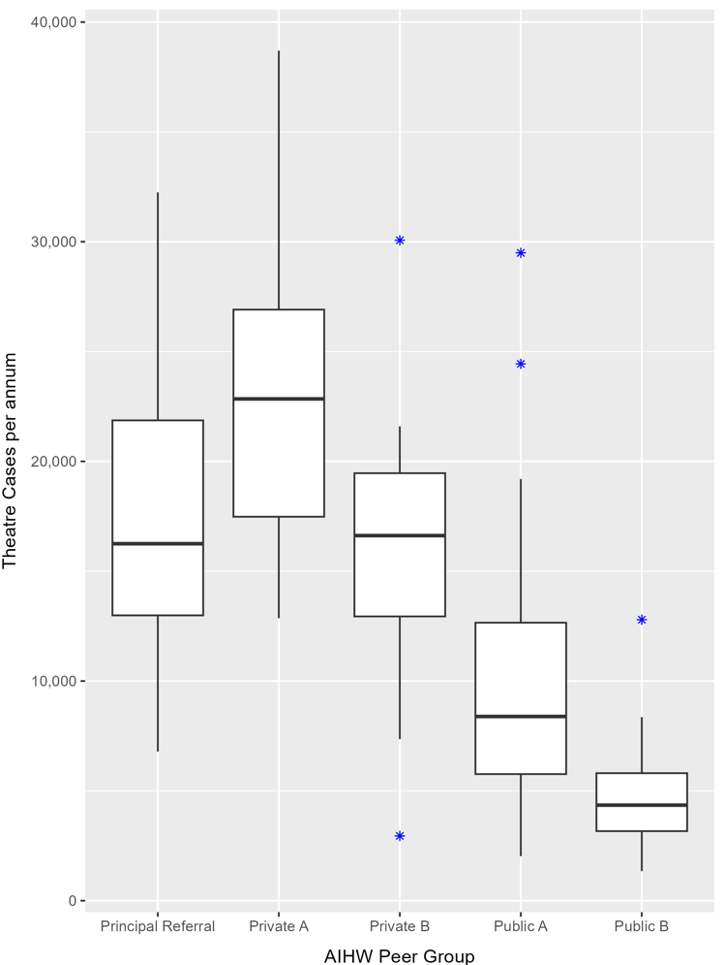
Figure 12 illustrates the wide variation in the reported number of theatre cases by each contributor within selected peer groups. Of note, the median number of theatre cases reportedly undertaken in principal referral hospitals is 16,252 per facility (Interquartile Range (IQR): 12,991–21,868). Private hospitals report a much higher number of theatre cases per facility compared with their similarly peered public counterparts, which is likely to be a reflection of elective procedures undertaken in the private sector. Private Acute Group A hospitals reported a median of 22,845 cases per annum (IQR: 17,481–26,910) compared with Public Acute Group A, with a median of 8,387 (IQR: 5,765–12,657). Private Acute Group B hospitals reported approximately 4 times the number of theatre cases per annum compared to Public Acute Group A (median cases per annum 16,622 and 4,350 respectively).
NAUSP continues to work with contributor hospitals and Commonwealth agencies to improve data definitions and collection to improve the utility and application of surveillance in this setting.

Priority Antibacterial List
In 2020, the Priority Antibacterial List for Antimicrobial Resistance Containment (PAL)11 was developed and published by the Australian Commission on Safety and Quality in Health Care as a tool to support AMS. The PAL categorises antibacterials based on whether they are recommended as first-line treatment in nationally endorsed guidelines and/or their use has potential for driving AMR.
Table 6 illustrates the stratification criteria for the 3 PAL categories. In general, use of Access antibacterials is encouraged in preference to antibacterials in the Curb or Contain categories.
Table 6: Classification framework for the Access, Curb and Contain categories of the Priority Antibacterial List11
Category | Inclusion criteria
Access | Includes:  - antibacterials recommended as first-line treatment for bacterial infections with a low antimicrobial resistance (AMR) or healthcare-associated infection (HAI) potential  - antibacterials not recommended as first-line treatment for common infections but with a low resistance potential.
Review: Curb | Includes:  - antibacterials recommended as first-line agents for common bacterial infections, despite a high AMR potential  - antibacterials not recommended as first-line treatment but with moderate to high AMR or HAI potential  - antibacterials only recommended as first-line for prophylaxis as opposed to treatment.
Review: Contain | Includes:  - antibacterials for treatment of bacterial infections with high AMR or HAI potential that are not recommended as first-line options.
Systemic antimicrobials included in NAUSP surveillance are listed in Appendix 4, and antibacterials included in each of the PAL categories are listed in Appendix 5. In general, the Access category includes antibacterials that are recommended as first-line treatment in clinical guidelines or are agents with lower potential for driving resistance. The Curb and Contain categories include antibacterials that are second- or reserve-line, with the exception of cefazolin. Cefazolin is considered a first-line agent for surgical prophylaxis but is a second-line agent for treatment of infections such as cellulitis.

Usage by Priority Antibacterial List category – by state and territory, 2018–2022
Figure 13 illustrates the 5-year trend in inpatient antibacterial use by PAL category, by state and territory, from 2018 to 2022. The same data are illustrated in Figure 14 according to proportional use. When interpreting the following figures, it is important to note that usage rates from January 2021 do not include theatre and ED use.
Figure 13: Aggregate inpatient antibacterial usage rates (DDD/1,000 OBD) by PAL category in NAUSP contributor hospitals, by state and territory, 2018–2022 (3-month moving average)
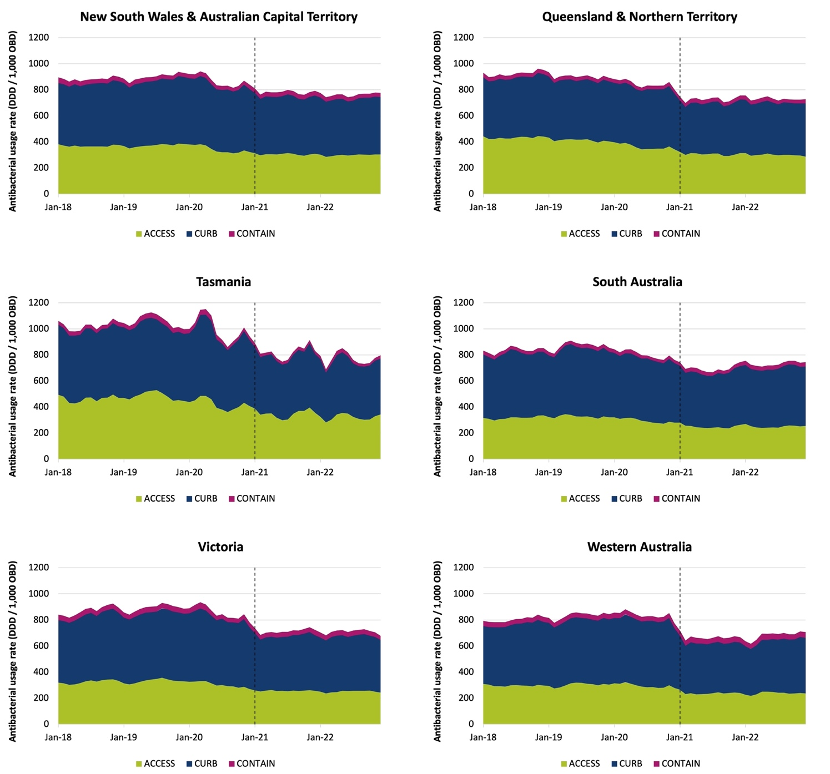
Note: Dashed line denotes exclusion of emergency department and operating theatre from acute inpatient usage rates.
DDD = defined daily dose; NAUSP = National Antimicrobial Utilisation Surveillance Program; OBD = occupied bed days; PAL = Priority Antibacterial List.

Figure 14 illustrates proportionate inpatient use by PAL category, showing the variation in usage between the states and territories. In 2022, Tasmania used the highest proportionate average monthly use in the Access category at 41.7% of their total PAL use. South Australia was the state with the highest use in the Curb category, with a monthly average of 61.5%. Western Australia had the highest proportionate usage in the Contain category; on average each month, 6.2% of inpatient antibacterial use in NAUSP contributor hospitals in Western Australia was from this category.
Figure 14: Proportional inpatient antibacterial usage (percentage of rate) by PAL category in NAUSP contributor hospitals, by state and territory, 2018–2022 (3-month moving average)
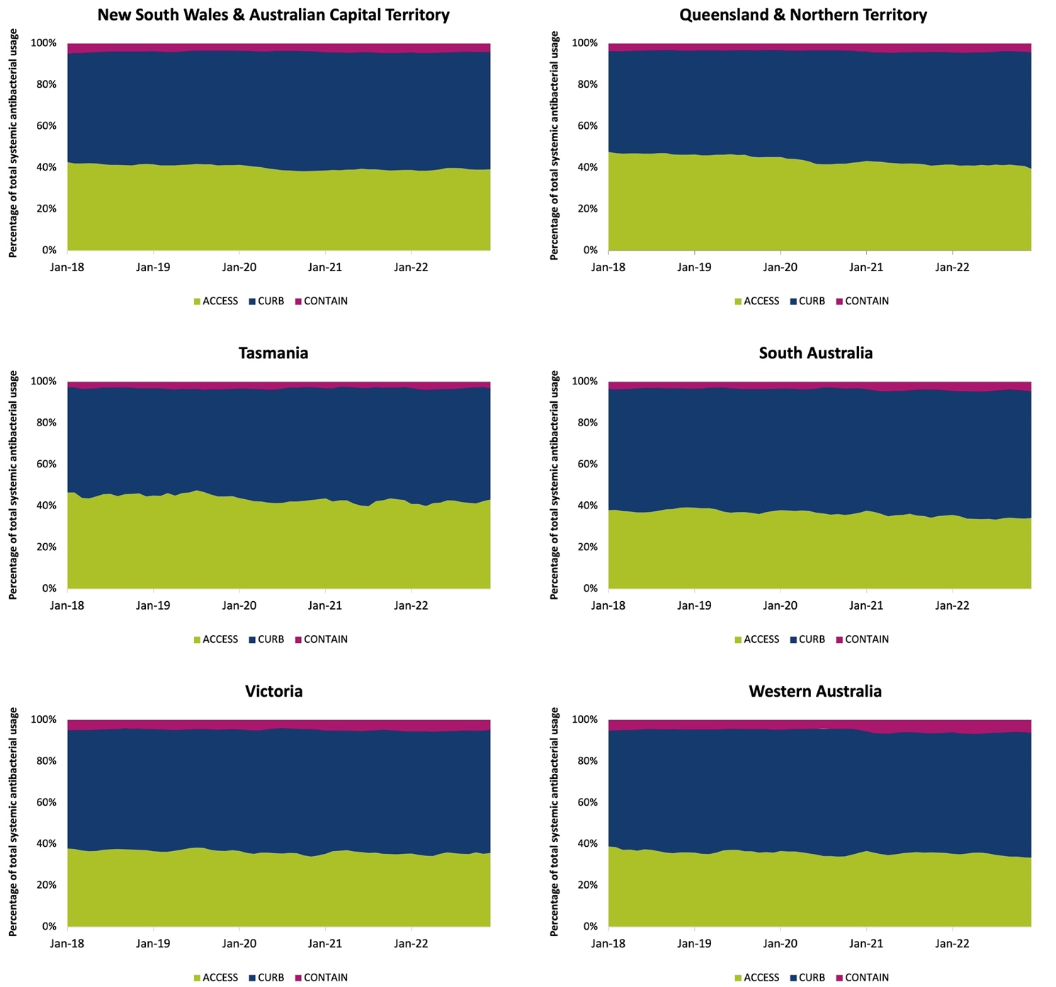
NAUSP = National Antimicrobial Utilisation Surveillance Program; PAL = Priority Antibacterial List.

Usage by Priority Antibacterial List category – critical care versus non-critical care
Antibacterials in the Curb category are typically reserved for severe or multidrug-resistant infections. Figure 15 illustrates the comparison in usage by PAL category in the critical care setting compared with the non-critical care setting, showing 5-year usage rates (DDD/1,000 OBD) and proportional use. ‘Non-critical care’ is the aggregate of all acute inpatient areas except for intensive care units and high dependency units. As expected, the overall use of antibacterials in critical care is approximately double that of acute settings outside critical care. The average monthly usage rate in critical care in 2022 was 1314.1 DDD/1,000 OBD compared with 707.3 DDD/1,000 OBD in other/combined inpatient areas outside of critical care.
In 2022, the average aggregate monthly usage rate for Access antibacterials in non-critical care settings was 279.1 DDD/1,000 OBD, and the usage rates for Curb and Contain antibacterials was 400.1 and 28.1 DDD/1,000 OBD respectively (Figure 15). In the critical care setting, the average monthly usage rate for Curb antibacterials was 847.3 DDD/1,000 OBD in 2022 – more than double the non-critical care setting. For Contain antibacterials, the average monthly usage rate in critical care in 2022 was 148.2 DDD/1,000 OBD – more than 5 times the usage rate outside of critical care.

Figure 15: Aggregate critical care and non-critical care inpatient antibacterial usage rates (DDD/1,000 OBD) by PAL category in NAUSP contributor hospitals, 2018–2022
(3-month moving average)
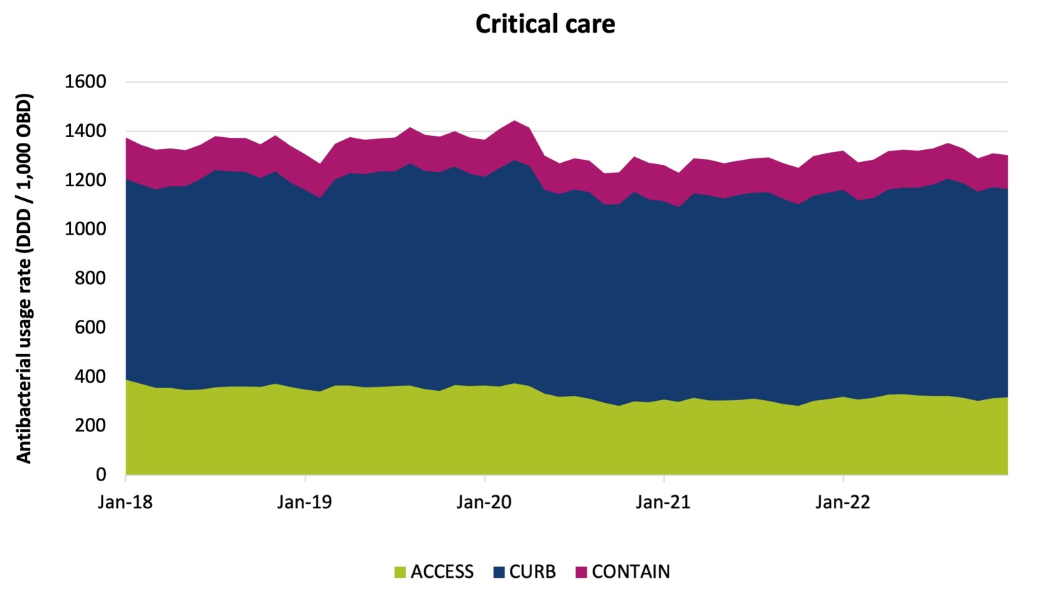
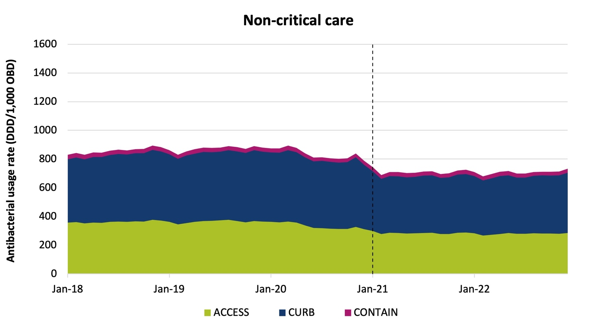
Note: Dashed line denotes exclusion of emergency department and operating theatre from acute inpatient usage rates. DDD = defined daily dose; NAUSP = National Antimicrobial Utilisation Surveillance Program; OBD = occupied bed days.
In 2022, as a proportion of total antibacterial use in critical care, on average Contain antibacterials comprised 11.3% of the total monthly use (Figure 16). Outside of critical care, Contain antibacterials comprised on average 4.0% of total monthly use.

Figure 16: Proportional use by PAL category in critical care versus non-critical care (percentage of total PAL usage rate), NAUSP contributor hospitals, 2018–2022
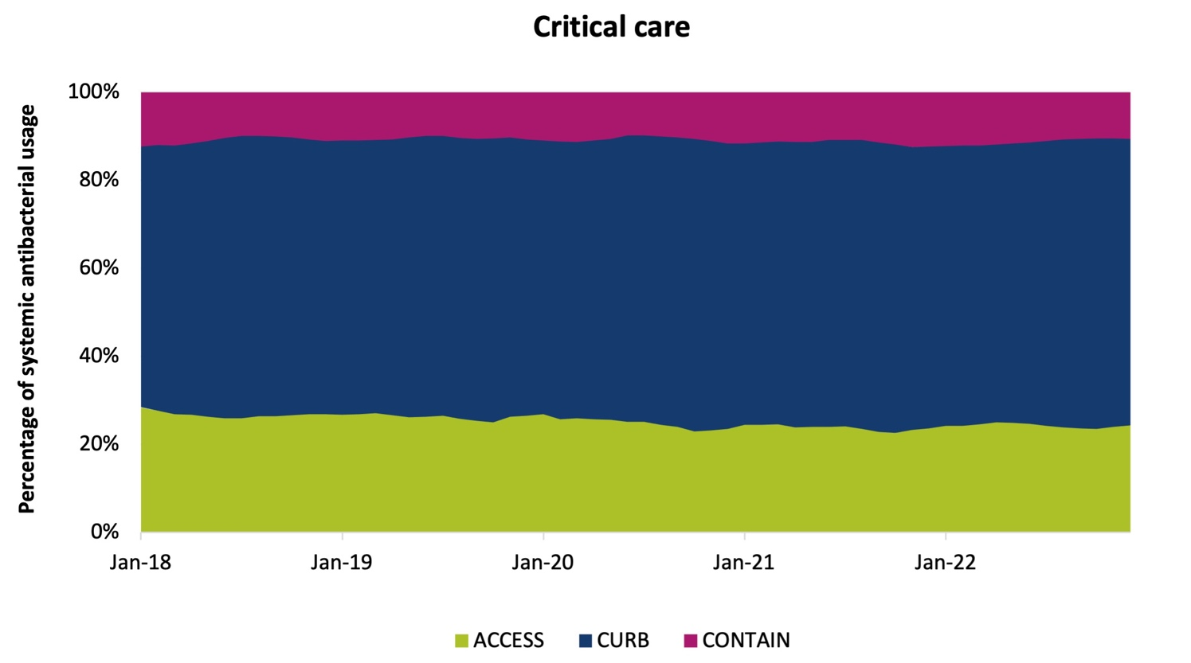
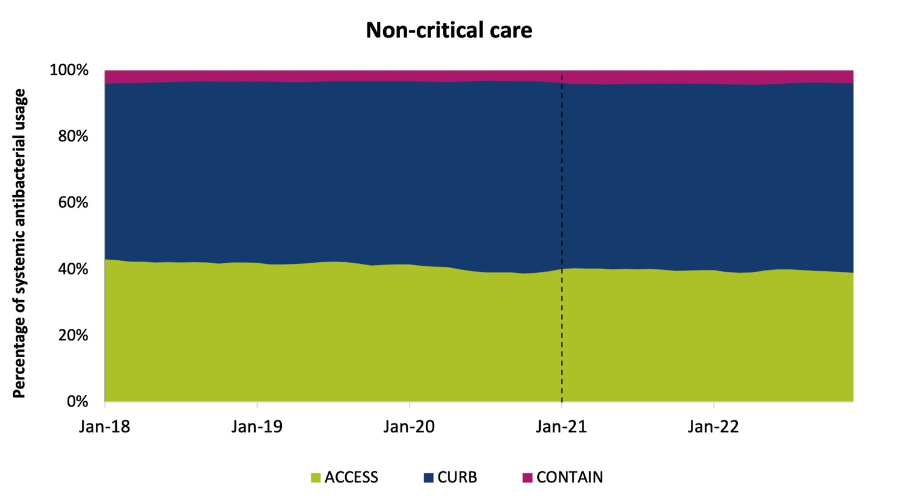
Note: Dashed line denotes exclusion of emergency department and operating theatre from acute inpatient usage rates. NAUSP = National Antimicrobial Utilisation Surveillance Program; PAL = Priority Antibacterial List.

Usage by Priority Antibacterial List category – public versus
private hospitals
Figure 17 shows inpatient antibacterial use by PAL category, comparing public hospital use to private hospital use. Figure 17a shows the aggregate usage rates (DDD/1,000 OBD) and Figure 17b shows the same data as a proportion of inpatient antibacterial use.
Figure 17: Aggregate inpatient antibacterial use by PAL category in NAUSP contributor hospitals, public versus private, 2018–2022
(17a) Aggregate inpatient antibacterial usage rates (DDD/1,000 OBD) (3-month moving average)
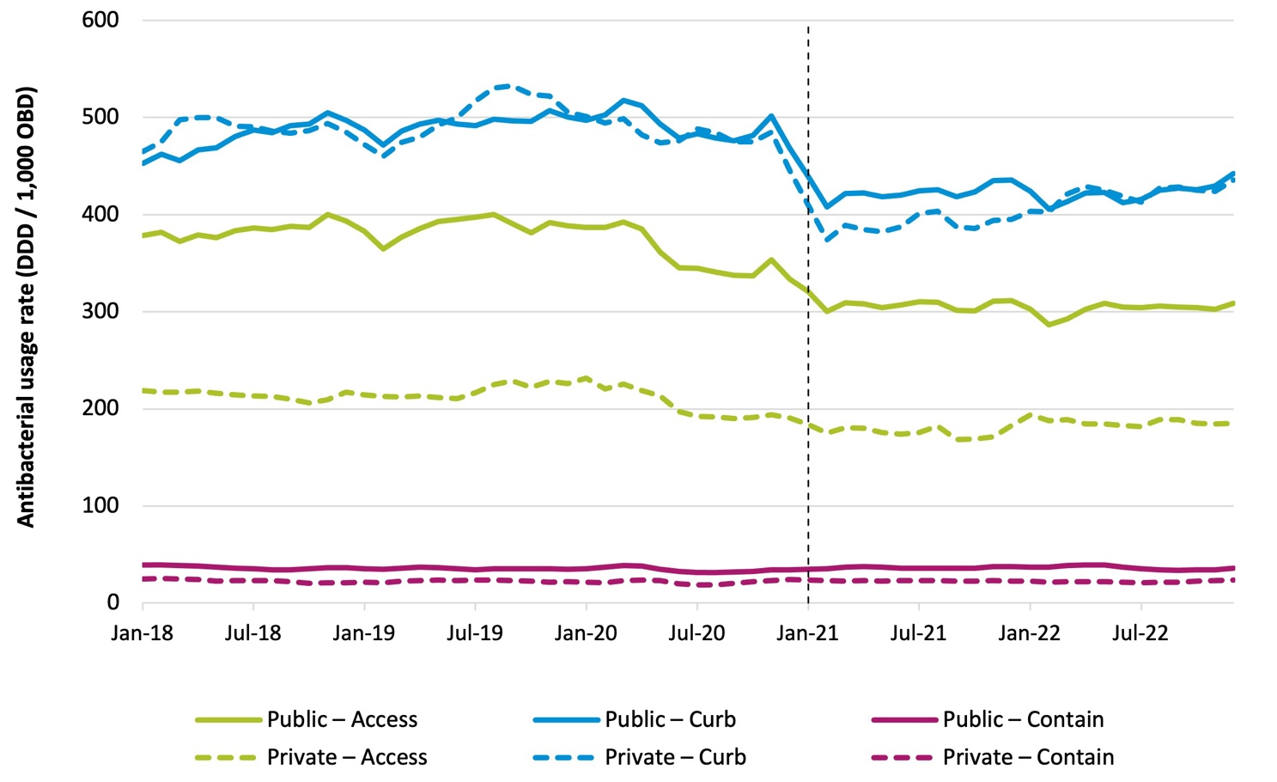

(17b) Proportionate inpatient antibacterial use by PAL category
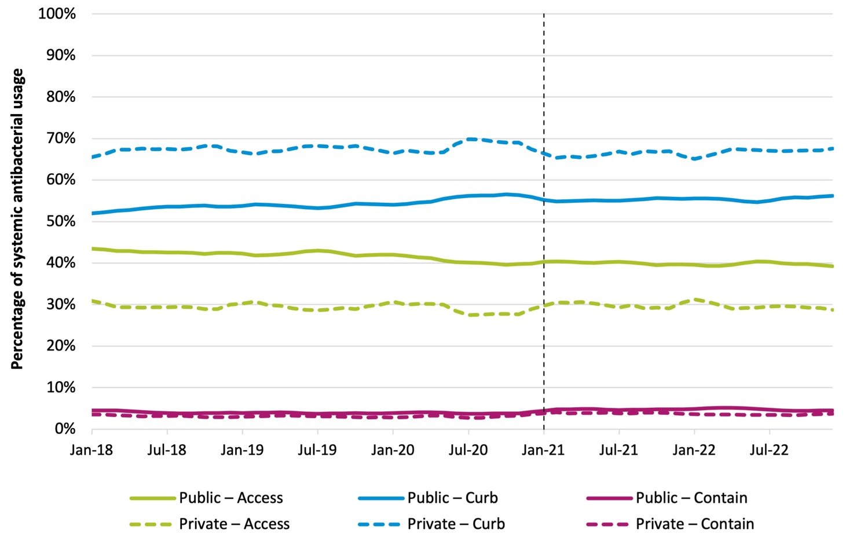

Note: Dashed line denotes exclusion of emergency department and operating theatre from acute inpatient usage rates.
DDD = defined daily dose; NAUSP = National Antimicrobial Utilisation Surveillance Program; OBD = occupied bed days; PAL = Priority Antibacterial List.

While the average aggregate monthly usage rate in 2022 for Curb antibacterials was similar in public hospitals compared with private hospitals (422.1 DDD/1,000 OBD and 421.1 DDD/1,000 OBD respectively) (Figure 17a), as a proportion of total antibacterial use, there is quite a substantial difference (Figure 17b). In 2022, Curb antibacterials comprised an average 66.9% of monthly inpatient usage in private hospitals, whereas in public hospitals Curb antibacterials made up 55.5% of monthly antibacterial consumption. The inpatient usage rate for Access antibacterials in public hospitals is almost twice that seen in private facilities.

Longitudinal antibacterial usage rates
Figures 18 to 22 show monthly aggregated inpatient usage rates for key antibacterials and antibacterial classes for the 5-year period January 2018 to December 2022. Note that, from January 2021, usage
in the ED and theatre and recovery settings/areas are reported separately and are not included in the aggregated inpatient usage rate. Data should be interpreted with this in mind.

Usage rates for high-volume oral antibacterials, 2018–2022
In 2022, the top 5 most used antibacterials in NAUSP contributor hospitals were doxycycline, amoxicillin – clavulanic acid, amoxicillin, cefalexin and azithromycin. The monthly inpatient usage rates for the 5-year period 2018 to 2022 are illustrated in Figure 18.

Figure 18: National aggregate inpatient usage rates (DDD/1,000 OBD) for high-volume antibacterials in NAUSP contributor hospitals, 2018–2022 (3-month moving average)
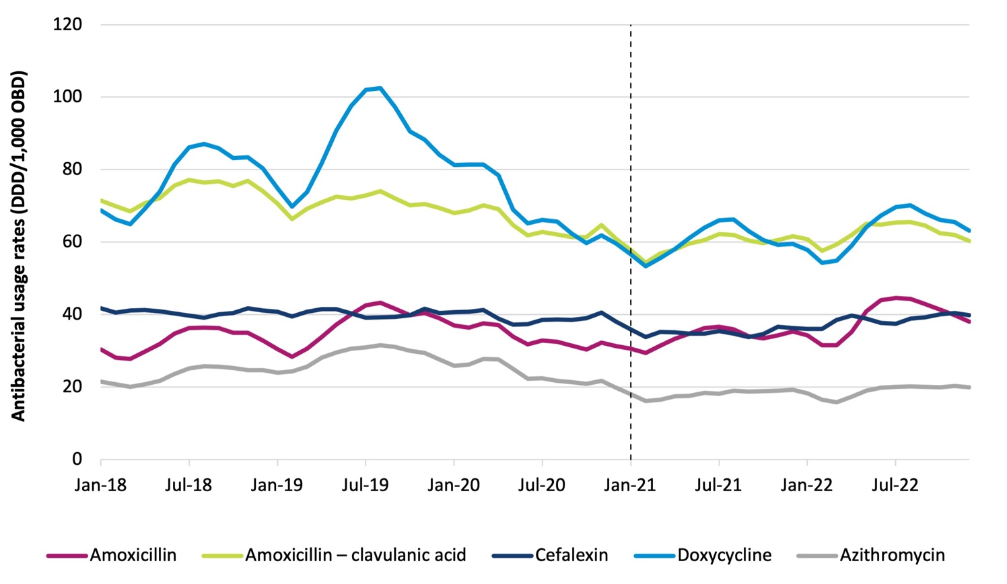
Note: Dashed line denotes exclusion of emergency department and operating theatre from acute inpatient usage rates. DDD = defined daily dose; NAUSP = National Antimicrobial Utilisation Surveillance Program; OBD = occupied bed days.
Usage rates for these top 5 most commonly used antibacterials by state and territory are shown in Figures 19 and 20.

Figure 19: Aggregate oral amoxicillin, oral amoxicillin – clavulanic acid and cefalexin usage rates (DDD/1,000 OBD) in NAUSP contributor hospitals, by state and territory, 2018–2022 (3-month moving average)
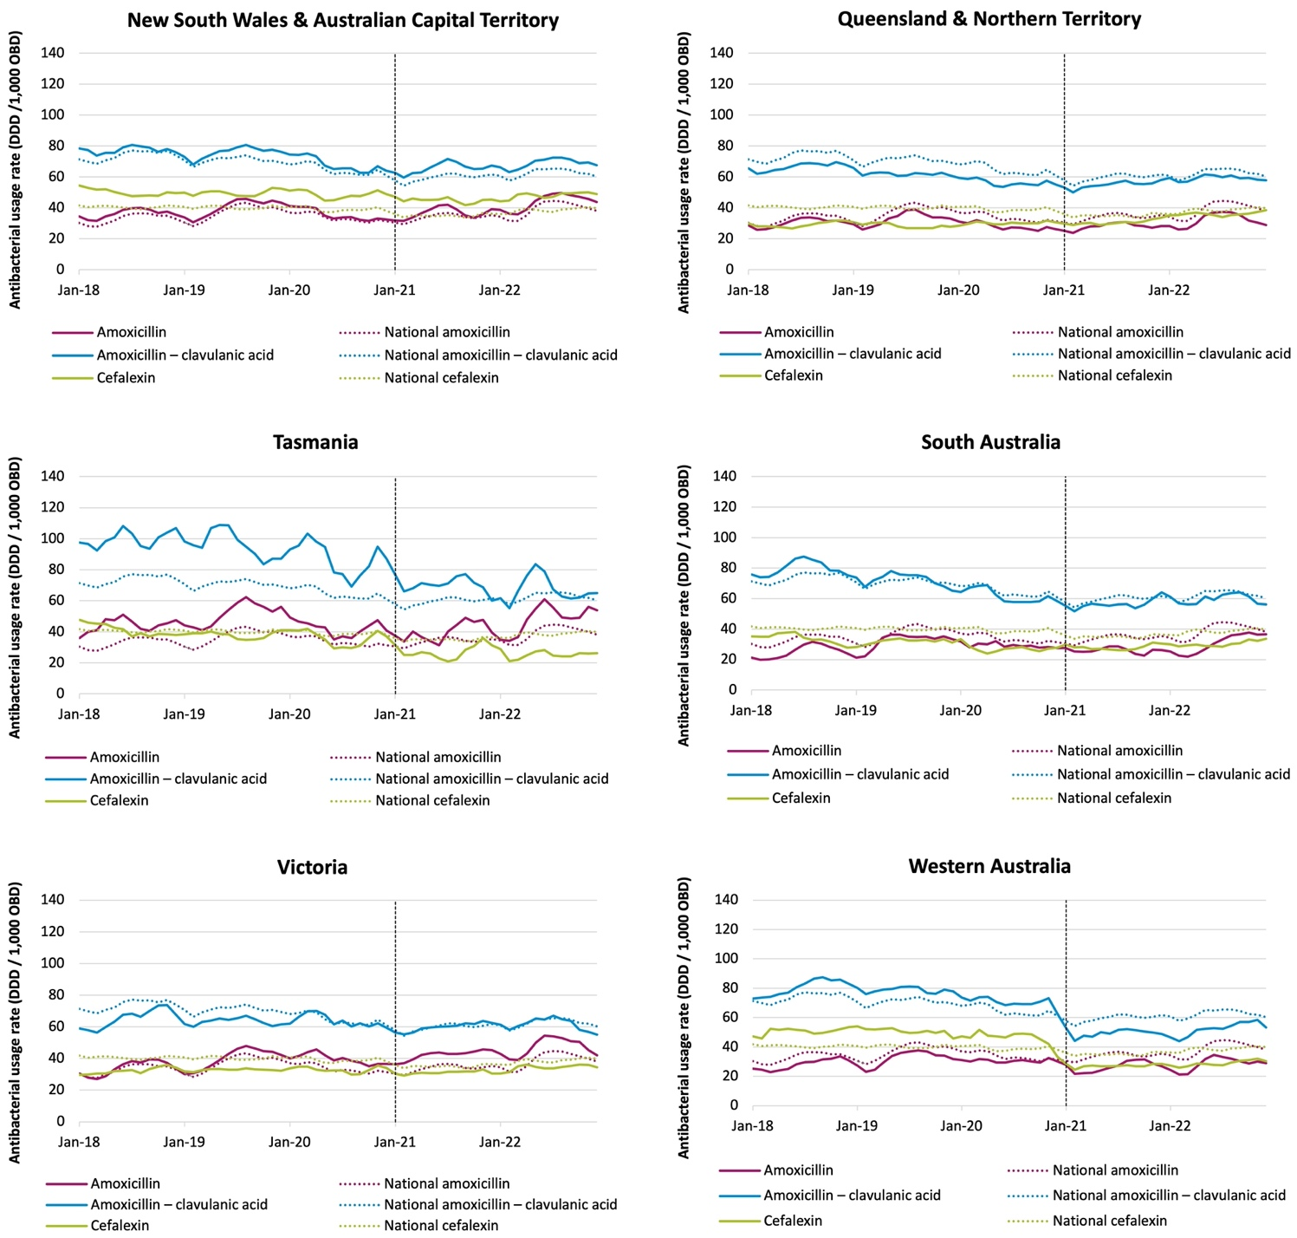
Note: Dashed line denotes exclusion of emergency department and operating theatre from acute inpatient usage rates. DDD = defined daily dose; NAUSP = National Antimicrobial Utilisation Surveillance Program; OBD = occupied bed days.

Figure 20: Aggregate oral doxycycline and oral azithromycin usage rates (DDD/1,000 OBD) in NAUSP contributor hospitals, by state and territory, 2018–2022 (3-month moving average)
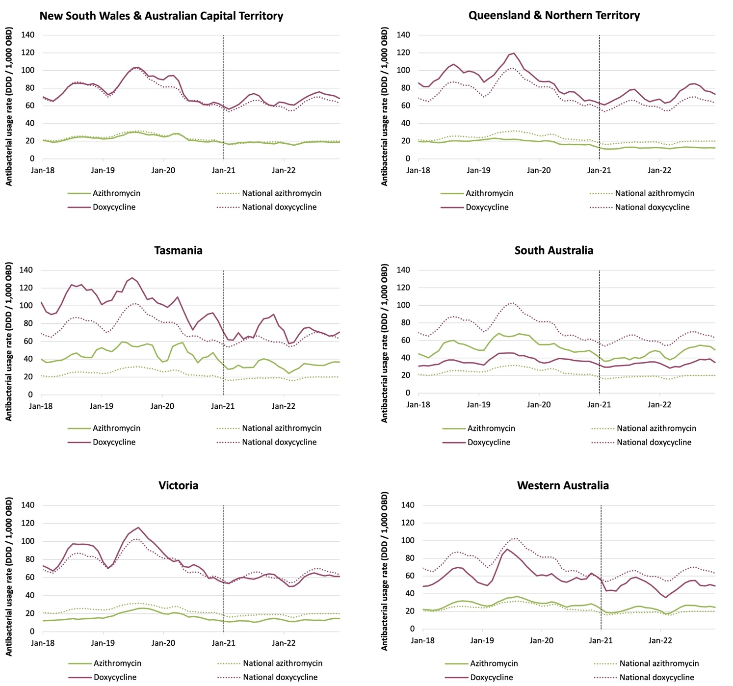
Note: Dashed line denotes exclusion of emergency department and operating theatre from acute inpatient usage rates. DDD = defined daily dose; NAUSP = National Antimicrobial Utilisation Surveillance Program; OBD = occupied bed days.
Similar to the usage seen in the ED, South Australia is the only state where inpatient usage of oral azithromycin is higher than usage of doxycycline. This is likely to be reflective of local guidelines for the treatment of community-acquired pneumonia.

Usage rates for intravenous broad-spectrum antibacterials,
2018–2022
Figures 21 to 25 illustrate the inpatient usage of broad-spectrum antibacterials. Note that usage rates for 2021 and 2022 do not include usage in the ED and operating theatre.

Penicillin-ß-lactamase inhibitor combinations: intravenous amoxicillin – clavulanic acid and piperacillin–tazobactam
Figure 21 illustrates the 5-year usage of piperacillin–tazobactam and intravenous amoxicillin – clavulanic acid. Intravenous amoxicillin – clavulanic acid usage has increased each year since it was first registered for use in Australia in 2017. Amoxicillin – clavulanic acid has a narrower spectrum of activity compared with piperacillin–tazobactam and, if used as an alternative to piperacillin–tazobactam, there is potential for a reduction in selection pressure for resistance. However, there has not been any decrease in piperacillin–tazobactam use observed with the concurrent increase in intravenous amoxicillin – clavulanic acid as might have been anticipated, highlighting an opportunity for education and stewardship.
Figure 21: Aggregate intravenous amoxicillin – clavulanic acid and piperacillin–tazobactam usage rates (DDD/1,000 OBD) in NAUSP contributor hospitals, by state and territory, 2018–2022 (3-month moving average)
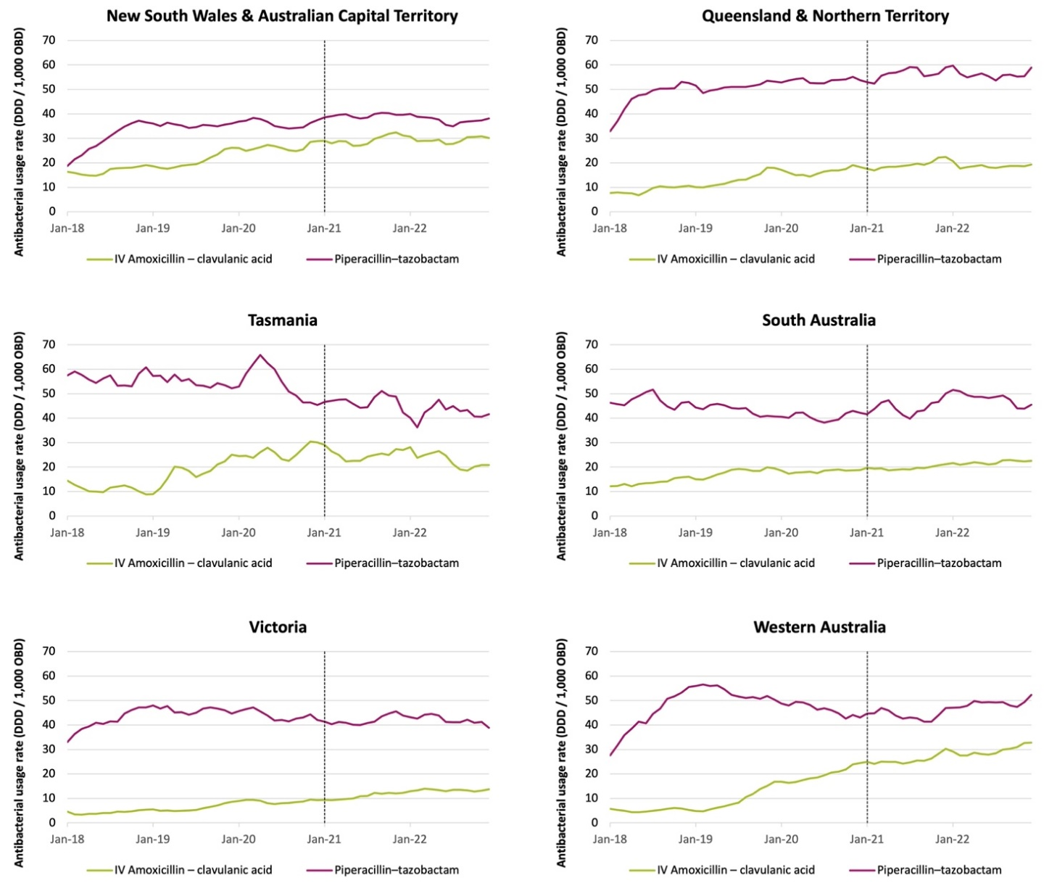
Note: Dashed line denotes exclusion of emergency department and operating theatre from acute inpatient usage rates. DDD = defined daily dose; IV = intravenous; NAUSP = National Antimicrobial Utilisation Surveillance Program;
OBD = occupied bed days.

Third- and fourth-generation cephalosporins: cefepime, ceftazidime and ceftriaxone
Usage rates for the broad-spectrum third- and fourth-generation cephalosporins, all of which are administered intravenously, are shown in Figure 22. Ceftriaxone is the most used of these agents; the stratification of ED usage from other acute settings has resulted in a drop in the calculated usage rates in inpatient settings. It is likely that high usage in the ED setting was comprising much of the total hospital usage rates reported prior to January 2021. However, stratification of the data was not possible to confirm this observation. From January 2021, hospitals can access usage reports specific to the ED so that they can monitor usage of this high-volume antibacterial in the emergency setting.
Figure 22: Aggregate third- and fourth-generation cephalosporin usage rates (DDD/1,000 OBD) in NAUSP contributor hospitals, by state and territory, 2018–2022 (3-month moving average)
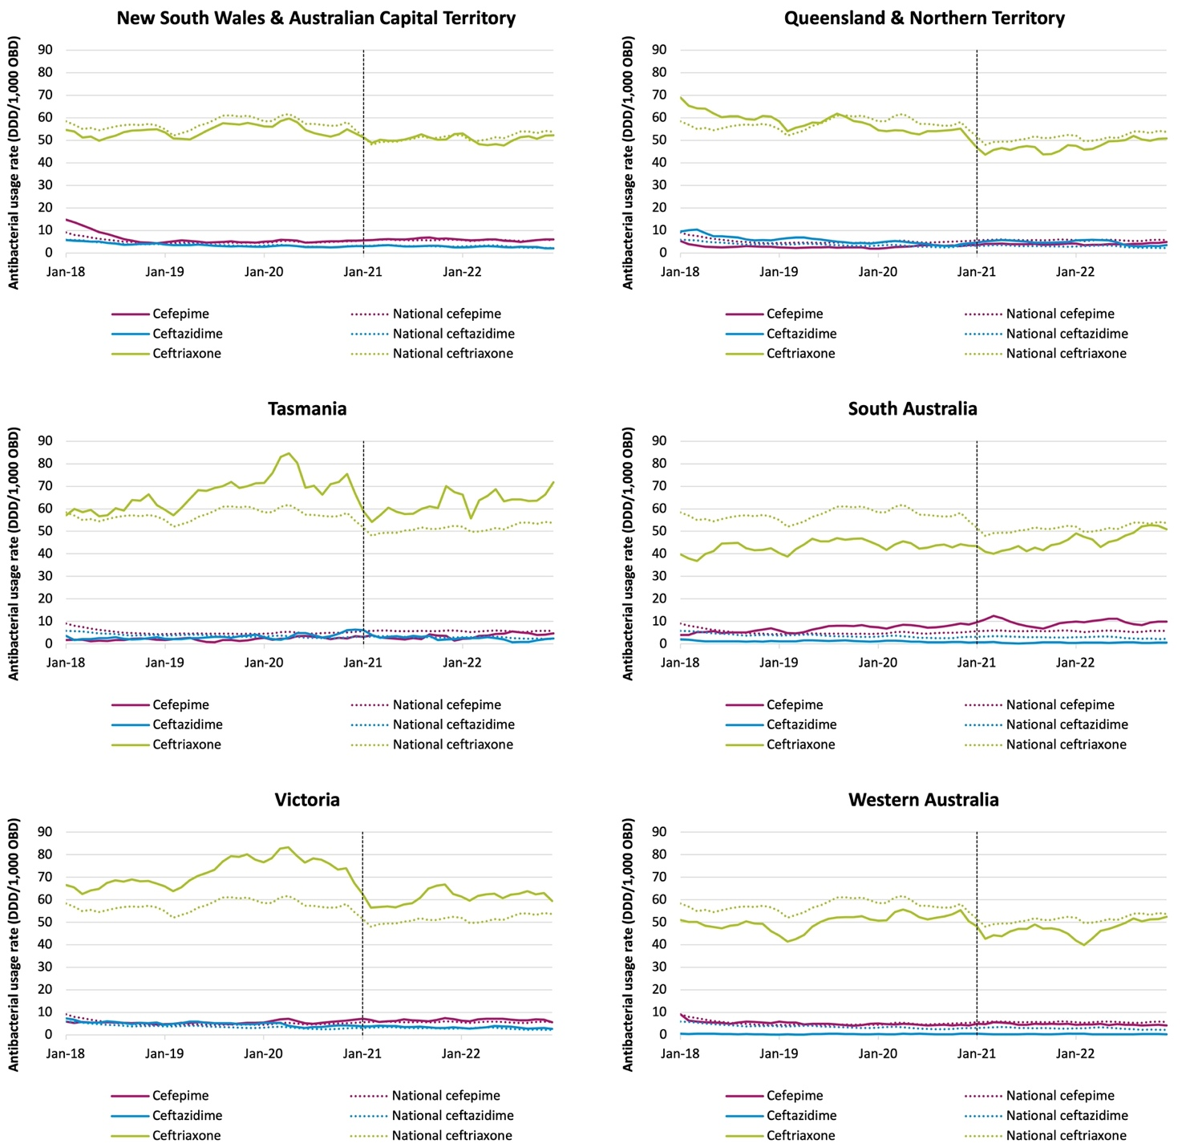
Note: Dashed line denotes exclusion of emergency department and operating theatre from acute inpatient usage rates. DDD = defined daily dose; NAUSP = National Antimicrobial Utilisation Surveillance Program; OBD = occupied bed days.

National proportional annual use of penicillin-ß-lactamase inhibitor combinations and third- and fourth-generation cephalosporins, 2018–2022
The consumption of penicillin-ß-lactamase inhibitor combinations (piperacillin–tazobactam and amoxicillin – clavulanic acid), third-generation cephalosporins (ceftriaxone and ceftazidime) and the fourth-generation cephalosporin cefepime is of interest not only because of the critical role they play in the treatment of severely ill patients but also due to the correlation between their use and increasing rates of resistance.
Since its introduction to the Australian market in 2017, use of intravenous amoxicillin – clavulanic acid is trending upwards (Figure 23). While the 2021 rate appears lower than that seen 2020, it is important to remember the methodological updates that resulted in ED usage being removed from the calculated 2021 and 2022 inpatient usage rates. In 2022, the inpatient usage rate was 22.9 DDD/1,000 OBD – an increase of 4.2% from 2021.
Despite an increase in the use of intravenous amoxicillin – clavulanic acid, there has not been a corresponding decrease in the use of piperacillin–tazobactam observed as may have been expected. Instead, there has been 14.3% increase in usage over the last 5 years from 39.3 DDD/1,000 OBD in 2018 to 44.9 DDD/1,000 OBD in 2022.
Figure 23: National aggregate inpatient intravenous penicillin-ß-lactamase inhibitor combinations and third- and fourth-generation cephalosporins usage rates (DDD/1,000 OBD) in NAUSP contributor hospitals, 2018–2022
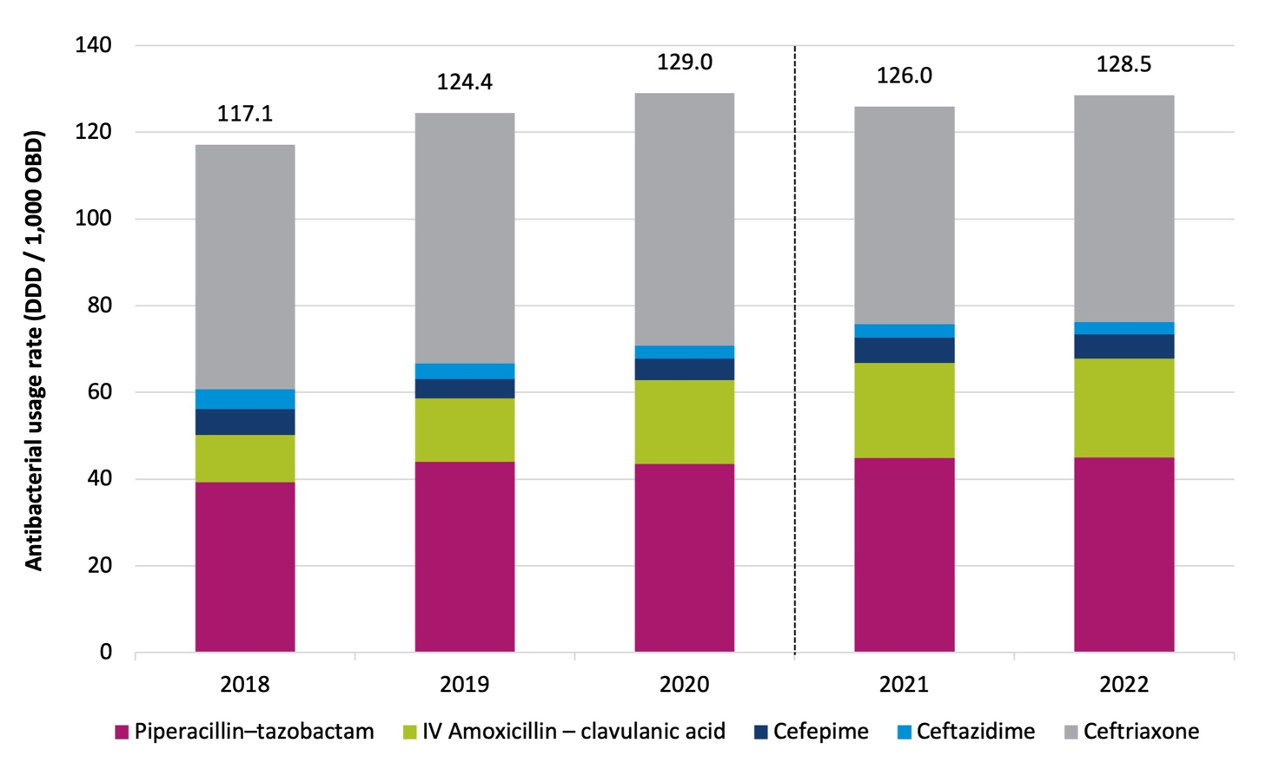
Note: Dashed line denotes exclusion of emergency department and operating theatre from acute inpatient usage rates. DDD = defined daily dose; IV = intravenous; NAUSP = National Antimicrobial Utilisation Surveillance Program;
OBD = occupied bed days.

Acute inpatient usage rates for these broad-spectrum agents vary substantially between the states and territories. Figure 24 illustrates the comparative annual aggregate usage between the jurisdictions for 2022. Nationally, the relative proportionate use of piperacillin–tazobactam to intravenous amoxicillin – clavulanic acid is approximately two-thirds to one-third; however, there is wide variation at a jurisdictional level.
Figure 24: Aggregate inpatient intravenous penicillin-ß-lactamase inhibitor combinations and third- and fourth-generation cephalosporins usage rates (DDD/1,000 OBD) in NAUSP contributor hospitals, by state and territory, 2022
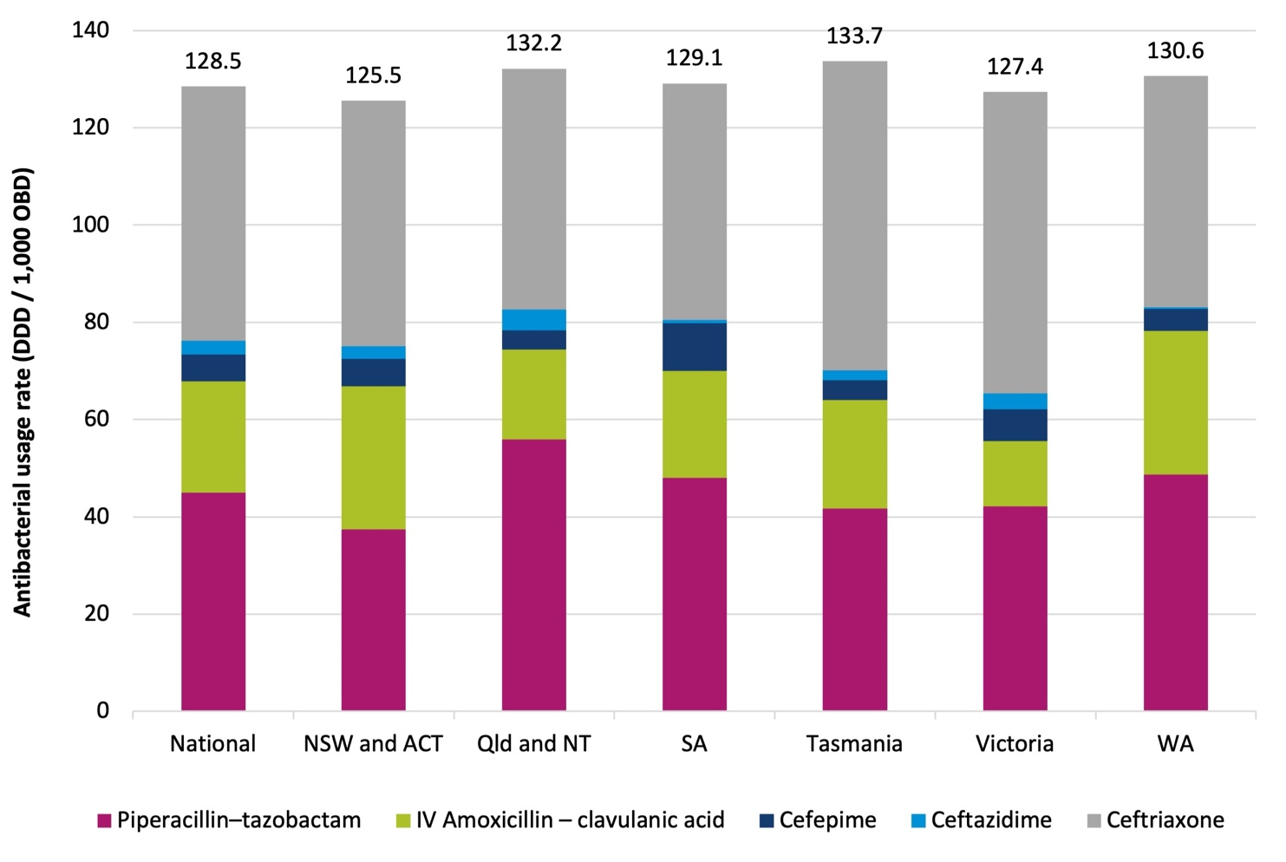
ACT = Australian Capital Territory; DDD = defined daily dose; IV = intravenous; NAUSP = National Antimicrobial Utilisation Surveillance Program; NSW = New South Wales; NT = Northern Territory; OBD = occupied bed days; Qld = Queensland; SA = South Australia; WA = Western Australia.

Carbapenems: meropenem and ertapenem
Figure 25 shows the longitudinal trends in usage rates of meropenem and ertapenem in the inpatient setting between 2018 and 2022. Imipenem–cilastatin and doripenem are rarely used and have not been included in the figure below.
Figure 25: Aggregate carbapenem usage rates (DDD/1,000 OBD) in NAUSP contributor hospitals, by state and territory, 2018–2022 (3-month moving average)
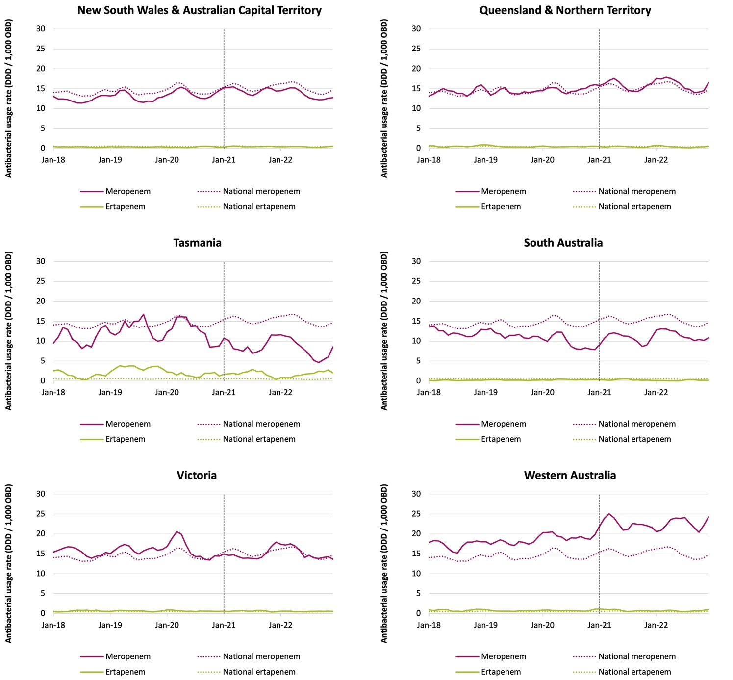
Note: Usage of imipenem–cilastatin, doripenem and meropenem–vaborbactam are negligible and not shown. Dashed line denotes exclusion of emergency department and operating theatre from acute inpatient usage rates.
DDD = defined daily dose; NAUSP = National Antimicrobial Utilisation Surveillance Program; OBD = occupied bed days.

Lincosamides: intravenous clindamycin and lincomycin
Two lincosamide antimicrobials are available in Australia; clindamycin is marketed as both oral and intravenous formulations and lincomycin only as intravenous. Clindamycin is the preferred intravenous lincosamide in all states and territories, except for Queensland/NT, where lincomycin is the favoured agent (Figure 26). Lincosamides are commonly used to treat Gram-positive organisms, often as an alternative option in patients with high-risk allergies to ß-lactam antimicrobials or in methicillin-resistant strains (for example, MRSA). Despite this, resistance to clindamycin is increasing in MRSA isolates12, threatening the usefulness of these agents for treatment of MRSA infections.
Figure 26: Aggregate intravenous lincosamide usage rates (DDD/1,000 OBD) in NAUSP contributor hospitals, by state and territory, 2018–2022 (3-month moving average)
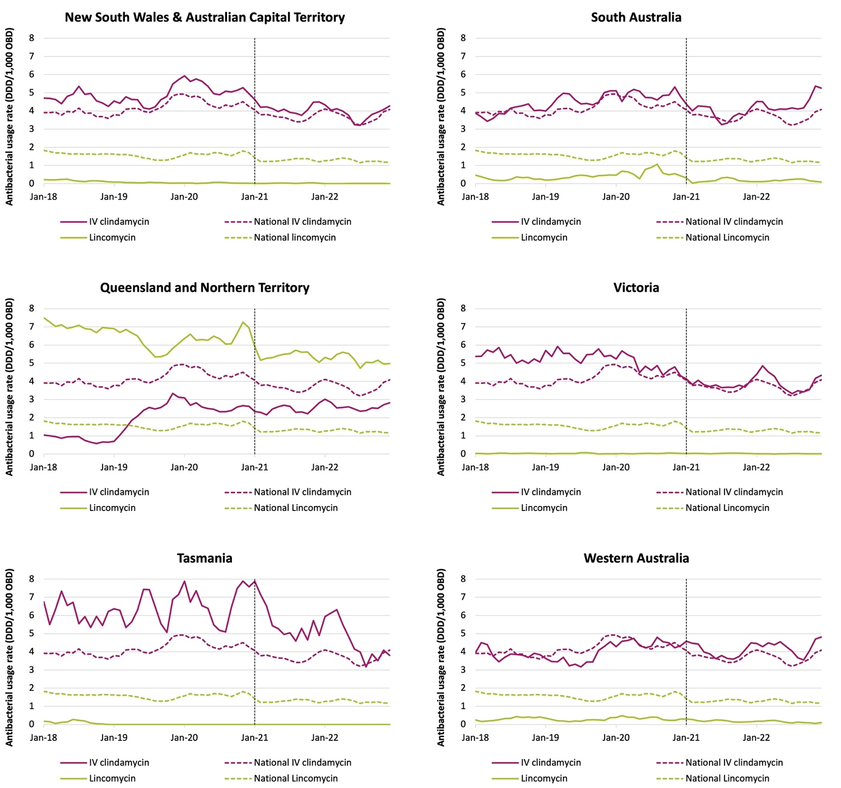
Note: Dashed line denotes exclusion of emergency department and operating theatre from acute inpatient usage rates. DDD = defined daily dose; IV = intravenous; NAUSP = National Antimicrobial Utilisation Surveillance Program;
OBD = occupied bed days.

Usage rates for reserve-line antibacterials
Reserve-line antibacterials are generally restricted to the treatment of infections caused by pathogens resistant to first-line options in prescribing guidelines or where the patient may not be able to be treated with preferred options due to allergies or adverse effects.

Fluoroquinolones: ciprofloxacin, moxifloxacin and norfloxacin
Figure 27 shows the usage rates for ciprofloxacin and moxifloxacin (oral and intravenous combined, for both antibacterials) together with norfloxacin, which is only available in oral formulation. Ciprofloxacin is the most common fluoroquinolone used in Australian hospitals, but usage is trending down; the average monthly usage rate in Tasmania fell 24.0% in 2022 to 17.7 DDD/1,000 OBD. Use is also trending down in NSW/ACT and Western Australia. In contrast, the average monthly usage rate increased 8.0% in South Australia from 14.6 DDD/1,000 OBD in 2021 to 15.8 DDD/1,000 OBD in 2022.
Figure 27: Aggregate fluoroquinolone usage rates (DDD/1,000 OBD) in NAUSP contributor hospitals, by state and territory, 2018–2022 (3-month moving average)
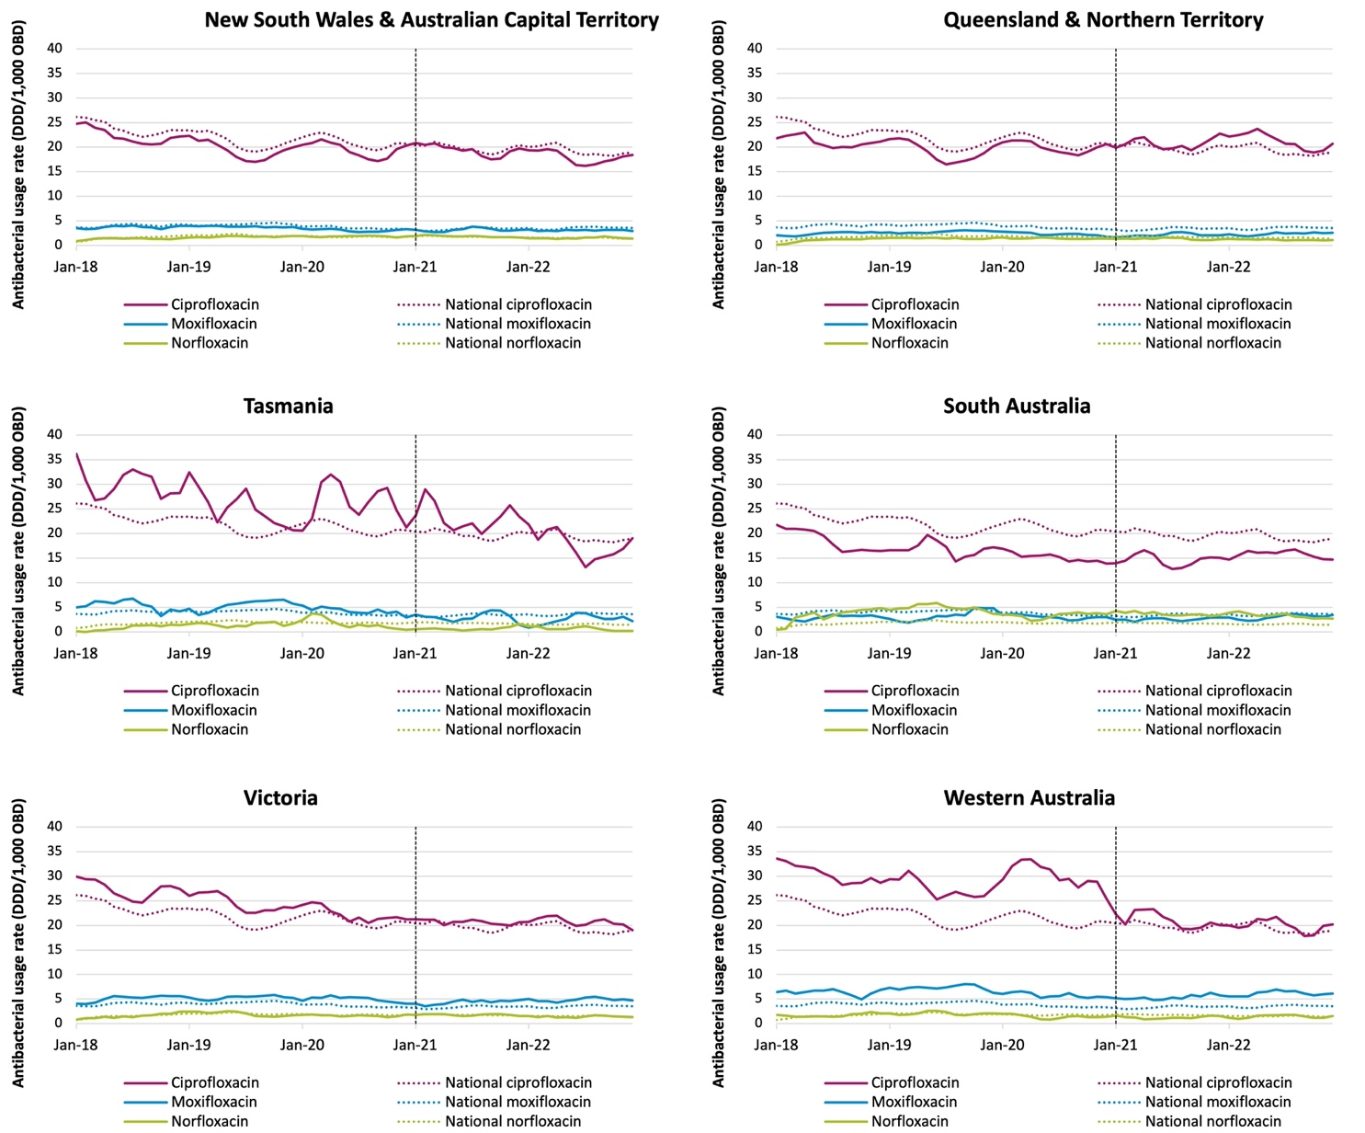
Note: Dashed line denotes exclusion of emergency department and operating theatre from acute inpatient usage rates. DDD = defined daily dose; NAUSP = National Antimicrobial Utilisation Surveillance Program; OBD = occupied bed days.

Ceftaroline, ceftazidime–avibactam and ceftolozane–tazobactam
Figure 28 shows the usage of newly introduced cephalosporins for each of the states and territories. These agents are considered to be reserve-line only. There was a global shortage of ceftolozane– tazobactam during the period December 2020 to March 2022.13 Although usage of these agents across Australia is generally low (<1.0 DDD/1,000 OBD), prior to the shortage usage of ceftolozane–tazobactam was increasing, particularly in Western Australia. Ceftazidime–avibactam was first registered in Australia in February 2019. While usage remains low in NAUSP contributor hospitals, increases can be observed in Tasmania and Western Australia in 2022.
Figure 28: Ceftaroline, ceftazidime–avibactam and ceftolozane–tazobactam usage rates in NAUSP contributor hospitals, by state and territory, 2018–2022 (5-month moving average)
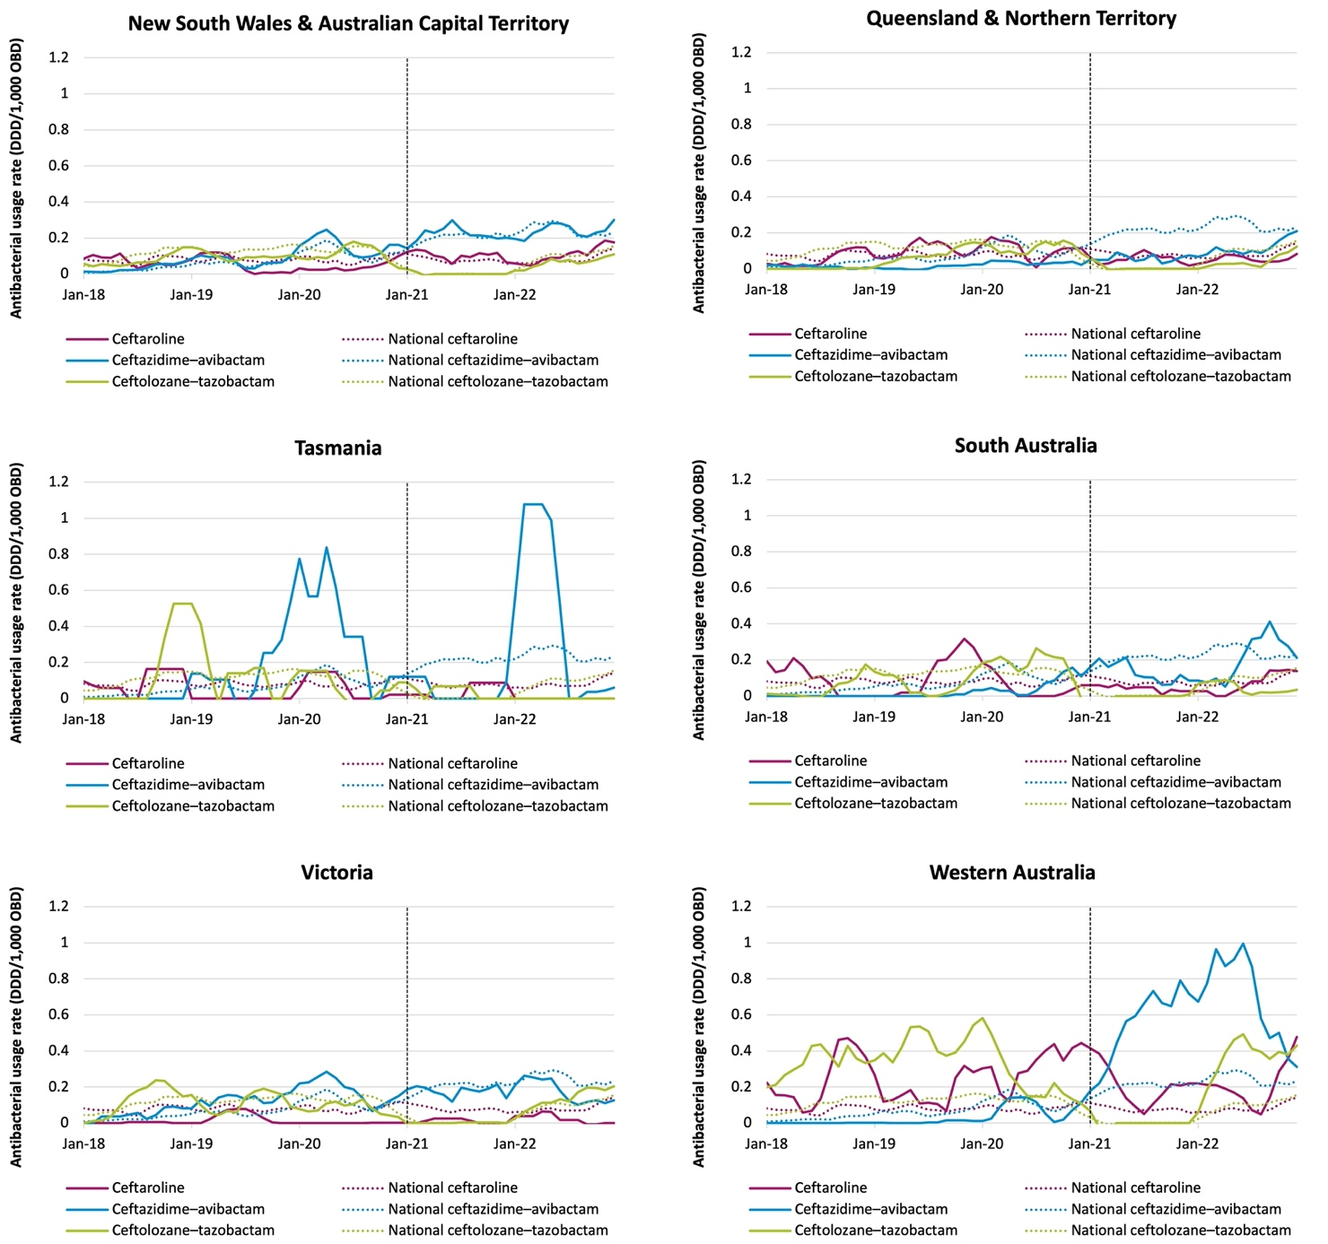
Note: Dashed line denotes exclusion of emergency department and operating theatre from acute inpatient usage rates. DDD = defined daily dose; NAUSP = National Antimicrobial Utilisation Surveillance Program; OBD = occupied bed days.

Daptomycin, linezolid and pristinamycin
Daptomycin is a reserve-line antibacterial used for the treatment of Gram-positive infections. Although daptomycin resistance in Gram-positive bacteria is uncommon in Australia, there are increasing reports of daptomycin resistance in Staphylococcus aureus and linezolid resistance in Enterococcus species.14 Daptomycin usage is trending upwards in Australian hospitals, particularly in NSW/ACT, South Australia and Western Australia (Figure 29). Usage of linezolid is consistently low across all states and territories, except in Tasmania, where some variation can be seen (note that low contributor count here may indicate a small number of patients receiving therapy). Use of pristinamycin, an oral streptogramin antibacterial used for treatment of MRSA and vancomycin-resistant enterococci, remains low.
Figure 29: Daptomycin, linezolid and pristinamycin usage rates in NAUSP contributor hospitals, by state and territory, 2018–2022 (5-month moving average)
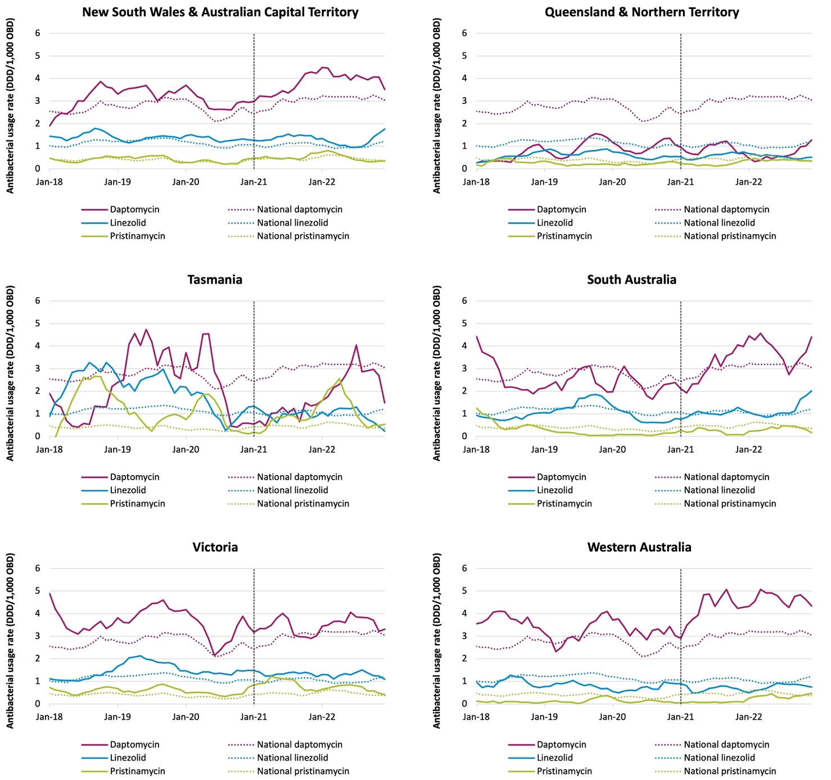
Note: Dashed line denotes exclusion of emergency department and operating theatre from acute inpatient usage rates. DDD = defined daily dose; NAUSP = National Antimicrobial Utilisation Surveillance Program; OBD = occupied bed days.

Colistin, tigecycline and fosfomycin
Colistin and tigecycline are last-line antibacterials used as salvage treatment for multidrug-resistant infections. Colistin is bactericidal against Gram-negative bacteria that are resistant to other drug classes, including strains of Pseudomonas aeruginosa and Acinetobacter baumannii.15,16 Usage of both these antibacterials was very low in Australian hospitals (Figure 30), although usage rates were higher on average in Tasmania. Fosfomycin has activity against many strains of multidrug-resistant Gram-negative bacteria but is inactive against P. aeruginosa. Oral fosfomycin is a reserve-line agent used to treat multidrug-resistant urinary tract infections. Intravenous fosfomycin is rarely used in NAUSP contributor hospitals.
Figure 30: Colistin, tigecycline and fosfomycin usage rates in NAUSP contributor hospitals, by state and territory, 2018–2022 (5-month moving average)
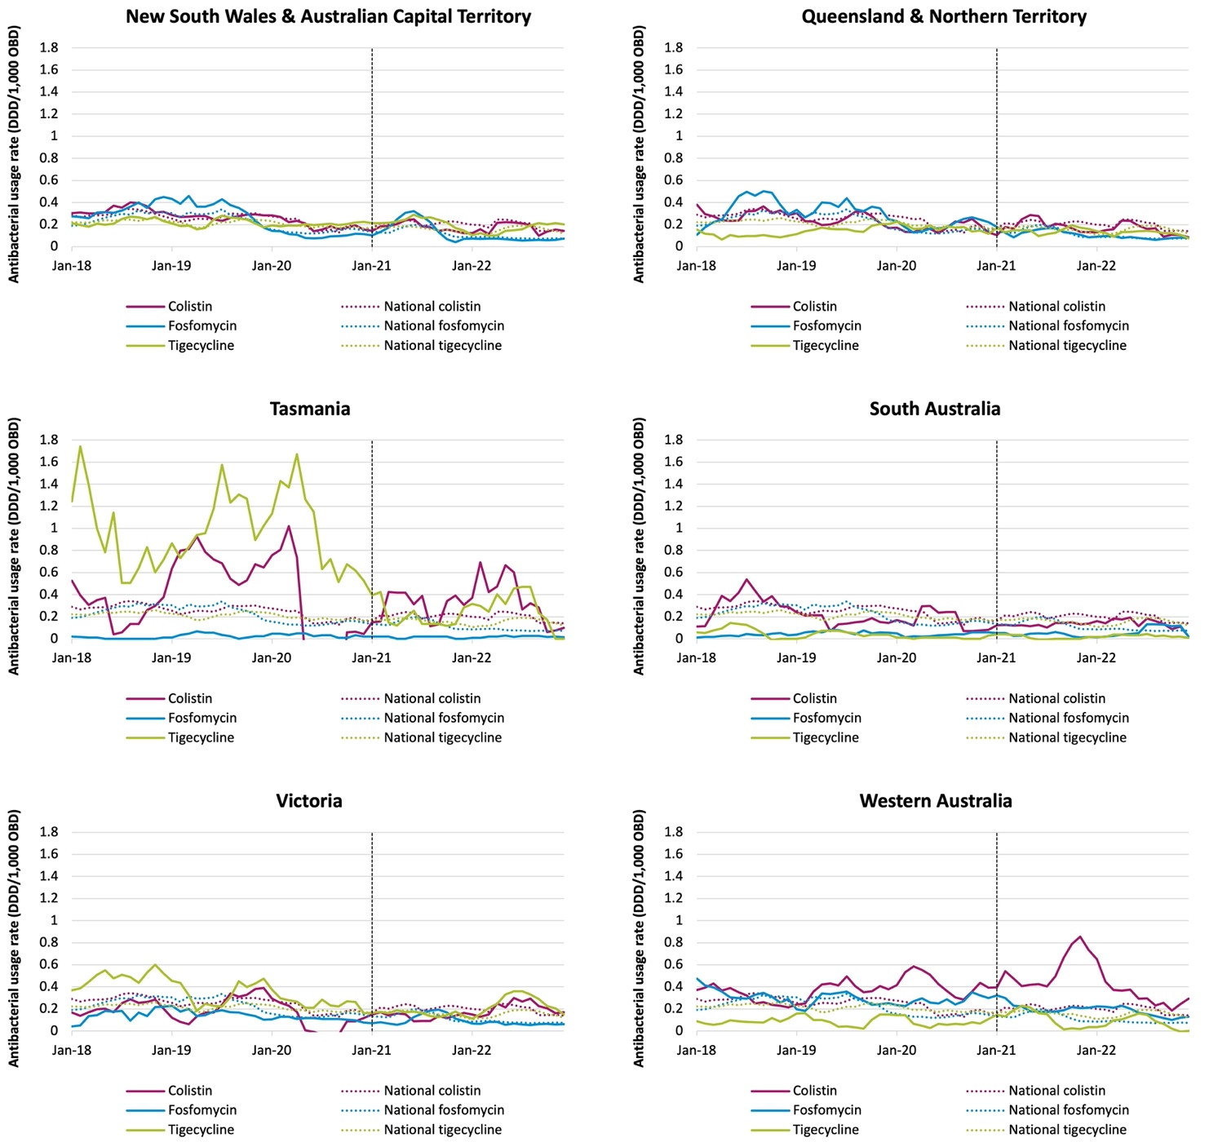
Note: Dashed line denotes exclusion of emergency department and operating theatre from acute inpatient usage rates. DDD = defined daily dose; NAUSP = National Antimicrobial Utilisation Surveillance Program; OBD = occupied bed days.

Antifungal usage rates
Systemic antifungals are used for prophylaxis and treatment of invasive fungal infections. The risk of invasive fungal infections is higher in immunocompromised individuals such as those undergoing chemotherapy or transplantation or those who have primary or acquired immunodeficiencies. There are uncertainties regarding the impact of antifungal use and the acquisition of fungal resistance; however, overuse of antifungals may lead to the development of resistant fungal pathogens that are more difficult and costly to treat.
Candida auris, an emergent fungal pathogen associated with high mortality, was first reported in 2009 in Japan.17 Infections with C. auris are increasing globally18 and there is an increasing number of cases reported annually in Australia.19 Echinocandins (for example, anidulafungin or caspofungin) are often considered first-line agents for treating C. auris infections; however, approximately 2% to 10% of clinical isolates exhibit echinocandin resistance, which usually emerges during treatment.20
Antifungal stewardship is becoming increasingly important to ensure appropriate antifungal selection, dosing and monitoring.21 Surveillance of antifungal use allows benchmarking between institutions to identify unexpected trends in usage and enable targeted educational interventions to improve prescribing.
Routine submission of antifungal usage data to NAUSP commenced in 2017. Previous NAUSP reports have highlighted an increasing trend in antifungal use in Australian hospitals.1,2 Antifungal usage rates below are reported for the 5-year period 2018 to 2022.

National antifungal usage rates
Total annual inpatient antifungal use fell slightly from 37.3 DDD/1,000 OBD in 2021 to 35.6 DDD/1,000 OBD in 2022 – an overall decrease of 4.6% (Table 7).
Table 7: Annual aggregate inpatient antifungal usage rates (DDD/1,000 OBD) in NAUSP contributor hospitals, 2018–2022
Antifungal | 2018 | 2019 | 2020 | 2021 | 2022 | % change 2021 to 2022#
Amphotericin B (deoxycholate) | 0.26 | 0.24 | 0.23 | 0.23 | 0.16 | -30.4%
Amphotericin, liposomal* | 1.05 | 1.09 | 0.95 | 1.06 | 1.16 | 9.4%
Anidulafungin | 1.62 | 1.72 | 1.50 | 1.57 | 1.55 | -1.3%
Caspofungin | 0.51 | 0.35 | 0.82 | 1.07 | 0.97 | -9.3%
Fluconazole | 18.99 | 18.67 | 19.07 | 19.39 | 17.72 | -8.6%
Flucytosine | 0.14 | 0.16 | 0.16 | 0.16 | 0.14 | -12.5%
Griseofulvin | 0.14 | 0.13 | 0.11 | 0.12 | 0.10 | -16.7%
Isavuconazole | 0.02 | 0.01 | 0.02 | 0.04 | 0.05 | 25.0%
Itraconazole | 2.55 | 2.46 | 2.88 | 2.55 | 2.40 | -5.9%
Ketoconazole | 0.09 | 0.05 | 0.06 | 0.08 | 0.07 | -12.5%
Micafungin | 0.19 | 0.25 | 0.27 | 0.32 | 0.35 | 9.4%
Posaconazole | 5.90 | 5.97 | 6.20 | 6.32 | 6.53 | 3.3%
Terbinafine | 0.98 | 0.92 | 1.02 | 1.13 | 1.22 | 8.0%
Voriconazole | 3.20 | 3.15 | 3.12 | 3.23 | 3.14 | -2.8%
Total | 35.6 | 35.2 | 36.4 | 37.3 | 35.6 | -4.6%
* amphotericin lipid complex (Abelcet) has been discontinued and is not shown. Nil usage was reported in 2021 and 2022.
# % change calculated on usage rates prior to rounding. Excludes emergency department and operating theatre use. DDD = defined daily dose; NAUSP = National Antimicrobial Utilisation Surveillance Program; OBD = occupied bed days.
Echinocandin usage increased between 2018 and 2021 but appears to have stabilised in 2022 (Figure 31). Posaconazole use is also increasing, rising 10.2% over the 5-year period 2018 to 2022 (5.9 DDD/1,000 OBD in 2018 to 6.5 DDD/1,000 OBD in 2022). Fluconazole remains the most used agent in Australian hospitals, comprising approximately half of all inpatient systemic antifungal use. The inpatient usage rate for fluconazole in 2022 was 17.7 DDD/1,000 OBD – an 8.8% decrease from 2021 (19.4 DDD/1,000 OBD). The use of amphotericin formulations in NAUSP contributor hospitals has remained relatively constant over the last 5 years. Liposomal amphotericin is the most used amphotericin formulation (Table 7). Please note that, due to methodological changes to NAUSP, usage rates for 2021 and 2022 do not include antifungal use in the ED or operating theatre.
Figure 31: Annual aggregate inpatient antifungal usage rates (DDD/1,000 OBD) in NAUSP contributor hospitals, 2018–2022
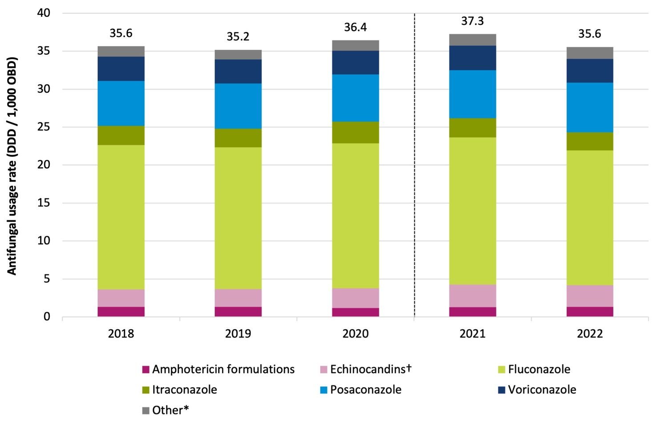
† ‘Echinocandins’ includes anidulafungin, caspofungin and micafungin.
* ‘Other’: flucytosine, griseofulvin, isavuconazole, ketoconazole and terbinafine.
Note: Dotted line denotes exclusion of emergency department and operating theatre from acute inpatient usage rates. Usage rates in 2021 and 2022 exclude emergency department and operating theatre.
DDD = defined daily dose; NAUSP = National Antimicrobial Utilisation Surveillance Program; OBD = occupied bed days

Antifungal use in Australian hospitals by state and territory
Total inpatient antifungal use declined between 2021 and 2022 in every state and territory in Australia, except for South Australia, where a 5.3% increase was seen (Figure 32). Annual usage in this state increased from 37.7 DDD/1,000 OBD in 2021 to 39.7 DDD/1,000 OBD in 2022, which represents a rate 11.5% higher than the national aggregate inpatient rate.
Use of individual antifungal agents varies between the states and territories. Itraconazole use in NSW/ ACT is over 5 times the rate of usage in all the other states and territories. Posaconazole use in South Australia is almost double the national aggregate rate.
Figure 32: Annual aggregate inpatient antifungal usage (DDD/1,000 OBD) in NAUSP contributor hospitals, by state and territory, 2021–2022
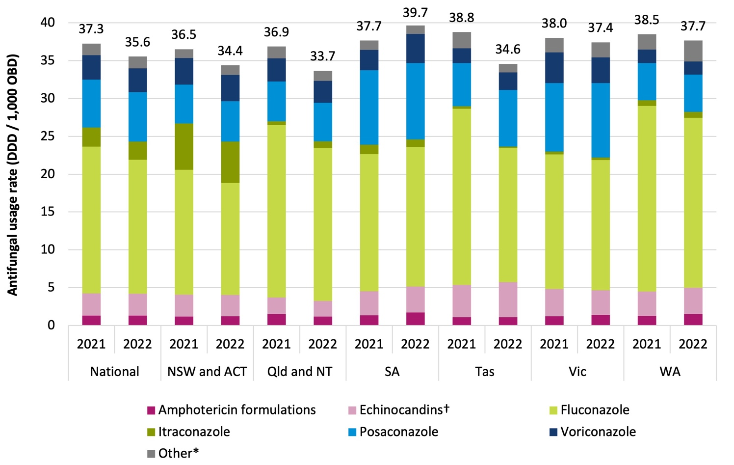
† ‘Echinocandins’ includes anidulafungin, caspofungin and micafungin.
* ‘Other’: flucytosine, griseofulvin, isavuconazole, ketoconazole and terbinafine.
Note: Usage rates in 2021 and 2022 exclude emergency department and operating theatre.
DDD = defined daily dose; NAUSP = National Antimicrobial Utilisation Surveillance Program; OBD = occupied bed days.
As mentioned previously, fluconazole is the most commonly used antifungal agent in the inpatient setting, comprising approximately 50% of systemic antifungal use in NAUSP contributor hospitals. The proportionate use of fluconazole varies between the jurisdictions; in NSW/ACT, fluconazole comprises 43.1% of inpatient antifungal use compared with 60.1% in Queensland/NT.
The proportionate use of echinocandins is highest in Tasmania, comprising 13.4% of systemic antifungal usage. This is substantially higher than observed in other jurisdictions; nationally, the proportionate use of echinocandins is 8.1%.

Hospital antifungal use by specialty setting or location
Haematology/oncology and critical care settings typically see higher rates of antifungal use due to their patient populations being at higher risk of invasive fungal infections (Figure 33).
Figure 33: National aggregate antifungal usage rates (DDD/1,000 OBD) in NAUSP contributor hospitals, by setting, 2018–2022 (with trendlines)
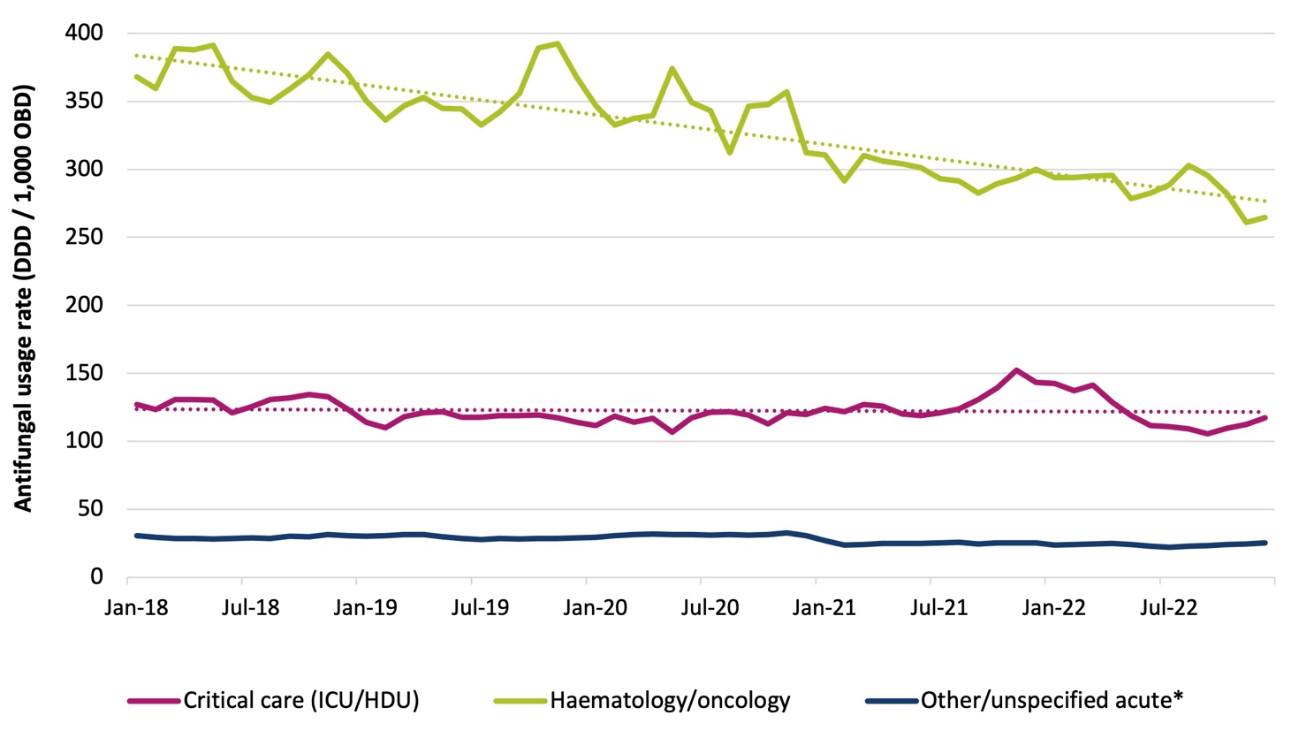
* ‘Other/unspecified acute’: acute inpatient settings that are not critical care or haematology/oncology – excludes emergency department and operating theatre from January 2021.
DDD = defined daily dose; NAUSP = National Antimicrobial Utilisation Surveillance Program; OBD = occupied bed days.
Figure 33 illustrates the decreasing trend in antifungal use in the inpatient haematology/oncology setting. This could be because this setting is a focus area for antifungal stewardship, and concerns of emerging antifungal resistance have increased strategies to improve antifungal use.21 Other reasons for the observed decreasing trend could be that more patients are being treated in their homes rather than the inpatient setting to minimise the risk of healthcare-acquired infections. Administration of intravenous antimicrobials in the home via a Hospital in the Home service (HITH) is an expanding area of healthcare delivery and is discussed later in this report.

Figure 34 shows the inpatient usage in the inpatient haematology/oncology setting by antifungal class or agent.

Figure 34: Aggregate inpatient haematology/oncology antifungal usage rates (DDD/1,000 OBD) in NAUSP contributor hospitals, 2018–2022
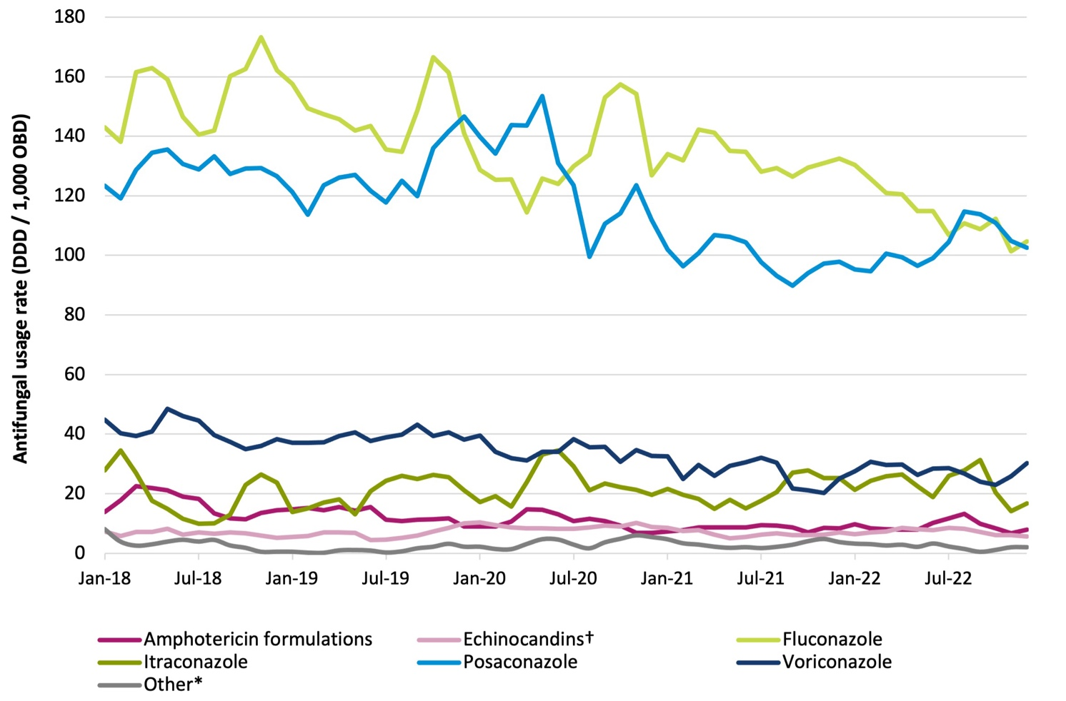
† ‘Echinocandins’ includes anidulafungin, caspofungin and micafungin.
* ‘Other’: flucytosine, griseofulvin, isavuconazole, ketoconazole and terbinafine.
Note: Usage rates from January 2021 exclude emergency department and operating theatre.
DDD = defined daily dose; NAUSP = National Antimicrobial Utilisation Surveillance Program; OBD = occupied bed days.
Fluconazole use is trending downwards; the average monthly fluconazole usage rate in the haematology/ oncology inpatient setting decreased 14.1%, from 131.8 DDD/1,000 OBD in 2021 to 113.2 DDD/1,000 OBD in 2022.

Critical care use by antifungal agent, by state and territory
Figures 35 below illustrates the monthly antifungal use in the critical care setting for each of the states and territories over the 5-year period, January 2018 to December 2022.
Figure 35: Aggregate critical care antifungal usage (DDD/1,000 OBD) in NAUSP contributor hospitals, by state and territory, 2018–2022 (3-month moving average)
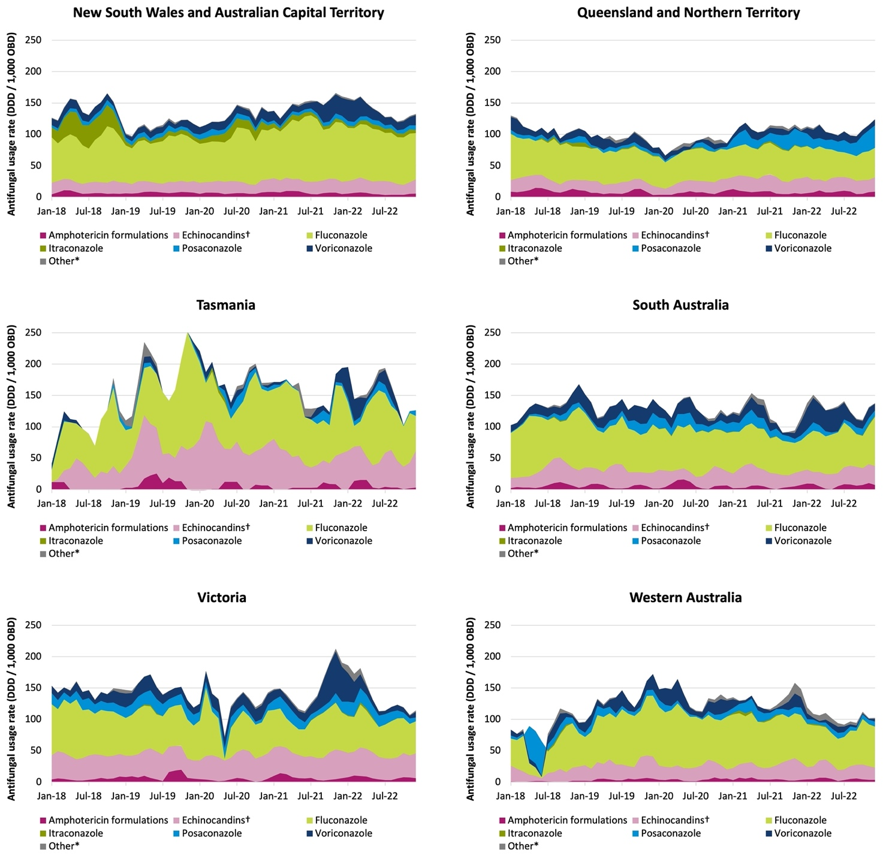
† ‘Echinocandins’ includes anidulafungin, caspofungin and micafungin.
* ‘Other’: flucytosine, griseofulvin, isavuconazole, ketoconazole and terbinafine.
DDD = defined daily dose; NAUSP = National Antimicrobial Utilisation Surveillance Program; OBD = occupied bed days.
Echinocandin usage as a proportion of all systemic antifungal use is higher in the critical care setting compared with other inpatient settings. On average, echinocandin usage in Tasmania comprised 31.7% of total monthly antifungal use in critical care over the last 5 years. Victoria had the second highest proportional use, with echinocandins making up 27.6% of antifungal use in this setting. Queensland/ NT had the lowest proportionate use of echinocandins in critical care; on average each month, this antifungal class comprised 15.3% of systemic antifungal use.

Topical antimicrobials
Despite not being ingested or administered systemically, overuse of topical antimicrobials contributes to the antimicrobial burden, increasing the risk of AMR. There are very few clinical situations requiring treatment with topical antibacterials, and there are several stewardship resources developed specifically to assist in educating prescribers to reduce inappropriate use.22
Topical antimicrobials have been included in the NAUSP data definitions for capture and surveillance since 2019. At the time of writing this report, there is usage data for 52 unique antimicrobials in topical formulations included in the NAUSP database.
Defined daily doses, as defined by the WHO, do not apply to topical antimicrobials; therefore, topical usage rates are presented in this report as the number of grams (g) of active ingredient per 1,000 OBD.

High-volume topical antimicrobials
This section provides the usage rates for some of the high-volume topical antimicrobials used in Australian hospitals for the 4-year period 2019 to 2022. From January 2021, ED and theatre usage is reported separately from usage rates in other acute settings. Relative use of the high-volume topical antimicrobials is variable between the states and territories, as illustrated in Figure 36.

Figure 36: Aggregate inpatient topical antimicrobial use (grams/1,000 OBD) in NAUSP contributor hospitals, by state and territory, 2022
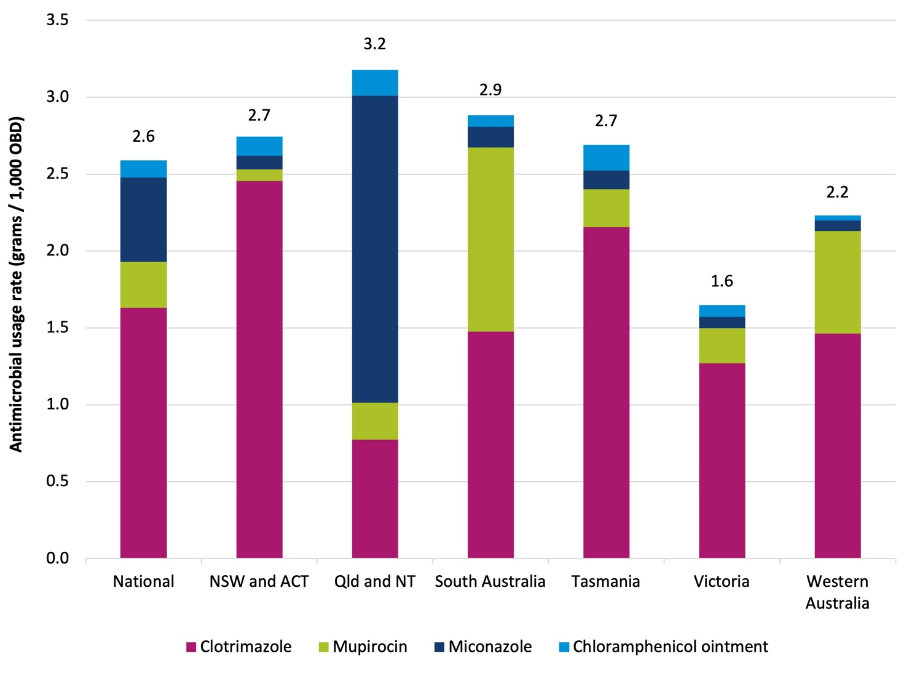
Note: Usage rates exclude emergency department and operating theatre.
ACT = Australian Capital Territory; NAUSP = National Antimicrobial Utilisation Surveillance Program; NSW = New South Wales; NT = Northern Territory; OBD = occupied bed days; Qld = Queensland.

Chloramphenicol ointment
Topical chloramphenicol ointment is frequently applied to surgical wounds, despite the practice generally not being recommended in most clinical situations. The stratification of theatre usage from other acute inpatient usage from January 2021 has illustrated the high proportionate use of this product in the theatre and recovery setting (Figure 37). Outside of theatre, usage of chloramphenicol ointment is relatively low. (Note: One 4g tube of 1% chloramphenicol ointment contains 0.04g chloramphenicol.)
Figure 37: Aggregate inpatient use of chloramphenicol 1% ointment (grams of active ingredient*/1,000 OBD) in NAUSP contributor hospitals by state and territory, 2019–2022 (3-month moving average)
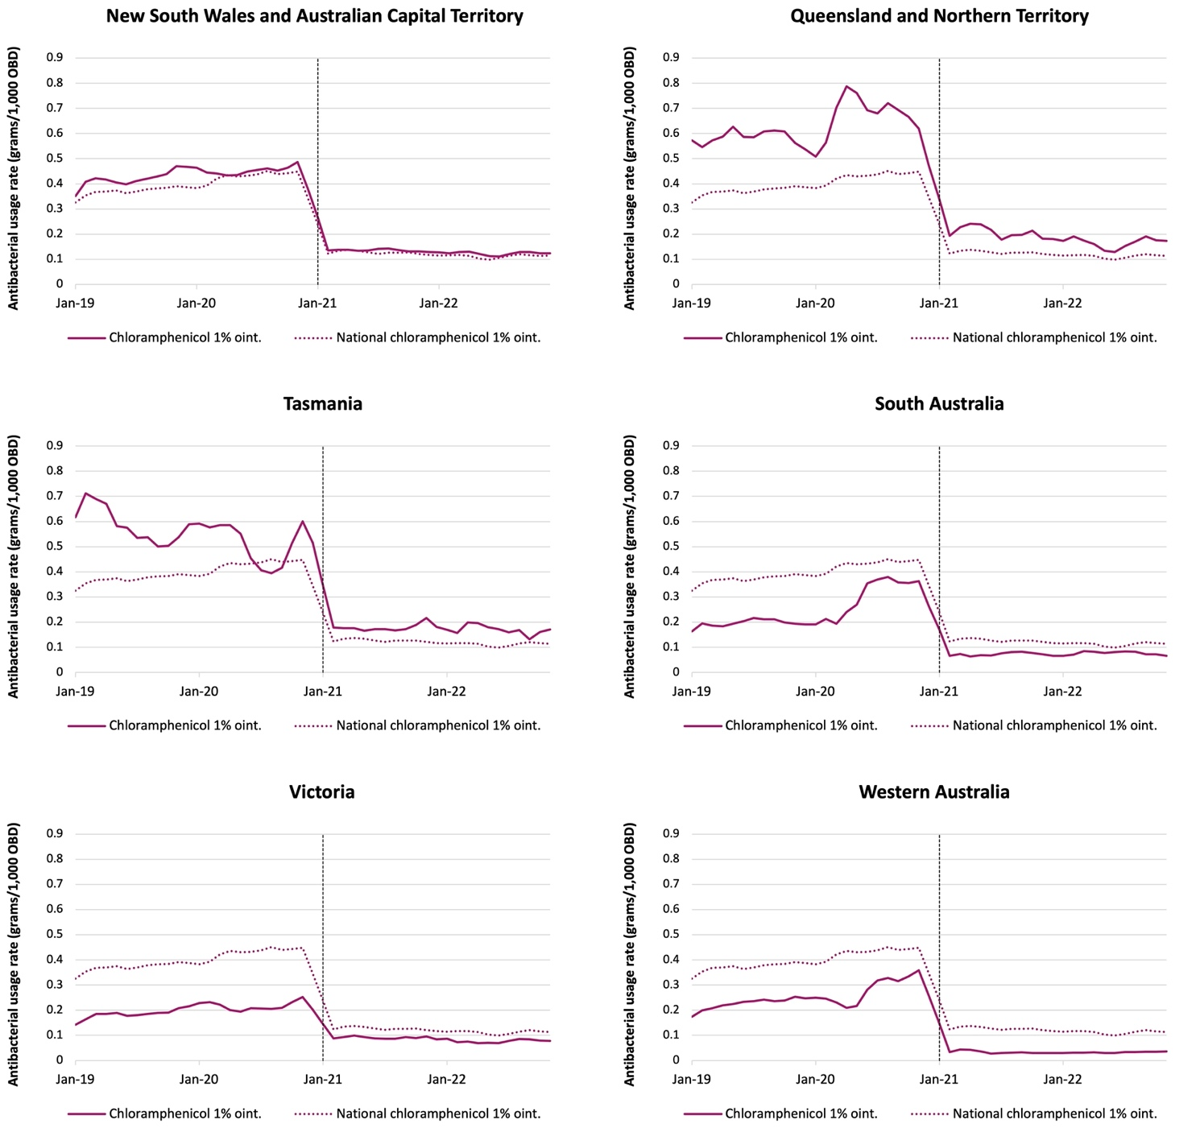
* One 4g tube of 1% chloramphenicol contains 0.04g chloramphenicol.
Note: Dashed line denotes exclusion of emergency department and operating theatre from acute inpatient usage rates. NAUSP = National Antimicrobial Utilisation Surveillance Program; OBD = occupied bed days; oint. = ointment.

Clotrimazole and miconazole
Clotrimazole and miconazole are the most frequently used topical antifungals. There is notable variation in the usage rates of these topical antifungals between the states and territories (Figure 38). Queensland/ NT has the highest usage rate for topical miconazole (3 times the national aggregate usage rate) and lower use of clotrimazole compared with other states. Differences in the preferred product approved for formulary listings in public hospitals may account for some of the variation between jurisdictions. Clotrimazole usage is highest in NSW/ACT, closely followed by Tasmania.
Figure 38: Aggregate inpatient use of topical clotrimazole and topical miconazole (grams of active ingredient/1,000 OBD) in NAUSP contributor hospitals by state and territory, 2019–2022 (3-month moving average)
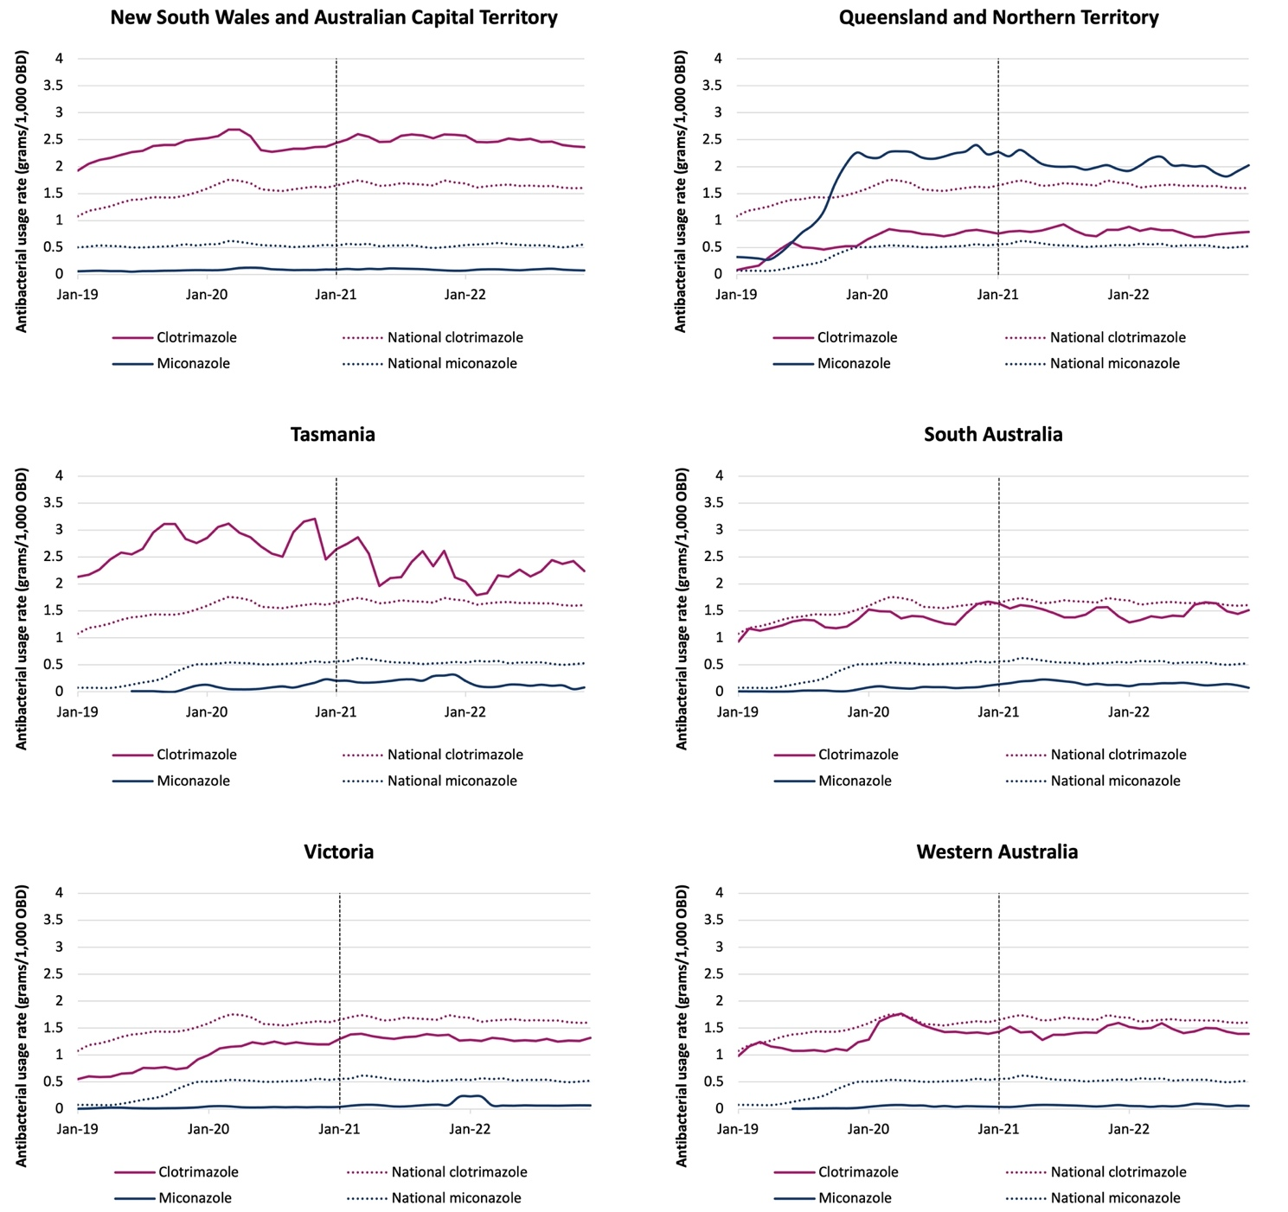
Note: Dashed line denotes exclusion of emergency department and operating theatre from acute inpatient usage rates. NAUSP = National Antimicrobial Utilisation Surveillance Program; OBD = occupied bed days.

Hospital in the Home
In Australia, HITH services provide acute or subacute care to patients in their usual place of residence as a substitute for hospital accommodation. HITH patients receive hospital-level care and are considered inpatients under the care of a designated admitting clinician or treatment team. Patients are commonly administered intravenous antimicrobials in this setting, which may also be referred to as OPAT (outpatient parenteral antimicrobial therapy).
From January 2021, hospitals have been invited to submit HITH antimicrobial usage data to NAUSP to enable monitoring of usage in this setting. Sixty-one hospitals are registered to contribute HITH data to NAUSP (Table 8), with 58 sites submitting data between January 2021 and December 2022. Because models of care for HITH differ substantially between hospitals and jurisdictions, comparator rates are not provided to contributor hospitals for the purpose of benchmarking. However, HITH providers are still able to monitor trends in their antimicrobial use over time and utilise NAUSP data to inform quality improvement activities in this setting.
Table 8: Number of NAUSP contributors registered to contribute Hospital in the Home data by AIHW peer group
 | Principal referral | Private | Public Acute Group A | Public Acute Group B | Public Acute Group C | Total by jurisdiction
ACT | 1 |  | 1 |  |  | 2
NSW | 6 |  | 11 | 4 | 1 | 22
NT |  |  | 1 |  |  | 1
Qld | 4 | 2 | 8 | 4 |  | 18
SA |  |  | 1 |  |  | 1
Vic | 2 | 1 | 8 | 3 | 1 | 15
WA | 1 | 1 |  |  |  | 2
Total by peer group | 14 | 4 | 30 | 11 | 2 | 61
ACT = Australian Capital Territory; AIHW = Australian Institute of Health and Welfare; NAUSP = National Antimicrobial Utilisation Surveillance Program; NSW = New South Wales; NT = Northern Territory; Qld = Queensland; SA = South Australia; Vic = Victoria; WA = Western Australia.

Analysis of HITH data that have been submitted to NAUSP indicates that, on average, 86% of monthly antimicrobial use in this setting is parenteral therapy (Figure 39).
Cefalexin is the most used oral antibacterial in the HITH setting, comprising 16.1% of total oral antibacterial usage contributed to NAUSP during 2021 and 2022. Oral amoxicillin – clavulanic acid comprised 14.6% of oral HITH antibacterial use, with ciprofloxacin and doxycycline comprising 9.3% and 9.0% respectively during the 2-year period.

Figure 39: Proportion of parenteral and oral antimicrobial use (as a percentage of total DDDs) in the Hospital in the Home setting in NAUSP contributor hospitals (n=61),
2021–2022
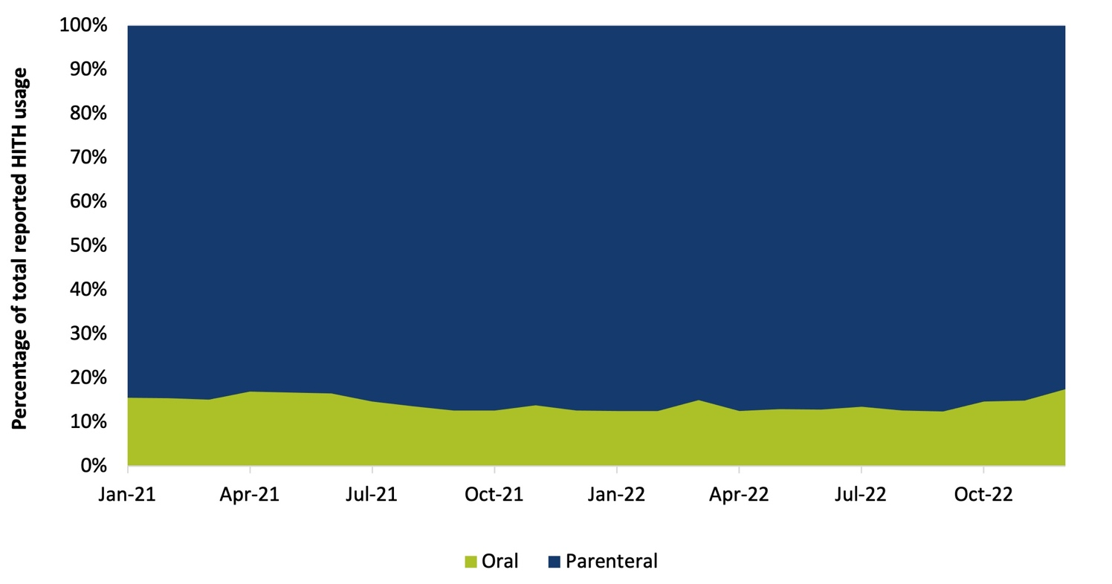
NAUSP = National Antimicrobial Utilisation Surveillance Program, HITH = Hospital in the Home.

Analysis of the parenteral antimicrobials used in the HITH setting found that flucloxacillin is the most used intravenous antibacterial, comprising 31.4% of all usage (by total DDDs) reported to NAUSP. Table 9 illustrates the top 10 most frequently used parenteral antibacterials in the HITH data reported to NAUSP in 2021 and 2022, as a proportion of total DDDs.

Table 9: Top 10 parenteral antibacterials in Hospital in the Home data from NAUSP contributor hospitals, 2021–2022
Antibacterial | Total DDDs reported to NAUSP |  |  | Proportion of total use (%)
 | 2021 (n=53) | 2022 (n=57) | Both years* (n=58)
Flucloxacillin | 77,755 | 75,161 | 152,916 | 30.9
Cefazolin | 48,395 | 55,373 | 103,768 | 21.0
Benzylpenicillin | 31,191 | 60,800 | 91,991 | 18.6
Vancomycin | 9,482 | 27,448 | 36,929 | 7.5
Ceftriaxone | 16,555 | 16,931 | 33,485 | 6.8
Piperacillin–tazobactam | 14,074 | 16,786 | 30,860 | 6.2
Ertapenem | 4,967 | 5,486 | 10,453 | 2.1
Ceftazidime | 3,351 | 3,524 | 6,875 | 1.4
Meropenem | 2,449 | 3,140 | 5,588 | 1.1
Teicoplanin | 2,454 | 1,839 | 4,293 | 0.9
* Number of contributors with eligible HITH data in both 2021 and 2022.
DDD = defined daily dose; NAUSP = National Antimicrobial Utilisation Surveillance Program.
Other antibacterials comprised the remaining 3.4% of total parenteral use in the HITH setting, including cefepime (0.8%) and daptomycin (0.7%).

Surveillance pilot projects in other settings
The methodology used to measure antimicrobial use in Australian hospitals can be applied to undertake surveillance in other settings, where volume of use is reported relative to bed occupancy (or other measure of hospital activity). The human health sector has established surveillance programs to measure antimicrobial use. However, several identified gaps exist, including the hospital outpatient/ discharge setting, residential aged care facilities, and the prison and correctional services sector. During 2022, the Australian Government Department of Health and Aged Care funded SA Health to undertake 3 NAUSP pilot projects to investigate the feasibility, usefulness and acceptability of, and barriers to, volume-based surveillance of antimicrobial usage in these settings in South Australia.
Within each sector, individual facilities would be able to monitor their antimicrobial usage in real time, identify any trends or unexpected use, identify areas requiring improvement, evaluate the impact of AMS activities and compare usage rates against other similar facilities. If the projects are successful during the pilot period, there is potential for national implementation pending availability of funding.
The justification for targeting these settings for the surveillance pilot projects is provided below.

Residential aged care facilities
Older adults are at a high risk of acquiring multidrug-resistant infections due to advancing age, lower immunity and increased likelihood of other comorbidities.23 Close living environments for older adults in residential aged care facilities (RACFs) and regular contact with potentially infected or colonised healthcare staff can also increase the risk of infections that are resistant to antimicrobials.24 Residents of aged care facilities also frequently transition between hospital and the RACF, increasing the risk of healthcare-associated infections. Point prevalence studies conducted in Australia suggest that antimicrobial use within RACFs may be inappropriate.25 Internationally, similar national surveillance systems for antimicrobial use have established routine volume-based surveillance of antimicrobial usage in RACFs to measure and monitor the impact of interventions to reduce usage in this setting.26

Hospital outpatients / discharge settings
Hospitals are a major source of antimicrobial supply and usage. Currently, volume-based surveillance of antimicrobial usage in the hospital sector is limited to inpatients and does not include antimicrobials supplied on discharge from hospital or to outpatients. While antimicrobial prescriptions that are subsidised on the Pharmaceutical Benefits Scheme (PBS) are captured by monitoring of PBS data, Australian hospitals also dispense a significant volume of antimicrobials not funded on the PBS or unregistered in Australia. Currently, there is no routine surveillance system for this in the outpatient setting.27

Prison and correctional facilities
On average, 65,000 individuals transition in and out of Australia’s prison and correctional facilities per year.28 The AIHW reports that individuals in prisons and correctional facilities often have higher levels of chronic health conditions and more complex, long-term health needs than the general adult population, and a large proportion of incarcerated individuals are on prescribed medication, including antimicrobials.29,30 With the potential for confined living quarters, poor hygiene practices and limited access to healthcare services,31 individuals residing in prisons and correctional facilities may be at a high risk of developing and spreading antimicrobial-resistant organisms. In Australia, prisoners are ineligible for Medicare benefits (including PBS subsidised prescriptions); therefore, usage rates in this setting are unknown.

Discussion and conclusions
Analysis of data contributed to NAUSP in 2022 demonstrates that there has been little to no change in the aggregated inpatient consumption rate of antibacterials compared to the previous year. Despite this, the proportional use of some broad-spectrum classes remains high. For example, the ß-lactamase inhibitor combination agents, amoxicillin – clavulanic acid and piperacillin–tazobactam, comprised 17.9% of the total aggregate acute inpatient consumption rate for 2022. Use of third-generation cephalosporins increased 3.2% to 55.7 DDD/1,000 OBD in 2022, making up 7.5% of the total aggregate rate. Fluoroquinolone usage in Australian hospitals has now decreased for the past 5 consecutive years, with a 2.1% reduction in 2022 compared to 2021. Fluroquinolone use is a known driver of antibiotic resistance globally, and high rates of resistance to fluoroquinolones have been reported internationally due to overuse. It is encouraging to see the reduction in fluroquinolone use in Australian hospitals.
While the aggregate antibacterial usage rate remained constant nationally between 2021 and 2022, at jurisdictional level there were notable changes in usage rates, with South Australia reporting the greatest increase at 5.3%. As with previous NAUSP reports, this report highlights substantial differences in usage rates of the various antibacterial classes between the states and territories, illustrating wide variation in clinical practice. Even for similarly peered hospitals with comparable casemix and acuity, there are wide variations in the usage rates for some agents. At a jurisdictional level, this information can be used to investigate clinical practice that routinely differs from recommended national guidelines.
Stratification of ED and operating theatre usage at the beginning of 2021 saw a substantial drop in the national aggregate antibacterial usage rates. The increasing participation of hospitals with a high proportion of day procedures relative to the count of inpatient procedures was raising concerns that using OBD for benchmarking was not an appropriate metric of activity. Furthermore, several smaller and remote hospitals have joined NAUSP over recent years, some of which have EDs where patients are initially treated prior to being transferred to larger sites. Settings where there is frequent antimicrobial use without overnight admissions are not amenable to utilising OBD as a measure of activity. Reported NAUSP antimicrobial usage rates are a surrogate measure for actual patient consumption. While the 2021 updates to program methodology and data capture (such as expansion of denominator types to include ED presentations and operating theatre case numbers) limits the ability to compare usage with recent years, it is anticipated that redefining the data definitions will better reflect acute inpatient use and allow more robust benchmarking in the future.
The separation of operating theatre and ED usage from other acute care usage also optimises analysis of usage using the PAL. Analysis of data from 2021 and 2022, since the stratification of usage in these settings, has highlighted a concerning proportionate amount of Curb antibacterial use, particularly in private hospitals. Potential reasons for higher rates of inappropriate prescribing in private hospitals include less onsite access to infectious diseases expertise and less resourcing for AMS education and training.
Approximately one-quarter of hospitalisations in Australia involve surgery, with private hospitals performing slightly more than half (59%) of all surgeries.32 Inappropriate usage of antimicrobials for surgical prophylaxis is a focus area for AMS. Using operating theatre case numbers as a denominator for calculating usage rates in this setting is an advancement that enables more comparable benchmarking, where use can be reported relative to the number of procedures rather than the proportion of patients that stay overnight. Despite this, many NAUSP contributor hospitals have experienced difficulties in obtaining validated operating theatre case numbers, and there is wide variation between sites regarding which surgical procedures are included as operating theatre cases. At a federal level, there is an opportunity to facilitate access to monthly, standardised surgical procedure data that would assist benchmarking of antimicrobial usage in the operating theatre.

Systemic antifungal usage in Australian hospitals decreased in 2022 after a steady rise in previous years. Antifungal stewardship is an increasing focus due to concerns of antifungal resistance and the emergence of multi-drug resistant fungi such as C. auris. Recently published Australian consensus guidelines for antifungal stewardship have emphasised the importance of educational strategies to improve antifungal prescribing, including post-prescription review and feedback.21 The variation between large tertiary hospitals may be attributed to the different casemix – for example, some organ transplants are performed only by a very small subset of principal referral hospitals.
While the overall inpatient antibacterial consumption rate remained relatively constant between 2021 and 2022, focus on the use of broad-spectrum antimicrobials, as well as infection prevention and control, remains crucial. There is still a high reported level of consumption of antimicrobials such as the third- and fourth-generation cephalosporins and the ß-lactamase inhibitor combination agents, including amoxicillin – clavulanic acid and piperacillin–tazobactam.

Appendix 1: Contributors
Table A1: Hospitals that contributed data included in the analyses for the National Antimicrobial Utilisation Surveillance Program Annual Report 2022
Contributor | State/territory
Albany Hospital | Western Australia
Albury Wodonga – Albury | Victoria
Albury Wodonga – Wodonga | Victoria
Alfred Hospital | Victoria
Alice Springs Hospital | Northern Territory
Angliss Hospital | Victoria
Armadale Kalamunda Group | Western Australia
Armidale Hospital | New South Wales
Atherton Hospital | Queensland
Auburn Hospital | New South Wales
Austin Hospital | Victoria
Ballarat Base Hospital | Victoria
Bankstown Hospital | New South Wales
Batemans Bay District Hospital | New South Wales
Bathurst Base Hospital | New South Wales
Bellinger River District Hospital | New South Wales
Belmont Hospital | New South Wales
Bendigo Health | Victoria
Bentley Health Service | Western Australia
Berri Hospital | South Australia
Blacktown Hospital | New South Wales
Blue Mountains Hospital | New South Wales
Bowral Hospital | New South Wales
Box Hill Hospital | Victoria
Brisbane Waters Private Hospital | New South Wales
Broome Hospital | Western Australia
Buderim Private Hospital | Queensland
Bunbury Regional Hospital | Western Australia
Bundaberg Hospital | Queensland
Burnside War Memorial Hospital | South Australia
Busselton Health | Western Australia
Caboolture Hospital | Queensland
Cabrini Hospital Brighton | Victoria
Cabrini Hospital Malvern | Victoria

Contributor | State/territory
Cairns Base Hospital | Queensland
Calvary Adelaide Private Hospital | South Australia
Calvary Central Districts Hospital | South Australia
Calvary North Adelaide Hospital | South Australia
Calvary Public Hospital Bruce | Australian Capital Territory
Campbelltown Hospital | New South Wales
Canberra Hospital | Australian Capital Territory
Canterbury Hospital | New South Wales
Casey Hospital | Victoria
Central Gippsland Health | Victoria
Cessnock District Hospital | New South Wales
Chris O’Brien Lifehouse | New South Wales
Coffs Harbour Hospital | New South Wales
Concord Hospital | New South Wales
Cooma Hospital | New South Wales
Dandenong Hospital | Victoria
Darwin Private Hospital | Northern Territory
Derby Hospital | Western Australia
Dubbo Base Hospital | New South Wales
Esperance Hospital | Western Australia
Fairfield Hospital | New South Wales
Fiona Stanley Hospital | Western Australia
Flinders Medical Centre | South Australia
Flinders Private Hospital | South Australia
Forbes District Hospital | New South Wales
Forster Private Hospital | New South Wales
Frankston Hospital | Victoria
Fremantle Hospital | Western Australia
Gawler Health Service | South Australia
Geelong Hospital | Victoria
Geraldton Hospital | Western Australia
Gladstone Hospital | Queensland
Glen Innes District Hospital | New South Wales
Gloucester Soldiers’ Memorial Hospital | New South Wales
Gold Coast Private Hospital | Queensland
Gold Coast University Hospital | Queensland
Gosford Hospital | New South Wales
Gosford Private Hospital | New South Wales

Contributor | State/territory
Goulburn Base Hospital | New South Wales
Gove District Hospital | Northern Territory
Grafton Base Hospital | New South Wales
Greenslopes Hospital | Queensland
Griffith Base Hospital | New South Wales
Gunnedah Hospital | New South Wales
Gympie Health Service | Queensland
Hedland Health Campus | Western Australia
Hervey Bay Hospital | Queensland
Holmesglen Private Hospital | Victoria
Hornsby Ku-Ring-Gai Hospital | New South Wales
Hurstville Private Hospital | New South Wales
Innisfail Hospital | Queensland
Institute Of Rheumatology and Orthopaedics | New South Wales
Inverell District Hospital | New South Wales
Ipswich Hospital | Queensland
John Fawkner Private Hospital | Victoria
John Flynn Private Hospital | Queensland
John Hunter Hospital | New South Wales
Joondalup Health Campus | Western Australia
Kalgoorlie Health Campus | Western Australia
Kareena Private Hospital | New South Wales
Karratha Health Campus | Western Australia
Katherine District Hospital | Northern Territory
Kempsey District Hospital | New South Wales
Kilcoy Hospital | Queensland
King Edward Memorial Hospital | Western Australia
Kingaroy Hospital | Queensland
Kununurra Hospital | Western Australia
Kurri Kurri Hospital | New South Wales
Launceston General Hospital | Tasmania
Lingard Private Hospital | New South Wales
Lismore Base Hospital | New South Wales
Lithgow Hospital | New South Wales
Liverpool Hospital | New South Wales
Logan Hospital | Queensland
Lyell McEwin Hospital | South Australia
Mackay Base Hospital | Queensland

Contributor | State/territory
Macksville District Hospital | New South Wales
Maitland Hospital | New South Wales
Maitland Private Hospital | New South Wales
Manning Base Hospital | New South Wales
Mannum District Hospital | South Australia
Mareeba Hospital | Queensland
Maroondah Hospital | Victoria
Maryborough Hospital | Queensland
Mater Bundaberg | Queensland
Mater Hospital Brisbane | Queensland
Mater Mackay | Queensland
Mater Mothers’ Hospital | Queensland
Mater Private Hospital Brisbane | Queensland
Mater Private Hospital Springfield | Queensland
Mater Private Hospital Townsville – Hyde Park | Queensland
Mater Private Hospital Townsville – Pimlico | Queensland
Mater Redland Private | Queensland
Mater Rockhampton | Queensland
Memorial Hospital | South Australia
Mercy Women’s Hospital | Victoria
Mersey Community Hospital | Tasmania
Milton–Ulladulla Hospital | New South Wales
Modbury Hospital | South Australia
Mona Vale Hospital | New South Wales
Monash Medical Centre Clayton | Victoria
Monash Moorabbin Hospital | Victoria
Moree Hospital | New South Wales
Moruya Hospital | New South Wales
Mount Barker District Soldiers’ Memorial Hospital | South Australia
Mount Hospital | Western Australia
Mt Druitt Hospital | New South Wales
Mt Gambier Hospital | South Australia
Mt Isa Hospital | Queensland
Mudgee District Hospital | New South Wales
Muswellbrook Hospital | New South Wales
Nambour General Hospital | Queensland
Narrabri Hospital | New South Wales
Narrogin Hospital | Western Australia

Contributor | State/territory
Nepean Hospital | New South Wales
Nepean Private Hospital | New South Wales
Newcastle Mater | New South Wales
Noarlunga Hospital | South Australia
North West Regional Hospital | Tasmania
Northam Hospital | Western Australia
Northern Beaches Hospital | New South Wales
Orange Health Service | New South Wales
Osborne Park Hospital | Western Australia
Palmerston Regional Hospital | Northern Territory
Parkes Hospital | New South Wales
Peninsula Private Hospital | Queensland
Peter MacCallum Cancer Centre | Victoria
Port Lincoln Hospital | South Australia
Port Macquarie Base Hospital | New South Wales
Prince Of Wales Hospital | New South Wales
Queanbeyan Hospital | New South Wales
QEII Jubilee Hospital | Queensland
Queen Elizabeth Hospital | South Australia
Redcliffe Hospital | Queensland
Redland Hospital | Queensland
Robina Hospital | Queensland
Rockhampton Hospital | Queensland
Rockingham Hospital | Western Australia
Rosebud Hospital | Victoria
Royal Adelaide Hospital | South Australia
Royal Brisbane and Women’s Hospital | Queensland
Royal Darwin Hospital | Northern Territory
Royal Hobart Hospital | Tasmania
Royal Melbourne Hospital | Victoria
Royal North Shore Hospital | New South Wales
Royal Perth Hospital | Western Australia
Royal Prince Alfred Hospital | New South Wales
Ryde Hospital | New South Wales
Sandringham Hospital | Victoria
Scott Memorial Hospital Scone | New South Wales
Shellharbour Hospital | New South Wales
Shoalhaven Hospital | New South Wales

Contributor | State/territory
Singleton District Hospital | New South Wales
Sir Charles Gairdner Hospital | Western Australia
South Coast District Hospital | South Australia
South East Regional Hospital | New South Wales
South Eastern Private Hospital | Victoria
St Andrew’s Hospital | South Australia
St Andrew’s War Memorial Hospital | Queensland
St George Hospital | New South Wales
St John Of God Bunbury | Western Australia
St John Of God Geelong | Victoria
St John Of God Midland | Western Australia
St John Of God Murdoch | Western Australia
St John Of God Subiaco | Western Australia
St Stephen’s Hospital Hervey Bay | Queensland
St Vincent’s Hospital Melbourne | Victoria
St Vincent’s Hospital Sydney | New South Wales
St Vincent’s Private East Melbourne | Victoria
St Vincent’s Private Fitzroy | Victoria
St Vincent’s Private Hospital Brisbane | Queensland
St Vincent’s Private Hospital Kew | Victoria
St Vincent’s Private Hospital Northside | Queensland
St Vincent’s Private Hospital Sydney | New South Wales
St Vincent’s Private Hospital Toowoomba | Queensland
St Vincent’s Private Hospital Werribee | Victoria
Surgical Treatment and Rehabilitation Services (STARS) | Queensland
Sunshine Coast University Hospital | Queensland
Sutherland Hospital | New South Wales
Swan Hill District Health | Victoria
Sydney Adventist Hospital | New South Wales
Tamworth Hospital | New South Wales
Tennant Creek Hospital | Northern Territory
The Northern Hospital | Victoria
The Prince Charles Hospital | Queensland
The Tweed Hospital | New South Wales
Toowoomba Hospital | Queensland
Toronto Private Hospital | New South Wales
Townsville Hospital | Queensland
Wagga Wagga Base Hospital | New South Wales

Contributor | State/territory
Warwick Hospital | Queensland
Werribee Mercy Hospital | Victoria
Wesley Hospital | Queensland
West Gippsland Hospital | Victoria
Western Health – Footscray | Victoria
Western Health – Sunshine | Victoria
Westmead Hospital | New South Wales
Westmead Private Hospital | New South Wales
Wollongong Hospital | New South Wales
Wyong Hospital | New South Wales

Appendix 2: Methods
This section describes data elements, quality assurance processes and analyses.

Data elements
Pharmacy departments of Australian hospitals that participate voluntarily in NAUSP supply monthly antimicrobial utilisation data, based on dispensing and distribution reports for the different clinical departments or wards for inpatient use, and upload the data via an online portal. Monthly hospital occupancy data are collected in the form of occupied bed days (OBD). Operating theatre activity data is collected in the form of monthly theatre cases or surgical operations, and emergency department (ED) activity is collected in the form of monthly ED presentations.
Each contributor hospital is assigned a unique code by NAUSP. Contributor codes allow de-identified comparative usage rates to be reported, enabling hospitals to benchmark their usage against other similarly peered hospitals. All hospitals currently contributing data to NAUSP were issued with a new de-identified contributor code on 1 January 2020.

Data quality
Each contributing hospital is responsible for the accuracy of antimicrobial usage data submitted to NAUSP, including compliance with NAUSP data definitions.33 Alerts are generated automatically during the data submission process if quantities fall outside a usual or expected range. This enables user validation of data at an early stage of data submission.
The NAUSP team undertakes periodic quality assurance processes to validate the accuracy and integrity of data uploaded to the online portal managed by SA Health.34 The NAUSP team notifies contributors if data anomalies are identified or if resubmission of data is required.

Measurement of consumption rates
Antimicrobial surveillance data are reported by NAUSP as a standardised usage density rate, calculated using monthly usage and activity data. Usage rates are calculated for inpatient use, with OBD being the denominator used for all settings except for the ED and operating theatre and recovery. Dispensing and distribution data submitted to NAUSP are aggregated into the total number of grams used each month for each individual antimicrobial. Proprietary drug names and product descriptions extracted by hospital dispensing software are mapped to a standardised list as part of the analysis. Antimicrobial usage is then converted from total grams used into the defined daily dose (DDD) metric assigned for each antimicrobial by the World Health Organization (WHO). These DDD values are based on ‘the assumed average maintenance dose per day for the main indication in adults’.35 One limitation of the DDD as a consumption metric is that the published WHO DDD for some antimicrobials does not always reflect the usual daily doses used in Australian clinical practice (see Appendix 3).
DDDs are reviewed by the WHO annually, as dosing recommendations change over time and may no longer correlate with DDD values. On 1 January 2019, new increased DDD values were assigned to 9 broad-spectrum antimicrobials (Table A2).

Table A2: Changes applied to DDD values in the NAUSP database from 1 January 201936
Antibacterial | Anatomical Therapeutic Chemical Classification | Route of administration | DDD prior to January 2019 | DDD from January 2019
Amoxicillin | J01CA04 | Oral | 1g | 1.5g
Amoxicillin | J01CA05 | Parenteral | 1g | 3g
Amoxicillin with clavulanic acid | J01CR02 | Oral | 1g | 1.5g
Ampicillin | J01CA01 | Parenteral | 2g | 6g
Ampicillin with sulbactam | J01CR01 | Parenteral | 2g | 6g
Cefepime | J01DE01 | Parenteral | 2g | 4g
Ciprofloxacin | J01MA02 | Parenteral | 0.5g | 0.8g
Colistin | J01XB01 | Parenteral | 0.1g (3MU) | 0.3g (9MU)
Meropenem | J01DH02 | Parenteral | 2g | 3g
DDD = defined daily dose; NAUSP = National Antimicrobial Utilisation Surveillance Program; MU = million units.
Utilisation rates in this report have been calculated using the DDD values as at 1 June 2023. DDD values for the anitimicrobials in Table A2 were updated in January 2019.36 As a result, rates reported will differ from previous NAUSP reports that used the DDD values that applied prior to 1 January 2019. In addition to changes to the DDD values in Table A1, care is required when interpreting NAUSP data because of historical changes to DDD definitions for various other antimicrobial agents.
There are no DDDs for topical antimicrobials; topical usage has been reported as the number of grams of active ingredient per 1,000 OBD/presentations/cases.
The data presented in this report are correct at the time of publication and reflect usage rates based on data on antibacterial and antifungal quantities and OBD supplied by individual contributors. Minor discrepancies between NAUSP reports may occur as a result of data submitted retrospectively by contributing hospitals or by the inclusion of hospitals that were excluded from previous reports.
From 2021, antimicrobial usage in the ED is reported as DDD per 1,000 ED presentations, and antimicrobial usage in the operating theatre and recovery setting is reported as DDD per 1,000 theatre cases.

Appendix 3: Limitations
The antimicrobial usage rates calculated for this report are correct at the time of publication and are contingent on the accuracy of the antibacterial and antifungal quantities and occupied bed days (OBD) supplied by individual contributors, including compliance with NAUSP data definitions.
Due to smaller numbers of private hospitals contributing data to NAUSP, data from private hospitals has been benchmarked with public hospitals of similar size and acuity. Data from Public Acute Group D, Private Acute Group D, Public Acute Group C and Private Acute Group C have been combined as a single benchmarking group.
Usage reflects antimicrobials distributed or dispensed from pharmacy and does not reflect actual antimicrobial consumption at patient level. Reported usage rates are limited to acute hospital usage only and do not include antimicrobial use in subacute specialties. Outpatient usage and day-only usage is currently not included in NAUSP data.
Prior to January 2021, operating theatre and ED usage was included in NAUSP data but was not stratified from other inpatient usage. Because patients in these locations often do not remain overnight, the use of OBD as a denominator resulted in inflated usage rates for hospitals with a high proportion of day-only patients. From January 2021, usage in these 2 locations is reported separately from other inpatient use. For this reason, data pre- and post-Jan 2021 should be compared with caution.
Antimicrobials currently included in the NAUSP dataset are the most commonly used antibacterials and antifungals in Australian hospitals. The defined daily doses (DDDs) assigned by the World Health Organization (WHO) Anatomical Therapeutic Classification system are used to calculate the usage rates. Care is required when interpreting NAUSP data where the published WHO DDD does not accurately reflect the Australian setting. If routine doses used in the Australian setting are higher or lower than the WHO-assigned DDD, this may contribute to an over- or under-estimation of usage rates.

Appendix 4: Antimicrobial agents – World Health Organization Anatomical

Therapeutic Classification for antimicrobial agents included in NAUSP analyses
Table A3: Antibacterial agents

ATC classification | Generic name | DDD (g) | Route
J01AA | Tetracyclines
J01AA02 | Doxycycline | 0.1 | O, P
J01AA08 | Minocycline | 0.2 | O, P
J01AA12 | Tigecycline | 0.1 | P
J01B | Amphenicols
J01BA01 | Chloramphenicol | 3 | O, P
J01C | ß-lactam antibacterials, penicillins
J01CA | Penicillins with extended-spectrum:
J01CA01 | Ampicillin | 6* | O, P
J01CA04 | Amoxicillin | 1.5* | O
J01CA04 | Amoxicillin | 3* | P
J01CA17 | Temocillin | 4 | P
J01CE | ß-lactamase-sensitive penicillins
J01CE01 | Benzylpenicillin | 3.6 | P
J01CE02 | Phenoxymethylpenicillin | 2 | O
J01CE08 | Benzathine benzylpenicillin | 3.6 | P
J01CE09 | Procaine benzylpenicillin | 0.6 | P
J01CF | ß-lactamase-resistant penicillins
J01CF01 | Dicloxacillin | 2 | O, P
J01CF05 | Flucloxacillin | 2 | O, P
J01CR | Combinations of penicillins, including ß-lactamase inhibitors
 | Without antipseudomonal activity:
J01CR02 | Amoxicillin and enzyme inhibitor | 1.5* | O
J01CR02 | Amoxicillin and enzyme inhibitor | 3 | P
 | With antipseudomonal activity:
J01CR03 | Ticarcillin and enzyme inhibitor | 15 | P
J01CR05 | Piperacillin and enzyme inhibitor | 14 | P
J01D | Other ß-lactam antibacterials

ATC classification | Generic name | DDD (g) | Route
J01DB | First-generation cephalosporins
J01DB01 | Cefalexin | 2 | O
J01DB03 | Cefalotin | 4 | P
J01DB04 | Cefazolin | 3 | P
J01DC | Second-generation cephalosporins
J01DC01 | Cefoxitin | 6 | P
J01DC02 | Cefuroxime | 0.5 | O
J01DC04 | Cefaclor | 1 | O
J01DD | Third-generation cephalosporins
J01DD01 | Cefotaxime | 4 | P
J01DD02 | Ceftazidime | 4 | P
J01DD04 | Ceftriaxone | 2 | P
J01DD08 | Cefixime | 0.4 | O
J01DD52 | Ceftazidime and enzyme inhibitor | 6 | P
J01DE | Fourth-generation cephalosporins
J01DE01 | Cefepime | 4 | P
J01DH | Carbapenems
J01DH02 | Meropenem | 3 | P
J01DH03 | Ertapenem | 1 | P
J01DH04 | Doripenem | 1.5 | P
J01DH51 | Imipenem and enzyme inhibitor | 2 | P
J01DF | Monobactams
J01DF01 | Aztreonam | 4 | P
J01DI | Other cephalosporins and penems
J01DI02 | Ceftaroline | 1.2 | P
J01DI03 | Faropenem | 0.75 | O
J01DI54 | Ceftolozane and ß-lactamase inhibitor | 3 | P
J01E | Sulfonamides and trimethoprim
J01EA01 | Trimethoprim | 0.4 | O, P
J01EC02 | Sulfadiazine | 0.6 | O
J01EE01 | Sulfamethoxazole and trimethoprim | 1.9 | O, P

ATC classification | Generic name | DDD (g) | Route
J01F | Macrolides, lincosamides and streptogramins
J01FA | Macrolides
J01FA01 | Erythromycin | 1 | O, P
J01FA01 | Erythromycin ethylsuccinate | 2 | O
J01FA02 | Spiramycin | 3 | O
J01FA06 | Roxithromycin | 0.3 | O
J01FA09 | Clarithromycin | 0.5 | O
J01FA10 | Azithromycin | 0.3 | O
J01FA10 | Azithromycin | 0.5 | P
J01FF | Lincosamides
J01FF01 | Clindamycin | 1.2 | O
J01FF01 | Clindamycin | 1.8 | P
J01FF02 | Lincomycin | 1.8 | P
J01FG | Streptogramins
J01FG01 | Pristinamycin | 2 | O
J01FG02 | Quinupristin/dalfopristin | 1.5 | P
J01GB | Aminoglycoside antibacterials
J01GA01 | Streptomycin | 1 | P
J01GB01 | Tobramycin | 0.24 | P
J01GB01 | Tobramycin | 0.3 | Inh solution
J01GB01 | Tobramycin | 0.112 | Inh powder
J01GB03 | Gentamicin | 0.24 | P
J01GB05 | Neomycin | 1 | O
J01GB06 | Amikacin | 1 | P
J01MA | Quinolone antibacterials
J01MA02 | Ciprofloxacin | 1 | O
J01MA02 | Ciprofloxacin | 0.8 | P
J01MA06 | Norfloxacin | 0.8 | O
J01MA12 | Levofloxacin | 0.5 | O, P
J01MA14 | Moxifloxacin | 0.4 | O, P
J01XA | Glycopeptide antibacterials
J01XA01 | Vancomycin | 2 | O, P
J01XA02 | Teicoplanin | 0.4 | P
J01XA04 | Dalbavancin | 1.5 | P
J01XA05 | Oritavancin | 1.2 | P

ATC classification | Generic name | DDD (g) | Route
J01XB | Polymyxins
J01XB01 | Colistin | 3MU | Inh
J01XB01 | Colistin | 9MU | P
J01XB02 | Polymyxin B | 0.15 | P
J01XC | Steroid antibacterials
J01XC01 | Fusidic acid | 1.5 | O, P
J01XD | Imidazole derivatives
J01XD01 | Metronidazole | 1.5 | P
P01AB01 | Metronidazole | 2 | O, R
P01AB02 | Tinidazole | 2 | O
J01XX | Other antibacterials
J01XX01 | Fosfomycin | 3 | O
J01XX01 | Fosfomycin | 8 | P
J01XX08 | Linezolid | 1.2 | O, P
J01XX09 | Daptomycin | 0.28 | P
J04 | Antimycobacterials
J04AB03 | Rifampicin | 0.6 | O, P
A07AA | Intestinal anti-infectives
A07AA11 | Rifaximin | 0.6 | O
A07AA12 | Fidaxomicin | 0.4 | O
ATC = Anatomical Therapeutic Classification; DDD = defined daily dose; Inh = inhalation; MU = Million units; O = oral;
P = parenteral; R = rectal
* DDD assigned by NAUSP
Source: WHO Collaborating Centre for Drug Statistics Methodology (2023)37

Table A4: Antifungal agents

ATC classification | Generic name | DDD (g) | Route
J02AB, J02AC | Triazole antifungals
J02AC01 | Fluconazole | 0.2 | O, P
J02AC02 | Itraconazole | 0.2 | O, P
J02AC02 | Itraconazole MR | 0.1 | O (MR)
J02AC03 | Voriconazole | 0.4 | O, P
J02AC04 | Posaconazole | 0.8 | O
J02AC04 | Posaconazole | 0.3 | P
J02AA | Polyene antifungals
J02AA01 | Amphotericin B | 0.035 | P
J02AA01 | Liposomal amphotericin | 0.21* | P
J02AA01 | Amphotericin lipid complex | 0.35* | P
J02AX | Echinocandins
J02AX04 | Caspofungin | 0.05 | P
J02AX05 | Micafungin | 0.1 | P
J02AX06 | Anidulafungin | 0.1 | P
J02AX01 | Flucytosine | 10 | O, P
D01BA01 | Griseofulvin | 0.5 | O
D01BA02 | Terbinafine | 0.25 | O
J02AB02 | Ketoconazole | 0.2 | O
* DDD assigned by NAUSP.
ATC = Anatomical Therapeutic Classification; DDD = defined daily dose; MR = modified release; O = oral; P = parenteral. Source: WHO Collaborating Centre for Drug Statistics Methodology (2023) 37

Table A5: Topical antimicrobials – dermatological
ATC classification | Generic name
D01AA01 | Nystatin
D01AC01 | Clotrimazole
D01AC02 | Miconazole
D01AC03 | Econazole
D01AC08 | Ketoconazole
D01AC10 | Bifonazole
D01AC20 | Imidazoles / triazoles in combination with corticosteroids
D01AC52 | Miconazole, combinations
D01AC60 | Bifonazole, combinations
D01 AE14 | Ciclopirox
D01AE15 | Terbinafine
D01AE16 | Amorolfine
D01AE18 | Tolnaftate
D06AX01 | Sodium fusidate
D06AX09 | Mupirocin
D06BA01 | Silver sulfadiazine
D06BB01 | Idoxuridine
D06BB03 | Aciclovir
D06BB06 | Penciclovir
D06BX01 | Metronidazole
D07CB01 | Triamcinolone and antibiotics, combinations
D10AF01 | Clindamycin
ATC = Anatomical Therapeutic Classification.
Source: World Health Organization, ‘Anatomical Therapeutic Chemical (ATC) Classification’, WHO website (28 June 2024)
Table A6: Topical antimicrobials – vaginal
ATC classification | Generic name
G01AA01 | Nystatin (gynaecological)
G01AA10 | Clindamycin (gynaecological)
G01AF01 | Metronidazole (gynaecological)
G01AF02 | Clotrimazole (gynaecological)
G01AF04 | Miconazole (gynaecological)
ATC = Anatomical Therapeutic Classification.
Source: World Health Organization, ‘Anatomical Therapeutic Chemical (ATC) Classification’, WHO website (28 June 2024)

Appendix 5: Antibacterials included in the Priority Antibacterial List, according to the Access, Curb and Contain classification
Table A7: Antibacterial classifications in the Priority Antibacterial List11
Access | Review
 | Curb | Contain
Amoxicillin Ampicillin  Benzathine benzylpenicillin Benzylpenicillin Chloramphenicol Dicloxacillin  Doxycycline Flucloxacillin Gentamicin Metronidazole Minocycline Nitrofurantoin Phenoxymethylpenicillin Procaine benzylpenicillin Streptomycin  Sulfamethoxazole–trimethoprim Tetracycline  Tinidazole  Tobramycin  Trimethoprim | Amoxicillin – clavulanic acid Azithromycin  Cefaclor Cefalexin Cefalotin Cefazolin Cefotaxime Cefoxitin Ceftriaxone Cefuroxime Clarithromycin Ciprofloxacin Clindamycin Erythromycin Fidaxomicin Lincomycin Norfloxacin  Piperacillin–tazobactam Rifampicin  Rifaximin Roxithromycin Sodium fusidate Spiramycin Teicoplanin  Vancomycin | Amikacin Aztreonam Cefepime Ceftaroline Ceftazidime  Ceftazidime–avibactam Ceftolozane–tazobactam Colistin  Daptomycin Doripenem Ertapenem Fosfomycin Imipenem–cilastatin Linezolid Meropenem Moxifloxacin Pivmecillinam Polymyxin B Pristinamycin Tigecycline

Appendix 6: Glossary
Table A8: Glossary of acronyms and terms
Term | Definition
ACT | Australian Capital Territory
AIHW | Australian Institute of Health and Welfare
Aggregate antibacterial usage rate | The total number of defined daily dose of antibacterials divided by the total hospital occupancy measured in occupied bed days.
AMS | Antimicrobial stewardship
Antimicrobials | Medicines used to treat or prevent infections caused by microbes, including antibacterial, antifungal, antiviral and anti-parasitic medicines.  In this report, the term ‘antimicrobial’ is used to refer to data on all, classes of antimicrobials. When specifically referring to a type of antimicrobial, the term ‘antibacterial’ or ‘antifungal’ is used.
ATC | Anatomical Therapeutic Chemical
AURA | Antimicrobial Use and Resistance in Australia
Critical care | Intensive care units and high dependency units
Defined daily dose (DDD) | The average maintenance dose per day for an average adult for the main indication of the medicine.
ED | Emergency department
Emergency department (ED) presentation | The arrival of a patient at the emergency department. This is the earliest occasion of being registered clerically or triaged.
HITH | Hospital in the Home
Hospital peer groups (AIHW) | Hospital groups as defined by shared characteristics reflecting the services and resources for the purposes of analysing or comparing performance.9, 38
Hospital remoteness category | Remoteness areas of Australia as classified by the Australian Statistical Geography Standard. The 5 classes of remoteness are Major Cities, Inner Regional, Outer Regional, Remote, and Very Remote.39
NAUSP | National Antimicrobial Utilisation Surveillance Program
NSW | New South Wales
NT | Northern Territory
Occupied bed days (OBD) | The sum of the length of stay for each acute adult inpatient separated during the reporting period who remained in hospital overnight (adapted from the definition of the Australian Institute of Health and Welfare). Day patients (including dialysis and day surgery), outpatients, Hospital in the Home and mental health and rehabilitation units are excluded.
OPAT | Outpatient Parenteral Antimicrobial Therapy
OT | Operating theatre
RACF | Residential aged care facility
Remoteness area | Classification system dividing Australia into 5 classes of remoteness based on relative access to services: Major Cities, Inner Regional, Outer Regional, Remote, and Very Remote.39
SA | South Australia
SA Health | South Australian Department of Health and Wellbeing
Subacute | Hospital settings with low antimicrobial use, including mental health, palliative care, long- term aged care, and rehabilitation.
Total acute inpatient usage rate | The number of defined daily dose (DDD) used per 1,000 occupied bed days (OBD). Data for day patients (including dialysis), outpatients, Hospital in the Home, and mental health and rehabilitation units are excluded. (Usage in the emergency department and operating theatre (including day surgery) is reported separately relative to presentations or cases.)  The acute inpatient usage rate is calculated as follows: Usage (density) rate = Number of DDDs/time period x 1,000  OBD/time period
WA | Western Australia
WHO | World Health Organization

References
- SA Health. National Antimicrobial Utilisation Surveillance Program: 2019 Key Findings. Australian Commission on Safety and Quality in Health Care, Sydney. www.safetyandquality.gov.au/sites/ default/files/2021-03/report_-_2019_nausp_-_key_findings_-_11_mar_2021.pdf; 2020.
- SA Health. National Antimicrobial Utilisation Surveillance Program: 2020 Annual Report Australian Government Department of Health and Aged Care, Canberra. www.amr.gov.au/sites/default/ files/2023-09/antimicrobial-use-in-australian-hospitals-national-antimicrobial-utilisation-surveillance- program-annual-report-2020.pdf; 2021.
- SA Health. Antimicrobial use in Australian hospitals: biennial report of the National Antimicrobial Utilisation Surveillance Program, 2017-2018. Australian Commission on Safety and Quality in Health Care, Sydney. www.safetyandquality.gov.au/sites/default/files/2020-06/2017-2018_nausp_biennial_ report.pdf; 2020.
- SA Health. National Antimicrobial Utilisation Surveillance Program: 2021 Annual Report Australian Government Department of Health and Aged Care, Canberra. www.amr.gov.au/sites/default/ files/2024-01/antimicrobial-use-in-australian-hospitals-national-antimicrobial-utilisation-surveillance- program-annual-report-2021.pdf; 2024.
- Chang C, Blyth C, Chen S, Khanina A, Morrissey C, Roberts J, et al. Introduction to the updated Australasian consensus guidelines for the management of invasive fungal disease and use of antifungal agents in the haematology/oncology setting, 2021. Int Med J. 2021;51(Suppl 7):3-17.
- Australian Commission on Safety and Quality in Health Care. National Safety and Quality Health Service Standards. 2nd ed. – version 2. ACSQHC. Sydney; 2021.
- Commonwealth Department of Health and Aged Care and Department of Agriculture Fisheries and Forestry. The use of antibiotics in food producting animals: antibiotic-resistant bacteria in animals and humans. Report of the Joint Expert Technical Advisory Committee on Antibiotic Resistance (JETACAR). Commonwealth Government of Australia; 1999.
- Australian Government Department of Health, Australian Government Department of Agriculture Water and the Environment. Australia’s National Antimicrobial Resistance Strategy, 2020 and beyond. https://www.amr.gov.au/australias-response/national-amr-strategy. Canberra 2020.
- Australian Institute of Health and Welfare. Australian hospital peer groups: Listing of public and private hospitals by peer group (online data table) https://www.aihw.gov.au/reports/hospitals/australian-hospital-peer-groups/data
[Accessed 17 Feb 2023]. Canberra.
- Antibiotic Expert Groups. Therapeutic Guidelines: Antibiotic (online). Melbourne; 2022.
- Australian Commission on Safety and Quality in Health Care. Priority Antibacterial List for antimicrobial resistance containment: A stewardship resource for human health. Sydney; ACSQHC; 2020.
- Coombs G, Daley D, Shoby P, Mowlaboccus S, Australian Group on Antimicrobial Resistance (AGAR). Australian Staphylococcus Aureus Surveillance Outcome Program (ASSOP). Comm Dis Intell. 2022;46:doi:10.33321/cdi.2022.46.76. PMID:36529133.
- Therapeutic Goods Administration (TGA). Ceftolozone-sulfate / tazobactam (Zerbaxa) – medicine shortage information (website). https://apps.tga.gov.au/shortages/Search/Details/ceftolozane%20 sulfate [Accessed 14 June 2022]. Canberra.
- Australian Commission on Safety and Quality in Health Care. CARAlert annual report: 2022.
Sydney: ACSQHC
www.safetyandquality.gov.au/sites/default/files/2023-07/caralert_annual_report_2022.pdf 2023.
- Kassamali Z, Jain R, Danziger L. An update on the arsenal for multidrug-resistant Acinetobacter infections: polymyxin antibiotics (Review). Int J Infect Dis. 2015;30:125-32.
- Langton Hewer S, Smyth A. Antibiotic strategies for eradicating Pseudomonas aeruginosa in people with cystic fibrosis (Review). Cochrane Database of Systematic Reviews. 2017;4:CD004197.
- Satoh K, Makimura K, Hasumi Y, Nishiyama Y, Uchida K, Yamaguchi H. Candida auris, a novel ascomycetous yeast isolated from the external ear canal of an inpatient in a Japanese hospital. Microbiol Immunol. 2009;53:41-4.
- Harris E. CDC: Candida auris fungal infections and drug resistance on the rise. JAMA. 2023;329(15):1248.
- ACSQHC. CARAlert data update 31: 1 January 2023 – 28 February 2023. Sydney,
https://www.safetyandquality.gov.au/sites/default/files/2023-05/caralert_data_update_31.pdf. 2023.
- Chowdhary A, Sharma C, Meis J. Candida auris A rapidly emerging cause of hospital-acquired multidrug-resistant fungal infections globally. PLoS Pathog. 2017;13(5):e1006290.
- Khanina A, Tio S, Ananda-Rajah M, Kidd S, Williams E, Chee L, et al. Consensus guidelines for antifungal stewardship, surveillance and infection prevention, 2021. Internal Medicine Journal. 2021;51:18-36.
- Australian Commission on Safety and Quality in Health Care. Topical antimicrobials in surgical prophylaxis. Sydney: ACSQHC; 2020.
- Australian Commission on Safety and Quality in Health Care. AURA 2021: Fourth Australian report on antimicrobial use and resistance in human health. Sydney: ACSQHC; 2021.
- Rogers GB, Papanicolas LE, Wesselingh SL. Antibiotic stewardship in aged care facilities. The Lancet Infectious Diseases. 2018;18(10):1061-3.
- Royal Melbourne Hospital and the National Centre for Antimicrobial Stewardship. Infections and antimicrobial prescribing in Australian residential aged care facilities. Results of the 2022 Aged Care National Antimicrobial Prescribing Survey. Canberra: Australian Government Department of Health and Aged Care; 2024.
- Statens Serum Institut. DANMAP 2021: Use of antimicrobial agents and occurence of antimicrobial resistance in bacteria from food animals, food and humans in Denmark https://www.danmap.org. Copenhagen; 2022.
- Hillock N, Karnon J, Turnidge J, Merlin T. Estimating the utilisation of unregistered antimicrobials in Australia. Infect Dis Health. 2020;25(2):82-91.
- Australian Bureau of Statistics. Corrective Services, Australia (webpage) [Available from: https://www.abs.gov.au/statistics/people/crime-and-justice/corrective-services-australia/latest- release#data-download [Accessed 9 June 2022].
- Australian Institute of Health and Welfare. Adults in prison (webpage): AIHW; [Available from: https://www.aihw.gov.au/reports/australias-welfare/adults-in-prison [Accessed 16 Dec 2023].
- Australian Institute of Health and Welfare. The health of people in Australia’s prisons 2022, catalogue number PHE 334,. AIHW, Australian Government; 2023.
- World Health Organization. Prisons and Health https://www.who.int/europe/publications/i/item/9789289050593 Denmark 2014.
- Australian Institute of Health and Welfare. Surgery in Australian hospitals (webpage). https://www.aihw.gov.au/reports/hospitals/hospitals-at-a-glance-2017-18/contents/surgery-in- australias-hospitals [Accessed 24 June 2022].
- SA Health. National Antimicrobial Utilisation Surveillance Program (NAUSP): Data principles and definitions V7.0 https://www.sahealth.sa.gov.au/wps/wcm/connect/6160c380498ada628ac08eaa8650257d/ NAUSP_Data_Principles_and_Definitions_2022_V7.1+final.pdf?MOD=AJPERES&amp;CACHEID=RO OTWORKSPACE-6160c380498ada628ac08eaa8650257d-ofF31w9. Adelaide 2021.

- SA Health. NAUSP Quality Assurance. Adelaide National Antimicrobial Utilisation Surveillance Program; 2019.
- World Health Organization (WHO). Defined Daily Dose (DDD): Definition and general considerations (webpage).
https://www.who.int/medicines/regulation/medicines-safety/toolkit_ddd/en/ [Accessed 20 Jul 2021].
- WHO Collaborating Centre for Drug Statistics Methodology. DDD Alterations from 2005–2020. Norwegian Institute of Public Health, WHO. [Available from: https://www.whocc.no/atc_ddd_alterations cumulative/ddd_alterations/ [Accessed 3 Sep 2024].
- WHO Collaborating Centre for Drug Statistics Methodology. ATC/DDD Index 2023 [Available from: https://atcddd.fhi.no/atc_ddd_index/ [Accessed 1 May 2023].
- Australian Institute of Health and Welfare (AIHW). Australian hospital peer groups. Health service series no. 66. Cat no. HSE 170. Canberra; 2015.
- Australian Bureau of Statistics. Australian Statistical Geography Standard (ASGS): Volume 5 – Remoteness Structure, July 2016 [Accessed 6 Sep 2023]: ABS; [Available from: https://www.abs.gov.au/ausstats/abs@.nsf/mf/1270.0.55.005.

Acknowledgements
This report was prepared by Dr Nadine Hillock and Ms Erin Connor of the Antimicrobial Programs Section, Communicable Disease Control Branch, SA Health, in collaboration with the Australian Government Department of Health and Aged Care. Funding for NAUSP is provided by the Australian Government Department of Health and Aged Care.
The NAUSP team can be contacted at:
Antimicrobial Programs
Communicable Disease Control Branch
Department for Health and Wellbeing | Government of South Australia
Level 3, 11 Hindmarsh Square Adelaide, South Australia 5000
Enquiries should be directed to:
Email: Health.NAUSPhelp@sa.gov.au Phone: (+61) 8 7425 7169
A suite of national resources developed as part of Australia’s response to antimicrobial resistance, including previous NAUSP annual reports, can be found at https://www.amr.gov.au/resources.
Additional information on NAUSP methodology and reports are available at www.sahealth.sa.gov.au/NAUSP.
The NAUSP team thanks all hospitals that voluntarily provide data on antimicrobial use.

