Scoping the antimicrobial resistance research and development agenda

An analysis of the Australian research and development landscape and opportunities for the future

February 2023

Title: Scoping the antimicrobial resistance research and development agenda: An analysis of the Australian research and development landscape and opportunities for the future

Copyright

© 2024 Commonwealth of Australia as represented by the Department of Health and Aged Care

Disclaimer

**This publication is provided for general information only.**

**The opinions, comments, recommendations, and/or analysis expressed in this publication are those of the author(s) and relevant third parties and do not necessarily reflect the views of the Australian Government, including the Department of Health and Aged Care, and cannot be taken in any way as an endorsement or a commitment to a particular course of action, including any future development or implementation.**

**The Department of Health and Aged Care, its employees and advisers disclaim all liability, including liability for negligence and for any loss, damage, injury, expense or cost incurred by any person as a result of accessing, using or relying on any of the information or data in this publication to the maximum extent permitted by law.**

**The report should be considered as a foundation for further development and not as Government policy endorsement.**

Creative Commons Licence

This image signifies the Creative Commons Licence.

This publication is licensed under the Creative Commons Attribution 4.0 International Public License available from [**https://creativecommons.org/licenses/by/4.0/legalcode**](https://creativecommons.org/licenses/by/4.0/legalcode) (“Licence”). You must read and understand the Licence before using any material from this publication.

Restrictions

The Licence may not give you all the permissions necessary for your intended use. For example, other rights (such as publicity, privacy and moral rights) may limit how you use the material found in this publication.

The Licence does not cover, and there is no permission given for, use of any of the following material found in this publication:

* the Commonwealth Coat of Arms. (by way of information, the terms under which the Coat of Arms may be used can be found on the Department of Prime Minister and Cabinet website http://www.dpmc.gov.au/government/commonwealth-coat-arms);
* any logos and trademarks;
* any photographs and images;
* any signatures; and
* any material belonging to third parties.

Attribution

Without limiting your obligations under the Licence, the Department of Health requests that you attribute this publication in your work. Any reasonable form of words may be used provided that you:

* include a reference to this publication and where, practicable, the relevant page numbers;
* make it clear that you have permission to use the material under the Creative Commons Attribution 4.0 International Public License;
* make it clear whether or not you have changed the material used from this publication;
* include a copyright notice in relation to the material used. In the case of no change to the material, the words “© Commonwealth of Australia (Department of Health and Aged Care) 2024” may be used. In the case where the material has been changed or adapted, the words: “Based on Commonwealth of Australia (Department of Health and Aged Care) material” may be used; and
* do not suggest that the Department of Health endorses you or your use of the material.

Enquiries

Enquiries regarding any other use of this publication should be addressed to the Branch Manager, Communication Branch, Department of Health and Aged Care, GPO Box 9848, Canberra ACT 2601, or via e-mail to [**copyright@health.gov.au**](mailto:copyright@health.gov.au)

Authors

This report was commissioned by the Australian Government Department of Health and Aged Care and delivered under contract by the Commonwealth Scientific and Industrial Research Organisation (CSIRO).

Report prepared by Tara Sutherland, Claire Naughtin, Chris Angwin, Audrey Rollin, Monique Binet, Emma Schleiger, Shanae Burns and Branwen Morgan.

Preferred citation

Sutherland T, Naughtin C, Angwin C, Rollin A, Binet M, Schleiger E, Burns S, and Morgan B. Scoping the antimicrobial resistance research and development agenda: An analysis of the Australian research and development landscape and opportunities for the future. Canberra: Australian Government Department of Health and Aged Care (2024).

Currency conversions

All dollar value figures denote Australian dollars unless otherwise specified. Conversions were made using the annual average exchange rate for a given currency, as specified by the Reserve Bank of Australia’s historical data. Conversions for forecast values were made using the June exchange rate for the year in which the forecast was calculated.

Acknowledgements

The authors would like to acknowledge the input and expertise provided by the Project Steering Committee who oversaw all stages of this project. This Committee consisted of Annabelle Duncan, Erica Donner, Erica Kneipp, Jane Ryan, Jo Coombe, Jodie McVernon, Robert Barlow and Trevor Lithgow.

The authors would like to acknowledge the generous contributions of the industry, government and academic stakeholders who participated in the interviews and workshops held as part of this project. The authors would also like to thank and acknowledge Cameron Reid for his assistance in conducting the analysis of the national antimicrobial resistance research and development landscape presented in this report. We also thank Sam Beckett, Karen Patterson and Paul de Barro for their input in earlier reviews of this work.

Table of contents

List of acronyms 5

List of figures 6

List of tables 6

Executive summary 7

Introduction 9

About this report 9

Project approach 10

1 AMR R&D funding landscape 12

The global AMR R&D funding landscape 12

Australian AMR R&D funding landscape 19

2 AMR R&D needs 32

International AMR R&D strategies and agendas 32

National AMR R&D needs 34

Sector-specific AMR R&D considerations 37

3 National AMR R&D strengths and barriers 47

Australia’s R&D strengths and capabilities to tackle AMR 47

Barriers, challenges and possible solutions to AMR R&D in Australia 49

4 AMR R&D priorities and recommendations 56

Priority 1: Optimise antimicrobial use through best-practice approaches for infection prevention and control, biosecurity and other antimicrobial stewardship activities 56

Priority 2: Develop diagnostic tools to support effective decision-making around antimicrobial use 56

Priority 3: Understand the role of each sector in the evolution and persistence of AMR 57

Priority 4: Understand the transmission of AMR across sectors 57

[Priority 5: Develop new or improved antimicrobial and alternative therapeutics and treatment   
regimens 58](#_Toc177121739)

Priority 6: Establish foundations for an integrated and fit-for-purpose national One Health antimicrobial use and resistance surveillance system 58

Priority 7: Strengthen Australia’s position in the global AMR R&D landscape 59

Conclusion 61

Appendices 62

Appendix A: Analysis of Australian AMR R&D landscape 62

Appendix B: Methodology for explorative publication and patent analysis 66

Appendix C: Delphi validation process methodology and outputs 68

References 77

# List of acronyms

AAMRNet Australian Antimicrobial Resistance Network

ACARE Australian Centre for Antimicrobial Resistance Ecology

AIAS Animal Industry Antimicrobial Stewardship Research, Development and Extension Strategy

AMR Antimicrobial resistance

ARC Australian Research Council

AURA Antimicrobial Use and Resistance in Australia Surveillance System

BEAM Biotech companies from Europe innovating in Anti-Microbial resistance research

CARB-X Combating Antibiotic Resistant Bacteria Biopharmaceutical Accelerator

US CDC United States Centers for Disease Control and Prevention

CO-ADD Community for Open Antimicrobial Drug Discovery

CRE Centre of Research Excellence

CRE-ID Centre of Research Excellence in Protecting the Public from Emerging infectious Diseases

CRE-MARC Centre of Research Excellence in Minimising Antibiotic Resistance in the Community

CRE-REDUCE Centre of Research Excellence in Redefining Antimicrobial Use to Reduce Resistance

CRE-RESPOND Centre of Research Excellence in Reducing the Burden of Antimicrobial Resistance Through Optimal Personalised Dosing

CRC SAAFE Cooperative Research Centre for Solving Antimicrobial Resistance in Agribusiness, Food, and Environments

FAIR Findability, accessibility, interoperability and reusability

FAO Food and Agriculture Organization of the United Nations

FIND Foundation for Innovative New Diagnostics

GAIN Generating Antibiotic Incentives Now

GAMRIF Global Antimicrobial Resistance Innovation Fund

GARDP Global Antibiotic Research and Development Partnership

GDP Gross domestic product

GMP Good manufacturing practices

GRDC Grains Research & Development Corporation

IMI Innovative Medicine Initiative

JPIAMR Joint Programming Initiative on Antimicrobial Resistance

MCDA Multi-criteria decision analysis

MRFF Medical Research Future Fund

NCAS National Centre for Antimicrobial Stewardship

NHMRC National Health and Medical Research Council

NGO Non-government organisation

OHMAP One Health Master Action Plan

R&D Research and development

REPAIR Replenishing and Enabling the Pipeline for Anti-Infective Resistance Impact Fund

SME Small-to-medium-sized enterprise

SPARK Shared Platform for Antibiotic Research and Knowledge

SRIA Strategic Research and Innovation Agenda

UNEP United Nations Environment Programme

WHO World Health Organization

WOAH World Organization for Animal Health (formerly the Office International des Epizooties [OIE])

# List of figures

Figure 1. Number of AMR R&D grants and amount funded (in million dollars) worldwide 11

Figure 2. Share of global AMR R&D funding dedicated to domestic and international projects between 2015 and 2021 12

Figure 3. Share of AMR R&D funding across the top 10 global funders between 2015 and 2021 12

Figure 4. Share of global AMR R&D funding across research sectors between 2015 and 2021 13

Figure 5. Number of AMR R&D grants and amount funded (in million dollars) worldwide between 2015 and 2021 14

Figure 6. Share of global AMR R&D funding by pathogen between 2015 and 2021 14

Figure 7. Number of AMR R&D grants and amount funded in Australia 19

Figure 8. Number of AMR R&D grants and amount funded in Australia by sector 20

Figure 9. Number of AMR R&D grants and amount funded in Australia by type of research activity 20

Figure 10. Number of unique AMR-related scholarly works with an Australian-affiliated author 21

Figure 11. Number of human health AMR R&D grants and amount funded in Australia 22

Figure 12. Number of human health AMR R&D grants and amount funded in Australia by funded institution 23

Figure 13. Number of human health AMR R&D grants and amount funded in Australia by type of research activity 24

Figure 14. Share of human health AMR R&D grants and amount funded in Australia by the top 10 pathogen genus of interest 24

Figure 15. Number of animal health AMR R&D grants and amount funded in Australia 25

Figure 16. Number of animal health AMR R&D grants and amount funded in Australia by funded institution 26

Figure 17. Number of animal health AMR R&D grants and amount funded in Australia by type of research activity 26

# List of tables

Table 1. Examples of international AMR R&D partnerships, initiatives and alliances 15

Table 2. Examples of national AMR-relevant partnerships, initiatives and alliances 29

Table 3. AMR-related keywords used to identify AMR-related research grants 62

Table 4. Definitions for AMR R&D in and out of scope 62

Table 5. Definitions for AMR-related sectors 63

Table 6. Reduced set of AMR-related keywords used to identify AMR-related scholarly works 65

Table 7. Summary of results from Round 1 of the Delphi process 67

Table 8. Summary of results from Round 2 of the Delphi process 71

# Executive summary

In 2020, the Australian Government released *Australia’s National Antimicrobial Resistance Strategy – 2020 and Beyond* (the Strategy), which was complemented by the subsequent *One Health Master Action Plan* to guide the implementation of the Strategy. Among the priority areas highlighted in the Strategy was the need to develop a national research agenda for antimicrobial resistance (AMR) that would address key knowledge gaps needed to prevent, manage and respond to AMR, as well as support stronger coordination and collaboration of research and development (R&D) activities and investment across sectors under a One Health approach.

This report, developed by CSIRO and commissioned by the Australian Government Department of Health and Aged Care, presents the findings of a research project that aimed to develop strategic priorities to support the Australian Government in developing a National One Health AMR R&D Agenda (the Agenda). It includes an analysis of the current $210 million that has been invested in AMR R&D in Australia from 2015 to 2021, covering the human health, animal health, food, non-animal agriculture and environment sectors. Similar to what is observed globally, the current national AMR R&D landscape is concentrated in the human health sector, with Australian research focusing on basic research, therapeutics and stewardship activities.

There are a range of current and emerging AMR R&D needs that require attention, from building the knowledge base to supporting our understanding of the problem, to developing and translating solutions. From a prevention perspective, this includes strengthening infection prevention and control, surveillance and stewardship activities to limit the emergence and spread of resistance. From a detection perspective, there are opportunities to develop diagnostic tools that effectively identify the presence of an infection or AMR and can guide prescribing decisions and population-level surveillance activities. Finally, from a treatment perspective, the need to identify alternative therapies and new antimicrobials is broadly acknowledged. These R&D needs are explored from a sector-specific and One Health lens.

Based on an analysis of the national and international AMR R&D landscape, covering the current areas of investment, national R&D strengths, key gaps and barriers requiring attention, this report developed a set of AMR R&D priorities and recommendations for consideration in developing the Agenda. A Delphi process was used to develop, test and refine these priorities and recommendations in conjunction with input from a panel of national and international AMR experts and stakeholders. The final set of priorities is listed below, with each supported by a number of more detailed recommendations focused on addressing key AMR R&D gaps relevant for Australia. These are:

|  |
| --- |
| 1. Optimise antimicrobial use through best-practice approaches for infection prevention and control, biosecurity and other antimicrobial stewardship activities |
| Infection prevention and control is a key mechanism for reducing the need for antimicrobials. This priority highlights R&D opportunities to develop and incentivise vaccines for drug-resistant pathogens in humans and animals, assess the efficacy of interventions targeting healthcare-associated infections and standardise antimicrobial testing approaches. |
| 1. Develop diagnostic tools to support effective decision-making around antimicrobial use |
| Diagnostic tools can provide valuable insights to inform clinical and veterinary decision-making around antimicrobials, preventing unnecessary or inappropriate use. This priority unpacks the need to identify the barriers and enablers that could inhibit or support future uptake of diagnostics and the establishment of a national diagnostic development network. |
| 1. Understand the role of each sector in the evolution and persistence of AMR |
| There are a multitude of factors that could contribute to the evolution and persistence of AMR and current knowledge gaps limit the capacity to identify which sources pose a human or animal health risk. This priority explores future R&D directions for scientific studies into the thresholds that pose a risk for the evolution or selection of AMR in the environment. |
| 1. Understand the transmission of AMR across sectors |
| There are significant knowledge gaps in how AMR is transmitted between sectors. This priority calls out the need to profile how drug-resistant pathogens and drug-resistance genes move from the environment or agricultural systems to humans and animals and to quantify the extent to which antimicrobial use in animals contributes to AMR in humans. |
| 1. Develop new or improved antimicrobial and alternative therapeutics and treatment regimens |
| Therapeutics research acknowledges the need to develop new antimicrobials, whilst also exploring alternative therapeutics and regimes. This priority covers a broad range of R&D activities focused on antimicrobial alternatives, new drug leads, treatments for reversing or responding to resistance and evaluation processes for assessing treatment efficacy. |
| 1. Establish foundations for an integrated and fit-for-purpose national One Health antimicrobial use and resistance surveillance system |
| The development of a national surveillance system for antimicrobial usage and resistance rests upon strong data collection, analysis and integration methods. This priority highlights the opportunities to leverage existing digital infrastructure and international approaches, maximise the predictive value of surveillance data and develop a shared data dictionary. |
| 1. Strengthen Australia’s position in the global AMR R&D landscape |
| There are opportunities to improve Australia’s connectivity to global networks of AMR R&D funders, collaborators and companies. This priority aims to improve the internal connectivity across Australia’s AMR research ecosystem, align Australia with regional and international AMR R&D partnerships and strategic initiatives, and assess the country’s role in global R&D pipelines. |

This report provides the foundations for developing the Agenda for Australia, acknowledging that the AMR R&D priorities and recommendations identified in this research may not reflect an exhaustive list of all potential future R&D directions. Close collaboration between government, industry and the academic sector will be required to prioritise these recommendations by urgency and potential impact to further focus Australia’s R&D efforts in areas that are likely to provide the greatest benefit. Moreover, the global AMR landscape will continue to shift and evolve in the coming years and decades, thus emphasising the importance of ongoing review and monitoring processes to respond to these changes.

# Introduction

Scientific research and development (R&D) has led to the discovery and mass production of antimicrobials, which have helped to reduce the impacts of infectious diseases across humans, animals and plants. This has saved countless lives and improved the productivity of our animal and agricultural sectors. Antimicrobial resistance (AMR) threatens to change this, however, by reducing the effectiveness of antimicrobial medicines. Without access to effective antimicrobials, infections that are easily treated now could become fatal. This phenomenon could endanger human and animal health, threaten food production and primary industries, and have flow-on impacts for national health and economic security.1

AMR arises when microbes (bacteria, fungi, parasites and viruses) develop resistance to antimicrobial medicines that were previously effective.2,3 The inappropriate use or poor disposal of antimicrobials further drives the spread of AMR. Slowing the rate of evolution and spread of AMR requires reducing inappropriate use of antimicrobials, improving antimicrobial disposal, removing the presence of residues and minimising the need for these compounds by eradicating pathogens or using alternative disease treatments.

AMR is a significant global public health threat. In 2019, the worldwide burden of deaths associated with bacterial AMR was estimated at around 4.95 million people, with 1.27 million deaths directly attributable to AMR.4 This statistic places AMR as a more significant cause of death than either malaria or human immunodeficiency virus. Various estimates suggest that AMR could lead to a decline in global domestic product (GDP) of between 3.5% and 3.8%,5,6 an annual decline in global livestock production of between 2.6% and 7.5%,7 and push up to 24 million people into poverty by 2050 if the current trajectory continues.7 Broader social impacts could include decreased quality of life, widened inequalities and weaker social connectivity.8 It could also lead to an increase in the discrimination of at-risk individuals and protectionist behaviours, such as restricted travel and the closing of borders to immigrants and tourists.8

AMR impacts and involves every aspect of life and should be treated as an economy-wide, rather than sector-specific, problem.9 A One Health approach is critical in preventing, detecting, containing and responding to the threat of AMR. According to the World Health Organization (WHO), a One Health approach to AMR acknowledges the interconnectivity between humans, animals, plants and the environment and importantly, it aims to balance and enhance the health of these various components.10 Further to this definition and specific to the Australian setting, *Australia’s National Antimicrobial Resistance Strategy – 2020 and Beyond* (the Strategy) defines One Health as ‘the principle of applying a collaborative and coordinated effort across multiple sectors – working locally, nationally and globally – to attain optimal health for people, animals and the environment’. The current report takes a One Health approach when considering the future AMR R&D needs, barriers and opportunities for Australia.

## About this report

In 2020, the Australian Government released the Strategy, which set out a 20-year vision for Australia to minimise the development and spread of AMR while continuing to have effective antimicrobials available. The Strategy is aligned with the World Health Assembly-endorsed *Global Action Plan on Antimicrobial Resistance*. It represents the collective expert views of stakeholders across governments and the human health, animal health, food, non-animal agriculture and environment sectors.

One of the seven key objectives of the Strategy was to develop a strong collaborative research agenda across all sectors, including establishing a National One Health AMR R&D Agenda (the Agenda) that strives for innovation. The Agenda’s goal will be to identify priority R&D solution areas relevant to Australia and related national and international collaboration opportunities.

This report was commissioned by the Australian Government Department of Health and Aged Care to provide evidence to support the development of the Agenda. The report aims to:

* identify Australia’s AMR-related R&D gaps from a national and international perspective
* outline R&D capabilities and strengths in Australia
* document knowledge gaps and research needs identified by key stakeholders from all sectors that contribute to a One Health approach.

The following areas were considered out of scope for the current report:

* pricing and reimbursement models to incentivise new approaches and products to prevent, detect and contain AMR
* funding for specific R&D activities or initiatives to address the identified priorities.

This report is structured as follows:

* **Section 1** outlines the current AMR R&D funding landscapes internationally and nationally.
* **Section 2** provides an overview of AMR R&D needs in a national context, with consideration for addressing AMR through prevention, containment, detection and treatment approaches. R&D needs are then addressed sector by sector.
* **Section 3** discusses Australia’s strengths and capabilities to tackle AMR R&D and the barriers and challenges that must be overcome to progress.
* **Section 4** outlines the AMR R&D priorities and recommendations at the national level and sector-specific analyses identified through an expert validation process.

## Project approach

The project team conducted an initial desktop review of published academic papers, reports and strategies to understand the current priorities and gaps in AMR R&D in Australia from a national and international perspective. This review was accompanied by an analysis of AMR R&D investment data across a diverse range of public, private and philanthropic funding sources to profile the current funding landscape.

These research activities were complemented with a series of expert and stakeholder consultations across the Australian and international AMR R&D ecosystem. An initial workshop was conducted with Australian Government stakeholders, including the Department of Health and Aged Care, the former Department of Agriculture, Water and the Environment, and Food Standards Australia New Zealand, amongst others. Discussions from this workshop provided initial insights into key gaps, barriers, potential areas of duplication and competitive advantage, and future strategic opportunities for AMR R&D activities and One Health collaboration.

A series of five roundtable discussions were also conducted to deep-dive into the AMR R&D needs across each AMR-related sector (human health, animal health, non-animal agriculture, environment and food). Domain experts and stakeholders across these respective sectors were invited to provide feedback on sector-specific analyses of AMR R&D funding trends in Australia and explore the knowledge gaps, barriers, competitive strengths, cross-sectoral impacts and future strategic opportunities relevant to each of the AMR-related sectors.

The outputs from the preceding phases of work were used to draft a set of AMR R&D priorities and recommendations. These recommendations covered, but were not restricted to, opportunities to address AMR R&D gaps, strategies for mitigating duplication, ways to foster cross-sectoral collaboration, learnings from international best practices, mechanisms for fostering a One Health approach, and avenues for stimulating future AMR R&D and international cooperation opportunities.

A modified Delphi method was employed to validate and refine the draft set of strategic priorities and recommendations and gain expert consensus on a final set of recommendations. Across two consultation rounds, a diverse panel of AMR experts, including Australian and international representatives spanning the human health, animal health, food, non-animal agriculture and environment sectors were surveyed to provide input into the refinement of these recommendations. Those recommendations that met the threshold of expert consensus were retained in the final set.

This project was overseen by a Project Steering Committee consisting of subject-matter experts covering each of the five AMR-related sectors relevant to a One Health approach. This Project Steering Committee provided oversight and direction of the interim outputs of the project and served to mitigate against potential sources of bias or conflicts of interest throughout the duration of the project. A detailed description of the project methodology is outlined in the Appendices.

# AMR R&D funding landscape

This section provides an overview of the AMR R&D funding landscape in Australia and globally over the past seven years, drawing upon a range of public, private and philanthropic funding sources. This assessment was used to profile current areas of investment relating to AMR R&D and opportunities to prioritise future funding in line with key AMR strategic priorities. Further details on the analysis methodology can be found in Appendix A. These analyses were complemented with an appraisal of current and emerging international and domestic partnerships, alliances and collaborations established to stimulate and accelerate AMR R&D.

## The global AMR R&D funding landscape

### Global R&D investments

This section provides an overview of the global AMR R&D funding landscape, drawing upon data from the Global AMR R&D Hub. Established in 2018, the Global AMR R&D Hub provides a centralised repository of AMR research and project funding from public and philanthropic funding bodies across 32 countries and regions.11 The Hub was established to provide data that guide and support evidence-based decision-making, promote knowledge and visibility, and enable greater collaboration of AMR R&D activity.12 The Hub’s Dynamic Dashboard includes information on AMR research grants and projects across the human, animal, plant and environment sectors.

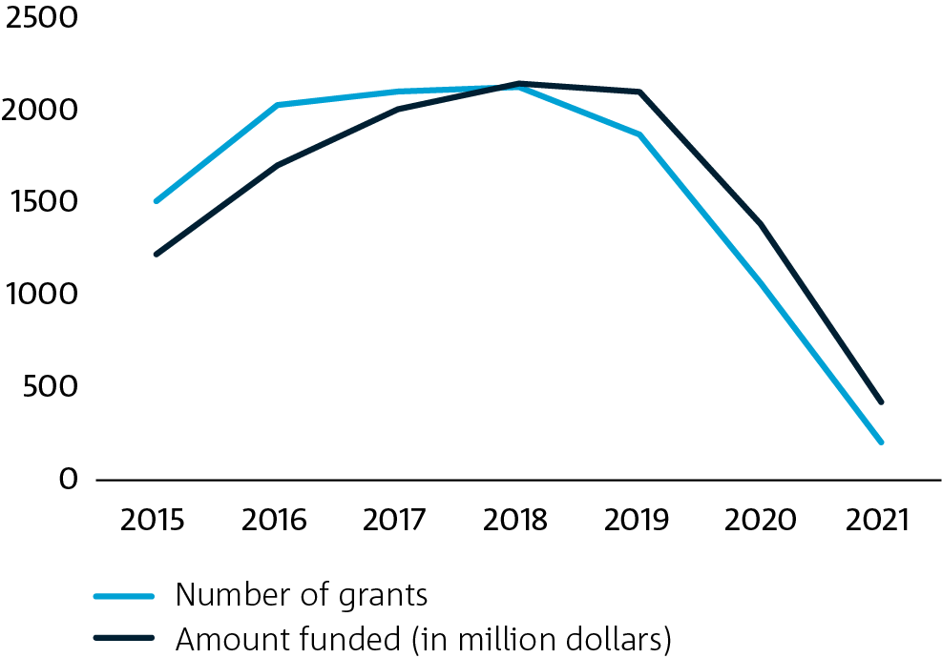

Figure 1. Number of AMR R&D grants and amount funded (in million dollars) worldwide

Data source: Global AMR R&D Hub11

Between 2015 and 2021, there were 10,914 AMR R&D projects, which equated to a total investment of $11 billion. The largest contributors to this funding were the US-based National Institutes of Health (22.9%), the Bill and Melinda Gates Foundation (8.0%), the European Commission (6.9%) and the Innovative Medicines Initiative (5.1%). Prior to 2018, AMR R&D funding had been increasing globally, but has since plateaued and then declined (Figure 1). The decline may be partly driven by delays in the reporting and integrating of data by the Global AMR R&D Hub.13 While this decline was evident prior to the global onset of COVID-19, it also could in part reflect a shift in funding priorities towards COVID-19 activities and social distancing restrictions placed on scientific activities.14 It has been hypothesised that COVID-19 has interrupted clinical trials and the routine microbiology samples that would have been collected in 2020 for global AMR surveillance activities are likely to be absent.14

Most AMR R&D funding (86.2%) is invested in domestic activities within the funding country (Figure 2). Across the 32 countries included in the Global AMR R&D Hub, all countries spent a greater proportion of funding on domestic projects, except Denmark, which allocated 63.5% of its funding to international projects. Denmark invested 39.4% of their total AMR R&D funding to US-based institutions through the Replenishing and Enabling the Pipeline for Anti-Infective Resistance (REPAIR) Impact Fund, a foundation that invests in early-stage development and discovery of therapies to fight AMR,15 and covered a range of therapeutic and vaccine-related activities.

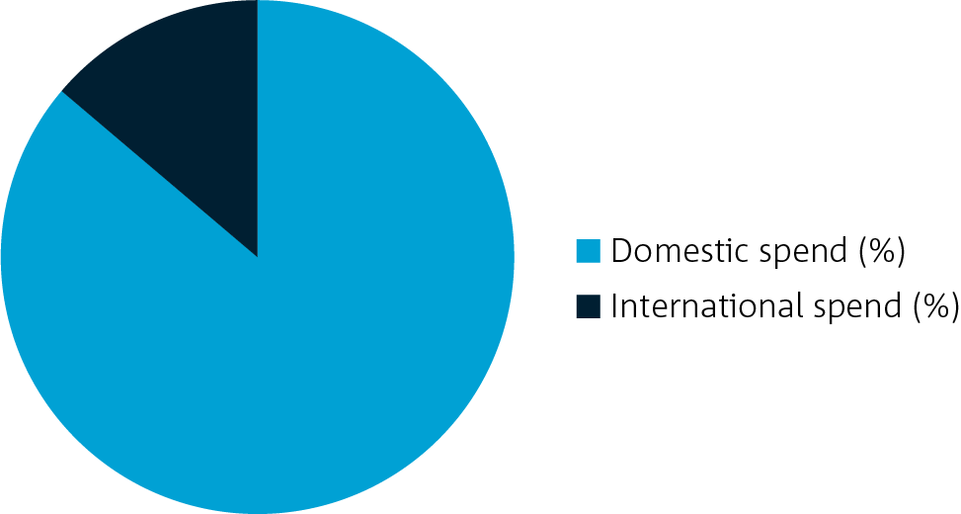

Figure 2. Share of global AMR R&D funding dedicated to domestic and international projects between 2015 and 2021

Data source: Global AMR R&D Hub11

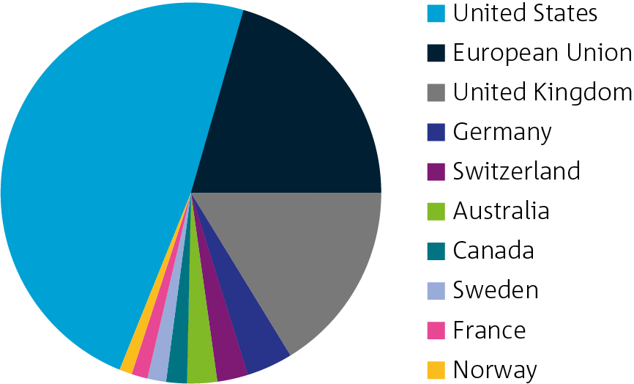

Figure 3. Share of AMR R&D funding across the top 10 global funders between 2015 and 2021

Data source: Global AMR R&D Hub11

Note. The European Union share of funding covers cross-country public and public-private partnerships, including the European Research Council and Innovative Medicines Initiative.

Advanced economies, including Australia, have been key drivers of investment into global AMR R&D activities over the past seven years (Figure 3). The United States, European Union and United Kingdom make up most of this funding, collectively contributing $8.7 billion across 4,883 projects. Here funders such as the Bill and Melinda Gates Foundation and Combating Antibiotic Resistant Bacteria Biopharmaceutical Accelerator (CARB-X) are attributed to the United States, the Wellcome Trust to the United Kingdom, and the European Union covers cross-country public and public-private partnerships, including the European Research Council and Innovative Medicines Initiative. Each of these countries and regions have established national/regional action plans and strategies highlighting the importance of funding and stimulating R&D to develop new AMR solutions,16–18 and are home to global AMR R&D partnerships, initiatives and alliances.

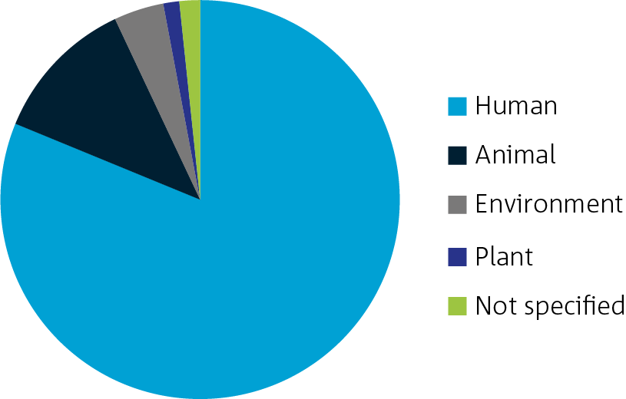

Figure 4. Share of global AMR R&D funding across research sectors between 2015 and 2021

Data source: Global AMR R&D Hub11

Note. A given research grant could appear in one or more sector categories if it reflected a cross-sector project involving more than one sector. Grants marked as ‘Not specified’ refer to projects that could not be assigned to a specific sector.

The majority of the global AMR R&D investments captured in the Global AMR R&D Hub are classified as human health research activities (Figure 4). Fewer AMR projects are classified as activities relating to animal health, the environment, or plant or plant-derived components. While the food sector is considered in the Strategy, the Global AMR R&D Hub does not categorise food-related research projects as a distinct sector; these projects are covered in the animal and plant sectors depending on whether the food product is animal- or plant-based. It is also important to note that the collation of data in the Global AMR R&D Hub has been staged, with initial efforts focused on human and animal health investments, followed by environment and plant sector investments. This staged process could in part contribute towards the low representation of funding in these latter sectors.

The majority of grants were focused within a single sector (93.3%), which in most cases were grants solely focused on the human health sector. An additional 6.3% of AMR R&D activities involved two or three sectors, and 0.4% of grants and projects were classified as One Health (i.e. collaborative and coordinated efforts involving multiple sectors to attain optimal health for people, animals and the environment, according to the Global AMR R&D Hub’s definition of One Health). We note that the definition for One Health used by the Global AMR R&D Hub differs from the Australian definition of One Health proposed in the Strategy.

The global landscape covers a diverse range of R&D activities that target AMR innovation and discovery across the pipeline. The most common AMR research activities were basic research (Figure 5), which covers all activities that address the fundamental aspects of a concept or phenomenon to increase scientific knowledge about a disease, immune response, process or pathogen. Other top areas of investment were development of new therapeutics to treat AMR infections and operational research, which included a broad range of activities focused on the management and decision-making around the control and prevention of AMR. Investment in other areas like diagnostics, preventatives and vaccines made up a comparatively smaller share of total global AMR R&D investments.13

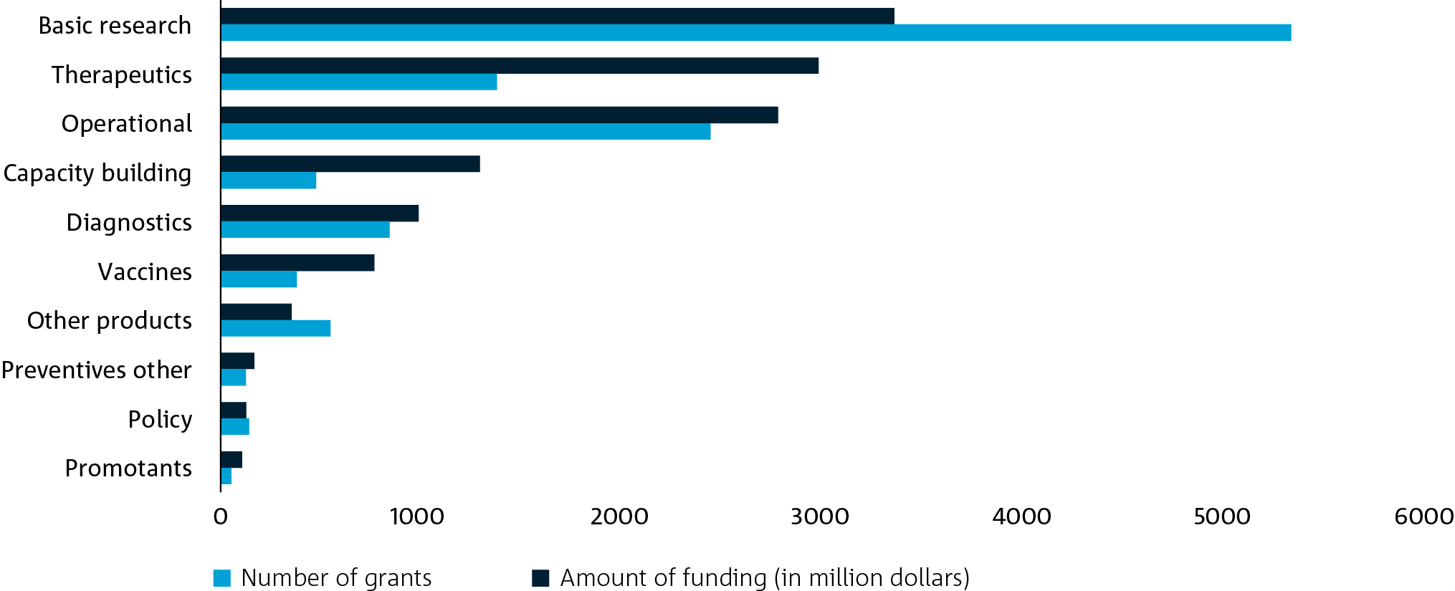

Figure 5. Number of AMR R&D grants and amount funded (in million dollars) worldwide between 2015 and 2021

Data source: Global AMR R&D Hub11

Most of the global AMR R&D investment is directed towards bacterial pathogens (Figure 6). This concentration of funding is primarily driven by the human health sector, with 88.9% of human health projects focused on bacterial pathogens. When projects that are not solely focused on human health are removed (i.e. including only projects that cover animal, food or plant health or those where the sector could not be defined), the share of funding targeting bacteria drops to 79.8%. The same share of funding is allocated to fungal pathogens between human health projects and other sectors (11.5%), but a greater share of AMR R&D allocated outside of the human health sector is aimed at viral pathogens and parasites (0.1% and 0.1% in the human health sector versus 3.3% and 1.8% in all other sectors, respectively).

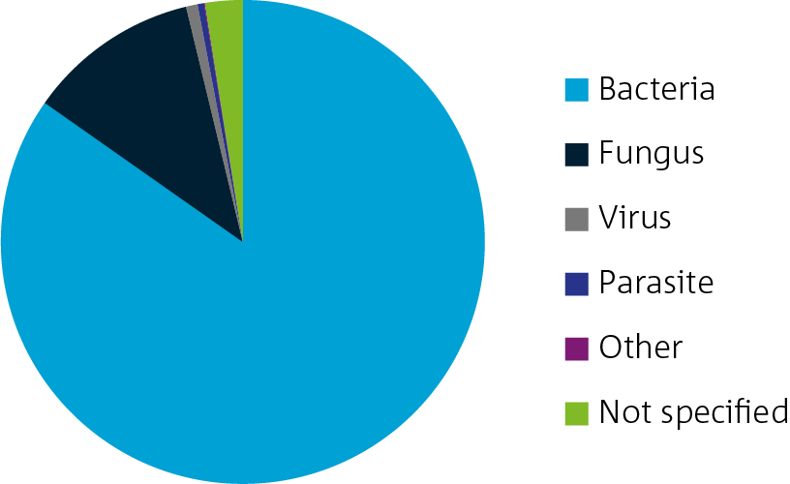

Figure 6. Share of global AMR R&D funding by pathogen between 2015 and 2021

Data source: Global AMR R&D Hub11

### International partnerships, initiatives, and alliances

Table 1 provides examples of public, philanthropic and private partnerships and initiatives that have been established globally to stimulate the development of AMR solutions through R&D and collaboration.

Table 1. Examples of international AMR R&D partnerships, initiatives and alliances

| Name | Region | Description |
| --- | --- | --- |
| AMR Action Fund | Global | The AMR Action Fund, launched in 2020, organised by the International Federation of Pharmaceutical Manufacturers and Associations and supported by the WHO, the European Investment Bank and the Wellcome Trust, is funded by 20 leading global pharmaceutical companies. It aims to invest over USD$1 billion to support the development and delivery of up to four new antibiotics by 2030.  This initiative aims to stimulate the market for new antibiotics and bridge the gap between scientific research and clinical application. The AMR Action Fund focuses on investments in assets centred on the WHO and US Centers for Disease Control and Prevention (CDC) priority lists of pathogens and novel treatments for bacterial infections. |
| AMR Industry Alliance | Global | Established in 2017, this Alliance is a coalition of over 100 biotechnology, diagnostics, generics and research-based pharmaceutical companies that aims to accelerate the efforts of the life-sciences industries towards curbing AMR.19 It is strategically focused on research and science into AMR-relevant innovation; improving access to AMR and infection-reducing technologies; improving the appropriate use of antibiotics; and advancing responsible manufacturing practices.19 |
| AMR Insights | Global | AMR Insights was set up in 2017 following an in-depth feasibility study carried out by 12 Dutch public and private organisations which identified the need for a new information platform on AMR. AMR Insights is a network-based organisation interacting with professionals in private companies, academia, authorities and non-government organisations (NGOs) around the globe, covering the human and animal, agrifood and environment sectors. AMR Insights offers targeted, up-to-date information and training courses, as well as knowledge exchange and partnering opportunities. |
| Bill and Melinda Gates Foundation | Global | The Bill and Melinda Gates Foundation is a philanthropic organisation that is committed to solving the greatest inequalities in the world. The Foundation provides funding and partners with government, industry, not-for-profit and community organisations for a range of R&D activities. In relation to AMR, the Foundation has invested in the development of new vaccines and other therapeutics designed to curb the global increase in antimicrobial-resistant bacteria in low and middle-income countries. One of the Foundation’s significant investments was a contribution of up to USD$25 million over three years to the CARB-X partnership in 2018.20 |
| Biotech companies in Europe combatting AntiMicrobial Resistance (BEAM Alliance) | Europe | The BEAM Alliance was launched in 2015 and reflects a consortium of over 60 small-to-medium-sized enterprises (SMEs) in Europe that develop innovative products aimed at tackling AMR.21 The Alliance advocates for the role of SMEs in responding to AMR and influencing policies and incentives relating to AMR R&D in Europe.21 |
| Combating Antibiotic Resistant Bacteria Biopharmaceutical Accelerator (CARB-X) | Global | CARB-X was officially launched in 2016. It is a global not-for-profit partnership that aims to accelerate innovative antimicrobial products towards clinical development and regulatory approval by providing competitive funding. Its portfolio includes an early development pipeline of new antibiotics, vaccines and rapid diagnostics, amongst other solutions for the prevention, diagnosis and treatment of bacterial infections. CARB-X focuses on the bacteria identified by the WHO/CDC priority lists and conditions with the highest degrees of mortality and morbidity. |
| Community for Open Antimicrobial Drug Discovery (CO-ADD) | Global | CO-ADD is a not-for-profit initiative funded by the Wellcome Trust and The University of Queensland and was established in 2015. It is led by researchers at The University of Queensland and provides free/open-access screening of compounds for academic researchers to support the discovery of new antibiotics. This platform is integrated with SPARK (Shared Platform for Antibiotic Research and Knowledge) – a cloud-based data resource for researchers to share insights and learnings to support future research into Gram-negative bacteria. To date, CO-ADD has screened over 310,000 compounds from 48 countries. |
| The Fleming Fund | Global | The Fleming Fund is a UK Government aid program, managed by the Department of Health and Social Care, supporting countries across Africa and Asia to tackle AMR. The Fund invests in strengthening surveillance systems through a portfolio of country and regional grants, global projects and fellowship schemes. The UK Government established the program in 2015 in response to the UK Review on Antimicrobial Resistance and the WHO Global Action Plan on AMR, which called for funding to improve AMR surveillance, public awareness and responsible drug use. The program focuses on low and middle-income countries because they are expected to bear the heaviest consequences of AMR. |
| Foundation for Innovative New Diagnostics (FIND) | Global | FIND, launched in 2003 by the WHO and the Bill and Melinda Gates Foundation, is a global health not-for profit organisation funded by more than 30 donors, including bilateral and multilateral organisations and private industry. FIND acts as a connector between countries, communities, funders, developers, decision-makers and healthcare professionals to develop innovative and affordable diagnostic tests for multiple health threats including AMR. |
| Global AMR Innovation Fund (GAMRIF) | Global | The GAMRIF is led by the UK Government to support early-stage R&D projects that aim to curb AMR in low and middle-income countries. This Fund was established following the recommendation from the UK Review on Antimicrobial Resistance to develop a fund to support R&D into new products to mitigate against AMR. The GAMRIF partners with research, government and industry organisations to fund R&D into new AMR technologies, establish global One Health partnerships and support the development of AMR solutions for low and middle-income countries.22 |
| Global AMR R&D Hub | Global | Launched in 2018 by the G20, the Hub is a dynamic data source. It brings together publicly funded R&D activities that aim to improve the understanding and coordination of future R&D activities, avoid duplicate and redundant efforts and channel activity into the most valuable and high-return areas. The Hub is a global partnership between 32 countries, non-governmental donor organisations and intergovernmental organisations. |
| Global Antibiotic Research and Development Partnership (GARDP) | Global | GARDP is a not-for-profit public health R&D organisation developing new and improved treatments for drug-resistant infections and promoting responsible antibiotic use, access and affordability. GARDP was created by the WHO and Drugs for Neglected Disease initiativein 2016 to deliver on the Global Action Plan on AMR and is funded by many governments including the Australian Government, as well as private foundations. |
| Innovative Medicine Initiative (IMI) | Europe | The IMI, launched in 2008, is a partnership between the European Union and the European pharmaceutical industry and is the largest public-private partnership in the life industries. The current goal of IMI is to develop next-generation vaccines, medicines and treatments, such as new antibiotics. One of the programs focuses on developing economic incentives for antibiotics development, their sustainable use and equitable availability.23 |
| Joint Programming Initiative on Antimicrobial Resistance (JPIAMR) | Global | The JPIAMR, created in 2011, is an international collaborative platform bringing together 29 nations and the European Commission in the fight against AMR. It coordinates national public investments and funds from transnational research to fill knowledge gaps on AMR using a One Health approach. Activities focus on six key priority areas: therapeutics, diagnostics, surveillance, transmission, environment and interventions. |
| Quadripartite partnership for One Health |  | The Quadripartite partnership includes the WHO, the Food and Agriculture Organization of the United Nations (FAO), the World Organization for Animal Health (formerly the OIE, now the WOAH) and the United Nations Environment Programme (UNEP). These four organisations have a long history of working together on global priorities. The recent inclusion of UNEP in the collaboration reflects the increasing acknowledgement of the role of the environment in AMR.24 |
| ReAct |  | ReAct was one of the seminal global networks that was established to address AMR.25 With a presence in North America, Latin America, Europe, Africa and the Asia Pacific, ReAct is a strong advocate for holistic solutions for AMR which take into account preventative and treatment approaches and different geographical contexts. |
| Replenishing and Enabling the Pipeline for Anti-Infective Resistance (REPAIR) Impact Fund | Denmark | Established in 2018 by Novo Holdings, a Danish life-science company, the REPAIR Impact Fund aims to provide investment for early-stage companies and start-ups that support the development of therapies addressing resistant microorganisms. With the goal to invest USD$20–40 million in projects each year, this initiative aims to bring at least one new therapy to market. |
| Wellcome Trust | Global | The Wellcome Trust is a UK-based charitable foundation that was founded in 1936 with the aim to fund science that will have an impact on the biggest health challenges. This includes a significant portfolio of research to strengthen the evidence base for AMR and advocacy work aimed to encourage and motivate evidence-based action to tackle AMR. |
| 2016 Davos Declaration | Global | This declaration, published in 2016, includes commitment from over 100 life-sciences companies and associations to invest in antibiotic R&D, reduce inappropriate use of antibiotics, improve global access and reduce environmental discharge from manufacturing. An industry roadmap was established, which details four key commitments on which signatory companies will deliver. These include: (1) supporting measures to reduce the environmental impact from production antibiotics, (2) committing to antibiotics only being used in patients who need them, (3) supporting mechanisms to facilitate affordable access to high-quality new and existing antibiotics, diagnostics and vaccines to patients who needs them, and (4) supporting open collaborations between industry and public researchers. |

## Australian AMR R&D funding landscape

### National AMR R&D investments

This section presents an analysis of AMR R&D investment trends in Australia. This includes research grants funded by the Australian Research Council (ARC), National Health and Medical Research Council (NHMRC), Medical Research Future Fund (MRFF), Australia’s Rural Research and Development Corporations and Australian Government agencies (see Appendix A for the full list of data sources). These findings are presented at the national level, reflecting the broad, macro-level trends present across the Australian AMR R&D ecosystem and across each AMR-related sector that falls under a One Health approach.

Across the 21 major funding groups identified in our analysis, a total of $209.8 million has been allocated to AMR R&D from 2015 to 2021, equating to 244 projects. The amount of funding allocated to Australian institutions peaked at $54.9 million in 2020, before dropping to $38.6 million in 2021 (Figure 7). The number of grants peaked sooner than this, with 53 projects funded in 2018 compared with 35 in 2021. These trends generally mirror what has been seen globally, with global R&D funding for AMR projects starting to drop from 2019 (see Figure 1). Given the methodology differences between the current analysis and that of the Global AMR R&D Hub, however, direct comparisons are not possible (see Appendix A for further details).

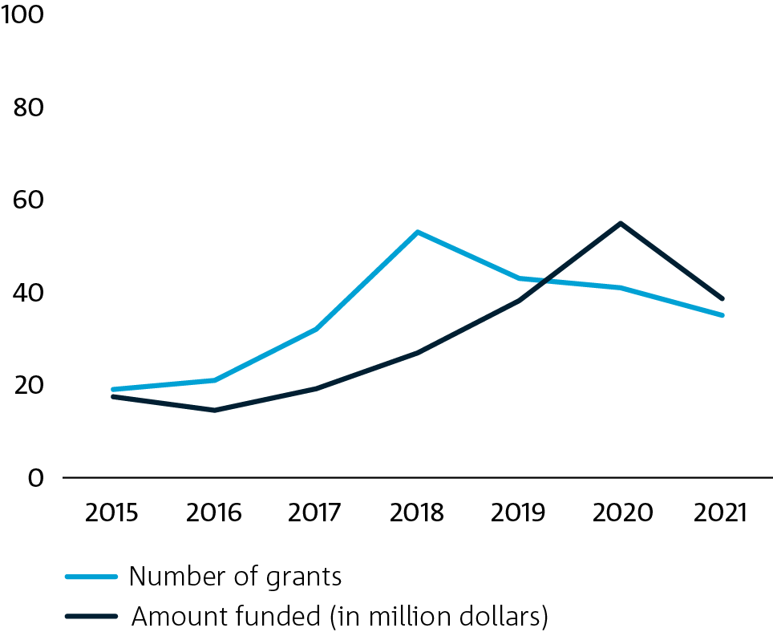

Figure 7. Number of AMR R&D grants and amount funded in Australia

Data source: CSIRO analysis (see Appendix A for full set of data sources included in this analysis)

Note. A key driver behind the steep decline in the amount of AMR R&D funding in Australia was a drop in One Health grants, which decreased from $17.9 million to $0.5 million from 2020 to 2021.

Most of this R&D is funded domestically (83.5%), with the remainder provided by international funding sources. The top funders of Australian AMR R&D were the NHMRC (57.3%), the UK-based Fleming Fund (12.9%), the ARC (12.6%) and the MRFF (9.7%). The funding allocated to Australian institutions from the Fleming Fund was focused on country grants and professional fellowships in the Asia-Pacific region, with a focus on capacity building for practitioners and surveillance systems capabilities for low and middle-income countries.

Other funders included industry-led research and development corporations, Australian Government agencies and international philanthropic organisations. An unpublished survey of AMR R&D investment in Australia conducted by DMTC and Biointelect (commissioned by MTPConnect) found a large share of funding also comes from state governments, internal university or institutional funding sources, private or client-funded research and equity investors. While the data on research grants and projects funded by these latter funding sources are not available in the public domain (and hence not included in the current analysis), these combined findings demonstrate the diversity of different sources of AMR R&D investment.

The university sector is the major recipient of AMR R&D funding in Australia. The institutions that received the greatest share of funding from 2015 to 2021 were Monash University (22.4%), The University of Queensland (15.1%) and The University of Melbourne (13%). Most of AMR R&D projects were conducted by the human health sector, followed by the animal health sector (see Figure 8). This finding demonstrates that most AMR R&D investment is currently focused on human health-related R&D, similar to the international AMR R&D landscape. One Health projects made up a small share of Australian AMR-related research projects, which were defined in the current analysis as research projects that cover the intersection between two or more sectors.

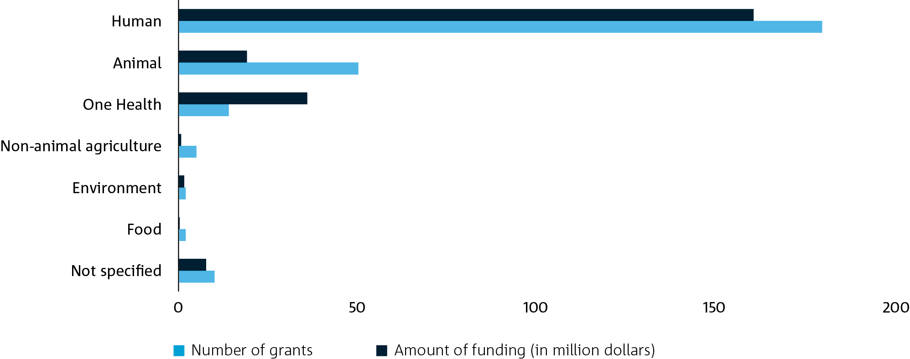

Figure 8. Number of AMR R&D grants and amount funded in Australia by sector

Data source: CSIRO analysis (see Appendix A for full set of data sources included in this analysis)

Note. A given research grant could appear in one or more sectoral categories if it reflected a cross-sectoral project involving more than one sector. Grants marked as ‘Not specified’ refer to projects that could not be assigned to a specific sector.

A large share of current One Health research projects conducted by Australian institutions are internationally funded (75.7%), namely from the UK-based Fleming Fund. These have included projects aimed at developing national AMR plans and surveillance systems for antimicrobial use and AMR in the Asia-Pacific region, collectively covered under public health and health services research topics (91%). Further details on the projects in other sectors are provided in the sector-specific sections below.

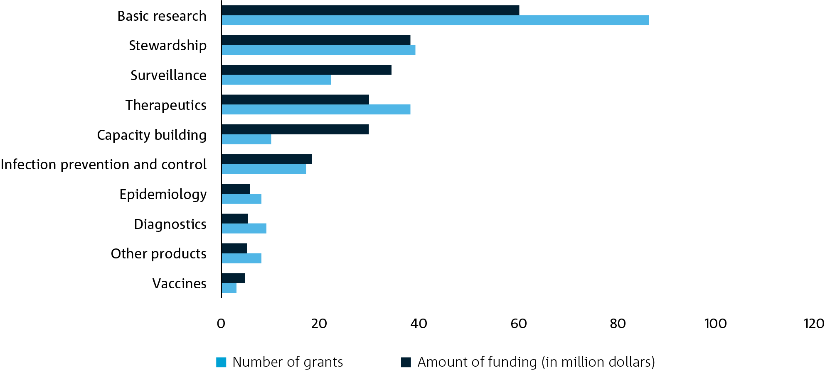

Figure 9. Number of AMR R&D grants and amount funded in Australia by type of research activity

Data source: CSIRO analysis (see Appendix A for full set of data sources included in this analysis)

Using the same categories developed by the Global AMR R&D Hub to define the research activities, we found the majority of Australian AMR R&D projects were basic research (35.2%) or operational/implementation research, including stewardship (16%) or surveillance activities (9%, Figure 9). Here basic research covers research that focuses on increasing the fundamental knowledge of disease, immune response, processes or pathogens. Surveillance research includes population-level analyses of disease monitoring, antimicrobial use and resistance trends, while stewardship research looks at ways to optimise the use of antimicrobials and other products to reduce the development of resistance and the need for antimicrobials.

The results from this national analysis are consistent with the 2022 survey of Australian organisations conducting AMR R&D conducted by DMTC and Biointelect on AMR-related technologies (not currently available in the public domain). The survey found that diagnostics and therapeutics made up the largest share of technologies being developed. Most diagnostic research activities were at the basic research or pre-clinical/translational stage (55% and 32% of organisations surveyed, respectively). Vaccines represented the smallest share of technology-based AMR R&D activities (13% of organisations), and of those organisations that are conducting research into vaccines to combat AMR, the majority are also focused on the basic research stage.26

### Measuring the impact of Australia’s AMR R&D

We conducted an explorative analysis to assess the potential impact of AMR R&D conducted by Australian institutions, as measured through citations of research publication and patents. We note that not all AMR R&D will lead to a patent, and hence, patenting activity is used here as one potential measure of the impact associated with this research. Other forms of AMR R&D (e.g. policy research, surveillance activities, infection prevention and control studies) can provide valuable outcomes that would not be covered by patenting activity. In this analysis, we used data from The Lens database, which is a rich repository of patents and scholarly works. Adopting a similar approach to the AMR R&D investment analyses, AMR-related research publications from the past seven years were first identified, limiting the resulting records to those that had an author with an Australian institution affiliation (see Appendix B for full methodology).

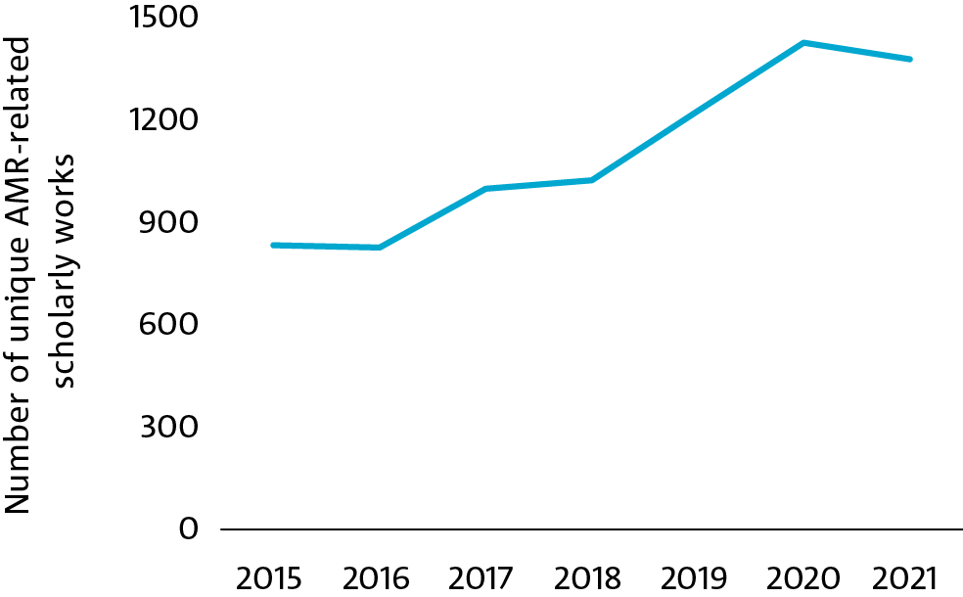

Figure 10. Number of unique AMR-related scholarly works with an Australian-affiliated author

Data source. The Lens

The analysis showed that Australian institutions published 7,713 unique scholarly works from 2015 to 2021, with outputs plateauing over the most recent two years (Figure 10). To identify where Australian AMR research has informed patenting activity globally, a patent/paper citation network was created. This process is used to identify instances where a given patent directly cites an Australian scholarly output as prior art (i.e. a direct connection). The network was also used to track instances where a given scholarly output cites an Australian AMR research publication and then this scholarly output, itself, is identified as prior art in a patent (i.e. an indirect connection). This approach enabled us to map both direct and indirect influences of Australian AMR research on global patenting activity.

This analysis identified 357 Australian AMR scholarly works that were directly connected to 672 unique patents. In addition, 1,173 Australian AMR scholarly works were indirectly connected (via another scholarly output) to 3,798 patents. Of the applicants that are directly citing Australian AMR research in their patents, the top applicants were Incyte Corporation (24 patents), Ablevia Biotech (12 patents) and US Health (11 patents). The top institutions that were indirectly citing Australian AMR research in their patents were the French National Institute of Health and Medical Research (47 patents), Guardant Health (28 patents) and the Massachusetts Institute of Technology (27 patents). These patents provide examples of the global reach of Australian AMR research and present an opportunity to use similar approaches to further deep dive into areas where Australia could contribute to the global AMR R&D pipeline.

### AMR R&D investments in the human health sector

Of the total AMR R&D investment in Australia, 179 projects and at least $160 million in funding from 2015 to 2021 were allocated to the human health sector. The amount of AMR R&D funding invested in human health has followed a positive growth trajectory over the past seven years (Figure 11). The Australian AMR R&D landscape is concentrated in the human health sector (76.3%). This result could reflect a lower concentration of funding in human health in Australia relative to the rest of the world (81.2%), according to the Global AMR R&D Hub,11 noting the aforementioned methodological differences between the current analysis and that used by the Global AMR R&D Hub which caution against direct comparisons.

The Australian human health sector receives 95.4% of its AMR R&D funding from domestic sources, such as the NHMRC (69.8%), ARC (11.9%) and MRFF (11.3%). The remaining 4.6% comes from international sources, with the US-based National Institutes of Health making up most of this funding (3.2% of total Australian human health AMR R&D funding). The majority of human health AMR R&D funding is allocated to the university sector (Figure 12). Examples of the largest investments made into human health AMR R&D over the past seven years identified in this analysis include the ARC Research Hub to Combat Antimicrobial Resistance (led by the University of New South Wales),27 the PEART trial (Pathway to the Elimination of Antibiotic-Resistant Tuberculosis in the Pacific,28 led by Monash University) and research led by Monash University into the development of new therapeutics for drug-resistant Gram-negative pathogens.29

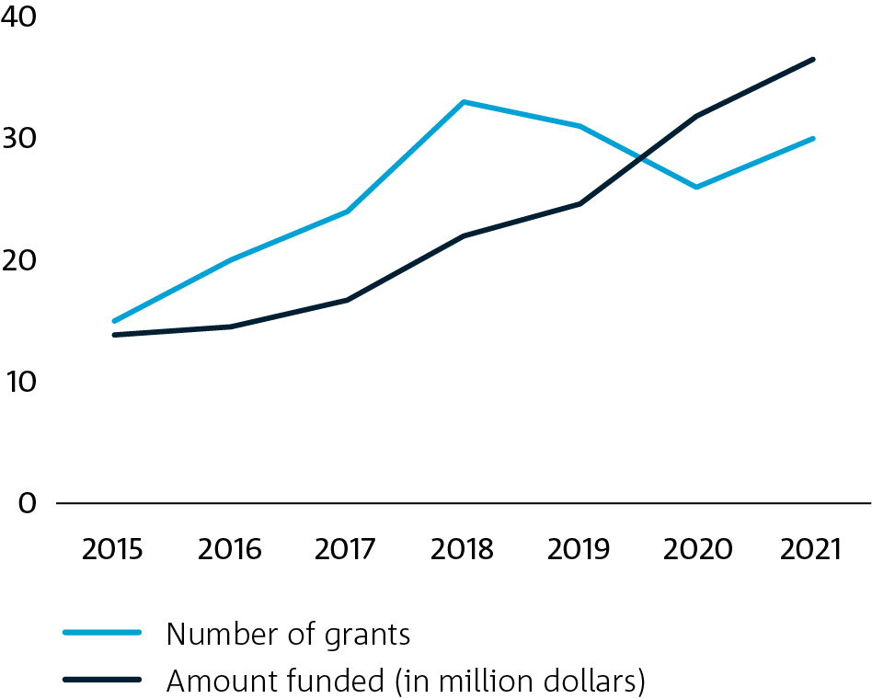

Figure 11. Number of human health AMR R&D grants and amount funded in Australia

Data source: CSIRO analysis (see Appendix A for full set of data sources included in this analysis)

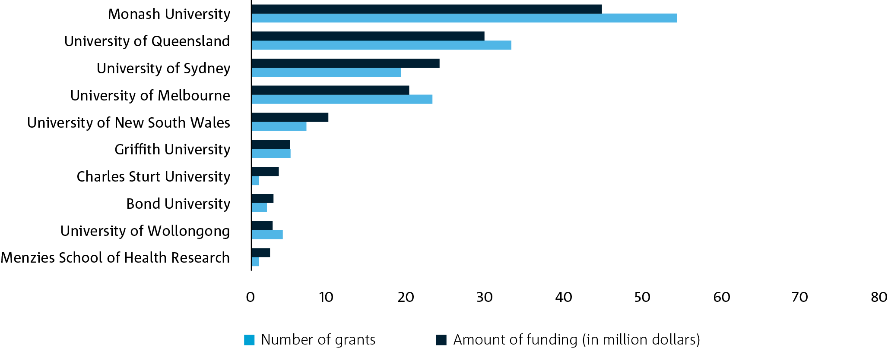

Figure 12. Number of human health AMR R&D grants and amount funded in Australia by funded institution

Data source: CSIRO analysis (see Appendix A for full set of data sources included in this analysis)

Consistent with global AMR R&D funding patterns, Australia’s human health AMR R&D investment is centred on basic research, therapeutics and operational/implementation areas like stewardship and infection prevention and control (Figure 13).[1] Within these top-funded areas, most of the human health basic research into AMR falls under the field of medical microbiology[2] (48.4% of basic research grants on AMR in human health). Australia’s therapeutics research into human health covers medical microbiology (31.4%) and pharmacology and pharmaceutical sciences[3] (28.6%). The recent unpublished audit conducted by DMTC and Biointelect of Australia’s research into new AMR agents and therapeutics found that most of this research is focused on antibiotics and antivirals.

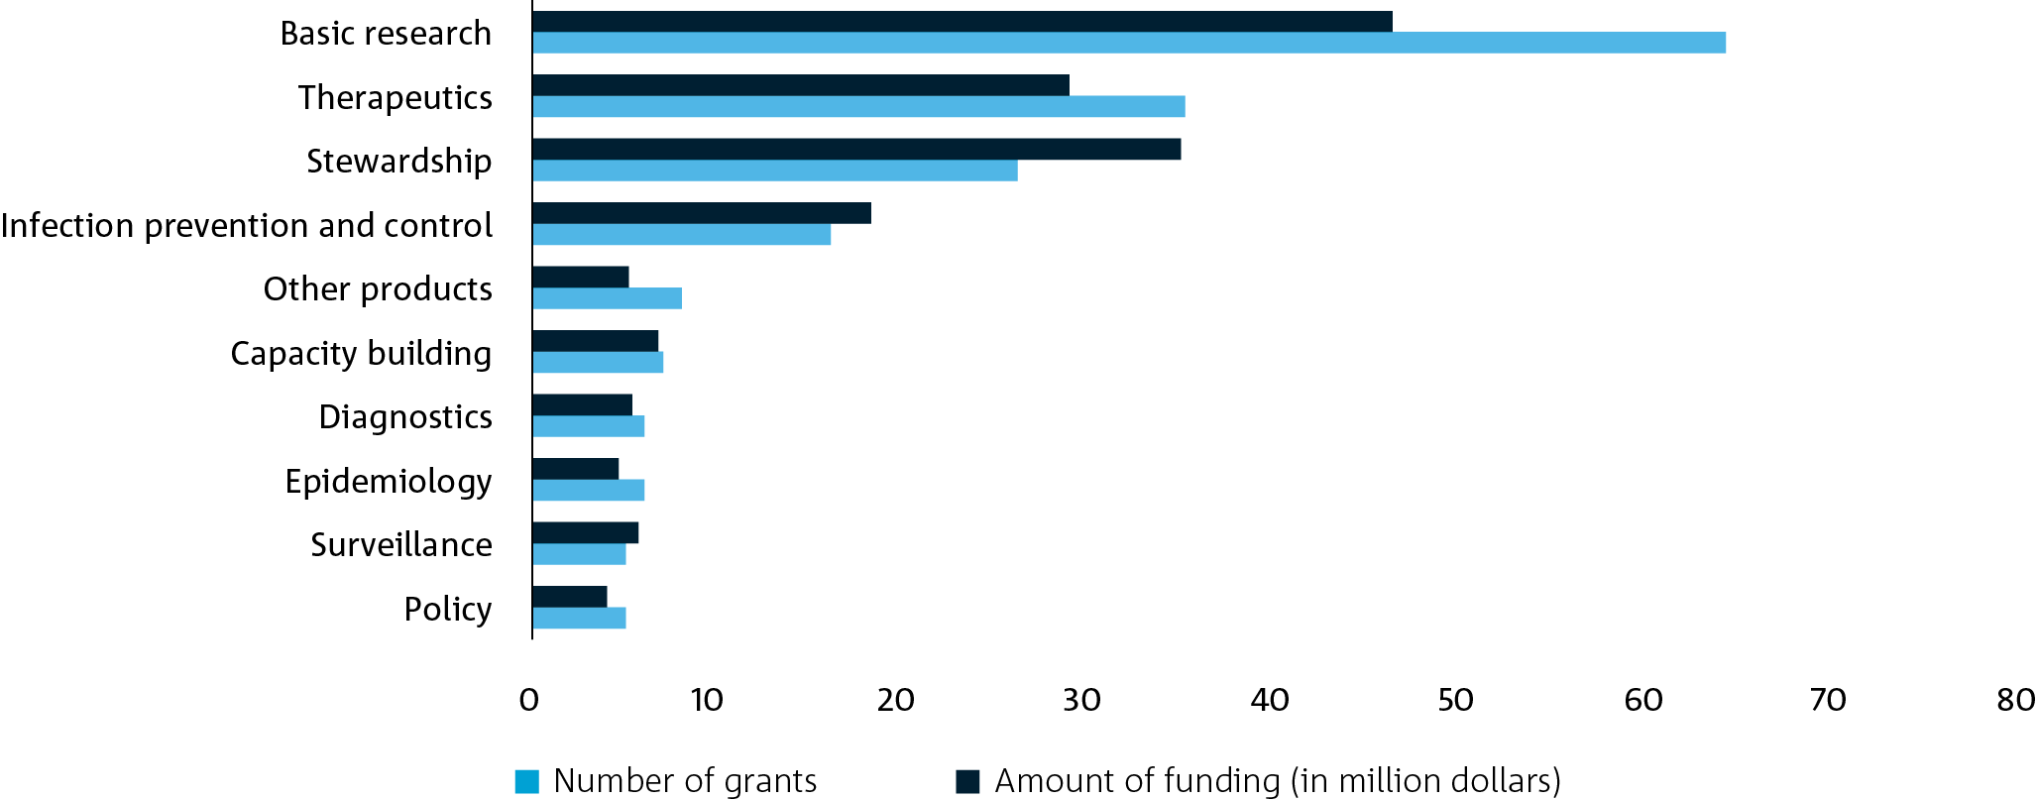

Figure 13. Number of human health AMR R&D grants and amount funded in Australia by type of research activity

Data source: CSIRO analysis (see Appendix A for full set of data sources included in this analysis)

Most of Australia’s human health AMR R&D is concentrated on bacterial pathogens (66.1% of grants). Fungal pathogens reflect a minor share of research activities, making up 3.4% of the total human health AMR grants funded over this period. Of the top six pathogens that were identified as accounting for 73% of deaths directly attributable to AMR,4 all of these pathogens (by genus name) are among Australia’s most highly researched pathogens, where the pathogen of interest could be identified (Figure 14). It is important to note, however, that the pathogen of interest could not be identified in 33.9% of grants. These results align with an unpublished report conducted by DMTC and Biointelect that found that 18 of the top 19 bacteria currently being studied in Australia are among the priority pathogens identified by the WHO, the exception being *Mycobacteria*.

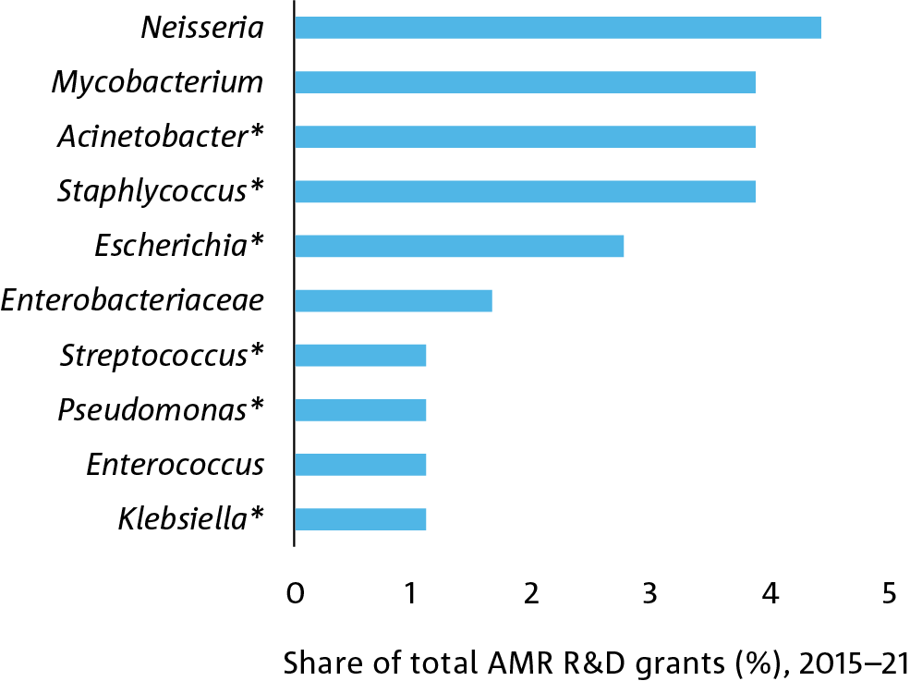

Figure 14. Share of human health AMR R&D grants and amount funded in Australia by the top 10 pathogen genus of interest

Data source: CSIRO analysis (see Appendix A for full set of data sources included in this analysis)

Note. Pathogen genus names marked with an asterisk denote those that were identified in prior research as the top pathogens that account for 73% of deaths directly attributable to AMR.4

### AMR R&D investments in the animal health sector

Based on the data sources in this analysis, 9.1% of the total funding invested in AMR in Australia between 2015 and 2021 included a focus on animal health, equating to 50 projects and at least $19 million.[4] A slightly higher proportion of global AMR R&D funding is allocated to the animal health sector globally (11.8%).11 Investment in animal health AMR R&D has increased gradually in Australia over the past seven years (Figure 15), even in the face of the recent COVID-19 disruptions to the AMR R&D funding landscape and the declining global investment in animal AMR research (i.e. $323.2 million was invested in animal health AMR R&D globally in 2019, but this declined to $165.8 million in 2020 and $39.4 million in 2021).11

Looking at the distribution of R&D investment across funding sources, all published AMR research funding comes from domestic funders, including the ARC (50%), the NHMRC (29.8%) and the national peak body, Dairy Australia (18.4%). We also acknowledge Meat and Livestock Australia and AgriFutures Australia as key animal health funding sources, which respectively funded 10 and 4 research grants over the past seven years. However, the available data did not permit the analysis of the size of these investments. Insights from consultations with key experts and stakeholders across the animal health sector anecdotally suggest that additional funding for animal health AMR R&D projects is provided by industry and other private funders, but this investment is currently difficult to account for or verify, given these projects are not reported externally.

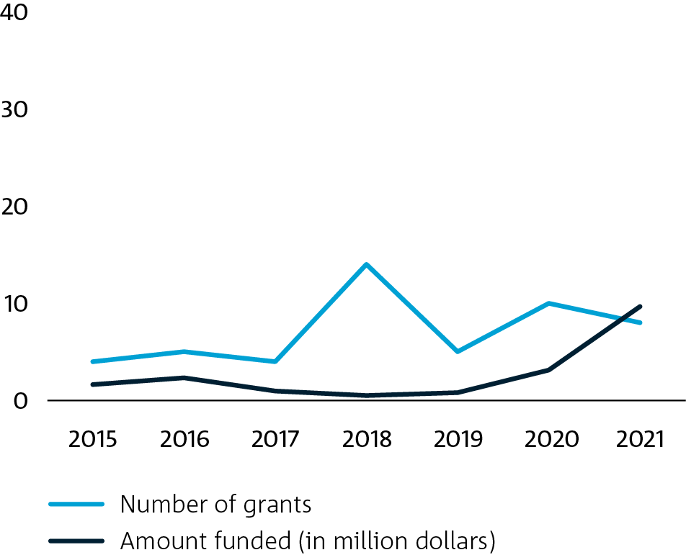

Figure 15. Number of animal health AMR R&D grants and amount funded in Australia

Data source: CSIRO analysis (see Appendix A for full set of data sources included in this analysis)

Animal health AMR R&D in Australia is driven by a range of academic and industry institutions (see Figure 16). Among the leading recipients of funding are Monash University, Charles Sturt University, The University of Melbourne and The University of Queensland. Some of the significant investments include the development of a machine-learning decision-support application to enable the on-farm diagnosis of clinical mastitis in cattle (led by Charles Sturt University),30 cross-sectoral programs of research focused on better understanding the gut ecosystem of humans and animals and the function of microbes (led by Monash University),31 and the use of molecular imaging techniques to identify how resistance emerges (led by the University of Wollongong).32

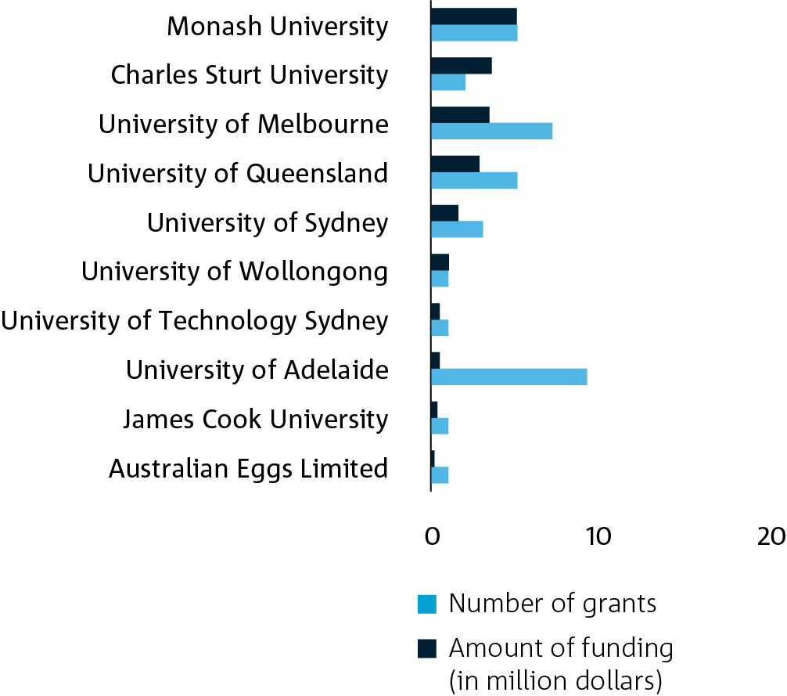

Figure 16. Number of animal health AMR R&D grants and amount funded in Australia by funded institution

Data source: CSIRO analysis (see Appendix A for full set of data sources included in this analysis)

Looking across the top-funded types of research activities in animal-related AMR R&D, the largest share of funding over the past seven years has concentrated on basic research, stewardship and surveillance projects (see Figure 17). The majority of the basic AMR research conducted in the animal health sector is focused on topics relating to microbiology (28.6% of basic research projects funded on animal health AMR R&D, 2015–21) and biochemistry and cell biology (18.6%). Stewardship projects were concentrated in animal production (66.7% of stewardship projects funded on animal health AMR R&D, 2015–21) and veterinary science areas (33.3%). From the data sources included in this analysis, the pathogens of interest could not be identified in two-thirds of animal-related AMR R&D projects. Still, where this was possible, the predominant focus of these research projects were bacterial pathogens (31.4% projects).

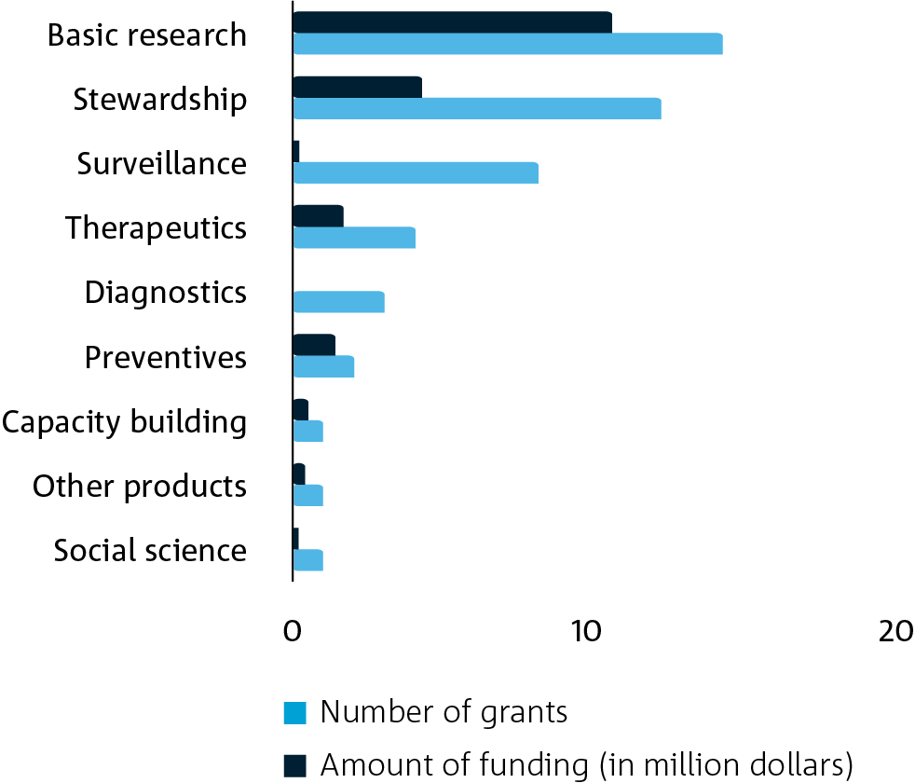

Figure 17. Number of animal health AMR R&D grants and amount funded in Australia by type of research activity

Data source: CSIRO analysis (see Appendix A for full set of data sources included in this analysis)

### AMR R&D investments in the non-animal agriculture sector

The non-animal agriculture sector, covering plants and crops cultivated and harvested as food or feed and excluding animal production, reflected a minor area of investment for AMR R&D in Australia. Over the past seven years, five non-animal agriculture-related AMR R&D grants were identified (2.1% of total grants), equating to at least $0.7 million.[5] The non-animal agriculture sector similarly makes up a small share of global AMR R&D funding, with 0.7% of AMR R&D projects identified in the Global AMR R&D Hub involving any plant or plant-derived components.11 Given the small number of grants funded under this sector, it is challenging to infer meaningful trends and patterns; hence, we have limited our discussion to a qualitative summary of current research activities.

Industry stakeholders indicated that a significant share of AMR-related research in this sector might be considered commercially sensitive, meaning that funding information is typically not made publicly available. These data gaps make it difficult to assess current AMR R&D activities, limiting our capacity to identify gaps or areas of underinvestment. Of the research reported publicly, the projects covered basic research topics (60% of non-animal agriculture-related AMR R&D projects), with some consideration for stewardship, surveillance and therapeutic research topics. Contrary to other sectors, research activities relating to AMR in the non-animal agriculture sector have focused on fungal pathogens (all projects included in this analysis), as opposed to other sectors which tend to be more bacterial-focused.

All publicly published AMR R&D funding for non-animal agriculture sector in Australia came from domestic funding sources, namely the ARC and Rural Research and Development Corporations (i.e. Grains Research & Development Corporation [GRDC], Wine Australia and Hort Innovation). The projects covered in this analysis include research into profiling the current status of fungicide resistance in specific crops (led by the Western Australian Government and University of Tasmania33) and understanding the evolution of fungicide resistance in crops (The University of Melbourne);34 engineering crop varieties that are resistant to fungal resistance (the Australian National University);35 and developing new crop management strategies that mitigate against resistance (the South Australian Health and Medical Research Institute).36

We also note the significant program of academic research on fungicide resistance conducted as part of the Centre for Crop and Disease Management at Curtin University, which was not covered in the data sources included in this analysis. This Centre has been co-funded by the GRDC since 2014. Research includes modelling and economics, enhancing disease resistance and the yield of crop varieties through improved germplasm, strategies to manage the effectiveness of current fungicides, and tools to study host resistance and pathogen virulence.

While our analysis covered AMR R&D investments between 2015 and 2021, we also acknowledge the recent investment in the Cooperative Research Centre for Solving Antimicrobial Resistance in Agribusiness, Food, and Environments (CRC SAAFE) announced in 2022. The CRC SAAFE will aim to monitor, manage and develop solutions to AMR risks across Australia’s food, agribusiness and environment sectors. This $149 million investment (over 10 years) will likely contribute towards future research into AMR in non-animal agriculture, as well as the food and environment sectors.

### AMR R&D investments in the environment sector

Only two research projects were identified in our AMR R&D funding analysis of the environment sector, making up 0.8% of Australia’s AMR R&D grants and at least $1.6 million in funding.[6] Here, environmental research covers all terrestrial and aquatic ecosystems and the native and introduced species that inhabit them (i.e. vertebrates, invertebrates, plants, fungi, macro and microorganisms). The environment similarly makes up a minor share of the global AMR R&D landscape, equating to 1.2% of the grants recorded by the Global AMR R&D Hub from 2015 to 2021.11 As with the non-animal agriculture sector, it is difficult to infer meaningful trend insights from a small pool of grants, so our discussion will focus on a qualitative summary of research in the environment sector.

The ARC funded both environmental projects identified in the current analysis. The first was led by The University of Queensland, focused on the transmission of antibiotic resistance genes in urban water systems,37 and the second was led by the University of Technology Sydney, aimed to develop innovative approaches to reducing the spread of AMR through wastewater systems in addition to other emerging microbial control challenges. Neither project focused on a specific pathogen.

### AMR R&D investments in the food sector

Focusing on research involving enterprises and premises engaged in food production, food processing, food preparation, food service and retail of food commodities, we found that the food sector made up 0.8% of the AMR R&D grants in Australia. This equated to $0.3 million in funding.[7] Given the small number of grants funded under this sector, our discussion of these results is limited to a qualitative summary of current research activities. It was also challenging to benchmark the level of food-related AMR R&D funding against the global landscape given that current sources of global AMR R&D investments (i.e. the Global AMR R&D Hub) do not segment research related to the food sector.

Australia’s food-related AMR R&D has been funded by the Australian Government and the Fisheries Research and Development Corporation. The first project, led by veterinary services company Future Fisheries Veterinary Service, aimed to quantify the presence of bacterial AMR and chemical residues in imported prawn products with the view to assess the import risk for Australia for prawn commodities.38 The second, conducted by Australian Eggs, focused on AMR surveillance in the Australian chicken egg industry.

### Australia’s initiatives and collaborations

Several collaborative national initiatives have emerged to help advance R&D priorities in Australia relating to AMR. Table 2 provides an overview of some of these significant partnerships, alliances and collaborations, describing who they are, why they have been established and what differentiates them from other initiatives.

Table 2. Examples of national AMR-relevant partnerships, initiatives and alliances

| Initiative/Partnership name | Description |
| --- | --- |
| Animal Industry Antimicrobial Stewardship Research, Development and Extension Strategy (AIAS) | Established in 2020, the AIAS consists of a collaboration funded by Dairy Australia, Australian Pork, Australian Eggs, Meat and Livestock Australia and Agrifood Australia. It was developed as a mechanism for Australian red meat, dairy, pork and poultry industries to identify common research, development and extension priorities for the effective monitoring of antimicrobial use and surveillance of AMR. This work is designed to inform stewardship actions that meet Australia’s animal health and market access needs, without impacting food safety or human health. |
| Australian Antimicrobial Resistance Network (AAMRNet) | Established in 2020, AAMRNet is an industry-led collaboration of industry, clinician and research AMR stakeholders focused on reducing the impact of AMR on human health. The network is operated by MTPConnect (a not-for-profit organisation that aims to accelerate the medical technologies, biotechnologies and pharmaceuticals sector). The network is working to establish an AMR Accelerator program that would be integrated with the global CARB-X network. AAMRNet is focused on addressing product development gaps and developing strategies to incentivise future investment in the development of new products, addressing the current market failure of antibiotic R&D. |
| Wollongong Antimicrobial Resistance Research Alliance | Formed in 2017, the Alliance aims to develop the Illawarra Shoalhaven region as a test bed for research into new ways to tackle AMR, in particular providing a site to test health interventions. The Alliance will provide evidence to drive policy and practice measures with national and global applicability. The contributors to the Alliance are academic researchers, local health authorities, clinicians, community stakeholders and industry partners within the Illawarra Shoalhaven region. |
| ARC Research Hub to Combat Antimicrobial Resistance | Announced in 2019, this Hub is based at the University of New South Wales and brings together Australian universities and national and international industry and other partners. The Hub aims to foster an enhanced pre-commercialisation environment to develop new molecular diagnostic technology and identify new antibiotic compounds. The Hub focuses on sexually transmitted microorganisms impacting human health as an example of the wider problem of AMR. |
| Cooperative Research Centre for Solving Antimicrobial Resistance in Agribusiness, Food, and Environments (CRC SAAFE) | Announced in 2022, the CRC SAAFE aims to lead the AMR response for the Australian agribusiness, food, organic waste and environmental management sectors. It will identify and address key challenges and innovation opportunities. Through focused innovation, the CRC SAAFE aims to assist partners to develop, commercialise and apply game-changing solutions, decision support and interventions. |
| ARC Training Centre for Environmental and Agricultural Solutions to Antimicrobial Resistance | This newly announced Centre based at The University of Queensland aims to position Australia as a global leader in developing industry-led solutions to fight AMR in agriculture and the environment, contributing to cleaner water, improved animal health and new antibiotics. The primary goal of the centre is to train students and postdoctoral researchers with respect to AMR. |
| Centre of Research Excellence in Minimising Antibiotic Resistance in the Community (CRE-MARC) | Funded 2018–2023, the CRE-MARC is an NHMRC initiative run out of the Institute for Evidence-Based Healthcare at Bond University. It builds on an earlier Centre of Research Excellence (CRE), that focused on antimicrobial stewardship in the community. The CRE-MARC aims to generate the knowledge required to improve clinical care and reduce antibiotic resistance. |
| Centre of Research Excellence in Reducing the Burden of Antimicrobial Resistance Through Optimal Personalised Dosing (CRE-RESPOND) | Funded from 2021 and run out of The University of Queensland, the CRE-RESPOND will develop patient-centered approaches to guide evidence-based, personalised antimicrobial drug dosing to reduce AMR. The CRE will aim to generate new knowledge, translate research into health policy and clinical practice, provide training opportunities for emerging clinicians and medical researchers and facilitate collaboration across the human health sector. |
| Australian Centre for Antimicrobial Resistance Ecology (ACARE) | The ACARE, based at The University of Adelaide, focuses on antibiotic research and the development of new treatments and control strategies for infections in humans and animals. Their research programs bring together national experts who explore microbial pathogenesis, new drug development, molecular epidemiology, resistance mechanisms and novel approaches to AMR surveillance. |
| Centre to Impact AMR | The Monash University Centre to Impact AMR works with industry, government and other organisations through funded collaborative research and the provision of contract research services. The Centre works broadly on all stages of the R&D pipeline, from understanding the fundamental biology of AMR to engineering new detection methods and changing public thinking about AMR. |
| National Centre for Antimicrobial Stewardship (NCAS) | The NCAS was established in 2015 as a NHMRC-funded CRE and is based at the Peter Doherty Institute for Infection and Immunity. It consists of a group of healthcare professionals committed to promoting the rational use of antimicrobial drugs throughout Australia. The Centre focuses on optimising the use of antimicrobials in both humans and animals. |
| Centre for Research Excellence in Protecting the Public from Emerging infectious Diseases (CRE-ID) | Funded from 2016 to 2021, the CRE-ID, based at Macquarie University, focused on newly identified pathogens and the re-emergence, spread or increased antimicrobial drug resistance of existing ones. The Centre brought together research partners across New South Wales, Victoria, Western Australia and the Australian Capital Territory. |
| Centre of Research Excellence in Redefining Antimicrobial Use to Reduce Resistance (CRE-REDUCE) | Funded from 2015 to 2020, the CRE-REDUCE was based at The University of Queensland and was focused on research into reducing antimicrobial use and overcoming AMR.39 This included projects into new ways of treating conditions when antimicrobials prove ineffective and identifying new dosing regimens for antimicrobials to prevent overuse or misuse of antimicrobials. |

# AMR R&D needs

This section outlines key R&D needs for Australia, drawing upon insights from international published literature. First, we provide an overview of focus areas identified in international AMR R&D strategies and lessons learnt for Australia. Second, we describe the R&D solutions needed to prevent, detect, contain and treat AMR under a One Health approach, drawing upon previous assessments as part of the Strategy and the *One Health Master Action Plan* (OHMAP) to support strategy implementation,40 and insights from international strategies that reflect the strategic approach taken by a broad range of countries. Third, we highlight knowledge and/or solution gaps that, if addressed, will have impact across each of the five AMR-related sectors, namely, human health, animal health, non-animal agriculture, environment and food.

## International AMR R&D strategies and agendas

This section describes four noteworthy examples of global initiatives to develop strategies to identify key research priorities and gaps in knowledge to tackle the increasingly urgent issue of AMR. This section also covers key lessons learnt for Australia in developing its national research agenda for AMR.

#### Joint Programming Initiative on Antimicrobial Resistance (JPIAMR)

The JPIAMR, created in 2011, is an international collaborative platform bringing together 29 nations and the European Commission in the fight against AMR. It coordinates national public investments and funds from transnational research to fill knowledge gaps on AMR using a One Health approach. In 2021, the JPIAMR released its Strategic Research and Innovation Agenda (SRIA), which aims to initiate and coordinate international AMR R&D funding initiatives and identify joint objectives that could help to align and coordinate collaborative R&D opportunities across sectors.41 The JPIAMR activities align with the European One Health Action Plan against AMR and the WHO Global Action Plan on AMR.

The SRIA outlines six research priority areas, including:

* developing novel and improved therapeutics and treatment regimes, covering antimicrobials and alternative therapies
* developing new and improving existing diagnostic tools and technologies
* optimising and standardising surveillance systems for antimicrobial use and AMR
* understanding and preventing AMR transmission
* investigating the role of environmental factors in the spread of AMR
* developing and improving prevention and control measures for AMR, considering a One Health perspective.

The JPIAMR, in collaboration with other stakeholders, is leading the development of the One Health AMR Partnership, which is designed to coordinate AMR activities and funding across European Union countries in line with the European One Health Action Plan against AMR and the WHO Global Action Plan on AMR.42 Both these action plans are aimed at curbing the threat of AMR. To support the development of a One Health AMR Partnership, the JPIAMR has commenced the process of updating the original SRIA to include a set of Prioritised Research and Innovation Objectives.43 The development of these objectives has been informed by a recent survey of AMR experts, which included representatives from its member countries.43 Among the proposed inclusions is the integration of the previous Environment priority across the other priority objectives, rather than having it as a standalone priority topic.

#### Quadripartite partnership for One Health

The Quadripartite – a partnership between the FAO, WOAH, WHO and UNEP – released a Strategic Framework for Collaboration on Antimicrobial Resistance in 2022.24 This strategy aims to optimise the production and use of antimicrobials along the whole life cycle, from R&D to disposal, and decrease the incidence of infection in humans, animals and plants to reduce the development and spread of AMR. These two objectives have strong links to several United Nations Sustainable Development Goals, including those on poverty, hunger, health and wellbeing, and clean water and sanitation.

#### World Health Organization (WHO)

In collaboration with the Nossal Institute for Global Health at The University of Melbourne, the WHO is in the process of developing a One Health Priority Research Agenda for Antimicrobial Resistance.44 The objective is to catalyse investment and scientific interest amongst researchers, donors and professionals to inform the implementation of global and national One Health policies to mitigate AMR.45 This agenda will identify and prioritise research questions and provide a transparent assessment of the knowledge gaps related to the mitigation of AMR at the interface between humans, animals, plants and the environment through a global survey and literature review.46 The One Health Priority Research Agenda for Antimicrobial Resistance is expected to be completed by late 2022.

#### Global Antibiotic Research and Development Partnership (GARDP)

The GARDP has developed an AMR R&D strategy focusing on the development of therapeutics. Their strategy, released in 2020, is designed to address the challenges associated with the antibiotic R&D pipeline.47 GARDP has set the strategic goal to develop five new treatments to address AMR by 2025 with a focus on the WHO priority pathogen list, diseases and infections that impact children, and sexually transmitted infections. The development of pharmaceuticals, particularly antibiotics, and improved access for the most vulnerable or marginalised populations are key R&D priorities.

### Key lessons learnt for Australia

These global strategies and initiatives provide useful insights into the critical AMR R&D needs and potential future R&D directions for Australia. The need for AMR R&D is complex: it requires effort within and across multiple sectors to prevent the emergence of AMR and initiatives to manage the existing threat of AMR before it presents as a disease. The complexity of the system means that it is not clear what the impact of solutions aimed at preventing or managing AMR before disease presentation will eventually be on levels of AMR in human health. In contrast, solutions to respond to AMR after disease presentation are challenging but the impact of the solutions is more predictable. Global AMR R&D agendas and initiatives can provide lessons learnt for Australia into the ways that we can better respond to AMR disease through improved diagnostics and the development of new treatments.

Significant improvements in our ability to respond to AMR infections, however, will have little impact on the increasing threat of AMR. To impact the phenomenon of AMR, there is a need to prevent AMR arising and to manage the existing threat of AMR before it becomes an inherent and accepted component of most infectious bacterial diseases. Many existing AMR R&D strategies focus heavily on these latter aspects. Whilst there is an understanding of the broad concepts in relation to preventing and managing AMR before disease presentation, it is unclear which approaches will achieve maximum impact. Consequently, existing AMR R&D strategies have acknowledged the need to invest in understanding the complex, cyclic interrelationships and causal factors that underpin AMR.

Given the urgency of the AMR threat and the time it will take to improve our knowledge of AMR, most international AMR R&D agendas note the importance of using surveillance as a mechanism to predict future AMR events and guide decision-making. The focus of R&D efforts relating to surveillance is to collect, improve and standardise data collection and analysis methods to enhance surveillance of antimicrobial use and AMR. Better surveillance will assist in identifying where mitigation efforts are needed in response to current and future AMR risks and to evaluate the success of these mitigation strategies.

A recurrent theme across global and national AMR R&D strategies is an acknowledgment of insufficient funds to address all aspects of AMR identified by experts. AMR strategies and R&D agendas commonly emphasise the need to remove duplication and promote cross-sectoral learnings and innovation to maximise the efficiency of available AMR funding. Opportunities to improve the connectivity between all sectors involved in AMR and organisations conducting AMR R&D would be a useful consideration for Australia, as well as exploring other ways to prioritise future R&D directions that are likely to have the greatest impact on reducing AMR risks for humans and animals.

Another common theme within AMR strategies and R&D agendas is a promotion of collaborative research efforts to better unravel the multisectoral nature of AMR. The need for improved collaboration, both across disciplines and geographical boundaries, acknowledges the complex and interconnected nature of AMR. This need is a key motivator behind One Health approaches to AMR. Among the potential mechanisms discussed in support of stronger cross-sectoral and cross-disciplinary collaboration are the need for joint industry-academia expert or funding networks, appropriate research governance structures and streamlined processes for translating research into commercial or policy outcomes.

## National AMR R&D needs

The Strategy and OHMAP released by the Australian Government represent views of experts and stakeholders across the human and animal health, non-animal agriculture, food and environment sectors in Australia. These strategic documents detail how best Australia can prevent, detect, contain and treat AMR under a One Health approach.40 The OHMAP provides guidance on implementing the seven objectives identified in the current Strategy.48 This section provides a summary of the R&D priorities outlined within these seven objectives from the OHMAP and the Strategy, with consideration of broader international assessments. While Australia’s AMR R&D needs may differ from the global landscape in some areas, identifying points of alignment between Australia and global AMR R&D agendas (e.g. the JPIAMR SRIA) could assist in identifying potential global collaboration and partnership R&D opportunities.

### To prevent and contain AMR

In the context of this report, ‘prevention’ of AMR is defined as activities designed to prevent infection with an AMR organism or exposure to AMR genes, the emergence of an AMR epidemic, the development of new forms of resistance, or the movement of resistance genes to other microbes. ‘Containment’ of AMR is defined as activities aimed to curtail the spread of AMR infections or AMR organisms, the progression of an AMR epidemic, or minimise the ongoing development of new forms of resistance. Given the complementary nature of AMR prevention and containment activities, these AMR R&D needs are considered together.

The Strategy identifies the need to strengthen activities to prevent and control infections and monitor and review regulatory measures to limit the emergence and spread of resistance more effectively. Key R&D activities identified in the Strategy to support these aims include the development of solutions to improve waste management in animal and agricultural settings; on-farm biosecurity; and knowledge of infection prevention and control to inform standards and supporting resources in clinical and community settings. Also important is the need to identify and develop mechanisms to support and monitor compliance of antimicrobial use in hospitals and general practice.

To reduce infections, and consequentially the need for antimicrobials, activities that improve the awareness of the importance of infection control in reducing AMR in humans and animals are proposed, including hand hygiene, improved nursing and sanitation practices and the use of human and animal vaccines. Other focus areas identified in the Strategy include activities to improve or increase compliance with national biosecurity and infection prevention and control guidelines through improved use of accreditation and/or quality assurance programs. The Strategy and OHMAP also highlight the need for greater community involvement in reducing inappropriate antimicrobial use and the spread of resistant organisms and the need to better understand behavioural drivers and interventions for antimicrobial use across all sectors.

Appropriate antimicrobial usage is also emphasised in the Strategy through the need to develop resources to support appropriate prescribing, use and disposal within all sectors and the need for solutions that better assist professionals in influencing health-consumer decisions associated with appropriate antimicrobial use, and development of accreditation standards to support stewardship and resources to support appropriate antimicrobial use.40 These AMR R&D needs align with those identified by the JPIAMR,41 and highlight the importance of One Health approaches to policies on antimicrobial production and usage.

The Strategy identifies the need to better understand current antimicrobial prescribing practices in settings outside of hospitals (e.g. primary care and aged care sectors, and animal health settings) to identify potential barriers to best-practice prescribing practices. These outputs could inform the development of innovative approaches that support and encourage adoption of best-practice prescribing and stewardship practices. The JPIAMR similarly highlights the need to better understand the behavioural process of antibiotic and antifungal prescribing, acknowledging the importance of the standardisation of data collection on antimicrobial use across sectors.41

The use of antimicrobials has led to the emergence of AMR and reservoirs of antimicrobial-resistant organisms and AMR genes that are present in the human health, animal health, non-animal agriculture, food and environment sectors. Understanding where these organisms or genes are, the risk they pose and the mitigation strategies that will be effective in managing this threat will support proactive actions in containing AMR before it manifests in disease. The fifth objective of the Strategy identifies the necessity to develop and review lists of priority organisms and associated antimicrobials for the human and animal health, non-animal agriculture, environment and food sectors.

The Strategy also highlights the importance of surveillance, namely in the form of a nationally coordinated surveillance system covering all sectors. Establishing such a system requires mechanisms to provide and analyse antimicrobial usage and resistance data across the human and animal health, non-animal agriculture and food sectors. These data and systems could be used to inform policy and the development of targeted interventions to support antimicrobial stewardship and other prevention and containment activities.

In their exploration of the requirements of AMR surveillance systems, the JPIAMR focuses on the need to improve and standardise data collection methods from sampling tools, methodology and reporting to data analysis.41 The JPIAMR further encourages the development of techniques and infrastructure to facilitate the exchange and integration of surveillance data and opportunities to use these data to identify reservoirs of AMR, estimate AMR burden and assess the impact of interventions.

The final set of AMR R&D needs outlined in the Strategy include the development of solutions to contribute to international surveillance and monitoring initiatives to track the emergence and spread of AMR in neighbouring countries. This includes the development of improved solutions for infection prevention and control of malaria, tuberculosis and other significant diseases. These regional activities could include capacity building for diagnosis, reporting and response, and the development of genomic-based AMR and pathogen diagnostics.

The OHMAP also notes the necessity to better understand the extent to which resistant bacteria are present in, and transmitted via, the food chain. The research priorities developed by the JPIAMR also highlight the need to understand the complex dynamics of selection and transmission of AMR, and to identify what factors are responsible for maintaining, selecting and spreading AMR.41 In particular, the JPIAMR points out the requirement to understand the reservoirs and exposure routes of AMR in the environment, animals and humans. To prevent and contain AMR, the JPIAMR recommends assessing the impact of industrial systems, such as agriculture and healthcare facilities, on the environment and identifying antimicrobial residues and antimicrobial-resistant organisms in environmental ecosystems.

### To detect AMR threats

In the context of this report, ‘detection’ of AMR includes methods of detecting a pathogen or an AMR infection in a human or animal, identifying new forms of resistance, or identifying resistance genes in microbes. Diagnostic devices are those that can identify an infection or the presence of AMR, guide if antimicrobial use is required, recommend the type of antimicrobial to use, and promote the use of narrow-spectrum antimicrobials. The Strategy identifies rapid diagnostic technologies as a candidate for further research under a national research agenda. Similarly, the JPIAMR recommends development of rapid diagnostics in appropriate One Health settings, both for clinical diagnostic needs and to support prevention and control measures.41 The JPIAMR also highlights the need to overcome behavioural and socioeconomic barriers that may contribute to low use or slow uptake of rapid diagnostics.

In addition to detecting infection and/or AMR and identifying when treatment or action is required, diagnostic tools are required to support the management of AMR through population-level surveillance and monitoring initiatives. Currently the food, animal health, non-animal agriculture and environment sectors have less developed surveillance solutions relative to the human health sector. Consequently, to form a nationally coordinated surveillance system covering all sectors, R&D to improve detection technology will be required across these sectors.

Other areas of R&D proposed in the OHMAP include the identification of appropriate and consistent methods for antimicrobial-susceptibility testing across sectors; the establishment of a nationally coordinated response to AMR emergence and outbreaks of multidrug-resistant organisms; and an assessment of the suitability and technical capability of solutions that allow real-time collection, analysis and reporting of AMR.

### To treat AMR infections

In the context of this report, ‘treatment’ of AMR encompasses R&D activities that lead to eliminating an AMR pathogen from an individual or otherwise support the individual’s body in removing the infection; removing an AMR organism from a healthcare setting; or removing forms of resistance or newly resistant microbes from a population or environment. The OHMAP identifies the need to investigate opportunities to incentivise the development of new antimicrobials and to understand and address barriers preventing the optimal selection and targeted use of antimicrobials in all animal settings.

The JPIAMR SRIA identifies the need to find new antimicrobials and for early-stage research into antimicrobial discovery and development, including methods that can better identify compounds with acceptable pharmacokinetic and safety profiles to de-risk the development process. In particular, the JPIAMR recognises the need to develop novel chemical scaffolds as the basis of new antimicrobials, including investigating the potential to improve pharmacokinetics and safety of antimicrobials previously discarded during development due to safety issues. While the Strategy highlights that discovering new classes of antimicrobials is essential, it will only be part of an effective R&D response to AMR.

The JPIAMR also identifies other R&D requirements in relation to AMR treatment.41 These include the need to investigate the role that policy can play in reducing the barriers in antimicrobial R&D, as well as the use of combination therapy using antimicrobials combined with non-antimicrobial compounds to treat disease and reduce the likelihood of AMR arising.

The OHMAP identifies the need to develop resources to improve biosecurity and waste management for different animal and agricultural settings, improve hand hygiene approaches and develop or improve resources and capabilities to better prevent infection across all sectors. The OHMAP also highlights the benefit of establishing national coordination of surveillance and response to emergence and outbreaks of multi-resistant organisms, which may involve targeted treatments to remove resistant organisms from contaminated populations or environments.

## Sector-specific AMR R&D considerations

This section explores the sector-level AMR knowledge gaps, with the view to identify where R&D solutions are most needed within each sector and candidate areas for future One Health collaborations. This appraisal aims to extend upon the previous national and global AMR R&D needs identified through the Strategy and other international AMR R&D initiatives. Within each sector, we describe sector-specific AMR gaps, looking both at the impact that AMR has on that sector and the impact of that sector on the emergence and transmission of AMR. We also discuss how each sector impacts other sectors, the One Health implications that arise from these impacts and the R&D gaps required to address these impacts.

### Human health

The impact of AMR is greatest in human health, with AMR associated with high economic costs from prolonged illness, extended hospital stays, increased medicine costs and an increased rate of death and disability.49 The WHO has declared AMR as one of the top 10 greatest threats to global public health.50

#### AMR R&D needs in the human health sector

In Australia, one in every 74 hospitalisations resulted in a healthcare-acquired infection (2015–16 figure),51 with 10.3% of healthcare-acquired infections associated with multidrug-resistant organisms (2018 figure).52 The US CDC estimate that medical devices, such as catheters and ventilators, have a more significant impact on antibiotic-resistant infections than surgical procedures.53 As the use of medical devices continues to increase, there is a need to invest in medical device technologies that minimise the risk of infection. This includes designing devices that prevent bacterial colonisation and which are easier to clean and maintain. The need for improved surveillance of healthcare-acquired infections has also been emphasised in previous reviews.52

There is a pressing need in the human health sector for therapies to treat AMR infections. This is especially relevant to those caused by the ESKAPE pathogens – six bacterial species[8] that are drug-resistant, highly virulent and responsible for some of the deadliest hospital-acquired infections.54,55 Global research has largely focused on the discovery of new antibiotics and, more recently, repurposing of existing medicines that have been approved for other diseases, but which also have antibacterial properties.56 There are opportunities to expand the current focus of therapeutics R&D to include the use and development of non-traditional antimicrobial treatments, such as biotherapeutics (e.g. bacteriophage, antimicrobial peptides and probiotics), and combination therapies which minimise the risk of developing antibiotic resistance.57

Vaccines for pathogens reduce the requirement for antimicrobials through infection prevention, and in some situations, therapeutic vaccines can be used for treatment. To date, vaccines have been used to treat cancer, tuberculosis and Human immunodeficiency virus ,58 and have recently been proposed to treat infectious disease and persistent infections,59 or to prevent relapse following cure.60 In addition to the need for vaccine R&D for preventative purposes, there is a need to better understand the potential of therapeutic vaccines to reduce the severity of infection or prevent relapse in infection-prone vulnerable patient groups.

As part of these potential future therapeutic and vaccine research directions, there will be opportunities for Australia to contribute to global R&D pipelines. There is a need to assess how Australia can participate in international endeavours to generate vaccines for AMR threats and contribute to the development of new antimicrobials. This includes investigating development pipelines in the context of existing federal and state investment in onshore vaccine production methods, defining and validating clinical endpoints, fill and finish processes, regulatory approval processes for vaccines and incentives to either decrease vaccine development costs or improve the market conditions for newly approved vaccines.

Currently, the primary method of identifying AMR infections is laboratory-based culture followed by antimicrobial-susceptibility testing, which can take days to weeks to obtain a result. Until the cause of the infection is known, antimicrobials are prescribed empirically, usually in the form of broad-spectrum drugs to increase the chances of targeting the correct pathogen. The development and adoption of rapid, cost-effective diagnostic methods to identify the cause and antimicrobial susceptibility of infectious agents to inform prescribing practices would greatly benefit AMR efforts.61 R&D into such diagnostics would support decision-making around prescribing and limit emerging resistances.

Antimicrobial prescribing rates across Australia are high by international standards, with 40.3% of the Australian population receiving at least one antimicrobial prescription in 2019.51 There is considerable deviation between antibiotic prescribing practices and the Australian Therapeutic Guidelines.62 An analysis of prescribing rates among general practitioners in Australia for acute respiratory infections from 2010 to 2015 found antibiotics were prescribed four to nine times more frequently per 100 encounters than the estimated prescribing rates based on the Australian Therapeutic Guidelines.62 The appropriate use of antimicrobials can be enhanced by improving concordance with prescribing guidelines and this could be supported by R&D efforts to design and establish a system to monitor and facilitate adherence.

Specific segments of the healthcare system have been highlighted as key candidates for improving antimicrobial use. The first is paediatric antimicrobial use, access and guidelines, with recent analyses of prescribing practices in hospitalised children showing that almost one in five were inappropriate.63 A review by Australia’s National Antimicrobial Prescribing Survey notes that there are gaps in information about the quality of prescribing in general practice, including the lack of a nationally available audit tool to measure and improve prescribing for Australian children.63 Second, in the aged care sector, 25.1% of cases where an antimicrobial was prescribed had no documented signs or symptoms of an infection.64 Paediatric and aged care settings could therefore be a focus for further R&D into antimicrobial use and prescribing behaviours.

Currently, antibiotic prescribing primarily considers weight and age. Optimising antibiotic use could also be facilitated by an enhanced understanding of antibiotic pharmacokinetics and how this relates to patient-related factors beyond the considerations of weight and age. This knowledge could be used to tailor the dose and regimen of antibiotics to an individual’s requirements and would enhance the development of technologies that allow prescribers to modify prescriptions and drug administration accordingly.

Social and behavioural drivers of inappropriate antimicrobial use also contribute to the development of AMR. Whilst there is a general awareness of AMR in the Australian public, there is an incomplete understanding of appropriate antimicrobial use and the consequences of AMR.65 A 2020 survey found that 92% of Australians did not know the difference between viral and bacterial infections and a sizeable share incorrectly thought antibiotics could be used to treat the flu (34%), a common cold (19%) or the coronavirus (13%).66 Behavioural change principles have been successfully implemented enhancing infection prevention and control practices and compliance among healthcare workers.67 There is a need to understand the shortcomings of public awareness campaigns on AMR to explore opportunities to influence behaviours associated with antibiotic use.

Rates of antimicrobial use and resistance are monitored through the Antimicrobial Use and Resistance in Australia (AURA) Surveillance System.68 While this system has its strengths, there are significant gaps in the timeliness of the data and their geographical coverage and other individual risk factors that relate to the likelihood of an individual acquiring a drug-resistant infection (e.g. exposure to healthcare settings, ethnicity, occupation, age and co-morbidities). An exception to this is the set of nationally agreed critical antimicrobial-resistant pathogens, which are subject to more frequent monitoring and reporting as part of the National Alert System for Critical Antimicrobial Resistances.69 Having a more comprehensive, timely and consistent coverage of antimicrobial use and resistance data across Australia would support future R&D efforts to develop and implement targeted AMR control measures. This could also be supported by the use of novel data sources for surveillance purposes, such as digital health records collected across industry and the research sector.

AMR-relevant data are often collected in different formats, which can act as a barrier to data integration efforts. For example, current guidelines, standards and criteria for assessing antimicrobial susceptibility vary across Australian states and territories and sectors. Similarly, there is variability in DNA isolation methods, software and bioinformatics pipelines.70 R&D is required to develop methods to standardise the collection or collation of surveillance data. Discrepancies between surveillance data sources can affect clinical decision-making,71 and limit efforts to develop a national One Health approach to surveillance.48 Such systems need to consider FAIR data principles (i.e. ensuring data findability, accessibility, interoperability and reusability), data privacy, the use of sophisticated analytics including artificial intelligence and machine learning, and appropriate data visualisation tools.

The majority of AMR R&D in Australia and globally is concentrated on bacterial pathogens, even though fungal disease presents a significant global public health risk.72 Of the investments in AMR R&D globally, 85% of funding from 2015 to 2021 was focused on bacterial pathogens compared to 11% on fungal pathogens.11 Treating fungal infections is also difficult because there are only four chemical classes of antifungals registered for use in people (albeit many different chemicals have antifungal activity). There could be opportunities to address this R&D gap by expanding future studies into drug-resistant fungal pathogens and developing new antifungal medicines, particularly in relation to the WHO fungal priority pathogen list.73

#### One Health perspective: How AMR from the human health sector impacts other sectors

Therapeutic guidelines and categorisation of antimicrobials used in the human health sector influence the restrictions and recommendations placed on their use in animal industries. Extensive consultation between the human and animal health sectors in Australia led to the development of an Australian-specific guide to inform decision-making on the registration and use of antibacterial medicines in Australia.74 Experts across the Australian livestock sector, however, have raised concerns about the lack of direct evidence linking the use of antimicrobials in animals to AMR infections in community or clinical settings. Quantifying the impact of antimicrobial use in animals on the human health sector would facilitate the development of cross-sectoral AMR solutions.

There are significant R&D gaps in our understanding of the role of the food sector in AMR in humans. The threat of AMR from humans to food is currently difficult to ascertain as there are multiple points along the food supply chain where the product could be contaminated (e.g. through the equipment used, farm workers, harvesters, food handlers). Filling this knowledge gap would help identify if the food sector presents an AMR risk for humans and, if necessary, where future interventions should be targeted.

Studies have shown that people and companion animals (such as cats, dogs and horses) within the same household have shared intestinal bacteria, including those that carry antibiotic resistance.75,76 The level of association was dependent of the closeness of the owner-pet relationship,75 highlighting the potential risk of AMR genes and antimicrobial-resistant microbes being exchanged between humans and their companion animals.76 Further research is required to better understand the level of risk that this poses to human health.

Most of the wastewater from human activities is treated in facilities that are not designed to specifically remove drug residues, antimicrobial-resistant organisms or AMR genes.77 This is relevant to AMR because wastewater from hospitals have higher antibiotic residue levels than wastewater from the general community,78 and it has been estimated that approximately two-thirds of biosolids produced in Australia (including human waste) are re-applied to the land as fertiliser or soil-improvement products.79 There is a need to understand the efficacy of current wastewater treatment processes in mitigating AMR transmission risks and the extent to which human wastewater, including hospital wastewater, contributes to the evolution or selection of AMR in the environment.

### Animal health

The animal health sector covers terrestrial (land-based) and aquatic food- and fibre-producing animals, companion animals, zoological collections, laboratory animals and wildlife.48 Animal health includes the use of medicines to promote and maintain animal welfare. Of the antimicrobials sold in Australia for animal use, 98% are used in food animals, with the remainder used on non-food animals and wildlife (2005–2010 figures).80 Coccidiostats – which are a class of antimicrobials that are not used in humans and which are not considered to pose AMR risks to humans – make up more than half of the antimicrobials sold for use in food-producing animals.80 Certain antibiotics of critical importance to human health (e.g. fluoroquinolones, colistin and fourth-generation cephalosporins) are restricted in livestock industries but are permitted on a controlled basis in non-food animals.

#### AMR within the animal health sector

Australia generally has low rates of antibiotic use in animals, with a 2015 UK review of antibiotic use in agriculture (including animal sectors) placing Australia as the fifth-lowest user.81 This, combined with Australia’s strong biosecurity standards, places Australian livestock industries in a strong position compared with other countries in relation to AMR. However, experts consulted in this project acknowledged the need to continue to improve prescribing guidelines and other stewardship materials to help ensure that antimicrobials are used appropriately. Furthermore, there is a need to better understand antimicrobial usage in both companion and production animals to help identify key opportunities for improved stewardship.

Vaccination is recognised by the WHO as a promising alternative to antibiotics for diseases of livestock with a known bacterial aetiology,82 with multiple studies demonstrating that vaccination of animal populations can lead to significant reductions in antibiotic consumption.83–86 But not all studies have shown a link between vaccination and decreased antibiotic use.87 The development of vaccines is lengthy and costly; thus there is a need to understand if and where vaccination may have a positive impact on infection prevention in Australian livestock industries. Addressing this gap will support the targeted development of vaccines that will reduce antibiotic consumption, fill a livestock industry need and help to ensure market uptake.

There is also an ongoing requirement to refine best-practice biosecurity measures to reduce the need for antimicrobials, particularly in animal industries that are moving towards greater intensification. Practices known to reduce the need for antibiotics include property isolation and boundary biosecurity, eradication of specific diseases, hygiene control and improved feed quality and environmental conditions to prevent or reduce stress.88 Most production systems have periods of high disease risk which often coincide with stressful management procedures (e.g. weaning of animals, change of environment or diet and social mixing with unfamiliar animals). These conditions can compromise immune functioning and increase susceptibility to disease, which is commonly treated with antibiotics where that disease has a bacterial aetiology.

Breeding programs can be used to help generate healthy and easy-to-manage animals without impacting productivity.89 Further research is needed to develop biomarkers or indicators of resilience that can be used to guide animal breeding programs. Alternatively, there is good evidence to suggest that complex combinations of compounds, such as those found in attenuated or heat-killed bacterial or viral vaccine preparations, can induce a trained immune response that protects the host from subsequent infections caused by other unrelated pathogens.90 R&D is required to understand if antimicrobial alternatives, such as innate immune stimulants, can be used as alternatives to antibiotics to prevent and treat disease in food-producing animals.

AMR surveillance models have been developed for the pork industry,91 the chicken meat industry,92 and the egg industry,93 and are under development in the Tasmanian salmon industry. However, R&D is needed to improve the quality of surveillance data across animal sectors and consolidate these data in a centralised and coordinated manner.94 Enhanced surveillance capabilities could improve the animal health sector’s capacity to assess the relationship between antimicrobial use and resistance in animals and humans and support Australia’s ability to contribute to global international AMR partnerships, such as WOAH’s global surveillance of antimicrobial usage data in animals.95 The Australian Government has identified that there is a lack of quantitative, ongoing, volume-based surveillance data on antimicrobial use and AMR in the animal health sector and surveillance data for companion and production animals.94 Funding with respect to antimicrobial use and AMR across the companion and production animal sectors has also been highlighted as a constraint.94

With the growing profile of AMR globally, certain exporting countries may focus on market niches where they can demonstrate both the integrity of their product and stewardship of AMR. Continuing to focus on understanding antimicrobial use and AMR in animal products will be important in demonstrating Australia’s favourable standing in this area, although the way this information is collected and resourced needs to be balanced with the cost of acquiring such information. For instance, terrestrial animal industries are not currently well positioned to meet this challenge. The categorisation of antimicrobials underpinning the regulation of global trade may differ materially from that which is applied in Australia and may therefore present market access challenges for certain products.

Antibiotic use in shellfish and farmed fish production is low in Australia and there are no antibiotics registered with the Australian Pesticides and Veterinary Medicines Authority for use in aquaculture.96 While this presents a low AMR risk for the industry, experts have raised concerns about the presence of AMR genes through seafood imports and other food products that are destined for human consumption. An example research project conducted by the Future Fisheries Veterinary Service, an aquatic animal health veterinary consultancy, examined this potential AMR risk in frozen uncooked prawn imports.97 While no AMR was identified in the bacteria isolated from these commodities,97 more extensive research is required to quantify the potential risks.

The impact of antimicrobial use in companion animals on AMR risks for humans (covered in the *Human health* section), is another key knowledge gap. Research into aspects of AMR in companion animals has largely focused on prescribing behaviours of veterinarians to understand the situations where antimicrobials of a higher value to public health are used to treat animals.98–100 There is a need to better understand the impact of antimicrobial use in companion animals on the development of AMR in animals and humans.

Research into AMR in production animals has focused on the development of resistance in specific pathogens and opportunities to identify interventions that may provide an alternative, or adjunct to, antimicrobial therapies. Industry experts consulted in this research emphasised that welfare considerations are often neglected in conversations about the use of antimicrobials in the animal health sector and should be considered in future research and applications into alternative treatments for animals.

#### One Health perspective: How AMR from the animal health sector impacts other sectors

Some antimicrobials used in animals are also used in humans and hence there is concern that the evolution and selection of resistance within the animal health sector will have direct impacts on AMR in the human health sector. As a result, certain important antibiotics for human medicine have not been registered for use in food-producing animals. Experts consulted in this research raised concern on the potential implications for the animal health sector arising from increasing AMR in the human health sector, despite a lack of clear evidence linking antimicrobial use in animals with an increased occurrence of AMR infections in community or clinical settings. A deeper understanding of where the animal health sector impacts AMR risks in human health, and vice versa, is important to developing cross-sectoral AMR solutions to address these threats.

For production animals, humans are likely to be exposed to AMR risks through the consumption of animal products (covered in the *Food* section), exposure to faecal or waste matter in the environment (covered in the *Environment* section) or direct contact with animals or faecal matter as a result of poor infection prevention and control measures. There is a need to understand how to minimise these exposure pathways, and consequently, the overall impact on AMR to allow prioritising of resources towards the most effective interventions.

AMR pathogens have been detected in wild Australian mammals,98,99 wild birds receiving treatment at veterinary or rehabilitation facilities,101 and green turtles in the Great Barrier Reef.102 There is a need to quantify the threat from AMR within wildlife populations, and in particular the likelihood and consequences of resistant bacteria moving between the wildlife, the environment, production and companion animals, and humans. This knowledge would help to identify if and where interventions are required to mitigate the AMR risk for humans and production and companion animals.

Information provided by Wildlife Health Australia revealed that the expense of laboratory diagnostics is a barrier to monitoring AMR in Australian wildlife. Furthermore, there is a lack of baseline data on antimicrobial use in wildlife due to frequent use of off-label antimicrobials (noting that most animal medicines are only registered for use in companion or production animal species).103 Access to affordable, point-of-care diagnostics could present an opportunity to improve prescribing practices and antimicrobial use in Australian wildlife, although the low volume of use within this sector may render the overall benefits of this questionable.

The animal health sector also impacts AMR in other sectors through the movement of faecal and waste matter. This can occur through the use of biosolids in agriculture, which could lead to resistant bacteria and resistance genes in soil and food systems. As agriculture increasingly moves towards a circular economy, biosolids and other forms of repurposed resources from waste could become a more significant transmission pathway for AMR. Untreated animal faecal matter can also be introduced into the environment through farm runoff and through defecation of companion animals (primarily in urban environments). The possible pathways of faecal-mediated antimicrobial-resistant organism and AMR gene transmission from animals to human is a key candidate for future scientific exploration.104

### Non-animal agriculture

This sector covers plants and crops cultivated and harvested as food or feed and excludes animal production (covered in the *Animal health* section). Antimicrobials are used in cropping, horticulture, plant nurseries and forestry to treat or prevent diseases of plants and minimise post-harvest losses. Significantly, the most common causes of plant infectious disease are fungi,105 and there is a heavy reliance on the use of fungicides to control fungal pathogens in Australia.106 No antibiotics are registered in Australia for use on plants.

Australia has over 100 years of agricultural research into selective plant breeding. This work has focused on developing ways to protect crops of interest to Australia from disease and select fungi-resistant crops that minimise the need for fungicides. Emerging fungicide resistance is impacting the productivity of agricultural crops and post-harvest product integrity and poses a significant threat to national and global food security. Without ongoing intervention, fungicide resistance is likely to become more prevalent across Australia’s agricultural systems, particularly in the context of large and continuous areas under similar cropping regimens, which allows for rapid dissemination of resistance.

#### AMR within the non-animal agriculture sector

There is global recognition of the urgent need to develop strategies to prolong the effectiveness of existing fungicides to manage disease in crops. Internationally, the Fungicide Resistance Action Committee, a specialist technical group within CropLife International, provides fungicide resistance management guidelines for fungicide responsible use and stewardship to prolong the effectiveness of designated ‘at risk’ fungicides and to limit crop losses where resistance occurs.107 In Australia, there are a range of sector-specific guidelines and strategies to manage fungicidal resistance, including programs initiated by the GRDC,108 Wine Australia,36 Citrus Australia109 and Greenlife Australia.110

Continued monitoring of the efficacy of fungicides across the Australian non-animal agriculture sector will be required to refine understanding of the development of fungicide resistance. Current examples of monitoring include that conducted by the Centre for Crop and Disease Management at Curtin University, which profiled current cases of fungicide failure across broadacre grain crops in Australia in 2021.111 Often within the agricultural industry there is little understanding of the causes behind fungicidal failures, which makes it difficult to distinguish between application errors or instances of fungal resistance. A baseline picture of fungal AMR in Australian agriculture is required to support future fungicide management strategies.

Stewardship and similar resistance management programs have also been led by state and territory agriculture departments. The Australian Fungicide Resistance Extension Network, funded by GRDC, has initiatives that bring together regional plant pathologists, fungicide resistance experts and communications specialists to develop and deliver resources for growers and advisers in the grains industry.112 The goal of the network is to provide knowledge and understanding of best-practice management strategies to reduce the impact and emergence of fungicide resistance.

Despite these strategies, it is unclear how well best-practice guidelines are translating into practice. Further R&D work is required to profile current fungicide management practices in relation to best-practice guidelines and to explore the behavioural and economic factors that could be enabling or hindering appropriate fungicide application practices. These insights could also be used to inform the development of integrated disease management approaches across the non-animal agriculture sector and where appropriate, the development of enforceable policy and regulation to increase compliance.

The low cost of fungicides means they are often used as a preventative measure, even in the absence of evidence for the presence of a fungal crop pathogen. The use of early disease detection technologies and tools that can identify if a pathogen is present could enable more targeted use of fungicides and alternative management strategies. Research conducted by the Centre for Crop and Disease Management is using innovative sequencing technologies to detect genetic changes associated with pathogens that are resistant to fungicides.113 These tools could be complemented with studies exploring the behavioural, policy and regulatory factors impacting the adoption and application of such tools across industry to ensure strong uptake.

#### One Health perspective: How AMR from the non-animal agriculture sector impacts other sectors

There are key R&D gaps with respect to the impact of fungicide use in the non-animal agriculture sector on the resistance profile of fungi that are pathogenic for humans. For example, whilst the resistance of *Aspergillus fumigatus* to triazole antifungal medications after long-term therapy with triazoles has been documented, numerous studies have also reported instances where triazole resistance occurs in patients who have no prior exposure to these medicines.114–116 Similarities in the chemical structure of these medications and triazole fungicides used in the non-animal agriculture sector, combined with the rising use of triazole fungicide use, has prompted suggestions on the potential transmission of resistance from agriculture to human health settings.114 The resistance is thought to have arisen within the environment and subsequently been transmitted to the patient.115,116

Estimating the scale of this threat requires an understanding of the proportion of patients who became infected prior to or whilst in hospital.117,118 Understanding direct links between fungicidal use in agriculture and resistance mechanisms is necessary to facilitate risk management plans to reduce this threat. Moreover, most of the research into the impact of agricultural fungicides on the resistance in fungi that are pathogenic for humans has centred on *A. fumigatus* and the triazole fungicides, with less attention given to evolution of resistance in other fungal species.

Given the uncertainty about how humans are acquiring fungicide-resistant infections from their environment, research is required to quantify the risk (in terms of likelihood and consequence) of fungicidal resistance in agriculture impacting on the resistance profile of fungi pathogenic for humans. This knowledge would guide the development of targeted interventions to reduce the transmission of resistance from crops to humans. These potential transmission risks should be evaluated relative to other potential risks to help prioritise the allocation of R&D resources towards research areas that could have a more significant impact on the overall public health burden of AMR.

### Environment

The environment can act as a bridge through which AMR organisms or AMR genes are transmitted between humans, animals and plants.119 The role of the environment in the development and spread of AMR is complex and poorly understood due to the cyclic interrelationships between multiple causal factors.120 A One Health approach, while relevant to other sectors, is critical to understanding the interplay between AMR in the environment and its potential to spread to humans, animals and plants.120,121 Yet in terms of understanding the five One Health pillars, the contribution of the environment to AMR is the least developed.122 Research to date has generally focused on the anthropogenic contamination of point locations in the natural environment with AMR organisms or AMR genes.123–125 The link between AMR organisms or AMR genes at these locations and the occurrence of AMR infections in healthcare settings is poorly understood.

#### AMR within the environment sector

There is considerable interest in the role that the environment sector may have in contributing to increasing the pool of AMR organisms or AMR genes. Antimicrobials are not commonly used in the environment but residues can enter the environment through untreated human and animal excreta – in the form of inadequate wastewater management or the use of manure in crop production – or through healthcare and farming systems, pharmaceutical manufacturing processes, urban stormwater, mining waste discharge, runoff water and terrestrial agriculture.41,123 At sufficiently high concentrations, these residues can potentially modify the profile of natural populations by reducing the number of susceptible organisms and this may have flow-on effects within the ecosystem. In addition, the proportion of resistant microbes may increase when microbial populations are exposed to sufficiently high concentrations of antimicrobials, biocides and metals.41,120,126

There is ongoing debate on the relative contribution of specific environmental contaminants to the selection for AMR. Further work is required to understand the type, quantity and thresholds at which contaminants within the environment affect the development of AMR. This knowledge will enable identification and development of low-cost, low-resource surveillance methodologies and technologies for passive sampling and monitoring in the environment, and the critical risk thresholds of these contaminants. This could include the use of wastewater-based epidemiology as part of population-level AMR surveillance activities.127

#### One Health perspective: How AMR from the environment sector impacts other sectors

Of greatest concern is the potential transmission of AMR pathogens and AMR genes from the environment to humans. There are significant gaps in our understanding of how AMR pathogens and AMR genes can be transmitted from the environment to people, and the consequences of exposure. Further work is required to understand what pathogens and genes are present, where they are located and the thresholds at which they pose a significant risk.128 Future cross-sectoral collaborations could explore these pathways, with the view to develop effective guidelines and behavioural interventions for mitigating AMR exposure risks across sectors.

Given the marked differences in the climate, landscape ecology, land use, antimicrobial use and agriculture in Australia, it is uncertain how relevant global studies will be to the Australian AMR situation. The *Australia State of the Environment 2021* report found that greenhouse gas emissions that have already occurred will continue to increase land and ocean temperatures and increase the frequency of extreme events in Australia such as flooding and rainfall.129 Limited research shows that warmer temperatures influence the growth rates of antibiotic-resistant organisms,130,131 and high rainfall and flooding events can increase the risk of untreated wastewater and sewage spreading resistant microbes to surrounding areas.120 There is a lack of consistency in the results of studies on AMR bacteria and AMR genes in the natural environment,123 and the global understanding of environmental AMR risk will need to be validated within Australia. This will require a broader context consideration of the underpinning environmental factors and stronger experimental designs that mitigate against potential sources of bias or confounds.123

### Food

In the context of this report, the food sector has been defined as all enterprises and premises engaged in food production, food processing, food preparation, food service and retail of food commodities. There are three pathways through which AMR can be present in food: at the point of slaughter or harvest; added to foods, with the deliberate inclusion of biotic elements; or developed within foods during processing. To manage the risk of antimicrobials entering the food chain, Australia has strict limits on the maximum levels for these compounds in food, which reduce the risk of selection or amplification of AMR within foods as a result of antimicrobial residues. The most recent reporting from the National Residue Survey suggests that there is over 99% compliance for animal food products and plant products (2020–2021 figure).132

#### AMR within the food sector

Research has shown the horizontal transfer of AMR genes between bacterial species present in food products containing biotic elements (e.g. starter cultures, probiotics, bio-preservation or bacteriophage).133–139 Furthermore, food processing and preservation techniques that are sub-lethal to most bacteria, including salt, acid, cold or heat stress, have been shown to modify the AMR profile of food-related pathogens, possibly by increasing DNA transfer between species.133,140 Further research is needed, however, to quantify the relative AMR risks posed by different food processing and preservation techniques and the significance of these food processing systems to the AMR conversation.

As AMR becomes a more significant issue for trade, there could be increasing pressure to demonstrate the absence of, or minimal prevalence of AMR organisms and AMR genes in food products. This condition will require improvements in the quality and availability of data for Australia’s food supply and processing chains – an area that is significantly lacking.141 The US CDC have taken steps to introduce a range of diagnostic techniques to identify AMR organisms or AMR genes across the food chain.142 Australia has access to, and is conducting R&D in, similar diagnostic methods that could contribute towards this purpose. Future developments could focus on (a) enhanced sensitivity and specificity; (b) identification of AMR genes; and (c) rapid point-of-care applications that can be deployed in a range of practical settings.

#### One Health perspective: How AMR from the food sector impacts other sectors

The key area of concern for food safety is the contamination of food with bacteria, fungi or other microorganisms, leading to gastrointestinal and other diseases. The WHO estimates that one in ten people fall ill due to foodborne hazards each year globally, resulting in 420,000 deaths annually.143 Foodborne illness constitutes a key route of AMR exposure in humans and a large body of peer-reviewed and grey literature found AMR in many food products in Australia.144 This evidence base has raised concerns on AMR from the food sector being a key transmission route into the human health sector.

Food contamination can occur at the point of slaughter or harvest, or from contamination during processing, such as handling food with contaminated hands, implements or food processing machinery. The burden of foodborne illness will continue as there are no effective interventions to eliminate pathogens from food-producing animals.145 The profile of AMR organisms and AMR genes from this contamination will reflect the profile found in the source of contamination. If AMR rates in microorganisms rise in Australia as predicted over coming years, there is likely to be an increasing proportion of AMR cases of gastrointestinal disease in Australia.

As part of the review commissioned by the former Australian Government Department of Health on the presence of AMR in food in Australia and New Zealand, it was recommended that food surveillance be included in a national surveillance system for AMR.144 There is a need to understand the requirements and economics of surveillance of food directly, and the surveillance of food processing systems to determine the most appropriate method to collect surveillance data.

Whilst food contamination is known to occur during slaughter, harvest or food processing, some studies have identified certain resistances (e.g. fluoroquinolone) that exist in chicken food products that do not appear to originate in production or processing.146 Understanding where and how these resistances develop and if this route of transmission poses a significant threat to humans and animals are additional knowledge gaps that require future attention.

# National AMR R&D strengths and barriers

This section investigates Australia’s R&D strengths and barriers which could potentially support or inhibit current and future efforts to address key AMR R&D needs. It draws upon a desktop review of published and grey literature and the insights provided by stakeholders and subject-matter experts through a series of consultations in this project. The R&D strengths and barriers serve as additional input into the development of a set of AMR R&D priorities and recommendations (see Section 4), drawing upon national or international examples of best practice where relevant.

## Australia’s R&D strengths and capabilities to tackle AMR

### AMR stakeholder effort and engagement

Australia has an extensive and engaged community of industry, government and academic experts that contributed to the development of the Strategy and the OHMAP. AMR is actively considered by stakeholders within the human and animal health sectors and there is a high level of understanding of the need to approach AMR with a One Health lens. Current estimates also suggest that the burden of bacterial AMR on human health is lower in Australasia than many other geographical areas globally.4 An engaged and educated community of AMR stakeholders, combined with a low AMR burden, provides strong foundations for Australia in preventing AMR emergence before presentation of AMR disease relative to many other countries.

Australian funding bodies have recognised the importance of collaborative activity in addressing the threat of AMR and have funded a number of multi-organisational activities aimed at tackling AMR. This includes Cooperative Research Centres, an ARC Research Hub and a Training Centre and various NHMRC-funded CREs. Furthermore, since 2015, the ARC has also funded approximately 60 linkage grants or linkage infrastructure projects aimed at encouraging and extending cooperative approaches to research in AMR and/or infection prevention. Experts consulted in this project suggested that increased coordination between existing and future AMR-related research centres and hubs in Australia could further foster One Health collaborations and partnerships, including linking CREs to enable sharing of resources and research infrastructure.

### Antimicrobial stewardship

Australia has funded, or is actively funding, a number of large initiatives to improve antimicrobial stewardship, particularly in human health, including five CREs (CRE-REDUCE, CRE-RESPOND, CRE-MARC, CRE-ID and NCAS; see Table 2). Efforts in this area have led to a steady but small decrease in antimicrobial use in the community from 2015.68 While this is a positive trend, overprescribing and inappropriate prescribing remains a problem: the latest AURA report found that Australia continues to prescribe antimicrobials at much higher rates than most European countries and Canada.68 Key areas requiring attention include hospitals and aged care homes, which have seen increases in antimicrobial use.68

Relative to many parts of the world, Australia ranks well in comparisons of antimicrobial stewardship in livestock industries. This favourable global standing is in part driven by Australia’s comparatively high use of extensive agricultural systems, which generally are associated with lower antibiotic use.147 A 2015 UK review of antibiotic use in agriculture (including animal sectors) across 29 countries placed Australia as the fifth-lowest user.81 Furthermore, there are high levels of AMR education and awareness in animal health stakeholder groups. The threat of AMR is acknowledged both in individual stakeholder groups and through the AIAS, a collaboration of livestock industry stakeholders.

### Infection prevention and control and biosecurity

The Australian human health sector has established strong infection prevention and control practices that include guidelines and a hierarchy of controls to reduce infection transmission.148 Examples include the successful implementation of the National Hand Hygiene initiative in 2008,149 which was associated with a 15% decline in healthcare-associated *Staphylococcus aureus* bacteraemia infections from 2009 to 2017.150 The COVID-19 pandemic also led to changes in infection prevention and control in the human health system. For example, in early 2022, the Australian Government mandated that all aged care facilities must include a healthcare worker trained in infection prevention and control.148 Moreover, workforce immunisation policies, and compliance with environmental cleaning and disinfection processes have been included in Australia’s infection prevention and control systems. While the level of compliance to these new policies and processes is not yet known, if accepted, these will strengthen the containment of AMR.

Australia has a high-value national biosecurity system worth $314.8 billion,151 with intergovernmental responsibility for the system institutionalised across federal and state governments to ensure ongoing national policy principles and frameworks. A strong national biosecurity system provides solid foundations for managing current and future AMR risks, and the capacity and capability for biosecurity across Australia can be utilised for managing AMR. At the same time, there are various existing and emerging trends which could pose future challenges for Australia’s biosecurity system, including the growing global demand for travel and trade, biodiversity loss, climate change and urbanisation.152

### Surveillance

The AURA system is an effective national surveillance system for AMR in human health in Australia. This system is designed to support strategies, policies and clinical practice to prevent and contain AMR and provides insights into trends in AMR and antimicrobial use in Australia.153 According to experts involved in developing the system in the Australian human health sector, the data collected via the AURA system are among the most comprehensive sources of national trends in antimicrobial use and AMR globally.153 This system provides a proof-of-concept for the value of surveillance, as well as learnings for what is required more broadly of surveillance to maximise return on investment.

The COVID-19 pandemic demonstrated to the public and government the value of a national approach to disease surveillance.154 During the pandemic, surveillance of wastewater, stormwater and sewage became a common means of tracking the burden of COVID-19. The systems used for surveillance of COVID-19 provide knowledge that can be used for the surveillance of AMR and other infectious agents in wastewater systems. The pandemic has also been a key catalyst in driving demand for genomic surveillance.155 AusTrakka is a national genomics surveillance platform which was leveraged during the pandemic to track and support the management of outbreaks across jurisdictions155 – capabilities which could be leveraged in future AMR surveillance activities too.

### Regulation for antimicrobial use

Australia has notable examples where regulation has supported good antimicrobial stewardship and helped to limit AMR. For example, fluoroquinolones (i.e. ciprofloxacin, norfloxacin and moxifloxacin) can only be reimbursed for a narrow range of indications in human health. Consequently, they are prescribed less frequently and fluoroquinolone resistance is comparatively lower in Australia relative to other European countries (although recent data shows it is increasing in community isolates).68 Fourth-generation cephalosporins, fluoroquinolones and colistin are not registered in Australia for use in food-producing animals and resistance to these antibiotics has not been reported.

### Connectivity with regional neighbours

Australia has provided significant support for infection prevention and control and AMR management in the Indo-Pacific region over the last decade. These include the Australian Government’s investment in the Indo-Pacific Centre for Health Security from 2017 to 2022, to support activities designed to prevent and contain infectious disease risks for Australia and the region. Example activities funded through the Centre include the Watershed Interventions for Systems Health – a multi-organisational collaboration, led by The University of Sydney, designed to improve watershed and water management practices in response to water-related diseases.156

The Australian Centre for International Agricultural Research, NHMRC and MRFF have also supported the region to better understand the drivers and baseline rates of AMR and infectious diseases in regional neighbouring countries, and to develop their healthcare systems to better contain and manage AMR. These include collaborative programs aimed at preventing the spread of infectious diseases (including waterborne diseases) and AMR in Fiji and Vietnam.157,158 Additional regional support has come from international funders, such as the Wellcome Trust and the Fleming Fund. These previous and ongoing collaborations and engagements have fostered positive development and diplomatic partnerships for Australia with respect to AMR.

### Capabilities and product pipelines

The 2022 audit of Australia’s R&D capabilities and infrastructure as it relates to AMR conducted by DMTC and Biointelect (which is yet to be published) provides insights into the capability areas where Australia’s AMR R&D strengths may lie. This audit found that the majority of current AMR R&D activities conducted in Australia were focused on research and education/training. Of the R&D activities conducted into new AMR technologies, the most common were therapeutics and diagnostics, followed by vaccines and other novel AMR technologies. The majority of this research was focused on basic research or pre/clinical stages of development. This analysis points towards Australia’s strengths in the earlier stages of AMR R&D technology development, but also the gaps in later stages of R&D development around AMR technologies.

Australia houses a number of valuable resources that can support product development. For example, the Griffith Institute for Drug Discovery provides services and resources including access to more than 1.3 million compounds in assay-ready format.159 These resources are available to Australian and international researchers and are designed to facilitate the discovery of novel drugs. Furthermore, Australia (through The University of Queensland) has recently been given responsibility for the SPARK database via the CO-ADD.160 This platform integrates chemical and biological data, including published and unpublished industry data and negative results, and is used to understand how molecules penetrate the Gram-negative bacterial cell. It is a valuable resource that can be used to facilitate drug-design research in Australia, with potential applications for artificial intelligence and machine-learning methods in the future.

## Barriers, challenges and possible solutions to AMR R&D in Australia

### Funding considerations

Access to R&D funding is a challenge not only for AMR, but for research in Australia more broadly. Australia’s gross domestic expenditure on R&D is low by global standards, equating to 1.8% of GDP in 2019 relative to the OECD average of 2.5%.161 Australia’s R&D share of GDP has been in decline, down from its most recent peak of 2.2% of GDP in 2008, over the past decades.161 This national trend stands in contrast to what is observed globally, with the OECD average instead increasing from 2.2% of GDP spent in 2008 to 2.7% in 2020.161 Investment in R&D is critical in helping to fuel future scientific discoveries and the development of new solutions.

From the AMR R&D investment analysis presented in Section 1, we found that approximately 80% of AMR R&D funding for Australian institutions comes from Australian Government sources (primarily the NHMRC, ARC and MRFF). In addition to driving overall investment in R&D, accessing a broader funding pool for AMR R&D in Australia – including public, private and philanthropic funding sources – will also be critical in helping to fuel future efforts to tackle AMR. This could be incentivised through regulatory, policy or legislative initiatives or other types of mechanisms, such as environmental, social and governance policies that are linked to R&D investment, or through partnerships between the private and/or philanthropic sector around a core AMR need or challenge (similar to what has been established globally, see Table 1).

Whilst there is an ongoing need for basic research in AMR to fill fundamental knowledge gaps, 35% of AMR funding in Australia is currently focused on fundamental aspects of particular diseases, including immune response, disease pathogenesis and the biology and epidemiology of individual pathogens. While investment in basic research will still be needed to fill existing knowledge gaps, diversifying funding towards R&D for solutions that are closer to market and that immediately and tangibly benefit AMR stakeholders could promote the benefit of investment in AMR solutions to industry and the not-for-profit sector.

In their 2022 AMR R&D capability audit, DMTC and Biointelect noted several funding and financial incentive mechanisms that could help to stimulate future AMR R&D in Australia (unpublished report). These suggestions included developing a dedicated funding scheme for SMEs conducting AMR R&D and a scheme dedicated to bridging the gap between basic research and the later stages of development, including clinical trials and manufacturing. Other issue-specific funding considerations for AMR R&D in Australia are discussed in the following sections.

#### Investment beyond human health

Despite the strong focus of One Health approaches in most AMR stewardship and strategy documents in Australia, our funding analysis found that 17% of AMR R&D funding in Australia allocated over the past seven years was focused on One Health projects. The majority of funding was dedicated to the human health sector (76%), reflecting the current concentration of AMR R&D activities in AMR in humans. While the funding associated with AMR R&D in some sectors might be underrepresented in this analysis, as funding may come from private sources, this pattern of results reflected stakeholders’ perspectives of the current funding distribution.

The concentration of Australia’s One Health funding for AMR projects in overseas funding sources could pose another potential challenge. Much of Australia’s AMR R&D funding for One Health projects comes from a single international funder, the Fleming Fund, which made up 76% of One Health AMR R&D funding over the past seven years. All sectors are reservoirs of AMR, and a One Health approach requires action within and across all sectors to prevent and manage the threat of AMR before it manifests as disease. Experts consulted in this project acknowledged the value of dedicated national funding opportunities that encourage researchers to unite across sectors and disciplines under a One Health approach.

#### Incentives for new antimicrobial development

Whilst global and national guidelines and strategic initiatives acknowledge a demand for new antibiotics and antifungals, the financial challenges surrounding their development have been widely recognised.41 A major hindrance to commercial-sector support for new antimicrobial development is the low investment return.162 The traditional pharmaceutical industry profit model is centred on volume-based sales, whereas reducing the threat of AMR requires that antimicrobials are used sparingly. Exacerbating this, any new antimicrobials, if effective against high-importance pathogens, would be reserved as last-line therapies which contributes to low-volume sales.

Australia currently imports the vast majority of its antimicrobial actives, which makes antimicrobial supply vulnerable. While the analysis of AMR R&D capabilities in Australia by DMTC and Biointelect highlighted barriers around funding and the regulatory environment, the development of new antimicrobials in Australia is also limited by incomplete infrastructure and limited capabilities with respect to clinical trial design and generation of data to support regulatory review, particularly in the later phases. There is a need to assess how Australia can participate in the global development of antimicrobials, potentially supporting the early stages of development and leveraging international partners to fill later stage capability gaps.

The AAMRNet has proposed establishing an AMR incubator/accelerator in Australia modelled on systems like the Incubator for Antibacterial Therapies in Europe or CARB-X in the United States. These vehicles could potentially help to speed up the timeline for progressing the development and registration of new antimicrobials, attract international engagement and foreign direct investment and connect Australian researchers with global R&D networks. Another potential mechanism suggested in the DMTC and Biointelect audit for consideration in Australia was the process established under the 2012 Generating Antibiotic Incentives Now (GAIN) Act (US). This US Act provides financial incentives for developing new antimicrobials by providing an additional five years of exclusivity in the United States.

#### The cost of alternatives to antimicrobials

When antimicrobials are easily accessible and relatively cheap, this can promote overuse or detract from the use of alternatives. In animal industries and agriculture sectors, producers will often opt for the short-term low cost of using non-prescription antimicrobials (for example, fungicides) over the longer term high-cost investments in farm management practices for infection prevention and control. Reducing the economic burden associated with alternatives to antimicrobials could encourage greater use of alternatives, when appropriate. The economic considerations of alternatives should be a key consideration in future R&D efforts to develop these AMR solutions.

### The challenge in prioritising the most effective AMR R&D

The transmission pathways for AMR in the environment to AMR disease in humans and animals are complex and poorly understood. Consequently, it is difficult or impossible to predict which specific AMR solutions will have significant impact on AMR. Building this knowledge and evidence base can be addressed by two approaches: large-scale data analysis including broadscale antimicrobial use and resistance surveillance and the analysis of these data to identify causal relationships; and/or scientific studies targeting particular pathways or hypotheses. The elucidation of key pathways and their importance would completely repurpose the AMR conversation with respect to agriculture and animal health, both in Australia and globally. This knowledge would focus R&D on the development of solutions that are known to have impact, which could stimulate further private-sector investment into the commercialisation of these solutions.

Surveillance is already providing insight into which solutions help prevent AMR. For example, the last decade of investment in antimicrobial stewardship in human health in Australia has been associated with declines in antimicrobial use in the community, noting that exceptions to this trend have been overprescribing rates in hospitals (which has increased) and aged care homes (which has not changed).68 To provide insights into causal relationships more broadly and the impact of interventions in one sector or another, surveillance and targeted studies are required across the One Health AMR ecosystem of humans, animals and the environment.

Experts see value in a nationally coordinated One Health approach to surveillance for AMR and antimicrobial use. The data generated through such a system would provide a valuable resource for future R&D efforts to develop and assess the efficacy of AMR preventative approaches or interventions and for identifying current and future R&D gaps and needs across the system. However, establishing such a system would be resource intensive which could act as a barrier for individual industries that have less-developed (or non-existent) surveillance systems.

Current research aimed at identifying threats to prevent and manage existing AMR risk is predominately focused on point locations, such as wastewater treatment plants and wildlife faeces. Effectively breaking transmission pathways of AMR from the environment to health settings requires a greater emphasis on understanding and quantifying the impact that AMR at any location has on animal and/or human health. A move away from research at point locations and a greater focus on system-based thinking to understand transmission pathways and broader ecosystem AMR impacts would facilitate the identification and quantification of the more significant risk factors that impact AMR, allowing prioritisation of further research and/or interventions likely to have the greatest impact.

Many pharmaceutical companies have AMR surveillance programs with different levels of information publicly available.163 Most of these programs share aggregated results through open-access data platforms or through open-access journals. For example, Pfizer’s Atlas program covers 13 priority pathogens across 81 countries including Australia; the Sentry program from Cipla, Pfizer and Shionogi covers 11 priority pathogens over 57 countries; and MSD’s SMART program covers 8 priority pathogens across 63 countries.164 If available, the data underpinning these programs may provide useful learnings for Australia in expanding its current surveillance capabilities.

#### Data accessibility and interoperability

There are a range of potential data sources that can be used to support the development of AMR solutions including antibiotic-sensitivity testing data, prescribing data, genomic data from agencies and academic datasets. There are generally restrictions placed on the use of these datasets (e.g. privacy reasons) or interoperability issues that limit their use for broader R&D purposes. This barrier could be addressed through the development of data protection methods that facilitate access and connection of antimicrobial use or AMR data generated from the human health, animal health and environment sectors as well as those maintained in proprietary databases. Enabling analysis of combined datasets would increase knowledge of AMR threats and where mitigation is required.

The heterogenous nature of the software systems employed in the human health sector across different Australian jurisdictions can also make it challenging to collate data. Data can be stored in different formats, in different fields of the software application, or associated with different metadata. There is an opportunity to consider common and consistent data extraction and exchange models for antimicrobial prescribing and associated diagnostic clinical information. Moreover, the development and implementation of clinical terminology servers can support use, interoperability and effective large-scale data analysis.

The Australian Government has identified that there was a lack of transparency about antimicrobial use within the animal health sector, with potential implications for both antimicrobial stewardship and trade. In 2022, the Department of Agriculture, Fisheries and Forestry and CSIRO evaluated opportunities for collecting, analysing and reporting on data about the use of antimicrobials in Australian companion and production animal health. The project concluded that an integrated national system based to a large extent on data collected from veterinary practitioners will be the most appropriate for Australia. For companion animals, the data would be collected via veterinary practice management systems, and for production animals, the data would be entered manually through an online portal. This prototype could provide useful learning for future expansions for antimicrobial use surveillance in the animal health sector.

Public repositories of genomic data also open up new opportunities for future AMR R&D directions. These data repositories have been enabled by the requirements made by many peer-reviewed research publications for authors to submit and share raw scientific data on publication. Over the last few years, the establishment of dedicated resources to support pairing of genomic sequences with laboratory-derived antibiotic sensitivity data from the same organism has led to the development of phenotype prediction models.165 These freely available datasets are a valuable resource for machine-learning applications to predict the likelihood of resistance emerging in response to a new antimicrobial treatment or possibly to design new chemicals that avoid current resistance mechanisms. To facilitate this, there is a requirement to include high-quality standardised antibiotic sensitivity testing data along with genomic data.

**Capability and capacity limitations in translating human health solutions**

In the human health sector, clinicians and clinical researchers are well-placed to identify needs and areas of intervention that could reduce the impact of AMR on hospital patients. Yet, as reported by the Australian Association of Health and Medical Research Institutes, clinicians who wish to be involved in research face a number of difficulties with limited career opportunities and access to funding.166 This includes tight hospital budgets, the need to ‘buy-back’ time for research and restrictions relating to the eligibility of hospital staff to lead the majority of research grants. The report calls for action to build a clinician research workforce that would increase the potential of research to transform health outcomes and rebalance grant programs to support this goal.166

New antimicrobials and antimicrobial alternatives to treat conditions like severe hospital-acquired infections or severe blood-stream infections require clinical trials to obtain regulatory approval before use. Usual endpoints recommended for assessing drug efficacy are not suitable for trials involving severely ill patient populations. There is a need for all stakeholders to agree on appropriate clinical endpoints to ensure regulatory approval of these new types of antibiotic agents.167

The Association of Regulatory and Clinical Scientists to the Australian Pharmaceutical Industry identified an acute shortage of skilled workers, particularly in clinical trials operations, as a substantial risk in the clinical trials sector.168 The paper estimates that 29% of organisations foresaw challenges with meeting their recruitment needs locally and 43% expected to offshore regulatory work in the next two years.168 Industry stakeholders identified the need for a professional framework to uplift professional standards and improve the conditions for recruitment and the acquisition of regulatory services.169 The need for national competency frameworks to support these professional standards was also emphasised.169 These capabilities in regulatory and clinical trials could help strengthen the R&D pipeline for novel antimicrobial diagnostics or therapeutics within Australia.

### Regulatory and policy challenges

Australia is a small market, and thus, commercial entities may decide the registration hurdles outweigh the benefits. During consultations, it was noted that Australian regulators have a 100% cost-recovery model, making it expensive to get Therapeutic Goods Administration approval. Experts also remarked that the US Food and Drugs Administration and the European Medicines Agency are actively investigating how to regulate alternative therapeutics such as bacteriophages in anticipation of regulatory approval submissions, whereas Australia seems to have a less proactive and more reactive approach.

A recent systematic review of international government policy interventions for human antimicrobial use found that there is a lack of existing research into the strategies and policies that are needed to achieve improvements in antimicrobial use, resistance and their associated outcomes.2 Of the 69 studies included in the review, 43.5% did not implement experimental design features that are needed to infer causality, which limits their usefulness in guiding future policy decisions.170,171 To optimise the allocation of public resources, the effectiveness and feasibility of candidate AMR policy interventions should be prioritised with consideration of previous research and consultation with key stakeholders; evaluated using a rigorous evaluation design; and disseminated publicly to promote shared learning and mitigate against duplication.2

There are examples of legislative mechanisms that have been introduced to support the development of new antimicrobials, which Australia could consider. Namely, the 2012 GAIN Act (US) provides companies developing new antibacterial or antifungal drugs with fast-tracked review and approval processes and an additional five years of market protection in the United States. The 2021 Developing an Innovative Strategy for Antimicrobial Resistant Microorganisms Act (US) (not yet enacted) proposes to address the cost of new antibiotics by removing the current incentive for hospitals to choose lower cost antibiotics over newer and more costly antimicrobials. The Pioneering Antimicrobial Subscriptions to End Upsurging Resistance Act (US), which is also currently passing through US Congress and not yet enacted, would create a subscription-style model for new antibiotics. Companies that develop critically needed antibiotics for resistant infections would receive a government fixed payment contract that is independent of the volume of drug sold.

Currently, manufacturers of antibiotics available in Australia are required to meet an acceptable standard of good manufacturing practice (GMP). However, there is no requirement for the manufacturer to appropriately dispose of waste or treat pharmaceutical effluent in an environmentally friendly way. The Responsible Antibiotics Manufacturing Platform is an international partnership between stakeholders in the antibiotics industry and other stakeholders that aims to demonstrate sustainable yet low-cost solutions. The Platform has proposed that the inclusion of environmental criteria alongside GMP requirements in government medicines procurement policies could reduce the emergence of AMR globally.172 This is most relevant for countries like Australia that have purchasing power and import the majority of their antimicrobials.

### Low public AMR awareness and knowledge

A lack of public understanding of how and when antibiotics are appropriate to use and the correct ways to dispose of them increases the risk of inappropriate use or misuse of antibiotics, and in turn, the emergence of drug-resistant pathogens. This was evidenced in four studies from Australia where 30% of respondents (a total of 2,750) believed that antibiotics were useful for viral infections.65 Continued engagement and education of the Australian public and healthcare professionals about the AMR threat is therefore required, particularly studies aimed at testing the efficacy of different public awareness interventions.

### Decision-making for antimicrobial use

For both animal and human health, the primary method of identifying the cause of infection and if the infective agent is susceptible to antibiotics is laboratory-based culture and antimicrobial-susceptibility testing. It can take days to weeks to obtain results. If necessary, whilst waiting for results, healthcare providers may prescribe what they predict to be the most likely effective treatment. In both animal and human health, access to rapid, cost-effective diagnostic methods to identify the cause and antibiotic susceptibility of infectious agents would help clinicians and veterinarians make more timely and informed prescribing decisions and reduce ineffective or unnecessary use. Such tools could be used to identify if it is appropriate to prescribe antibiotics and if so, which is the correct antibiotic to prescribe.

### The global nature of AMR

Despite best efforts to prevent AMR, Australia will remain at risk from regions and countries with a high AMR burden. As such, it cannot rely solely on other nations to provide solutions, nor is it likely to have the R&D capacity and capabilities to tackle the threat of AMR independently. Moreover, investment in national AMR R&D capabilities and infrastructure, including the development of new antimicrobials, should aim to leverage rather than replicate international efforts, highlighting the value of formally connecting Australian R&D to global alliances, collaborations and networks.

For example, this could be achieved by aligning Australia’s One Health AMR R&D Agenda to other international agendas; exploring Australia’s capacity to join regional and international partnerships such as the JPIAMR; or through establishing an Australian AMR-focused accelerator that is connected to the CARB-X Global Accelerator Network or other similar networks. Australia already has international AMR-based R&D relationships, including two AMR WHO collaborating centres: the WHO Collaborating Centre for Sexually Transmitted Infections and AMR at NSW Ministry of Health/Pathology (expired in August 2022) and the WHO Collaborating Centre for Antimicrobial Resistance at the Doherty Institute (commenced from November 2021).

# AMR R&D priorities and recommendations

This section presents a set of AMR R&D priorities and recommendations for consideration in developing a National One Health AMR R&D Agenda. These priorities and recommendations are based on the analysis described in earlier sections of this report: current areas of investment; national R&D strengths; and R&D gaps and barriers requiring attention across each sector. A Delphi process was employed to test, refine and expand upon a preliminary set of AMR R&D priorities and recommendations that were identified from the proceeding analyses (see Appendix C for further methodology details and interim outputs).

The Delphi method is a systematic process for gaining a consensus view among a group of experts on complex or ill-defined topics.173 This section presents the final set of items that reached a consensus among a panel of AMR experts following an initial validation round, adjustments based on feedback from that panel and then a second validation round. Minor adjustments were made by the CSIRO based on reviews of these recommendations with key project stakeholders.

## Priority 1: Optimise antimicrobial use through best-practice approaches for infection prevention and control, biosecurity and other antimicrobial stewardship activities

This priority outlines approaches to reduce inappropriate antimicrobial use by expanding upon existing infection prevention and control interventions for AMR. This research should consider a range of approaches that reduce the need for antimicrobial use by reducing the overall disease burden for humans and animals and interventions to ensure appropriate prescribing and disposal practices for antimicrobials.

The following recommendations are made under this priority:

* Explore approaches for developing and incentivising vaccines for drug-resistant pathogens in humans and animals
* Identify barriers to new animal vaccine development and registration in Australia and prioritise the development of vaccines for Australian livestock industries based on feasibility, economic viability and infection prevention benefits
* Assess the efficacy and impact of processes, including behavioural interventions, to reduce the incidence of healthcare-associated infections
* Develop methods to standardise and collate results from antimicrobial-susceptibility testing across sectors, states and territories to facilitate analysis at a national level.

## Priority 2: Develop diagnostic tools to support effective decision-making around antimicrobial use

This priority aims to reduce the use of antimicrobials in human and animal settings where such medication is not required and/or would be ineffective or inappropriate. The data generated from diagnostic and antimicrobial susceptibility tools could support ongoing AMR surveillance activities and the development of targeted decision-making tools for clinical medical and veterinary practice settings.

The following recommendations are made under this priority:

* Identify barriers to the adoption of existing rapid point-of-care diagnostic tools that can effectively identify the source of infection and/or antimicrobial susceptibility in humans and animals, including those that have been developed internationally, and explore the potential mechanisms to increase uptake in Australia
* Establish a dedicated national network for the development of diagnostics from concept to clinical practice (including a dedicated stream for AMR diagnostics) to leverage platform technologies across sectors.

## Priority 3: Understand the role of each sector in the evolution and persistence of AMR

This priority aims to identify factors contributing to the evolution and persistence of AMR within each sector. This research would determine which chemical and/or biological contamination sources contain antimicrobials that pose the most significant human and animal health risk or contain contaminants that co-select for AMR. The knowledge generated from this research could be used to develop hazard, exposure and risk assessment and mitigation tools, identify discharge limits for contaminants, support regulatory changes, inform the design of a national One Health surveillance system, and prioritise future AMR R&D activities and investments.

The following recommendations are made under this priority:

* Support targeted scientific studies to understand the threshold concentrations at which antimicrobial residues, biocides and metals pose no significant risk to the evolution or selection of AMR in the environment
* Evaluate the level of antibiotic residues in Australian hospital wastewater and, if necessary, develop appropriate wastewater treatments to reduce residues to below predicted no effect concentration levels.

## Priority 4: Understand the transmission of AMR across sectors

This priority aims to better understand the transmission of AMR within and between sectors and quantify the relative risks posed by the presence of AMR in pathogens and commensals to humans and animals. This research will aim to unravel the complex interplay between sectors to identify how AMR is transmitted across human, animal, food and non-agriculture systems and the role of the environment in this process. Basic and applied research under this priority would provide relevant knowledge in development of a One Health surveillance system and could be used to identify opportunities for targeted solutions and interventions.

The following recommendations are made under this priority:

* Understand the transmission pathways of drug-resistant pathogens or drug-resistance genes in the environment or agricultural systems to humans and animals, and identify the threshold levels of AMR genes and antimicrobial-resistant pathogens within these pathways that pose a threat to human or animal health
* Understand and quantify the extent to which antimicrobial use in livestock industries and agriculture leads to AMR in humans.

## Priority 5: Develop new or improved antimicrobial and alternative therapeutics and treatment regimens

This priority aims to expand R&D into innovative new or improved antimicrobials and alternatives to antimicrobials, and therapeutic regimes. This research could cover therapeutic alternatives to antimicrobials such as, but not limited to, bacteriophages, anti-virulence strategies, antimicrobial peptides, biotherapeutics and immune stimulants, including natural products. This priority should consider opportunities for Australia to collaborate with international partners across therapeutic R&D pipelines and align with other efforts to minimise AMR emergence.

The following recommendations are made under this priority:

* Develop and deploy systems to optimise antibiotic treatment (dose and regimens) for individual patients, rather than using generic treatment regimens
* Increase support for the development and translation of antimicrobial alternatives for treating infections and develop incentives to increase their use in Australia, including consideration of the regulatory environment
* Support identification of new antifungal and antibacterial drug leads, incorporating fail-fast mechanisms in the development pathway
* Increase support for the development of real-time monitoring of infections and treatment efficacy to reduce the need for prophylactic and metaphylactic antimicrobial use
* Develop and assess the efficacy of treatments that reverse resistance to current antimicrobials in humans, animals and the environment
* Identify a list of priority pathogens specifically for Australia and the Southeast Asia and Pacific regions to guide future AMR R&D in human, animal and plant health
* Support clinical trials that evaluate therapeutic combinations, including antimicrobial combination therapies, for controlling and treating AMR infections
* Explore the use of therapeutic vaccines to treat AMR infections and/or prevent relapse, particularly in vulnerable patient groups
* Develop monitoring and evaluation processes for AMR interventions to measure impact across sectors.

## Priority 6: Establish foundations for an integrated and fit-for-purpose national One Health antimicrobial use and resistance surveillance system

This priority aims to establish and strengthen research on surveillance methods and data collection for antimicrobial usage and resistance across the human health, animal health (including aquaculture), food, non-animal agriculture and environment sectors. This research should consider the efficacy and cost-effectiveness of different methods and technologies, opportunities to employ real-time and predictive analytical approaches, and alignment with existing national and international surveillance systems and networks.

The following recommendations are made under this priority:

* Explore opportunities to leverage digital health data and infrastructure, such as electronic health records, to improve surveillance of antimicrobial use and AMR in the human health sector, including coverage of AMR in children and the primary healthcare sector
* Evaluate surveillance methods and technologies for monitoring the development of AMR in Australia’s livestock industries and companion animals, and the prevalence of resistance in key animal and zoonotic pathogens
* Develop and validate data streams for AMR surveillance in the environment and non-animal agriculture and food sectors, including the development of low-cost, point-of-use methods that could be used to collect and quantify resistance data from these sectors
* Develop predictive analytical approaches that maximise the value of surveillance data for the early prediction of AMR outbreaks and emerging threats
* Assess international sector-specific surveillance models to determine which elements can be applied and/or adapted for the Australian context
* Develop a shared data dictionary to facilitate data aggregation and analysis across samples and sectors and support the development of a national One Health surveillance system
* Investigate the cost and benefit of using passive monitoring approaches, such as water and wastewater-based epidemiology, to provide population-level indicators of circulating drug-resistant pathogens
* Identify a set of strategic R&D activities through which Australia can support the global development of antimicrobials and alternative treatments, with a focus on areas that maximise existing national strengths and competitive advantages.

## Priority 7: Strengthen Australia’s position in the global AMR R&D landscape

This priority aims to strengthen Australia’s connectivity to the global AMR R&D landscape, learn from international best practices and promote Australia’s AMR R&D capabilities to global networks of funders, collaborators and companies. This research priority will consider One Health AMR R&D challenges and opportunities relevant to Australia, Southeast Asia and the Pacific. This research could guide long-term strategic AMR R&D investment decisions, encourage stronger One Health collaborations across sectors, consider linkages with other R&D initiatives and investments, and reduce the risk of duplicated efforts.

The following recommendations are made under this priority:

* Support high-level coordination and connectivity across AMR-related research centres and hubs in Australia to foster stronger One Health collaborations and partnerships across the national and international AMR R&D landscape
* Continue Australia’s involvement in AMR R&D projects and activities in the Southeast Asia and Pacific regions through the Australian Government’s Indo-Pacific Centre for Health Security and other similar strategic initiatives
* Investigate Australia’s capacity and willingness to join new international and regional AMR R&D partnerships and networks such as the JPIAMR, to support coordinated strategic research activities
* Identify a set of strategic R&D activities through which Australia can support the global development of antimicrobials and alternative treatments, with a focus on areas that maximise existing national strengths and competitive advantages
* Establish vaccine pipelines that consider onshore production methods, clinical endpoints, fill and finish and regulatory approval processes that enable Australia to contribute to global vaccine capabilities
* Consider opportunities to align Australia’s AMR R&D Agenda with other international agendas, such as the Quadripartite One Health agenda, to identify opportunities for Australia to contribute to joint global research priorities
* Assess the feasibility for local manufacturing and formulation of antimicrobial active pharmaceutical ingredients and products in Australia
* Strengthen Australia’s connectivity to international discovery and development efforts for new AMR solutions, potentially through the establishment of an AMR-focused accelerator that supports the Western-Pacific region and is connected to the CARB-X Global Accelerator Network.

# Conclusion

AMR presents a pressing threat for Australia and the world. Given the complexity of the challenge ahead and the diverse range of factors that influence and contribute to the risk of AMR, there is a need to prioritise a coordinated and collaborative research response. This report presents a set of AMR R&D strategic priorities and recommendations that could inform future R&D directions in Australia. These recommendations were derived from an analysis of current trends in AMR R&D investment in Australia and globally, multiple rounds of consultations with key AMR stakeholders and subject-matter experts across Australia and globally, and a desktop analysis of existing AMR literature, policy and strategy documents.

The outputs from this report are designed to inform the development of a National One Health AMR R&D Agenda. While the AMR R&D priorities and recommendations reflect a set of areas that were identified and agreed upon among a diverse cross-section of AMR experts and stakeholders, we acknowledge that this may not reflect an exhaustive list of all potential future R&D directions. In particular, key areas identified by our analysis that did not reach broad consensus with the expert panel could benefit from further exploration and analysis to understand the strengths and weaknesses of these R&D areas and the potential drivers of the divergence in expert perspectives (see Appendix C for the original set of priorities and recommendations that were identified from the analysis).

Some examples of areas that could benefit from further exploration include the impact of reverse zoonosis (i.e. the transmission of AMR from humans to animals) and R&D into the transmission pathways into the human health sector. Moreover, the development of an integrated monitoring system for antimicrobial use in the animal health sector has been proposed as an Australian Government priority and was emphasised as a key R&D need by some experts. However, this did not reach expert consensus in the current work. The development of such a system would need to consider and align with the broader development of a One Health surveillance system. Finally, while the current recommendations reflect the need to better understand the transmission pathways from the environment and non-animal agriculture sectors to animals and humans, global recommendations also consider the need to understand the equivalent pathways from food sectors.

These recommendations reflect a broad range of AMR R&D activities and include various strategic, policy or funding initiatives. To assist with implementing these recommendations, further work to prioritise these recommendations by urgency and potential impact could be beneficial. This could involve approaches such as multi-criteria decision analysis (MCDA), which is a decision-support technique that can be used to rank or score options against multiple policy objectives. The MCDA approach is helpful in multi-stakeholder decision-making environments characterised by uncertainty and where a range of outcomes require consideration. MCDA has previously been used in a range of healthcare contexts, including prioritising AMR pathogens to guide public health responses and future R&D directions.174,175

This report highlights the opportunities to leverage Australia’s current and emerging strengths in AMR R&D and address key R&D gaps and barriers to the development of AMR knowledge and solutions. It illustrates the potential to expand the current focus beyond the human health sector, adopting a stronger One Health approach supported by collaborations across sectors, disciplines and geographies. The global AMR landscape will continue to shift and evolve in the coming years and decades, thus emphasising the importance of embedding ongoing review and monitoring processes to assess emerging trends and align to best-practice approaches.

# Appendices

## Appendix A: Analysis of Australian AMR R&D landscape

The current state of the AMR R&D landscape in Australia was assessed via a quantitative analysis of key Australian and international funding sources. Research grant data over the past seven years (2015–21) were sourced from a variety of sources, including, where available, the funding body, grant commencement year and duration, funded institution, grant title and abstract, funded amount, Field of Research (4-digit codes) and Chief Investigator. All funding amounts were converted to Australian dollars using the Reserve Bank of Australia’s exchange rate for a given currency as of 30 June of the reference year. Data sources included public, private and philanthropic funders:

* Australian Research Council grants database
* National Health and Medical Research Council grant database
* Medical Research Future Fund grant recipients' database
* Department of Foreign Affairs and Trade grant recipients' database
* Grant Connect database
* Australia and Pacific Science Foundation grants register
* Australian Centre for International Agricultural Research grants register
* Rural Research and Development Corporations grant data sourced via GrowAg database
* Global AMR R&D Hub Dashboard (for international funding sources only)
* Fleming Fund Fellowship grants register
* Grants listed under the Animal Industries Antimicrobial Stewardship Research, Development and Extension Strategy register

The title and abstract of grants and projects were searched to identify relevant records based on a set of AMR-related keywords (Table 3). These keywords reflect an extension of the current set of AMR-related keywords developed by the Global AMR R&D Hub,11 and were developed in consultation with internal and external AMR experts. The resulting grant titles and abstracts were manually screened to ensure they met the criteria for R&D in-scope (Table 4). These scope definitions were adapted from those that have been developed by the Global AMR R&D Hub,11 and focused on research grants and projects that specifically aimed to reduce the development and transmission of AMR across one or more sectors.

We note that the pattern of results shown for R&D investment in the Australian AMR R&D landscape cannot be directly compared with the results reported by the Global AMR R&D Hub for a number of reasons. First, the set of keywords and scope definition for AMR R&D in this report differed from the Global AMR R&D Hub to constrain the analysis to projects and grants that were specifically designed to address AMR. Additional manual screening ensured that all grants and projects included in this analysis met this inclusion criteria. A broader scope of AMR R&D is included in the Global AMR R&D Hub, including activities related to, but not directly designed to address AMR.

Second, funding amounts were assigned to the year the grant was awarded in the current report, but the Global AMR R&D Hub distributes funding amounts across the years pertaining to the grant. The specific grants and funding amounts assigned to each year over the 7-year period (2015–21) analysed in this current report may differ. Finally, while there is reasonable correspondence between the sectoral definitions for the human, animal, plant and environment sectors with the sectors used in this report (i.e. human health, animal health, non-animal agriculture and environment, respectively), the Global AMR R&D Hub does not segment research related to the food sector.

Table 3. AMR-related keywords used to identify AMR-related research grants

|  |
| --- |
| **List of keywords** |
| AMR  AMS  AMU  One health  Antimicrobial resistan*  Antimicrobial susceptibility  Antimicrobial surveillance  Antimicrobial stewardship  Anti-microbial resistan*  Anti-microbial susceptibility  Anti-microbial surveillance  Anti-microbial stewardship  Antibiotic resistan*  Antibiotic susceptibility  Antibiotic surveillance  Antibiotic stewardship  Antibiotics resistan*  Antibiotics susceptibility  Antibiotics surveillance  Antibiotics stewardship  Antifungal resistan*  Antifungal susceptibility  Antifungal surveillance  Antifungal stewardship  Anti-fungal resistan*  Anti-fungal susceptibility  Anti-fungal surveillance  Anti-fungal stewardship  drug-resistant bacteria  multi drug resistan*  multidrug resistan*  multi-drug resistan*  multiple drug resistan*  superbug*  extensively drug-resistan*  extensively drug resistan*  pandrug resistan*  pandrug-resistan*  pan drug-resistan*  pan drug resistan*  pan-drug-resistan*  pan-drug resistan*  disease-resistance variet*  disease-resistant variet*  disease resistant variet*  fungicide resistan*  resistance gene  resistant gene  integrated disease management  integrated pest management  anti-phage antibod*  phage  enzybiotic  bacteriophage  phagotherapy  prophage  antibiotic alternative  immunomodulation  immunostimulant  antimicrobial use  anti-microbial use  antibiotic use  antifungal use  anti-fungal use  reverse zoonosis  hospital acquired infection  hospital-acquired infection  healthcare associated infection  healthcare-associated infection  nosocomial  community acquired infection  community-acquired infection  antimicrobial residue |

Table 4. Definitions for AMR R&D in and out of scope

| **Category** | **Definition** |
| --- | --- |
| R&D in scope | Basic and applied research that aims to reduce the development or transmission of AMR across one or more sectors under a One Health approach. The activities could include but are not limited to:   * All types of product-oriented and product-based R&D, including research, discovery, development (including field trials), first registration and post registration studies for therapeutics, preventives, promotants and diagnostics * Basic research that improves understanding of the pathogen, virulence, transmission, impact of external factors and roles and interaction of different AMR-related sectors and is not necessarily geared towards a specific product, policies or operational processes * Operational/implementation research such as exploring improvements to surveillance, access to and optimal use of products, epidemiology-related studies, digital products, infection prevention and control and disease management programs * Research of new or existing medical interventions * Research into quality and fake or sub-standard products * Research to inform policy or regulation development or revision * Relevant research training (such as support for PhDs & post-docs) and network establishment (capacity building) * Research on breeding genetic variances targeting AMR * Research that leads to reduced antibiotic/antimicrobial use (agent not specified) |
| Exclusion criteria | Information will not be collected for projects or investments on:   * Research which has not been established with the a priori aim of undertaking specific AMR research across one or more sectors – regardless of the topic of the research * Research on areas related to AMR (e.g. diagnostics, vaccines, epidemiology studies) that are not designed or conceived to specifically address AMR * Grants solely for symposia or meetings or travel * Funding for buildings / capital investments * Training and professorships where there is not a strong focus on AMR R&D |

The resulting database of AMR research grants and projects was categorised to facilitate a more detailed analysis. This included assigning each research grant and project to one or more sectors (human health, animal health, non-animal agriculture, food, environment). Definitions for each sector were adapted from the OHMAP40 (Table 5). Grants or projects that consisted of collaborative and coordinated efforts involving multiple sectors to attain optimal health for people, animals and the environment were classified as ‘One Health’. Where the sector of interest could not be determined, such grants were classified as ‘Not specified’.

Table 5. Definitions for AMR-related sectors

| **Category** | **Definition** |
| --- | --- |
| Human health | Relates to medical microbiology and the provision of clinical, public health and healthcare services |
| Animal health | Includes terrestrial and aquatic food- and fibre-producing animals, companion animals, zoological collections, laboratory animals and wildlife treated with antimicrobials |
| Food | Includes all enterprises and premises engaged in food production, processing, food preparation, food service and retail of food commodities |
| Non-animal agriculture | Relates to plants and crops cultivated and harvested as food or feed; excludes animal production |
| Environment | Covers all terrestrial and aquatic ecosystems and the native and introduced species (vertebrates, invertebrates, plants, fungi, macro and microorganisms) |
| One Health | Covers projects that cross the human health, animal health and environment sectors |

Grants and projects were also categorised by the type of research activity and the target infectious agent. These categories were adapted from those that have been developed by the Global AMR R&D Hub.11 A given research grant or project could be classified under multiple research activities and infectious agents if applicable. Where the research activity or infectious agent could not be identified, such grants were classified as ‘Not specified’.

Where not available, the Field of Research code was not assigned to a given research grant or project, these codes were assigned manually based on other grants conducted by the same Chief Investigator, or grants covering similar research topics or activities. Similarly, where the grant commencement year was not available, the announcement year was used as a proxy, assuming research activities would have commenced the following year (e.g. if the grant was announced in 2020, it was assumed to have commenced in 2021).

Incomplete funding information was available for certain research grants and projects, particularly those projects funded by industry funding bodies. Moreover, the data sources used in this analysis likely have limited coverage of non-contracted AMR R&D (i.e. research that is funded and conducted internally by an organisation), as such information is not typically publicly reported. As such, the results presented in this report likely underestimate the total funding amounts allocated to AMR R&D in Australia, but nonetheless provide an indication of the relative funding trends across sectors and research activities.

The preliminary results for the national-level and sectoral-level analyses of the AMR R&D landscape were tested and refined through a series of stakeholder consultations involving representatives across government, industry and academia. An initial workshop involved 12 stakeholders across the Australian Government to comment on the outputs of the national analysis of the AMR R&D landscape. This workshop served to identify additional sources of funding not identified in the analysis, future research priorities for AMR in Australia and potential mechanisms for addressing current barriers. The outputs from this workshop were used to refine the analysis and guide the subsequent sectoral-level analysis.

The Australian AMR R&D landscape was also analysed across each of the five AMR-related sectors to explore sector-specific investment trends. The outputs from these analyses were presented and discussed across five sector-specific roundtable discussions with subject-matter experts and stakeholders across government, industry and academia. A total of 61 experts and stakeholders participated across these forums. These roundtable discussions served to refine the preliminary sectoral analysis outputs, and identify current AMR R&D strengths and needs within that sector, and opportunities to address current barriers and foster stronger One Health collaborations across sectors. The outputs from these roundtable discussions were used to refine the analysis and guide subsequent desktop research to expand upon preliminary qualitative insights.

## Appendix B: Methodology for explorative publication and patent analysis

To gauge the potential impact associated with Australian AMR research, we conducted an explorative publication and patent analysis using scholarly literature sourced through The Lens database. At the time of conducting our search, The Lens database contained 249,019,130 scholarly works across all output types, such as journal articles, conference papers, book chapters. This appendix provides an overview of the process that was taken to identify AMR-related publications and map the connections between these publications and global patenting activity.

First, scholarly works present in The Lens database were searched by title, abstract and keywords to identify relevant records based on a set of AMR-related keywords (see Table 6). These keywords reflected a reduced set to what was used in the Australian AMR R&D landscape analysis (see Appendix A) as manual screening of the publications was not practical. Only publications that were published between 2015 and 2021 and which had an Australian institution in an author’s by-line were included in the final pool of records. From this process, 7,713 unique AMR-related scholarly works were identified.

Second, to identify how Australian AMR research has informed global patenting activity, we identified all patents in The Lens database that reference an Australian AMR-related publication as prior art (i.e. any information that is listed as relevant to the patent application for an invention). These connections are referred to as ‘direct connections’. For each Australian AMR-related publication, we also identified all scholarly papers that cite that paper in The Lens database (‘citing papers’). Finally, we identified all the patents in The Lens database that reference the citing papers as prior art (these are referred to as ‘indirect connections’). The resulting pool of patents are either directly or indirectly connected to Australian AMR research, effectively mapping the influence of Australia’s AMR research on global patenting activity.

Table 6. Reduced set of AMR-related keywords used to identify AMR-related scholarly works

| **List of keywords** |
| --- |
| AMR  AMS  antibiotic alternatives  antibiotic resistance  antibiotic resistant  antibiotic stewardship  antibiotic surveillance  antibiotic use  antibiotics resistance  antibiotics resistant  antibiotics stewardship  antibiotics surveillance  antifungal resistance  anti-fungal resistance  antifungal resistant  anti-fungal resistant  antifungal stewardship  anti-fungal stewardship  antifungal surveillance  anti-fungal surveillance  antifungal use  anti-fungal use  antimicrobial resistance  anti-microbial resistance  antimicrobial resistant  anti-microbial resistant  antimicrobial stewardship  anti-microbial stewardship  antimicrobial surveillance  anti-microbial surveillance  antimicrobial use  anti-microbial use  fungicide resistance  fungicide resistant  multi drug resistance  multi drug resistant  multidrug resistance  multi-drug resistance  multidrug resistant  multi-drug resistant  multidrug-resistant  multiple drug resistance  multiple drug resistant |

## Appendix C: Delphi validation process methodology and outputs

A modified Delphi process was used to validate and refine a set of AMR R&D priorities and recommendations with a panel of national and international AMR experts. The goal of this process was to identify a final set of AMR R&D priorities and recommendations that reflected consensus agreement among AMR experts across a broad cross-section of disciplines, industries and sectors. The Delphi process consisted of two survey rounds, where the outputs from the proceeding survey were incorporated into the items for the subsequent survey. This appendix outlines the Delphi methodology and the interim outputs which underpin the final set of AMR R&D priorities and recommendations presented in Section 4.

### Expert panel

Twenty-five individuals were invited to participate in the expert panel (15 male, 10 female) consisting of individuals with expertise in AMR in the context of human health, animal health, food, non-animal agriculture or the environment, or who work at the intersection between these sectors. The expert panel was carefully selected to ensure equal representation across the five AMR-related sectors, and to include at least one international representative for each sector. All experts were invited to participate in each round of the Delphi process via email. Participation in Round 2 of the process was not conditional on participation in Round 1.

### Overview of the Delphi process

The Delphi method is a technique that is used to gain a consensus view among a group of experts, typically about topics that are complex or ill-defined.173 It draws upon the collective opinion of experts through an iterative process of questionnaires and controlled feedback to build consensus on a topic or problem.176–179 In the context of the current report, the Delphi method was used to build consensus on a set of AMR R&D priorities and recommendations for consideration in developing a National One Health AMR R&D Agenda for Australia. Consistent with previous Delphi approaches,180 we used a modified Delphi approach where the opinions and suggestions of experts were gathered over two survey rounds.

In Round 1, the expert panel were presented an initial set AMR R&D priorities and recommendations via a Microsoft Forms survey. These items were developed based on the outputs from the analysis of the Australian AMR R&D landscape and the desktop review of existing academic literature, policy documents and strategies on AMR R&D needs and future R&D directions. Experts were asked to rate the extent to which they agreed with each R&D recommendation on a scale ranging from ‘strongly disagree’ (1) to ‘strongly agree’ (6). Experts were also given the opportunity to provide feedback on recommendations they scored as four (somewhat agree) or less and provide feedback on how the research priority could be refined and additional recommendations that could be considered.

The outputs from the Round 1 survey were analysed to assess expert consensus. We defined consensus *a priori* as a mean score of ≥ 5 (i.e. experts agreed or strongly agreed with the inclusion of the recommendation) and an interquartile range (IQR) of ≤1.5 (i.e. the range of expert scores were narrow). Item scores that met this threshold were considered to reflect expert consensus agreement. Items that did not reach consensus were reviewed and refined or dropped based on expert feedback. All new and refined items were included in the Round 2 survey, which followed the same format as Round 1. Items that did not reach consensus following Round 2 were dropped, with the recommendations presented in Section 4 reflecting those that reached consensus across Round 1 or 2.

### Round 1 results

Of the 25 experts that were invited to participate in the Round 1 survey, there was a 64% response rate. Most of the Round 1 participants were based in Australia (75%), with representation across government (37.5%), industry (31.3%), research (18.8%), not-for-profit sectors (6.3%) and international organisations (6.3%). There was also a balanced representation of participants across AMR-related sectors: human health (37.5%), animal health (25%), non-animal agriculture (25%), food (31.3%) and the environment (18.8%), noting that participants could hold expertise in one or more sectoral domains.

There were moderate levels of agreement across the 52 items, with 48.1% of the items reaching the threshold for consensus (Table 7). Expert feedback collected through the survey was used to amend existing items or determine if the item should be dropped for consideration, as well as identify new recommendations. Based on this feedback, nine items were removed, eighteen items were revised, and eight new recommendations were added. All new and revised recommendations were assessed for consensus agreement in the Round 2 survey (see Table 8).

Table 7. Summary of results from Round 1 of the Delphi process

Note. Bolded items reflect those that met the consensus threshold (mean score of 5 or more and an interquartile range [IQR] of 1.5 or less)

| **Recommendation** | **Mean** | **IQR** |
| --- | --- | --- |
| Priority 1: Optimising antimicrobial use through best-practice approaches for infection prevention and control, biosecurity and other antimicrobial stewardship activities |  |  |
| * 1. **Explore approaches for developing and incentivising vaccines for drug-resistant pathogens in humans and animals** | **5.38** | **1.00** |
| * 1. **Identify barriers to new animal vaccine development and registration in Australia and prioritise the development of vaccines for Australian livestock industries based on feasibility, economic viability and infection prevention benefits** | **5.38** | **1.00** |
| * 1. Investigate mechanisms to increase immune competence in food-producing animals, including better quality food and water, bioactives (pre/pro/synbiotics), immune stimulants, selective breeding programs for resilience traits or improvements to farm environmental conditions | 4.63 | 1.25 |
| * 1. Improve products and processes to reduce the incidence of healthcare-associated infections, including behavioural interventions and the development of superior device technologies that are easier to maintain and resistant to microbial colonisation | 4.88 | 1.00 |
| * 1. Investigate how to harmonise antimicrobial-susceptibility testing methods and reporting across Australian states, territories and sectors | 5.19 | 2.00 |
| * 1. Conduct social and behavioural studies to understand how to improve access and use of national therapeutic guidelines and other stewardship materials in the human and animal sectors, with a particular focus on the primary healthcare sector | 4.69 | 0.25 |
| * 1. Research and develop a system to monitor and assess the adherence of antimicrobial prescribing to the therapeutic guidelines | 4.56 | 1.00 |
| * 1. Enhance research into the behavioural, social, economic and cultural drivers that impede the implementation of infection prevention and control strategies and facilitate evaluations of the potential return on investment for specific preventative solutions | 4.69 | 1.25 |
| * 1. Enhance the understanding of AMR impacts on remote and First Nations communities, including consideration of the social determinants of health, and support the development of potential solutions in partnership with First Nations communities and remote healthcare providers | 4.75 | 2.00 |
| Priority 2: Diagnostic tools to support effective decision-making around antimicrobial use |  |  |
| * 1. **Identify barriers to the adoption of existing rapid point-of-care diagnostic tools that can effectively identify the source of infection and/or antimicrobial susceptibility in humans and animals, including those that have been developed internationally, and explore the potential mechanisms to increase uptake in Australia** | **5.13** | **1.25** |
| * 1. Establish a dedicated national One Health AMR diagnostic network for the development of diagnostics, from concept to clinical practice, to leverage platform technologies across sectors with a clear line of sight to market entry | 4.94 | 0.50 |
| * 1. Assess the specific need and use considerations for diagnostic tools in supporting the use of antimicrobials in production and companion animals and wildlife | 4.88 | 2.00 |
| * 1. Develop predictive methods, including incorporating artificial intelligence, to predict antimicrobial susceptibility for pathogens that cannot be cultured | 4.63 | 1.00 |
| * 1. Evaluate the incentives and regulatory and reimbursement frameworks that support the uptake and use of diagnostics in human health and consider both individual and population-level benefits | 4.81 | 1.25 |
| Priority 3: Understand the role of each sector in the evolution and persistence of AMR |  |  |
| * 1. **Support targeted scientific studies to understand the threshold concentrations at which antimicrobial residues, biocides and metals pose no significant risk to the evolution or selection of AMR in the environment** | **5.13** | **1.00** |
| * 1. **Evaluate the level of antibiotic residues in Australian hospital wastewater and, if necessary, develop appropriate wastewater treatments to reduce residues to below predicted no effect concentration levels** | **5.06** | **0.25** |
| * 1. Expand scientific studies to understand if food production, processing or preparation methods or retail food practices impact the profile of AMR in food products | 4.81 | 2.00 |
| * 1. Identify and evaluate the efficacy of financial and non-financial incentives and regulatory measures that seek to minimise or prevent high-threat contaminants from entering the environment | 4.75 | 0.25 |
| * 1. Explore how antimicrobial use impacts biodiversity and functioning of natural ecosystems | 4.69 | 1.00 |
| * 1. Establish transparent and ongoing approaches for evaluating the efficacy of policies, products and processes to limit the drivers of AMR and/or unnecessary or inappropriate antimicrobial use | 4.81 | 0.25 |
| * 1. Explore how international travel into Australia may impact the incursion and spread of high-priority drug-resistant pathogens | 4.38 | 1.25 |
| Priority 4: Understand the transmission of AMR across sectors |  |  |
| * 1. **Understand the transmission pathways of drug-resistant pathogens or genes in the environment or agricultural systems to humans and animals, and identify the threshold levels of AMR genes and pathogens within these pathways that pose a threat to human or animal health** | **5.31** | **1.00** |
| * 1. **Understand and quantify the impact of antimicrobial use in livestock industries and agriculture on human health** | **5.06** | **1.00** |
| * 1. Understand and quantify the impact of antimicrobial use in humans on animal health | 4.81 | 1.50 |
| * 1. Establish risk assessment methods and tools for regulators and policymakers to quantify AMR-related risks in food supply chains efficiently | 4.63 | 1.00 |
| * 1. Explore how climate change may impact the geographic spread and patterns of high-priority drug-resistant pathogens | 4.25 | 1.00 |
| Priority 5: New or improved antimicrobial and alternative therapeutics and treatment regimens |  |  |
| * 1. **Develop and deploy systems to optimise antibiotic treatment (dose and regimens) for individual patients, rather than using generic treatment regimens** | **5.06** | **1.25** |
| * 1. Develop methods that support repurposing existing medicines for use as antimicrobials | 4.44 | 1.00 |
| * 1. Support clinical trials that evaluate combination therapies for treating infections | 4.94 | 1.5 |
| * 1. Explore the use of therapeutic vaccines against AMR infectious agents | 4.81 | 0.50 |
| * 1. **Increase support for the development and translation of antimicrobial alternatives for treating infections and develop incentives to increase their use in Australia, including consideration of the regulatory environment** | **5.19** | **1.25** |
| * 1. **Support identification of new antifungal and antibacterial drug leads, incorporating fail-fast mechanisms in the development pathway** | **5.00** | **1.00** |
| * 1. **Increase support for the development of real-time monitoring of infections and treatment efficacy to reduce the need for prophylactic and metaphylactic antimicrobial use** | **5.19** | **1.50** |
| * 1. **Develop and assess the efficacy of treatments that reverse resistance to current antimicrobials in humans, animals and the environment** | **5.00** | **1.00** |
| * 1. **Identify a list of priority pathogens specifically for Australia and the Southeast Asia and Pacific regions to guide future AMR R&D in human, animal and plant health** | **5.06** | **1.00** |
| Priority 6: Foundations for an integrated and fit-for-purpose national One Health surveillance for resistance and usage |  |  |
| * 1. **Explore opportunities to leverage digital health data and infrastructure, such as electronic health records, to improve surveillance of antimicrobial use and AMR in the human health sector, including coverage of AMR in children and the primary healthcare sector** | **5.40** | **1.00** |
| * 1. Support research to develop infrastructure that links all surveillance data, considering FAIR data principles (findability, accessibility, interoperability, and reusability), data privacy, analytics (including machine learning and artificial intelligence), visualisation, and real time decision-making tools | 4.93 | 0.00 |
| * 1. **Evaluate surveillance methods and technologies for monitoring the development of AMR in Australia’s livestock industries and companion animals, and the prevalence of resistance in key animal and zoonotic pathogens** | **5.20** | **1.00** |
| * 1. Evaluate data streams for measuring antimicrobial usage, leveraging existing data sources (e.g. prescriber data, sales data, data managed by animal production industries) to address gaps in surveillance data for animals and the agriculture sector. | 4.86 | 1.00 |
| * 1. **Develop and validate data streams for AMR surveillance in the environment and agricultural and food sectors, including the development of low-cost, point-of-use methods that could be used to collect and quantify resistance data from these sectors** | **5.36** | **1.00** |
| * 1. Explore opportunities to use genomic data and other innovative approaches and data sources to identify or predict new and emerging AMR pathogens when there is low coverage of local surveillance data | 5.14 | 1.75 |
| * 1. **Develop predictive analytical approaches that maximise the value of surveillance data for the early prediction of AMR outbreaks and emerging threats** | **5.00** | **1.50** |
| * 1. **Assess international sector-specific surveillance models to determine which elements can be applied and/or adapted for the Australian context** | **5.14** | **0.00** |
| * 1. **Develop a shared data dictionary to facilitate data aggregation and analysis across samples and sectors and support the development of a national One Health surveillance system** | **5.07** | **0.75** |
| * 1. **Investigate the cost and benefit of using passive monitoring approaches, such as water and wastewater-based epidemiology, to provide population-level indicators of circulating drug-resistant pathogens** | **5.14** | **0.75** |
| Priority 7: Strengthen Australia’s position in the global AMR R&D landscape |  |  |
| * 1. **Provide support for high-level coordination and connectivity across the myriad AMR-related research centres and hubs in Australia to foster stronger One Health collaborations and partnerships across the national and international AMR R&D landscape** | **5.13** | **1.25** |
| * 1. **Continue Australia’s involvement in AMR R&D projects and activities in the Southeast Asia and Pacific region through the Australian Government’s Indo-Pacific Centre for Health Security and other similar strategic initiatives** | **5.44** | **1.00** |
| * 1. **Investigate Australia’s capacity and willingness to join new international and regional AMR R&D partnerships and networks such as the Joint Programming Initiative on Antimicrobial Resistance, to support coordinated strategic research activities** | **5.31** | **1.00** |
| * 1. **Identify a set of strategic R&D activities through which Australia can support the global development of antimicrobials and alternative treatments, with a focus on areas that maximise existing national strengths and competitive advantages** | **5.13** | **1.00** |
| * 1. **Establish vaccine pipelines that consider onshore production methods, clinical endpoints, fill and finish and regulatory approval processes that enable Australia to contribute to global vaccine capabilities** | **5.19** | **1.00** |
| * 1. Establish an AMR-focused accelerator that is connected to CARB-X Global Accelerator Network and supports the Western-Pacific region, enabling Australia to be part of an international pipeline attraction process and facilitating connections to local clinical trial capabilities and biomedical manufacturers | 4.94 | 0.50 |
| * 1. Explore applications of automated tools to support the aggregation and synthesis of data on Australian AMR R&D projects funded across sectors under a One Health approach to improve the efficiency, transparency and coordination of research activities | 4.88 | 2.00 |

### Round 2 results

All 25 members of the expert panel were invited to participate in the Round 2 survey, of which 28% responded to the survey. All participants were Australian and covered government (14.3%), industry (57.1%), research (14.3%) and not-for-profit (14.3%) sectors. Participants identified with four out of the five AMR-related sectors: human health (42.9%), animal health (28.6%), non-animal agriculture (14.3%) and food (28.6%), noting that participants could hold expertise in one or more sectoral domains.

There were low-to-moderate levels of agreement across the 26 items included in the Round 2 survey, with 34.6% of the new and revised items reaching the threshold for consensus (Table 8). Of the items that did not reach consensus, 16 items were viewed as less important by the expert panel (i.e. items that had a mean agreement rating of less than 5 but an IQR of 1.5 or less). For these recommendations (i.e. items 1.1, 1.4, 1.5, 1.6, 1.7, 2.1, 2.3, 2.4, 2.5, 3.2, 3.3, 3.4, 4.1, 6.1, 6.2 and 6.3), there was lower support among the expert panel with a minimal spread of scores, suggesting that these items should be dropped from further consideration.

A single remaining item that did not reach the consensus threshold had low levels of expert agreement (i.e. items had a IQR greater than 1.5). This recommendation (item 3.1) was considered of lower priority due the lower perceived AMR risk of food chains for humans. Given the low response rate for the Round 2 survey, the feedback received on this item should be interpreted with caution and further consultations with subject domain experts and stakeholders is recommended to better understand the AMR R&D needs, if any, relating to assessing AMR in the food sector. Of the recommendations that were assessed across the two surveys, a total of 34 recommendations across the 7 research priority areas reached expert consensus. These recommendations are presented in Section 4 for consideration in developing a National One Health AMR R&D Agenda for Australia.

Table 8. Summary of results from Round 2 of the Delphi process

Note. Bolded items reflect those that met the consensus threshold (mean score of 5 or more and an interquartile range [IQR] of 1.5 or less)

| **Recommendation** | **Mean** | **IQR** |
| --- | --- | --- |
| Priority 1: Optimising antimicrobial use through best-practice approaches for infection prevention and control, biosecurity and other antimicrobial stewardship activities |  |  |
| * 1. Improve or develop medical devices that are easier to maintain and resistant to microbial colonisation to reduce the incidence of healthcare-associated infections | 4.71 | 0.50 |
| * 1. **Assess the efficacy and impact of processes, including behavioural interventions, to reduce the incidence of healthcare-associated infections** | **5.00** | **0.00** |
| * 1. **Develop methods to standardise and collate results from antimicrobial-susceptibility testing across sectors, states and territories to facilitate analysis at a national level** | **5.29** | **0.50** |
| * 1. Assess the efficacy of, and if appropriate, modify, interventions designed to improve access and use of national therapeutic guidelines and other stewardship materials in the human and animal health sectors | 4.71 | 0.00 |
| * 1. Develop methods to measure the extent to which different infection prevention and control, biosecurity and antimicrobial stewardship strategies are currently implemented and quantify their relative efficacy when used in isolation and in combination | 4.71 | 0.50 |
| * 1. Identify, design, and evaluate the efficacy of AMR interventions on remote and First Nations communities, in partnership with First Nations communities and remote healthcare providers | 4.57 | 1.50 |
| * 1. Evaluate the efficacy of public education campaigns and initiatives designed to raise consumer awareness around AMR across different population groups | 4.71 | 0.50 |
| Priority 2: Diagnostic tools to support effective decision-making around antimicrobial use |  |  |
| * 1. Identify early markers of infection in animals, and associated detection tools and technologies to facilitate rapid intervention and improved disease management | 4.29 | 1.50 |
| * 1. **Establish a dedicated national network for the development of diagnostics from concept to clinical practice (including a dedicated stream for AMR diagnostics) to leverage platform technologies across sectors** | **5.14** | **0.00** |
| * 1. Assess the specific need and use considerations for diagnostic tools in optimising the use of antimicrobials in production and companion animals | 4.71 | 1.50 |
| * 1. Develop predictive methods, including incorporating artificial intelligence, to predict antimicrobial susceptibility for pathogens present in humans that cannot be cultured | 4.43 | 1.00 |
| * 1. Evaluate incentive-based mechanisms, including reimbursement frameworks, to support uptake of diagnostics in human and animal health | 4.29 | 1.50 |
| Priority 3: Understand the role of each sector in the evolution and persistence of AMR |  |  |
| * 1. Expand scientific studies to understand if and how food production, processing or preparation methods or retail food practices impact the profile of AMR in food products to determine if the food sector contributes to, or is impacted by, the evolution of AMR | 3.86 | 2.50 |
| * 1. Evaluate the efficacy of incentives, policies and regulatory measures that seek to minimise or prevent high-threat contaminants from entering the environment | 4.43 | 1.00 |
| * 1. Identify transmission pathways for AMR pathogens into Australia and quantify the risks associated with these pathways | 4.86 | 1.50 |
| * 1. Support scientific studies to understand the risk of emergence of AMR during treatment and assess the impact of interventions to reduce risk, such as altered prescribing practices | 4.29 | 1.00 |
| Priority 4: Understand the transmission of AMR across sectors |  |  |
| * 1. Establish risk assessment methods and tools to quantify AMR-related risks across sectors | 4.43 | 1.00 |
| Priority 5: New or improved antimicrobial and alternative therapeutics and treatment regimens |  |  |
| * 1. **Support clinical trials that evaluate therapeutic combinations, including antimicrobial combination therapies, for controlling and treating AMR infections** | **5.14** | **0.50** |
| * 1. **Explore the use of therapeutic vaccines to treat AMR infections and/or prevent relapse, particularly in vulnerable patient groups** | **5.00** | **1.00** |
| * 1. **Develop monitoring and evaluation processes for AMR interventions to measure impact across sectors** | **5.00** | **1.00** |
| Priority 6: Foundations for an integrated and fit-for-purpose national One Health surveillance for resistance and usage |  |  |
| * 1. Explore opportunities to develop and leverage digital data and infrastructure to improve surveillance of antimicrobial use and AMR in the animal health and agricultural sectors, including terrestrial and aquatic food-producing animals, companion animals and wildlife | 4.29 | 1.00 |
| * 1. Support research to develop infrastructure that links surveillance data across sectors, considering FAIR data principles (findability, accessibility, interoperability and reusability), data privacy and confidentiality, analytics (including machine learning and artificial intelligence), visualisation and real-time decision-making tools | 4.14 | 0.50 |
| * 1. Explore innovative approaches, such as using genomic data or other data sources, as a basis for identifying or predicting new and emerging AMR | 4.71 | 0.50 |
| Priority 7: Strengthen Australia’s position in the global AMR R&D landscape |  |  |
| * 1. **Consider opportunities to align Australia’s AMR R&D Agenda with other international agendas, such as the Quadripartite One Health agenda, to identify opportunities for Australia to contribute to joint global research priorities** | **5.00** | **0.00** |
| * 1. **Assess the feasibility for local manufacturing and formulation of antimicrobial active pharmaceutical ingredients and products in Australia** | **5.00** | **1.00** |
| * 1. **Strengthen Australia’s connectivity to international discovery and development efforts for new AMR solutions, potentially through the establishment of an AMR-focused accelerator that supports the Western-Pacific region and is connected to the CARB-X Global Accelerator Network** | **5.00** | **0.50** |

References

1 Mattar C, Edwards S, Baraldi E, Hood J (2020). An overview of the global antimicrobial resistance research and development hub and the current landscape. Current Opinion in Microbiology, 57: 56–61.

2 Rogers Van Katwyk S, Hoffman S J, Mendelson M, Taljaard M, Grimshaw J M (2020). Strengthening the science of addressing antimicrobial resistance: A framework for planning, conducting and disseminating antimicrobial resistance intervention research. Health Research Policy and Systems, 18(1): 60.

3 MTP Connect. Australian Antimicrobial Resistance Network (cited 13 April 2022). Available from: <https://www.mtpconnect.org.au/programs/AAMRNet>.

4 Murray C J L, Ikuta K S, Sharara F, Swetschinski L, Robles Aguilar G, Gray A, Han C, Bisignano C, Rao P, Wool E, Johnson S C, Browne A J, Chipeta M G, Fell F, Hackett S, Haines-Woodhouse G, Kashef Hamadani B H, Kumaran E A P, McManigal B, Agarwal R et al. (2022). Global burden of bacterial antimicrobial resistance in 2019: A systematic analysis. The Lancet, 399(10325): 629–655.

5 O'Neill J (2014). Antimicrobial resistance: Tackling a crisis for the health and wealth of nations. Review on Antimicrobial Resistance, 20: 1–16.

6 OECD (2019). Antimicrobial resistance – 'Stemming the Superbug Tide'.Paris, France: Organisation for Economic Co-operation and Development.

7 Jonas O B, Irwin A, Berthe F C J, Le Gall F G, Marquez P V (2017). Drug-resistant infections: A threat to our economic future. Washington D.C., United States: The World Bank.

8 Council of Canadian Academies (2019). When antibiotics fail: The expert panel on the potential socio-economic impacts of antimicrobial resistance in Canada. Ottawa, Canada: Council of Canadian Academies.

9 Fernando R, McKibbin W (2022). Antimicrobial resistance: Designing a comprehensive macroeconomic modeling strategy. Washington D.C., United States: Brookings Institution.

10 World Health Organization. Tripartite and UNEP support OHHLEP’s definition of 'One Health' (cited 19 December 2022). Available from: <https://www.who.int/news/item/01-12-2021-tripartite-and-unep-support-ohhlep-s-definition-of-one-health>.

11 Global AMR R&D Hub (2021). Dynamic dashboard.Berlin, Germany: Global AMR R&D Hub.

12 Global AMR R&D Hub. About (cited 11 July 2022). Available from: <https://globalamrhub.org/about/>.

13 Global AMR R&D Hub (2021). Annual report 2021: The Global AMR R&D funding landscape. Berlin, Germany: Global AMR R&D Hub.

14 Knight G M, Glover R E, McQuaid C F, Olaru I D, Gallandat K, Leclerc Q J, Fuller N M, Willcocks S J, Hasan R, van Kleef E, Chandler C I (2021). Antimicrobial resistance and COVID-19: Intersections and implications. Elife, 10.

15 Novo Holdings. REPAIR Impact Fund: Home page (cited 12 July 2020). Available from: <https://www.repair-impact-fund.com/>.

16 Federal Task Force on Combating Antibiotic-Resistant Bacteria (2020). National action plan for combating antibiotic-resistant bacteria. Washington D.C., United States: U.S. Department of Health & Human Services.

17 Courtenay M, Castro-Sanchez E, Fitzpatrick M, Gallagher R, Lim R, Morris G (2019). Tackling antimicrobial resistance 2019–2024 – The UK's five-year national action plan. Journal of Hospital Infection, 101(4): 426–427.

18 European Commission (2017). A European One Health Action Plan against Antimicrobial Resistance (AMR). Brussels, Belgium: European Commission.

19 AMR Industry Alliance (2022). Progress report: AMR industry alliance 2021 survey. Geneva, Switzerland: AMR Industry Alliance.

20 CARB-X. UK Government and Bill & Melinda Gates Foundation join CARB-X partnership in fight against superbugs (cited 24 November 2022). Available from: <https://carb-x.org/carb-x-news/uk-government-and-bill-melinda-gates-foundation-join-carb-x-partnership-in-fight-against-superbugs/>.

21 BEAM Alliance. Home page (cited 7 July 2022). Available from: <https://beam-alliance.eu/>.

22 UK Government. The Global AMR Innovation Fund (cited 24 November 2022). Available from: <https://www.gov.uk/government/groups/the-global-amr-innovation-fund>.

23 Savic M, Årdal C (2018). A grant framework as a push incentive to stimulate research and development of new antibiotics. Journal of Law, Medicine & Ethics, 46(S1): 9–24.

24 Food and Agriculture Organization of the United Nations, World Organisation for Animal Health, World Health Organization, United Nations Environment Programme (2022). Strategic framework for collaboration on antimicrobial resistance. Geneva, Switzerland: World Health Organization, Food and Agriculture Organization of the United Nations and World Organization for Animal Health.

25 ReAct. Home page (cited 31 October 2022). Available from: <https://www.reactgroup.org/>.

26 Biointelect, Health Security Systems Australia (2022). National capability audit for antimicrobial resistance research & development in Australia. Sydney, Australia: Biointelect and Health Security Systems Australia.

27 UNSW. ARC awards $5m to establish research hub tackling antimicrobial resistance at the Kirby Institute (cited 19 December 2022). Available from: <https://kirby.unsw.edu.au/news/arc-awards-5m-establish-research-hub-tackling-antimicrobial-resistance-kirby-institute>.

28 Monash University. Pathway to the elimination of antibiotic-resistant tuberculosis in the Pacific (cited 19 December 2022). Available from: <https://research.monash.edu/en/projects/pathway-to-the-elimination-of-antibiotic-resistant-tuberculosis-i>.

29 Monash University. Targeting the urgent need for new antibiotics against Gram-negative ‘superbugs’ (cited 19 December 2022). Available from: <https://research.monash.edu/en/projects/targeting-the-urgent-need-for-new-antibiotics-against-gram-negati>.

30 Food Agility. Clinical mastitis decision support tool (cited 19 December 2022). Available from: <https://www.foodagility.com/research/clinical-mastitis-decision-support-tool#:~:text=The%20Clinical%20Mastitis%20Decision%20Support,antibiotics%20and%20improve%20animal%20health>.

31 Monash University. Understanding how bacteria adapt and function in the complex gut ecosystem (cited 19 December 2022). Available from: <https://research.monash.edu/en/projects/understanding-how-bacteria-adapt-and-function-in-the-complex-gut->.

32 University of Wollongong Australia. Roadblocks to DNA replication and implications for antimicrobial resistance (cited 12 December 2022). Available from: <https://scholars.uow.edu.au/display/grant132643>.

33 Hort Innovation. Integrated disease management in pyrethrum (cited 19 December 2022). Available from: <https://www.horticulture.com.au/growers/help-your-business-grow/research-reports-publications-fact-sheets-and-more/py16000/>.

34 The University of Melbourne. Mechanisms of antifungal resistance in blackleg disease of canola (cited 19 December 2022). Available from: <https://findanexpert.unimelb.edu.au/project/103798-mechanisms-of-antifungal-resistance-in-blackleg-disease-of-canola>.

35 Australian National University. Synthetic biology to engineer novel disease resistance in cereal crops (cited 19 December 2022). Available from: <https://biology.anu.edu.au/study/student-projects/synthetic-biology-engineer-novel-disease-resistance-cereal-crops>.

36 Wine Australia. Managing fungicide resistance in Australia viticulture (cited 15 October 2022). Available from: <https://www.wineaustralia.com/research/projects/managing-fungicide-resistance-in-austral>.

37 The University of Queensland. Combating the spread of antibiotic resistance in urban water systems (cited 19 December 2022). Available from: <https://researchers.uq.edu.au/research-project/31457>.

38 Fisheries Research and Development Corporation. Assessment of frozen uncooked imported prawns for antimicrobial-resistant micro-organisms of aquaculture and public health significance and residues of Ag-vet chemicals (cited 19 December 2022). Available from: <https://www.frdc.com.au/project/2017-091>.

39 Roberts J (2017). A focus on resistance to antimicrobials. Bristol, United Kingdom: Impact.

40 Australian Government (2020). One Health Master Action Plan for Australia’s National Antimicrobial Resistance Strategy – 2020 and beyond. Canberra, Australia: Australian Government.

41 JPIAMR (2021). Strategic Research and Innovation Agenda on Antimicrobial Resistance. Stockholm, Sweden: Joint Programming Initiative on Antimicrobial Resistance.

42 JPIAMR. The Horizon Europe Candidate Partnership: One Health AMR (cited 12 July 2022). Available from: <https://www.jpiamr.eu/activities/one-health-amr/>.

43 JPIAMR (2022). JPIAMR SRIA global survey 2022. Stockholm, Sweden: Joint Programming Initiative on Antimicrobial Resistance.

44 United Nations Global Marketplace. One Health Priority Research Agenda for Antimicrobial Resistance (cited 19 July 2022). Available from: <https://www.ungm.org/Public/Notice/146908>.

45 World Health Organization (2021). Support for the development of the One Health Priority Research Agenda for Antimicrobial Resistance: Request for Proposals (RFP). Geneva, Switzerland: World Health Organization.

46 Hamers R L, Cassini A, Asadinia K S, Bertagnolio S (2022). Developing a priority global research agenda for antimicrobial resistance in the human health sector: Protocol for a scoping review. BMJ Open, 12(6).

47 GARDP (2020). Uniting against antibiotic resistance. Geneva, Switzerland: Global Antibiotic Research and Development Partnership.

48 Department of Health, Department of Agriculture, Water and the Environment (2020). Australia’s National Antimicrobial Resistance Strategy – 2020 and beyond. Canberra, Australia: Australian Government.

49 Hay S I, Rao P C, Dolecek C, Day N P J, Stergachis A, Lopez A D, Murray C J L (2018). Measuring and mapping the global burden of antimicrobial resistance. BMC Medicine, 16(1): 78.

50 World Health Organization. Antimicrobial resistance (cited 13 October 2022). Available from: <https://www.who.int/news-room/fact-sheets/detail/antimicrobial-resistance>.

51 Australian Commission on Safety and Quality in Health Care (2018). Healthcare associated infections. Sydney, Australia: Australian Commission on Safety and Quality in Health Care.

52 Russo P L, Stewardson A J, Cheng A C, Bucknall T, Mitchell B G (2019). The prevalence of healthcare associated infections among adult inpatients at nineteen large Australian acute-care public hospitals: A point prevalence survey. Antimicrobial Resistance & Infection Control, 8(1): 114.

53 Weiner-Lastinger L M, Abner S, Edwards J R, Kallen A J, Karlsson M, Magill S S, Pollock D, See I, Soe M M, Walters M S, Dudeck M A (2020). Antimicrobial-resistant pathogens associated with adult healthcare-associated infections: Summary of data reported to the National Healthcare Safety Network, 2015–2017. Infection Control & Hospital Epidemiology, 41(1): 1–18.

54 Mulani M S, Kamble E E, Kumkar S N, Tawre M S, Pardesi K R (2019). Emerging strategies to combat ESKAPE pathogens in the era of antimicrobial resistance: A review. Frontiers in Microbiology, 10: 539.

55 Oliveira D M P D, Forde B M, Kidd T J, Harris P N A, Schembri M A, Beatson S A, Paterson D L, Walker M J (2020). Antimicrobial resistance in ESKAPE pathogens. Clinical Microbiology Reviews, 33(3).

56 Boyd N K, Teng C, Frei C R (2021). Brief overview of approaches and challenges in new antibiotic development: A focus on drug repurposing. Frontiers in Cellular and Infection Microbiology, 11.

57 Angst D C, Tepekule B, Sun L, Bogos B, Bonhoeffer S (2021). Comparing treatment strategies to reduce antibiotic resistance in an in vitro epidemiological setting. The Proceedings of the National Academy of Sciences, 118(13).

58 Cafaro A, Ensoli B (2022). HIV-1 therapeutic vaccines in clinical development to intensify or replace antiretroviral therapy: The promising results of the Tat vaccine. Expert Review of Vaccines, 21(9): 1243–1253.

59 Melief C J, van Hall T, Arens R, Ossendorp F, van der Burg S H (2015). Therapeutic cancer vaccines. The Journal of Clinical Investigation, 125(9): 3401–3412.

60 Bouzeyen R, Javid B (2022). Therapeutic vaccines for tuberculosis: An overview. Frontiers in Immunology, 13.

61 Alm R A, Lahiri S D (2020). Narrow-spectrum antibacterial agents—benefits and challenges. Antibiotics, 9(7): 418.

62 McCullough A R, Pollack A J, Plejdrup Hansen M, Glasziou P P, Looke D F, Britt H C, Del Mar C B (2017). Antibiotics for acute respiratory infections in general practice: Comparison of prescribing rates with guideline recommendations. Medical Journal of Australia, 207(2): 65–69.

63 McMullan B, Rajkhowa A, Thursky K (2019). Curbing inappropriate antimicrobial use in children. The Medical Journal of Australia, (46).

64 Dowson L, Rajkhowa A, Buising K, Kong D C, Stuart R L, Thursky K, Bennett N (2019). The 2018 aged care national antimicrobial prescribing survey: Results show room for improvement. Australian Prescriber, 42(6): 200.

65 Hawkins O, Scott A M, Montgomery A, Nicholas B, Mullan J, van Oijen A, Degeling C (2022). Comparing public attitudes, knowledge, beliefs and behaviours towards antibiotics and antimicrobial resistance in Australia, United Kingdom, and Sweden (2010–2021): A systematic review, meta-analysis, and comparative policy analysis. PloS one, 17(1).

66 Outbreak. Public information key to combatting rising superbug threat (cited 4 August 2022). Available from: <https://outbreakproject.com.au/2020/05/14/public-information-key-to-combatting-rising-superbug-threat/>.

67 Greene C, Wilson J (2022). The use of behaviour change theory for infection prevention and control practices in healthcare settings: A scoping review. Journal of Infection Prevention, 23(3): 108–117.

68 Australian Commission on Safety and Quality in Health Care (2021). AURA 2021 – Highlights: Fourth Australian report on antimicrobial use and resistance in human health. Sydney, Australia: Australian Commission on Safety and Quality in Health Care.

69 Antimicrobial Use and Resistance Australia. National Alert System for Critical Antimicrobial Resistances (CARAlert) (cited 14 October 2022). Available from: <https://www.safetyandquality.gov.au/our-work/antimicrobial-resistance/antimicrobial-use-and-resistance-australia-surveillance-system/national-alert-system-critical-antimicrobial-resistances-caralert>.

70 Sherry N L, Gorrie C L, Kwong J C, Higgs C, Stuart R L, Marshall C, Ballard S A, Sait M, Korman T M, Slavin M A, Lee R S, Graham M, Leroi M, Worth L J, Chan H T, Seemann T, Grayson M L, Howden B P (2022). Multi-site implementation of whole genome sequencing for hospital infection control: A prospective genomic epidemiological analysis. The Lancet Regional Health – Western Pacific, 23.

71 Cusack T P, Ashley E A, Ling C L, Rattanavong S, Roberts T, Turner P, Wangrangsimakul T, Dance D A B (2019). Impact of CLSI and EUCAST breakpoint discrepancies on reporting of antimicrobial susceptibility and AMR surveillance. Clinical Microbiology and Infection, 25(7): 910–911.

72 Denning D W (2016). Minimizing fungal disease deaths will allow the UNAIDS target of reducing annual AIDS deaths below 500 000 by 2020 to be realized. Philosophical Transactions of the Royal Society B, 371(1709).

73 World Health Organization. WHO fungal priority pathogens list to guide research, development and public health action (cited 26 November 2022). Available from: <https://www.who.int/publications/i/item/9789240060241>.

74 Office of Health Protection (2018). Importance ratings and summary of antibacterial uses in human and animal health in Australia. Canberra, Australia: Australian Government.

75 Wipler J, Čermáková Z, Hanzálek T, Horáková H, Žemličková H (2017). Sharing bacterial microbiota between owners and their pets (dogs, cats). Klinicka Mikrobiologie a Infekcni Lekarstvi, 23(2): 48–57.

76 Harrison E M, Weinert L A, Holden M T, Welch J J, Wilson K, Morgan F J, Harris S R, Loeffler A, Boag A K, Peacock S J (2014). A shared population of epidemic methicillin-resistant *Staphylococcus aureus* 15 circulates in humans and companion animals. mBio, 5(3).

77 Zhang S, Huang J, Zhao Z, Cao Y, Li B (2020). Hospital wastewater as a reservoir for antibiotic resistance genes: A meta-analysis. Frontiers in Public Health, 8(574968).

78 Thompson J M, Gündoğdu A, Stratton H, Katouli M (2013). Antibiotic resistant *Staphylococcus aureus* in hospital wastewaters and sewage treatment plants with special reference to methicillin‐resistant *Staphylococcus aureus* (MRSA). Journal of Applied Microbiology, 114(1): 44–54.

79 Department of Sustainability, Environment, Water, Population and Communities (2012). Biosolids snapshot. Brisbane, Australia: Australian Government.

80 Australian Pesticides and Veterinary Medicines Authority (2014). Quantity of antimicrobial products sold for veterinary use in Australia. Kingston, Australia: Australian Government.

81 O'Neill J (2015). Antimicrobials in agriculture and the environment: Reducing unnecessary use and waste. London, United Kingdom: United Kingdom Government.

82 World Health Organization (2014). Antimicrobial resistance: Global report on surveillance. Geneva, Switzerland: World Health Organization.

83 Murphy D, Ricci A, Auce Z, Beechinor J G, Bergendahl H, Breathnach R, Bureš J, Duarte Da Silva J P, Hederová J, Hekman P, Ibrahim C, Kozhuharov E, Kulcsár G, Lander Persson E, Lenhardsson J M, Mačiulskis P, Malemis I, Markus-Cizelj L, Michaelidou-Patsia A, Nevalainen M et al. (2017). EMA and EFSA Joint Scientific Opinion on measures to reduce the need to use antimicrobial agents in animal husbandry in the European Union, and the resulting impacts on food safety (RONAFA). EFSA Journal 15(1).

84 Morrison D B, Saksida S (2013). Trends in antimicrobial use in Marine Harvest Canada farmed salmon production in British Columbia (2003–2011). The Canadian Veterinary Journal, 54(12): 1160.

85 Bak H, Rathkjen P H (2009). Reduced use of antimicrobials after vaccination of pigs against porcine proliferative enteropathy in a Danish SPF herd. Acta Veterinaria Scandinavica, 51(1): 1–4.

86 Mombarg M, Bouzoubaa K, Andrews S, Vanimisetti H B, Rodenberg J, Karaca K (2014). Safety and efficacy of an aroA-deleted live vaccine against avian colibacillosis in a multicentre field trial in broilers in Morocco. Avian Pathology, 43(3): 276–281.

87 Hoelzer K, Bielke L, Blake D P, Cox E, Cutting S M, Devriendt B, Erlacher-Vindel E, Goossens E, Karaca K, Lemiere S, Metzner M, Raicek M, Collell Suriñach M, Wong N M, Gay C, Van Immerseel F (2018). Vaccines as alternatives to antibiotics for food producing animals. Part 1: Challenges and needs. Veterinary Research, 49(1): 64.

88 National Research Council (1999). 'Approaches to minimizing antibiotic use in food-animal production'. In: The use of drugs in food animals: Benefits and risks. Washington D.C., United States: National Academies Press.

89 Berghof T V L, Poppe M, Mulder H A (2019). Opportunities to improve resilience in animal breeding programs. Frontiers in Genetics, 9.

90 Alexander A L, Doyle E, Ingham A B, Colditz G, McRae G, Alkemade S, Cervantes M P, Hine B (2022). The innate immune stimulant Amplimune® is safe to administer to young feedlot cattle. Australian veterinary journal, 100(6): 261–270.

91 Australian Pork Limited (2017). Surveillance for antimicrobial resistance in enteric commensals and pathogens in Australian pigs. Canberra, Australia: Australian Pork Limited.

92 Australian Chicken Meat Federation (2018). Surveillance for antimicrobial resistance in enteric commensals and pathogens in Australian meat chickens. North Sydney, Australia: Australian Chicken Meat Federation.

93 Australian Eggs (2019). Antimicrobial resistance surveillance in salmonella isolates from environments on Australian commercial egg farms. North Sydney, Australia: Australian Eggs.

94 Department of Health, Department of Agriculture (2019). Consultation paper: Australia's Antimicrobial Resistance Strategy – 2020 and beyond. Canberra, Australia: Australian Government.

95 Department of Agriculture and Water Resources (2018). Responding to antimicrobial resistance: Australian animal sector national antimicrobial resistance plan 2018. Canberra, Australia: Australian Government.

96 Australian Commission on Safety and Quality in Health Care (2013). Australian One Health Antimicrobial Resistance Colloquium. Sydney, Australia: Australian Commission on Safety and Quality in Health Care.

97 Landos M, Trott D, Kidd S (2018). Assessment of frozen uncooked imported prawns for antimicrobial-resistant microorganisms of aquaculture and public health significance and residues of Ag-vet chemicals. East Ballina, Australia: Future Fisheries Veterinary Service.

98 Takle G L, Suedmeyer W K, Hunkeler A (2010). Selected diagnostic ophthalmic tests in the red kangaroo (*Macropus rufus*). Journal of Zoo and Wildlife Medicine, 41(2): 224–233.

99 Sherley M, Gordon D M, Collignon P J (2000). Variations in antibiotic resistance profile in Enterobacteriaceae isolated from wild Australian mammals. Environmental Microbiology, 2(6): 620–631.

100 Hur B, Hardefeldt L, Verspoor K, Baldwin T, Gilkerson J (2019). Using natural language processing and VetCompass to understand antimicrobial usage patterns in Australia. Australian Veterinary Journal, 97(8): 298–300.

101 Blyton M D, Pi H, Vangchhia B, Abraham S, Trott D J, Johnson J R, Gordon D M (2015). Genetic structure and antimicrobial resistance of *Escherichia coli* and cryptic clades in birds with diverse human associations. Applied and Environmental Microbiology, 81(15): 5123–5133.

102 Ahasan M S, Picard J, Elliott L, Kinobe R, Owens L, Ariel E (2017). Evidence of antibiotic resistance in Enterobacteriales isolated from green sea turtles, *Chelonia mydas* on the Great Barrier Reef. Marine Pollution Bulletin, 120(1–2): 18–27.

103 Wildlife Health Australia (2019). Antimicrobial resistance and Australian wildlife factsheet. Sydney, Australia: Wildlife Health Australia.

104 Graham D W, Bergeron G, Bourassa M W, Dickson J, Gomes F, Howe A, Kahn L H, Morley P S, Scott H M, Simjee S, Singer R S, Smith T C, Storrs C, Wittum T E (2019). Complexities in understanding antimicrobial resistance across domesticated animal, human, and environmental systems. The New York Academy of Sciences, 1441(1): 17–30.

105 Myung K, Klittich C J (2015). Can agricultural fungicides accelerate the discovery of human antifungal drugs? Drug Discovery Today, 20(1): 7–10.

106 Van de Wouw A P, Scanlan J L, Marcroft S J, Smith A J, Sheedy E M, Perndt N W, Harrison C E, Forsyth L M, Idnurm A (2021). Fungicide sensitivity and resistance in the blackleg fungus, *Leptosphaeria maculans*, across canola growing regions in Australia. Crop and Pasture Science, 72(12): 994–1007.

107 Fungicide Resistance Action Committee. Home page (cited 19 December 2022). Available from: <https://www.frac.info/>.

108 Grains Research and Development Corporation. Fungicide resistance management techniques explained in videos (cited 30 August 2022). Available from: <https://groundcover.grdc.com.au/weeds-pests-diseases/diseases/fungicide-resistance-management-techniques-explained-in-videos>.

109 Citrus Australia. Citrus postharvest sanitation and fungicide resistance service (cited 30 August 2022). Available from: <https://citrusaustralia.com.au/growers-industry/citrus-postharvest-sanitation-and-fungicide-resistance-service>.

110 Greenlife Australia (2012). Preventing fungicide resistance. Kiama, Australia: Greenlife Australia.

111 Poole N, Wylie T, Fuhrmann K, Morris B, Dodhia K, Chang K, Chang S, Lopez-Ruiz F, Simpfendorfer S, the AFREN team (2020). Fungicide resistance update – national situation and issues for the northern grains region. Perth, Australia: Centre for Crop and Disease Management.

112 Australian Fungicide Resistance Extension Network. Home page (cited 19 December 2022). Available from: <https://afren.com.au/>.

113 Curtin University (2021). Improved approaches for rapid de novo fungicide resistance and disease diagnostics. Perth, Australia: Curtin University.

114 Toda M, Beer K D, Kuivila K M, Chiller T M, Jackson B R (2021). Trends in agricultural triazole fungicide use in the United States, 1992–2016 and possible implications for antifungal-resistant fungi in human disease. Environmental Health Perspectives, 129(5): 55001.

115 van der Linden J W, Camps S M, Kampinga G A, Arends J P, Debets-Ossenkopp Y J, Haas P J, Rijnders B J, Kuijper E J, van Tiel F H, Varga J (2013). Aspergillosis due to voriconazole highly resistant *Aspergillus fumigatus* and recovery of genetically related resistant isolates from domiciles. Clinical Infectious Diseases, 57(4): 513–520.

116 Verweij P E, Lestrade P P, Melchers W J, Meis J F (2016). Azole resistance surveillance in *Aspergillus fumigatus*: Beneficial or biased? Journal of Antimicrobial Chemotherapy, 71(8): 2079–2082.

117 Hollomon D (2017). Does agricultural use of azole fungicides contribute to resistance in the human pathogen *Aspergillus fumigatus*? Pest Management Science, 73(10): 1987–1993.

118 Berger S, El Chazli Y, Babu A F, Coste A T (2017). Azole resistance in *Aspergillus fumigatus*: A consequence of antifungal use in agriculture? Frontiers in Microbiology, 8: 1024.

119 Fouz N, Pangesti K N A, Yasir M, Al-Malki A L, Azhar E I, Hill-Cawthorne G A, Abd El Ghany M (2020). The contribution of wastewater to the transmission of antimicrobial resistance in the environment: Implications of mass gathering settings. Tropical Medicine and Infectious Disease, 5(1).

120 UNEP (2022). Environmental dimensions of antimicrobial resistance: Summary for policymakers. Nairobi, Kenya: United Nations Environment Programme.

121 McCubbin K D, Anholt R M, de Jong E, Ida J A, Nóbrega D B, Kastelic J P, Conly J M, Götte M, McAllister T A, Orsel K, Lewis I, Jackson L, Plastow G, Wieden H-J, McCoy K, Leslie M, Robinson J L, Hardcastle L, Hollis A, Ashbolt N J et al. (2021). Knowledge gaps in the understanding of antimicrobial resistance in Canada. Frontiers in Public Health, 9.

122 Essack S Y (2018). Environment: The neglected component of the One Health triad. The Lancet Planetary Health, 2(6): 238–239.

123 Bueno I, Williams-Nguyen J, Hwang H, Sargeant J M, Nault A J, Singer R S (2018). Systematic review: Impact of point sources on antibiotic-resistant bacteria in the natural environment. Zoonoses and Public Health, 65(1): 162–184.

124 Bonnedahl J, Järhult J D (2014). Antibiotic resistance in wild birds. Upsala Journal of Medical Sciences, 119(2): 113–116.

125 Yi X, Liang J-L, Su J-Q, Jia P, Lu J-l, Zheng J, Wang Z, Feng S-w, Luo Z-h, Ai H-x, Liao B, Shu W-s, Li J-t, Zhu Y-G (2022). Globally distributed mining-impacted environments are underexplored hotspots of multidrug resistance genes. The ISME Journal, 16(9): 2099–2113.

126 Singer A C, Shaw H, Rhodes V, Hart A (2016). Review of antimicrobial resistance in the environment and its relevance to environmental regulators. Frontiers in Microbiology, 7.

127 Jin L, Pruden A, Boehm A B, Alvarez P J J, Raskin L, Kohn T, Li X (2022). Integrating environmental dimensions of 'One Health' to combat antimicrobial resistance: Essential research needs. Environmental Science & Technology, 56(21), 14871–14874.

128 Fletcher S (2015). Understanding the contribution of environmental factors in the spread of antimicrobial resistance. Environmental Health and Preventive Medicine, 20(4): 243–252.

129 Cresswell I, Janke T, Johnston E (2022). Australia state of the environment 2021: Overview. Canberra, Australia: Department of Agriculture, Water and the Environment.

130 McGough S F, MacFadden D R, Hattab M W, Mølbak K, Santillana M (2020). Rates of increase of antibiotic resistance and ambient temperature in Europe: A cross-national analysis of 28 countries between 2000 and 2016. Eurosurveillance, 25(45).

131 Kaba H E J, Kuhlmann E, Scheithauer S (2020). Thinking outside the box: Association of antimicrobial resistance with climate warming in Europe – A 30 country observational study. International Journal of Hygiene and Environmental Health, 223(1): 151–158.

132 Department of Agriculture, Water and the Environment, (2021). National Residue Survey 2020–21 Annual summary. Canberra, Australia: Australian Government.

133 Verraes C, Van Boxstael S, Van Meervenne E, Van Coillie E, Butaye P, Catry B, De Schaetzen M-A, Van Huffel X, Imberechts H, Dierick K (2013). Antimicrobial resistance in the food chain: A review. International Journal of Environmental Research and Public Health, 10(7): 2643–2669.

134 Walsh C, Duffy G, Nally P, O’Mahony R, McDowell D, Fanning S (2008). Transfer of ampicillin resistance from *Salmonella* Typhimurium DT104 to *Escherichia coli* K12 in food. Letters in Applied Microbiology, 46(2): 210–215.

135 Toomey N, Monaghan A, Fanning S, Bolton D J (2009). Assessment of antimicrobial resistance transfer between lactic acid bacteria and potential foodborne pathogens using in vitro methods and mating in a food matrix. Foodborne Pathogens and Disease, 6(8): 925–933.

136 Van der Auwera G A, Timmery S, Hoton F, Mahillon J (2007). Plasmid exchanges among members of the *Bacillus cereus* group in foodstuffs. International Journal of Food Microbiology, 113(2): 164–172.

137 Bezanson G, MacInnis R, Potter G, Hughes T (2008). Presence and potential for horizontal transfer of antibiotic resistance in oxidase-positive bacteria populating raw salad vegetables. International Journal of Food Microbiology, 127(1–2): 37–42.

138 Zenz K I, Neve H, Geis A, Heller K J (1998). *Bacillus subtilis* develops competence for uptake of plasmid DNA when growing in milk products. Systematic and Applied Microbiology, 21(1): 28–32.

139 Jeon B, Muraoka W, Sahin O, Zhang Q (2008). Role of Cj1211 in natural transformation and transfer of antibiotic resistance determinants in *Campylobacter jejuni*. Antimicrobial Agents and Chemotherapy, 52(8): 2699–2708.

140 Mc Mahon M A, Blair I S, Moore J E, Mc Dowell D A (2007). The rate of horizontal transmission of antibiotic resistance plasmids is increased in food preservation-stressed bacteria. Journal of Applied Microbiology, 103(5): 1883–1888.

141 De Barro P, Beckett S, Sutherland T (2020). Antimicrobial resistance and food in Australia: A CSIRO Position Paper. Australia: CSIRO.

142 Centers for Disease Control and Prevention (2019). Antibiotic resistance threats in the United States, 2019. Atlanta, United States: U.S. Department of Health and Human Services.

143 World Health Organization (2016). WHO estimates of the global burden of foodborne diseases: Foodborne disease burden epidemiology reference group 2007–2015. Geneva, Switzerland: World Health Organization.

144 Gobius K, Trott D, King N, Barlow R, McAuley C, Page S, French N (2019). Review of published and grey literature on the presence of antimicrobial resistance in food in Australia and New Zealand. Canberra, Australia: Department of Health.

145 Heredia N, García S (2018). Animals as sources of food-borne pathogens: A review. Animal Nutrition, 4(3): 250–255.

146 Abraham S, Sahibzada S, Hewson K, Laird T, Abraham R, Pavic A, Truswell A, Lee T, O’Dea M, Jordan D (2020). Emergence of fluoroquinolone-resistant *Campylobacter jejuni* and *Campylobacter coli* among Australian chickens in the absence of fluoroquinolone use. Applied and Environmental Microbiology, 86(8): 2765–2819.

147 Van Boeckel T P, Brower C, Gilbert M, Grenfell B T, Levin S A, Robinson T P, Teillant A, Laxminarayan R (2015). Global trends in antimicrobial use in food animals. Proceedings of the National Academy of Sciences, 112(18): 5649–5654.

148 Department of Health and Aged Care. Infection prevention and control leads (cited 19 December 2022). Available from: <https://www.health.gov.au/initiatives-and-programs/infection-prevention-and-control-leads>.

149 Australian Commission on Safety and Quality in Health Care. National hand hygiene – audit requirements (cited 15 September 2022). Available from: <https://www.safetyandquality.gov.au/our-work/infection-prevention-and-control/national-hand-hygiene-initiative/national-audits-and-hhcapp/national-hand-hygiene-audit-requirements>.

150 Grayson M L, Stewardson A J, Russo P L, Ryan K E, Olsen K L, Havers S M, Greig S, Cruickshank M (2018). Effects of the Australian national hand hygiene initiative after 8 years on infection control practices, health-care worker education, and clinical outcomes: A longitudinal study. The Lancet Infectious Diseases, 18(11): 1269–1277.

151 Dodd A, Stoeckl N, Baumgartner J, Kompas T (2020). Key result summary: Valuing Australia’s biosecurity system. Melbourne, Australia: Centre of Excellence for Biosecurity Risk Analysis.

152 CSIRO (2020). Australia's biosecurity future: Unlocking the next decade of resilience (2020–2030). Canberra, Australia: CSIRO.

153 Australian Commission on Safety and Quality in Health Care. About the AURA Surveillance System (cited 7 November 2022). Available from: <https://www.safetyandquality.gov.au/our-work/antimicrobial-resistance/antimicrobial-use-and-resistance-australia-surveillance-system/about-aura-surveillance-system>.

154 Donner E, Zamyadi A, Jex A, Short M, Drigo B, McCarthy D, Crosbie N, Ahmed W, Mueller J, Thomas K, Monis P, Keegan A, Ginige M, Hugenholtz P, Tyson G, Hill K, Blackall L (2021). Wastewater monitoring for SARS-CoV-2. Microbiology Australia, 42(1): 18–22.

155 Hoang T, da Silva A G, Jennison A V, Williamson D A, Howden B P, Seemann T (2022). AusTrakka: Fast-tracking nationalized genomics surveillance in response to the COVID-19 pandemic. Nature Communications, 13(1): 865.

156 The University of Sydney (2022). Watershed interventions for systems health in Fiji. Sydney, Australia: The University of Sydney.

157 Australian Centre for International Agricultural Research. Enhancing the management of antimicrobial resistance in Fiji (cited 19 December 2022). Available from: <https://www.aciar.gov.au/project/ls-2019-119>.

158 Australian Centre for International Agricultural Research. Supporting Fijian health and agricultural authorities implement the National Antimicrobial Resistance Action Plan (cited 19 December 2022). Available from: <https://www.aciar.gov.au/project/ls-2018-212>.

159 Griffith University. Griffith Institute for Drug Discovery (cited 19 December 2022). Available from: <https://www.griffith.edu.au/institute-drug-discovery>.

160 PEW. The Shared Platform for Antibiotic Research and Knowledge (SPARK) (cited 3 November 2022). Available from: <https://www.pewtrusts.org/en/research-and-analysis/articles/2018/09/21/the-shared-platform-for-antibiotic-research-and-knowledge>.

161 OECD (2021). Gross domestic spending on R&D.Paris, France: Organisation for Economic Co-operation and Development.

162 Towse A, Hoyle C K, Goodall J, Hirsch M, Mestre-Ferrandiz J, Rex J H (2017). Time for a change in how new antibiotics are reimbursed: Development of an insurance framework for funding new antibiotics based on a policy of risk mitigation. Health Policy, 121(10): 1025–1030.

163 Antimicrobial Resistance Benchmark. Most companies support global efforts to track the spread of resistance (cited 3 November 2022). Available from: <https://accesstomedicinefoundation.org/amr-benchmark/results/most-companies-support-global-efforts-to-track-the-spread-of-resistance>.

164 Access to Medicine Foundation (2021). Antimicrobial resistance benchmark 2021. Amsterdam, The Netherlands: Access to Medicine Foundation.

165 VanOeffelen M, Nguyen M, Aytan-Aktug D, Brettin T, Dietrich E M, Kenyon R W, Machi D, Mao C, Olson R, Pusch G D, Shukla M, Stevens R, Vonstein V, Warren A S, Wattam A R, Yoo H, Davis J J (2021). A genomic data resource for predicting antimicrobial resistance from laboratory-derived antimicrobial susceptibility phenotypes. Briefings in Bioinformatics, 22(6).

166 Association of Australian Medical Research Institutes (2021). Australia's missing link: A national health and medical research strategy. Melbourne, Australia: Association of Australian Medical Research Institutes.

167 Timsit J F, de Kraker M E A, Sommer H, Weiss E, Bettiol E, Wolkewitz M, Nikolakopoulos S, Wilson D, Harbarth S (2017). Appropriate endpoints for evaluation of new antibiotic therapies for severe infections: a perspective from COMBACTE's STAT-Net. Intensive Care Medicine, 43(7): 1002–1012.

168 ARCS Australia (2022). Workforce and capability summit: Addressing capacity and capability in the medical technologies, biotech and pharmaceutical (MTP) sector. Sydney, Australia: ARCS Australia.

169 ARCS Australia (2022). Workforce & capacity summit. Sydney, Australia: ARCS Australia.

170 Rogers Van Katwyk S, Grimshaw J M, Nkangu M, Nagi R, Mendelson M, Taljaard M, Hoffman S J (2019). Government policy interventions to reduce human antimicrobial use: A systematic review and evidence map. PLOS Medicine, 16(6).

171 Rogers Van Katwyk S, Grimshaw J M, Mendelson M, Taljaard M, Hoffman S J (2017). Government policy interventions to reduce human antimicrobial use: Protocol for a systematic review and meta-analysis. Systematic Reviews, 6(1): 256.

172 Stockholm International Water Institute. How RAMP works (cited 3 November 2022). Available from: <https://siwi.org/project_page/how-ramp-works/>.

173 Keeney S, Hasson F, McKenna H P (2001). A critical review of the Delphi technique as a research methodology for nursing. International Journal of Nursing Studies, 38(2): 195–200.

174 Garner M J, Carson C, Lingohr E J, Fazil A, Edge V L, Trumble Waddell J (2015). An assessment of antimicrobial resistant disease threats in Canada. PLoS One, 10(4).

175 World Health Organization (2017). Prioritization of pathogens to guide discovery, research and development of new antibiotics for drug-resistant bacterial infections, including tuberculosis. Geneva, Switzerland: World Health Organization.

176 Geist M R (2010). Using the Delphi method to engage stakeholders: A comparison of two studies. Evaluation and Program Planning, 33(2): 147–154.

177 Shelton K, Creghan K A (2015). 'Demystifying the delphi method'. In: Research methods: Concepts, methodologies, tools, and applications, Vol. 1–4.

178 De Loë R C, Melnychuk N, Murray D, Plummer R (2016). Advancing the state of policy Delphi practice: A systematic review evaluating methodological evolution, innovation, and opportunities. Technological Forecasting and Social Change, 104: 78–88.

179 Turoff M (1970). The design of a policy Delphi. Technological Forecasting and Social Change, 2(2): 149–171.

180 McMaster D, Courtenay M, Santucci C, Davies A P, Kirby A, Seddon O, Price D A, Barlow G, Lim F H, Davies B S (2020). Consensus-based antimicrobial resistance and stewardship competencies for UK undergraduate medical students. JAC Antimicrobial Resistance, 2(4).

|  |  |  |
| --- | --- | --- |
| As Australia’s national science agency and innovation catalyst, CSIRO is solving the greatest challenges through innovative science and technology.  CSIRO. Unlocking a better future for everyone.  Contact us  1300 363 400  +61 3 9545 2176  csiroenquiries@csiro.au  csiro.au |  | For further information  Data61  Claire Naughtin +61 7 3833 5658  Claire.Naughtin@data61.csiro.au  csiro.au/data61  Health and Biosecurity  Branwen Morgan +61 413 817 343  Branwen.Morgan@csiro.au  csiro.au/hb |

1. We note that the pattern of results shown for R&D investment in the Australian human health sector differs from the pattern of results reported by the Global AMR R&D Hub. Most notably, the analysis presented in this report finds a larger share of human health AMR R&D projects were focused on therapeutics (18.7%) relative to what is reported by the Global AMR R&D Hub (4.3%). This discrepancy was likely driven by key methodological differences between the two approaches. First, the set of keywords and scope definition for AMR R&D in this report differed from the Global AMR R&D Hub to constrain the analysis to projects and grants that were specifically designed to address AMR. Additional manual screening ensured that all grants and projects included in this analysis met this inclusion criteria. A broader scope of AMR R&D is included in the Global AMR R&D Hub, including activities related to, but not directly designed to address AMR. Second, funding amounts were assigned to the year the grant was awarded in the current report, but the Global AMR R&D Hub distributes funding amounts across the years pertaining to the grant. The specific grants and funding amounts assigned to each year over the 7-year period (2015–21) analysed in this current report may differ.
2. Medical Microbiology, as defined under the Australian and New Zealand Research Classification, refers to microbiology associated with human health and disease, other than clinical microbiology.
3. Pharmacology and Pharmaceutical Sciences, as defined under the Australian and New Zealand Research Classification, refers to the preparation, properties, uses and actions of drugs for medical uses. It includes pharmacogenomics.
4. We note that there are significant data gaps in the funding amounts allocated to industry-funded AMR research projects, meaning that this figure could underestimate the total amount of funding allocated to AMR-related R&D in this sector.
5. We note that there are significant data gaps in the funding amounts allocated to industry-funded AMR research projects, meaning that this figure could underestimate the total amount of funding allocated to AMR-related R&D in this sector.
6. We note that there are significant data gaps in the funding amounts allocated to industry-funded AMR research projects, meaning that this figure could underestimate the total amount of funding allocated to AMR-related R&D in this sector.
7. We note that there are significant data gaps in the funding amounts allocated to industry-funded AMR research projects, meaning that this figure could underestimate the total amount of funding allocated to AMR-related R&D in this sector.
8. Enterococcus faecium, Staphylococcus aureus, Klebsiella pneumoniae, Acinetobacter baumannii, Pseudomonas aeruginosa and Enterobacter spp.